Customer Retention & Churn Analysis
A Data-Driven Retention Report for a Subscription-Based Telecom Business
Dataset: IBM Telco Customer Churn (7,043 customers, 21 attributes)
Prepared for: Future Interns — Data Science & Analytics Task 2 (2026)
Tools used: Python (pandas, matplotlib) for analysis · Excel for the interactive dashboard

1. Executive Summary
This report analyzes 7,043 telecom customer records to understand why customers churn, which segments are most at risk, how long customers typically stay active, and what actions the business can take to improve retention. The analysis was performed as if advising a subscription-based telecom company's product, growth, and retention teams.
Headline finding: the company is losing 26.5% of its customers to churn, which erases roughly 30% of monthly recurring revenue. Churn is not random — it is heavily concentrated in a predictable profile: new customers, on month-to-month contracts, using fiber-optic internet, paying by electronic check, and not using protective add-on services such as Tech Support or Online Security.
26.5%  Overall Churn Rate | 7,043  Customers Analyzed | $139.1K  Monthly Revenue at Risk | 30.5%  Share of Revenue Lost
Figure 1: Top-line churn metrics from the cleaned dataset
The remainder of this report walks through the data preparation steps, the churn and retention drivers uncovered, cohort and customer-lifetime patterns, and a prioritized set of recommendations to reduce churn.

2. Dataset & Methodology

2.1 About the Dataset
The analysis uses the widely-used Telco Customer Churn dataset (IBM sample dataset, also hosted on Kaggle), which was one of the recommended datasets for this task. It contains one row per customer with:
- Demographics: gender, senior citizen status, partner, dependents
- Account information: tenure (months as a customer), contract type, payment method, billing type, monthly and total charges
- Subscribed services: phone, multiple lines, internet type, online security, online backup, device protection, tech support, streaming TV, streaming movies
- Target label: Churn (Yes/No) — whether the customer left in the last billing period

2.2 Data Cleaning Steps
Before analysis, the raw CSV (7,043 rows × 21 columns) was cleaned and enriched using Python (pandas). The steps taken were:
- Fixed data types: "TotalCharges" was stored as text and contained 11 blank values. These blanks corresponded exactly to customers with 0 months tenure (brand-new customers who had not yet been billed), so they were converted to numeric and filled with 0 rather than dropped, preserving all 7,043 records.
- Standardized categorical labels: values like "No internet service" and "No phone service" were consolidated into "No" for the relevant service columns, since for churn-driver analysis they behave the same as "No" (customer does not have the add-on).
- Recoded SeniorCitizen from 0/1 to "No"/"Yes" for readability in tables and charts.
- Created a binary ChurnFlag (1 = churned, 0 = retained) to allow numeric aggregation (averages = churn rate).
- Engineered a TenureGroup feature bucketing customers into 0-1, 1-2, 2-3, 3-4, 4-5, and 5+ year cohorts, to support cohort and customer-lifetime analysis.
- Engineered a ChargeBand feature (Low/Mid/High/Premium) by binning MonthlyCharges, to see how price level relates to churn.
- Engineered a NumServices count (0–8) — the number of add-on/telecom services each customer subscribes to — as a proxy for product engagement and "stickiness".
No records were removed. All 7,043 customers remain in the final, cleaned dataset used for analysis.

2.3 Analysis Approach
With the cleaned dataset, the following analyses were performed:
- Overall churn rate and revenue-at-risk calculation
- Churn rate broken out by every categorical attribute (contract, internet type, payment method, demographics, add-on services)
- Cohort analysis: churn rate by tenure group crossed with contract type
- Customer lifetime patterns: average tenure, monthly charges, and total revenue for churned vs. retained customers
- Revenue-impact quantification: monthly recurring revenue lost to churn, and revenue at risk among high-value customers
All charts in this report were generated in Python (matplotlib) directly from the cleaned data. A companion interactive Excel dashboard (churn_dashboard.xlsx) recomputes every metric live from the raw data using formulas (AVERAGEIF/COUNTIF/AVERAGEIFS), so the business can refresh the analysis whenever new data is loaded.

3. Churn Patterns & Key Drivers

3.1 Overall Churn
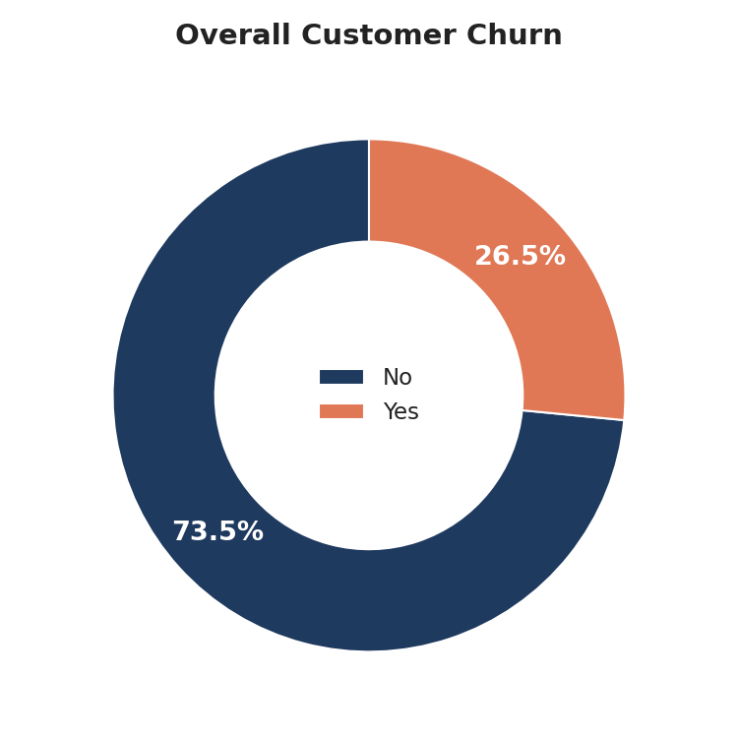
Figure 2: 26.5% of the 7,043 customers analyzed have churned

3.2 Contract Type Is the Strongest Predictor
Contract length shows by far the widest spread in churn rate of any variable in the dataset:
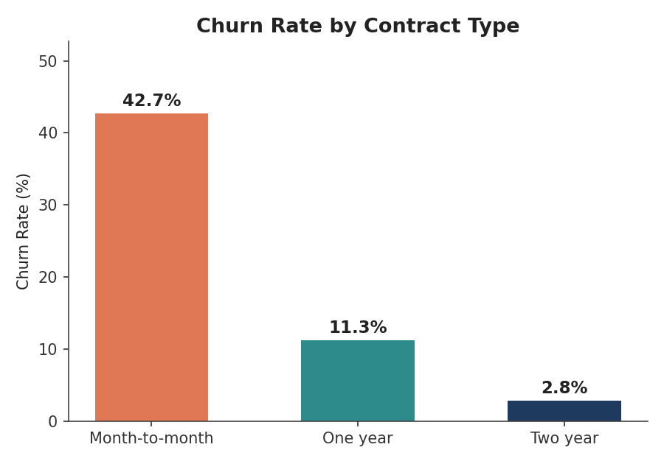
Figure 3: Month-to-month customers churn 15x more often than two-year contract customers
Contract | Customers | Churn Rate
Month-to-month | 3,875 | 42.7%
One year | 1,473 | 11.3%
Two year | 1,695 | 2.8%
Table 1: Churn rate by contract type
This is the single most actionable lever in the dataset: month-to-month customers make up 55% of the customer base and churn at nearly 43%, while two-year contract holders — who represent a comparable share of customers — churn at under 3%.

3.3 Churn Is Front-Loaded in Customer Lifetime
Nearly half of first-year customers leave. Retention risk falls sharply and steadily the longer a customer stays:
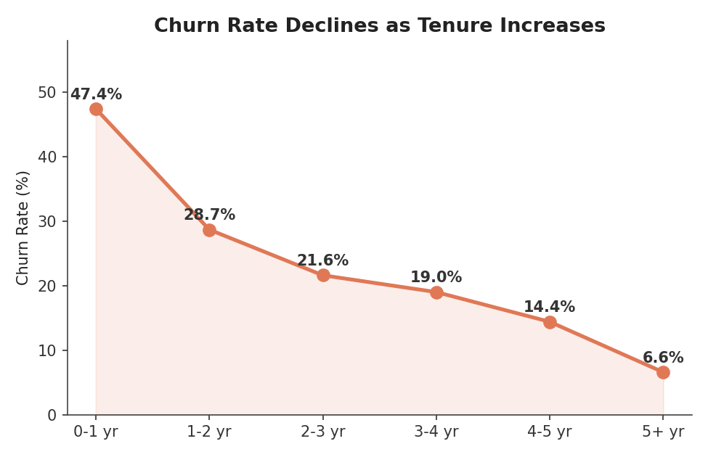
Figure 4: Churn rate by tenure cohort — risk is highest in year one and declines every year after
Average tenure for churned customers is about 18 months, versus about 38 months for retained customers — churners leave, on average, well before reaching the two-year mark where contract-based retention (and typically lower churn) kicks in.

3.4 Fiber-Optic Customers Churn Despite Paying a Premium
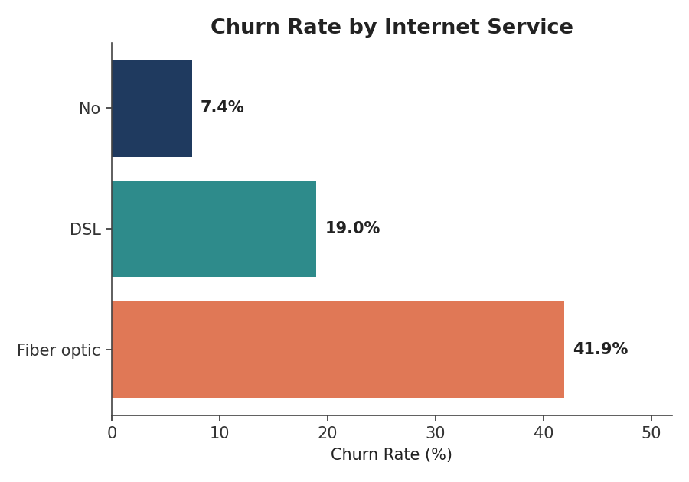
Figure 5: Fiber-optic customers churn more than twice as often as DSL customers
Fiber-optic customers churn at 41.9%, compared to 19.0% for DSL and 7.4% for customers with no internet service at all. Since fiber is typically the company's premium, higher-revenue product, this pattern is worth investigating directly — it may point to service reliability issues, price sensitivity, or stronger competitive offers targeting fiber subscribers specifically.

3.5 Payment Method Correlates Strongly With Churn
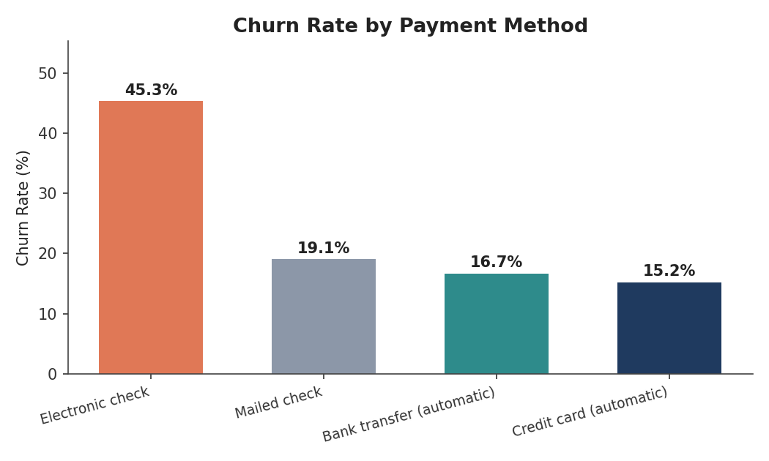
Figure 6: Electronic check payers churn roughly 3x more than automatic-payment customers
Customers paying by electronic check churn at 45.3%, nearly three times the rate of customers on automatic bank transfer (16.7%) or credit card (15.2%). Electronic check is a manual, recurring-friction payment method, and 60% of all month-to-month churners use it — suggesting payment friction and low commitment often travel together.

3.6 Service Adoption Builds Stickiness
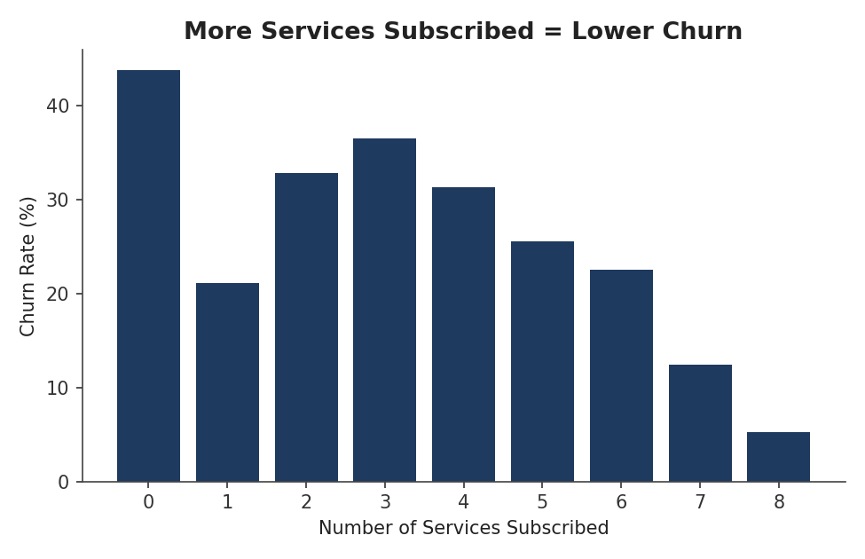
Figure 7: Churn falls from 43.8% (no services) to 5.3% (all 8 services)
The number of add-on services a customer subscribes to is strongly protective. Customers with zero add-on services churn at 43.8%, while customers with all eight available services churn at just 5.3%. Specific services with the largest individual impact are Online Security, Tech Support, and Online Backup, each roughly halving churn risk versus customers without them.
Service | Churn Rate (Has Service) | Churn Rate (No Service)
Online Security | 14.6% | 31.3%
Tech Support | 15.2% | 31.2%
Online Backup | 21.5% | 29.2%
Device Protection | 22.5% | 28.7%
Table 2: Add-on services with the largest churn-reduction effect

3.7 Other Notable Segments
- Senior citizens churn at 41.7% vs. 23.6% for non-seniors — nearly double the base rate.
- Customers without a partner (33.0%) or without dependents (31.3%) churn substantially more than those with a partner (19.7%) or dependents (15.5%) — single-person households appear more price/switching sensitive.
- Customers in the $65–95/month charge band churn the most of any price band (35.9%) — higher than even the $95+ "Premium" band (32.3%), suggesting a "high price, underwhelming value" segment rather than price alone driving churn.
- Paperless billing customers churn at 33.6% vs. 16.3% for traditional billing — likely correlated with the same lower-commitment, digitally-transacting customer profile as month-to-month/electronic-check payers.

4. Cohort Analysis: Tenure × Contract
To understand how churn risk evolves over a customer's lifetime within each contract type, customers were grouped into a cohort matrix crossing tenure band with contract type:
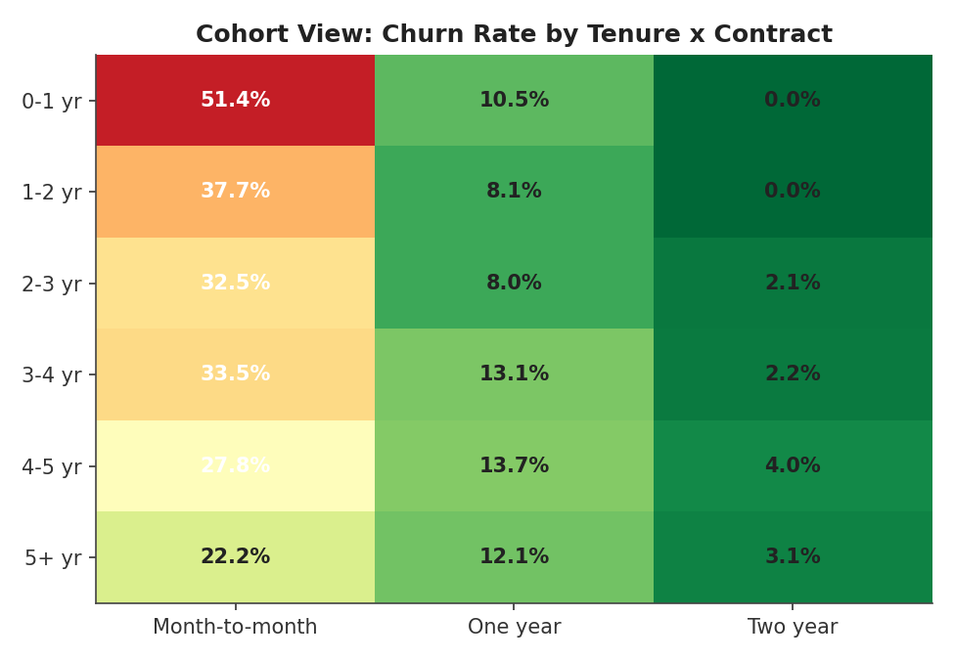
Figure 8: Churn rate (%) by tenure cohort and contract type — darker red = higher churn
Two patterns stand out. First, within every tenure band, month-to-month churn is far higher than one- or two-year contracts — contract type dominates the risk, not just tenure. Second, even month-to-month churn declines somewhat with tenure (from 51.4% in year one to 22.2% after five years), showing that customers who survive long enough on a flexible contract do become more loyal — but the company loses the vast majority of that cohort before they get there.
Business takeaway: the highest-value cohort to target is new (0–1 year), month-to-month customers — they combine the highest per-customer churn probability (51.4%) with the largest cohort size, making them the biggest single opportunity for a contract-upgrade or retention campaign.

5. Customer Lifetime Patterns & Revenue Impact
Metric | Churned Customers | Retained Customers
Average tenure (months) | 18.0 | 37.6
Average monthly charges | $74.44 | $61.27
Average total revenue to date | $1,531.80 | $2,549.91
Table 3: Lifetime metrics — churned customers pay more per month but leave earlier, capping their lifetime value
Churned customers actually pay $13/month more on average than retained customers — they are not low-value customers being lost, they are higher-paying customers leaving too early. Because they leave after ~18 months instead of ~38, their realized lifetime value is roughly 40% lower than a retained customer's, despite the higher monthly rate.
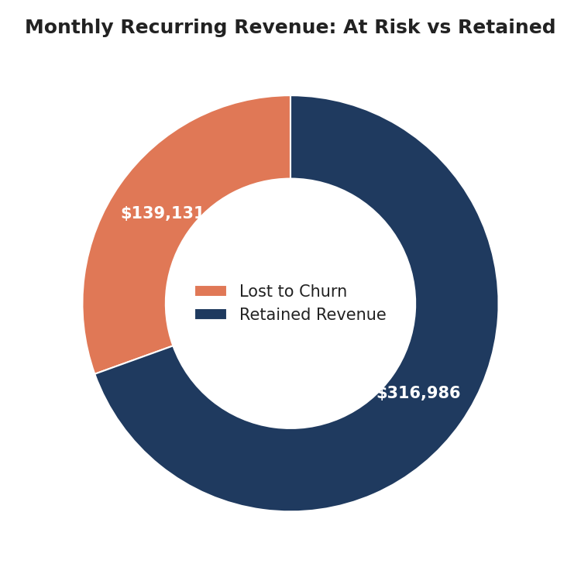
Figure 9: 30.5% of monthly recurring revenue ($139,130 of $456,117) is currently exposed to churn
Within that exposure, customers in the top quartile of monthly charges (≥$89.85/month) who churned account for $57,683 in lost monthly revenue on their own from just 580 customers — a concentrated, high-value segment that justifies dedicated retention-specialist attention.

6. Recommendations: A Retention Action Plan
The following recommendations are prioritized by expected impact and are grounded directly in the patterns observed above.

1. Convert month-to-month customers to annual contracts
Contract type is the single strongest churn predictor (42.7% vs. 2.8%). Launch a targeted upgrade campaign — a discount, a free add-on month, or loyalty pricing — aimed first at the 3,875 month-to-month customers, prioritizing those still in their first 12 months. Even a 10–15% conversion rate would materially reduce blended churn.

2. Fix the first-year experience
Since 47.4% of first-year customers churn, build a structured onboarding and check-in program for days 1–365: proactive support outreach, usage tips, and satisfaction surveys at 30/90/180 days. This is the single largest concentration of churn risk in the business.

3. Investigate fiber-optic service quality and pricing
Fiber customers churn more than twice as often as DSL despite paying a premium. Run a dedicated satisfaction and competitive-pricing study on fiber accounts to determine whether the driver is service reliability, price perception, or aggressive competitor offers targeting fiber subscribers.

4. Migrate customers off electronic check payments
Electronic check payers churn at 45.3%, roughly 3x automatic-payment customers. Offer a small bill credit or fee waiver to incentivize enrollment in automatic bank transfer or credit card payment.

5. Bundle protective add-on services
Each additional service a customer adopts is linked to materially lower churn. Proactively offer a discounted bundle of Online Security, Tech Support, and Online Backup to customers currently subscribed to 0–2 services.

6. Build a senior-citizen retention track
Senior citizens churn at nearly double the base rate (41.7% vs. 23.6%). Consider simplified plans, dedicated support lines, or senior-specific discounts.

7. Prioritize save efforts on high-value accounts
$57,683 in monthly revenue is lost from top-quartile monthly-charge customers alone. Route these accounts to retention specialists proactively — ahead of contract renewal dates or immediately upon any support complaint — rather than relying on reactive save offers.

7. Conclusion
This analysis shows that churn at this company is not random noise — it is concentrated in a clear, addressable profile: new, month-to-month, fiber-optic customers paying by electronic check who have not adopted protective add-on services. Because these same customers tend to pay above-average monthly charges, the revenue opportunity in fixing this pattern is significant: roughly 30% of monthly recurring revenue is currently at risk.
The recommended actions — contract-upgrade campaigns, a stronger first-year onboarding experience, autopay incentives, service bundling, and targeted attention to fiber and senior-citizen segments — are all directly traceable to patterns in the data and represent the highest-leverage places for a retention team to focus next.
A companion interactive Excel dashboard (churn_dashboard.xlsx) is provided alongside this report, allowing the business to explore every metric above and refresh the analysis as new customer data becomes available.

