Marketing Funnel & Conversion
Performance Analysis
Bank Marketing Campaign Dataset — UCI Machine Learning Repository
Data Science & Analytics Internship — Task 3 (2026)
Prepared for: Future Interns

Executive Summary
This report analyzes 41,188 client records from a Portuguese bank's phone-based term deposit marketing campaigns to understand how leads move through the marketing funnel — from being contacted, to engaging in a real conversation, to converting into a customer. The analysis identifies where the biggest drop-offs occur, which channels and audience segments convert best, and provides concrete, actionable recommendations to improve overall conversion performance.
41,188 | 11.27% | 4,640
Total Leads Contacted | Overall Conversion Rate | Converted Customers

1. Methodology
The dataset does not contain an explicit website-style funnel (visitor → lead → customer), since it originates from an outbound call marketing campaign. To make it analyzable as a funnel, the following three stages were defined:
- Stage 1 – Total Leads Contacted: every client called during the campaign (41,188 records).
- Stage 2 – Engaged Leads: clients whose call lasted 3 minutes or longer, used as a proxy for genuine interest rather than an immediate hang-up.
- Stage 3 – Converted Customers: clients who subscribed to the term deposit product (target variable y = “yes”).
All analysis was performed in Python (pandas, matplotlib) inside a documented Jupyter Notebook. Duplicate rows were removed; “unknown” categorical values were retained as their own category rather than dropped, to avoid losing usable segment data.

2. The Funnel: Where Leads Drop Off
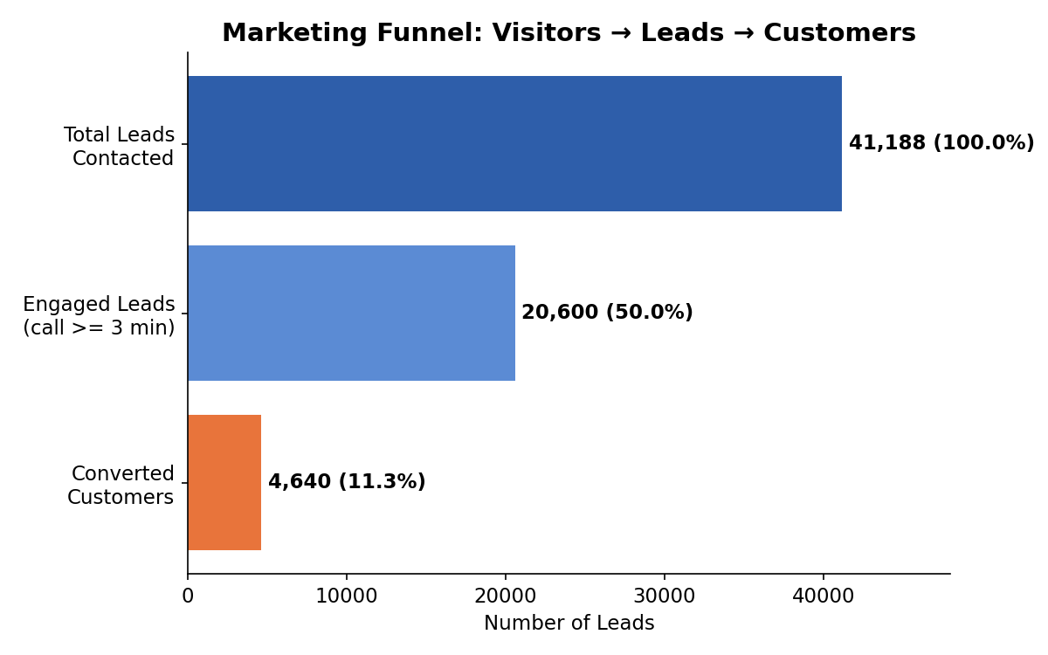
Figure 1 — Funnel volume and conversion at each stage.
Only 50.0% of contacted leads engage in a call of 3+ minutes — this is the single largest drop-off point in the entire funnel. Of those engaged leads, 22.5% go on to convert, giving an overall contacted-to-converted rate of 11.27%.

3. Conversion by Contact Channel
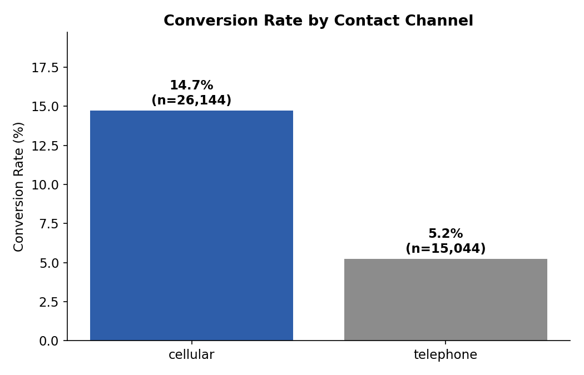
Figure 2 — Conversion rate: cellular vs. landline telephone.
Cellular outreach converts at 14.74%, nearly three times the rate of landline telephone (5.23%). This is one of the clearest, most actionable levers in the dataset — wherever a mobile number is available, it should be the default contact channel.

4. Conversion by Month — Volume vs. Quality
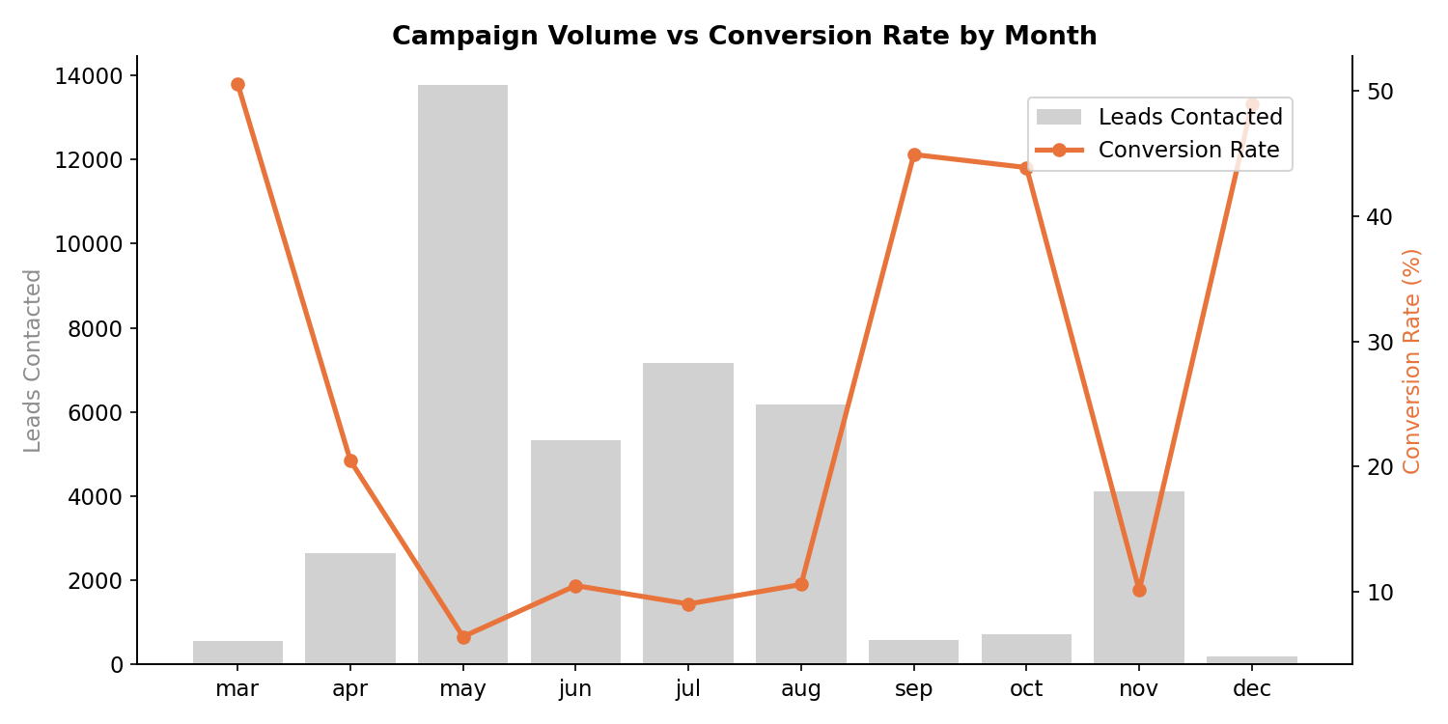
Figure 3 — Campaign volume (bars) vs. conversion rate (line) by month.
The busiest campaign months (May–August) show the lowest conversion rates (6–10%), while low-volume months such as March, September, October, and December convert at 44–51%. This points to a quality-vs-quantity trade-off: smaller, more targeted campaigns convert dramatically better than mass outreach.

5. Conversion by Previous Campaign Outcome
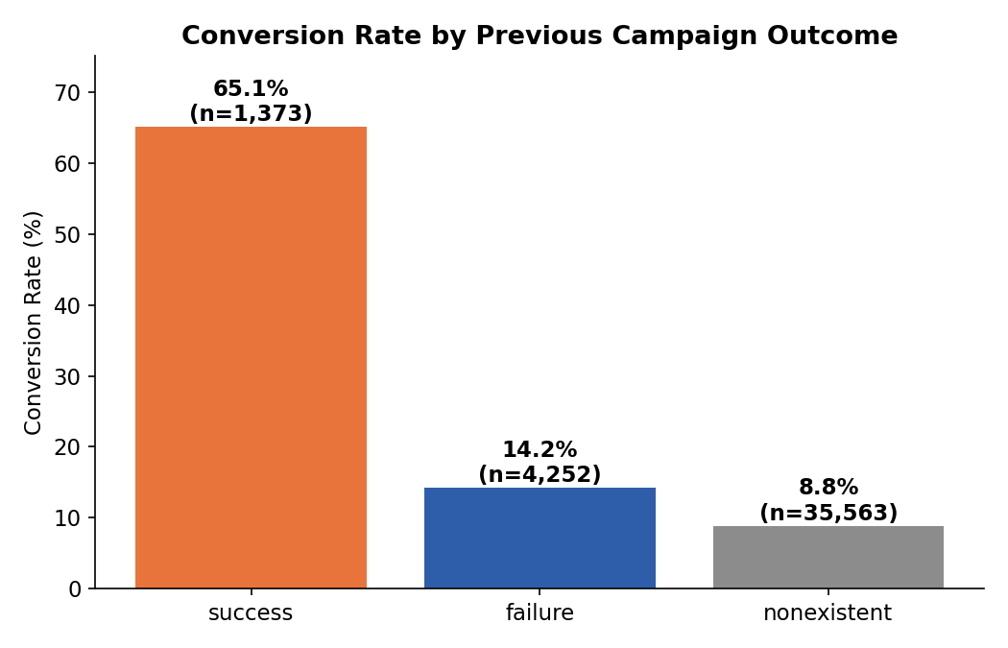
Figure 4 — Conversion rate by outcome of the client's previous campaign contact.
Clients with a previous successful conversion convert at 65.11% — nearly six times the campaign average. This segment (1,373 clients, just 3.3% of the dataset) is by far the highest-value audience and is currently a small share of total outreach.

6. Conversion by Occupation Segment
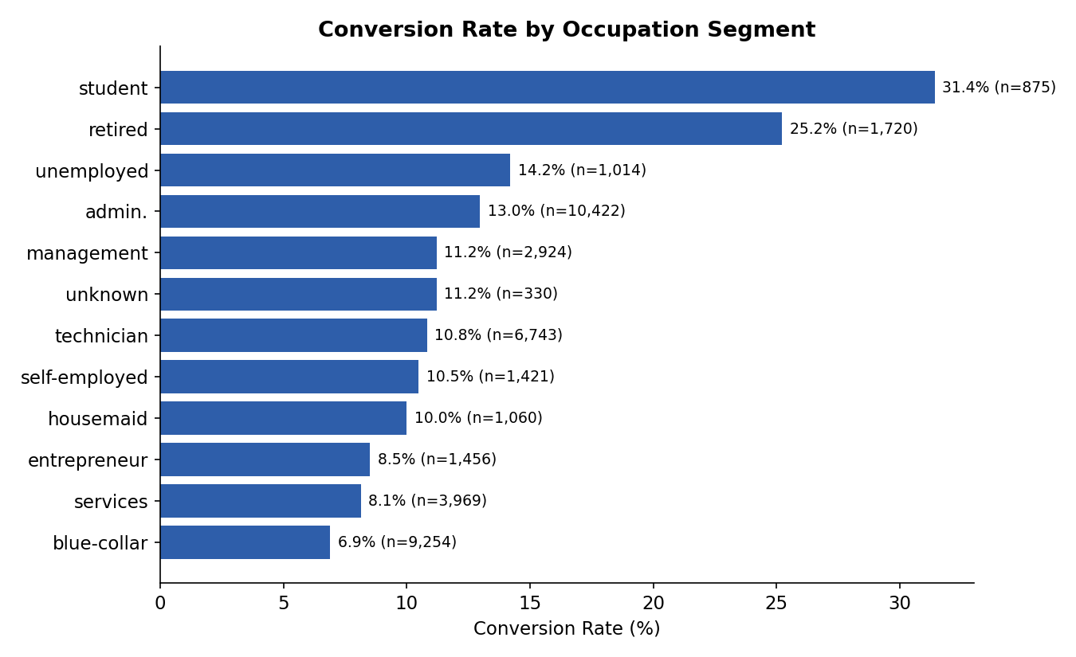
Figure 5 — Conversion rate by client occupation.
Students (31.4%) and retirees (25.2%) convert far above the campaign average, while blue-collar (6.9%) and services (8.1%) workers convert well below it. Occupation is a strong, low-cost segmentation variable for targeting future campaigns.

7. Call Engagement Duration vs. Conversion
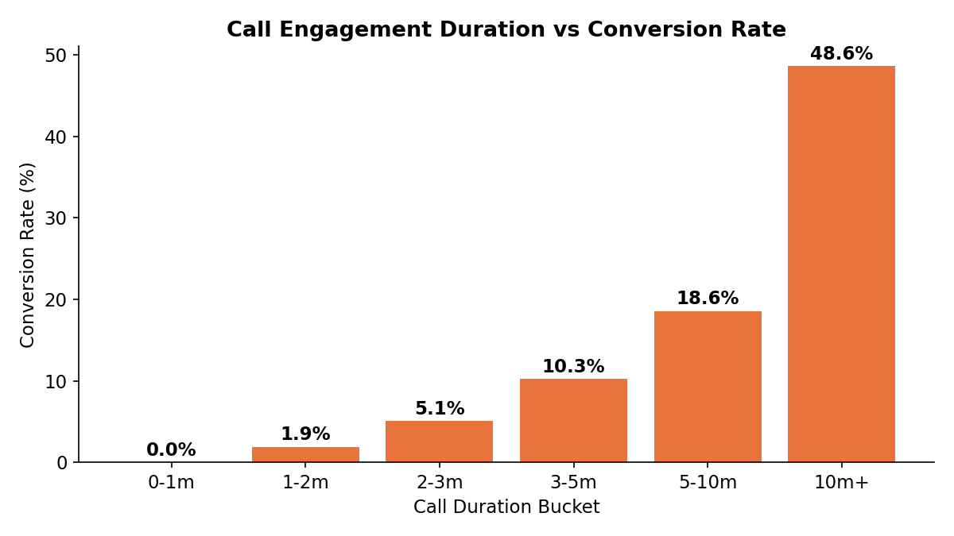
Figure 6 — Conversion rate rises sharply with call duration.
Conversion climbs from effectively 0% for calls under 1 minute to 48.6% for calls exceeding 10 minutes. This confirms that keeping a prospect engaged on the call is one of the strongest predictors of conversion, and that agent scripting/training which extends meaningful conversation time is likely to have an outsized impact.

8. Key Insights
- Biggest drop-off happens at first contact — about half of all leads never engage in a meaningful (3+ minute) call.
- Cellular contact converts ~3x better than landline telephone (14.7% vs. 5.2%).
- Quality beats quantity — high-volume campaign months convert far worse than low-volume, better-targeted months.
- Retargeting past successful customers is the single highest-value segment, converting at 65.1%.
- Students and retirees convert far above average; blue-collar and services workers convert below average.
- Longer, more engaged calls convert dramatically better, confirming call quality and agent training matter.

9. Recommendations
- Prioritize cellular contact over landline wherever a mobile number is available.
- Build a systematic retargeting flow for clients with a previous successful outcome — this segment is under-leveraged relative to its value.
- Shift budget toward smaller, targeted campaigns rather than mass outreach in peak months, or apply the same tighter targeting used in low-volume months to high-volume months.
- Segment campaigns by occupation — lead with students and retirees in acquisition efforts, and use tailored offers/messaging for lower-converting segments.
- Invest in call-opening scripts that get prospects past the critical first 1–2 minutes, since conversion rises sharply the longer a prospect stays engaged.

10. Dataset & Tools
Dataset: Bank Marketing Campaign Dataset, UCI Machine Learning Repository (archive.ics.uci.edu/dataset/222/bank+marketing).
Tools used: Python (pandas, matplotlib), Jupyter Notebook for exploratory analysis, and this report generated from the underlying analysis.

