Q. 1 A company wants to compare the average salaries of male and female employees. A random sample of 20 male and 20 female employees is taken, and their salaries are recorded.
Question:
At a 5% significance level, is there a significant difference in the average salaries of male and female employees?

Hint: t test as n<30

Q. 2 A smartphone company claims that the average battery life of its latest model is 12 hours. A consumer group tests 40 randomly selected phones and finds an average battery life of 11.5 hours with a standard deviation of 1.8 hours.
Question:
At a 5% significance level, can we conclude that the true mean battery life is different from 12 hours?
Hint: z test as n>=30

Q.3 A supermarket believes that customers are equally likely to shop on any day of the week. A sample of 700 customers shows the following distribution:
Day | Mon | Tue | Wed | Thu | Fri | Sat | Sun
Customers | 90 | 85 | 100 | 120 | 110 | 105 | 90
Question:
At a 5% significance level, can we conclude that customer shopping preferences are not equally distributed across the days of the week?
Q.4 A retailer wants to determine whether a customer's preferred payment method is related to their shopping preference (Online or In-Store). A survey of 300 customers provides the following data:
Payment Method | Online | In-Store | Total
Credit Card | 50 | 70 | 120
UPI | 80 | 50 | 130
Cash | 40 | 10 | 50
Total | 170 | 130 | 300
The retailer wants to test whether payment method and shopping preference are independent at a 5% significance level.
Q.5 Let X and Y be discrete random variables with the following joint probability mass function (PMF):
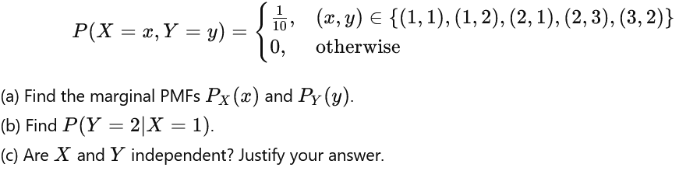
Q.6 Suppose the joint probability density function (PDF) of X and Y is given by:
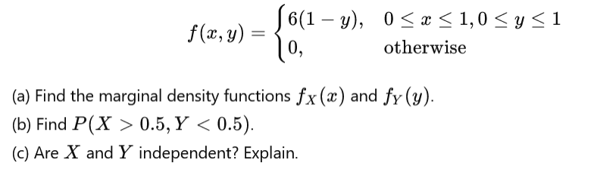
Q.7 Given a joint PDF:
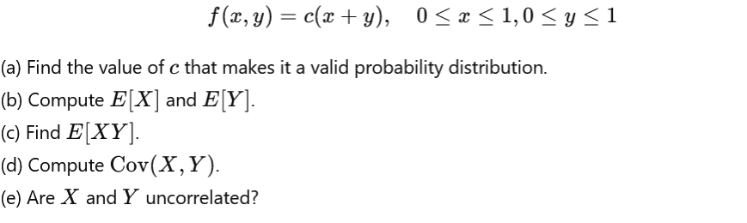
Q.8 Suppose X and Y are independent uniform random variables on [0,1], and we define:
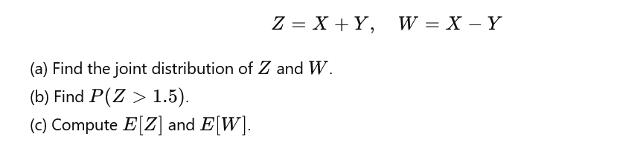
Q.9 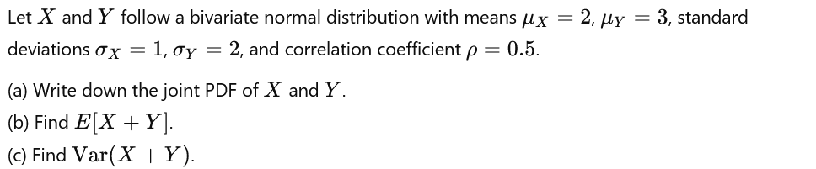
Q.10 and Q.11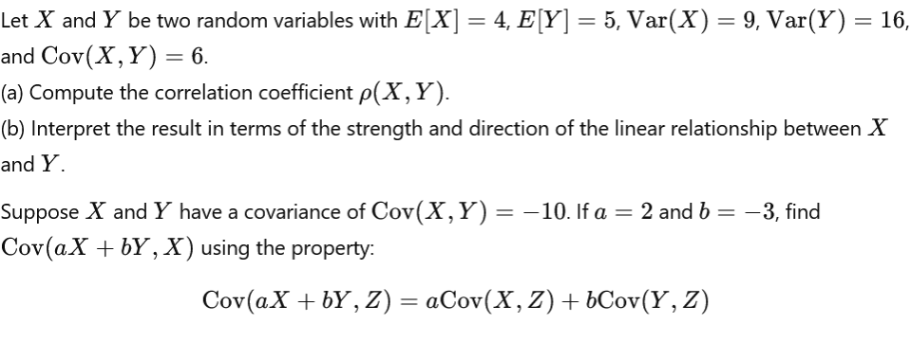
Q. 12 Consider two random variables X and Y with joint PMF given in Table
- Find P(X=0,Y≤1)
- Find the marginal PMFs of X and Y
- Find P(Y=1|X=0)
- Are X and Y independent?
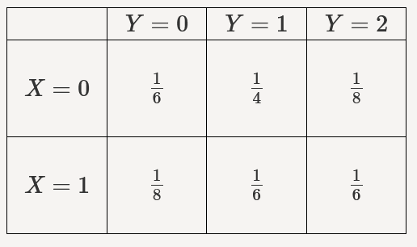
Q. 13
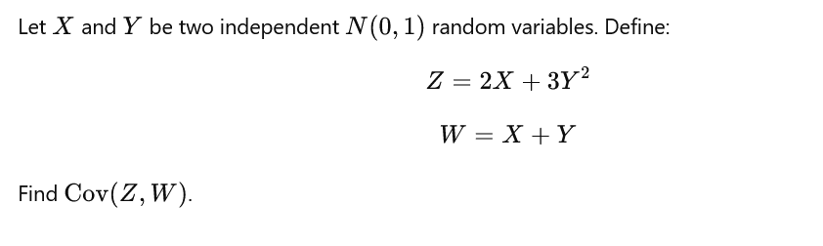
Q. 14 A box contains 5 red, 4 blue, and 3 green balls. Two balls are drawn at random one after another without replacement.
What is the probability that the second ball drawn is blue, given that the first ball drawn was red?
Q. 15 A factory produces 60% of its items from Machine A and 40% from Machine B. The defect rate is 3% for Machine A and 5% for Machine B.
If a randomly selected item is found to be defective, what is the probability that it was produced by Machine B?
Q. 16 Let X and Y be two discrete random variables with joint probability distribution given by:
X | Y | P(X,Y)
0 | 0 | 0.25
0 | 1 | 0.25
1 | 0 | 0.25
1 | 1 | 0.25
Are X and Y independent? Justify your answer using the definition of independence.

