Customer Churn Analysis Project - Insights & Report

# 📊 Project Overview

This project analyzes customer churn using the Telco dataset, which contains data on 7,043 customers with 21 features including demographics, service subscriptions, billing methods, and churn status. The primary goal is to understand the drivers of churn and build predictive models to identify at-risk customers.

# 📂 Dataset Details

- Total Customers: 7,043  
- Features: 21 (Demographics, Services, Billing, Contract, Charges)  
- Target Variable: Churn (Yes/No)

# 🔎 Key Insights

1. Churn Rate: ~26% of customers have churned.  
2. Tenure Effect: Customers with <12 months tenure are most likely to churn.  
3. Contract Type: Month-to-month contracts have the highest churn; two-year contracts see very low churn.  
4. Services & Support: Lack of online security, tech support, and backup services correlates with higher churn.  
5. Payment Method: Electronic check users churn the most, while auto-pay customers are more loyal.  
6. Charges: High monthly charges (> $70) increase churn likelihood.

# 🤖 Modeling Approach

Several machine learning algorithms were applied to predict churn:  
- Logistic Regression  
- Random Forest  
- Gradient Boosting  
  
Best performing model: Gradient Boosting, achieving ~80-82% accuracy with balanced precision and recall.

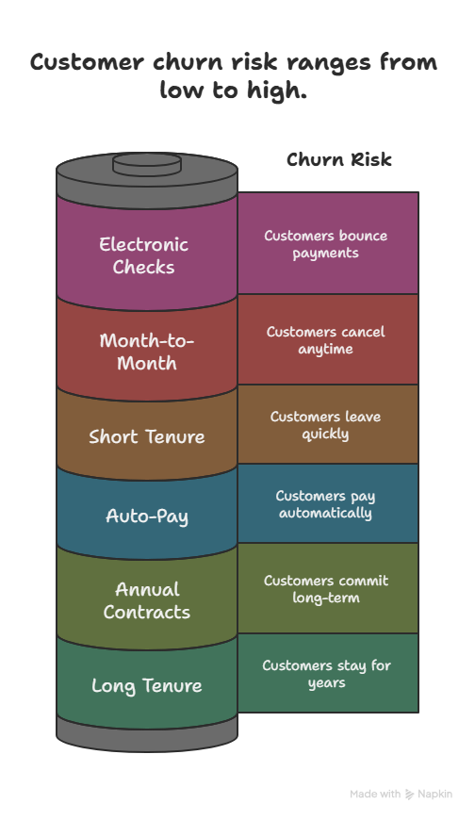

**Customer Churn Mind-Map**

# 💡 Business Recommendations

- Offer discounts or loyalty programs to customers with short tenure.  
- Encourage customers to switch from month-to-month to yearly contracts.  
- Promote auto-pay options to reduce churn linked with electronic check users.  
- Enhance customer support, online security, and technical assistance services.  
- Consider offering bundled service packages to increase retention.

# 🚀 LinkedIn-ready Post

Customer Retention > Customer Acquisition 💡  
  
I recently worked on a Customer Churn Analysis Project where I explored the Telco dataset (7,000+ customers).  
  
✅ Key Insight: Customers on month-to-month contracts with high monthly charges are the most likely to churn.  
✅ Offering loyalty discounts, annual plans, and better customer support can significantly reduce churn.  
  
📊 Using ML models like Random Forest & Gradient Boosting, I achieved ~82% churn prediction accuracy.  
  
Takeaway: Businesses can save millions by focusing on retention strategies rather than acquisition.  
  
💬 What strategies have you seen companies use to successfully reduce churn?