User Interfaces and Visualization

  - Introduction
This chapter discusses user interfaces for communication between human information seekers and information retrieval systems. Information seeking is an imprecise process. When users approach an information access system they often have only a fuzzy understanding of how they can achieve their goals. Thus the user interface should aid in the understanding and expression of information needs. It should also help users formulate their queries, select among available information sources, understand search results, and keep track of the progress of their search.
The human-computer interface is less well understood than other aspects of information retrieval, in part because humans are more complex than computer systems, and their motivations and behaviors are more difficult to measure and characterize. The area is also undergoing rapid change, and so the discussion in this chapter will emphasize recent developments rather than established wisdom.

  - Human-Computer Interaction
What makes an effective human-computer interface? an expert in the field, writes:
Well designed, effective computer systems generate positive feelings of success, competence, mastery, and clarity in the user community. When an interactive system is well-designed, the interface almost disappears, enabling users to concentrate on their work, exploration, or pleasure.

As steps towards achieving these goals, Shneiderman lists principles for design of user interfaces. Those which are particularly important for information access include (slightly restated): provide informative feedback, permit easy reversal of actions, support an internal locus of control, reduce working memory load, and provide alternative interfaces for novice and expert users. Each of these principles should be instantiated differently depending on the particular interface application.

    - Design Principles
Offer Informative feedback. This principle is especially important for information access interfaces. In this chapter we will see current ideas about how to provide users with feedback about the relationship between their query specification and documents retrieved, about relationships among retrieved documents, and about relationships between retrieved documents and metadata describing collections. If the user has control of how and when feedback is provided, then the system provides an intern of locus of control.
Reduce working memory load. Information access is an iterative process, the goals of which shift and change as information is encountered. One key way information access interfaces can help with memory load is to provide mechanisms for keeping track of choices made during the search process, allowing users to return to temporarily abandoned strategies, jump from one strategy to the next, and retain information and context across search sessions. Another memory-aiding device is to provide browsable information that is relevant to the current stage of the information access process. This includes suggestions of related terms or metadata, and search starting points including lists of sources and topic lists.
Provide ofternotive interfaces for novice and e:cpert users. An important tradeoff in all user interface design is that of simplicity versus power. Simple interfaces are easier to learn, at the expense of less flexibility and sometimes less efficient use. Powerful interfaces allow a knowledgeable user to do more and have more control over the operation of the interface, but can be time- consuming to learn and impose a memory burden on people who use the system only intermittently. A common solution is to use a ‘scaffolding’ technique 684]. The novice user is presented with a simple interface that can be learned quickly and that provides the basic functionality of the application, but is restricted in power and flexibility. Alternative interfaces are offered for more experienced users, giving them more control, more options, and more features, or potentially even entirely different interaction models. Good user interface design provides intuitive bridges between the simple and the advanced interfaces.
Information access interfaces must contend with special kinds of simplic- ity/power tradeoffs. One such tradeoff is the amount of information shown about the workings of the search system itself. Users who are new to a system or to a particular collection may not know enough about the system or the domain associated with the collection to make choices among complex features. They may not know how best to weight terms, or in the case of relevance feedback, not know what the effects of reweighting terms would be. On the other hand, users that have worked with a system and gotten a feeling for a topic are likely to be able to choose among suggested terms to add to their query in an informed manner. Determining how much information to show the user of the system is a major design choice in information access interfaces.

    - The Role of Visualization
The tools of computer interface design are familiar to most computer users today: windows, menus, icons, dialog boxes, and so on. These make use of bit-mapped displays and computer graphics to provide a more accessible interface than command-line-based displays.

A less familiar but growing area is that of information visualization, which attempts to provide visual depictions of very large information spaces.
Humans are highly attuned to images and visual information . Pictures and graphics can be captivating and appealing, especially if well designed. A visual representation can communicate some kinds of information much more rapidly and effectively than any other method.

Visualization of inherently abstract information is more difficult, and visualization of textually represented information is especially challenging. Language is our main means of communicating abstract ideas for which there is no obvious physical manifestation.
Brushing and linking refers to the connecting of two or more views of the same data, such that a change to the representation in one view affects the representation in the other views as well.
Panning and zooming refers to the actions of a movie camera that can scan sideways across a scene (panning) or move in for a closeup or back away to get a wider view (zooming).
When zooming is used, the more detail that is visible about a particular item, the less can be seen about the surrounding items. Focus-plus-context is used to partly alleviate this effect. The idea is to make one portion of the view — the focus of attention — larger, while simultaneously shrinking the surrounding objects.

    - Evaluating Interactive Systems
From the viewpoint of user interface design, people have widely differing abilities, preferences, and predilections. Important differences for information access interfaces include relative spatial ability and memory, reasoning abilities, verbal aptitude, and (potentially) personality differences. Age and cultural differences can contribute to acceptance or rejection of interface techniques. An interface innovation can be useful and pleasing for some users, and foreign and cumbersome for others.

Thus software design should allow for flexibility in interaction style, and new features should not be expected to be equally helpful for all users.
An important aspect of human-computer interaction is the methodology for evaluation of user interface techniques. Precision and recall measures have been widely used for comparing the ranking results of non-interactive systems, but are less appropriate for assessing interactive systems.
The standard evaluation emphasize high recall levels; in the TREC tasks systems are compared to see how well they return the top 1000 documents. However, in many interactive settings, users require only a few relevant documents and do not care about high recall to evaluate highly interactive information access systems, useful metrics beyond precision and recall include: time required to learn the system, time required to achieve goals on benchmark tasks, error rates, and retention of the use of the interface over time.
Empirical data involving human users is time consuming to gather and difficult to draw conclusions from. This is due in part to variation in users' characteristics and motivations, and in part to the broad scope of information access activities. Formal psychological studies usually only uncover narrow conclusions within restricted contexts. For example, quantities such as the length of time it takes for a user to select an item from a fixed menu under various conditions have been characterized empirically, but variations in interaction behavior for complex tasks like information access are difficult to account for accurately. Nielsen advocates a more informal evaluation approach (called heuristic evaluation) in which user interface affordances are assessed in terms of more general properties and without concern about statistically significant results.

  - The Information Access Process
A person engaged in an information seeking process has one or more goals in mind and uses a search system as a tool to help achieve those goals. Goals requiring information access can range quite widely, from finding a plumber to keeping informed about a business competitor, from writing a publishable scholarly article to investigating an allegation of fraud.
To accomplish these goals, users perform information access tasks. These tasks range along a spectrum: on one end are focused queries that aim to answer specific questions, and on the other are broad, exhaustive searches for in-depth understanding of a topic. Many tasks fall somewhere in between.
A study of business analysts identified three primary types of information-seeking behaviors:
- Monitoring – Tracking a familiar topic over time (e.g., researching competitors' activities each quarter).
- Planned searching – Following a structured or routine set of searches to achieve a known objective (e.g., staying current on business best practices).
- Exploratory searching – Engaging in open-ended exploration to become familiar with a new subject or industry.

    - Models of Interaction
Most accounts of the information access process assume an interaction cycle consisting of query specification, receipt and examination of retrieval results, and then either stopping or reformulating the query and repeating the process until a perfect result set. In more detail, the standard process can be described according to the following sequence of steps :

- Start with an information need.
- Select a system and collections to search on.
- Formulate a query.
- Send the query to the system.
- Receive the results in the form of information items.
- Scan, evaluate, and interpret the results.
- Either stop, or,
- Reformulate the query and go to step 4.
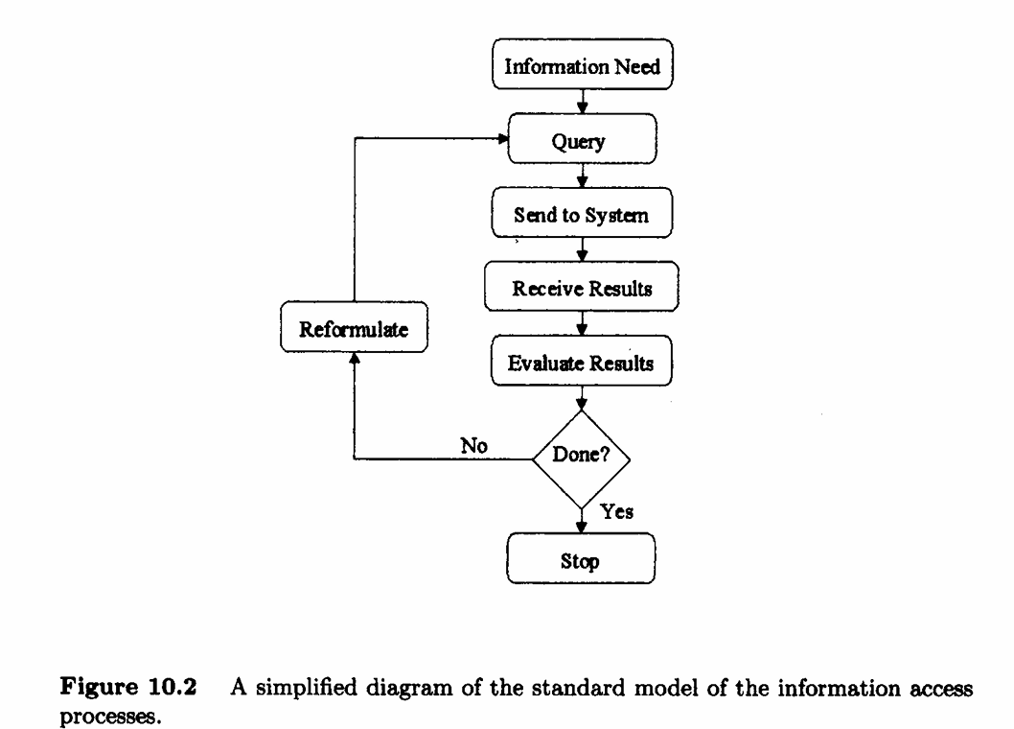
Problems with This Model:
- Assumes the user’s information need stays the same throughout the process.
- Assumes the goal is to find a perfect set of results.
- Fails to handle dynamic learning—users often change or refine their goals during the search.
- Presents users with long, unstructured result lists.
- Does not consider hyperlink navigation, browsing, or scanning related topics.
The 'Berry-Picking' Model (by Marcia Bates)
This model challenges the traditional model by recognizing how people actually search for information in real situations.
Key Features:
- Information needs evolve during the search.As users find new info, their goals may shift or branch off.
- Users gather bits and pieces of information from different sources (like picking berries).
- There’s no final perfect result set—the process is incremental and adaptive.
- Emphasizes learning, scanning, exploring, and changing strategies during the search.
Example:
A user searching for “history of climate change” might:
Read an article, discover a new interest in “climate policy in the 1980s,”.Shift focus, search again, and gradually build knowledge from many different documents.
Implications for User Interfaces
To support real-world information seeking:
- Interfaces should let users:
  - Adjust goals mid-search.
  - Switch strategies easily.
  - Track their progress, store intermediate results, and resume previous paths.
- Should support multiple strategies at once (e.g., browsing and querying together).
- Must accommodate exploration, navigation, and serendipitous discovery.
- Monitoring and evaluation tools help users assess if continuing a path is worth the time (cost-benefit).
These are different modes of interacting with information:
Mode | Description
Scanning | Looking over structures (titles, labels, links) quickly.
Querying | Actively searching by inputting keywords or selecting terms.
Navigating | Clicking through links to reach related content.
Browsing | Casual, less goal-directed exploration of content.
- These modes often interact—e.g., scanning leads to browsing, which leads to querying.
- The output of one action (like finding a useful term) should be usable in the next (like forming a new query).

    - Non-Search Parts of the Information Access Process
The O'Day and Jeffries study found that information seeking is only one part of the full work process their subjects were engaged in. In between searching sessions many different kinds of work was done with the retrieved information, including reading and annotating and analysis. O'Day and Jeffries examined the analysis steps in more detail, finding that 80% of this work fell into six main types: finding trends, making comparisons, aggregating information, identifying a critical subset, assessing, and interpreting. The remaining 20% consisted of cross-referencing, summarizing, finding evocative visualizations for reports, and miscellaneous activities. The Sensemaking work of Russell et al. also discusses information work as a process in which information retrieval plays only a small part. They observe that most of the effort made in Sensemaking is in the synthesis of a good representation, or ways of thinking about, the problem at hand. They describe the process of formulating and crystallizing the important concepts for a given task. From these observations it is convenient to divide the entire information access process into two main components: search/retrieval, and analysis/synthesis of results. User interfaces should allow both kinds of activity to be tightly interwoven. However, analysis/synthesis are activities that can be done independently of information seeking, and for our purposes it is useful to make a distinction between the two types of activities.

    - Earlier Interface Studies
Earlier Systems (Pre-Internet Era)
- Often used bibliographic records (only titles, authors, abstracts).
- Required professional intermediaries to do the searching.
- Search used Boolean logic (AND, OR, NOT), which was rigid.
- Text interfaces (e.g., TTYs) required users to memorize commands.
- Switching databases was slow and required advance knowledge.
Modern Systems
- Use full-text search (e.g., the actual content of web pages, papers).
- Users are typically end users (non-experts).
- Use statistical ranking (e.g., relevance ranking like in Google).
- Documents are hyperlinked, making navigation seamless.
- Search interfaces are graphical, supporting direct manipulation (e.g., clicking, dragging).
- A “near miss” result can still be useful because users can follow links to better content
  - Starting Points
Search interfaces must provide users with good ways to get started. An empty screen or a blank entry form does not provide clues to help a user decide how to start the search process. Users usually do not begin by creating a long, detailed expression of their information need. Studies show that users tend to start out with very short queries, inspect the results, and then modify those queries in an incremental feedback cycle. Thus, one task of an information access interface is to help users select the sources and collections to search on.
For example, there are many different information sources associated with cancer, and there are many different kinds of information a user might like to know about cancer. Guiding the user to the right set of starting points can help with the initial problem formulation. Traditional bibliographic search assumes that the user begins by looking through a list of names of sources and choosing which collections to search on, while Web search engines obliterate the distinctions between sources and plunge the user into the middle of a Web site with little information about the relationship of the search hit to the rest of the collection. In neither case is the interface to the available sources particularly helpful.
four main types of starting points: lists, overviews, examples, and automated source selection.

    - Lists of Collections
Typical online systems such as LEXIS-NEXIS require users to begin any inquiry with a scan through a long list of source names and guess which ones will be of interest. Usually little information beyond the name of the collection is provided online for these sources. If the user is not satisfied with the results on one collection, they must reissue the query on another collection.
Experienced users (like researchers or professionals) learn which sources are most useful for their needs:Through trial and error ,Through training ,From recommendations
They often use “favorites” lists, also called:Bookmarks ,Hotlists (on the Web)
Challenges for New or Unfamiliar Topics:
- If someone is searching outside their area of expertise, these favorites or bookmarks won’t help.
- Professional searchers (like librarians) develop deep knowledge over time of which sources are good for different needs.
- But traditional interfaces don’t make it easy for regular users to explore or discover new sources.

    - Overviews
Faced with a large set of text collections, how can a riser choose which to be with? One approach is to study overview of the contents of the Collections. An overview can show the topic domains represeñted within the consideration; to help users select or eliminate sources from consideration. An overview can help users get started, directing them into general neighborhoods, after which they can navigate using more detailed descriptions. Shneiderman [724] advocates an interaction model in which the user begins with an overview of the information to be worked with, then pairs and zooms' to find areas of potential’interest, and then view details. Thé process is repeated aa often as necessary.

Three types of overviews :
- Topical Hierarchies (Manual Categories):
  - These are like tree structures showing categories and subcategories of topics.
  - Documents are organized based on predefined themes.
  - Users can browse through categories to find what fits.
- Automatically Generated Overviews (Clustering):
  - These use machine learning (especially unsupervised clustering) to group documents based on their content.
  - The system identifies themes or topics from the text without human input.
  - Helps reveal hidden patterns or groupings in the data.
- Link-Based Overviews (Co-Citation or Network Analysis):
  - Based on connections between items (e.g., citations, links, or shared references).
  - For example, documents that are often cited together might be related in theme.
  - This method uses relationship networks to define groupings.

Category or Directory Overviews
Structured category hierarchies are commonly used in large information systems to help users find and browse documents. These categories can be manual labels like subject headings or hierarchical directories like those used by Yahoo! and MEDLINE. But while helpful, they often have usability issues—especially around navigation and integration with search queries.

Examples of Category-Based Systems:
- Traditional Libraries:Use subject headings for books/documents (e.g., in bibliographic catalogs).
- MEDLINE (biomedical database):Uses MeSH (Medical Subject Headings) with ~18,000 categories.
- ACM (Association for Computing Machinery):Has ~1,200 keyword categories for computing topics.
- Yahoo! Web Directory:One of the first major web search tools that used a category hierarchy to organize content
Why Are Category Overviews Useful?
- They give users a starting point instead of making them guess search terms.
- They help avoid irrelevant or low-quality content.
- They support logical exploration through a tree-like structure of topics.
Problems with Category Systems:
- Poor Interfaces:
  - Users often don’t use subject headings because the interface is bad (e.g., old command-line systems).
  - Even with web interfaces, scrolling long lists or deep hierarchies is frustrating.
- Hard to Navigate:
  - Users must guess which category to pick.
  - If they’re wrong, they have to backtrack and try again.
  - Going deep into categories often leads to losing context (what you were originally searching for).
- Limited Search Capability:
Most systems don’t allow combining multiple categories in a search (e.g., can’t search documents in both “Children” and “Injuries”).
- Large Screen Space:
Showing full hierarchies takes up a lot of space, especially on screens with limited room.
Systems That Try to Improve on These Problems:
1. Internet Grateful Med:
- Web interface to search MeSH categories.
- But: when users click on a category, it replaces the search page, loses context, and navigating the tree becomes clumsy.
2. MeSHBrowse:
- Lets users interactively browse a subset of the MeSH hierarchy.Uses a 2D tree view to show only relevant categories.
- Limitation: no direct searching of documents, and still constrained by screen space.
3. HiBrowse:
- More flexible and powerful.Uses faceted navigation (users choose multiple attributes like Disease, Therapy, Age Group).Shows document counts for each selection.Dynamically updates counts when users refine their filters.
- Problem: Users must still navigate the category tree—querying is not tightly integrated.
Preview of a Better Solution:At the end, the text hints at a system called Cat-a-Cone, which aims to solve some of these usability problems.

Automatically Derived Collection Overviews
Instead of manually organizing documents into categories, we can use unsupervised methods like clustering to automatically group similar documents. These groups (or clusters) represent emerging themes in the collection and help users navigate or browse large datasets.
Clustering groups documents based on similarity (e.g., shared words or topics).Each group has a centroid that characterizes the main theme of the cluster.This allows users to explore a high-level overview of a collection without reading every document.This is a well-known system for cluster-based browsing.
How it works:
- The system clusters a large collection into topical groups.
- It presents summary terms and sample titles for each group.
- The user selects interesting clusters.
- Those clusters are then re-clustered for more detailed exploration.
It’s an interactive, iterative way to explore content from general to specific.
Limitations:
- A study found that Scatter/Gather alone (without search) wasn’t as effective as traditional search for finding relevant documents.
- Users navigating only through clusters often struggled to reach precise, relevant results.
- But when combined with search (clustering only the documents returned by a query), performance improved.

Benefits of Combining Clustering with Search:
- Clustering can be applied after search results are retrieved.
- For example, if a search returns 100 documents:
  - Cluster them into 5 groups.
  - Often, most relevant documents are in just 1 or 2 clusters.
  - This makes it faster and easier for users to find the best content.
- Precision and recall (quality measures of search results) were found to be higher in the best cluster than in the full list of search results.
Challenges of Clustering:
- No one clustering algorithm consistently outperforms others.
- Themes generated can be inconsistent:
  - Some are very specific (e.g., "Artificial Intelligence")
  - Others are very broad (e.g., "Government") and less relevant.
  - This mix can confuse users, as levels of detail vary.
Visual Representations of Clustering:Researchers have developed graphical methods to display clusters:
- Scatter-plot-style layouts:
  - Each document = a small icon/glyph in a 2D space.
  - Users see visual patterns (clusters) emerging.
  - Examples:BEAD,Galaxy of News,ThemeScape (3D topographic map view with cluster “mountains”)
- Kohonen Feature Maps (Self-Organizing Maps):
  - A type of neural network that maps high-dimensional data to 2D grids.
  - Documents are arranged into regions based on themes.
  - Adjacent regions are semantically related.
  - Moving your cursor over a region shows titles of documents in that area.
- Other visualization methods:
  - Inter-document similarity graphs (showing how documents relate to one another)
  - Hierarchies or networks of related documents
Evaluations of Graphical Overviews
While graphical overviews (like maps or visual clusters) seem promising, user studies show they’re often not very effective, especially for general users.
Key Findings:
- Users struggle with graphical clusters like circles and lines (which represent document groups and relationships), because:
  - It’s hard to know what a document is about without seeing some text.
  - Textual summaries (e.g., titles, keywords) are usually more effective.
Study: Kohonen Map vs Yahoo!
- Compared Yahoo!’s category-based directory (text-based) with a Kohonen feature map (graph-based) for browsing entertainment websites.
- Results:
  - 11 of 15 users starting with the Kohonen map found an interesting page.
  - But only 2 of those could later find the same page using Yahoo!.
  - Conversely, 14 of 16 users starting with Yahoo! succeeded, but only 2 of those could find the same page on the Kohonen map.
- Conclusion:
Yahoo!’s simple label view was more effective and navigable.
User Feedback:
- What users liked about the map:
  - Could jump quickly between areas (no backtracking).
  - Liked the varying levels of detail (granularity).
- What users disliked:
  - No visible hierarchy (hard to orient).
  - Couldn’t zoom in easily for more detail.
  - Labels were confusing or ambiguous (e.g., a region called “BILL” was misinterpreted).
  - Wanted alphabetical order to find topics faster.
- Overall conclusion: Graphical maps might work well for casual browsing, but are less useful for direct search tasks.
Co-Citation Clustering for Overviews
This part introduces a different approach to creating overviews, based on citation patterns, not text or visuals.
If two documents are cited together by another document, they are said to be co-cited.Assumption: co-cited documents share related themes or topics.You can also link documents that cite the same source.These co-citation relationships are used to build a similarity matrix, which is then clustered.
What It Reveals:
- Helps identify:
  - Thematic clusters (dominant topics).
  - Central documents or key authors in a field.
- Clustering can be based on:
  - Documents (to find key papers).
  - Authors (to find influential researchers).
Applications:
- Referral Web project: Applies co-citation logic to web documents.
- Also used on web pages, based on their link structure (how pages link to one another).
- Authority Pages (Kleinberg):
  - Identifies good starting points for specific topics on the web.
  - These are pages often linked to by many others on the same topic.

    - Automated Source Selection
Selecting the right source (e.g., database, website, search engine) to search in is critical, but doing it manually is hard. This section explores automated methods to help match user needs to the best sources.

Two Main Approaches to Source Selection:
1. Modeling the User and the Source (Ambitious, AI-driven)
- Build a model of the user’s information need.
- Also build a model of each source’s content.
- Then try to match them—figure out which source fits the user’s needs.
- Used in:User modeling systems,Intelligent tutoring systems,Online help systems
Challenge: This is complex and resource-heavy, requiring a deep understanding of both the user's intent and the source contents.
2. Content-Based Matching (Simpler and Practical)
Instead of building deep models, this method uses textual representations of sources and compares them directly to the query.
Examples:
- GIOSS:
Looks at how often the query terms appear in different databases.Chooses the best database based on term frequencies.
- SavvySearch:Uses not only the query but also user behavior:
If users click more on results from a certain source, that source's ranking increases.This helps learn which engines work better for different kinds of queries.
Alternative Approach: Metasearch and Collection Fusion
Instead of picking one best source, you can:
- Send the query to multiple sources at once.
- Combine results from different systems.
This is what metasearch engines do (e.g., Dogpile, Metacrawler).
Challenge: How to combine results meaningfully when:
- Different systems rank results differently.
- Some may return duplicates.
- Others may return inconsistent formats.
This process is called collection fusion—a hot research area in information retrieval.

  - Query Specification
To formulate a query, a user must select collections, metadata descriptions, or information sets against which the query is to be matched, and must specify words, phrases, descriptors, or other kinds of information that can be compared to or matched against the information in the collections. As a result, the system creates a set of documents, metadata, or other information type that match the query specification in some sense and displays the results to the user in some form.
Shneiderman [725a identifies five primary human-computer interaction styles. These are: command language, form flllin, menu selection, direct manip- ulation, and natural !*^9•age.p Each technique has been used in query specifica- tion interfaces and each has advantages and disadvantages. These are described below in the context of Boolean query specification.

    - Boolean Queries

In modern information access systems the matching process usually employs a statistical ranking algorithm. However, until recently most commercial full-text systems and most bibliographic systems supported only Boolean queries. Thus the focus of many information access studies has been on the problems users have in specifying Boolean queries. Unfortunately, studies have shown time and again that most users have great difficulty specifying queries in Boolean format and often misjudge what the results will be 111, 322, 558, 841].
Boolean queries are problematic for several reasons. Foremost among these is that most people find the basic syntax counter-intuitive. Many English- speaking users assume everyday semantics are associated with Boolean oper- ators when expressed using the English words AND and OR, rather than their logical equivalents. To inexperienced users, using AND implies the widening of the scope of the query, because more kinds of information are being requested. For instance, ‘dogs and cats’ may imply a request for documents about dogs and documents about cats, rather than documents about both topics at once. ‘Tea or coffee’ can imply a mutually exclusive choice in everyday language. This kind of conceptual problem in well documented 111, 322, 558, 841]. In addi- tion, most query languages that incorporate Boolean operators also require the user to specify complex syntax for other kinds of connectors and for descriptive metadata. Most users are not familiar with the use of parentheses for nested evaluation, nor with the notions associated with operator precedence.
By serving a massive audience possessing little query-specification expe- rience, the designers of World Wide Web search engines have had to come up with more intuitive approaches to query specification. Rather than forcing users to specify complex combinations of ANDs and ORs, they allow users to choose from a selection of common simple ways of combining query terms, including ‘all the words’ (place all terms in a conjunction) and ‘any of the words’ (place all terms in a disjunction).
Another Web-based solution is to allow syntactically-based query specifica- tion, but to provide a simpler or more intuitive syntax. The ‘+’ prefix operator gained widespread use with the advent of its use as a mandatory specifier in the Altavista Web search engine. Unfortunately, users can be misled to think it is an inhx AND rather than a prefix mandatory operator, and thus assume that ‘cat + dog’ will only retrieve articles containing both terms (where in fact this query requires dog but allows cat to be optional).
Another problem with pure Boolean systems is they do not rank the re- trieved documents according to their degree of match to the query. In the pure Boolean framework a document either satisfies the query or it does not. Com- mercial systems usually resort to ordering documents according to some kind of descriptive metadata, usually in reverse chronological order. (Since these sys- tems usually index timely data corresponding to newspaper and news wires, date of publication is often one of the most salient features of the document.) Web- based systems usually rank order the results of Boolean queries using statistical algorithms and Web-specific heuristics.
    - From Command Lines to Forms and Menus
Aside from conceptual misunderstandings of the logical meaning of AND and OR, another part of the problem with pure Boolean query specification in online bibliographic systems is the arbitrariness of the syntax and the contextlessness nature of the TTY-based interface in which they are predominantly available. Typically input is typed at a prompt and is of a form something like the following:

COMMAND ATTRIBUTE value (BOOLEAN-OPERATOR AT-
TRIBUTE value}* e.g.,
FIND PA darwin AND TW species OR TW descent FIND TW Mt St. Helens AND DATE 1981
(These examples are derived from the syntax of the telnet interface to the University of California Melvyl system 626).) The user must remember the commands and attribute names, which are easily forgotten between usages of the system (553]. Compounding this problem, despite the fact that the command languages for the two main online bibliographic systems at UC Berkeley have different but very similar syntaxes, after more than ten years one of the systems still reports an error if the author field is specified as PA instead of PN, as is done in the other system. This lack of flexibility in the syntax is characteristic of interfaces designed to suit the system rather than its users.
The new Web-based version of Me1vy1l1 rOvides form fillin and menu se- lection so the user no longer has to remember the names and types of attributes available. Users select metadata types from listboxes and attributes are shown explicitly, allowing selection as an alternative to specification. For example, the ‘search type’ field is adjacent to an entry form in which users can enter keywords, and a choice between AND and NOT is provided adjacent to a list of the avail- able document types (editorial, feature, etc.). Only the metadata associated with a given collection is shown in the context of search over that collection. (Unfortunately the system is restricted to searching over only one database at a time. It does however provide a mechanism for applying a previously executed search to a new database.) See Figure 10.9.
The Web-based version of Me1vy1 also allows retention of context between searches, storing prior results in tables and hyperlinking these results to lists containing the retrieved bibliographic information. Users can also modify any of the previously submitted queries by selecting a checkbox beside the record of the query. The graphical display makes explicit and immediate many of the powerful options of the system that most users would not learn using the command-line version of the interface.
Bit-mapped displays are an improvement over command-line interface, but do not solve all the problems. For example, a blank entry form is in some ways

|| http://www.me1vy1.ucop.edu/

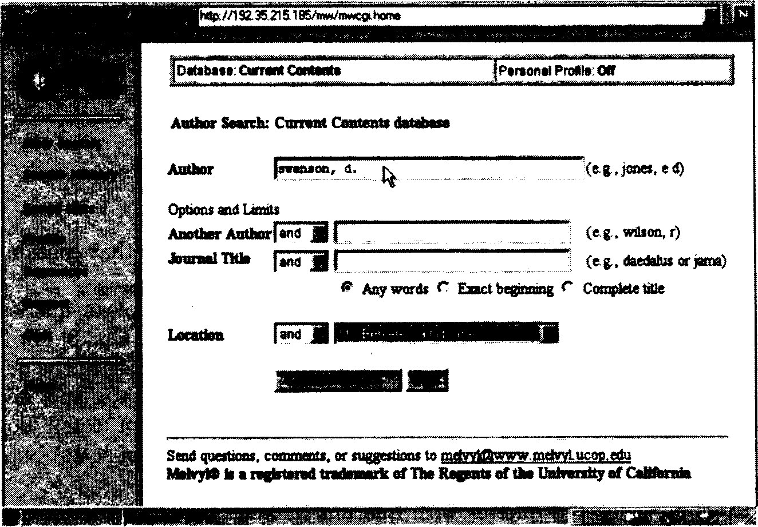

Figure 10.0 A view of query specification in the Web-based version of the Melvyl
bibliographic catalog. Copyright @c 1998, The Regents of the University of California.

not much better than a TTY prompt, because it does not provide the user with clues about what kinds of terms should be entered.

    - Faceted Queries
Yet another problem with Boolean queries is that their strict interpretation tends to yield result sets that are either too large, because the user includes many terms in a disjunct, or are empty, because the user conjoins terms in an e8ort to reduce the result set. This problem occurs in large part because the user does not know the contents of the collection or the role of terms within the collection.
A common strategy for dealing with this problem, employed in systems with command-line-based interfaces like DIALOG's, is to create a series of short queries, view the number of documents returned for each, and combine those queries that produce a reasonable number of results. For example, in DIALOG, each query produces a resulting set of documents that is assigned an identifying name. Rather than returning a list of titles themselves, DIALOG shows the set number with a lifting of the number of matched documents. Titles can be shown by specifying the set number and issuing a command to show the titles. Document sets that are not empty can be referred to by a set name and combined with AND operations to produce new sets. If this set in turn is too small, the user can back up and try a different combination of sets, and this process is repeated in pursuit of producing a reasonably sized document set.
This kind of query formulation is often called a faceted query, to indicate that the user's query is divided into topics or facets, each of which should be
present in the retrieved documents 553, 348]. For example, a query on drugs for the prevention of osteoporosis might consist of three facets, indicated by the disjuncts

(osteoporosis OR ‘bone loss’) (drugs OR pharmaceuticals) (prevention OR cure)

This query implies that the user would like to view documents that contain all three topics.
A technique to impose an ordering on the results of Boolean queries is what is known as post-coordinate or qtiorurri-level ranking (700, Ch. 8]. In this approach, documents are ranked according to the size of the subset of the query terms they contain. So given a query consisting of ‘cats, ‘dogs, ‘fish, and 'mice, the system would rank a document with at least one instance of ‘cats, ‘dogs, and ‘fish’ higher than a document containing 30 occurrences of ‘cats’ but no occurrences of the other terms.
Combining faceted queries with quorum ranking yields a situation inter- mediate between full Boolean syntax and free-form natural language queries. An interface for specifying this kind of interaction can consist of a list of entry lines. The user enters one topic per entry line, where each topic consists of a list of semantically related terms that are combined in a disjunct. Documents that contain at least one term from each facet are ranked higher than documents con- taining terms only from one or a few facets. This helps ensure that documents which contain discussions of several of the user's topics are ranked higher than those that contain only one topic. By only requiring that one term from each facet be matched, the user can specify the same concept in several different ways in the hopes of increasing the likelihood of a match. If combined with graphical feedback about which subsets of terms matched the document, the user can see the results of a quorum ranking by topic rather than by word. Section 10.6 describes the TileBars interface which provides this type of feedback.
This idea can be extended yet another step by allowing users to weight each facet. More likely to be readily usable, however, is a default weighting in which the facet listed highest is assigned the most weight, the second facet is assigned less weight, and so on, according to some distribution over weights.

    - Graphical Approaches to Query Specification
Direct manipulation interfaces provide an alternative to command-line syntax. The properties of direct manipulation are 725, p.205): (1) continuous represen- tation of the object of interest, (2) physical actions or button presses instead of complex syntax, and (3) rapid incremental reversible operations whose impact on the object of interest is immediately visible. Direct manipulation interfaces often evoke enthusiasm from users, and for this reason alone it is worth exploring their use. Although they are not witho_lit drawbacks, they are easier to use than other methods for many users in many contexts.

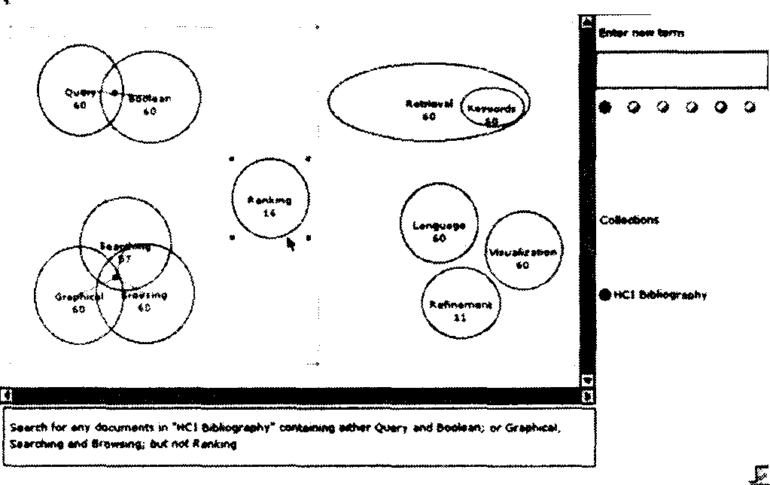

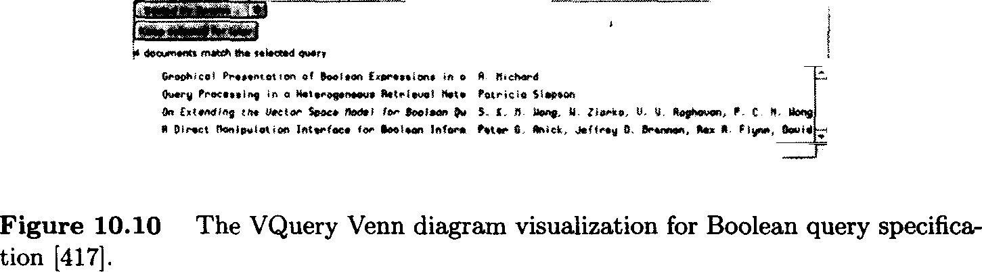

Several variations of graphical interfaces, both directly manipulable and static, have been developed for simplifying the specification of Boolean syntax. User studies tend to reveal that these graphical interfaces are more effective in terms of accuracy and speed than command-language counterparts. Three such approaches are described below.
Graphical depictions of Benn diopronis have been proposed several times as a way to improve Boolean query specification. A query term is associated with a ring or circle and intersection of rings indicates conjunction of terms. Typi- cally the number of documents that satisfy the various conjuncts are displayed within the appropriate segments of the diagram. Several studies have found such interfaces more effective than their command-language-based syntax (417, 368, 558]. Hertzum and Frokjaer found that a simple Venn diagram represen- tation produced faster and more accurate results than a Boolean query syntax. However, a problem with this format is the limitations on the complexity of the expression. For example, a maximum of three query terms can be ANDed together in a standard Venn diagram. Innovations have been designed to get around this problem, as seen in the VQuery system 417] (see Figure 10.10). In VQuery, a direct manipulation interface allows users to assign any number of query terms to ovals. If two or more ovals are placed such that they overlap with one another, and if the user selects the area of their intersection, an AND is implied among those terms. (In Figure 10.10, the term ‘Query’ is conjoined with ‘Boolean’.) If the user selects outside the area of intersection but within the ovals, an OR is implied among the corresponding terms. A NOT operation

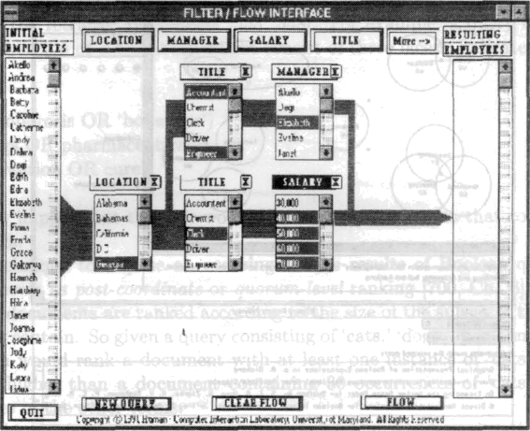

Figure 10.11 ‘ The filter-8ow %ua1ization for Booleñn query apecificatiön [841].

is asaociated with any term whose oval appears in the active area of the display but which romains unaelècted (in the figure, NOT ‘Ranking’, hàs been specified). An active area indicates the current query; all groups ofi ovals within the active area are considered part of a conjunction. Ovals containing query terms can .be moved oiit. of the active area for latér use.
.Young and Shneiderman [841] found improvemènts over standard Boolean syntax by'prpviding users with a direct.manipulation ôter-wow model: The user ta ehown a ocrollable list oÏ attribute typèa on the left-hand side and: selects at- trtbutes from another list of attribuée types shown acrosa.the top of the screen: Clicking on:an attribuée name cdusès a listbox containing values for those at- tributee to’be displayed in the main portion of the aereen. The user then selects which values of the attribuées to let the 8ow go through. Placing two or more of theae attributee in sequenée:eieatea the eemantics of a conjunct ovei the selected values.. Placing two or more of thèse in parallel creates the aemantics of a dix junct. The number:of documents that match thè query at each point is indicated by thê width of the ‘water’ 8o ing from one attribute to the next. (See Figure 10.11.) A c6njunct can reduce the amount of 8oii. The itemé that match the full qtierJ are aho on the far..righ hand side. A user. study found' that: fewer er- rors. were made using the filter 8ow.inodel than a stmidard SQL database q:iery.
!However; the examples and study pdrtain only to database querying rather than
he t
n. a sb llabee "T "interface .cnuld ‘perhaps be
modified to bètter auit information accees applications by having the user supply initial.querÿ tèröis, and using the attribute selection facility to show those terms
QUERYSPEGF]CATION 285



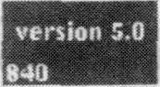


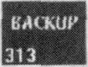




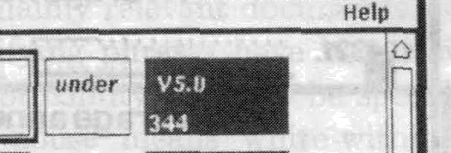
Sya4S:Qveyy Refemuletion \¥ezkspace

Flle ’ Temía
-





Plgure 10.11 A block- iriénted diagram visúalization Por Bóoléah query ap&ification
{21]. ’

that are conceptually related tp.the query tenns. Another alternative is this display as a category metadata aeleútion interface (eeé Jécti}oft.t0.4).
Anick et of. [21] describe mother innovative direút manipulation interface for Boolean queries. .Initially the User types a natural' language query which is
resented within a block. The blocks are arranged into rows. and columns (See Figure 10.12). If two or more blocks appear along the same row they are con- sidered to be ANDed together. Two ‹ir more blocks withln the sane ci›1umn are ORed. Thui the iisér can répresent ’a techfiicml term iii miiltiple ways within the same query, providing a kind of faceted que interface. For example, the‘terms ‘*ersion 5’, ‘version 5.0’; and ‘v5’’ might be ahown in the same column. Users can quickly experiment with different combinations of‘terms wfthin Boolean queries simply by actii'ating and deactivating blocks. This facility allot users to have multiple repreeeritations of the sañie term in iliiferent placés tliroughout the display;’thus allowing rapid féedback on the conséquences of specifying . oIa Combinations ‹if query terma. Informal evaluation of the system found that users were able to leaéri to manipulate the’interface qiiickly and enjoyed using‘ it. li was not formally compáréd to óther interaetion techniques [21}.
This interface provides a kind of query pretiietr: a low cost, rapid)urnaround vihualization of the results of‘many variations on a query |643j. :Another. example of query previewiñg can be found in some help systems, which show all the wordÉ in the index whooe first letteré match the characters that the ueer has t ped ao far. The móre éharácters typed, the fewer possible uiatcheh beeome avallab2e. The HiBrowse sy8tém described asove [646] provides a kind of preview for viewing catégory hieraichies and facets, showing how’ many do‹iuments would be matched if a category one level below the current Óne were Selected. lt perhaps




could be improved by shtiwing the éonsequences gories in an animafed manner. If baéed on prior actioo

co binatipes of
query previewing may become more generally a licable for information aeceas intedaces.

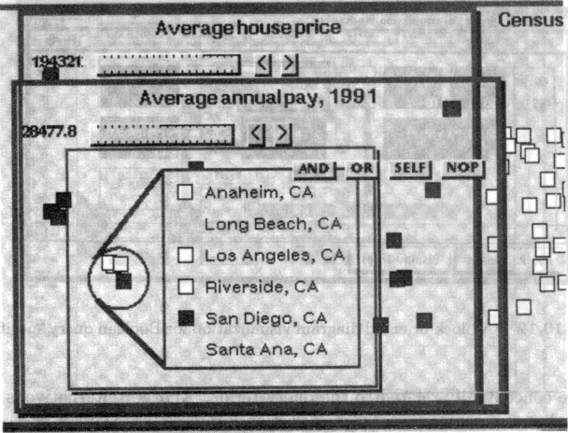

Fig’ iire Fislikin).
10:13 A magic lens’ interface for quéry speéificatión (courtésy of Ken

A final example of a graphical approiich to query specification is the use
.of magic.lenses. Fishltin. and Stone have suggested an extension. to the usage of tliis visualization tool for the specification of Boolean .queries [256]. Information is representéd an lists or. icons within. a. 2D space. Lepses act as filters on the do.cument set. (See Figure 10.13.) For exapiple, a word can be associated with.a transparent Iene. When this lens is placed over an iconic representation of a sét of documents, it .cin cauce all documents that do not .contain a given wórd to disappear.. If á.second feos repreeeóting mother word is then laid over /the.first; the’ lensés cómbine to act mi a conjiinction of the two words with the document ect, hiding any.documénts that fío not. contain both words. Additiorial informa- tion.can be adjusted dynamically, such as a minimum threshold for how often the term oecurs In the documents, or an on-ofi switch for word siemming. For exampÍe,. Figure 10.13 ahows a disjunctive. guery that fuids cities with relatively. low housing pricea or lügh aenual ialaries. Oné lens ‘cnJls out’ a clump of koutfi- ern California cities, labeling each. Above that is a le;;s screening for cities with average house priçe below $194,821 (the data ii from 1990), 9nd above.táis one is a Iene screening for cities with average annuál pay above.: $28,47a. This approach, while prpmising, has not been evaluated in a;i. information access. setting.

    - ”Phraseá and”Proximity
In general, proximity. ioformation'can be quite effective at improving precision of searches. On the Web, the difference between a single-word query and a two-word

QUERY SPECIFICATION 287
exact phrase match can mean the difference between an unmanageable mess of retrieved documents and a short list with mainly relevant documents.
A large number of methods for specifying phrases have been developed. The syntax in LEXIS-NEXIS requires the proximity range to be specified with an infix operator. For example, ‘white w/3 house’ means ‘white within 3 words of house, independent of order.’ Exact proximity of phrases is specified by simply listing one word beside the other, separated by a space. A popular method used by Web search engines is the enclosure of the terms between quotation marks. Shneiderman et of. (726] suggest providing a list of entry labels, as suggested above for specifying facets. The difference is, instead of a disjunction, the terms on each line are treated as a phrase. This is suggested as a way to guide users to more precise query specification.
The disadvantage of these methods is that they require exact match of phrases, when it is often the case (in English) that one or a few words comes between the terms of interest. For example, in most cases the user probably wants ‘president’ and ‘lincoln’ to be adjacent, but still wants to catch cases of the sort ‘President Abraham Lincoln.’ Another consideration is whether or not stemming is performed on the terms included in the phrase. The best solution may be to allow users to specify exact phrases but treat them as small proximity ranges, with perhaps an exponential fall-off in weight in terms of distance of the terms. This has been shown to be a successful strategy in non-interactive ranking algorithms 174a. It has also been shown that a combination of quorum ranking of faceted queries with the restriction that the facets occur within a small proximity range can dramatically improve precision of results 356, 566].

    - Natural Language and Free Text Queries
Statistical ranking algorithms have the advantage of allowing users to specify queries naturally, without having to think about Boolean or other operators. But they have the drawback of giving the user less feedback about and control over the results. Usually the result of a statistical ranking is the listing of documents and the association of a score, probability, or percentage beside the title. Users are given little feedback about why the document received the ranking it did and what the roles of the query terms are. This can be especially problematic if the user is particularly interested in one of the query terms being present.
One search strategy that can help with this particular problem with sta- tistical ranking algorithms is the specification of ‘mandatory’ terms within the natural language query. This in effect helps the user control which terms are considered important, rather than relying on the ranking algorithm to correctly weight the query terms. But knowing to include a mandatory specification re- quires the user to know about a particular command and how it works.
The preceding discussion assumes that a natural language query entered by the user is treated as a bag of words, with stopwords removed, for the pur- poses of document match. However, some systems attempt to parse natural language queries in order to extract concepts to match against concepts in the
text collection 399, 552, 748].
Alternatively, the natural language syntax of a question can be used to at- tempt to answer the question. (Question answering in information access is dif- ferent than that of database management systems, since the information desired is encoded within the text of documents rather than specified by the database schema.) The Murax system (463a determines from the syntax of a question if the user is asking for a person, place, or date. It then attempts to find sen- tences within encyclopedia articles that contain noun phrases that appear in the question, since these sentences are likely to contain the answer to the question. For example, given the question ‘Who was the Pulitzer Prize-winning novelist that ran for mayor of New York City?, the system extracts the noun phrases ‘Pulitzer Prize,’ ‘winning novelist, ‘mayor, and ‘New York City.’ It then looks for proper nouns representing people's names (since this is a ‘who’ question) and finds, among others, the following sentences:

The Armies of the Night (1968), a personal narrative of the 1967 peace march on the Pentagon, won Mailer the Pulitzer Prize and the National Book Award.

In 1969 Mailer ran unsuccessfully as an independent candidate for
mayor of New York City.

Thus the two sentences link together the relevant noun phrases and the system hypothesizes (correctly) from the title of the article in which the sentences appear that Norman Mailer is the answer.
Another approach to automated question answering is the FAQ finder sys- tem which matches question-style queries against question-answer pairs on var- ious topics 130]. The system uses a standard IR search to find the most likely FAQ (frequently asked questions) files for the question and then matches the terms in the question against the question portion of the question-answer pairs. A less automated approach to question answering can be found in the Ask Jeeves system (34]. This system makes use of hand-picked Web sites and matches these to a predefined set of question types. A user's query is first matched against the question types. The user selects the most accurate rephrase of their question and this in turn is linked to suggested Web sites. For example, the question ‘Who is the leader of Sudan?’ is mapped into the question type ‘Who is the head of state of X (Sudan)?’ where the variable is replaced by a list box of choices, with Sudan the selected choice in this case. This is linked to a Web page that lists current heads of state. The system also automatically substitutes in the name ‘Sudan’ in a query against that Web page, thus bringing the answer directly to the user's attention. The question is also sent to standard Web search engines. However, a system is only as good as its question templates. For example a question ‘Where can I find reviews of spas in Calistoga?’ matches the question ‘Where can I find X (reviews) of activities for children aged Y (1)?’ and ‘Where
can I find a concise encyclopedia article on X (hot springs)?’
  - Context
This section discusses interface techniques for placing the current document set in the content of other information types, in order to make the document set more understandable. This includes showing the relationship of the document set to query terms, collection overviews, descriptive metadata, hyperlink structure, document structure, and to other documents within the set.

    - Document Surrogates
The most common way to show results for a query is to list information about documents in order of their computed relevance to the query. Alternatively, for pure Boolean ranking, documents are listed according to a metadata attribute, such as date. Typically the document list consists of the document's title and a subset of important metadata, such as date, source, and length of the article. In systems with statistical ranking, a numerical score or percentage is also often shown alongside the title, where the score indicates a computed degree of match or probability of relevance. This kind of information is sometimes referred to as a document surropote. See Figure 10.14 from 824].
Some systems provide users with a choice between a short and a detailed view. The detailed view typically contains a summary or abstract. In biblio- graphic systems, the author-written or service-written abstract is shown. Web search engines automatically generate excerpts, usually extracting the first few lines of non-markup text in the Web page. -
In most interfaces, clicking on the document’s title or an iconic representa- tion of the document shown beside the title will bring up a view of the document itself, either in another window on the screen, or replacing the listing of search re- sults. (In traditional bibliographic systems, the full text was unavailable online, and only bibliographic records could be readily viewed.)

    - Query Term Hits Within Document Content
In systems in which the user can view the full text of a retrieved document, it is often useful to highlight the occurrences of the terms or descriptors that match those of the user's query. It can also be useful for the system to scroll the view of the document to the first passage that contains one or more of the query terms, and highlight the matched terms in a contrasting color or reverse video. This display is thought to help draw the user's attention to the parts of the document most likely to be relevant to the query. Highlighting of query terms has been found time and again to be a useful feature for information access interfaces 481], 542, p.31). Color highlighting has also recently been found to be useful for scanning lists of bibliographic records (52].


z w « •sm

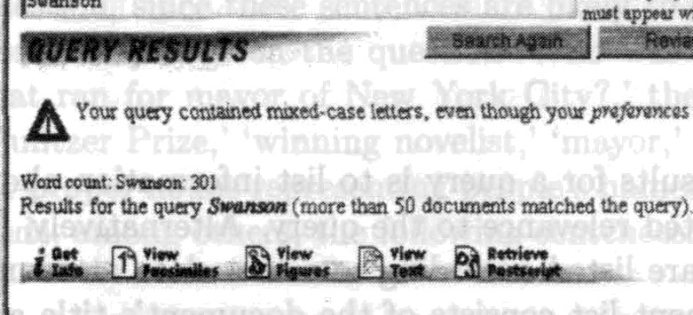
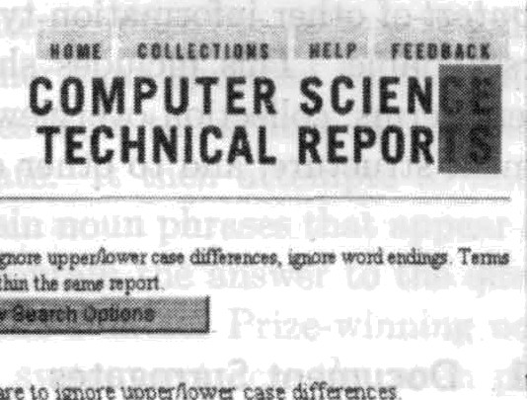



Dozy Th Ef m o7.son S gxet Meeds oo.0te Dqmtmaa oFDefb›se Ssfla• c Acg\ñdéai PBX
’ B". ” A7f€g'•Bt’Sezgoa V.’Tsyz tsp Ywtt NASA Laa$ley Caer, fbmptm. VA


Flgure 10.14 An example of a ranked list of titles and other document surrogate information [824].

xwic
A facility related to highlighting is the £epirord-in-content (KWIC) document surrogate. Sentence fragments, full sentences, ,or groups of sentences that contain query terms are extracted from the full text and presented for viewing along with other kinds of Surrogate information (such as document title and abstrâct). Note that a KWIC listing ia di8erent than an abstract. An abstract summarizes the iiiain topics of the document but might not contain references to the terms within the query.. A KWIC extract shows sentences that summarize the ways the query terms. aré iiâéd within the document. 'Fhis display can show not only which subsets of query terms occur in the retrieved documents, but also the context they appear in with respéct to one another.’
Tradeo8 decisions must be made between:how many lines of text to show and. which lines to display. It is dot known which contexts are best selected for i ewiiig but results froin text summarization research suggest that the best fragments to show are thoee that appear near the beginning of the document ând that contain the largest subset of query terms [464]. If users have specified which
terms are more important than others, then those fragments containing impor- tant terms should be shown before those that contain only less important terms. However, to help retain coherence of the excerpts, selected sentences should be shown in order of their occurrence in the original document, independent of how many search terms they contain.
The KWIC facility is usually not shown in Web search result display, most likely because the system must have a copy of the original document available from which to extract the sentences containing the search terms. Web search en- gines typically only retain the index without term position information. Systems that index individual Web sites can show KWIC information in the document list display.

TileBars
A more compact form of query term hit display is made available through the TileBars interface. The user enters a query in a faceted format, with one topic per line. After the system retrieves documents (using a quorum or statistical ranking algorithm), a graphical bar is displayed next to the title of each doc- ument showing the degree of match for each facet. TileBars thus illustrate at a glance which passages in each article contain which topics — and moreover, how frequently each topic is mentioned (darker squares represent more frequent matches).
Each document is represented by a rectangular bar. Figure 10.15 shows an example. The bar is subdivided into rows that correspond to the query facets. The top row of each TileBar corresponds to ‘osteoporosis, the second row to ‘prevention,’ and the third row to ‘research.’ The bar is also subdivided into columns, where each column refers to a passage within the document. Hits that overlap within the same passage are more likely to indicate a relevant document than hits that are widely dispersed throughout the document 356]. The pat- terns are meant to indicate whether terms from a facet occur as a main topic throughout the document, as a subtopic, or are just mentioned in passing.
The darkness of each square corresponds to the number of times the query occurs in that segment of text; the darker the square the greater the number of hits. White indicates no hits on the query term. Thus, the user can quickly see if some subset of the terms overlap in the same segment of the document. (The segments for this version of the interface are fixed blocks of 100 tokens each.)
The first document can be seen to have considerable overlap among the topics of interest towards the middle, but not at the beginning or the end (the actual end is cut off). Thus it most likely discusses topics in addition to research into osteoporosis. The second through fourth documents, which are considerably shorter, also have overlap among all terms of interest, and so are also probably of interest to the user. (The titles help to verify this.) The next three documents are all long, and from the TileBars we can tell they discuss research and prevention, but do not even touch on osteoporosis, and so probably are not of interest.
Because the TileBars interface allows the user to specify the query in terms



AP Grozp Sed‹ $ t Brlliou s Year for Aging
SJMN: ¥/OMEN'S HEALTH LEGISLATtON PROPOSED Ct

FR: Cfitaiaitm Meeiinp
FR: Cf &v Advisory Commitw: Meetinp
FjL €»n>>tidataj nde$sčon• or Authorit7 ror fblic7 De'dopo

Figure 10.15 An example of the TileBars retrieval results visualization [355].

of facets, where the terms for each facet are listed on an entry line, a color can be assigned to each facet. When the user displays a document with query term hits, the user can quickly ascertain what proportion of search topics appear in a passage based only on how many different highlight colors are visible. Most systems that use highlighting use only a single color to bring attention to all of the search terms.
It would be difficult for users to specify in advance which patterns of term hits they are interested in. Instead, TileBars allows users to sean graphic rep- resentations and recognize which documents are and are not of interest. It may be the case that TileBars may be most useful for helping users discard mislead- ingly interesting documents, but only preliminary studies have been conducted to date. Passages can correspond to paragraphs or sections, fixed sized units of arbitrary length, or to automatically determined multiparagraph segments 355).

SeeSob
The SeeSoft visualization (232] represents text in a manner resembling columns of newspaper text, with one ‘line’ of text on each horizontal line of the strip. (See Figure 10.16.) The representation is compact and aesthetically pleasing. Graphics are used to abstract away the details, providing an overview showing the amount and shape of the text. Color highlighting is used to pick out various attributes, such as where a particular word appears in the text. Details of a smaller portion of the display can be viewed via a pop-up window; the overview
shows more of the text but in less detail.
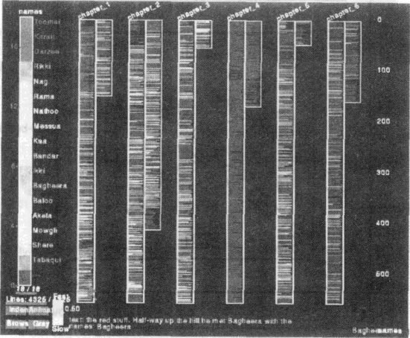

Figure 10.18 An example of the SeeSóft visualization for showing locatioñs of char- acters within a text (232].

SeeSoft wae originally designed for software development, in which a line of text is a meaningful unit of information. (Programmers tend tp plaće each individual programming statement on one line of text.) Thus SeeSoft shows attributes relevant to the prõgrømming domain, such as wliich ’lineâ of code were modified by which programmer, ønd how often particular’ lines ‘høve. been modified, ønd how mañy daya have elapsed since the lines wère.løøt, modified. The SeeSoft developers then experimented with applying this idea to the display of text, although thiB has not been integrated intö an information øcceæ syøtem. Golor highliğhting is used to ahow ,which characters appeør włierë in a boök of fiction, and which passages of the ,Bible contain.referencëø:,to pørticuțør people ønd items. Note the uøe of the abstràction of øn entire line‘to stønd for a single word such as a ćhørøcter’s/name (even though though thiø iăight obscure a tightly interwoven conversation between two characters).

10.6..3 Query Term Idits’ Ğètuæen”Óocumënts
Other visualization ideas have been developed to show a different kind of infor- mation about the relationship between query terms and .retrieved documents. Rather thøn showing how query terins appear within individuàl documents, øø is done in KWIC interfaces ønd TileBørs, thèæ systems display øn overview’or summary of the retrieved documents according to which øubøet of query terШs they contain. The following subsections describe variations on this idea.

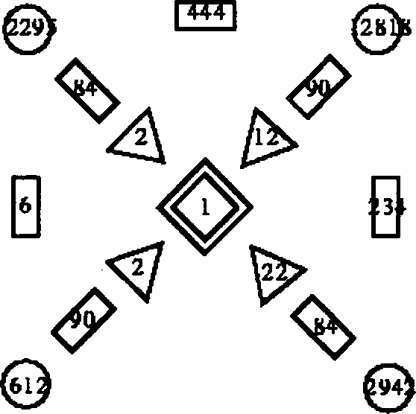

D

127

Figure 10.17 A sketch of the InfoCrystal retrieval results display [738].

InfoCrystal

The InfoCrystal shows how many documents contain each subset of query terms 738a. This relieves the user from the need to specify Boolean ANDs and ORs in their query, while still showing which combinations of terms actually appear in documents that were ordered by a statistical ranking (although beyond four terms the interface becomes difficult to understand). The InfoCrystal allows vi- sualization of all possible relations among N user-specified ‘concepts’ (or Boolean keywords). The InfoCrystal displays, in a clever extension of the Venn diagram paradigm, the number of documents retrieved that have each possible subset of the N concepts. Figure 10.17 shows a sketch of what the InfoCrystal might display as the result of a query against four keywords or Boolean phrases, la- beled A, B, C, and D. The diamond in the center indicates that one document was discovered that contains all four keywords. The triangle marked with ‘12’ indicates that 12 documents were found containing attributes A, B, and D, and
so OH.
The InfoCrystal does not show proximity among the terms within the doc- uments, nor their relative frequency. So a document that contains dozens of hits on ‘volcano’ and ‘lava’ and one hit on ‘Mars’ will be grouped with documents that contain mainly hits on ‘Mars’ but just one mention each of ‘volcano’ and ‘lava.’

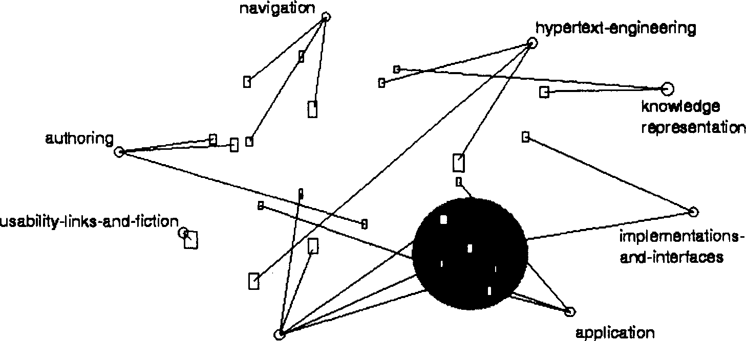

Figure 10.18 An example of the VIBE retrieval results display [452].

VIBE and Lyberworld
Graphical presentations that operate on similar principles are VIBE 452] and Lyberworld 363]. In these displays, query terms are placed in an abstract graph- ical space. After the search, icons are created that indicate how many documents contain each subset of query terms. The subset status of each group of docu- ments is indicated by the placement of the icon. For example, in VIBE a set of documents that contain three out of five query terms are shown on an axis connecting these three terms, at a point midway between the representations of the three query terms in question. (See Figure 10.18.) Lyberworld presents a 3D version of this idea.

Lattices
Several researchers have employed a graphical depiction of a mathematical lat- tice for the purposes of query formulation, where the query consists of a set of constraints on a hierarchy of categories (actually, semantic attributes in theae systems) 631, 147]. This is one solution to the problem of displaying documents in terms of multiple attributes; a document containing terms A, B, C, and D could be placed at a point in the lattice with these four categories as parents. However, if such a representation were to be applied to retrieval results instead of query formulation, the lattice layout would in most cases be too complex to allow for readability.
None of the displays discussed in this subsection have been evaluated for effec- tiveness at improving query specification or understanding of retrieval results, but they are intriguing ideas and perhaps are useful in conjunction with other displays.

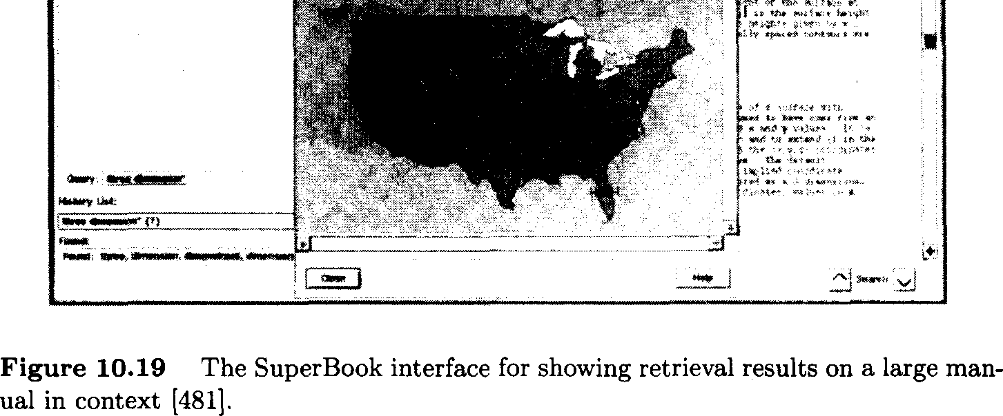

    - SuperBook: Context via Table of Contents

The SuperBook system (481, 229, 230a makes use of the structure of a large document to display query term hits in context. The table of contents (TOC) for a book or manual are shown in a hierarchy on the left-hand side of the display, and full text of a page or section is shown on the right-hand side. The user can manipulate the table of contents to expand or contract the view of sections and subsections. A focus-plus-context mechanism is used to expand the viewing area of the sections currently being looked at and compress the remaining sections. When the user moves the cursor to another part of the TOC, the display changes dynamically, making the new focus larger and shrinking down the previously observed sections.
After the user specifies a query on the book, the search results are shown in the context of the table of contents hierarchy. (See Figure 10.19.) Those sections that contain search hits are made larger and the others are compressed. The query terms that appear in chapter or section names are highlighted in reverse video. When the user selects a page from the table of contents view, the page itself is displayed on the right-hand side and the query terms within the page are highlighted in reverse video.
The SuperBook designers created innovative techniques for evaluating its special features. Subjects were compared using this system against using pa- per documentation and against a more standard online information access sys- tem. Subjects were also compared on different kinds of carefully selected tasks: browsing topics of interest, citation searching, searching to answer questions, and searching and browsing to write summary essays. For most of the tasks
SuperBook subjects were faster and more accurate or equivalent in speed and accuracy to a standard system. When differences arose between SuperBook and the standard system, the investigators examined the logs carefully and hypothe- sized plausible explanations. After the initial studies, they modified SuperBook according to these hypotheses and usually saw improvements ae a result 481].
The user studies on the improved system showed that users were faster and more accurate at answering questions in which some of the relevant terms were within the section titles themselves, but they were also faster and more accurate at answering questions in which the query terms fell within the full text of the document only, as compared both to a paper manual and to an interface that did not provide such contextualizing information. SuperBook was not faster than paper when the query terms did not appear in the document text or the table of contents. This and other evidence from the SuperBook studies suggests that query term highlighting is at least partially responsible for improvements seen in the system.

    - Categories for Results Set Context
In section 10.4 we saw the use of category or directory information for providing overviews of text collection content. Category metadata can also be used to place the results of a query in context.
For example, the original formulation of SuperBook allowed navigation within a highly structured document, a computer manual. The CORE project extended the main idea to a collection of over 1000 full-text chemistry articles. A study of this representation demonstrated its superiority to a standard search system on a variety of task types |228]. Since a table of contents is not available for this collection, context is provided by placing documents within a category hierarchy containing terms relevant to chemistry. Documents assigned a category are listed when that category is selected for more detailed viewing, and the categories themselves are organized into a hierarchy, thus providing a hierarchical view on the collection.
Another approach to using predefined categories to provide context for retrieval results is demonstrated by the DynaCat system 650]. The DynaCat system organizes retrieved documents according to which types of categories, se- lected from the large MeSH taxonomy, are known in advance to be important for a given query type. DynaCat begins with a set of query types known to be useful for a given user population and collection. One query type can encompass many different queries. For example, the query type ‘Treatment-Adverse Effects’ covers queries such as ‘What are the complications of a mastectomy?’ as well as ‘What are the side-effects of aspirin?’ Documents are organized according to a set of cri- teria associated with each query type. These criteria specify which types of cate- gories that are acceptable to use for organizing the documents and consequently, which categories should be omitted from the display. Once categories have been assigned to the retrieved documents, a hierarchy is formed based on where the categories exist within MeSH. The algorithm selects only a subset of the category

. | - | . | - - | -
. • | - - | - - - | - - -
B•ba•tor aa4 Bebc•tot Behavior and Behavior Mechanisms


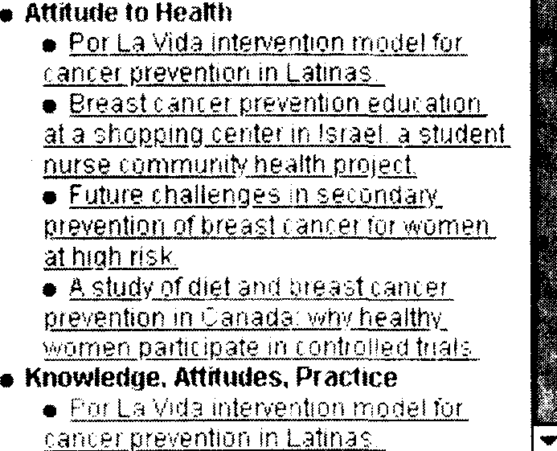
Iflcbx ms(4wfs) •An#u%e

HamSwa n1’s)
e not (Sz«ts?

Cksaucats aad. Drago

I mmunnsnppressiwe
enu 18 refs ^

Figure 10.20 The DynaCat interface for viewing category labels that correspond to query types |650].

labels that might be assigned to the document to be used in the organization.
Figure 10.20 shows the results for a query on breast cancer prevention. The interface is tiled into three windows. The top window displays the user's query and the number of documents found. The left window shows the categories in the first two levels of the hierarchy, providing a table of contents view of the organization of search results. The right pane displays all the categories in the hierarchy and the titles of the documents that belong in those categories.
An obstacle to using category labels to organize retrieval results is the re- quirement of precompiled knowledge about which categories are of interest for a particular user or a particular query type. The SONIA system (692] circumvents this problem by using a combination of unsupervised and supervised methods to organize a set of documents. The unsupervised method (document clustering similar to Scatter/Gather) imposes an initial organization on a user's personal information collection or on a set of documents retrieved as the result of a query. The user can then invoke a direct manipulation interface to make adjustments to this initial clustering, causing it to align more closely with their preferences (because unsupervised methods do not usually produce an organization that corresponds to a human-derived category structure 357]). The resulting orga- nization is then used to train a supervised text categorization algorithm which automatically classifies any new documents that are added to the collection. Aa the collection grows it can be periodically reorganized by rerunning the clustering algorithm and redoing the manual adjustments.
    - Using Hyperlinks to Organize Retrieval Results
Although the SuperBook authors describe it as a hypertext system, it is actu- ally better thought of as a means of showing search results in the context of a structure that users can understand and view all at once. The hypertext com- ponent was not analyzed separately to assess its importance, but it usually is not mentioned by the authors when describing what is successful about their design. In fact, it seems to be responsible for one of the main problems seen with the revised version of the system — that users tend to wander off (often unintentionally) from the pages they are reading, thus causing the time spent on a given topic to be longer for SuperBook in some cases. (Using completion time to evaluate users on browsing tasks can be problematic, however, since by definition browsing is a casual, unhurried process 804a.)
This wandering may occur in part because SuperBook uses a non-standard kind of hypertext, in which any word is automatically linked to occurrences of the same word in other parts of the document. This has not turned out to be how hypertext links are created in practice. Today, hyperlinked help systems and hyperlinks on the Web make much more discriminating use of hyperlink connections (in part since they are usually generated by an author rather than automatically). These links tend to be labeled in a somewhat meaningful manner by their surrounding context. Back-of-the-book indexes often do not contain listings of every occurrence of a word, but rather to the more important uses or the beginnings of series of uses. Automated hypertext linking should perhaps be based on similar principles. Additionally, at least one study showed that users formed better mental models of a small hypertext system that was organized hierarchically than one that allowed more flexible access [226]. Problems relating to navigation of hypertext structure have long been suspected and investigated in the hypertext literature 181, 551, 440, 334a.
More recent work has made better use of hyperlink information for provid- ing context for retrieval results. Some of this work is described below.

Cha-Cha: SuperBook on the Web
The Cha-Cha intranet search system 164] extends the SuperBook idea to a large heterogeneous Web site such as might be found in an organization's in- tranet. Figure 10.21 shows an example. This system differs from SuperBook in several ways. On most Web sites there is no existing real table of contents or category structure, and an intranet like those found at large universities or large corporations is usually not organized by one central unit. Cha-Cha uses link structure present within the site to create what is intended to be a meaningful organization on top of the underlying chaos. After the user issues a query, the shortest paths from the root page to each of the search hits are recorded and a subset of these are selected to be shown as a hierarchy, so that each hit is shown only once. (Users can begin with a query, rather than with a table of con- tents view.) If a user does not know to use the term ‘health center’ but instead queries on ‘medical center, if ‘medical’ appears as a term in a document within

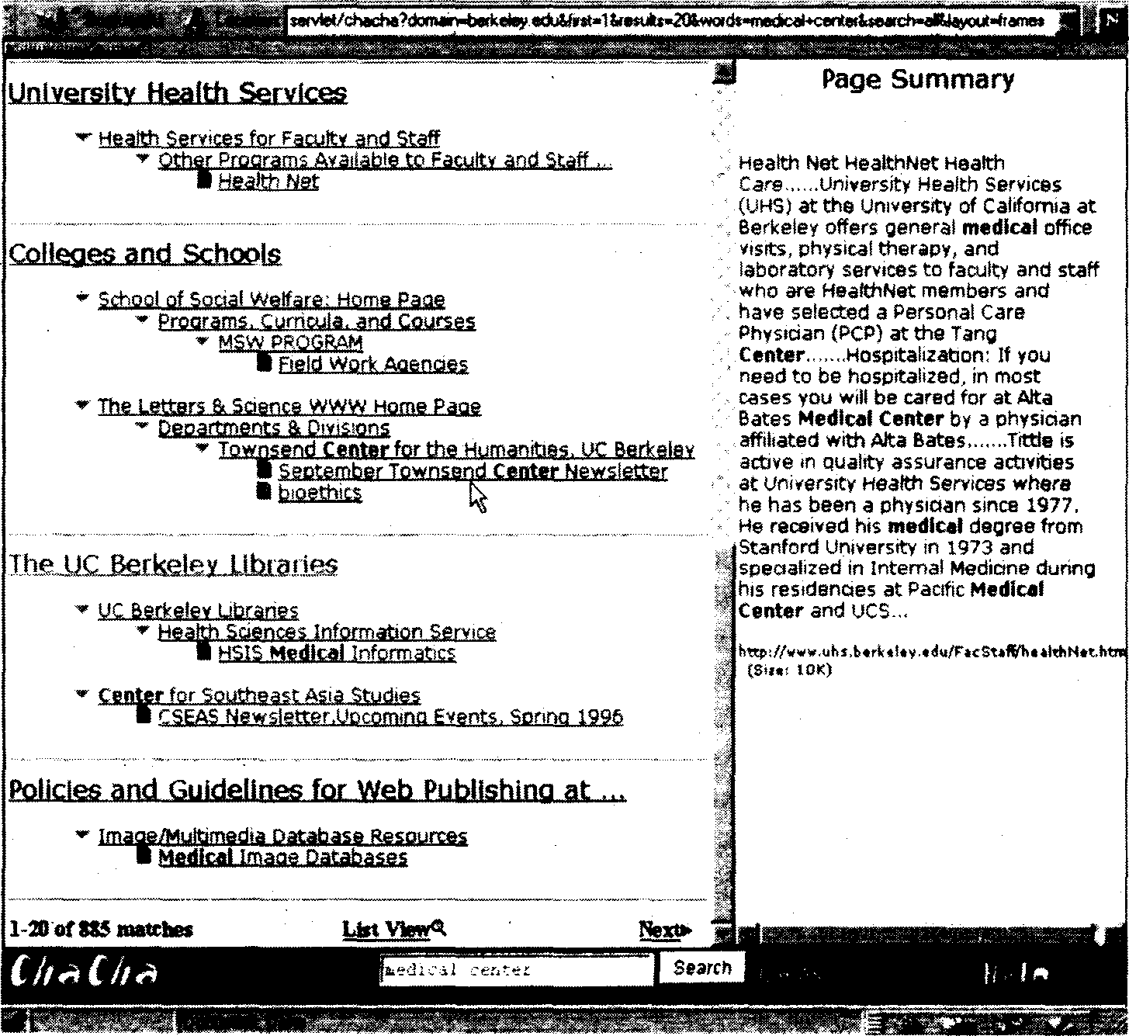

Figure 10.21 The Cha-Cha interface for showing Web intranet search results in context displaying results on the query ‘medical centre’[164] .

the health center part of the Web, the home page (or starting point) of this center will be presented as well as the more specific hits. Users can then either query or navigate within a subset of sites if they wish. The organization pro- duced by this simple method is surprisingly comprehensible on the UC Berkeley site. It seems especially useful for providing the information about the sources (the Web server) associated with the search hits, whose titles are often cryptic.
The AMIT system 826] also applies the basic ideas behind SuperBook to the Web, but focuses on a single-topic Web site, which is likely to have a more reasonable topic structure than a complex intranet. The link structure of the Web site is used as contextualizing information but all of the paths to a given document are shown and focus-plus-context is used to emphasize subsets of the document space. The WebTOC system 585] is similar to AMIT but focuses on showing the structure and number of documents within each Web subhierarchy, and is not tightly coupled with search.

Figure 10.22 Example of a Web subset visualized by Mapuccino (courtesy of M. Jacovi, B. Shaul and Y. Maarek).

Mapuccino: Graphical Depiction of Link Structure
The Mapuccino system (formerly WebCutter) 527] allows the user to issue a query on a particular Web site. The system crawls the site in real-time, checking each encountered page for relevance to the query. When a relevant page is found, the weights on that page's outlinks are increased. Thus, the search is based partly on an assumption that relevant pages will occur near one another in the Web site. The subset of the Web site that has been crawled is depicted graphically in a nodes-and-links view (see Figure 10.22). This kind of display does not provide the user with information about what the contents of the pages are, but rather only shows their link structure. Other researchers have also investigated spreading activation among hypertext links as a way to guide an information retrieval system, e.g., 278, 555].

    - Tables
Tabular display is another approach for showing relationships among retrieval documents. The Envision system 273] allows the user to organize results accord- ing to metadata such as author or date along the X and Y-axes, and uses graphics to show values for attributes associated with retrieved documents within each cell (see Figure 10.23). Color, shape, and size of an iconic representation of a document are used to show the computed relevance, the type of document, or

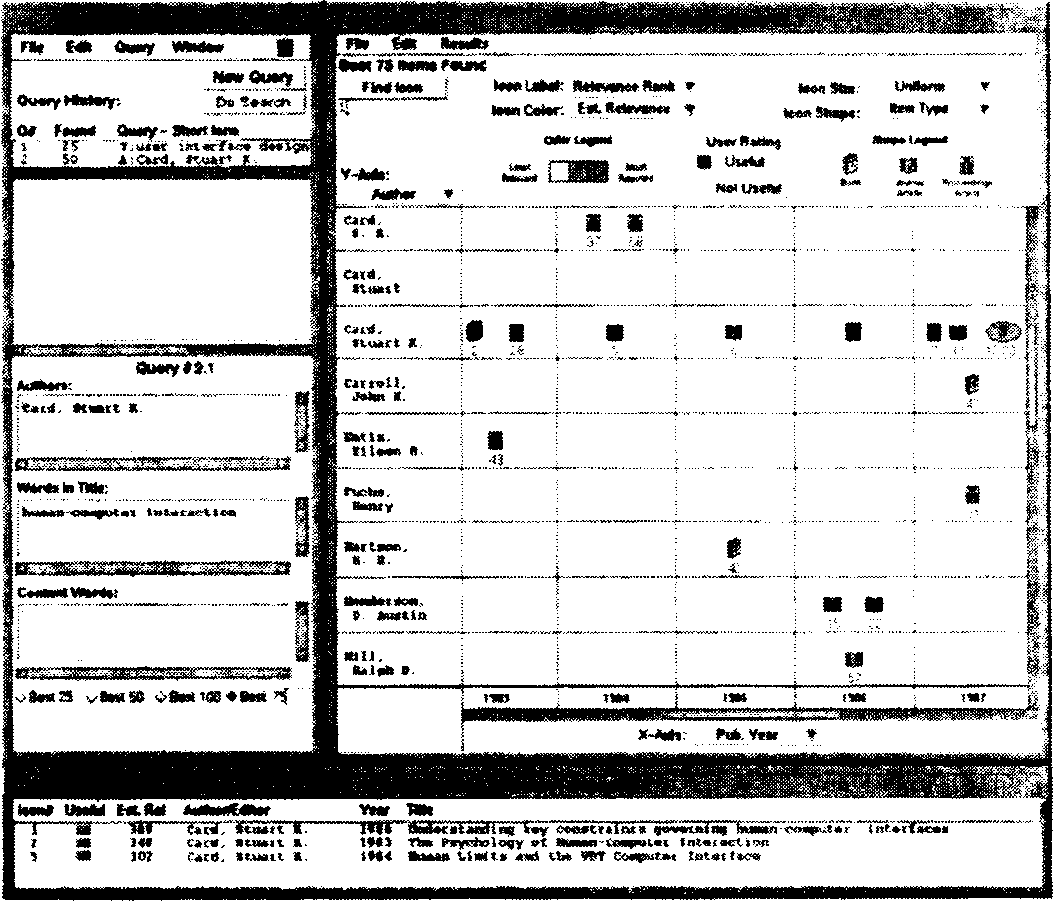

Figure 10.23 The Envision tabular display for graphically organizing retrieved doc-
umeots {2Y0{.

other attributes. Clicking on an icon brings up more information about the doc- ument in another window. Like the WebCutter system, this view provides few cues about how the documents are related to one another in terms of their con- tent or meaning. The SenseMaker system also allows users to group documents into different views via a table-like display 51], including a Scatter/Gather 203} style view. Although tables are appealing, they cannot show the intersections of many diflerent attributes; rather they are better for pairwise comparisons. Another problem with tables for display of textual information is that very little information can be fitted on a screen at a time, making comparisons difficult.
The Table Lens 666] is an innovative interface for viewing and interac- tively reorganizing very large tables of information (see Figure 10.24). It uses focus-plus-context to fit hundreds of rows of information in a space occupied by at most two dozen rows in standard spreadsheets. And because it allows for rapid reorganization via sorting of columns, users can quickly switch from a view focused around one kind of metadata to another. For example, first sorting doc- uments by rank and then by author name can show the relative ranks of different articles by the same author. A re-sort by date can show patterns in relevance scores with respect to date of publication. This rapid re-sorting capability helps circumvent the problems associated with the fact that tables cannot show many simultaneous intersections.
Another variation on the table theme is that seen in the Perspective Wall [530) in which a focus-plus-context display is used to center information currently

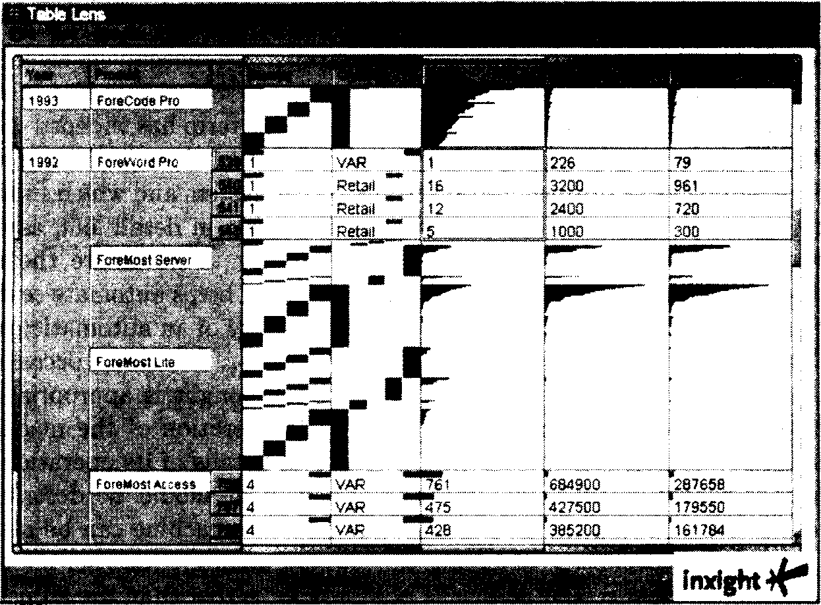

Figure 10.24 The TableLens visualization [666].

of interest in the middle of the display, compressing less important information into the periphery on the sides of the wall. The idea is to show in detail the cur- rently most important information while at the same time retaining the context of the rest of the information. For example, if viewing documents in chronolog- ical order, the user can easily tell if they are currently looking at documents in the beginning, middle, or end of the time range.
These interfaces have not been applied to information acceas tasks. The problem with such displays when applied to text is that they require an attribute that can be shown according to an underlying order, such as date. Unfortunately, information useful for organizing text content, such as topic labels, does not have an inherent meaningful order. Alphabetical order is useM for looking up individual items, but not for seeing patterns acroes items according to adjacency, as in the case for ordered data types like dates and size.

  - Using Relevance Judgements
An important part of the information access process ia query reformulation, and a proven effective technique for query reformulation is reference feedback. In ita original form, relevance feedback refers to an interaction cycle in which the user selects a small set of documents that appear to be relevant to the query, and the system then uses features derived from these selected relevant documents to re- vise the original query. This revised query is then executed and a new set of docu- ments is returned. Documents from the original set can appear in the new results
304 USER INTERFACES AND VISUALIZATION
list, although they are likely to appear in a different rank order. Relevance feed- back in ita original form has been shown to be an effective mechanism for improv- ing retrieval results in a variety of studies and settings [702, 343, 127a. In recent years the scope of ideaa that can be classified under this term has widened greatly. Relevance feedback introduces important design choices, including which operations should be performed automatically by the system and which should be user initiated and controlled. Bates discusses this issue in detail 66], asserting that despite the emphasis in modern systems to try to automate the entire process, an intermediate approach in which the system helps automate search at a strategic level is preferable. Bstes suggests an analogy of an automatic camera versus one with adjustable lenses and shutter speeds. On many occasions, a quick, easy method that requires little training or thought is appropriate. At other times the user needs more control over the operation of the machinery,
while still not wanting to know about the low level details of its operation.
A related idea is that, for any interface, control should be described in terms of the task being done, not in terms of how the machine can be made to accomplish the task |607]. Continuing the camera analogy, the user should be able to control the mood created by the photograph, rather than the adjustment of the lens. In information access systems, control should be over the kind of information returned, not over which terms are used to modify the query. Unfortunately it is often quite di&cult to build interfaces to complex systems that behave in this manner.

    - Interfaces for Standard Relevance Feedback
A standard interface for relevance feedback consists of a list of titles with check- boxes beside the titles that allow the user to mark relevant documents. This can imply either that unmarked documents are not relevant or that no opinion has been made about unmarked documents, depending on the system. Another option is to provide a choice among several checkboxes indicating relevant or not relevant (with no selection implying no opinion). In some cases users are al- lowed to indicate a value on a relevance scale [73). Standard relevance feedback algorithms Usually do not perform better given negative relevance judgement evidence 225], but machine learning algorithms can take advantage of negative feedback [629, 460].
After the user has made a set of relevance judgements and issued a search command, the system can either automatically reweight the query and re-execute the search, or generate a list of terms for the user to select from in order to augment the original query. (See Figure 10.25, taken from 448a.) Systems usually do not suggest terms to remove from the query.
After the query is re-executed, a new list of titles is shown. It can be helpful to retain an indicator such as a marked checkbox beside the documents that the user has already judged. A difficult design decision concerns whether or not to show documents that the user has already viewed towards the top of the ranked list [1]. Repeatedly Showing the same set of documents at the top may inconvenience a user who is trying to create a large set of relevant documents,

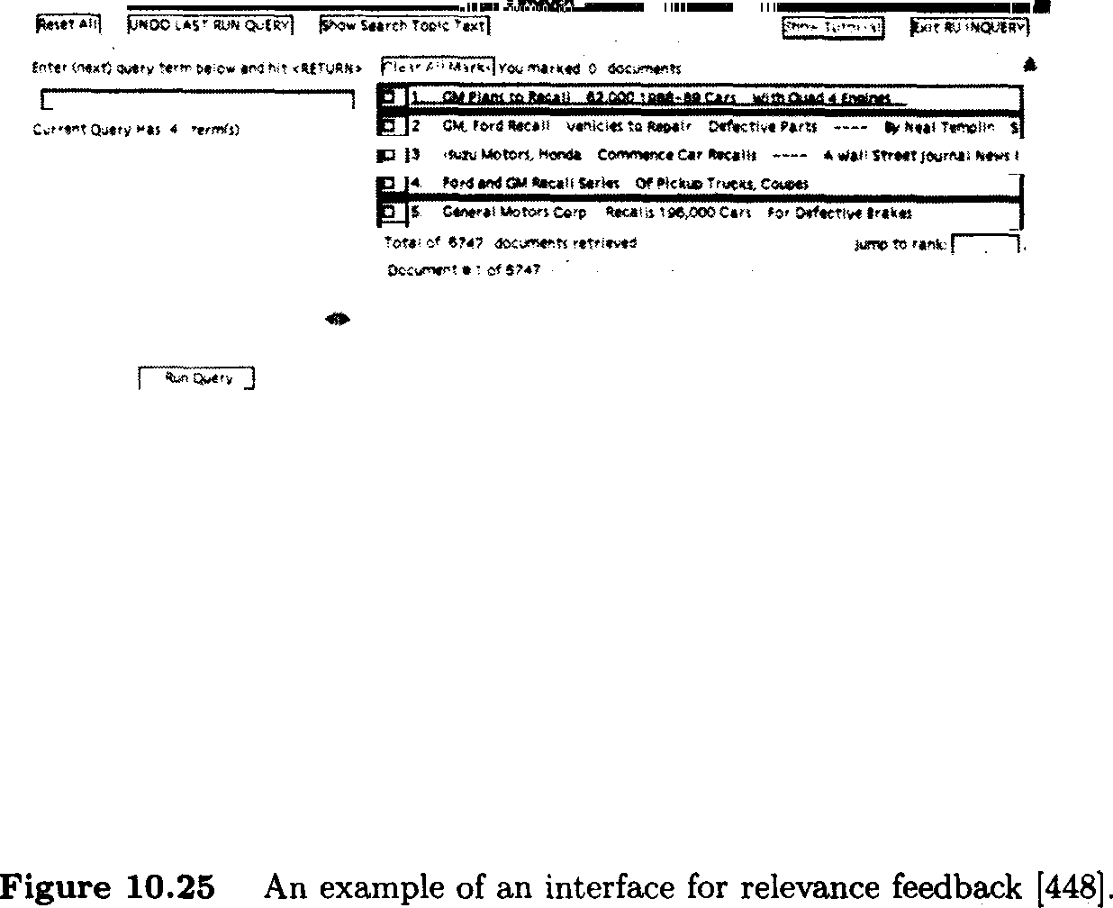

but at the same time, this can serve as feedback indicating that the revised query does not downgrade the ranking of those documents that have been found especially important. One solution is to retain a separate window that shows the rankings of only the documents that have not been retrieved or ranked highly previously. Another solution is to use smaller fonts or gray-out color for the titles of documents already seen.
Creating multiple relevance judgements is an effortful task, and the notion of relevance feedback is unfamiliar to most users. To circumvent these prob- lems, Web-based search engines have adopted the terminology of ‘more like this’ as a simpler way to indicate that the user is requesting documents similar to the selected one. This ‘one-click’ interaction method is simpler than standard relevance feedback dialog which requires users to rate a small number of doc- uments and then request a reranking. Unfortunately, in most cases relevance feedback requires many relevance judgements in order to work well. To partly alleviate this problem, Aalbersberg [1] proposes incremental relevance feedback which works well given only one relevant document at a time and thus can be used to hide the two-step procedure from the user.

    - Studies of User Interaction with Relevance Feedback Systems
Standard relevance feedback assumes the user is involved in the interaction by specifying the relevant documents. In some interfaces users are also able to
306 USER INTERF'ACES AND VISUALIZATION
select which terms to add to the query. However, most ranking and reweighting algorithms are difficult to understand or predict (even for the creators of the algorithms!) and so it might be the caee that users have difficulties controlling a relevance feedback system explicitly.
A recent study was conducted to invmtigate directly to what degree user control of the feedback process is beneficial. Koenemann and Belkin 448] mea- sured the benefits of letting users ‘under the hood’ during relevance feedback. They tested four caees using the Inquery system (7T2]:

- Control No relevance feedback; the subjects could only reformulate the query by hand.
- Opaque The subjects simply selected relevant documents and saw the revised rankings.
- Transparent The subjects could see how the system reformulated the queries (that is, see which terms were added — the system did not reweight the subjects' query terms) and the revised rankings.
- Penetrable The system is stopped midway through the reranking process. The subjects are shown the terms that the system would have used for opaque and transparent query reformulation. The subjects then select which, if any, of the new terms to add to the query. The system then presents the revised rankings.

The 64 subjects were much more effective (measuring precision at a cut- off of top 5, top 10, top 30, and top 100 documents) with relevance feedback than without it. The penetrable group performed significantly better than the control, with the opaque and transparent performances falling between the two in effectiveness. Search times did not differ significantly among the conditions, but there were significant differences in the number of feedback iterations. The subjects in the penetrable group required significantly fewer iterations to achieve better queries (an average of 5.8 cycles in the penetrable group, 8.2 cycles in the control group, 7.7 cycles in the opaque group, and surprisingly, the transparent group required more cycles, 8.8 on average). The average number of documents marked relevant ranged between 11 and 14 for the three conditions. All subjects preferred relevance feedback over the baseline system, and several remarked that they preferred the ‘lazy’ approach of selecting suggested terms over having to think up their own.
An observational study on a TTY-baeed version of an online catalog system 338] also found that users performed better using a relevance feedback mech- anism that allowed manual selection of terms. However, a later observational study did not find overall succes8 with this form of relevance feedback (337). The authors attribute these results to a poor design of a new graphical interface. These results may also be due to the fact that users often selected only one rel- evant document before performing the feedback operation, although they were using a system optimized from multiple document selection.
    - Fetching Relevant Information in the Background

Standard relevance feedback is predicated on the goal of improving an ad hoc query or building a profile for a routing query. More recently researchers have begun developing systems that monitor users’ progress and behavior over long interaction periods in an attempt to predict which documents or actions the user is likely to want in future. These systems are called semi-automated nssistonta or recommender ‘agents, and often make use of machine learning techniques [565). Some of these systems require explicit user input in the form of a goal statement |406] or relevance judgements 629a, while others quietly record users’ actions and try to make inferences based on these actions.
A system developed by Kozierok and Maes [460, 536] makes predictions about how users will handle email messages (what order to read them in, where to file them) and how users will schedule meetings in a calendar manager ap- plication. The system ‘looks over the shoulder’ of the users, recording every relevant action into a database. After enough data has been accumulated, the system uses a nearest-neighbors method (743] to predict a user's action based on the similarity of the current situation to situations already encountered. For example, if the user almost always saves email messages from a particular per- son into a particular file, the system can offer to automate this action the next time a message from that person arrives 536]. This system integrates learning from both implicit and explicit user feedback. If a user ignores the system's suggestion, the system treats this as negative feedback, and accordingly adds the overriding action to the action database. After certain types of incorrect predictions, the system asks the user questions that allow it to adjust the weight of the feature that caused the error. Finally, the user can explicitly train the system by presenting it with hypothetical examples of input-action pairs.
Another system, Syskill and Webert 629], attempts to learn a user profile based on explicit relevance judgements of pages explored while browsing the Web. In a sense this is akin to standard relevance feedback, except the user judgements are retained across sessions and the interaction model differs: as the user browses a new Web page, the links on the page are automatically annotated as to whether or not they should be relevant to the user's interest.
A related system is Letizia (518], whose goal is to bring to the user's atten- tion a percentage of the available next moves that are most likely to be of interest, given the user's earlier actions. Upon request, Letizia provides recommendations for further action on the user's part, usually in the form of suggestions of links to follow when the user is unsure what to do next. The system monitors the user's behavior while navigating and reading Web pages, and concurrently evaluates the links reachable from the current page. The system uses only implicit feed- back. Thus, saving a page as a bookmark is taken as strong positive evidence for the terms in the corresponding Web page. Links skipped are taken as negative support for the information reachable from the link. Selected links can indicate positive or negative evidence, depending on how much time the user spends on the resulting page and whether or not the decision to leave a page quickly is later reversed. Additionally, the evidence for user interest remains persistent across
browsing sessions. Thus, a user who often reads kayaking pages is at another time reading the home page of a professional contact and may be alerted to the fact that the colleague's personal interests page contains a link to a shared hobby. The system uses a best-first search strategy and heuristics to determine which pages to recommend most strongly.
A more user-directed approach to prefetching potentially relevant informa- tion is seen in the Butterfly system 531]. This interface helps the user follow a series of citation links from a given reference, an important information seek- ing strategy [66]. The system automatically examines the document the user is currently reading and prefetehes the bibliographic citations it refers to. lt also retrieves lists of articles that cite the focus document. The underlying assump- tion is that the services from which the citations are requested do not respond immediately. Rather than making the user wait during the delay associated with each request, the system handles many requests in parallel and the interface uses graphics and animations to show the incrementally growing list of available ci- tations. The system does not try to be clever about which cites to bring first; rather the user can watch the ‘organically’ growing visualization of the document and its citations, and based on what looks relevant, direct the system as to which parts of the citation space to spend more time on.

    - Group Relevance Judgements
Recently there has been much interest in using relevance judgements from a large number of different users to rate or rank information of general interest 672]. Some variations of this social recommendation approach use only simi- larity among relevance judgements by people with similar tastes, ignoring the representation of the information being judged altogether. This has been found highly effective for rating information in which taste plays a major role, such as movie and music recommendations 720]. More recent work has combined group relevance judgements with content information (64].

    - Pseudo-Relevance Feedback
At the far end of the system versus user feedback spectrum is what is informally known as pseudo-relevance feedback. In this method, rather than relying on the user to choose the top k relevant documents, the system simply assumes that its top-ranked documents are relevant, and uses these documents to augment the query with a relevance feedback ranking algorithm. This procedure has been found to be highly effective in some settings 760, 465, 12], most likely those in which the original query statement is long and precise. An intriguing extension to this idea is to use the output of clustering of retrieval results as the input to a relevance feedback mechanism, either by having the user or the system select the cluster to be used [359], but this idea has not yet been evaluated.
INTERFACE SUPPORT FÓR THE SEARCH PROCES.S 309
1t0.8 Interface ”Support for the Search I?rocess
The ueer interface designer must. make..decisions about how to arrange various kinda of information on the computer acreen .and how to structure. the possi- ble sequences .of ifiteractions. This design problem is specially .daunting for a coóiplek activity like information úccéaé. In .this séction we discuas deaign choiees surroimding the'1ayoút of information within complex .information aJs- tems, and illustraté the ideas with exainples of exiating iziterfäces, We begin with a diacuseion of very aimple search.interfaces, thnse used.for string search in ‘find’ operations, and then progress to multiwindow interfacm and aophisti- eated workspaces. Thii is followed by a diseuaoion of the integration of scanning, selecting, und querying within information acctss interfaces nid concludes .with interface support for retaining the histöry of the search prpüess.
    - Interfaces for String M.
atching
A common simple search need is that of the ‘find’ operation, typically run over the contenta of a document that’ ía currently.being viewed. Uaually this‘function docs not produce’ rúñked output, nór allow Boolean combinations of terms; the main operation is a simple string match (without regular expreseion capabilities). Typically a special purpose search window is created, containing a few simple controla (e.g., case-aensitivity, search forward or backward). The user typee the query string into an entry form and string matches are highlighted in the target document (ace Figure 10.26):
The. next degrée of complexity is the .‘find’ .function for. aearching across small collections, such as the files .on a personal computer's hard disk, or the history list of a Web browser. This type of function is also usually impleoiented as a simple string match. Again, the controla and parameter settings are shown at the top.ofi a s ial purpose aearch window ned the various options are set via checkboxes and entry forms. :The difference from the .previous example is.that a resulte li8t is ahown.within the aearch interface itself .(eee Figure 10.27).
A eominon problem ariaee even in these very simple interfaces. An ambigu- ous state'oceurs in which the .resulte. for an earlier search a.re:shown. while the ueer. is entering a new query or modifying. the .previous one. If the user types in
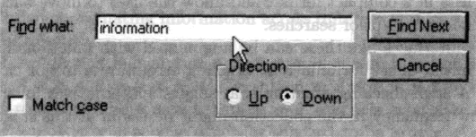

Figure 10.Z8 An example of a simple interface fpr string matching,i from Netscape
Communieator. 4,05.

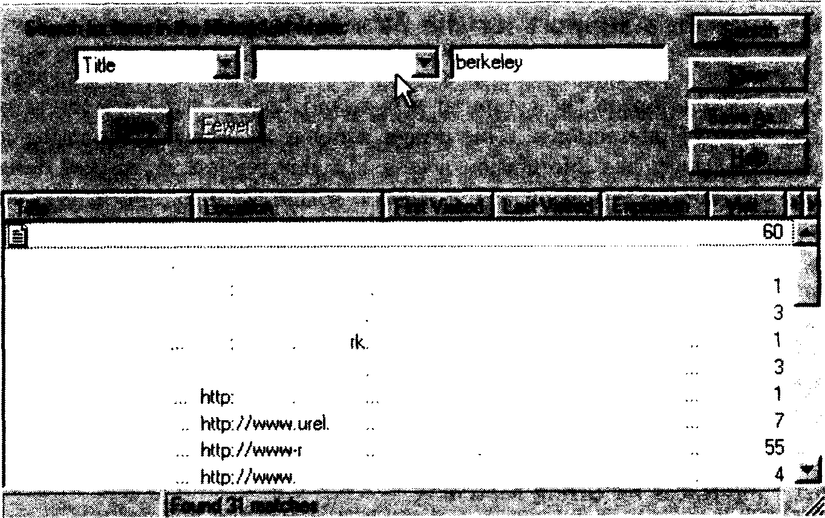

Ccrtâns
Searching UC .,. http://¥ u+¥-fescKxce... 7/7/199g ... 1 k‹x¥s ago 8/27/199... The UC B«ket . http://iñxay.beikele... 1 hoes ago 1 hccrs ago 8/2771S9:.. Bakeley Pledqe http 7/www.utel.betk. . 1 f•x•s a0o 1 hotzs ago 8/27/199... 1998 Betkeleya.. http://www.uld.Lerk .. 1 houfs ogo 1 hou‹s ago 8/27/J 99...
3
Bak an c N www• how,a9o 1 h• •a9o 8 271 9
Bakeleyan / Pi... htlp://www.txel.berk .. 1 Louis ago 1 houfs ago 8/27a 99
Betkeleyan 7 P‹ 02-1%Betket UCBe‹keleyDx UC 8e‹kdev 0i
hwww wd.betk
be‹k esoufca
J hairs ago 1 hours ago 8/27/199 2hous ago 1 houis ago 6/27/199 7/22/199,. 1 hours ago 8/277199.
bcrkehv... 1 h‹:xxs aoo 1 hauls aoo 8/277199..

Figure 10.27 An example of an string matching over a list, in this case, a history of recently viewed Web pages, from Netscape Communicator 4.05.

new terms and but then does not activate the search, the interface takes on a potentially misleading state, since a user could erroneously assume that the old search hits shown correspond to the newly typed-in query. One solution for this problem is to clear the results list as soon as the user begins to type in a new query.
However, the user may want to refer to terms shown in the search results to help reformulate the query, or may decide not to issue the new query and instead continue with the previous results. These goals would be hampered by erasing the current result set as soon as the new query is typed. Another solution is to bring up a new window for every new query. However, this requires the user to execute an additional command and can lead to a proliferation of windows. A third, probably more workable solution, is to automatically ‘stack’ the queries and results lists in a compact format and allow the user to move back and forth among the stacked up prior searches.
Simple interfaces like these can be augmented with functionality that can greatly aid initial query formulation. Spelling errors are a major cause of void result sets. A spell-checking function that suggests alternatives for query terms that have low frequency in the collection might be useful at this stage. Another option is to suggest thesaurus terms associated with the query terms at the time the query terms are entered. Usually these kinds of information are shown after the query is entered and documents have been retrieved, but an alternative is to provide this information as the user enters the query, in a form of query preview.

IN'I’ERFACE SUPPORT FOR ’I'HE SEARCH PROCESS 311
    - Window Management

For search tasks more complex than the simple string matching find operations described above, the interface designer must decide how to lay out the various choices and information displays within the interface.
As discussed above, traditional bibliographic search systems use TTY- based command-line interfaces or menus. When the system responds to a com- mand, the new results screen obliterates the contents of the one before it, requir- ing the user to remember the context. For example, the user can usually see only one level of a subject hierarchy at a time, and must leave the subject view in order to see query view or the document view. The main design choice8 in such a system are in the command or menu structure, and the order of presentation of the available options.
In modern graphical interfaces, the windowing system can be used to divide functionality into different, simultaneously displayed views (582]. In information access systems, it is often useful to link the information from one window to the information in another, for example, linking documents to their position in a ta- ble of contents, as seen in SuperBook. Users can also use the selection to cut and paste information from one window into another, for example, copy a word from a display of thesaurus terms and paste the word into the query specification form. When arranging information within windows, the designer must choose be- tween a monolithic display, in which all the windows are laid out in predefined positions and are all simultaneously viewable, tiled uñndows, and overlapping uñndows. User studies have been conducted comparing these options when ap- plied to various tasks 725, 96]. Usually the results of these studies depend on the domain in which the interface is used, and no clear guidelines have yet emerged
for information access interfaces.
The monolithic interface has several advantages. It allows the designer to control the organization of the various options, makes all the information simultaneously viewable, and places the features in familiar positions, making them easier to find. But monolithic interfaces have disadvantages as well. They often work best if occupying the full viewing screen, and the number of views is inherently limited by the amount of room available on the screen (as opposed to overlapping windows which allow display of more information than can fit on the screen at once). Many modern work-intensive applications adopt a monolithic design, but this can hamper the integration of information access with other work processes such as text editing and data analysis. Plaisant et of. [644] discuss issues relating to coordinating information across different windows to providing overview plus details.
A problem for any information access interface is an inherent limit in how many kinds of information can be shown at once. Information access systems must always reserve room for a text display area, and this must take up a signif- icant proportion of screen space in order for the text to be legible. A tool within a paint program, for example, can be made quite small while nevertheless re- maining recognizable and usable. For legibility reasons, it is difficult to compress many of the information displays needed for an information access system (such
as lists of thesaurus terms, query specifications, and lists of saved titles) in this manner. Good layout, graphics, and font design can improve the situation; for example, Web search results can look radically di8erent depending on spacing, font, and other small touches [680].
Overlapping windows provide flexibility in arrangement, but can quickly lead to a crowded, disorganized display. Researchers have observed that much user activity is characterized by movement from one set of functionally related windows to another. Bannon et nf. 54] define the notion of a workspace — the grouping together of sets of windows known to be functionally related to some activity or goal — arguing that this kind of organization more closely matches users’ goal structure than individual windows [96]. Card et of. 140] also found that window usage could be categorized according to a ‘working set’ model. They looked at the relationship between the demands of the task and the number of windows in use, and found the largest number of individual windows were in use when users transitioned from one task to another.
Based on these and other observations, Henderson and Card (420] built a system intended to make it easier for users to move between ‘multiple virtual workspaces’ 96]. The system uses a 3D spatial metaphor, where each workspace is a ‘room, and users transition between workspaces by ‘moving’ through virtual doors. By ‘traveling’ from one room to the next, users can change from one work context to another. In each work context, the application programs and data files that are associated with that work context are visible and readily available for reopening and perusal. The workspace notion as developed by Card et of. also emphasizes the importance of having sessions persist across time. The user should be able to leave a room dedicated to some task, work on another task, and three days later return to the first room and see all of the applications still in the same state as before. This notion of bundling applications and data together for each task has since been widely adopted by window manager software in workstation operating system interfaces.
Elastic windows 428] is an extension to the workspace or rooms notion to the organization of 2D tiled windows. The main idea is to make the transition easier from one role or task to another, by adjusting how much of the screen real estate is consumed by the current role. The user can enlarge an entire group of windows with a simple gesture, and this residing automatically causes the rest of the workspaces to reduce in size so they all still fit on the screen without overlap.

    - Example Systems
The following sections describe the information layout and management ap- proaches taken by several modern information access interfaces.

The InfoGrid Layout
The InfoGrid system 667] is a typical example of a monolithic layout for an information access interface. The layout assumes a large display is available

Search Parameters |  | Property Sheet  Document  Text
Control Panel | Thumbnail Images
Holding Area |  | Search Paths

Control Panel
Table of Contents | TOC Subset
Document
Text
Search Parameters

Figure 1fi.28 Diagrams of monolithic layouts for information access interfaces.

and is divided into a left-hand and right-hand side (see Figure 10.28). The left- hand side is further subdivided into an area at the top that contains structured entry forms for specifying the properties of a query, a column of iconic controls lining the left side, and an area for retaining documents of interest along the bottom. The main central area is used for the viewing of retrieval results, either as thumbnail representations of the original documents, or derived organizations of the documents, such as Scatter/Gather-style cluster results. Users can select documents from this area and store them in the holding area below or view them in the right-hand side. Most of the right-hand side of the display i5 used for viewing selected documents, with the upper portion showing metadata associated with the selected document. The area below the document display is intended to show a graphical history of earlier interactions.
Designers must make decisions about which kinds of information to show in the primary view(s). If InfoGrid were used on a smaller display, either the document viewing area or the retrieval results viewing area would probably have to be shown via a pop-up overlapping window; otherwise the user would have to toggle between the two views. If the system were to suggest terms for rele- vance feedback, one of the existing views would have to be supplanted with this information or a pop-up window would have to be used to display the candidate terms. The system does not provide detailed information for source selection, although this could be achieved in a very simple way with a pop-up menu of choices from the control panel.

The SuperBook Layout
The layout of the InfoGrid is quite similar to that of SuperBook (see section 10.6). The main difference is that SuperBook retains the table of contents-like display in the main left-hand pane, along with indicators of how many documents containing search hits occur in each level of the outline. Like InfoGrid, the main pane of the right-hand side is used to display selected documents. Query
formulation is done just below the table of contents view (although in earlier versions this appeared in a separate window). Terms related to the user's query are shown in this window as well. Large images appear in pop-up overlapping windows.
The SuperBook layout is the result of several cycles of iterative design 481]. Earlier versions used overlapping windows instead of a monolithic layout, allowing users to sweep out a rectangular area on the screen in order to create a new text box. This new text box had its own set of buttons that allowed users to jump to occurrences of highlighted words in other documents or to the table of contents. SuperBook was redesigned after noting results of experimental studies [350, 532] showing that users can be more efficient if given fewer, well chosen interaction paths, rather than allowing wide latitude (A recent study of auditory interfaces found that although users were more efficient with a more flexible interface, they nevertheless preferred the more rigid, predictable interface (801)). The designers also took careful note of log files of user interactions. Before the redesign, users had to choose to view the overall frequency of a hit, move the mouse to the table of contents window, click the button and wait for the results to be updated. Since this pattern was observed to occur quite frequently, in the next version of the interface, the system was redesigned to automatically perform this sequence of actions immediately after a search was run.
The SuperBook designers also attempted a redesign to allow the interface to fit into smaller displays. The redesign made use of small, overlapping windows. Some of the interaction sequences that were found useful in this more constrained environment were integrated into later designs for large monolithic displays.

The DLITE Interface
The DLITE system 193, 192a makes a number of interesting design choices. It splits functionality into two parts: control of the search process and display of results . The control portion is a graphical direct manipulation display with an- imation (see Figiire10.29). Queries, sources, documents, and groups of retrieved documents are represented as graphical objects. The user creates a query by filling out the editable fields within a query constructor object. The system manufactures a query object, which is represented by a small icon which can be dragged and dropped onto iconic representations of collections or search services. If a service is active, it responds by creating an empty results set object and at- taching the query to this. A set of retrieval results is represented as a circular pool, and documents within the result set are represented as icons distributed along the perimeter of the pool. Documents can be dragged out of the results set pool and dropped into other services, such as a document summarizer or a language translator. Meanwhile, the user can make a copy of the query icon and drop it onto another search service. Placing the mouse over the iconic represen- tation of the query causes a ‘tool-tips’ window to pop up to show the contents of the underlying query. Queries can be stored and reused at a later time, thus facilitating retention of previously successful search strategies.

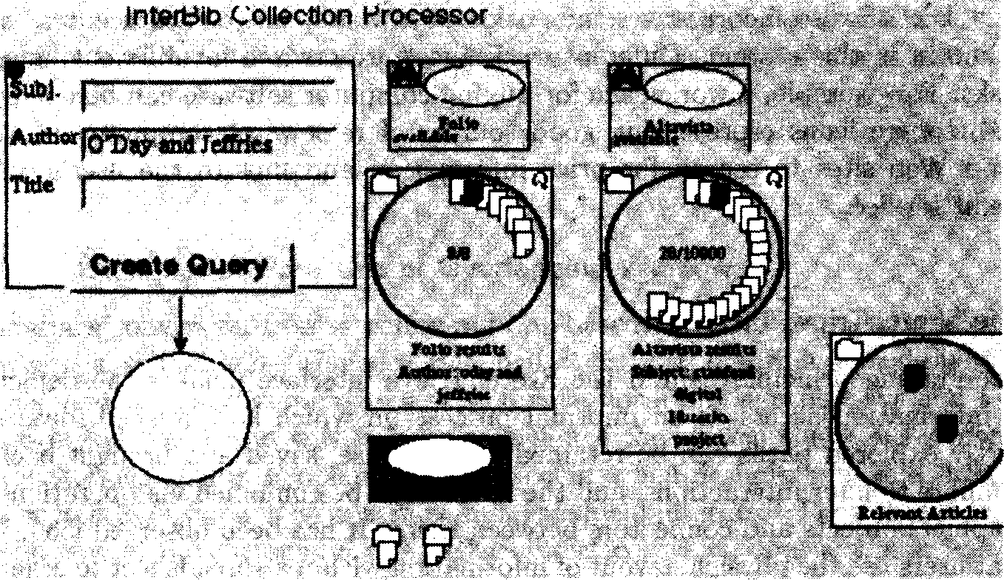

Figure 10.29 The DLITE interface {193].

A flexible interface architecture frees the user from the restriction of a rigid order of commands. On the other hand, as seen in the SuperBook discussion, such an architecture must provide guidelines, to help get the user started, give hints about valid ways to proceed, and prevent the user from making errors. The graphical portion of the DLITE interface makes liberal use of animation to help guide the user. For example, if the user attempts to drop a query in the document summarizer icon — an illegal operation — rather than failing and giving the user an accusatory error message [185], the system takes control of the object being dropped, refusing to let it be placed on the representation for the target appli- cation, and moves the object left, right, and left again, mimicking a ‘shake-the- head-no’ gesture. Animation is also used to help the user understand the state of the system, for example, in showing the progress of the retrieval of search results by moving the result set object away from the service from which it was invoked. DLITE uses a separate Web browser window for the display of detailed information about the retrieved documents, such as their bibliographic citations and their full text. The browser window is also used to show Scatter/Gather- style cluster results and to allow users to select documents for relevance feedback. Earlier designs of the system attempted to incorporate text display into the di- rect manipulation portion, but this was found to be infeasible because of the space required 192]. Thus, DLITE separates the control portion of the infor- mation access process from the scanning and reading portion. This separation allows for reusable query construction and service selection, while at the same time allowing for a legible view of documents and relationships among retrieved documents. The selection in the display view is linked to the graphical control portion, so a document viewed in the display could be used as part of a query
in a query constructor.
DLITE also incorporates the notion of a workspace, or ‘workcenter, as it is known in this system. Different workspaces are created for different kinds of tasks. For example, a workspace for buying computer software can be equipped with source icons representing good sources of reviews of computer software, good Web sites to search for price information and link to the user's online credit service.

The SketchTrieve Interface
The guiding principle behind the SketchTrieve interface [365) is the depiction of information access as an informal process, in which half-finished ideas and partly explored paths can be retained for later use, saved and brought back to compare to later interactions, and the results can be combined via operations on graphical objects and connectors between them. It has been observed (584, 722) that users use the physical layout of information within a spreadsheet to organize information. This idea motivates the design of SketchTrieve, which allows users to arrange retrieval results in a side-by-side manner to facilitate comparison and recombination (see Figure 10.30).
The notion of a canvas or workspace for the retention of the previous con- text should be adopted more widely in future. Many issues are not easily solved, such as how to show the results of a set of interrelated queries, with minor modifications based on query expansion, relevance feedback, and other forms of modification. One idea is to show sets of related retrieval results as a stack of
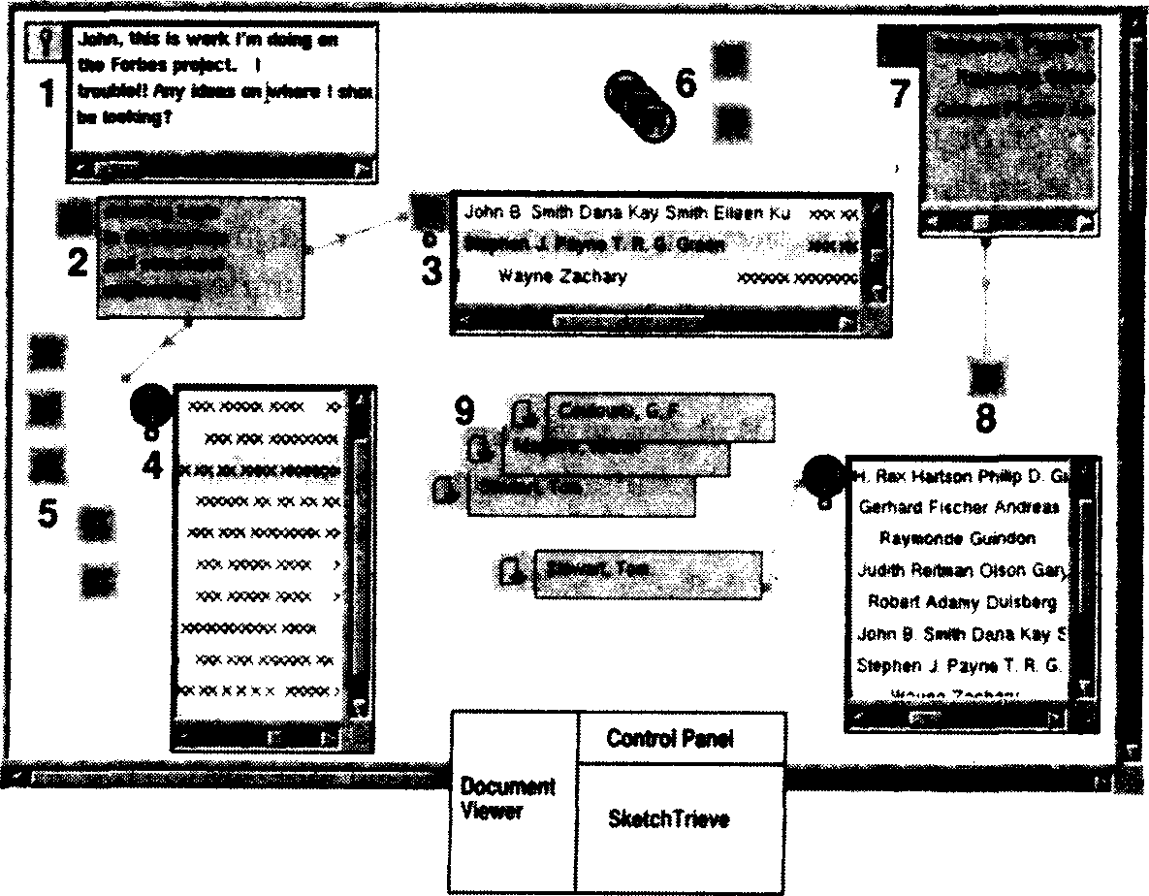

; 10

Figure 10.30 The SketchTrieve interface {365].
cards within a folder and allow the user to extract subsets of the cards and view them side by side, as is done in SketchTrieve, or compare them via a difference operation.

    - Examples of Poor Use of Overlapping Windows
Sometimes conversion from a command-line-based interface to a graphical dis- play can cause problems. Hancock-Beaulieu et of. 337] describe poor design de- cisions made in an overlapping windows display for a bibliographic system. (An improvement was found with a later redesign of the system that used a mono- lithic interface (336].) Problems can also occur when designers make a ‘literal’ transformation from a TTY interface to a graphical interface. The consequences can be seen in the current LEXIS-NEXIS interface, which does not make use of the fact that window systems allow the user to view different kinds of informa- tion simultaneously. Instead, despite the fact that it occupies the entire screen, the interface does not retain window context when the user switches from one function to another. For example, viewing a small amount of metadata about a list of retrieved titles causes the list of results to disappear, rather than over- laying the information with a pop-up window or rearranging the available space with resizable tiles. Furthermore, this metadata is rendered in poorly-formatted ASCII instead of using the bit-map capabilities of a graphical interface. When a user opts to see the full text view of a document, it is shown in a small space, a few paragraphs at a time, instead of expanding to fi11 the entire available space.

    - Retaining Search History
Section 10.3 discusses information seeking strategies and behaviors that have been observed by researchers in the field. This discussion suggests that the user interface should show what the available choices are at any given point, as well as what moves have been made in the past, short-term tactics as well as longer- term strategies, and allow the user to annotate the choices made and information found along the way. Users should be able to bundle search sessions as well as save individual portions of a given search session, and flexibly access and modify each. There is also increasing interest in incorporating personal preference and usage information both into formulation of queries and use of the results of search (277].
For the most part these strategies are not supported well in current user interfaces; however some mechanisms have been introduced that begin to address these needs. In particular, mechanisms to retain prior history of the search are useful for these tasks. Some kind of history mechanism has been made available in most search systems in the past. Usually these consist of a list of the commands eKecuted earlier. More recently, graphical history has been introduced, that allows tracking of commands and results as well. Kim and Hirtle

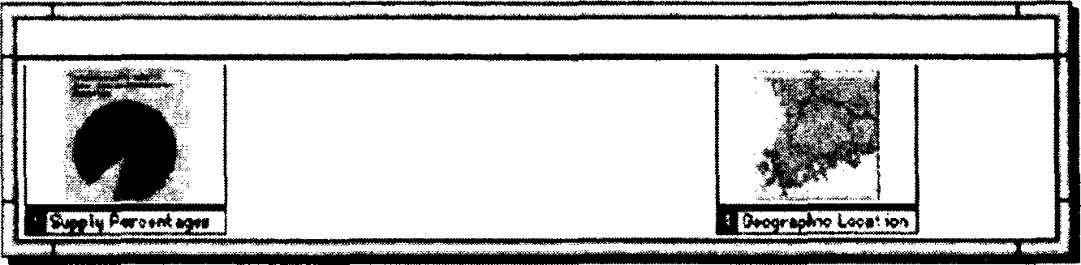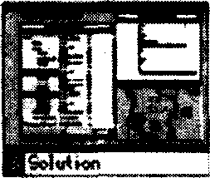

Slide sorter

Figure 10.31 The VISAGE interaction history visualization (685].

|440] present a summary of graphical history presentation mechanisms. Recently, a graphical interface that displays Web page access history in a hierarchical structure was found to require fewer page accesses and require less time when returning to pages already visited (370].
An innovation of particular interest for information access interfaces is exemplified by the saving of state in miniature form in a ‘slide sorter’ view as exercised by the VISAGE system for information visualization 685] (see Figure 10.31). The VISAGE application has the added advantage of being visual in nature and so individual states are easier to recognize. Although intended to be used as a presentation creation facility, this interface should also be useful for retaining search action history.

    - Integrating Scanning. Selection, and Querying
User interfaces for information access in general do not do a good job of sup- porting strategies, or even of sequences of movements from one operation to the next. Even something as simple as taking the output of retrieval results from one query and using them as input to another query executed in a later search session is not well supported in most interfaces.
Hertzum and Frokjaer 368] found that users preferred an integration of scanning and query specification in their user interfaces. They did not, however, observe better results with such interactions. They hypothesized that if interac- tions are too unrestricted this can lead to erroneous or wasteful behavior, and interaction between two different modes requires more guidance. This suggests that more flexibility is needed, but within constraints (this argument was also made in the discussion of the SuperBook system in section 10.6).
There are exceptions. The new Web version of the Melyvl system provides ways to take the output of one query and modify it later for re-execution (see Figure 10.32). The workspace-based systems such as DLITE and Rooms allow storage and reuse of previous state. However, these systems do not integrate the general search process well with scanning and selection of information from auxiliary structures. Scanning, selection, and querying needs to be better inte- grated in general. This discussion will conclude with an example of an interface that does attempt to tightly couple querying and browsing.
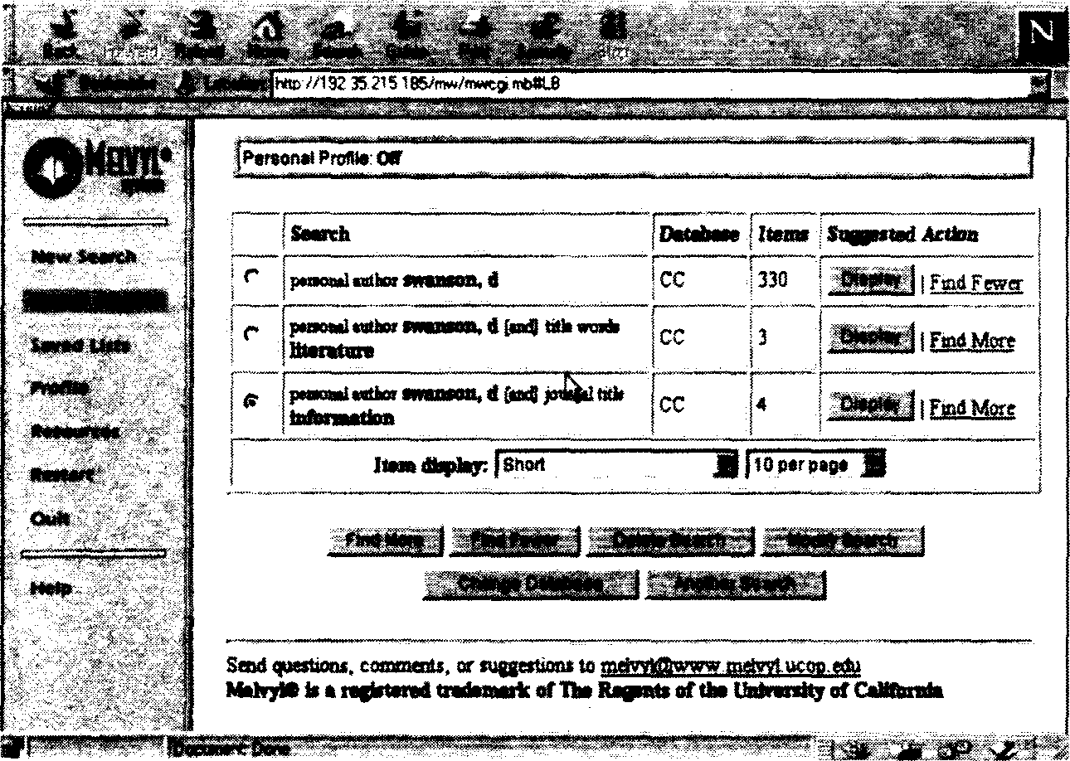

Figure 10.32 A view of query history revision in the Web-based version of the Melvyl bibliographic catalog. Copyright @, The Regents of the University of California.

The Cat-a-Cone interface integrates querying and browsing of very large category hierarchies with their associated text collections. The prototype system uses 3D+animation interface components from the Information Visualizer 144], applied in a novel way, to support browsing and search of text collections and their category hierarchies. See Figure 10.33. A key component of the interface is the separation of the graphical representation of the category hierarchy from the graphical representation of the documents. This separation allows for a fluid, flexible interaction between browsing and search, and between categories and documents. It also provides a mechanism by which a set of categories associated with a document can be viewed along with their hierarchical context.
Another key component of the design is assignment of first-class status to the representation of text content. The retrieved documents are stored in a 3D+animation book representation (144] that allows for compact display of moderate numbers of documents. Associated with each retrieved document is a page of links to the category hierarchy and a page of text showing the document contents. The user can ‘rufile’ the pages of the book of retrieval results and see corresponding changes in the category hierarchy, which is also represented in 3D+animation. All and only those parts of the category space that re8ect the semantics of the retrieved document are shown with the document.
The system allows for several different kinds of starting points. Users can start by typing in a name of a category and seeing which parts of the category hierarchy match it. For example, Figure 10.34 shows the results of searching on
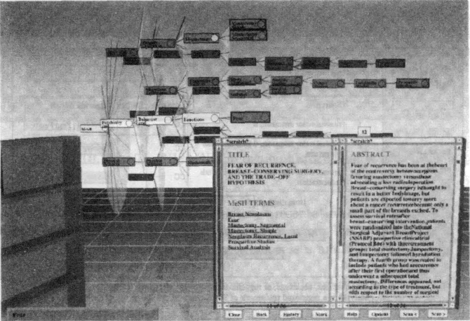
320 USER INTERPACB8. AND VISUALIZATION

Plgure 10.CB The Cat- -Gone interfaée for integrating category and text scanning
aod seazcb |358).

‘Radiation’ over the MeSH terms in this subcollection. The word appears un- der four main ‘headinga (Physical Séiencee, Diseases, Diagnostics, and BioJogical Science). Thé hierarchy immediately shows why ‘Radiation’ appeara under Dic- &ives — as part ‘of a aubtree on occupational hazards. Novr the user can aelect one or more of these category labels as input tó a query Specification.
Another way the uaer can atart is by aimply typing in a free text query into an entry label. This query is matched against the collection. Relevant documenta are retrieved and placed in the book format.’When the uaer ‘opens’ the book tá a retrieved document, the parts of the category hierarchy that corréepond to the retrieved documents are'shomi in the hierarchical representation. Thus, multiple inter8ecting categóties can óe shown simultaneously, in their hierarchical context. Thus, .this interface fluiílly combines large, cnmplex metadata, starting pointa, aeazuúng, and querying into one interface. The interfaée allows for a kind of relevance feedback, by suggestizig additional categories that are related to the documenta that have’beeñ retrieved. This interaétion model is similar to that propoaed by (5].
Recall the evaluation of the Kohónen feature map repreaentatión diacuaaed in section 10.4. The éxperimenters found that some users expressed ‘a desire for a visible hierarchical organizátióni ‘otheia wanted an ability to soom in on a subarea to get óiore detail; and aome uaera dialiked havin tÓ look through the entire map to find a theme, deairing an alphabeticál ordering’ instead. The subjecta liked the ease of being able to jiímp from one aires to mother without
.TRENDS AND RESEARCH ISSUES 321
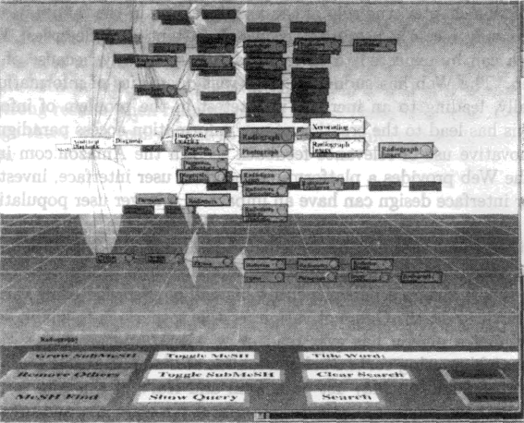

Figure 10.84 An intedace for ,a starting point for uearching over category labels
[358].

having to back up (as is required in Yahoo!) and liked thé f ét that the maps have varying levels of granularity.
Theae results all support the design decisioos made in the Cat-a-Cone. Hierarćhical repiesentation óf‘terin’meanings is suppotted; so users fair choośe which level of deficription is m aningful to th'em. Ffirthermore, di8eriint levfils of description’can be viewéd simultaneously, s6 crore familiar concepts can be viewed in more detail, and less familiar at a m‹ire general level. An alphabetical ordering of the categories coupled“with a regular expression sea?éh mechaiiisni allows for straightforward location of category labels. Retrieved documenta are represented as first-class objects, so full text is visible, but in a compact form. Category labels are disambiguated by their ancestor/descendant/sibling repre- sentation. Uaers can jump easily from one eate8ory to another and can in addi- tion query on multiple categoriee simultaneously (aomething that is not a natural feature of the maps). The Cat-a-Cone has s vór I additional advantages ae well, such as allowing a document to be placed at the interséction of several catégories, and Explicitly linking document contents with the category reprieventation.

10.9 Treńdsand Research” lsszzds
The importance. of human computer. interaction is receiving’ increasing iecogni- tioñ within the field of computer.science [587]. As should be evident from the

