UNIT-1
INTRODUCTION

1.1 Motivation
Information retrieval (IR) deals with the representation, storage, organization of, and access to information items. The representation and organization of the information items should provide the user with easy access to the information in which he is interested. Unfortunately, characterization of the user information need is not a simple problem.
Consider, for instance, the following hypothetical user information need in the context of the World Wide Web (or just the Web):Find all the pages (documents) containing information on college ten­nis teams which: (1) are maintained by an university in the USA and (2) participate in the NCAA tennis tournament. To be relevant, the page must include information on the national ranking of the team in the last three years and the email or phone number of the team coach.
Clearly, this full description of the user information need cannot be used directly to request information using the current interfaces of Web search engines. In­stead, the user must first translate this information need into a query which can be processed by the search engine (or IR system).
In its most common form, this translation yields a set of keywords (or index terms) which summarizes the description of the user information need. Given the user query, the key goal of an IR system is to retrieve information which might be useful or relevant to the user. The emphasis is on the retrieval of information as opposed to the retrieval of data.

1.1.1 Information versus Data Retrieval
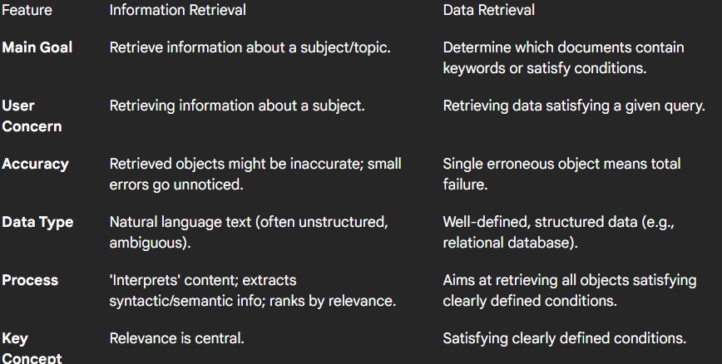
1.2 Basic Concepts
The effective retrieval of relevant information is directly affected both by the user task and by the logical view of the documents adopted by the retrieval system
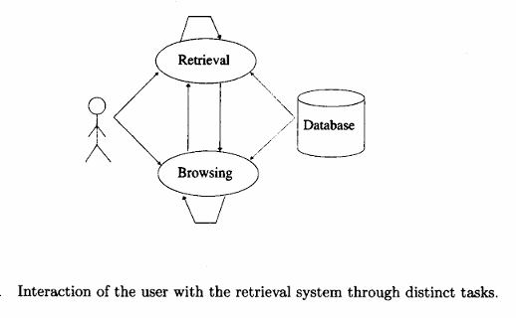
1.2.1 The User Task
The user of a retrieval, system has to translate his information need into a query in the language provided by the system. With an information retrieval system, this normally implies specifying a set of words which convey the semantics of the information need. With a data retrieval system, a query expression (such as, for instance, a regular expression) is used to convey the constraints that must be satisfied by objects in the answer set. In both cases, we say that the user searches for useful information executing a retrieval task.
Consider now a user who has an interest which is either poorly defined or which is inherently broad. For instance, the user might be interested in documents about car racing in general. In this situation, the user might use an interactive interface to simply look around in the collection for documents related to car racing. For instance, he might find interesting documents about Formula 1 racing, about car manufacturers, or about the '24 Hours of Le Mans.' Furthermore, while reading about the '24 Hours of Le Mans', he might turn his attention to a document which provides directions to Le Mans and, from there, to documents which cover tourism in France. In this situation, we say that the user is browsing the documents in the collection, not searching. It is still a process of retrieving information, but one whose main objectives are not clearly defined in the beginning and whose purpose might change during the interaction with the system.

1.2.2 Logical View of the Documents
Due to historical reasons, documents in a collection are frequently represented through a set of index terms or keywords. Such keywords might be extracted directly from the text of the document or might be specified by a human subject. No matter whether these representative keywords are derived automatically or generated by a specialist, they provide a logical view of the document.
Modern computers are making it possible to represent a document by its full set of words. In this case, we say that the retrieval system adopts a full text logical view (or representation) of the documents. With very large collections, however, even modern computers might have to reduce the set of representa­tive keywords.
This can be accomplished through the elimination of stopwords (such as articles and connectives), the use of stemming (which reduces distinct words to their common grammatical root), and the identification of noun groups (which eliminates adjectives, adverbs, and verbs). Further, compression might be employed. These operations are called text operations (or transformations. Text operations reduce the complexity of the document representation and allow moving the logical view from that of a full text to that of a set of index terms.
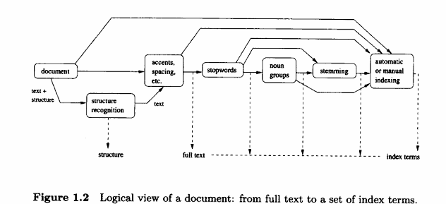

1.3 Past, Present, and Future
1.3.1 Early Developments
For approximately 4000 years, man has organized information for later retrieval and usage. A typical example is the table of contents of a book. Since the volume of information eventually grew beyond a few books, it became necessary to build specialized data structures to ensure faster access to the stored information. An old and popular data structure for faster information retrieval is a collection of selected words or concepts with which are associated pointers to the related information (or documents)- the index. In one form or another, indexes are at the core of every modern information retrieval system. They provide faster access to the data and allow the query processing task to be speeded up.
For centuries, indexes were created manually as categorization hierarchies. In fact, most libraries still use some form of categorical hierarchy to classify their volumes (or documents).Such hierarchies have usually been conceived by human subjects from the library sciences field. More recently, the advent of modern computers has made possible the construction of large indexes automatically. Automatic indexes provide a view of the retrieval problem which is much more related to the system itself than to the user need.
In this respect, it is important to distinguish between two different views of the IR problem: a computer-centered one and a human-centered one.
In the computer-centered view, the IR problem consists mainly of building up efficient indexes, processing user queries with high performance, and developing ranking algorithms which improve the 'quality' of the answer set. In the human-centered view, the IR problem consists mainly of studying the behavior of the user, of understanding his main needs, and of determining how such understanding affects the organization and operation of the retrieval system. According to this view, keyword based query processing might be seen as a strategy which is unlikely to yield a good solution to the information retrieval problem in the long run.
1.3.2 Information Retrieval in the Library
Libraries were among the first institutions to adopt IR systems for retrieving information. Usually, systems to be used in libraries were initially developed by academic institutions and later by commercial vendors. In the first generation, such systems consisted basically of an automation of previous technologies (such as card catalogs) and basically allowed searches based on author name and title. In the second generation, increased search functionality was added which allowed searching by subject headings, by keywords, and some more complex query facilities. In the third generation, which is currently being deployed, the focus is on improved graphical interfaces, electronic forms, hypertext features, and open system architectures.

1.3.3 The Web and Digital Libraries
If we consider the search engines on the Web today, we conclude that they continue to use indexes which are very similar to those used by librarians a century ago. What has changed then?
Three dramatic and fundamental changes have occurred due to the advances in modern computer technology and the boom of the Web. First, it became a lot cheaper to have access to various sources of information. This allows reaching a wider audience than ever possible before. Second, the advances in all kinds of digital communication provided greater access to networks. This implies that the information source is available even if distantly located and that the access can be done quickly (frequently, in a few seconds). Third, the freedom to post whatever information someone judges useful has greatly contributed to the popularity of the Web. For the first time in history, many people have free access to a large publishing medium.
Fundamentally, low cost, greater access, and publishing freedom have allowed people to use the Web (and modern digital libraries) as a highly interactive medium. Such interactivity allows people to exchange messages, photos, documents, software, videos, and to 'chat' in a convenient and low cost fashion. Further, people can do it at the time of their preference (for instance, you can buy a book late at night) which further improves the convenience of the service. Thus, high interactivity is the fundamental and current shift in the communication paradigm.
1.4 The Retrieval Process
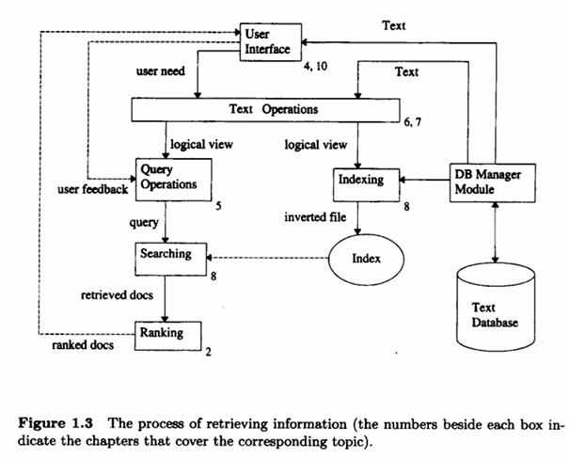
First of all, before the retrieval process can even be initiated, it is necessary to define the text database. This is usually done by the manager of the database, which specifies the following: (a) the documents to be used, (b) the operations to be performed on the text, and (c) the text model (i.e., the text structure and what elements can be retrieved). The text operations transform the original documents and generate a logical view of them.
Once the logical view of the documents is defined, the database manager (using the DB Manager Module) builds an index of the text. An index is a critical data structure because it allows fast searching over large volumes of data. Different index structures might be used, but the most popular one is the inverted file as indicated in Figure 1.3. The resources (time and storage space) spent on defining the text database and building the index are amortized by querying the retrieval system many times.
Given that the document database is indexed, the retrieval process can be initiated. The user first specifies a user need which is then parsed and transformed by the same text operations applied to the text. Then, query operations might be applied before the actual query, which provides a system representation for the user need, is generated. The query is then processed to obtain the retrieved documents. Fast query processing is made possible by the index structure previously built.
Before been sent to the user, the retrieved documents are ranked according to a likelihood of relevance. The user then examines the set of ranked documents in the search for useful information. At this point, he might pinpoint a subset of the documents seen as definitely of interest and initiate a user feedback cycle. In such a cycle, the system uses the documents selected by the user to change the query formulation. Hopefully, this modified query is a better representation of the real user need.

MODELING

2.1 Introduction
Traditional information retrieval systems usually adopt index terms to index and retrieve documents. In a restricted sense, an index term is a keyword (or group of related words) which has some meaning of its own (i.e., which usually has the semantics of a noun). In its more general form, an index term is simply any word which appears in the text of a document in the collection.
Retrieval based on index terms is simple but raises key questions regarding the information retrieval task. For instance, retrieval using index terms adopts as a fundamental foundation the idea that the semantics of the documents and of the user information need can be naturally expressed through sets of index terms. Clearly, this is a considerable oversimplification of the problem because a lot of the semantics in a document or user request is lost when we replace its text with a set of words. Furthermore, matching between each document and the user request is attempted in this very imprecise space of index terms. Thus, it is no surprise that the documents retrieved in response to a user request expressed as a set of keywords are frequently irrelevant.
Clearly, one central problem regarding information retrieval systems is the issue of predicting which documents are relevant and which are not. Such a decision is usually dependent on a ranking algorithm which attempts to establish a simple ordering of the documents retrieved. Documents appearing at the top of this ordering are considered to be more likely to be relevant. Thus, ranking algorithms are at the core of information retrieval systems.
A ranking algorithm operates according to basic premises regarding the notion of document relevance. Distinct sets of premises (regarding document relevance) yield distinct information retrieval models. The IR model adopted determines the predictions of what is relevant and what is not (i.e., the notion of relevance implemented by the system).

2.2 A Taxonomy of Information Retrieval Models
The three classic models in information retrieval are called Boolean, vector, and probabilistic. In the Boolean model, documents and queries are represented as sets of index terms. Thus, we say that the model is set theoretic. In the vector model, documents and queries are represented as vectors in a t-dimensional space. Thus, we say that the model is algebraic. In the probabilistic model, the framework for modeling document and query representations is based on probability theory. Thus, as the name indicates, we say that the model is probabilistic.

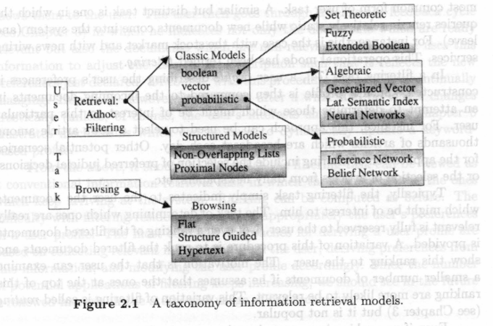
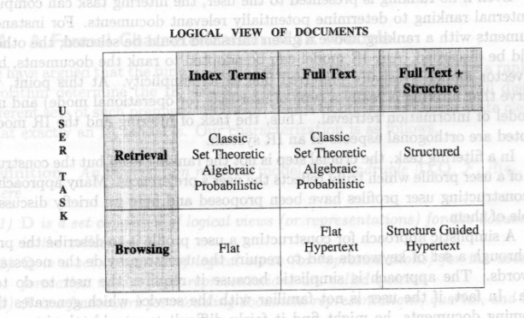
2.3 Retrieval: Ad hoc and Filtering

In a conventional information retrieval system, the documents in the collection remain relatively static while new queries are submitted to the system. This operational mode has been termed ad hoc retrieval in recent years and is the most common form of user task. A similar but distinct task is one in which the queries remain relatively static while new documents come into the system (and leave). For instance, this is the case with the stock market and with news wiring services. This operational mode has been termed filtering.
Example:
- Imagine an online library:
The collection includes 10,000 books (unchanging). Different students search things like:
  - “Quantum mechanics introduction”
  - “History of India”
  - “Data mining in healthcare”
The documents don’t change; the queries change.This is called ad hoc retrieval, the most common IR scenario

- Think of a news recommendation app:
A user sets their interest to "Artificial Intelligence".
Every day, hundreds of new articles are published.
The app automatically filters and recommends AI-related articles.
The query stays the same (user interest), and documents are dynamic.This is called filtering
Filtering is an IR task where new documents are matched against a fixed user profile.The system checks: “Is this new document likely to interest the user?”
How It Works:
- User Profile is created (based on user interests/preferences).
- New documents keep arriving (e.g., news, emails).
- The system compares incoming documents with the profile.
- Relevant documents are selected and shown to the user.
Ranking in Filtering:
- Normally, filtered documents are not ranked.
- In some systems, documents are ranked to make it easier for the user — this is called routing (but it's not widely used).
- Internally, the system may still rank documents and discard low-ranking ones.
Building the User Profile:
Two main ways:
- Manual Keywords (Simple):
User types keywords (e.g., “sports, politics”).
Problem: Too much effort, not accurate if user is unfamiliar with terms.
- Dynamic Feedback (Better):
User starts with a few keywords.
System shows matching documents.
User gives feedback (relevant / not relevant).
System updates the profile based on this.
Profile improves over time as system learns preferences.
2.4 A Formal Characterization of IR Models
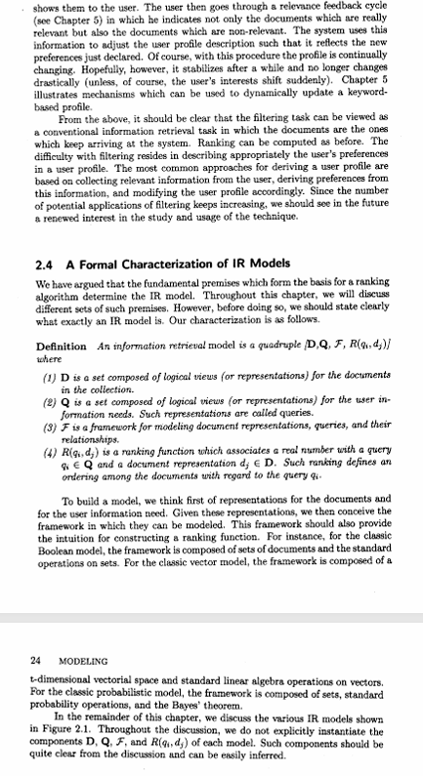

2.5 Classic Information Retrieval
2.5.1 Basic Concepts
The classic models in information retrieval consider that each document is described by a set of representative keywords called index terms. An index term is simply a (document) word whose semantics helps in remembering the document's main themes. Thus, index terms are used to index and summarize the document contents. In general, index terms are mainly nouns because nouns have meaning by themselves and thus, their semantics is easier to identify and to grasp.
Given a set of index terms for a document, we notice that not all terms are equally useful for describing the document contents. In fact, there are index terms which are simply vaguer than others. Deciding on the importance of a term for summarizing the contents of a document is not a trivial issue. Despite this difficulty, there are properties of an index term which are easily measured and which are useful for evaluating the potential of a term as such.
For instance, consider a collection with a hundred thousand documents. A word which appears in each of the one hundred thousand documents is completely useless as an index term because it does not tell us anything about which documents the user might be interested in. On the other hand, a word which appears in just five documents is quite useful because it narrows down considerably the space of documents which might be of interest to the user. Thus, it should be clear that distinct index terms have varying relevance when used to describe document contents. This effect is captured through the assignment of numerical weights to each index term of a document.
Document Representation with Index Terms
- Imagine you have a collection of documents and a list of all possible keywords or index terms that can describe those documents. Let’s say we have t index terms: K = {k₁, k₂, ..., kₜ}.Each document dⱼ is represented as a vector of weights: dⱼ = (w₁ⱼ, w₂ⱼ, ..., wₜⱼ)
where wᵢⱼ is a number ≥ 0 that tells how important term kᵢ is for document dⱼ.
- If a term does not appear in the document, its weight is 0.
Weight Function
- There's a function gᵢ(dⱼ) that gives the weight wᵢⱼ for term kᵢ in document dⱼ.
Mutual Independence Assumption
- In most systems, it's assumed that the weights for different index terms are independent. That is, knowing how important "computer" is for a document doesn’t tell you anything about how important "network" is for that same document.This assumption is made even though it’s not always realistic, because:
  - Terms like "computer" and "network" often occur together in topics like “computer networks.”
  - So their presence and importance are correlated in real usage.
Even though terms can be correlated, modeling these correlations is complex and computationally expensive.Most research shows that accounting for term correlation doesn’t consistently improve retrieval performance for general document collections.So, for simplicity and efficiency, systems usually assume independence unless stated otherwise.
2.5.2 Boolean Model
The Boolean model is a simple retrieval model based on set theory and Boolean algebra. Since the concept of a set is quite intuitive, the Boolean model provides a framework which is easy to grasp by a common user of an IR system. Furthermore, the queries are specified as Boolean expressions which have precise semantics. Given its inherent simplicity and neat formalism, the Boolean model received great attention in past years.
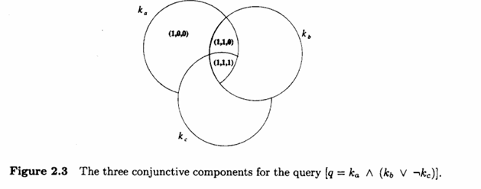

Drawbacks:
First, its retrieval strategy is based on a binary decision criterion (ie., a document is predicted to be either relevant or non-relevant) without any notion of a grading scale, which prevents good retrieval performance. Thus, the Boolean model is in reality much more a data (instead of information) retrieval model.
Second, while Boolean expressions have precise semantics, frequently it is not simple to translate an information need into a Boolean expression. In fact, most users find it difficult and awkward to express their query requests in terms of Boolean expressions.
Despite these drawbacks, the Boolean model is still the dominant model with commercial document database systems and provides a good starting point for those new to the field.
The Boolean model considers that index terms are present or absent in a document. As a result, the index term weights are assumed to be all binary, i.e., WE (0,1). A query q is composed of index terms linked by three connectives: not, and, or Thus, a query is essentially a conventional Boolean expression which can be represented as a disjunction of conjunctive vectors (ie., in disjunctive normal form DNF).
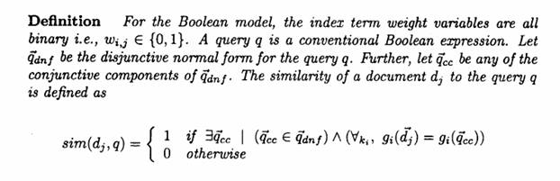
If sim(dj,q)=1 then the Boolean model predicts that the document d, is relevant to the query q (it might not be). Otherwise, the prediction is that the document is not relevant.
The Boolean model predicts that each document is either relevant or non- relevant. There is no notion of a partial match to the query conditions.
The main advantages of the Boolean model are the clean formalism behind the model and its simplicity. The main disadvantages are that exact matching may lead to retrieval of too few or too many documents.

Problems:
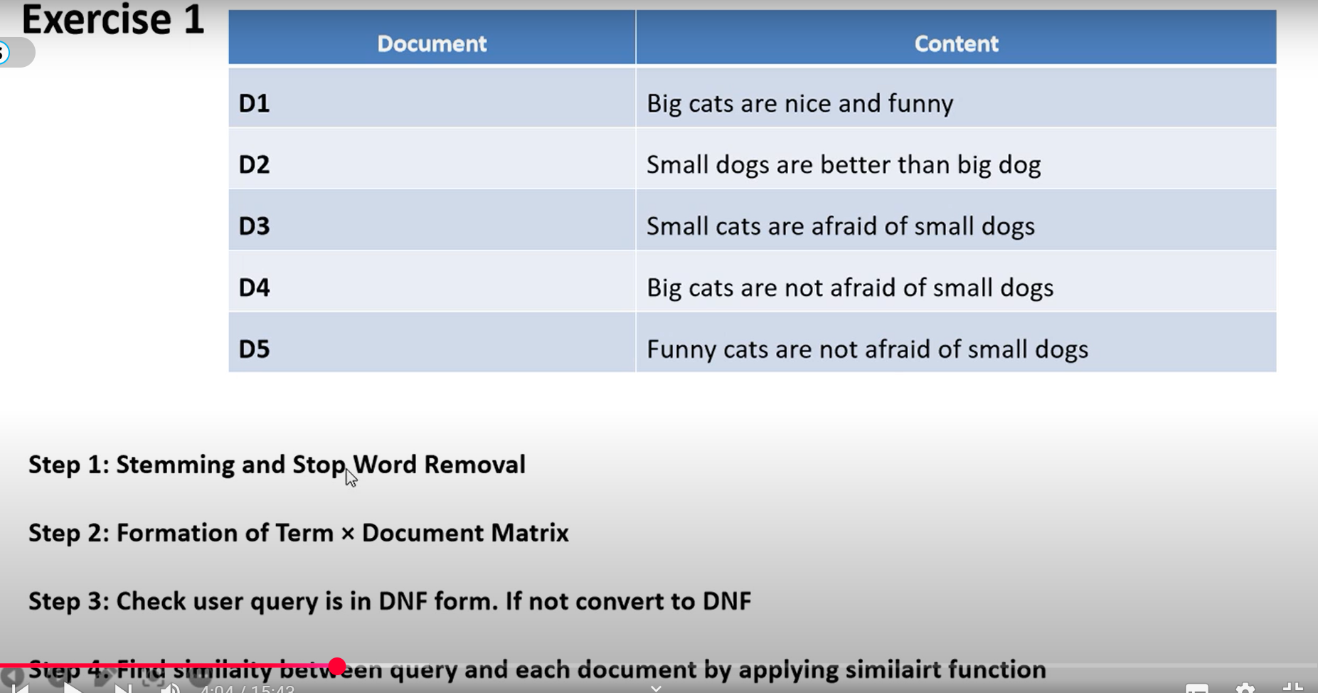
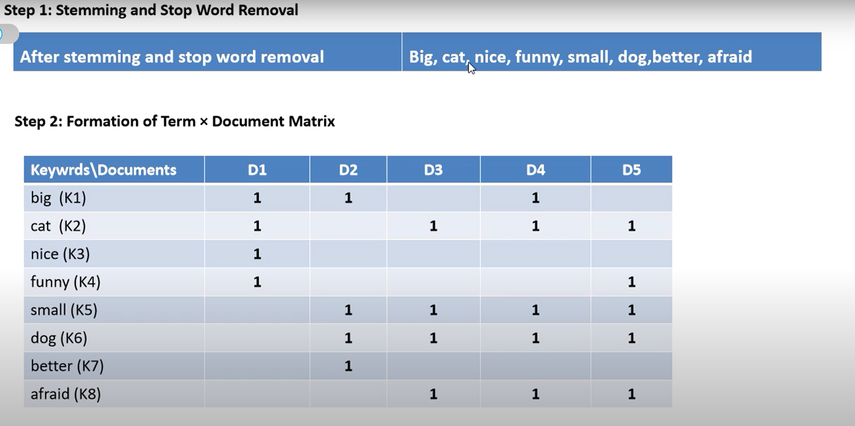
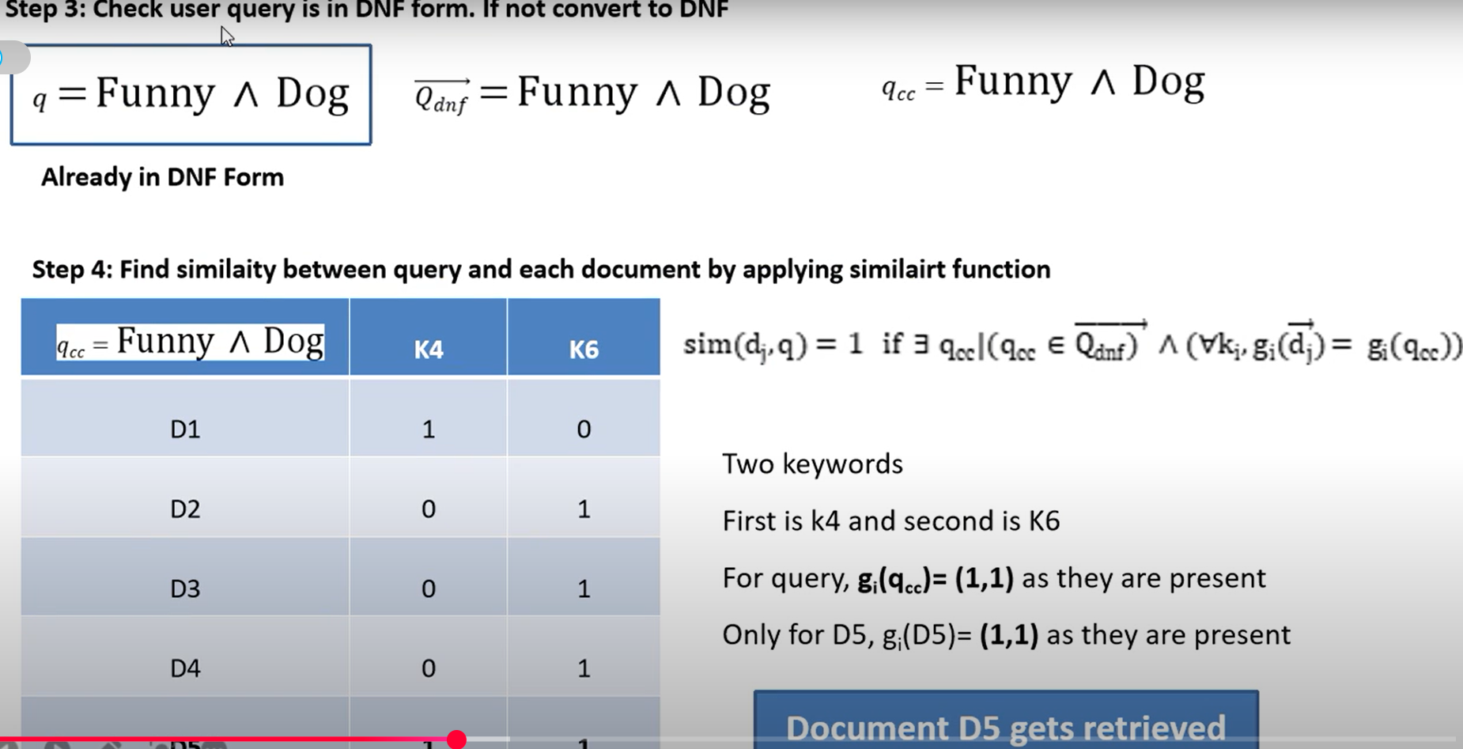
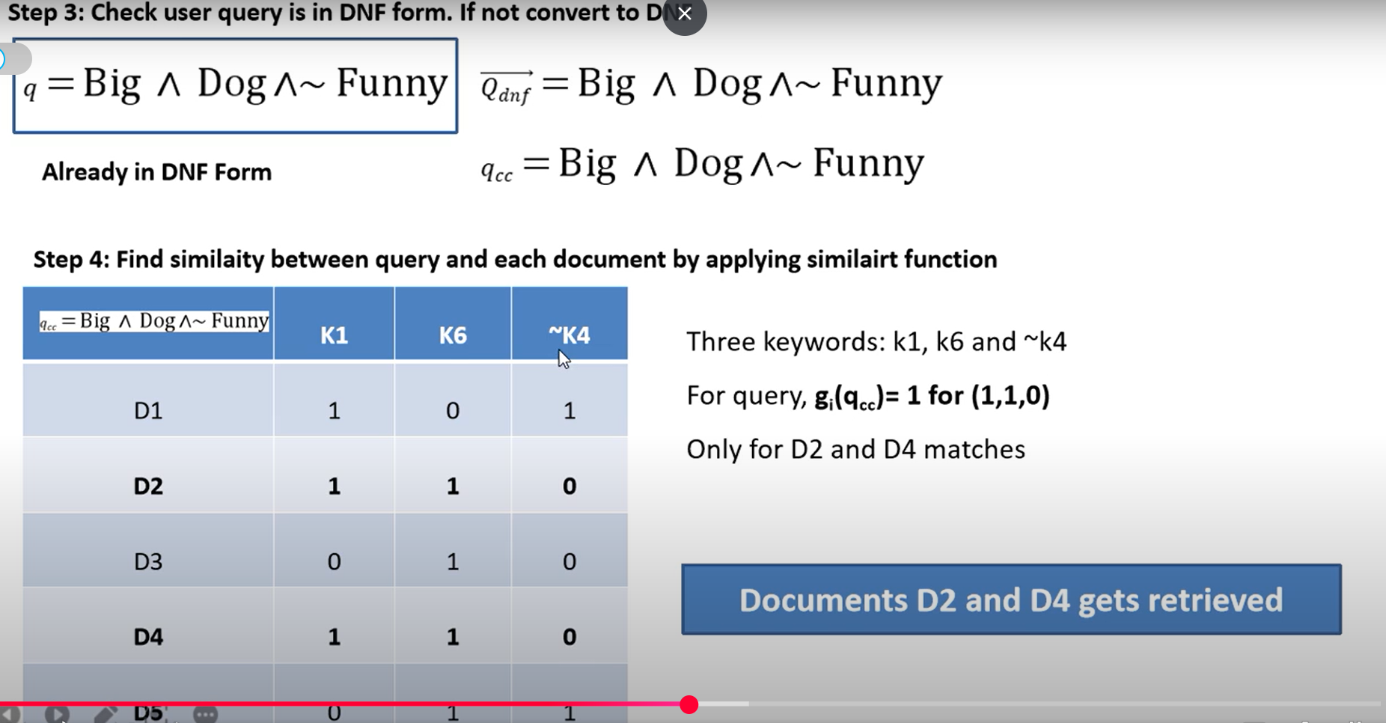
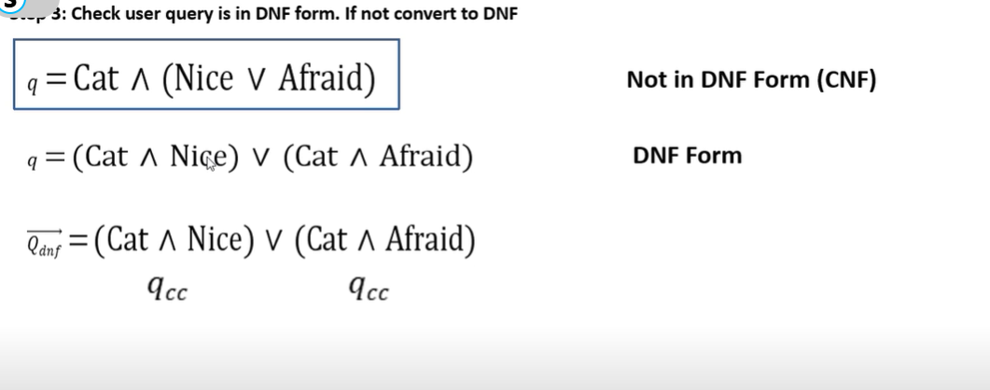
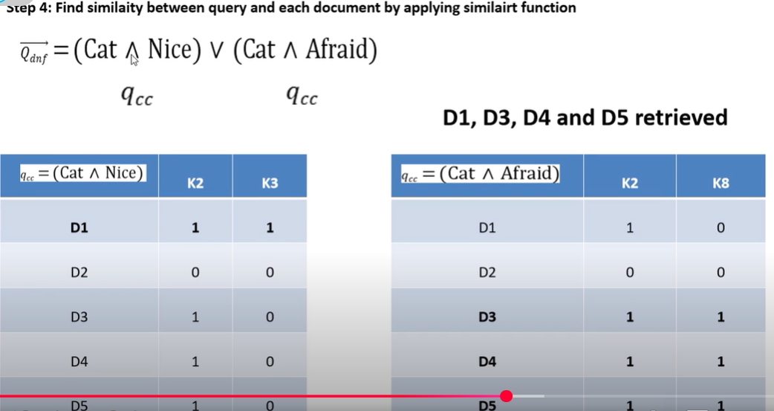
2.5.3 Vector Model
The Vector Space Model is a retrieval model that improves on the Boolean model by introducing the concept of partial matching and ranking of documents based on relevance. Instead of relying on binary presence or absence of terms, it uses weighted terms to represent documents and queries in a multi-dimensional vector space.Each document and query is represented as a vector in a high-dimensional space.Each dimension corresponds to a unique term (word) in the system.Term weights are non-binary (≥ 0), allowing degrees of importance.
The similarity between the document and query vectors determines relevance.
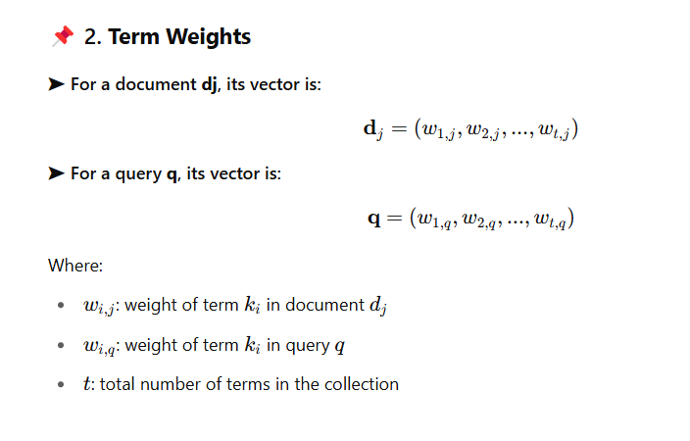
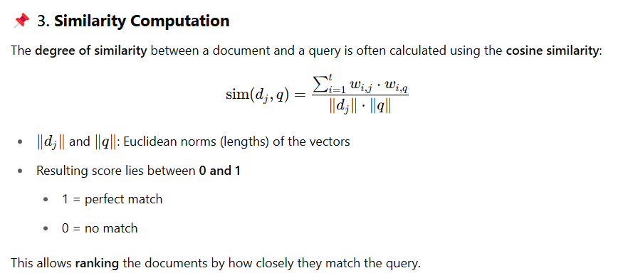
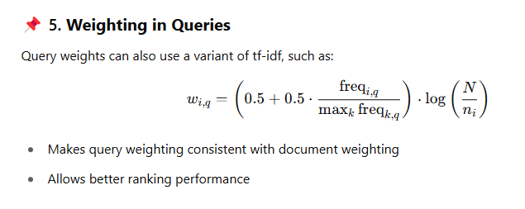
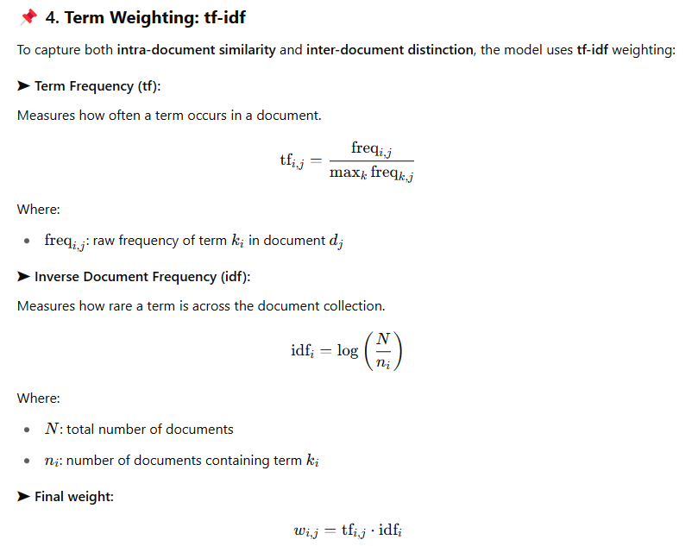
Clustering Analogy: The vector model aligns with clustering concepts:
- Documents = data points
- Query = vague description of a class
- The goal is to separate documents into relevant and non-relevant clusters
Effective weighting helps maximize: Intra-cluster similarity (documents like the query) ,Inter-cluster dissimilarity (documents unlike the query)
Advantages :Supports partial matching, Allows ranking of results, Term weighting (especially tf-idf) boosts performance, Fast and simple implementation, Widely used in modern IR systems
Disadvantages :Assumes term independence (terms don’t influence each other), Doesn’t model deeper semantic relationships between terms, Needs careful weight tuning, Sensitive to high-frequency/common terms (though tf-idf helps)
Practical Impact : Still a standard in search engine design and document ranking. Forms the foundation for more advanced models (e.g., BM25, neural embeddings). Highly adaptable with relevance feedback and query expansion techniques.
Problems :
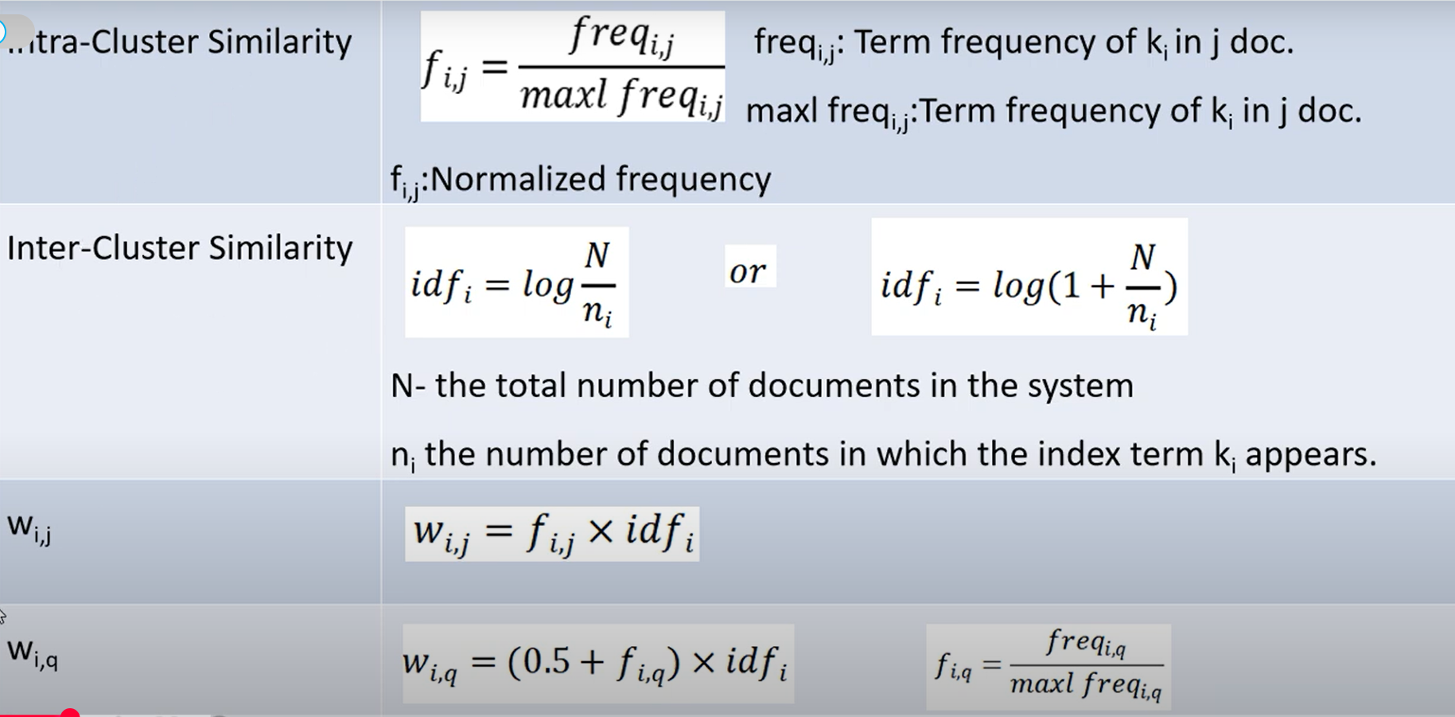
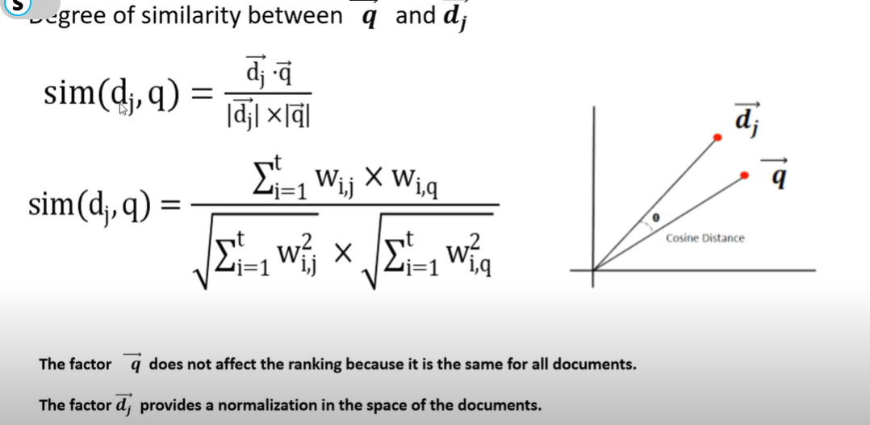
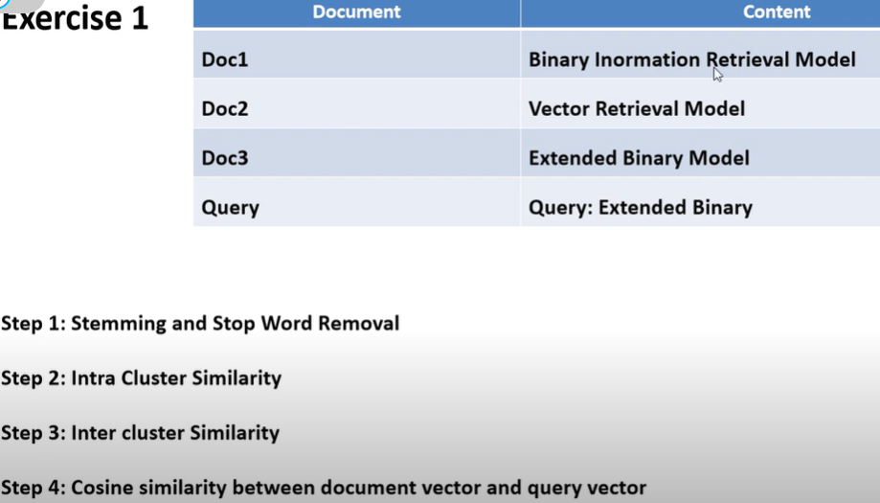
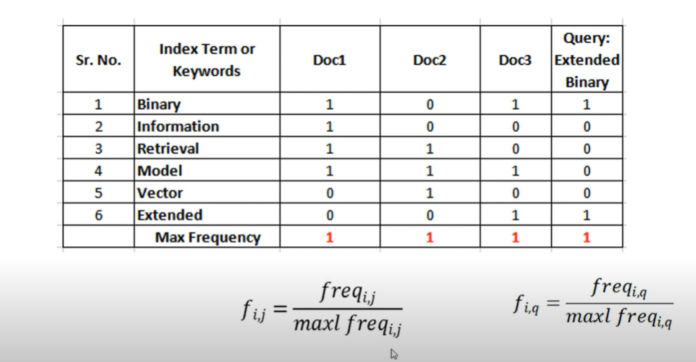
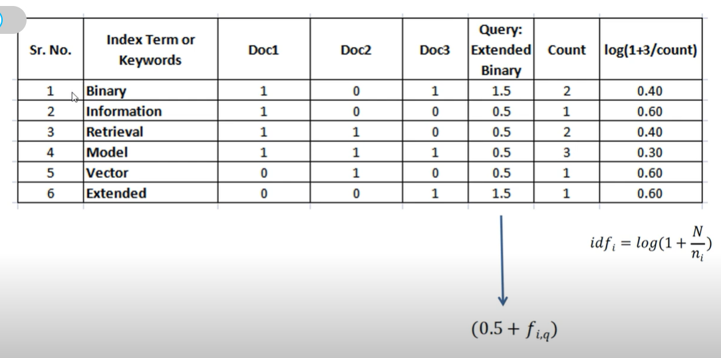
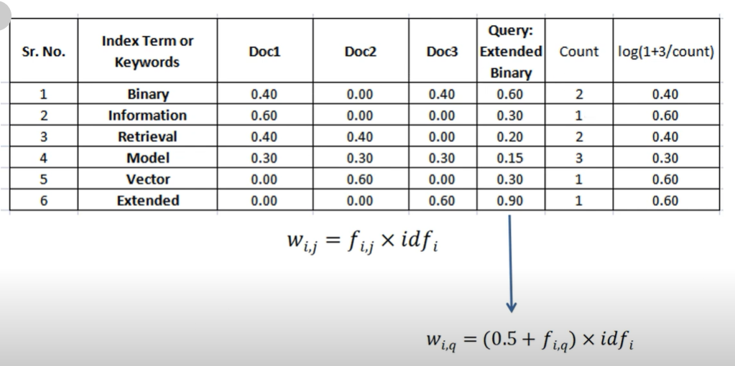
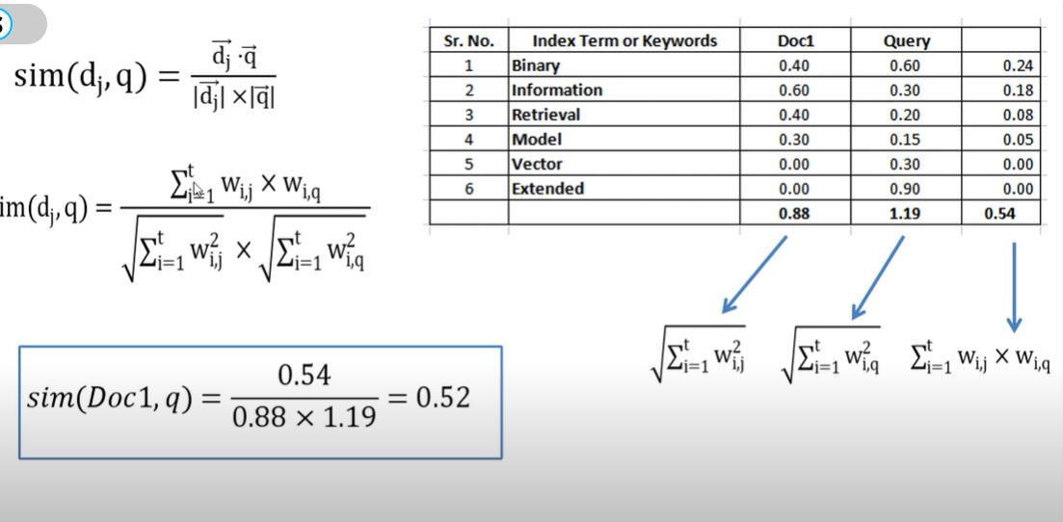
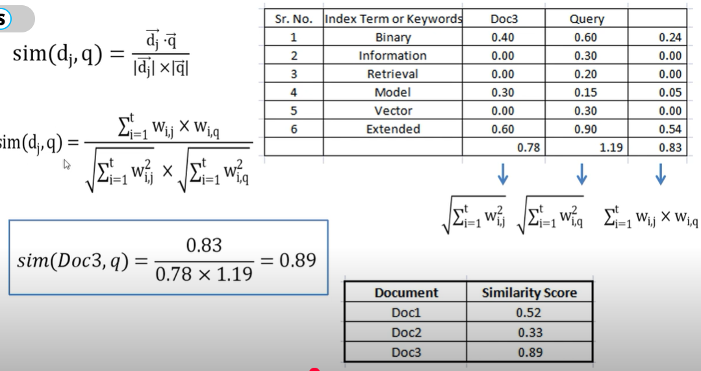

2.5.4 Probabilistic Model
The Probabilistic Model (also known as the Binary Independence Retrieval (BIR) model) views information retrieval as a probability estimation task: given a query, it tries to rank documents based on the probability that each document is relevant to the user.
Key Idea:
- Imagine an ideal answer set that contains all and only the relevant documents.
- Since we don’t know exactly which documents belong to this ideal set, the system guesses initially and updates its guesses based on user feedback or estimated statistics.
- The system ranks documents by calculating the odds ratio:
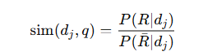
where P(R∣dj) is the probability that document dj​ is relevant, and P(Rˉ∣dj​) is the probability it's not relevant.
Assumptions:
- Index term weights are binary (either 0 or 1): terms are either present or absent.
- Terms are independent (no term influences the presence of another).
- Initially, assume:
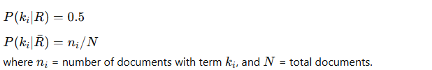
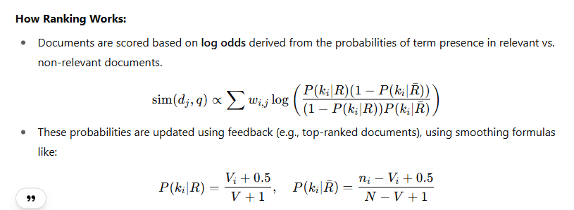
Advantages:Theoretically optimal: ranks documents by likelihood of relevance. Allows feedback to refine results over time.
Disadvantages:Initial guess of relevance is needed.Term frequencies are ignored (just binary presence).Assumes independence between terms (which might not reflect reality).

2.5.5 Brief Comparison of Classic Models
In general, the Boolean model is considered to be the weakest classic method. Its main problem is the inability to recognize partial matches which frequently leads to poor performance. There is some controversy as to whether the probabilistic model outperforms the vector model. Croft performed some experiments and suggested that the probabilistic model provides a better retrieval performance. However, experiments done afterwards by Salton and Buckley refute that claim. Through several different measures, Salton and Buckley showed that the vector model is expected to outperform the probabilistic model with general collections. This also seems to be the dominant thought among researchers, practitioners, and the Web community, where the popularity of the vector model runs high.
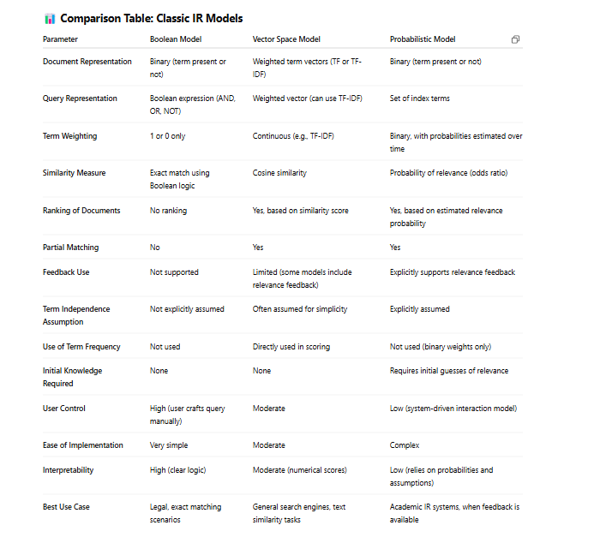

2.6 Alternative Set Theoretic Model
2.6.1Fuzzy Set Model
Traditional set-theoretic models (like Boolean retrieval) treat document-term relationships as binary — a document either contains a term or it doesn't. This rigid boundary often fails to capture the real semantic similarities between queries and documents. The fuzzy set model resolves this by allowing degrees of membership, i.e., partial matches.
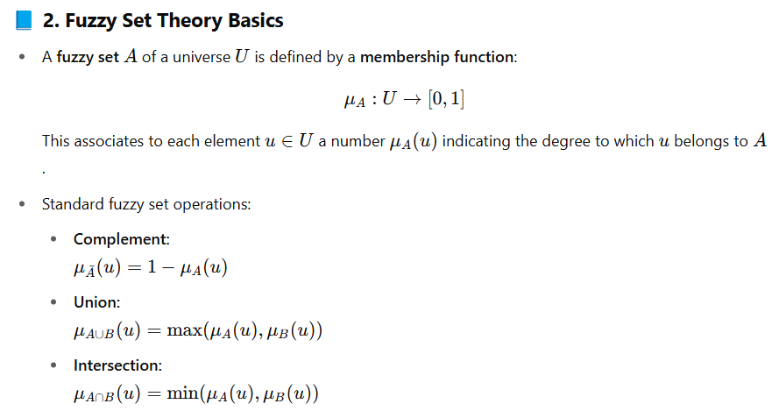
Fuzzy Information Retrieval (FIR):A document is a fuzzy set over the universe of index terms, and queries define fuzzy sets of terms. FIR allows for gradual relevance instead of binary decisions.
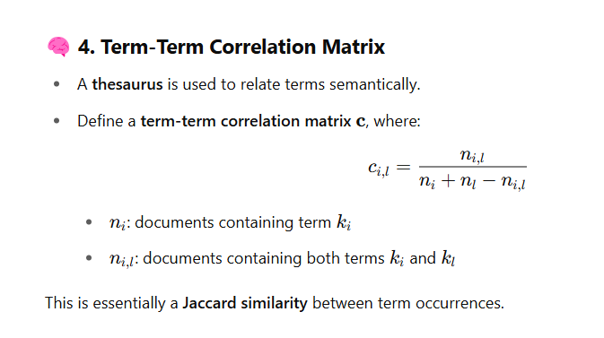
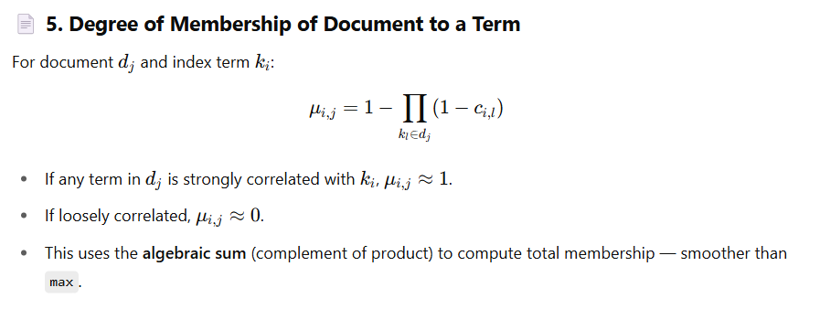
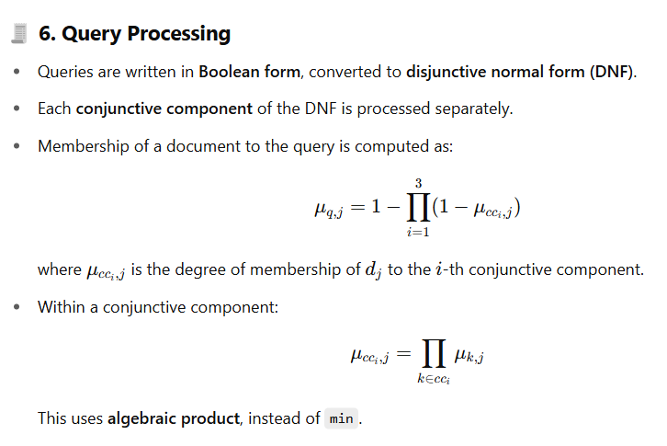
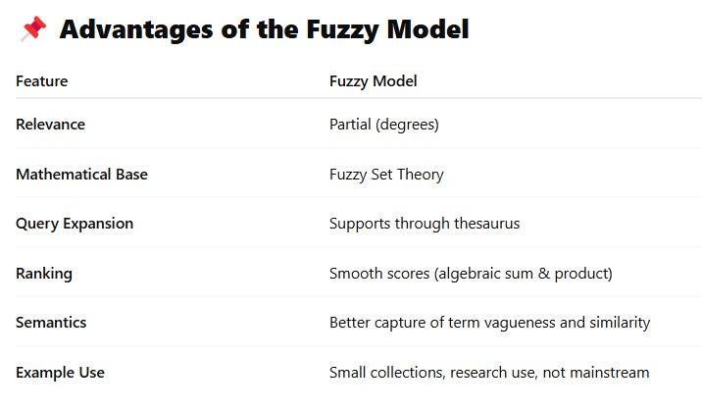
Limitations
- Computationally more intensive.
- Less popular in real-world systems.
- Mostly tested on small datasets.
- Limited by the quality of the thesaurus.

2.6.2 Extended Boolean Model
Traditional Boolean retrieval:
  - Simple & elegant.
  - Lacks term weighting and ranking.
  - Result set may be too large (low precision) or empty (low recall).
Extended Boolean Model (Salton, Fox, and Wu, 1983):
  - Combines Boolean logic with the vector space model.
  - Introduces partial matching and term weights.
  - Aims to preserve the structure of Boolean queries while enabling ranked retrieval.
  - Partial Matching:Documents no longer either fully match or completely fail the query.A document partially satisfying the query can still be considered relevant to a degree.
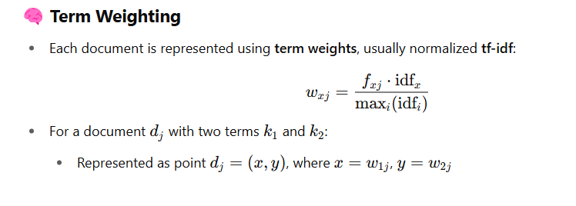
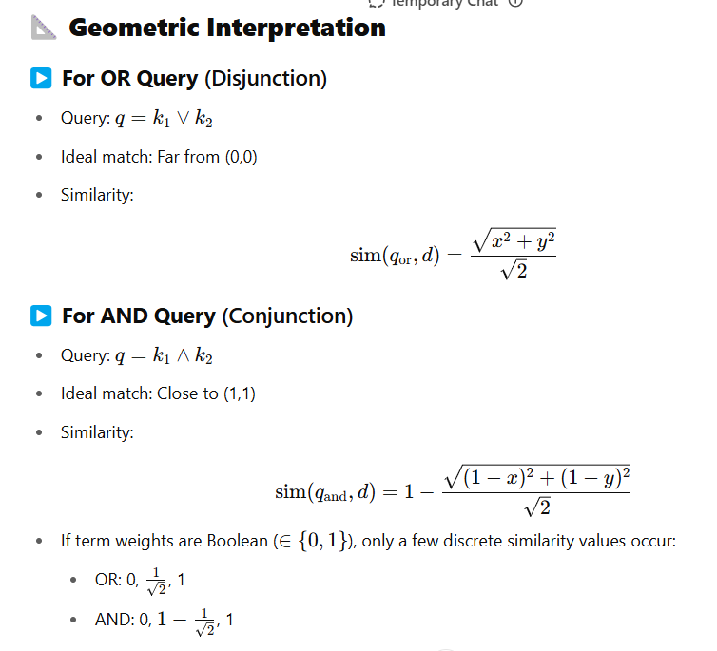
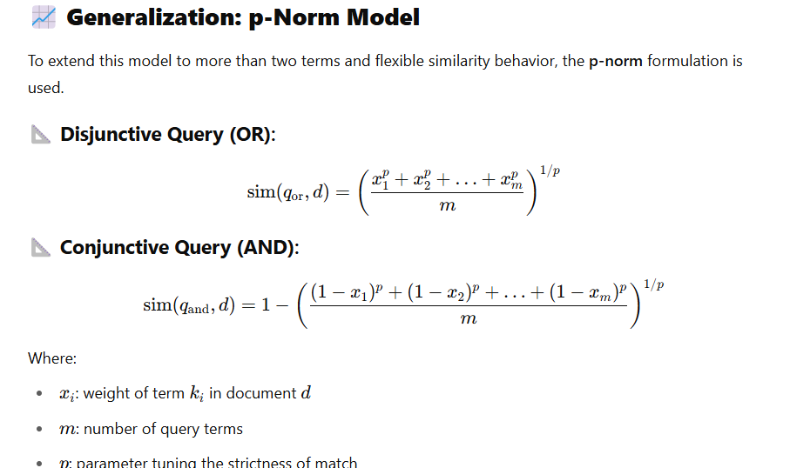
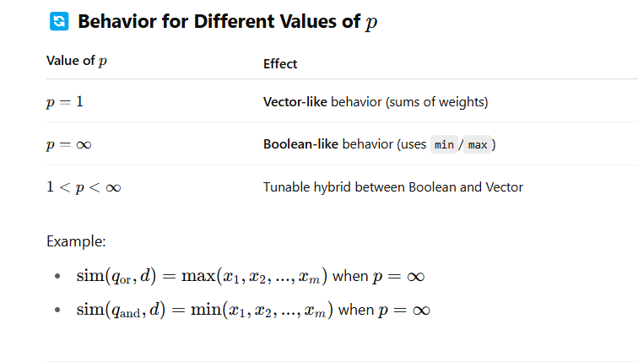
Query Nesting and Mixed Operators
- Nested queries like (k1∧k2)∨k3(k_1 \land k_2) \lor k_3(k1​∧k2​)∨k3​ are evaluated in predefined order, recursively applying the similarity functions.
- You can even assign different p-values for different subqueries to mix behavior:
  - E.g., use p=2 for one part (vector-like), and p=∞p=\inftyp=∞ for another (Boolean-like).

2.7 Alternative Algebraic Models
2.7.1 Generalized Vector Space Model
In the classical vector space model (VSM):Documents and queries are represented as vectors in a high-dimensional space.Each dimension corresponds to a term (keyword).A term is independent of all other terms.The term vectors are orthogonal (i.e., dot product = 0) and form a basis of the vector space.Relevance is computed via cosine similarity.
Limitation: It assumes independence among terms (e.g., "car" and "automobile" are unrelated), which is unrealistic.
The GVSM, introduced by Wong, Ziarko, and Wong in 1985, addresses this flawed independence assumption by:
- Allowing dependencies (correlations) among terms.
- Terms are not orthogonal.
- Incorporates co-occurrence patterns of terms in documents.
Concept of Minterms in GVSM:A minterm is a binary pattern that shows which terms are present in a document.For example, with 3 terms {k₁, k₂, k₃}, the minterms could be:
- m₁ = (0, 0, 0) → no terms present
- m₂ = (1, 0, 0) → only k₁ present
added
- m₈ = (1, 1, 1) → all terms present
There are 2^t minterms for t terms. But not all minterms are active — only those that match real documents are used.
Minterm Vectors as New Basis
- Each minterm is represented by a vector mᵢ (orthogonal to others).
- These vectors form a new orthonormal basis for the vector space.
- Index term vectors (like k₁) are then defined as a combination of the minterm vectors where that term appears
This shifts the model from viewing documents as combinations of terms, to viewing them as combinations of term occurrence patterns.
Computing Index Term Vectors
Each term vector kᵢ is calculated as:
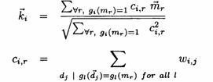
Where:
- gᵢ(mᵣ) = 1 means term kᵢ is present in minterm mᵣ.
- cᵢ,ᵣ is the correlation factor, which sums the weights of documents that exactly match minterm mᵣ.
Result: Each term vector is composed of multiple minterm vectors, and therefore is not orthogonal to others.
Term-Term Correlation
Now, because kᵢ • kⱼ ≠ 0, we can measure term-term correlations:
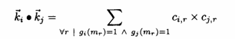
This allows us to quantify how closely related two terms are based on their co-occurrence patterns.
Document and Query Representation:Like in the classic model:
- Documents and queries are vectors (now built from minterm vectors, not just term vectors).
- Cosine similarity is still used for ranking.
But:Rankings now also consider term correlation information via cᵢ,ᵣ values.
✅ Pros:
- Captures semantic relationships among terms.
- Better modeling of real-world language use.
- Allows term correlation-based retrieval.
❌ Cons:
- Computationally expensive (needs to process all active minterms).
- May not always improve performance significantly.
- Complex to implement and optimize at scale.

2.7.2 Latent Semantic Indexing Model
Instead of matching words directly, LSI tries to match concepts.It does this by:
- Taking the term-document matrix (words vs. documents, with weights like tf–idf)
- Using Singular Value Decomposition (SVD) to find a reduced-dimensional space where terms and documents are represented by concepts rather than literal words.
The Math Skeleton
- t = number of terms (words in vocabulary)
- N = number of documents
- M = term-document matrix (size: t × N), where MijM_{ij} is the weight of term i in document j (e.g., tf–idf score).
SVD decomposes M into:
M=K S D^T
Where:
- K (t × r) → term-to-concept matrix (orthogonal eigenvectors of term correlation)
- S (r × r) → diagonal matrix of singular values (strength of each concept)
- D (N × r) → document-to-concept matrix (orthogonal eigenvectors of document correlation)
- r = rank of M (≤ min(t, N))
Dimensionality Reduction
We keep only the top s singular values (largest concepts), where s≪rs \ll r.
New approximation:

This reduced M_s is:
- Closest to the original M in least-squares sense
- Captures major concepts but filters noise (rare, unimportant variations in wording)
- Helps retrieve documents even if query words don’t appear exactly
Using LSI for Retrieval
- Represent the query as a pseudo-document in term space (vector of tf–idf weights).
- Project the query into the same concept space:
- Compute cosine similarity between qsq_s and all document vectors in concept space.
- Rank documents by similarity score.
This means:A doc can match the query because both relate to the same concept vector, even if they share no exact keywords.
Benefits
- Handles synonymy (different words, same meaning)
- Reduces noise from rare or irrelevant word patterns
- Works well when the same concept is expressed in multiple ways
Limitations
-Needs recomputation of SVD when new documents are added (costly)
-May over-generalize if s is too small (different topics get merged)
-Works best in moderate-sized collections — web-scale LSI is less common (word embeddings & transformers often replace it now)

2.7.3 Neural Networks
The goal here is to use a neural network (inspired by the brain) to rank documents for a given query — instead of only using traditional vector space models.
In IR, we:
- Have document vectors (representing documents using weights for each term).
- Have query vectors (representing the search query in the same space).
- Normally, we compute similarity (e.g., cosine similarity) to rank documents.
The chapter says: “Since neural networks are good at pattern matching, why not use them as an alternative model for IR?”
Biological Analogy
- Neuron = a processing unit.
  - Receives input signals.
  - Emits output signals (which go to other neurons).
- Signals pass through connections (synapses), each with a strength (weight).
- Signals can spread through multiple layers = spread activation process.
This is mapped into a graph model:
- Nodes = neurons (processing units).
- Edges = synaptic connections.
- Weight on an edge = strength of the connection.
- Activation level = how “excited” a node is, based on incoming signals and its own state.
3. Neural Network Structure for IR
The IR neural network has three layers:
- Query term nodes – activated directly when a search query is given.
- Document term nodes – represent the terms appearing in documents.
- Document nodes – represent the actual documents.
Signal flow:
- Phase 1: Query term nodes → Document term nodes → Document nodes
(activation spreads in the direction from query to document).
- Once document nodes are activated, they can send signals back (bidirectional links) to document term nodes — enabling repeated cycles.
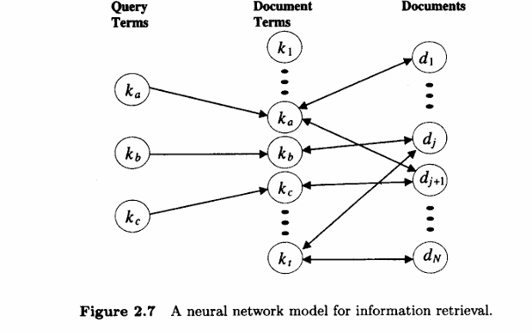
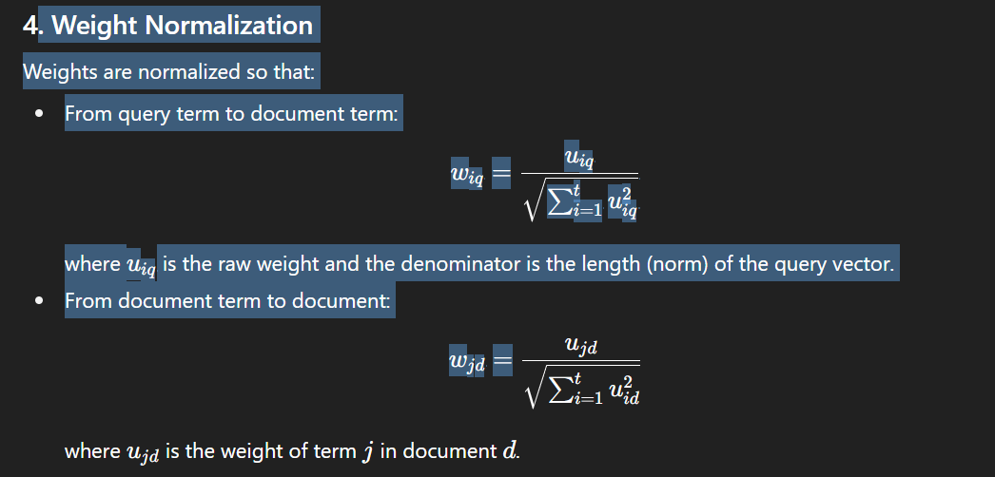
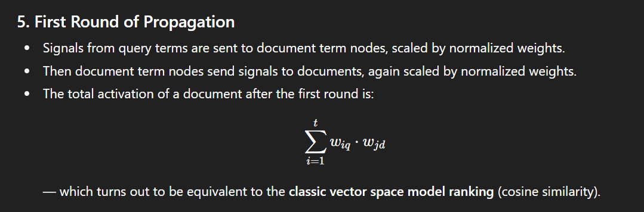
6. Spreading Activation Beyond First Round
Instead of stopping:
- Activated document nodes send signals back to document term nodes.
- Those document term nodes can then send signals to other documents.
- This allows retrieval of documents not directly matching query terms but connected via related terms — simulating a built-in thesaurus or relevance feedback.
A minimum activation threshold can be applied so that weakly activated documents stop spreading signals.

7. Pros & Limitations
Pros:
- Can retrieve related documents even if they don’t have query terms explicitly.
- Models term-document relationships more flexibly.
Limitations:
- No strong experimental proof that it’s better than classic models for large datasets.
- Complexity is higher.

