Project management:
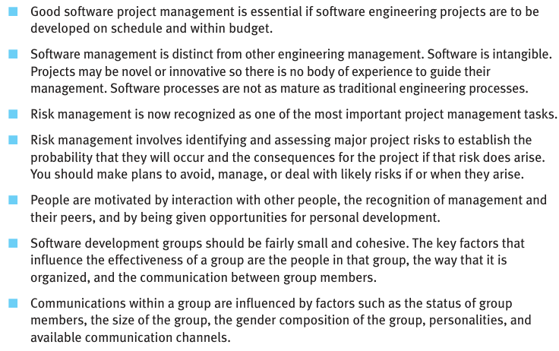
Explain why the intangibility of software systems poses special problems for software project management.
Ans:
• Software can’t be seen or touched, so it's hard to understand its progress.
• You can’t measure it physically, unlike hardware.
• Clients find it hard to know what they will get until the final product is ready.
• Mistakes are not visible easily, so they may go unnoticed for a long time.
• Progress is hard to track, since there's no physical output during development.
• It's difficult to estimate time and cost, because software is abstract.
• Testing is the only way to see if it works, which takes time and effort.
• Changes are invisible, so it's hard to know how much work is left after updates.

Explain why the best programmers do not always make the best software managers. You may find it helpful to base your answer on the list of management activities in Section 22.1.
Ans:
• Good programmers focus on coding, not on managing people or tasks.
• Managers need to plan projects, not write code.
• Programmers work alone, but managers must lead teams.
• Managers must communicate well, not just write efficient code.
• Managers solve people problems, not just technical ones.
• Managers track schedules and budgets, which coders may not enjoy.
• Programmers may prefer solving logic problems, not handling conflicts.
• A good manager needs patience and leadership, not just programming skills.
Using reported instances of project problems in the literature, list management difficulties and errors that occurred in these failed programming projects. (I suggest that you start with The Mythical Man Month, by Fred Brooks)
Ans:
• Poor time estimation caused deadlines to be missed.
• Lack of proper communication led to misunderstandings.
• No clear project goals confused the team.
• Managers ignored technical advice from developers.
• Tasks were not divided well, causing uneven workloads.
• Progress was measured by documents, not by working software.
• Too much focus on coding, not enough on planning and design.
• No backup plan for risks, which caused failure when things went wrong.
• False assumptions about productivity, thinking all programmers work the same way.
• Adding more people to a late project made it later.

In addition to the risks shown in Figure 22.1, identify at least six other possible risks that could arise in software projects
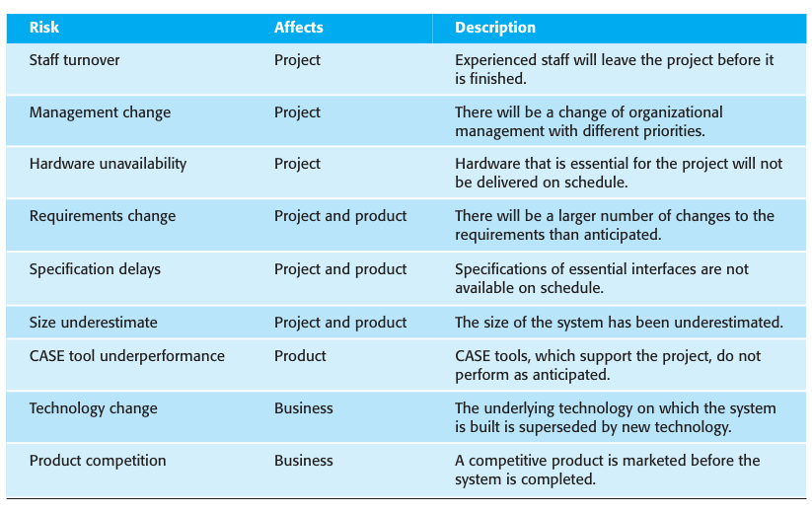

Fixed-price contracts, where the contractor bids a fixed price to complete a system development, may be used to move project risk from client to contractor. If anything goes wrong, the contractor has to pay. Suggest how the use of such contracts may increase the likelihood that product risks will arise
Ans:
• Contractors may rush the work to stay within budget.
• They may use low-quality methods to save time and cost.
• Less time is spent on testing, which increases bugs.
• Contractors avoid handling changes, even if they improve the product.
• Focus shifts to finishing cheaply, not building the best system.
• Important features may be skipped to meet deadlines.
• Poor communication with clients to avoid scope changes.

Explain why keeping all members of a group informed about progress and technical decisions in a project can improve group cohesiveness.
Ans:
• Everyone feels involved and part of the team.
• It builds trust among team members.
• Reduces misunderstandings and confusion.
• Helps everyone work toward the same goal.
• Makes communication easier and smoother.
• Team members support each other better.
• It avoids duplicate work and wasted effort.
• Encourages sharing of ideas and feedback.
• Keeps motivation high, as everyone knows the progress.
• Problems are solved faster, since all are aware of issues.

What problems do you think might arise in extreme programming teams where many management decisions are devolved to the team members?
Ans:
• Team may lack leadership, causing confusion.
• Decisions can take longer due to too many opinions.
• Conflicts may arise if members disagree.
• No one may take responsibility when things go wrong.
• Important tasks might be missed without clear planning.
• Focus may shift from goals to personal ideas.
• New or shy members may not speak up, leading to imbalance.
• Quality may suffer if there’s no strong decision-making.
• Lack of coordination can slow down progress.
• Risk of groupthink, where bad ideas are accepted to avoid conflict.

Write a case study in the style used here to illustrate the importance of communications in a project team. Assume that some team members work remotely and it is not possible to get the whole team together at short notice.
Case Study: Importance of Communication in a Remote Project Team
(Simple one-line points)
- A company started a software development project with 8 team members.
- Half of the team worked from the office, and the other half worked remotely.
- The team used emails and chat apps to stay in touch.
- At the beginning, there was no fixed schedule for meetings or updates.
- Remote members missed important design changes made during in-office discussions.
- One remote developer worked on outdated files for two weeks.
- This caused delays because their code no longer fit with the rest of the system.
- Another member misunderstood the client requirements due to a missed email.
- The team realized they needed a better way to communicate.
- They started using video calls twice a week to share updates.
- They created a shared document where all changes and decisions were recorded.
- A group chat was made for quick questions and replies.
- These steps helped everyone stay informed and reduced mistakes.
- The project got back on track and was finished on time.
- This case showed that clear, regular communication is very important—especially in remote teams.

You are asked by your manager to deliver software to a schedule that you know can only be met by asking your project team to work unpaid overtime. All team members have young children. Discuss whether you should accept this demand from your manager or whether you should persuade your team to give their time to the organization rather than to their families. What factors might be significant in your decision?
Ans:
Should You Accept the Manager’s Demand for Unpaid Overtime?
- No, you should not accept the demand without serious thought and discussion.

Reasons Not to Push Unpaid Overtime:
- Unethical – Asking people to work extra without pay is unfair, especially if it becomes expected.
- Family Impact – Your team has young children; taking away their family time can harm their personal life and well-being.
- Burnout Risk – Too much work and stress can lead to burnout, tiredness, or mistakes in the project.
- Long-Term Trust – Forcing unpaid overtime can reduce team morale and trust in leadership.
- Legal Issues – In some places, unpaid overtime can break labor laws.

Key Factors in Your Decision:
- Team’s health and family balance
- Legal and company policies on overtime
- Long-term team motivation and retention
- Quality of work under stress
- Possibility of a flexible or hybrid solution (e.g., voluntary paid overtime or bonus)

As a programmer, you are offered promotion to a project management position but you feel that you can make a more effective contribution in a technical rather than a managerial role. Discuss whether you should accept the promotion.
Ans:
Should You Accept the Promotion to Project Manager?
You should accept the promotion only if it matches your interests and strengths.
Reasons to Accept the Promotion:
- Career Growth – Project management may open doors to higher roles in the future.
- Leadership Opportunity – You can lead teams and make big decisions.
- Higher Salary – Usually comes with better pay and benefits.
- New Skills – You’ll learn planning, communication, and leadership skills.

Reasons to Stay in a Technical Role:
- Personal Interest – You enjoy coding and technical problem-solving more.
- Better Contribution – You feel your strengths are in building software, not managing people.
- Less Stress – Project management involves dealing with clients, deadlines, and team issues.
- Team Needs – Your technical skills may be more valuable to the current project.

Chapter 2
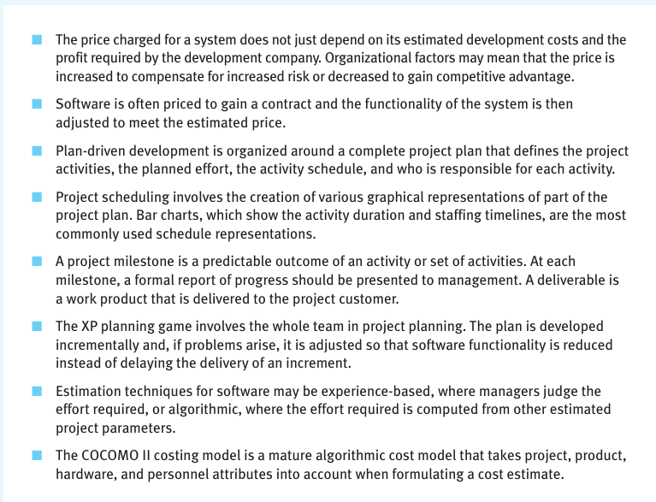
. Under what circumstances might a company justifiably charge a much higher price for a software system than the software cost estimate plus a reasonable profit margin?
Ans:
When Can a Company Charge Much Higher Price for Software?
- High Business Value – The software saves or earns the client a lot of money.
- Unique Solution – The software solves a rare or complex problem that no other product does.
- Urgent Delivery – The client needs the system very quickly, requiring extra effort or priority.
- High Risk Project – There is a lot of technical or business risk in developing the system.
- Long-Term Support – The price includes years of maintenance, updates, or 24/7 support.
- Strict Security or Legal Rules – The software must meet high safety, security, or legal standards.
- Customization – The system is tailored to the exact needs of the client, not reusable for others.
- Brand Reputation – The company is well-known for high-quality, trusted software.
- Licensing Rights – If the client gets full ownership or resale rights, the price increases.
Explain why the process of project planning is iterative and why a plan must be continually reviewed during a software project.
Ans:
Why Project Planning is Iterative and Needs Regular Review
- New information comes up – You learn more about the project as it progresses.
- Requirements may change – Clients or users may update their needs.
- Problems may arise – Technical or team issues can affect the schedule.
- Resources can change – Team members may leave or become unavailable.
- Estimates may be wrong – Time and cost guesses may need correction.
- Technology updates – New tools or updates may impact the plan.
- Progress tracking – You must check if the team is on track or falling behind.
- Risk management – Risks need to be watched and plans adjusted accordingly.

23.3. Briefly explain the purpose of each of the sections in a software project plan.
Ans:
• Introduction – Gives an overview of the project, goals, and who is involved.
• Project Organization – Describes the team structure and roles of each member.
• Risk Management – Lists possible risks and how the team will handle them.
• Project Schedule – Shows the timeline of tasks, deadlines, and milestones.
• Resource Allocation – Explains how people, tools, and budget will be used.
• Quality Plan – Describes how the team will ensure the software is correct and reliable.
• Validation Plan – Tells how the software will be tested to meet requirements.
• Configuration Management Plan – Explains how changes to code and documents will be tracked.
• Maintenance Plan – Outlines how the software will be supported after delivery.
• Documentation Plan – Lists what documents will be created (like manuals, reports, etc.).

Cost estimates are inherently risky, irrespective of the estimation technique used. Suggest four ways in which the risk in a cost estimate can be reduced.
Ans:
Here are four simple ways to reduce the risk in a cost estimate:
- Break the project into smaller tasks – Smaller parts are easier to estimate accurately.
- Use historical data – Base your estimates on data from similar past projects.
- Add a contingency buffer – Include extra time and cost to cover unexpected problems.
- Review and update estimates regularly – Adjust estimates as the project progresses and more is known.

23.5. Figure 23.14 sets out a number of tasks, their durations, and their dependencies. Draw a bar chart showing the project schedule.
Ans:
Figure 23.14 shows the task durations for software project activities. Assume that a serious, unanticipated setback occurs and instead of taking 10 days, task T5 takes 40 days. Draw up new bar charts showing how the project might be reorganized.
Ans:
The XP planning game is based around the notion of planning to implement the stories that represent the system requirements. Explain the potential problems with this approach when software has high performance or dependability requirements.
Ans:
Potential Problems:
- Stories focus on features, not system behavior
  - XP stories describe what the system should do, but may not capture non-functional needs like speed or reliability.
- Hard to plan performance early
  - High performance needs may require deep design decisions upfront, which XP avoids in early planning.
- Dependability needs detailed analysis
  - XP’s quick iterations may miss careful planning needed for safety, security, or fault tolerance.
- Performance and dependability may not be testable in small chunks
  - These qualities are often system-wide and can't be fully tested by just running a small story.
- Frequent changes may introduce risks
  - In highly dependable systems, even small changes can cause failures, but XP encourages frequent updates.

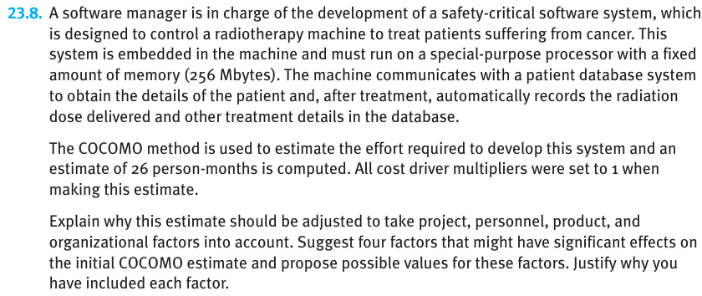
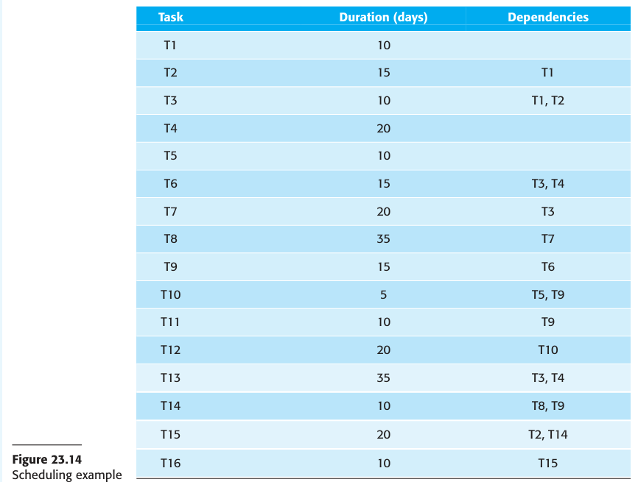
Some very large software projects involve writing millions of lines of code. Explain why the effort estimation models, such as COCOMO, might not work well when applied to very large systems.
Ans:
🔍 Why Estimation Models Like COCOMO May Fail for Very Large Projects
- Complexity Grows Faster Than Code Size
  - As code increases, managing dependencies and communication becomes harder.
- Changing Requirements Are Common
  - Large projects run for years, and user needs often change, making early estimates wrong.
- Unpredictable Integration Issues
  - Combining millions of lines of code can lead to unexpected bugs and delays.
- Limited Accuracy of Historical Data
  - COCOMO relies on past projects, but very large systems often have unique features.
- Human and Team Factors
  - More teams mean more coordination, delays, and misunderstandings.
- Tooling and Technology Changes
  - Tools or platforms used at the start may become outdated or replaced mid-project.
- Non-functional Requirements Add Hidden Work
  - Performance, security, and reliability needs are harder to estimate and test at large scales.

Is it ethical for a company to quote a low price for a software contract knowing that the requirements are ambiguous and that they can charge a high price for subsequent changes requested by the customer?
Ans:
⚖️ Is It Ethical? No. Here's Why:
- Dishonest Intent – It misleads the customer by hiding the true cost.
- Takes Advantage of Ambiguity – Exploiting unclear requirements for profit is unethical.
- Breaks Trust – Damages the client-company relationship and reputation.
- Violates Professional Standards – Goes against the principles of honesty and fairness in software engineering.
- Short-Term Gain, Long-Term Loss – May lead to legal disputes, lost clients, or bad publicity.

Agile software development:
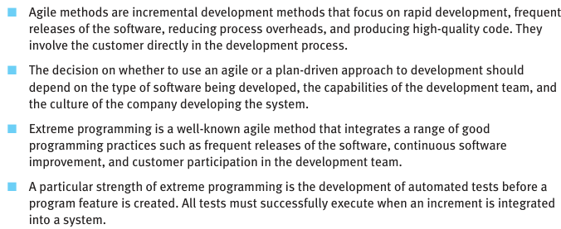
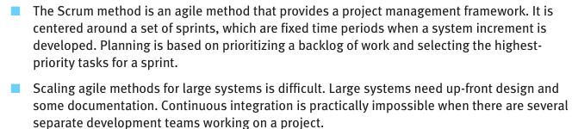
Explain why the rapid delivery and deployment of new systems is often more important to businesses than the detailed functionality of these systems.
Ans”
- Faster delivery means quicker use – Businesses can start using the system earlier.
- Early release gives competitive advantage – Being first in the market helps beat competitors.
- Helps solve urgent business problems – Quick systems fix issues that need fast action.
- Feedback can improve the system – Real users give input to shape future updates.
- Reduces risk of building unwanted features – Only useful features get added later.
- Saves time and cost upfront – No need to wait months or spend on unneeded features.
- Adapts to changing needs – Businesses can adjust as their goals change.

Explain how the principles underlying agile methods lead to the accelerated development and deployment of software.
Ans:
• Work is done in small parts – Makes it easier to build and deliver quickly.
• Focus on working software – Priority is on code that runs, not just documents.
• Regular feedback from users – Helps fix mistakes early and improve fast.
• Changes are welcome anytime – Team can adapt quickly to new needs.
• Daily team communication – Solves problems quickly through constant talk.
• Simple design and code – Avoids wasting time on unneeded complexity.
• Testing is done continuously – Bugs are caught early, saving time later.
• Fast delivery of usable software – Each version can be used and tested by users.

When would you recommend against the use of an agile method for developing a software system?
Ans:
- Requirements are very stable and fixed – No need for frequent changes.
- The system is safety-critical – Needs strong planning, documentation, and testing.
- Large team with no agile experience – Hard to manage without proper training.
- Customer is not available for regular feedback – Agile needs active user involvement.
- Strict government or legal rules apply – Requires full documents and approvals.
- Project involves many outside vendors – Coordination is hard in fast-changing environments.
- Company culture prefers detailed planning – Agile may not fit the management style.

Explain why test-first development helps the programmer to develop a better understanding of the system requirements. What are the potential difficulties with test-first development?
Ans:
✅ Why Test-First Development Helps:
- Forces clear thinking – Programmer must understand the requirement before writing a test.
- Focuses on expected behavior – Tests describe what the system should do.
- Catches mistakes early – Helps avoid wrong assumptions about requirements.
- Improves communication with users – Tests can be reviewed to confirm what users expect.
- Encourages small, testable features – Makes the system easier to build and understand.

❌ Potential Difficulties:
- Hard for unclear requirements – Writing tests is tough if needs are not fully known.
- Takes time upfront – Requires extra time before writing the actual code.
- Not suitable for UI or complex interactions – Some parts are hard to test first.
- Needs testing skills – Programmers must be good at writing meaningful tests.
- Frequent changes may break tests – If requirements change often, tests need constant updating.

Suggest four reasons why the productivity rate of programmers working as a pair might be more than half that of two programmers working individually.
Ans:
• Fewer mistakes – One catches errors while the other writes code, reducing bugs.
• Better focus – Working together keeps both more focused and less distracted.
• Shared knowledge – They help each other solve problems faster.
• Faster decisions – No need to wait for reviews or second opinions later.

Compare and contrast the Scrum approach to project management with conventional plan-based approaches, as discussed in Chapter 23. The comparisons should be based on the effectiveness of each approach for planning the allocation of people to projects, estimating the cost of projects, maintaining team cohesion, and managing changes in project team membership.?
Ans:
🔁 1. Planning the Allocation of People to Projects
- Scrum:
  - Uses small, self-organizing teams.
  - Team members often work on one project at a time.
  - Flexible in assigning roles based on sprint goals.
- Plan-Based:
  - Detailed resource planning done at the start.
  - People may be assigned to multiple projects.
  - Less flexibility in re-assigning roles mid-project.

💰 2. Estimating the Cost of Projects
- Scrum:
  - Uses story points and velocity to estimate effort.
  - Estimation is iterative and improves over time.
  - Hard to predict total cost upfront.
- Plan-Based:
  - Cost is estimated early using formal models.
  - More suitable when a fixed budget is needed.
  - Can be inaccurate if changes occur later.

🤝 3. Maintaining Team Cohesion
- Scrum:
  - Daily stand-ups, sprint reviews, and retrospectives build strong teamwork.
  - Focus on collaboration and communication.
  - Encourages shared ownership of tasks.
- Plan-Based:
  - Teams follow a hierarchical structure, with managers directing work.
  - Less focus on daily interaction.
  - Team cohesion may depend on the project manager’s leadership.

🔄 4. Managing Changes in Team Membership
- Scrum:
  - Team members are cross-functional, so others can cover missing roles.
  - Changes can affect team dynamics, but flexibility helps adapt.
  - New members may need time to adjust to Scrum practices.
- Plan-Based:
  - Well-documented roles and plans make handovers easier.
  - Less flexible in adapting roles quickly.
  - May require replanning or reassigning if someone leaves.
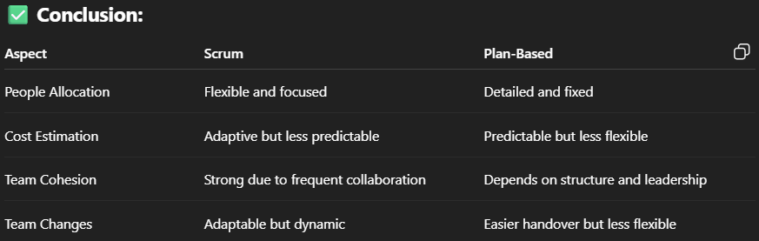

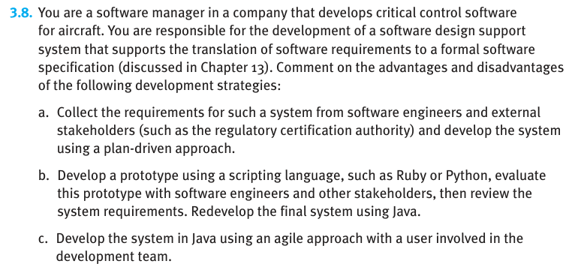Ans:
✅ (a) Plan-Driven Approach
Collect requirements upfront and build the system step by step.
Advantages:
- ✅ Clear documentation – Good for safety-critical systems needing certification.
- ✅ Well-structured process – Easy to track progress and manage risks.
- ✅ Predictable schedule and cost – Suitable when changes are not expected.
Disadvantages:
- ❌ Hard to handle changing needs – Poor flexibility if requirements change.
- ❌ Late user feedback – Errors in requirements might only be found during testing.
- ❌ Long time before usable product – No early working version for testing.

✅ (b) Prototype First, Then Redevelop in Java
Create a fast prototype in Python/Ruby, gather feedback, then build the final system in Java.
Advantages:
- ✅ Early feedback from users – Helps improve and refine requirements.
- ✅ Better understanding of system needs – Reduces misunderstandings.
- ✅ Faster initial development – Prototypes are quick to build and test.
Disadvantages:
- ❌ Extra effort needed – Time spent on both prototype and final system.
- ❌ May miss deeper design issues – Prototype might oversimplify real challenges.
- ❌ Rewriting can introduce new bugs – Final system still needs full testing.

✅ (c) Agile Development with User Involvement
Use Java directly, build in short cycles, with user always part of the team.
Advantages:
- ✅ Fast response to changes – Can adapt to new needs as they appear.
- ✅ Frequent testing and feedback – Bugs found and fixed early.
- ✅ Continuous user involvement – Helps build exactly what’s needed.
Disadvantages:
- ❌ Harder for formal certification – Less documentation and structure.
- ❌ Needs skilled and available users – User must stay engaged throughout.
- ❌ Can be hard to manage for safety-critical systems – Agile may skip heavy formal analysis.

3.9. It has been suggested that one of the problems of having a user closely involved with a software development team is that they ‘go native’; that is, they adopt the outlook of the development team and lose sight of the needs of their user colleagues. Suggest three ways how you might avoid this problem and discuss the advantages and disadvantages of each approach.
Ans:
✅ 1. Rotate Different Users into the Team Regularly
Idea: Don’t have just one user; involve different users at different stages of the project.
- Advantages:
✅ Brings fresh perspectives regularly.
✅ Reduces the chance of one user losing touch with real needs.
- Disadvantages:
❌ New users may need time to understand the project.
❌ May slow down development due to repeated onboarding.

✅ 2. Hold Frequent Reviews with External User Groups
Idea: Organize regular meetings with broader user groups not involved in daily development.
- Advantages:
✅ Keeps the team aware of the wider user needs.
✅ Ensures feedback from real-world scenarios.
- Disadvantages:
❌ Takes extra time and planning.
❌ Too much feedback might slow down progress.

✅ 3. Assign a User Advocate Role in the Team
Idea: Give someone (could be the original user or another team member) the responsibility to constantly speak for all users’ needs.
- Advantages:
✅ Keeps user needs in focus throughout development.
✅ Helps maintain balance between technical and user goals.
- Disadvantages:
❌ The "advocate" may still become biased over time.
❌ May lead to over-dependence on one person’s opinion.

3.10. To reduce costs and the environmental impact of commuting, your company decides to close a number of offices and to provide support for staff to work from home. However, the senior management who introduce the policy are unaware that software is developed using agile methods, which rely on close team working and pair programming. Discuss the difficulties that this new policy might cause and how you might get around these problems.
Ans:
❌ Difficulties Caused by Remote Work in Agile Teams
- Less face-to-face interaction – Makes quick discussions and teamwork harder.
- Pair programming is difficult – Sitting side-by-side is important in agile, now not possible.
- Daily stand-ups lose energy – Online meetings may feel less engaging or delayed.
- Harder to share ideas quickly – Whiteboards, sticky notes, and live collaboration are missed.
- Team spirit may reduce – Less bonding and informal chatting affects team cohesion.
✅ Ways to Solve These Problems
1. Use Online Tools for Collaboration
- Tools like Zoom, Microsoft Teams, Slack, and Jira can help teams communicate and track progress.
- Advantage: Keeps the team connected and informed.
- Disadvantage: May not fully replace in-person speed and clarity.
2. Use Remote Pair Programming Tools
- Tools like Visual Studio Live Share or Tuple allow two people to code together remotely.
- Advantage: Makes pair programming possible from home.
- Disadvantage: Needs good internet and can be tiring online.
3. Hold Daily Video Stand-ups
- Short video calls every morning to discuss work and blockers.
- Advantage: Maintains agile rhythm and team connection.
- Disadvantage: Less natural than standing together in one room.
4. Plan Weekly Team-Bonding Activities
- Virtual games, sharing sessions, or casual chats to maintain morale.
- Advantage: Keeps team spirit alive.
- Disadvantage: Needs time and planning.

Agile Coach – Short Notes for Exam
🧠 1. What is an Agile Coach?
- A person who helps teams adopt Agile methodologies effectively.
- Guides the team through the "how" and "why" of Agile practices.
- Supports overcoming mental, emotional, and technical barriers to Agile.

🔍 2. Why Agile Coaching is Needed
- Reading Agile values/principles is not enough — mindset shift is crucial.
- Some teams naturally align with Agile values → easy adoption.
- Other teams face barriers like:
  - Fear of change
  - Individual over team rewards
  - Punishment for mistakes
  - No customer/user interaction
  - Innovation stifled environments

🔄 4. Impact of an Agile Coach
- Prevents “just marginal improvement” by promoting real mindset change.
- Supports teams in achieving better-than-before outcomes by:
  - Choosing the right methodology (Scrum, XP, etc.)
  - Teaching Agile values and principles
  - Ensuring practices lead to mindset shift

Narrative: a team working on a mobile phone camera app at a company that was bought by a large Internet conglomerate Catherine – a developer Timothy – another developer Dan – their boss
Title: The Filter Fiasco
- A small team works on a camera app called SnapLyte.
- Their company was bought by a big tech giant, OmniCorp.
- Catherine, a developer, finds a bug—the filter turns skin green.
- Timothy jokes they should call it Alien Chic and pretend it’s a feature.
- Boss Dan rushes in—the CEO is demoing the app today.
- The team panics but can’t fix the green skin bug in time.
- During the demo, the app works perfectly—no green skin.
- But a new bug appears—random cat photos show up in the gallery.
- Surprisingly, people love the "glitch" and call it creative.
- OmniCorp praises the team, and the app becomes a hit.

✅ Why People Resist Change & Role of Agile Coaches – Summary
🔄 1. Why Change Feels Difficult
- Most people want to do their job well and fear losing comfort or failing at new tasks.
- Fear of job insecurity and emotional discomfort is common with change.
- Past success with current practices makes people reluctant to change.
- Teams often alter Agile practices to match what they already know, missing the real purpose.

🚫 2. Common Misuse of Agile Practices
- Daily Scrum becomes a status meeting (not self-organization).
- Teams add user stories to requirement docs but continue BRUF (Big Requirements Up Front).
- TDD (Test-Driven Development) is reduced to writing tests after code is written.

😟 3. Emotional Reaction to Change
- Fear: “If I don’t master this new way, I might lose my job.”
- Stress of deadlines + bugs + changes = no time to deeply learn new practices.
- Teams may keep Agile labels (e.g., Sprint, Task Board) but not change behavior → no real benefit.

👩‍🏫 4. Role of the Agile Coach
- Helps team members:
  - Understand the "why" behind the practice, not just the "what".
  - Feel safe and supported through change.
  - Adopt practices with their intended purpose, not just as names.
- Translates practices into clear, relatable language (e.g., how Scrum helps self-organization).
- Helps the team achieve true Agile transformation, not just cosmetic change.

✅ How People Learn Agile – Summary
🧠 1. Learning Agile = Learning a New Skill
- People learn agile not just by reading, but mostly by doing.
- When people start learning Agile, they want simple, rule-based guidance.
- Agile coaches must meet people where they are, not where the coach wants them to be.

🥋 2. The Shuhari Learning Model (from Martial Arts)
Used to explain how people progress in learning:
🔹 Shu (守) – "Follow the rule"
- Beginners want clear rules.
- Helps them get started with Agile (e.g., daily stand-up at 10:30 AM).
- Examples: using Scrum boards, doing sprints, answering 3 questions in Scrum.
🔹 Ha (破) – "Break the rule"
- Learners start to understand the principles behind the rules.
- Begin experimenting and adapting practices.
- Start to shift mindset and achieve true Agile gains, not just superficial ones.
🔹 Ri (離) – "Be the rule"
- Fully fluent with Agile values and principles.
- No longer tied to a named methodology (Scrum, XP, Kanban).
- Team does “whatever works” intuitively and efficiently.
- Process doesn’t need a label; the team simply delivers effectively.

⚠️ 3. Dangers of Agile Zealots
- Zealots stay stuck in Shu (rules-only mindset).
- They force one “correct” version of Agile without understanding team needs.
- Good coaches are not zealots – they help the team grow past Shu.

👩‍🏫 4. Role of the Agile Coach in Learning
- Identify the learning stage of each team member.
- Give rules to beginners (Shu), then help them understand principles (Ha).
- Eventually lead the team to independent fluency (Ri).
- Explain small decisions (like sticky notes vs. index cards) in a way that supports learning.

✅ What Makes a Methodology Work – Summary
🧠 1. Good Coaches See Teaching Moments
- A good Scrum Master spends time resolving problems.
- Not every problem is a teaching opportunity — but some are.
- A skilled coach can recognize a teaching moment by understanding why Scrum or XP practices exist, not just how to use them.

🔍 2. Example: Timeboxed Iteration and “Done Done”
- If incomplete work is allowed in sprints:
  - Iterations lose their meaning.
  - “Working software” (main Agile progress measure) is compromised.
  - Trust and collaboration between team and customer suffer.
  - Iterations become just milestones, not value-delivering cycles.

🧭 3. Coaches Know the Why, Not Just the What
- Scrum Coach knows: Self-organization, collective commitment.
- XP Coach knows: Embracing change, incremental design.
- Kanban Coach knows: WIP limits control flow—removing WIP limits breaks Kanban.
Without understanding the principles, practices fall apart.

💬 4. Letting Teams Fail (Sometimes)
- Letting a team fail in small ways can help them grow.
- Quoted advice from Lyssa Adkins:
“Don’t stand by as they crash—but do let them stumble and learn.”
- Retrospectives = key moments to learn from failure.

🧱 5. But Some Things Can’t Fail
- Some methodology rules are “supporting beams”:
  - Example: WIP limits in Kanban must not be removed.
- A coach with only shu-level knowledge may give in and break core rules.
- A good coach has ha-level understanding and knows what’s core vs. optional.

🔄 6. Shu vs Ha in Explaining Practices
- Shu-level explanation = Just follow the rules (e.g., “Use daily stand-ups”).
- Ha-level understanding = Explains why the practice works (e.g., “Daily stand-ups help self-organization and transparency”).
- The coach’s job is to help the team move from Shu to Ha, at a pace they’re ready for.

✅ The Principles of Coaching – Summary
Agile is not just about practices—it's about mindset, built on values and principles. Similarly, agile coaching also requires a foundational mindset. Legendary basketball coach John Wooden laid out 5 timeless coaching principles that apply powerfully to agile coaching too:

🛠️ 1. Industriousness (Hard Work)
- Agile brings new responsibilities:
  - Developers must plan and test, not just code.
  - Product Owners must understand development, not just assign features.
  - Scrum Masters must guide without controlling.
- Learning these new roles takes consistent, serious effort.

🔥 2. Enthusiasm
- Genuine excitement for agile spreads to the team.
- Positivity builds energy, motivation, innovation, and team harmony.
- An enthusiastic coach inspires belief in new ways of working.

🏋️‍♂️ 3. Condition (Skill & Pride in Work)
- Agile assumes that everyone is competent and improving.
- Teams take pride in building quality software.
- Continuous skill development keeps the team in top technical condition.

🧱 4. Fundamentals
- Don’t get lost in complexity.
- Agile works because of simple, strong fundamentals:
  - Clear values
  - Straightforward practices (e.g., standups, retrospectives)
- A good coach reinforces the basics, keeps things simple and effective.
“A complex system can't fix poor fundamentals.” – John Wooden

🤝 5. Development of Team Spirit
- Agile thrives on:
  - Self-organization
  - Collaboration
  - Empowered, motivated teams
- The coach must discourage selfishness (e.g., ego, envy, résumé-driven work).
- Encourage team-first mindset: sacrifice personal glory for team success.
- Watch for harmful attitudes early and stop them before they grow.

