Arithmetic Operators

These operators are used for performing mathematical operations.

#creating a and b variables  
a=10  
b=20  
print(a+b)  
print(a-b)  
print(a*b)  
print(a/b)

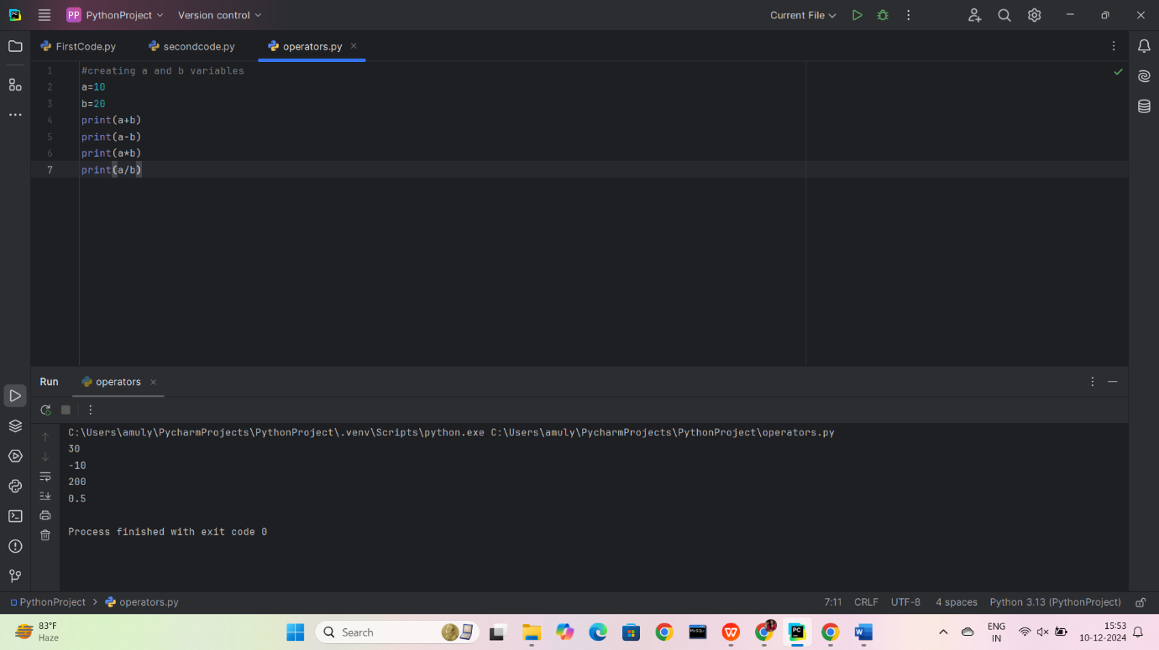

Comparison Operators

These operators compare two values and return True or False.

a=10  
b=20  
print(a<b) o/p is true  
print(a>b) o/p is false  
print(a>=b) o/p is false  
print(a<=b) o/p is true  
print(a==b) o/p is False  
print(a!=b) o/p is true

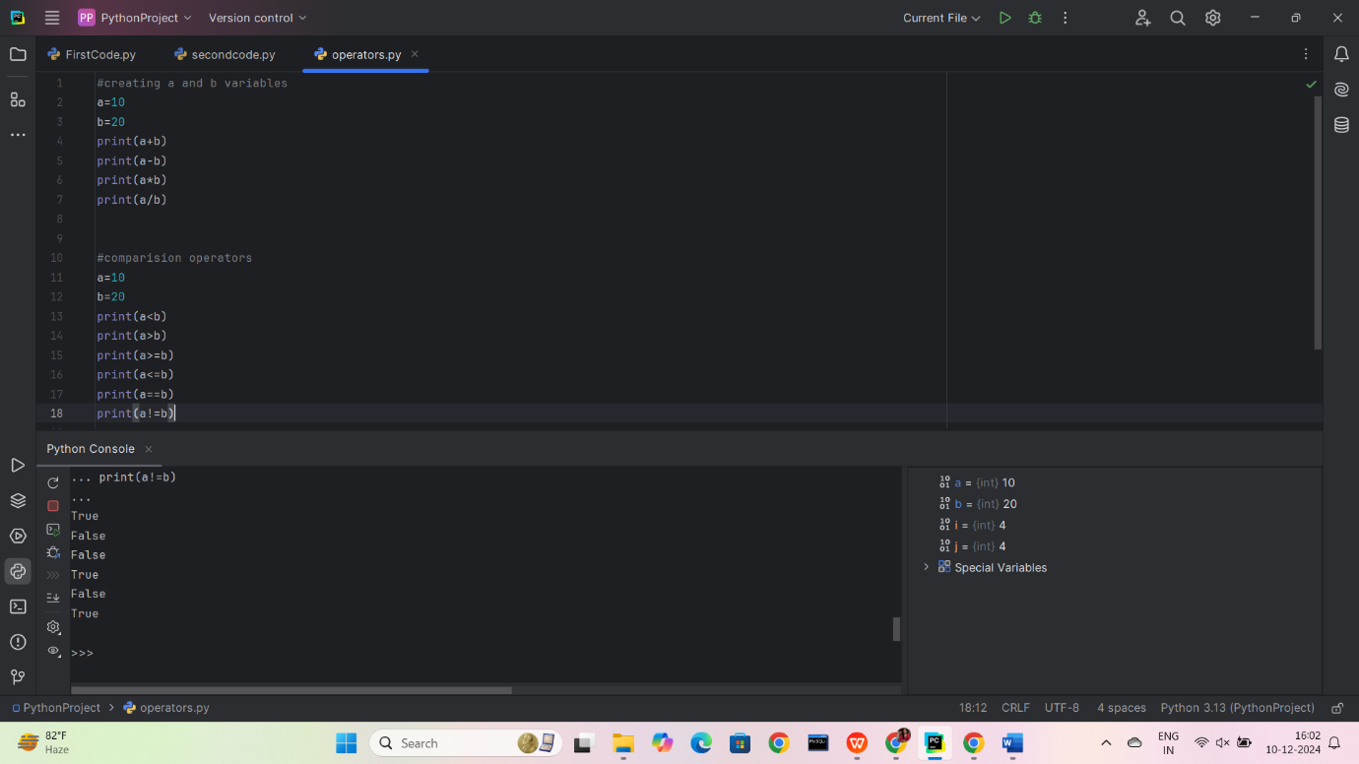

Logical Operators

1. Create two boolean variables, x and y.

2. Use logical operators (and, or, not) to perform various logical operations on x and y.

3. Print the results.

a=True  
b=False  
print(a and b)  
print( a or b)  
print(not a)  
print(not b)

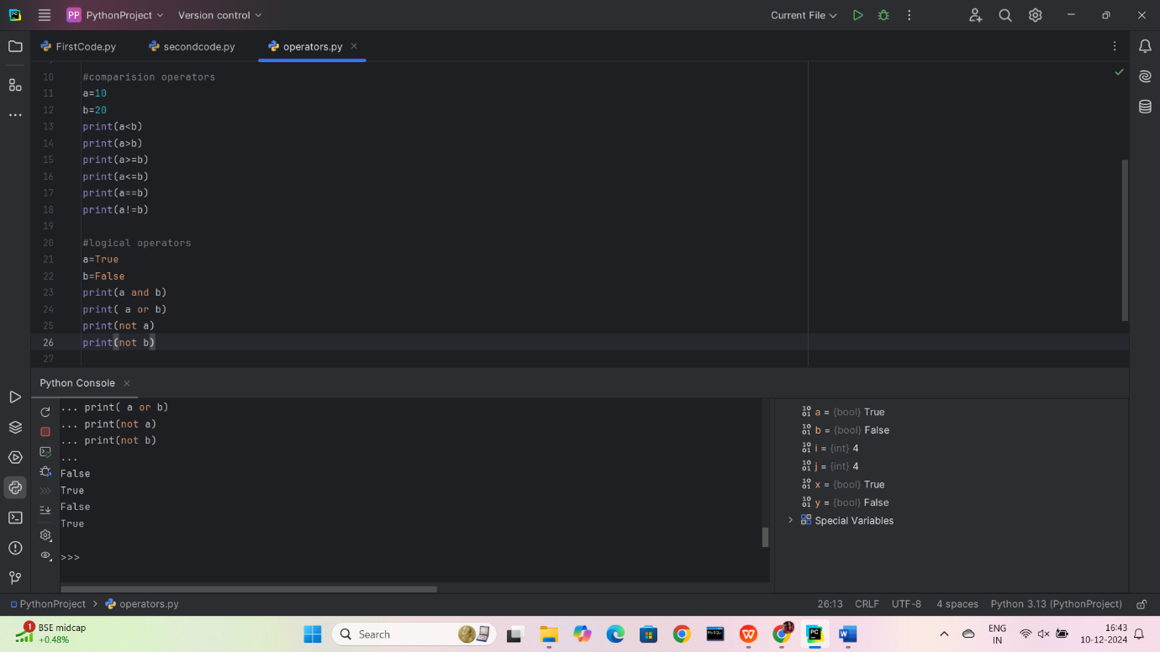

Task 4: Assignment Operators

1. Create a variable total and initialize it to 10.

2. Use assignment operators (+=, -=, *=, /=) to update the value of total.

3. Print the final value of total.

a = 10  
a -= 3  
a *= 2  
a /= 4  
print(“final value of a:”,a)

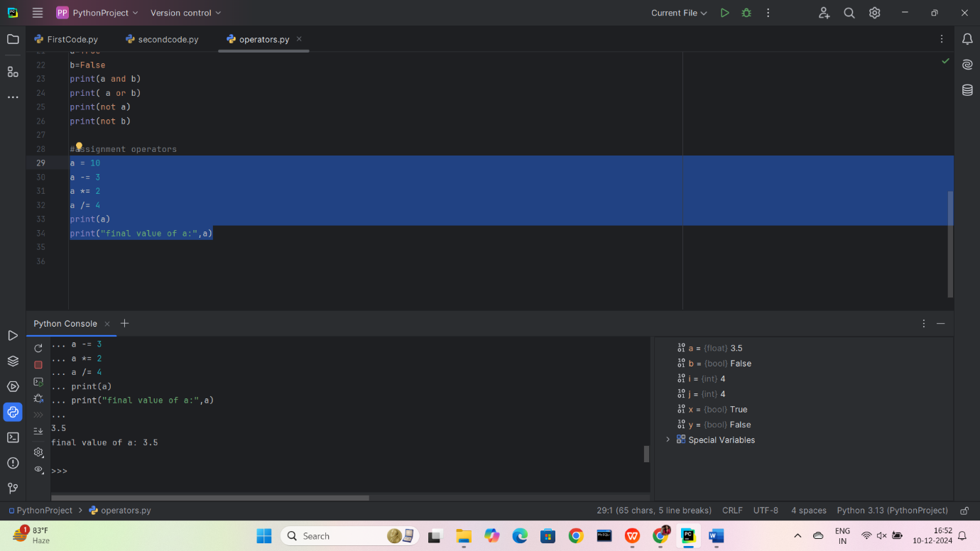

Task 5: Bitwise Operators (Optional)

1. If you are comfortable with bitwise operators, perform some bitwise operations on integer

values and print the results. If not, you can skip this task.

a = 8  
b = 5  
and_result = a & b  
or_result = a | b  
not_result = ~a  
xor_result = a ^ b  
leftshift_result = a << b  
rightshift_result = a >> b  
print(and_result, or_result, not_result, xor_result, leftshift_result, rightshift_result)



Task 6: Identity and Membership Operators

1. Create a list my_list containing a few elements.

2. Use identity operators (is and is not) to check if two variables are the same object.

3. Use membership operators (in and not in) to check if an element is present in my_list.

4. Print the results.

#create a list  
my_list = [1,2,3,'ammu','hema']  
a=(1,2,3,'ammu','hema')  
b=[1,2,3,'ammu','hema']  
identity_check_is = (a is my_list)   
identity_check_is_not = (b is not my_list)   
  
# Membership operators: 'in' and 'not in'  
check_in = 2 in my_list   
check_not_in = "ammu" in my_list   
check_not_in = "balu" in my_list

And output is

identity_check_is: False

identity_check_is_not: True

check_in (2 in my_list): True

check_not_in_ammu ('ammu' in my_list): True

check_not_in_balu ('balu' in my_list): False

