**1. Retrieve details of all books in the library – id, title, name of publisher, authors, number of copies in each branch, etc.**

SELECT B.BOOK_ID, B.TITLE, B.PUBLISHER_NAME, A.AUTHOR_NAME, C.NO_OF_COPIES, L.BRANCH_ID

FROM BOOK B, BOOK_AUTHORS A, BOOK_COPIES C, LIBRARY_BRANCH L WHERE B.BOOK_ID=A.BOOK_ID

AND B.BOOK_ID=C.BOOK_ID

AND L.BRANCH_ID=C.BRANCH_ID;

CREATE VIEW V_PUBLICATION AS SELECT PUB_YEAR

FROM BOOK;

CREATE VIEW V_BOOKS AS

SELECT B.BOOK_ID, B.TITLE, C.NO_OF_COPIES

FROM BOOK B, BOOK_COPIES C, LIBRARY_BRANCH L WHERE B.BOOK_ID=C.BOOK_ID

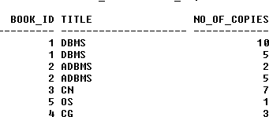AND C.BRANCH_ID=L.BRANCH_ID;