PV–PP Framework — Benchmark Results Summary
Version 1.0 | Publication-facing benchmark results document for the grenade self-sacrifice benchmark

Executive Summary
The benchmark shows the intended shape: parity at the easy edge, the widest PV–PP advantage in the moderate and difficult workloads, and partial reconvergence in the improbable tail case.
The benchmark’s narrow claim is not that scalar models cannot represent sacrifice. The claim is that this non-scalar PV–PP implementation can generate the observed rescue-and-sacrifice pattern without scalar aggregation as the governing decision rule.
The observed extraction advantage is not free. PV–PP generally accepts slightly higher average casualties in exchange for materially higher recoveree extraction rates in the workloads where sacrificial protection becomes decision-relevant.

Purpose
This document records the current benchmark results for the PV–PP grenade self-sacrifice benchmark and states the narrow benchmark claim supported by the current evidence. It is not a theorem-closure document and not a full framework specification. Its role is narrower: to document comparator discipline, run basis, empirical results, and benchmark-specific interpretation in a publication-facing format.

Comparator Discipline
This benchmark does not show that scalar reasoning is incapable of representing self-sacrifice in principle. A scalar model can always be specified with weights or priorities that make sacrificial action utility-maximizing. The benchmark instead compares PV–PP against a self-preserving scalar baseline that shares some protective behavior, but not direct center-square sacrificial smothering.

Run Configuration and Statistical Basis
The current benchmark values are drawn from 10,000-run batches for each individual scenario and for the mixed benchmark. The published seed set is shown below.
Workload | Seed
extraction_easy | 999
extraction_moderate | 1999
extraction_difficult | 2999
extraction_improbable | 3999
mixed | 3999
This is not perfect seed diversification because the improbable and mixed runs share a seed, but it is materially stronger than earlier smaller-run drafts and provides a more stable benchmark table.

Results Summary
Workload | Runs | Scalar % | PV–PP % | Scalar Avg Casualties | PV–PP Avg Casualties | PV–PP-only / Baseline-only Wins
extraction_easy | 10,000 | 99.43 | 99.43 | 0.000 | 0.000 | 0 / 0
extraction_moderate | 10,000 | 59.44 | 73.80 | 2.469 | 2.502 | 1,708 / 272
extraction_difficult | 10,000 | 41.28 | 54.44 | 2.918 | 3.030 | 1,892 / 576
extraction_improbable | 10,000 | 8.83 | 12.13 | 3.486 | 3.650 | 699 / 369
mixed | 10,000 | 42.48 | 53.18 | 2.831 | 2.916 | 1,481 / 411
Extracted % is the primary mission-success metric. Average casualties refers to average total casualties across runs. The win asymmetry shows that the extraction advantage is not a tiny percentage fluctuation in the middle workloads.

Visual Summary of the Main Pattern
The ordered-scenario line graph and mixed-workload bar chart tell the same story in two different ways. The ordered ladder shows parity at the easy edge, maximum spread in the middle, and partial reconvergence in the improbable tail. The mixed chart shows that the directional effect remains visible even when the ordered ladder is pooled.
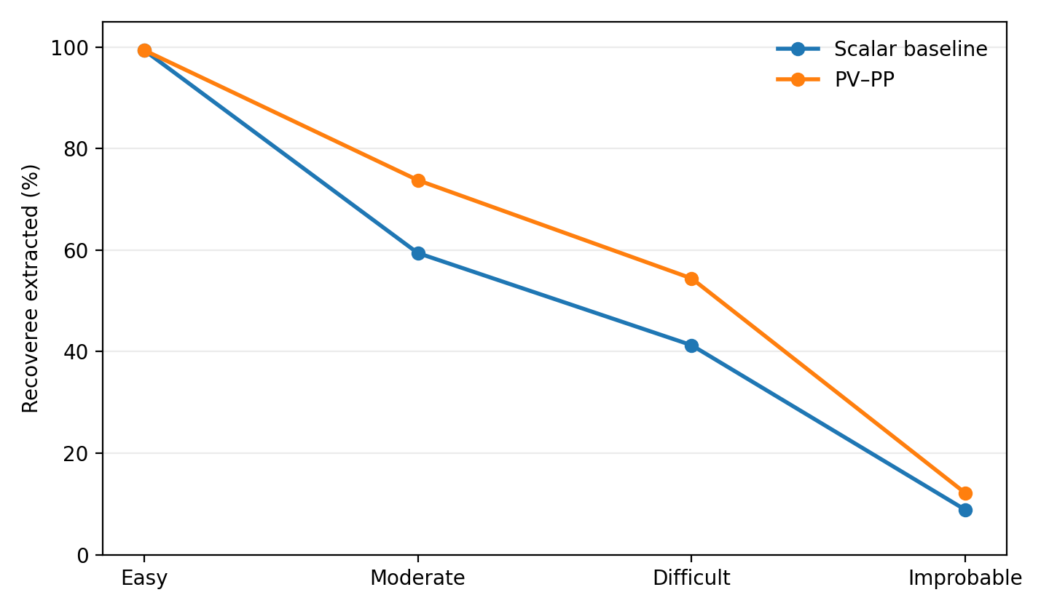
Figure 1. Ordered workloads: parity at the easy edge, widest separation in the moderate and difficult regimes, and partial reconvergence in the improbable tail.
The line graph is the core visual story of the benchmark. It shows that PV–PP does not diverge everywhere. It matches the scalar baseline in the easy case, separates sharply in the moderate and difficult workloads where sacrificial protection becomes structurally relevant, and then comes back somewhat in the improbable tail as both models approach broad mission failure.
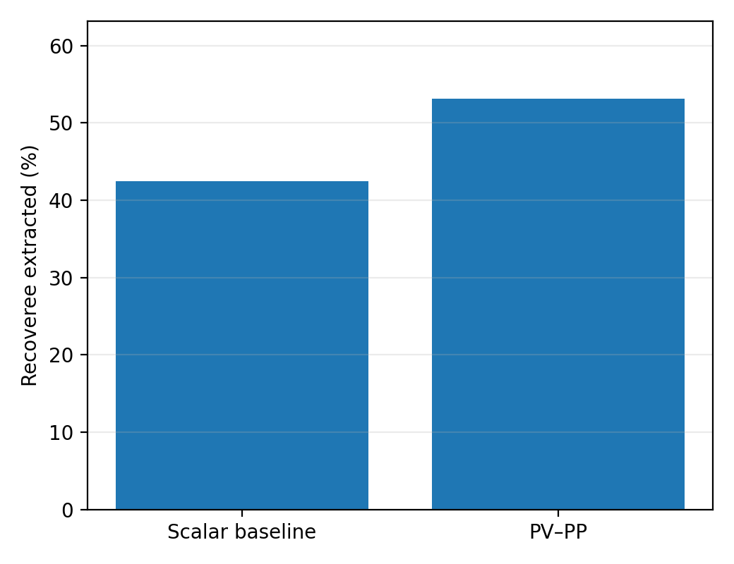
Figure 2. Mixed workload: PV–PP retains a clear extraction advantage under pooled conditions.
The mixed workload should not replace the ordered ladder, because it is less structurally interpretable. But it is a useful robustness check. Even under pooled conditions, PV–PP still maintains a notable extraction advantage over the scalar self-preserving baseline.

Workload-by-Workload Reading

Easy
The easy workload functions mainly as a convergence and control case. PV–PP and the scalar self-preserving baseline match exactly on extraction rate and casualties.

Moderate
The moderate workload is one of the strongest benchmark signal zones. PV–PP improves recoveree extraction from 59.44% to 73.80%, with a large PV–PP-only win count and only a small increase in average casualties.

Difficult
The difficult workload preserves the same directional pattern under stronger pressure. PV–PP improves recoveree extraction from 41.28% to 54.44%. Casualties rise modestly, but the extraction advantage remains substantial.

Improbable
The improbable workload is a tail stress case. Both models perform badly, as expected, but PV–PP still retains an advantage: 12.13% versus 8.83%. This is useful, but it is not the strongest headline workload because the signal is narrower and the environment is already close to broad collapse.

Mixed
The mixed workload is best read as a supplementary robustness check rather than a replacement for the ordered scenario ladder. Even under mixed conditions, PV–PP retains a clear extraction advantage.

Casualty Tradeoff
PV–PP’s extraction advantage is not free. In moderate, difficult, improbable, and mixed workloads, PV–PP generally accepts slightly higher average total casualties in exchange for higher recoveree extraction rates. That does not weaken the benchmark. It sharpens it. The current comparison is not a claim that PV–PP dominates the scalar baseline on every metric. It is a claim that PV–PP better preserves mission success under sacrificially relevant pressure, with a modest casualty tradeoff.

Claims Not Supported
- that scalar models in general cannot represent self-sacrifice
- that the benchmark proves theorem closure
- that PV–PP universally outperforms all scalar formulations
- that every source of divergence has been fully isolated beyond the center-square sacrificial case
- that PV–PP is superior on all welfare or casualty metrics

Bottom-Line Reading
The benchmark supports a narrow architecture-dependent claim. PV–PP and the scalar baseline coincide in easy extraction. In moderate and difficult grenade-bearing scenarios, PV–PP achieves substantially higher recoveree extraction rates. In the improbable case, the advantage remains but contracts as both models are increasingly overwhelmed by attritional pressure, background fire, and cumulative degradation. The mixed benchmark preserves the same direction of effect, though it is less structurally interpretable than the ordered ladder.

