PRACTICAL – 03

**NAME : Aryan Kashikar  
Roll n0: D2 32**

**Aim :** Implementation of queries using Aggregate Function and demonstrate the use of Group By clause on underlying tables in the database.

# Problem Definition

* Create table using DDL Script

Products (product_id Integer, product_type_id Integer, Name Varchar2(30), Price Integer)

*Note: product_id is Primary Key*

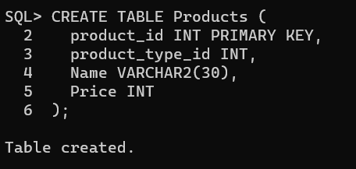

* Insert following 09 tupules using DML scripts
  + insert into products values (1,1,'Simple TV',1000.00);
  + insert into products values (2,1,'LED TV',1500.00);
  + insert into products values (3,1,'LCD TV',2000.00);
  + insert into products values (4,2,'Mobile Phone',1000.00);
  + insert into products values (5,2,'Smart Phone',2000.00);
  + insert into products values (6,2,'Jio Phone',3000.00);
  + insert into products values (7,3,'Simple WM',1500.00);
  + insert into products values (8,3,'Automated WM',2000.00);
  + insert into products values (9,3,'Semi WM',2500.00);

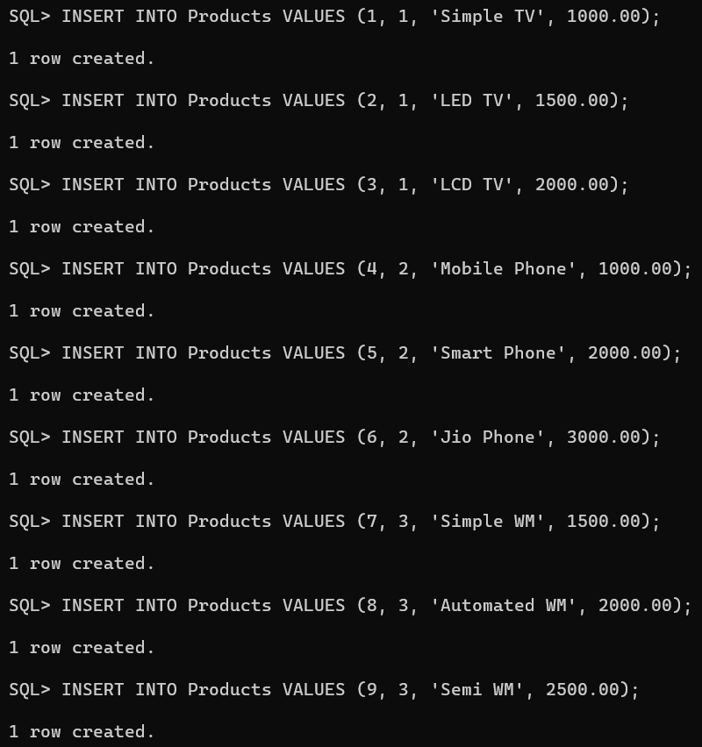

OUTPUT:

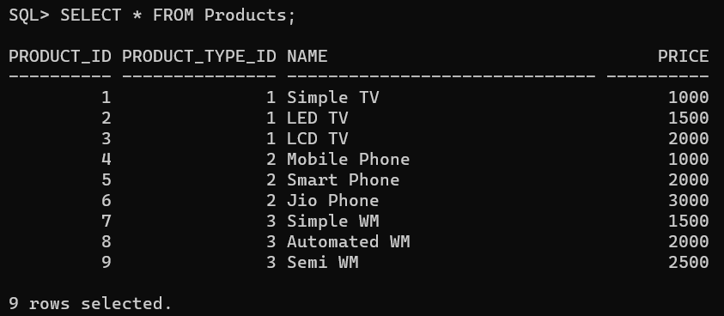

# Tasks-01:

1. Count the number of products

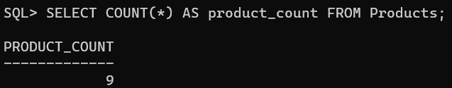

1. Count the number of products and sum of price of products

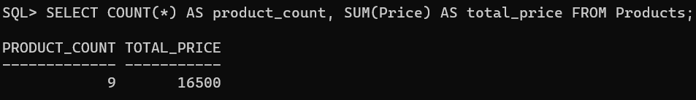

1. Count the number of products_type_id

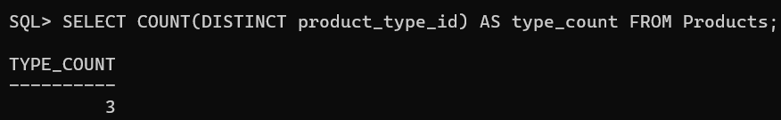

1. Count the number of distinct products_type_id

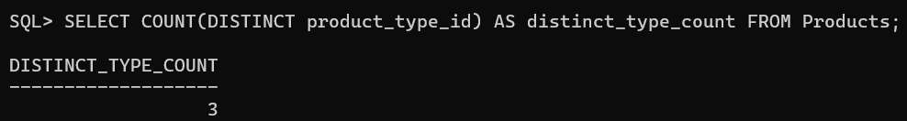

1. Calculate the average price of the product

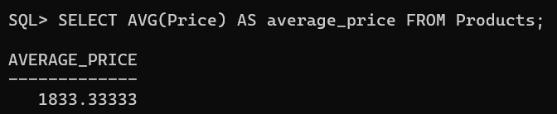

1. Calculate the average price of the distinct product

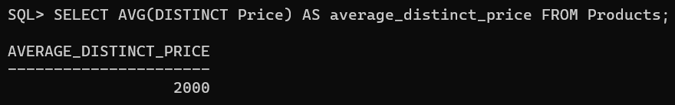

1. Calculate maximum and minimum price of the product

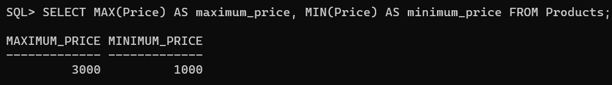

1. Find the count of number of ROWID

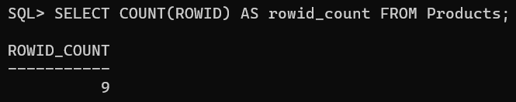

1. Find maximum and minimum product name

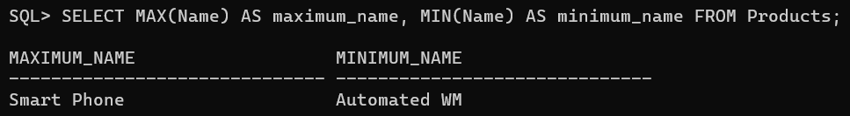

1. Calculate standard deviation of price

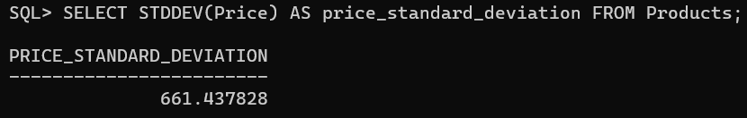

1. Calculate variance of price

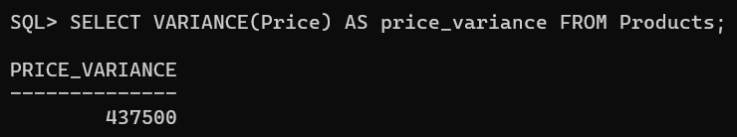

1. Calculate average price group by product_type_id

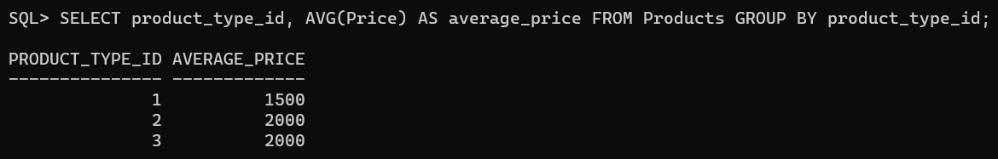

1. Calculate Variance on price group by product_type_id

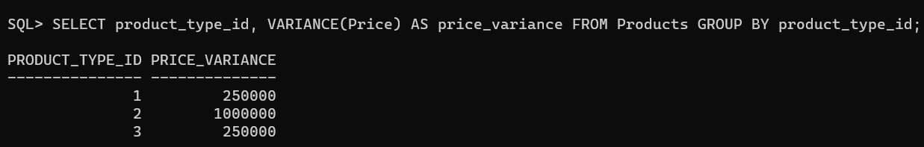

1. Calculate Variance on price group by product_type_id order by Variance

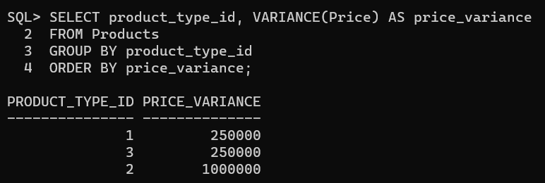

1. Calculate average price group by product_type_id and having average price greater than 1500.

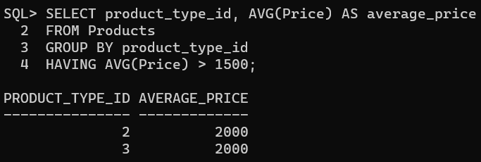

1. Calculate average price of the products whose price is less that Rs.2000 and group by product_type_id and having average price greater than 1500.

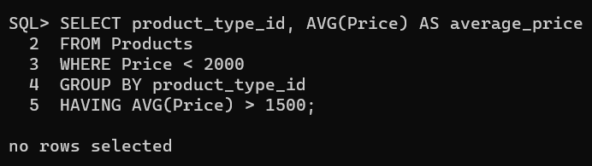

# Task-02: Execute the following Aggregate and Group By queries on Employee Table of

**Scott username**

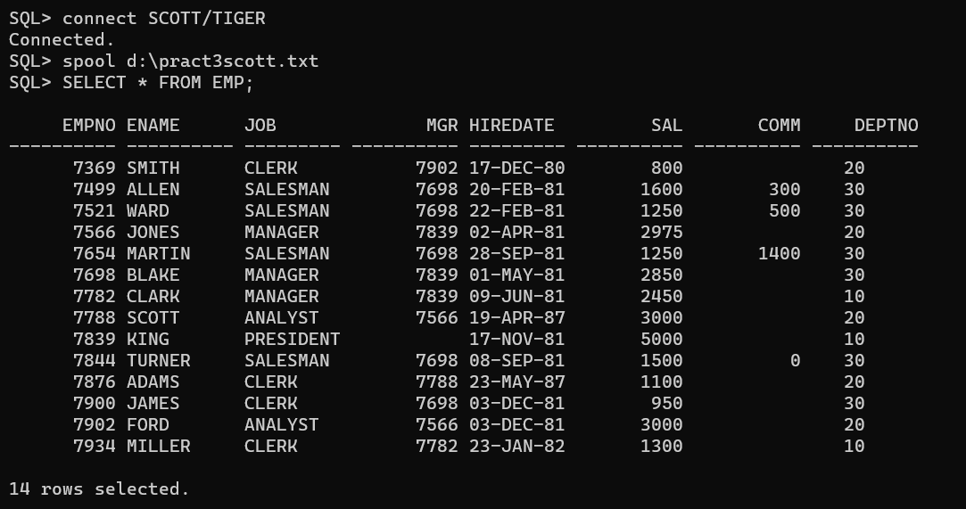

1. Find the highest sal of EMP table

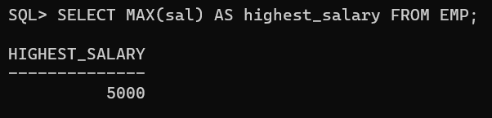

1. Find details of highest paid employee.

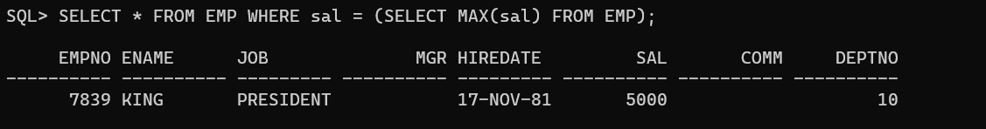

1. Find the highest paid employee of department 20

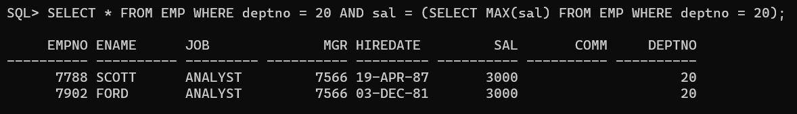

1. Find the total sal given to the MGR

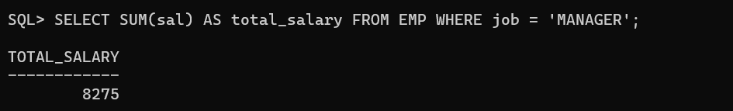

1. Find the total annual sal to distribute job wise in the year 81.

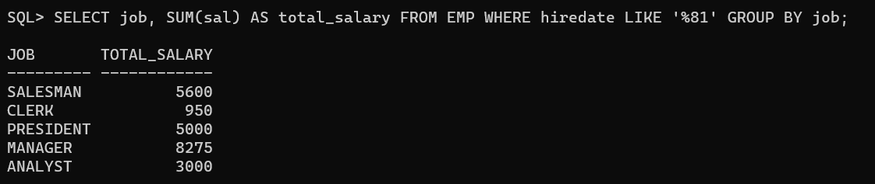

1. Display the average salaries of all the clerks.

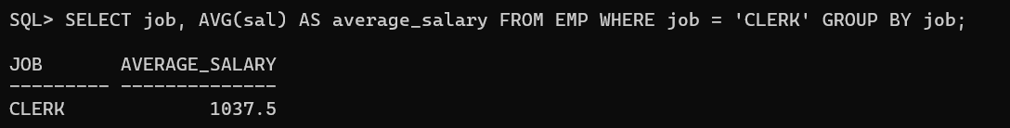

1. List the employeein dept 20 whose sal is >the average sal 0f dept 10 emps

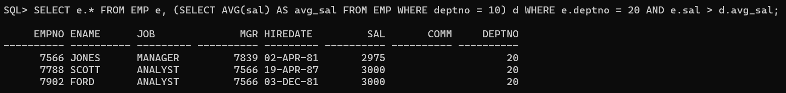

1. Display the number of employee for each job group deptno wise

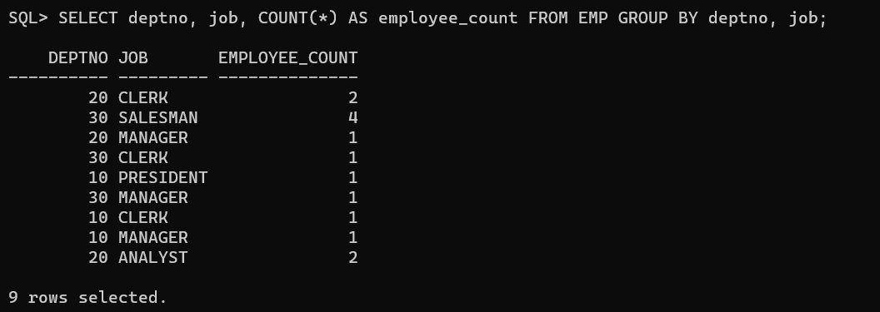

1. List the manage rno and the number of employees working for those mgrs in the ascending Mgrno.

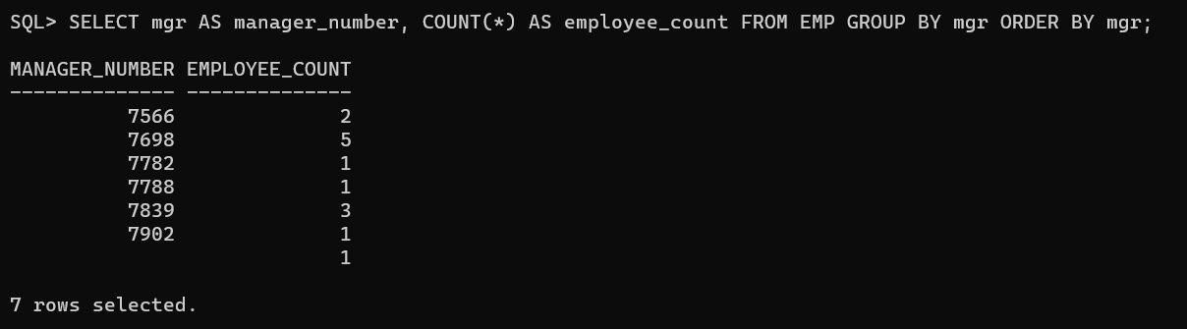

1. List departmentwise employee count

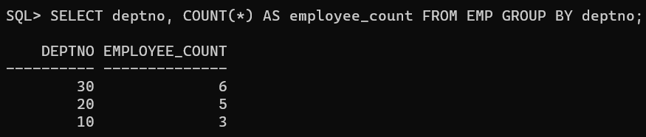

1. List the department, details where at least two emps are working

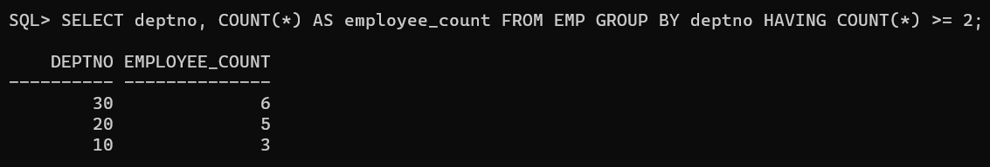

1. List the names of the emps who are getting the highest sal dept wise.

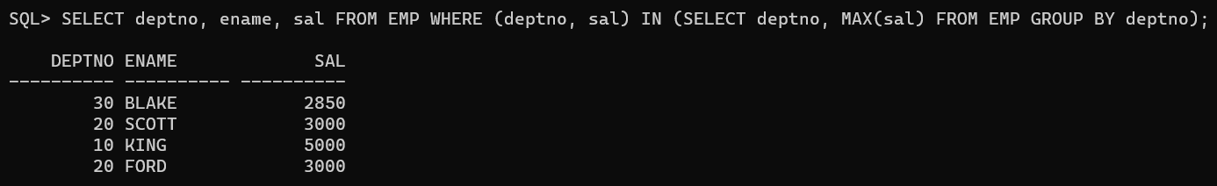

1. List the emps whose sal is greater than or equal to the average of max and minimum

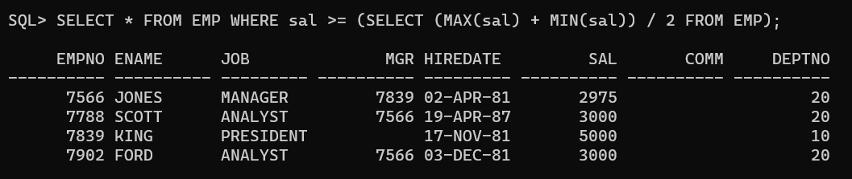

1. List the no. of emps in each department where the no. is more than 3.

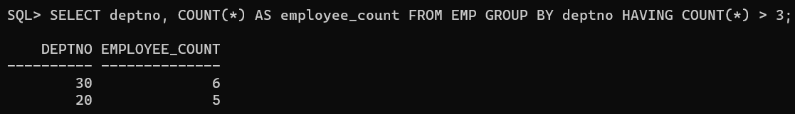

1. Find out how may Managers are their in the company.

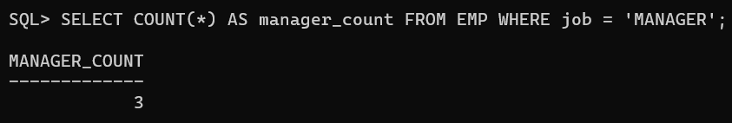

1. Check whether all the emps numbers are indeed unique

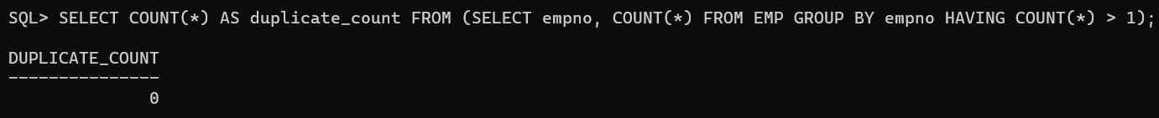

1. Find all the emps who earn the more than minimum Salary of department 50 in ascending order of deptno.



1. Find out all the emps who earn highest salary in each job type. Sort in descending salary order.

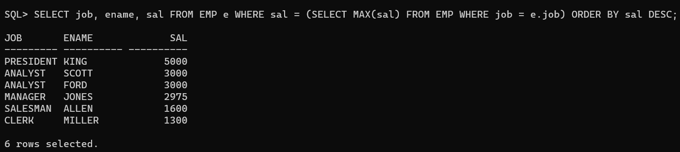

1. List the Deptno where there are no emps.



1. List the No.of emp’s and Avg salary within each department for each job.

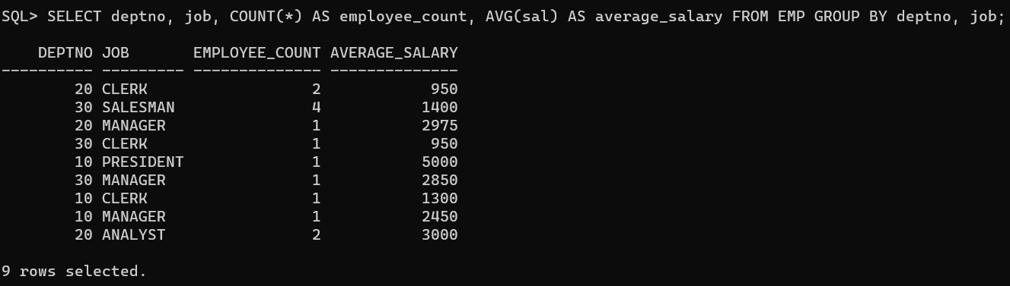

1. Find the maximum average salary drawn for each job except for ‘President’.

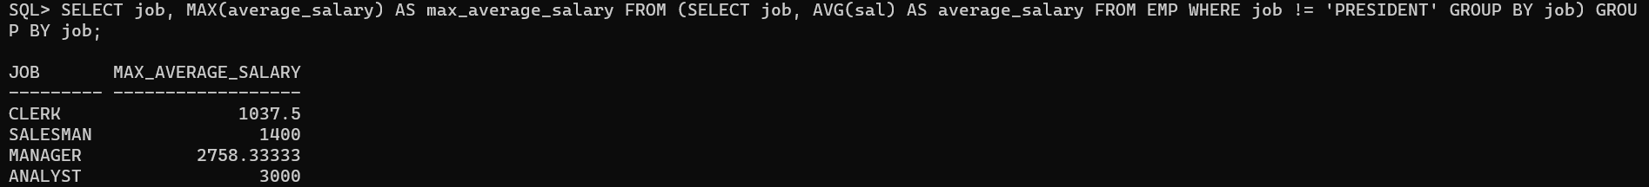

1. List the highest paid emp.

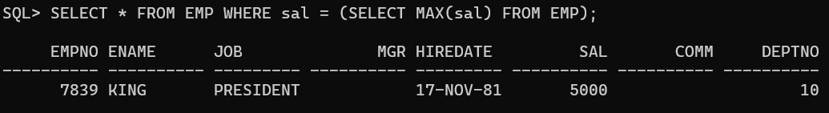

1. List the details of most recently hired emp of dept 30.

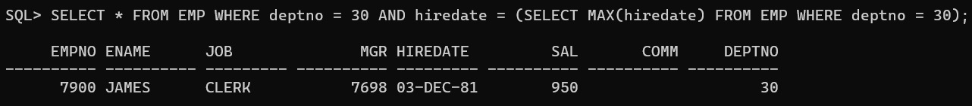

1. Find the count of employee, average salary and sum of the salary

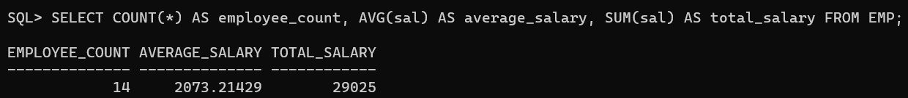

1. Find the count of employee, average salary and sum of the salary and group by department number wise in the ascending order

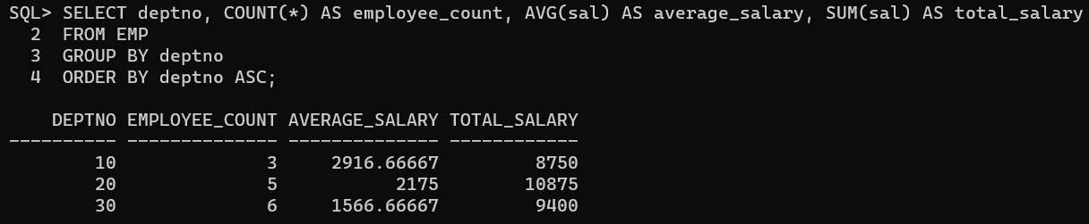

1. Find the count of employee, average salary and sum of the salary and group by department number wise and job wise and in the ascending order of dept number and Job.

