PRACTICAL – 07

**NAME : Aryan Kashikar  
Roll n0: D2 32**

Practical 7 : To implement Cursor in Oracle 11g

EMP

EMPNO ENAME JOB MGR HIREDATE SAL COMM DEPTNO

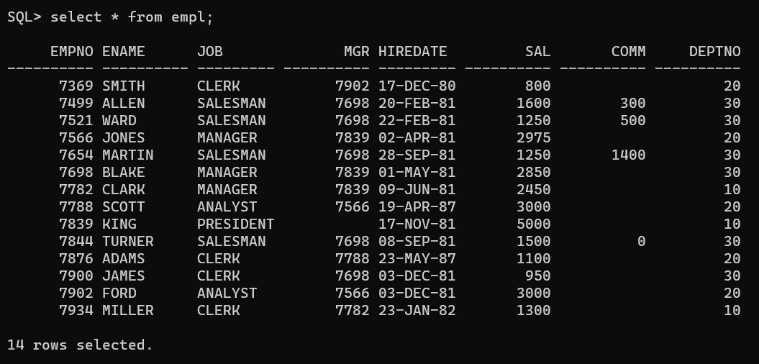

DEPT

DEPTNO DNAME LOC

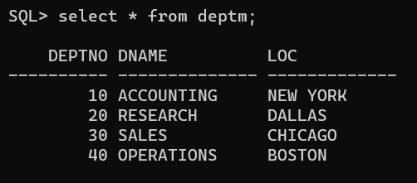

1. Increment salary of employee by 40% where dept name starts with „A‟ and joining date is in

year 2000. Find the number of rows affected by the use of SQL%ROWCOUNT attributes of

an implicit cursor. (implicit cursor). Also print message “Records not found‟ if no such data exist.

DECLARE

  v_dept_name dept.dname%TYPE := 'A%';

  v_year NUMBER := 2000;

BEGIN

  UPDATE empl

  SET sal = sal * 1.4

  WHERE deptno IN (

    SELECT deptno

    FROM deptm

    WHERE dname LIKE v_dept_name

  )

  AND EXTRACT(YEAR FROM hiredate) = v_year;

  IF SQL%ROWCOUNT = 0 THEN

    DBMS_OUTPUT.PUT_LINE('Records not found');

  ELSE

    DBMS_OUTPUT.PUT_LINE('Number of rows affected: ' || SQL%ROWCOUNT);

  END IF;

END;

/

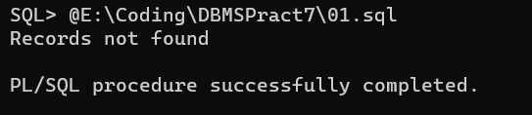

2. Create table emp1(empno,name,sal) emp2(empno,name,sal) . Initially emp1, emp2 are empty.Define explicit cursor on table emp. (select all columns using %rowtype). Insert records of deptno(10,20) in table emp1. And Insert other records in table emp2.

DECLARE

  CURSOR c_emp IS

    SELECT *

    FROM empl;

  v_emp c_emp%ROWTYPE;

BEGIN

  OPEN c_emp;

  LOOP

    FETCH c_emp INTO v_emp;

    EXIT WHEN c_emp%NOTFOUND;

    IF v_emp.deptno IN (10, 20) THEN

      INSERT INTO emp1(empno,ename, sal)

      VALUES (v_emp.empno, v_emp.ename, v_emp.sal);

    ELSE

      INSERT INTO emp2(empno,ename, sal)

      VALUES (v_emp.empno, v_emp.ename, v_emp.sal);

    END IF;

  END LOOP;

  CLOSE c_emp;

END;

/

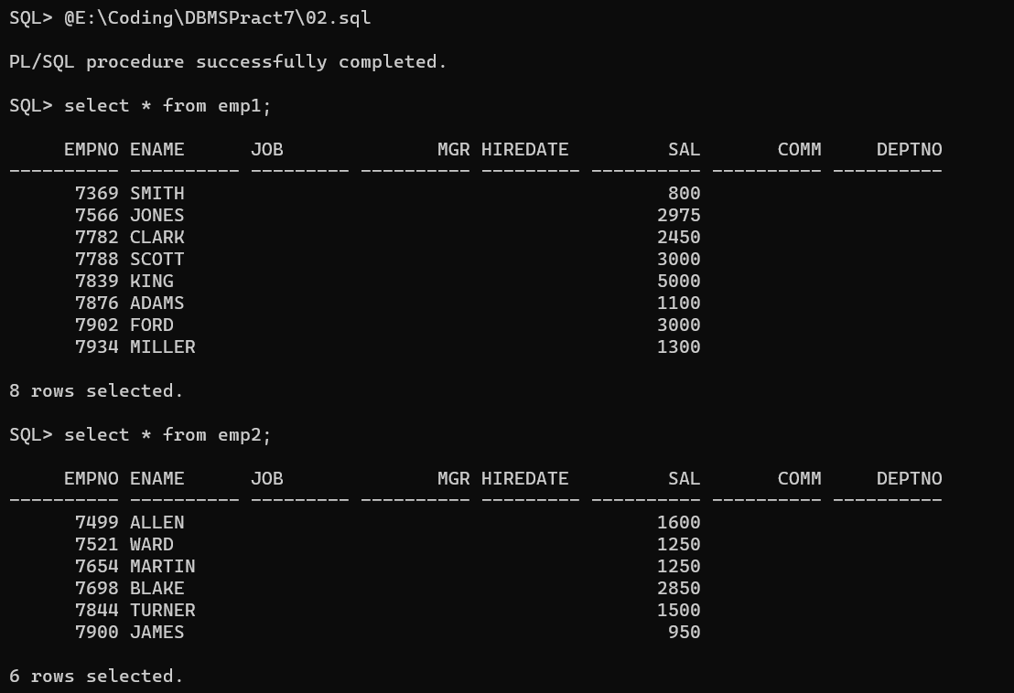

3. Write a program in PL/SQL to FETCH multiple records and more than one columns from different tables.

Define cursor to fetch data ename,sal,dname using table emp and dept. Display data where sal>3000.

DECLARE

  CURSOR c_emp_dept IS

    SELECT e.ename, e.sal, d.dname

    FROM empl e

    JOIN deptm d ON e.deptno = d.deptno

    WHERE e.sal > 3000;

  v_ename empl.ename%TYPE;

  v_sal empl.sal%TYPE;

  v_dname deptm.dname%TYPE;

BEGIN

  OPEN c_emp_dept;

  LOOP

    FETCH c_emp_dept INTO v_ename, v_sal, v_dname;

    EXIT WHEN c_emp_dept%NOTFOUND;

    DBMS_OUTPUT.PUT_LINE(v_ename || ' ' || v_sal || ' ' || v_dname);

  END LOOP;

  CLOSE c_emp_dept;

END;

/

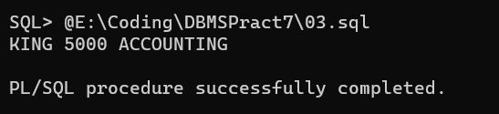

4. Write a program in PL/SQL to create a cursor displays the name and salary of each employee

in the EMPLOYEES table whose department number is equal to parameter 1, salary is less

than a parameter2 value passed in cursor. (use parameterized cursor).

DECLARE

  CURSOR c_employee(p_deptno NUMBER, p_salary NUMBER) IS

    SELECT ename, sal

    FROM empl

    WHERE deptno = p_deptno

    AND sal < p_salary;

  v_ename empl.ename%TYPE;

  v_sal empl.sal%TYPE;

BEGIN

  OPEN c_employee(10, 5000);

  LOOP

    FETCH c_employee INTO v_ename, v_sal;

    EXIT WHEN c_employee%NOTFOUND;

    DBMS_OUTPUT.PUT_LINE(v_ename || ' ' || v_sal);

  END LOOP;

  CLOSE c_employee;

END;

/

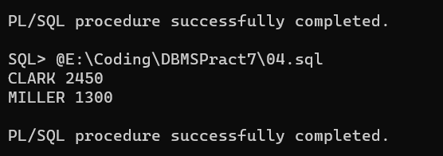

5. Define cursor on emp to store data of employs those worked for more than 1 year in the

organization. Increament salary of these employees by 30%.

DECLARE

  CURSOR c_emp IS

    SELECT *

    FROM empl

    WHERE hiredate < SYSDATE - 365;

BEGIN

  FOR emp_rec IN c_emp LOOP

    UPDATE empl

    SET sal = sal * 1.3

    WHERE empno = emp_rec.empno;

  END LOOP;

  COMMIT;

END;

/

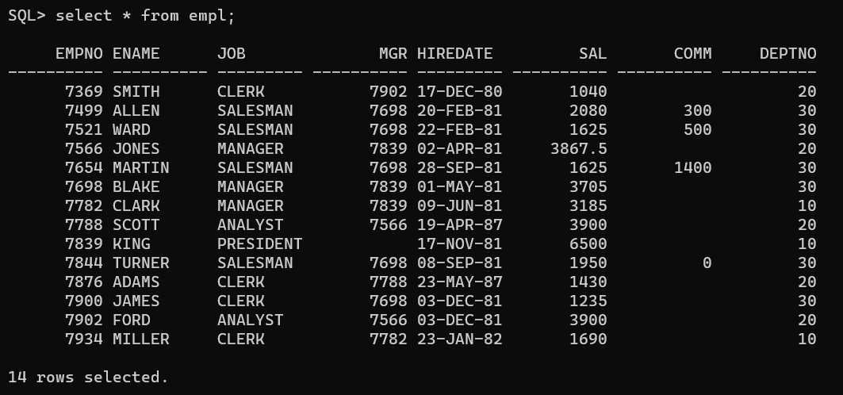

6. Create table account. Define cursor on account to select data of acct no 11,12,13. Fetch cursor

data to withdraw amount of Rs 2000. If Minimum balance after deduction >=1000, then only

deduct from table account otherwise Insert data of failure transaction “insufficient fund” in

table failtransaction. [ refer to pdf sent]

CREATE TABLE account (

  acct_no NUMBER,

  balance NUMBER

);

CREATE TABLE failtransaction (

  message VARCHAR2(100)

);

INSERT INTO account(acct_no, balance)

VALUES (11, 5000);

INSERT INTO account(acct_no, balance)

VALUES (12, 3000);

INSERT INTO account(acct_no, balance)

VALUES (13, 8000);

DECLARE

  CURSOR c_account IS

    SELECT *

    FROM account

    WHERE acct_no IN (11, 12, 13);

  v_acct_no account.acct_no%TYPE;

  v_balance account.balance%TYPE;

BEGIN

  FOR account_rec IN c_account LOOP

    v_acct_no := account_rec.acct_no;

    v_balance := account_rec.balance;

    IF v_balance - 2000 >= 1000 THEN

      UPDATE account

      SET balance = balance - 2000

      WHERE acct_no = v_acct_no;

    ELSE

      INSERT INTO failtransaction(message)

      VALUES ('insufficient funds');

    END IF;

  END LOOP;

  COMMIT;

END;

/

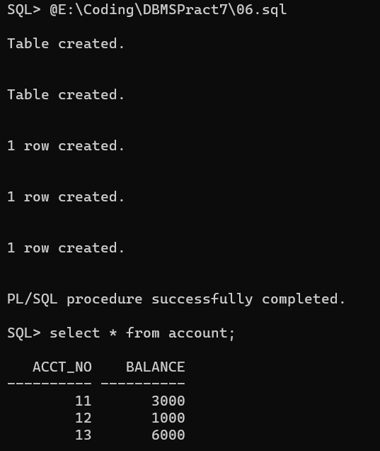

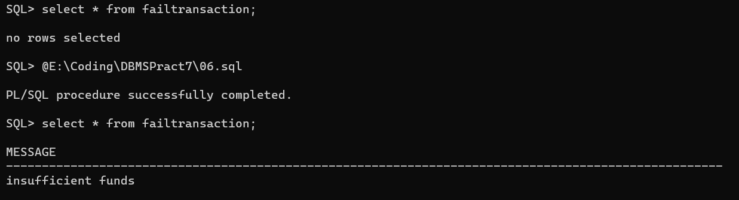

7. Define cursor to select deptno,dname and employee count working in that department. (use

join emp and dept). Use for loop and Display all information.

DECLARE

  CURSOR c_dept_employee IS

    SELECT d.deptno, d.dname, COUNT(*) AS emp_count

    FROM deptm d

    JOIN empl e ON d.deptno = e.deptno

    GROUP BY d.deptno, d.dname;

BEGIN

  FOR dept_employee_rec IN c_dept_employee LOOP

    DBMS_OUTPUT.PUT_LINE('Deptno: ' || dept_employee_rec.deptno || ', Dname: ' || dept_employee_rec.dname || ', Employee Count: ' || dept_employee_rec.emp_count);

  END LOOP;

END;

/

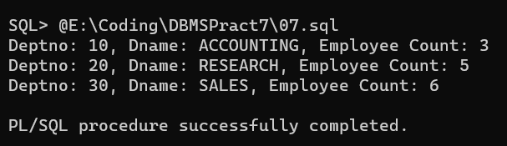

8. Modify 7 to Define cursor to select deptno,dname and employee count working in that

department having employee count >=3. (use join emp and dept). Use for loop and Display all

information.

DECLARE

  CURSOR c_dept_employee IS

    SELECT d.deptno, d.dname, COUNT(*) AS emp_count

    FROM deptm d

    JOIN empl e ON d.deptno = e.deptno

    GROUP BY d.deptno, d.dname

    HAVING COUNT(*) >= 3;

BEGIN

  FOR dept_employee_rec IN c_dept_employee LOOP

    DBMS_OUTPUT.PUT_LINE('Deptno: ' || dept_employee_rec.deptno || ', Dname: ' || dept_employee_rec.dname || ', Employee Count: ' || dept_employee_rec.emp_count);

  END LOOP;

END;

/

