**HW4 - Fast Food Chain Website**

*Group 24*

***1.Database Design***

Main tables:

* Branch
* Customer
* Category
* MenuItem
* BranchMenu
* Orders
* OrderItem
* Transaction
* Cashlog
* Position
* Employee

All tables satisfy 3NF/BCNF.

OrderItem table has a *composite key* form by **orderID** (from Order table) and **itemID** (from MenuItem table).

Transaction table with **transactionID** as *primary key*.

**ERD diagram**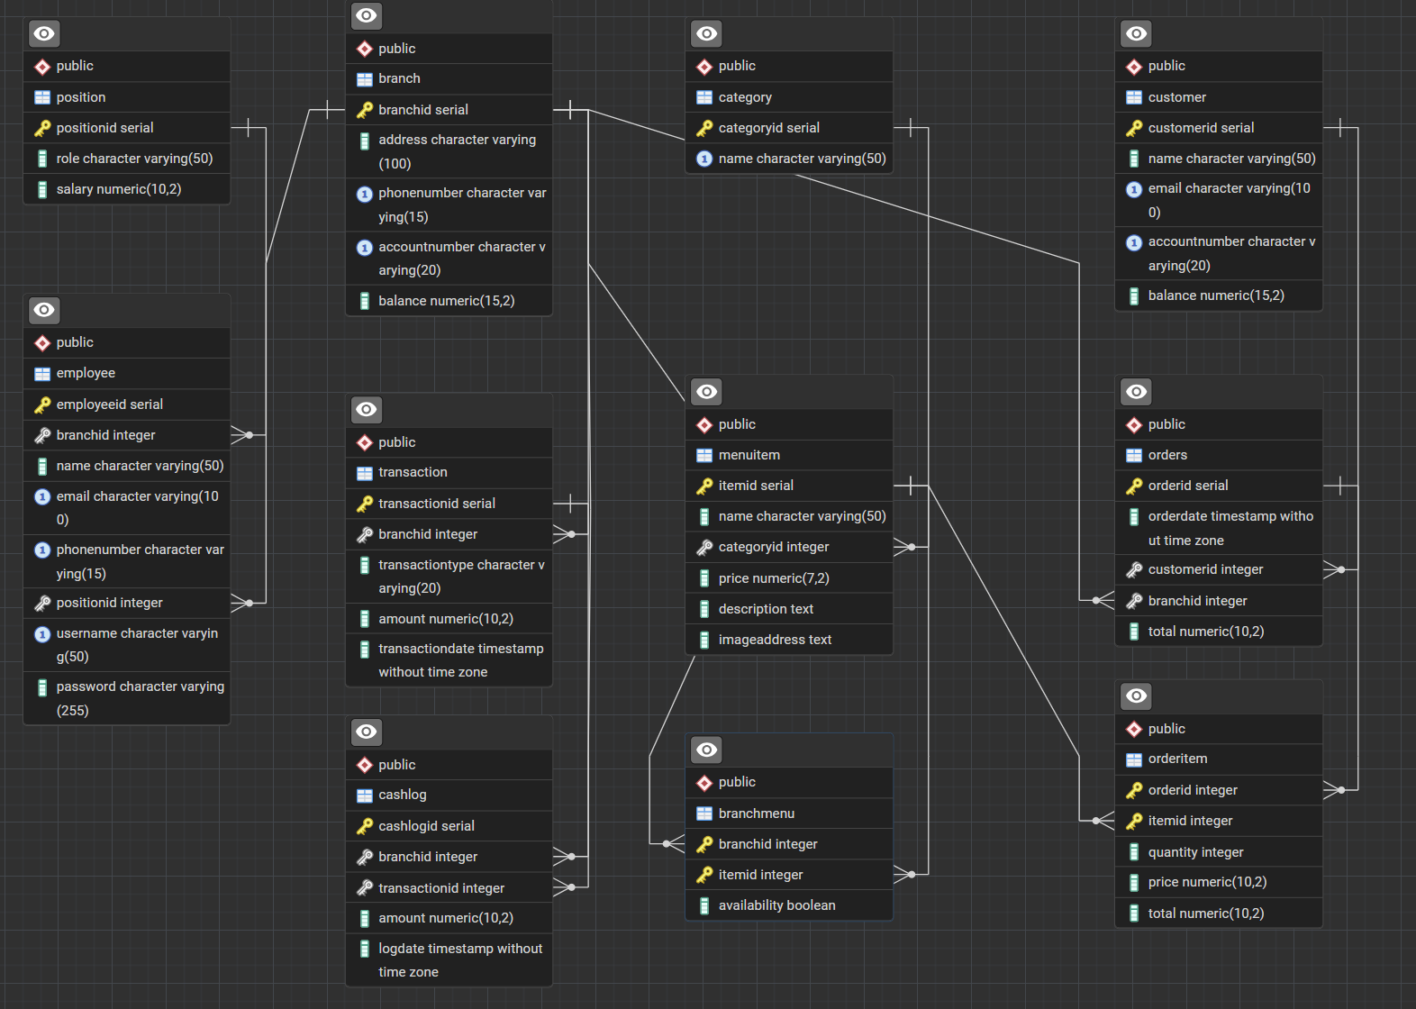

**UML diagram**

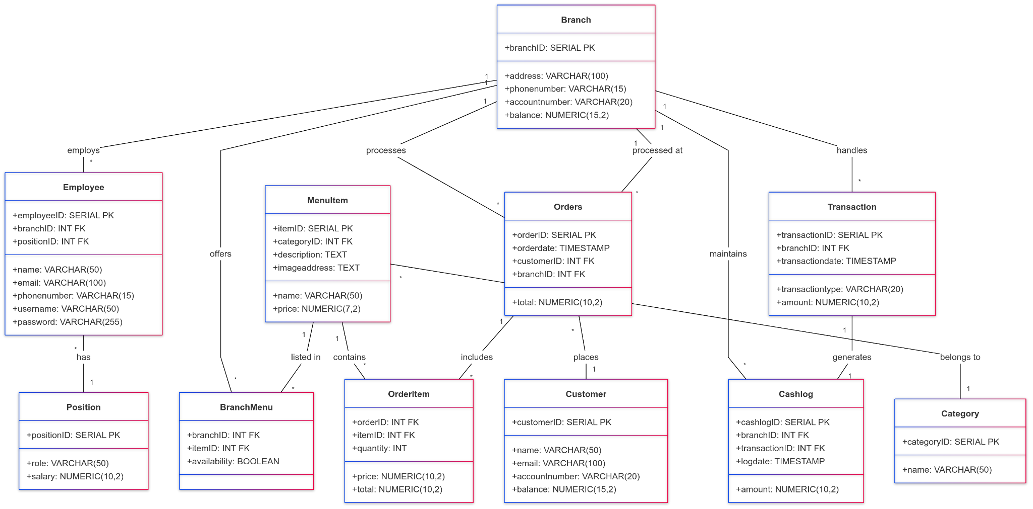

***2.Relationship between tables***

**One to Many:** Branch and Order, MenuItem and Category, Customer and Order, Order and OrderItem, Branch and Transaction, Branch and Employee, Position and Employee.

**One relation violates one to many:** Transaction and Cashlog **one to one**, separation between Transaction and Cashlog in order to control the cash flow into each branch, which is different from payment made by card.

***3. Queries for Report and Transaction***

Sample queries we use to get data for the report and transaction:

**Get available items in a specific branch:**

SELECT mi.itemID, mi.name, mi.price, mi.description, mi.imageaddress

FROM MenuItem mi

JOIN BranchMenu bm ON mi.itemID = bm.itemID

WHERE bm.branchID = $1 AND bm.availability = TRUE;

**Retrieve all orders sort by date:**

SELECT o.orderID, COALESCE(c.name, 'Guest') AS customerName, STRING_AGG(mi.name, ', ') AS itemNames,SUM(oi.price * oi.quantity) AS orderTotal, o.orderdate AS orderTime, b.address AS branchName

FROM Orders o

LEFT JOIN Customer c ON o.customerID = c.customerID

INNER JOIN OrderItem oi ON o.orderID = oi.orderID

INNER JOIN MenuItem mi ON oi.itemID = mi.itemID

INNER JOIN Branch b ON o.branchID = b.branchID

GROUP BY o.orderID, c.name, o.orderdate, b.address

ORDER BY o.orderdate;

**Transaction Logical:**

Check if customer exist or not:

If yes, customers can proceed to order and transaction.

Else, ask customers to register.

Order and Transaction:

Create Order in Order table

Insert into OrderItems

Update balance of customer and restaurant

Insert new record in transaction table

**Queries for transaction:**

*Register customer*

DO $$

DECLARE

customerId INT;

BEGIN

-- Check if account exists

SELECT customerid

INTO customerId

FROM Customer

WHERE accountnumber = 'accountNumberPlaceholder';

-- If account does not exist, register a new customer and set initial balance

IF customerId IS NULL THEN

INSERT INTO customer (name, email, accountnumber)

VALUES ('namePlaceholder', 'emailPlaceholder', 'accountNumberPlaceholder')

RETURNING customerid INTO customerId;

UPDATE customer

SET balance = 'initialBalancePlaceholder'

WHERE accountnumber = 'accountNumberPlaceholder';

END IF;

END $$;

COMMIT;

*Transaction Handling*

BEGIN;

-- Check if account exists and retrieve balance

DO $$

DECLARE

customerId INT;

customerBalance NUMERIC;

BEGIN

SELECT customerid, balance

INTO customerId, customerBalance

FROM Customer

WHERE accountnumber = 'accountNumberPlaceholder';

IF customerId IS NULL THEN

RAISE EXCEPTION 'Customer does not exist.';

ELSIF customerBalance < 'totalAmountPlaceholder' THEN

RAISE EXCEPTION 'Insufficient balance.';

END IF;

END $$;

-- Create order and insert order items

DO $$

DECLARE

orderId INT;

BEGIN

INSERT INTO orders (customerid, branchid, total)

VALUES (

(SELECT customerid FROM Customer WHERE accountnumber = 'accountNumberPlaceholder'),

'branchIDPlaceholder',

'totalAmountPlaceholder'

)

RETURNING orderid INTO orderId;

-- Insert order items

INSERT INTO orderitem (orderid, itemid, quantity, price)

SELECT

orderId,

item.itemid,

item.quantity,

item.price

FROM UNNEST('cartItemsPlaceholder'::jsonb) AS item(itemid, quantity, price);

END $$;

-- Update balances

UPDATE customer

SET balance = balance - 'totalAmountPlaceholder'

WHERE accountnumber = 'accountNumberPlaceholder';

UPDATE branch

SET balance = balance + 'totalAmountPlaceholder'

WHERE branchid = 'branchIDPlaceholder';

-- Record transaction

INSERT INTO transaction (branchid, transactiontype, amount)

VALUES ('branchIDPlaceholder', 'Card', 'totalAmountPlaceholder');

COMMIT;

**4.Testing**

We create a test 100 button 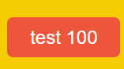 , when you click the button there will be 100 random transactions going into the restaurant.

**5. Video**

The video including how to setup and test our project:

https://drive.google.com/file/d/1Ig1inPFYXyiyljyptyOG7tKNHo8AijAs/view?usp=sharing

[HW4-dbs24.mp4](https://drive.google.com/file/d/1Ig1inPFYXyiyljyptyOG7tKNHo8AijAs/view?usp=sharing)