Week3_Day2_Assignments

Print the total number of change requests and CR numbers on the console which are having state as New (state="-5")

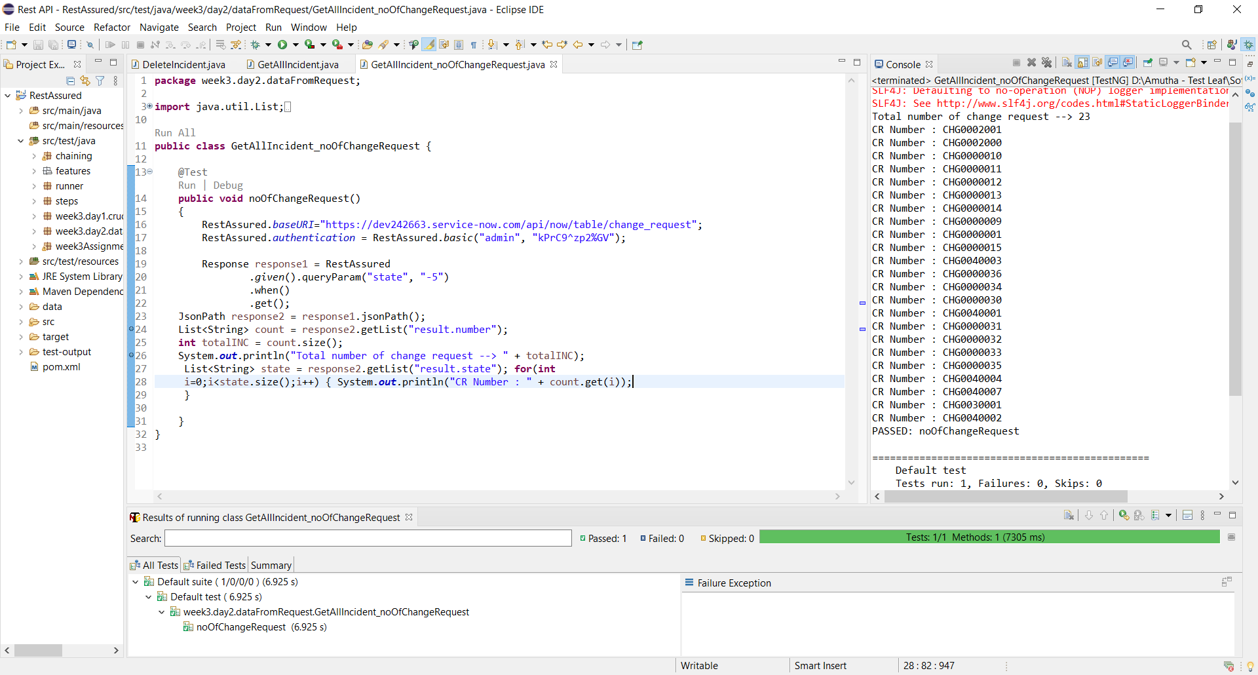

**Exercise: 2**

Create a new change request using RestAssured

Update the newly created change request by chaining

Delete the newly created change request by chaining

Base Class:

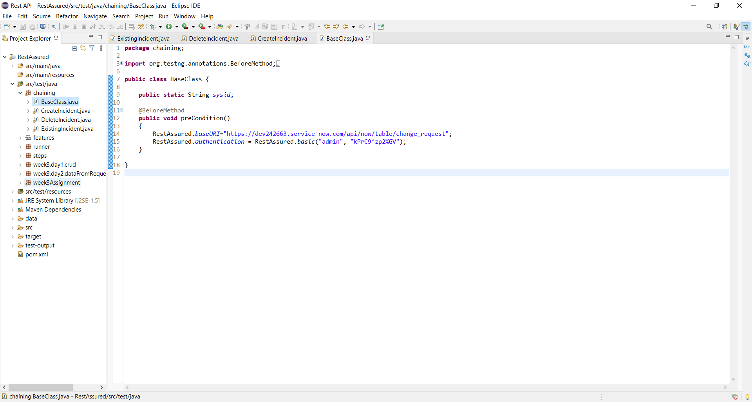

Create change request:

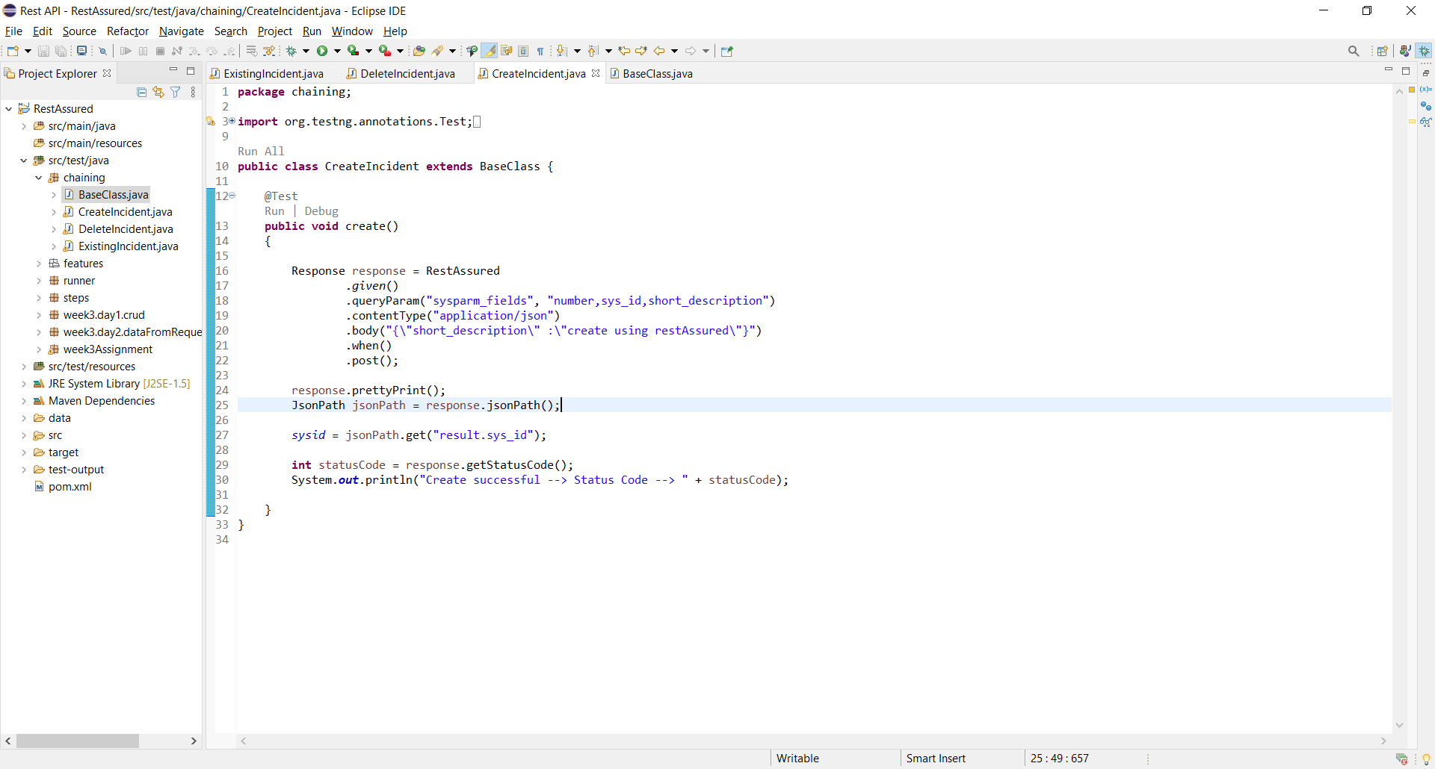

View change request: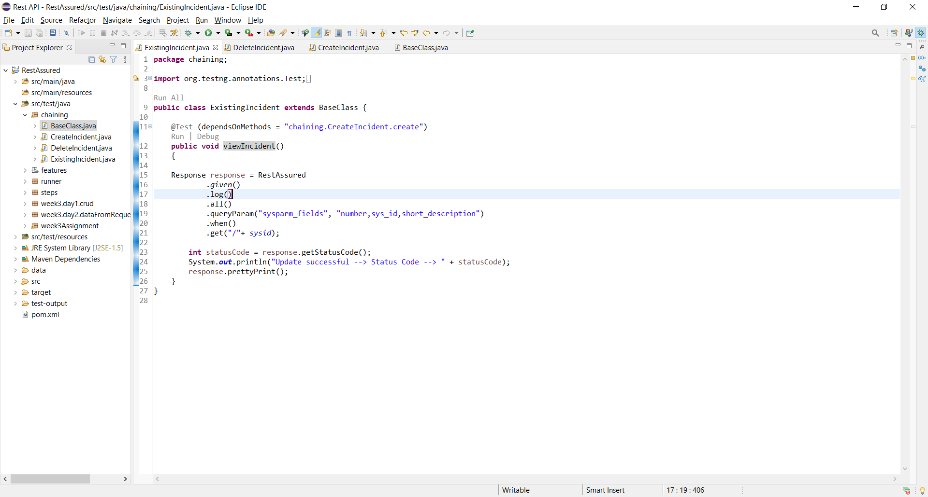

Delete change request:

