Home Assignments

Assignment1:

1. Create a change request with short_description as "created by <your name>"

2. Assert the status code as 201 using RestAssured assertion

3. Assert the short_description contains your name using Hamcrest

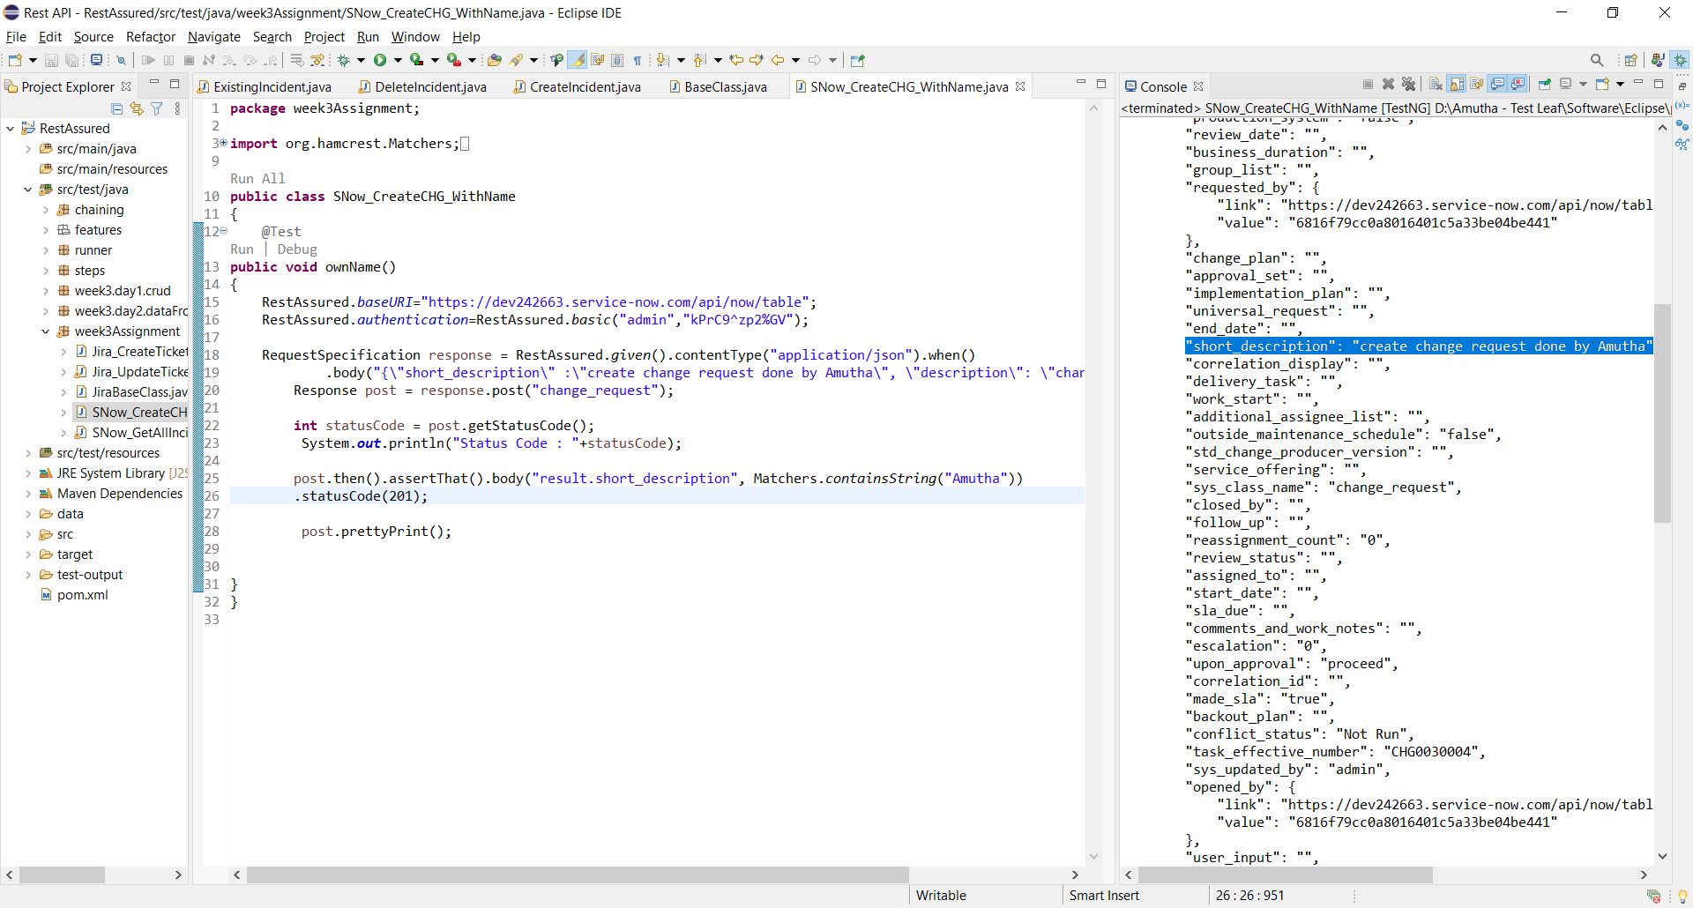

Assignment2:

1. Create a schema file for Create new change request and validate the response against the schema file

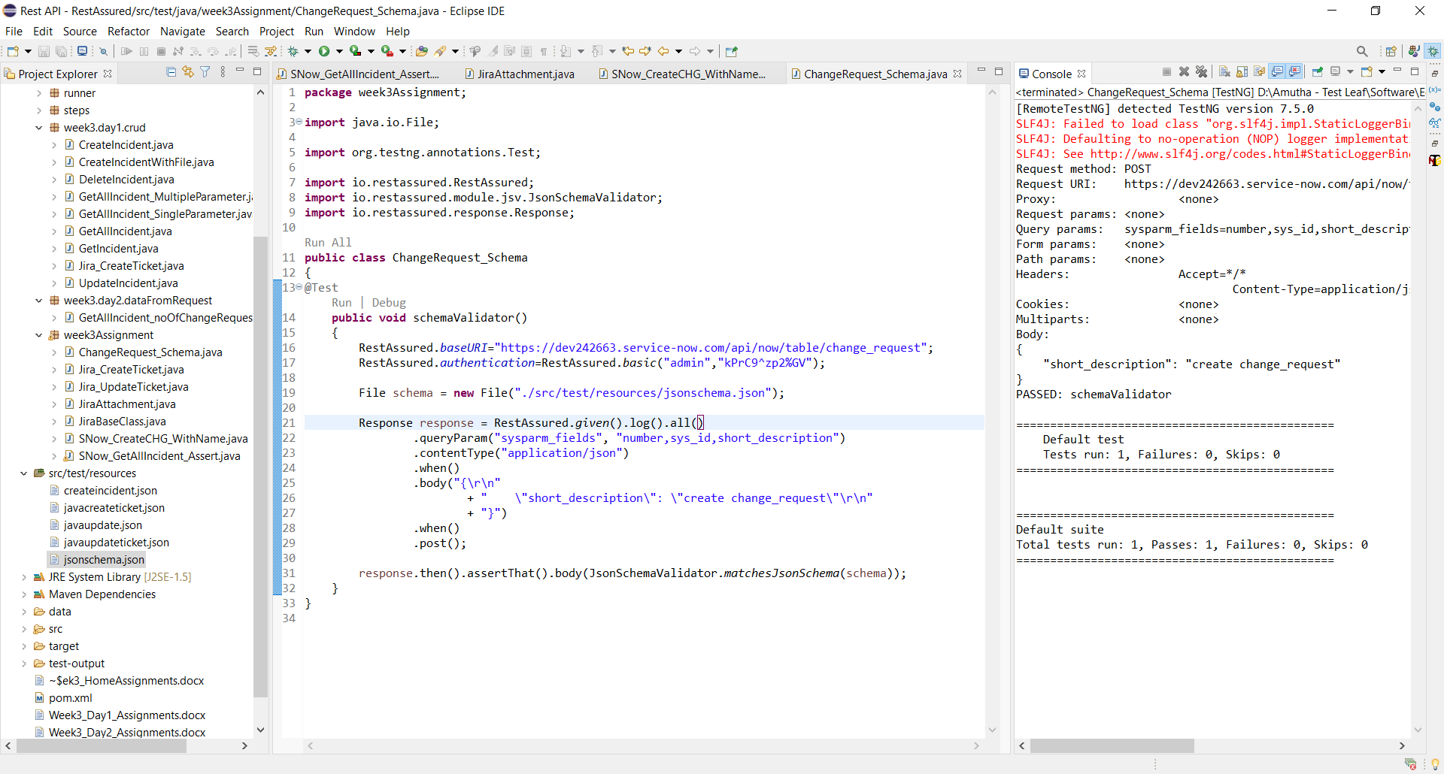

Assignment3:

1. Create new issue in JIRA using RestAssured and update the issue with a new description using chaining

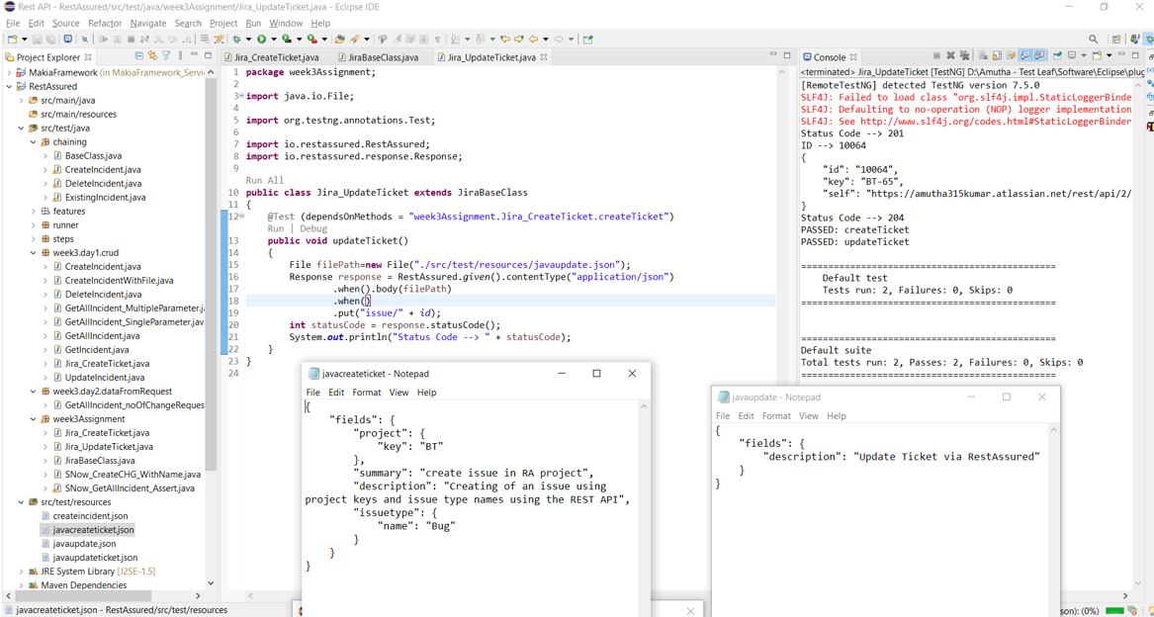

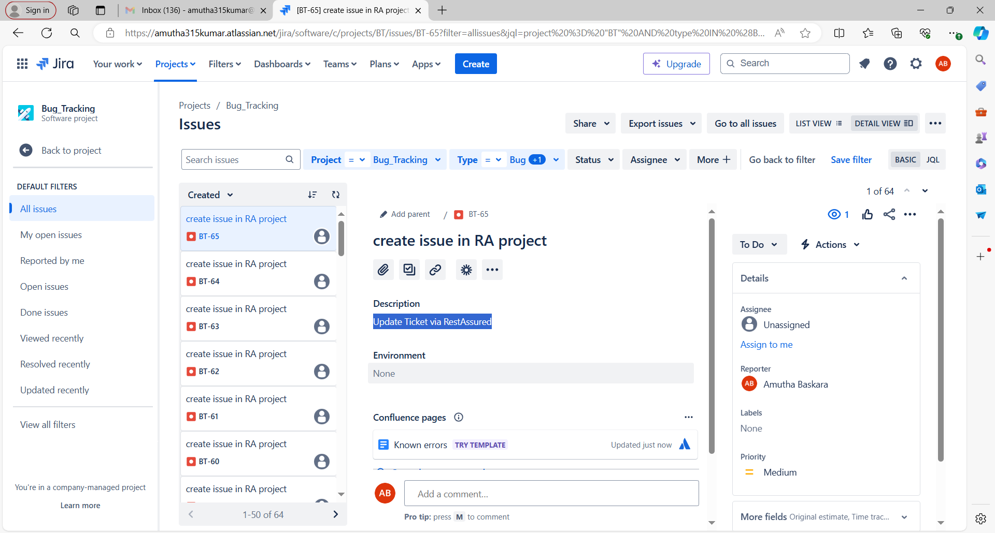

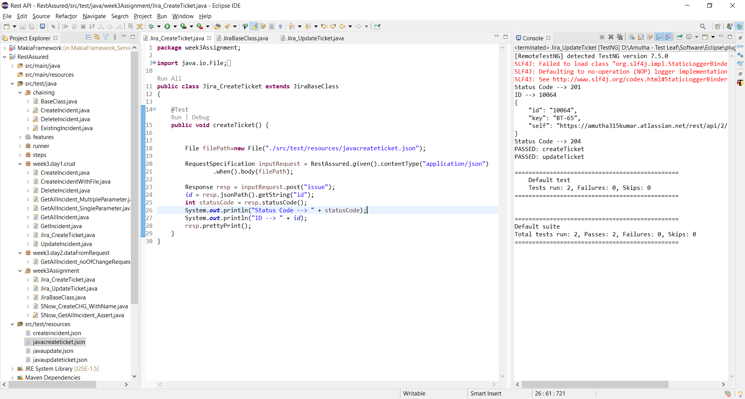

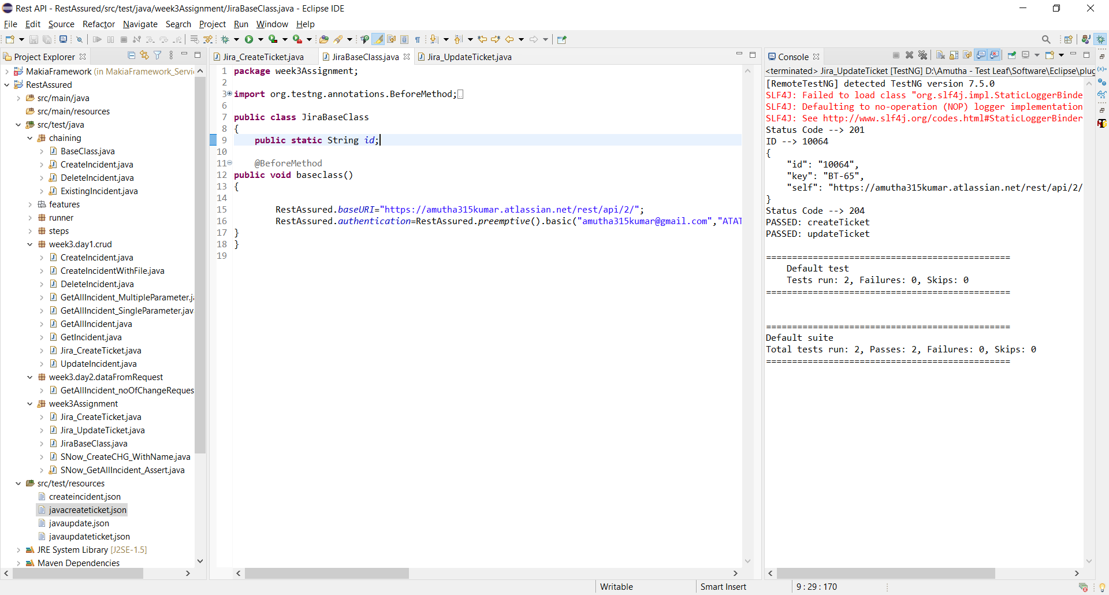

Assignment4:

1. Create a jira issue

2. Update the same issue with an attachment as snapshot 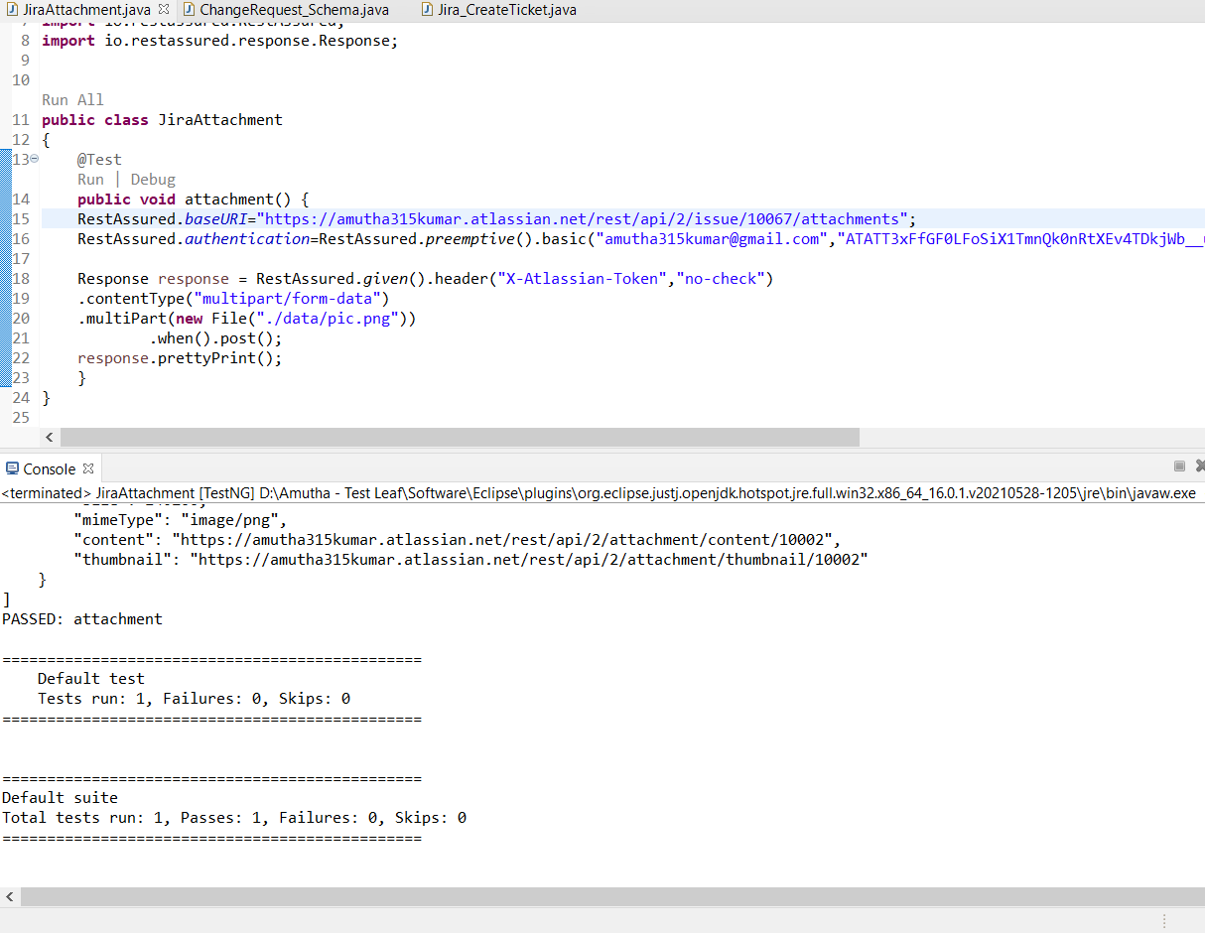

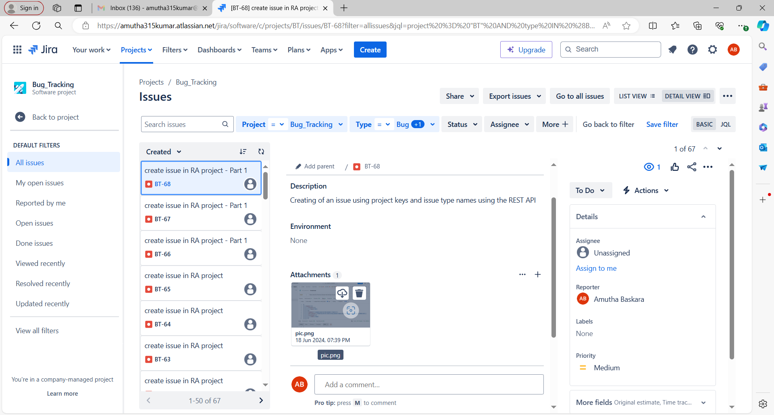

Assignment5:

1. Retrieve all the jira issue which are create within 24 hrs

