**运行结果**

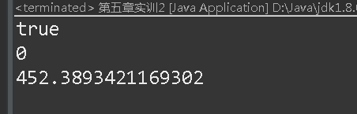

**源代码**

package 黄青林17031110123;

public class 第五章实训2 {

public static void main(String[] args) {

Cicle obj1=new Cicle();

Cicle obj2=new Cicle();

obj1.setRadius(12);

System.***out***.println(obj1.equals(obj2));

System.***out***.println(obj1.compareTo(obj2));

System.***out***.println(obj1.getArea());

}

}

class Cicle implements Comparable<Cicle>{

private double radius;

public Cicle() {

this(1.0);

}

public Cicle(double radius) {

this.radius=radius;

}

public double getRadius() {

return radius;

}

public void setRadius(double radius) {

this.radius=radius;

}

public double getArea() {

return Math.***PI***\*radius*radius;

}

*@Override*

public String toString() {

return "圆的半径="+radius;

}

*@Override*

public int compareTo(Cicle o) {

if (this.getArea()>o.getArea())

return 1;

else if(this.getArea()<o.getArea())

return -1;

else

return 0;

}

public boolean equals(Object obj) {

return this.getArea()==((Cicle)obj).getArea();

}

}