**运行结果**

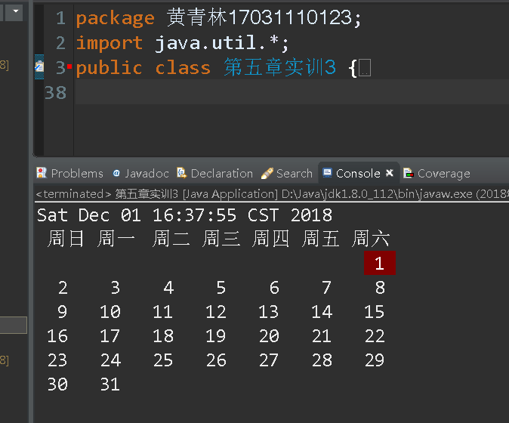

**源代码**

package 黄青林17031110123;

import java.util.*;

public class 第五章实训3 {

public static void main(String[] args) {

// **TODO** Auto-generated method stub

GregorianCalendar now=new GregorianCalendar();

Date date=now.getTime();

System.***out***.println(date.toString());

now.setTime(date);

int today=now.get(Calendar.***DAY_OF_MONTH***);

int month=now.get(Calendar.***MONTH***);

now.set(Calendar.***DAY_OF_MONTH***, 1);

int week=now.get(Calendar.***DAY_OF_WEEK***);

System.***out***.println(" 周日 周一 周二 周三 周四 周五 周六");

for(int i=Calendar.***SUNDAY***;i<week;i++)

System.***out***.print(" ");

while (now.get(Calendar.***MONTH***)==month) {

int day=now.get(Calendar.***DAY_OF_MONTH***);

if(day<10) {

if(day==today)

System.***out***.print("\u001b[0m \u001b[1;41m "+day+" \u001b[0m ");

else

System.***out***.print(" "+day+" ");

}

else {

if(day==today)

System.***out***.print("\u001b[0m\u001b[1;41m "+day+" \u001b[0m ");

else

System.***out***.print(" "+day+" ");

}

if(week==Calendar.***SATURDAY***)

System.***out***.println();

now.add(Calendar.***DAY_OF_MONTH***, 1);

week=now.get(Calendar.***DAY_OF_WEEK***);

}

}

}