**运行结果**

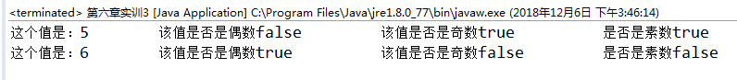

**源代码**

**package** 黄青林17031110123;

**class** Myinteger{

**int** value=32;

**public** Myinteger(**int** value){

**this**.value=value;

}

**public** **int** getValue(){

**return** **this**.value;

}

**public** **boolean** isEven(){

**return** value%2==0?**true**:**false**;

}

**public** **boolean** isEven(**int** value){

**return** value%2==0?**true**:**false**;

}

**public** **boolean** isOdd(){

**return** value%2!=0?**true**:**false**;

}

**public** **boolean** isOdd(**int** value){

**return** value%2!=0?**true**:**false**;

}

**public** **boolean** isPrime(){

**int** i;

**for**(i=2;i<Math.*sqrt*(value);i++){

**if**(value%i==0){

**break**;

}

}

**if**(i<=Math.*sqrt*(value)){

**return** **false**;

}

**return** **true**;

}

**public** **boolean** isPrime(**int** value){

**this**.value=value;

**return** isPrime();

}

}

**public** **class** 第六章实训3 {

**public** **static** **void** main(String[] args) {

// **TODO** Auto-generated method stub

Myinteger int1=**new** Myinteger(5);

System.***out***.println("这个值是："+int1.getValue()+"\t该值是否是偶数"+int1.isEven()+"\t\t该值是否是奇数"+int1.isOdd()+"\t\t是否是素数"+int1.isPrime());

System.***out***.println("这个值是：6\t该值是否是偶数"+int1.isEven(6)+"\t\t该值是否是奇数"+int1.isOdd(6)+"\t\t是否是素数"+int1.isPrime(6));

}

}