# 第四章实训1

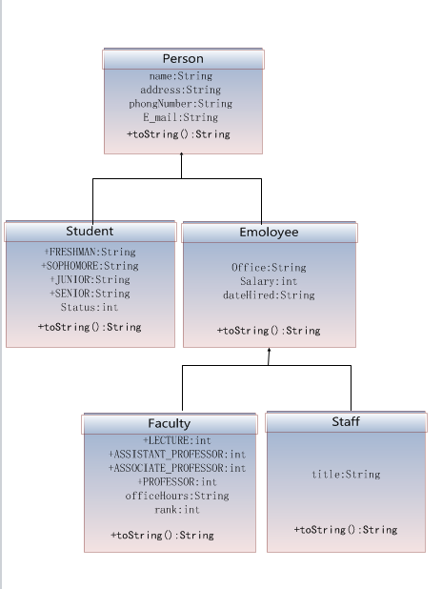

## 源代码

**package** 黄青林17031110123;

**public** **class** 第四章实训1 {

**public** **static** **void** main(String[] args) {

// **TODO** Auto-generated method stub

Student test=**new** Student();

//System.out.println("姓名："+test.name+"\n年级："+test.status+"\n地址："+test.address+"\n手机号："+test.phoneNumber+"\n电子邮件："+test.E_mail);

System.***out***.println(test.E_mail);

test.E_mail="15936075483@163.com";

System.***out***.println(test.E_mail);

}

}

**class** Person{

**protected** String name="黄青林";

**protected** String address="河南省周口市淮阳县四通镇";

**protected** String phoneNumber="17716283195";

**protected** String E_mail="2245411836@qq.com";

@Override

**public** String toString() {

**return** "person "+name;

}

}

**class** Student **extends** Person{

**public** **static** **final** String ***FRESHMAN***="大一";

**public** **static** **final** String ***SOPHOMORE***="大二";

**public** **static** **final** String ***JUNIOR***="大三";

**public** **static** **final** String ***SENIOR***="大四";

**protected** String status=***SOPHOMORE***;

@Override

**public** String toString(){

**return** "student "+name;

}

}

**class** Employee **extends** Person{

**protected** String office="209";

**protected** **int** salary=20000;

**protected** String dateHired="2018年11月16日";

@Override

**public** String toString(){

**return** "Employee "+name;

}

}

**class** Faculty **extends** Employee{

**public** **static** **char** *LECTURER* = 'A';

**public** **static** **char** *ASSISTANT_PROFESSOR* = 'B';

**public** **static** **char** *ASSOCTANT_PROFESSOR* = 'C';

**public** **static** **char** *PROFESSOR* = 'D';

**protected** String officeHours="周一到周五";

**protected** **char** rank=*ASSISTANT_PROFESSOR*;

@Override

**public** String toString(){

**return** "Faculty "+name;

}

}

**class** Staff **extends** Employee{

**protected** String title="第四章实训一";

@Override

**public** String toString(){

**return** "Staff "+name;

}

}

