COMP4901T Computer Vision, Fall 2021

Homework Assignment 5

Scene recognition with bag of words

**Part 1: Build Visual Words Dictionary**

**Q1.1 Extract Filter Responses**

>>> Channel 1 filter index 17

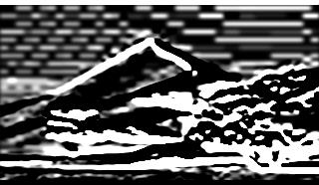

>>> Channel 1 filter index 19



>>> Channel 3 filter index 5



*CLE LAB colour space:*

CIE Lab colour space is the most ready model to simulate the colour perceived by human vision.

Colour in CIE Lab space is denoted by 3 parameters: [L*] is the brightness, [a*] and [b*] is the four unique colours perceived by human eyes, which are red, green, blue and yellow.

Because In this colour space, numerical differences between values roughly correspond to the amount of change humans see between colours.

**Q1.2 Collect sample of points from image**

Results of corner detector on 3 different images.

>>> result 1

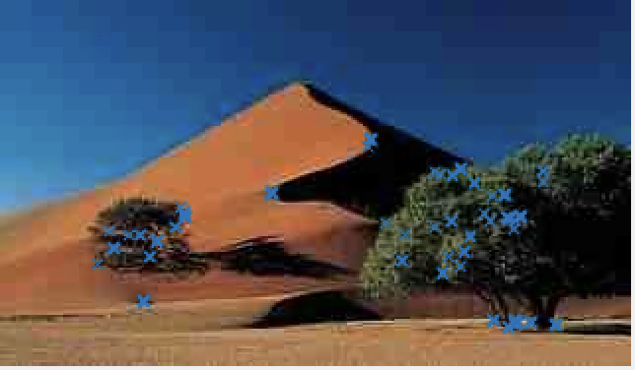

>>>result 2

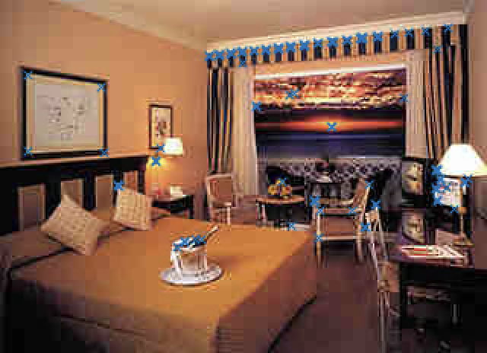

>>>result 3

