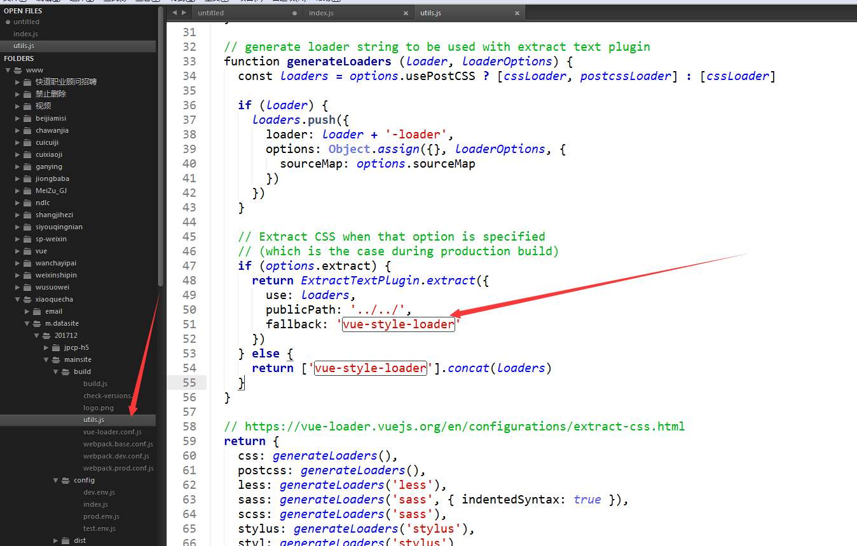  
if (options.extract) {

return ExtractTextPlugin.extract({

use: loaders,

publicPath:'../../',

fallback: 'vue-style-loader'

})

} else {

return ['vue-style-loader'].concat(loaders)

}  
  
  
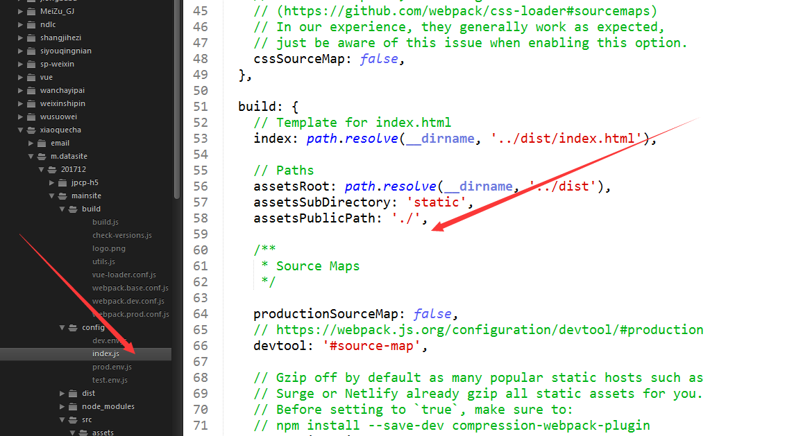  
// Paths

assetsRoot: path.resolve(__dirname, '../dist'),

assetsSubDirectory: 'static',

assetsPublicPath: './',  
  
