Issue 6

Why want to work on issue 6:

There are many languages in the world. A good ontology should support different languages. Nowadays, Chinese is widely used around the world. Therefore, we want our ontology to support Chinese. This is the reason that we plan to work on issue6.

Hypothesise:

Assuming we have fully functional ontology in English, when extending to support Chinese, we hope our ontology to provide same information as in English.

Implementation:

The lexicons we add are owl and Hedwig. For lexicon Hedwig, the gender is set to Neuter, and Number is set to Only Singular. The values of Singular Nominative, Singular Genitive and Singular Accusative are 海德薇 which is the Chinese name of Hedwig. For lexicon owl, the gender is set to Neuter, and Number is set to Only Singular. The values of Singular Nominative, Singular Genitive and Singular Accusative are 猫头鹰 which is the Chinese representation of owl. We also add NL Names for both owl and Hedwig. As a result, every time we refer to owl and Hedwig, it will show 猫头鹰 and 海德薇 respectively. In order to produce a meaningful sentence in Chinese, we need to add a Greek(Chinese) sentence plan corresponding to the default English sentence plan “isA”. The sentence plan is shown below. After adding lexicons, NL names and sentence plan, when generating text for Hedwig, we get “TO 海德薇是一个猫头鹰”. The leading “TO” is cause by build in Greek grammar. We cannot fix this because the only languages NaturalOWL supported are English and Greek. The rest of sentence is translating well into Chinese.

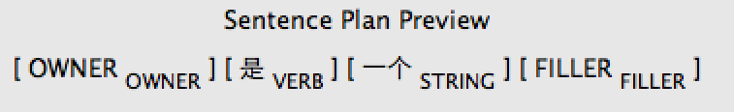

Problems:

One main problem is that NaturalOWL only supports English and Greek. To translate into Chinese, we only can add lexicons, NL names and Sentence Plans under Greek. This will cause an issue that there are some words which is meaningful in Greek sentence but not in Chinese sentence. For example, the sentence “Hedwig is an owl” will be translated to “TO 海德薇是一个猫头鹰”. The leading “TO” is used to identify the gender in Greek language. However, in Chinese, there is no such representation so that the leading “TO” does not have meaning in the translated sentence.

Solution:

The only languages supported are English and Greek. To translate into Chinese, we can add Chinese to Greek. However, we cannot fix the issue that caused by Greek grammar. An example is shown above.