DS Final Report: Health Risk Classification Using Tabular Physiological and Behavioural Data
Student Name: LIU ZHUORONG
Student ID: 26002304855
Course Name: Data Science
DS Final Assignment: Predictive Modeling with Domain-Specific Data
- Introduction
In current society, detecting health risks has long been a crucial problem across the medical and health fields, as well as public health and medical data science. The basic strategy for identifying the health risk status is based on BMI indicators. At the same time, other indicators, such as blood glucose and blood pressure, are strongly associated with health risks. However, unlike the BMI, there are no defined mathematical formulas that can successfully demonstrate such relationships. One practical solution is to propose a pre-trained classification model that takes the values of these medical indicators as input and outputs the health risk level. As a result, the primary target of this report is to train and compare current base models with advanced neural network models to assess their performance in classifying health risk based on medical indicators.
  - Dataset overview
The dataset was obtained from Harvard Dataverse. The original dataset name is “Li_Cahill_finalproj2_data.csv”. This dataset combines raw interview data from NHANES 1999-2012. Overall, this dataset likely contains health-related measurements and demographic information from individuals surveyed in a health study, which can be used for public health analyses, not originally for machine learning tasks. As a result, extensive data preprocessing and feature engineering were conducted in this assignment.
The original dataset contained 71916 records with numerous missing data points. All column data types are numerical. It contained the original survey information, participants’ information, and the medical indicator values. The following lists only the columns used in the subsequent model after data preprocessing.
- RIDSTATR: interview status indicator, categorical variable
- RIDAGEYR: participant’s ages, categorical variable
- RIAGENDR: participant’s gender, categorical variable
- LBXGLU: blood glucose level (mg/dL), continuous variable
- LBXGH: glycohemoglobin (HbA1c) percentage, continuous variable
- BPXSY1– BPXSY4: repeated systolic blood pressure measurements, continuous variable
- BPXDI1 – BPXDI4: repeated diastolic blood pressure measurements, continuous variable
Some columns were created during feature engineering. The detailed explanation will be presented in section 3.0.
- SBP_mean: mean systolic blood pressure, categorical variable
- DBP_mean: mean diastolic blood pressure, continuous variable
- Pulse_Pressure: difference between mean systolic and diastolic pressure, categorical variable
- Glycemic_Risk: binary indicator reflecting elevated glycemic risk, categorical variable
- Health_Risk: final binary variable representing overall health risk status, categorical variable
During model training, the binary value of the variable Health_Risk was used as the output label, and the others were used as input features. The missing values in these columns were handled by either deleting or filling with the mean during data preprocessing. The imbalanced problem was evaluated during model training. At the end, there are 17 features after feature engineering, and 61983 datapoints were used for further model training.
  - Model Usage and Evaluation
To compare performance across different models, 9 models were used in this assignment for the proposed binary classification task: two Gaussian Naïve Bayes models, three Random Forest models, one SVM model, one Gradient Descent model, and two advanced Neural Network models (MLP and TabNet).
To evaluate the model, accuracy, recall, precision, F1-score, confusion matrix, and a statistical test (t-test) were used.

- Related Work and Domain Research
Because of the increasing risk of chronic diseases such as cardiovascular disease and metabolic disorders, and the ageing of society, people and researchers are increasingly focusing on recognising and identifying health risks early, conducting health risk assessments, and providing preventive health care. There is plenty of research showing that machine learning can be used to predict early health risks. As reviewed by Shammi et al., machine learning models have been widely used with structured health data to support preventive healthcare and risk assessment. These applications emphasise the potential of machine learning to analyse medical indicators and cover complex risk patterns.
Most of the hazardous health problems lack accessibility indicators. Some research has shown that using standard medical indicators, such as blood pressure, can be a health risk indicator. Goldsmith pointed out that some medical indicators routinely measure physiological and anthropometric factors, such as blood pressure, metabolic variables, and body mass index, and are strongly associated with health risk. Rather than serving as diagnostic criteria, these indicators can be used for overall health risk for individuals. Such research indicates that existing medical indicators are strongly associated with health risk levels, making them effective inputs for subsequent model training.
Pulse pressure is a well-known medical indicator defined as the difference between systolic and diastolic blood pressures. It used to reflect arterial stiffness and cardiovascular stress load, and was associated with cardiovascular events and mortality risk. According to Robert’s research, pulse pressure provides cardiovascular risk information beyond traditional blood pressure measures. Schram’s journal research also showed that pulse pressure can reflect both glycemic and cardiovascular risk. These findings indicate that pulse pressure can provide supportive information for risk-level classification, for which a pulse pressure column was added as a new feature during model training.
Compared to these medical indicators, BMI is commonly used as a proxy indicator for health risk in large-scale epidemiological studies. Ashwell’s research showed that although BMI cannot capture individual body information in detail, large-scale health risk studies have consistently demonstrated its association with health risks and mortality outcomes. As a result, BMI records in the database were converted to binary risk-level labels based on their high acceptability and apparent correlation with the risk levels.

- Proposed Method
This section presents all methods, algorithms, and model architectures used in the assignments.
  - Data preprocessing
Missing Value
The missing values inside the dataset were calculated using “len(data[data.isna().any(axis=1)])” to see how many rows have at least one missing value. At the same time, a heatmap diagram of the missing value was also conducted by “sns.heatmap(data.isnull(),cbar=False)”.
After deleting the useless column, the missing values in the required column were imputed with the mode and median to preserve model performance while maintaining data balance.
- Using the mode value
  - RIDAGEYR (Age)
  - RIAGENDER (Gender)
  - RIDRETH1(Ethnicity)
- Using the median value
  - LBXGLU (Blood Glucose)
  - LBXGH (Glycated Hemoglobin)
  - BPXSY1-4 (Systolic Blood Pressure)
  - BPXDI1-4 (Diastolic Blood Pressure)
Balanced the Unbalanced Data
The original output labels were binary values 0 and 1, with an 8:2 ratio in their training set. As a result, it’s essential to address the imbalance to ensure the model’s performance. An up-sampling process was conducted to balance the training set. The elements in the smaller class (belonging to label “1”) were replicated to match the amount of data in the bigger class (label “0”).
Data Standardization
For some specific model training, the standard dataset was required. To standardise the dataset, “preprocessing.StandardScaler().fit_transform()” was called. Scaler fitted only on the training set.
Label Encoding
A new column that contains the binary value of risk level was created based on the BMI record and the following condition:
$$Health_Risk=1:BMI≥30$$
$$Health_{Risk}=0:BMI<30$$
The original BMI records were removed from the dataset. The output label of the binary classification task was finally conducted.
Feature Engineering
Firstly, systolic and diastolic blood pressure were averaged to yield overall blood pressure levels (SBP_mean and DBP_mean). At the same time, the original multiple measurements were preserved in all models to provide both detailed and aggregated information (BPXSY1– BPXSY4 and BPXDI1 – BPXDI4).
Secondly, the pulse pressure feature is also computed using the following formula:
$$Pulse Pressure= SBP_{mean}-DBP_{MEAN}$$
Thirdly, for glycemic status, a binary glycemic risk indicator (Glycemic_Risk) was derived from fasting blood glucose and HbA1c records. This indicator can capture overall metabolic risk.
By combining raw measurement records with engineered features, the datasets can provide both low-level medical indicator records and high-level risk summaries. Such a design allows models to learn more flexible representations and to access aggregated features, thereby improving classification performance.
  - Data Analysis
Whenever the dataframe's basic information was needed in the code, “data.head(10)” and “data.info()” were used to get head, datapoint, and datasize information.
To show the distributional relationships between the output label and important input features, several distributional graphs were generated.
Scatter plots and a correlation Matrix were used to show the correlations between features and the more specific distributions of different models across different feature values.
  - Model Architecture
There are 9 models used in this assignment.
Base Models:
- Gaussian Naïve Bayes Models: GaussianNB Classification Model and BernoulliNB Classification Model.
- Random Forest Models: Random Forest Model with 300 trees and Random Forest Model with 500 trees.
- SVM Model: Linear SVC model.
- Gradient Descent: SDG Regressor Model.
Advanced Model:
- Baseline MLP Model
  - Loss Function: Binary Cross-Entropy
  - Optimiser: Adam
  - Table 1 shows the architecture and training hyperparameters.
Architecture | Training Hyperparameter
Input Layer  → Dense (32 units, ReLU) [Hidden Layer]  → Dropout (0.3) [Regularization]  → Dense (16 units, ReLU) [Hidden layer]  → Dropout (0.3) [Regularization]  → Dense (1 unit, Sigmoid) [Output Layer] | Max Epochs = 50  Batch size = 32  Validation split = 0.2  Early Stop: TRUE
Table 1: Architecture and training hyperparameters of Baseline MLP
- Improved MLP
  - Loss Function: Binary Cross-Entropy
  - Optimiser: Adam
  - Table 2 shows the architecture and training hyperparameters
Architecture | Training Hyperparameter
Input Layer  → Dense (128 units)  → Batch Normalization  → ReLU  → Dropout (0.3)  → Dense (64 units)  → Batch Normalization  → ReLU  → Dropout (0.3)  → Dense (1 unit, Sigmoid) | Max Epochs = 100  Batch size = 32  Validation split = 0.2  Early Stop: TRUE
Table 2: Architecture and training hyperparameters of Improved MLP
- TabNet Classifier
  - Loss Function: Binary Cross-Entropy
  - Optimiser: Adam
  - Table 3 shows the architecture and training hyperparameters
Architecture | Training Hyperparameter
Input Features  → Feature Transformer (shared + independent blocks)  → Attentive Transformer (feature mask via entmax)  → Sequential Decision Steps (n_steps = 5)  → Aggregation of step outputs  → Sigmoid Output | Max Epochs = 200  Batch size = 256  Virtual batch size =128  Early stopping patience: 20
Table 3: Architecture and training hyperparameters of TabNet
  - Evaluation Metrics
Single Model Evaluation
- Loss and accuracy score plots were used to assess changes in loss and accuracy over epochs.
- Classification Metrics: Accuracy, Precision, Recall, and F1-score were used.
- Confusion Matrix
Model Comparison
- A box-and-whisker plot across models was created based on the F1 scores.
- Paired t-tests were used to evaluate the statistical significance of differences in model performance based on their accuracy scores.
In the assignments, all model training used the same dataset and the same train-test split method. As a result, the paired t-test can be used to compare the performance of different models.
Null hypothesis: There is no difference between the performances of two different models.
The null hypothesis is evaluated based on the following conditions:
$$p<0.05 :reject null hypothesis$$
$$p≥0.05 :failed reject null hypothesis$$
As a result, if the p-value computed from the t-test between two models is greater than 0.05, the null hypothesis is supported. There is no difference between these two models. In contrast, if the p-value is less than 0.05, the null hypothesis is rejected, and there is a significant difference between the two models, the model with the higher performance score is significantly better.

- Experiment and Results
4.1 Environment Setup
This assignment was conducted using Jupyter Notebook inside VSCode. The Random SEED was set at the beginning with SEED = 855 to ensure replicability. Train-test split following 7:3 for all models.
4.2 Data preprocessing and Data analysis
Missing values and useless columns
The dataset initially had 71916 data points and 22 features. All data points have at least one missing data point. Figures 1 show the heatmaps of the dataset before imputing missing values and removing unnecessary columns.
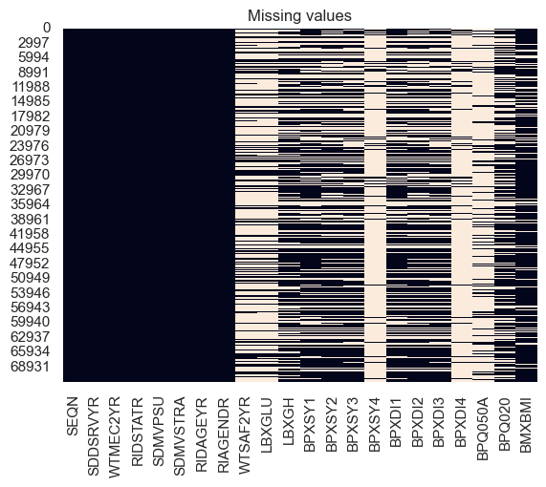
Figure 1: Heatmap of the missing values inside the original dataset.
After applying the missing-value process described in Section 3 and deleting unnecessary columns, the dataset contains no missing values. Figure 2 shows the missing value detection after the missing-value process.
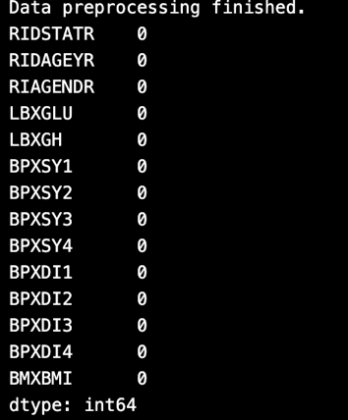
Figure 2: Number of Missing Values after Process
Label Encoding and Feature Engineering
Figure 3 shows the 10 heads of the dataframe after label Encoding and Feature Engineering mentioned in section 3.
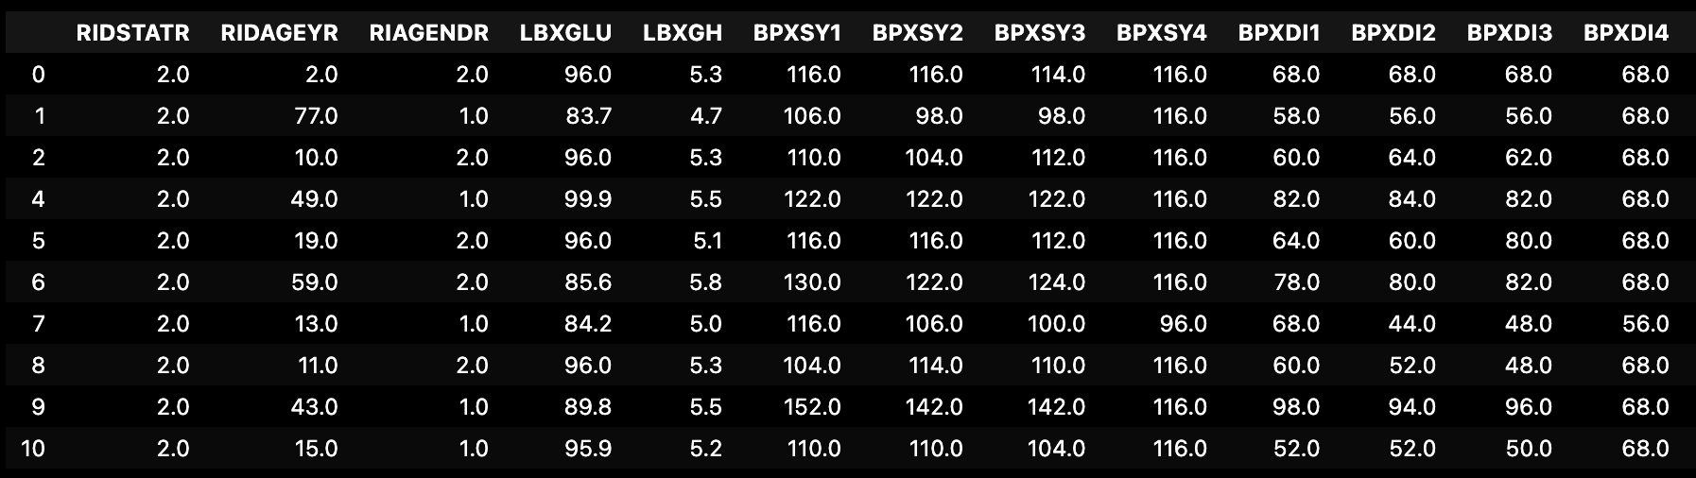
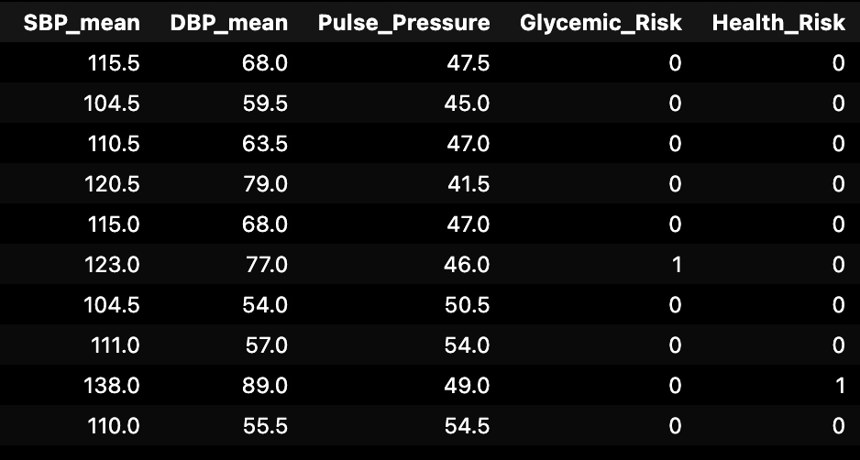
Figure 3: Final Input Data Frame
After feature engineering, there are 18 columns left. The last column (Health_Risk) is the label output created during label encoding. The previous 17 columns are the input features used for model training.
After data processing, all data are numerical, with no missing values, and 17 features, leaving 61983 data points.
Label Distribution via Different Features
After label engineering, it is easy to visualise the relationships between output labels with different features. Figure 4-11 shows the distribution plots.
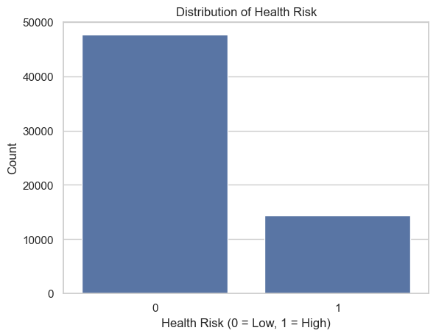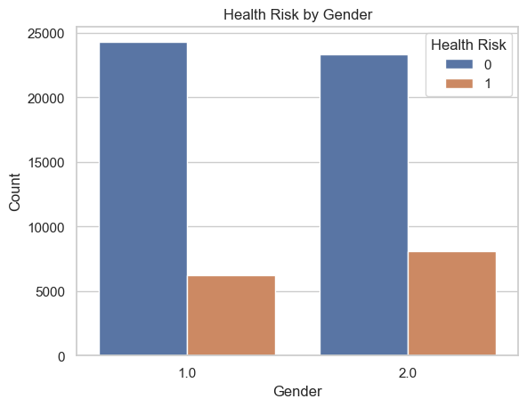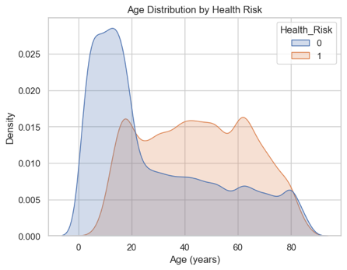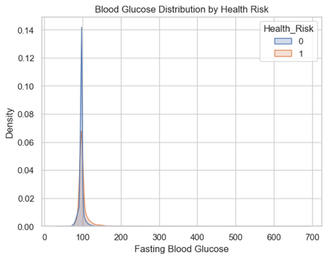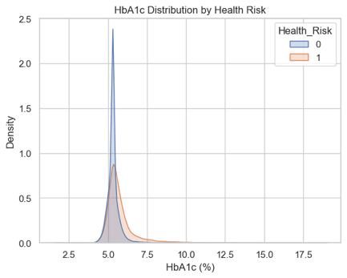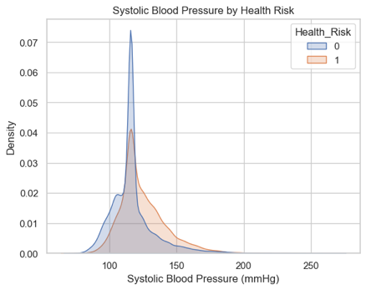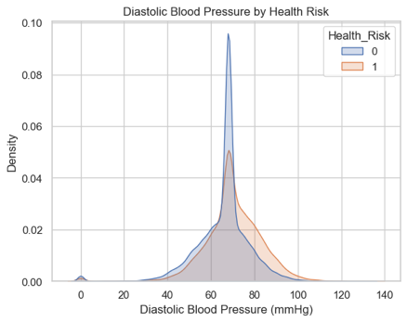
Figure 4-11: Distribution plots between labels and different features.
Figure 12-16 shows the scatter plots of the detailed distribution of the label via different features.
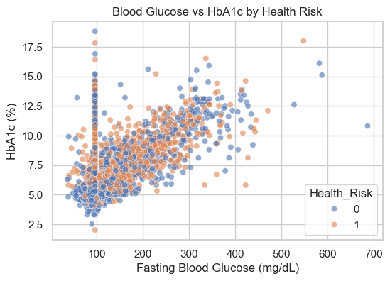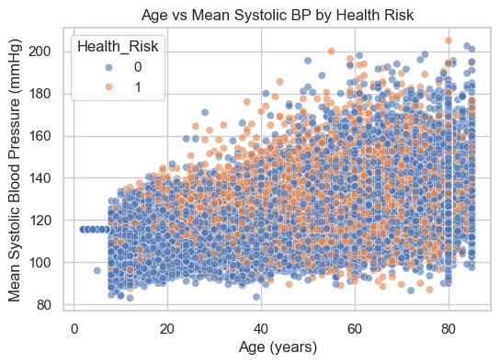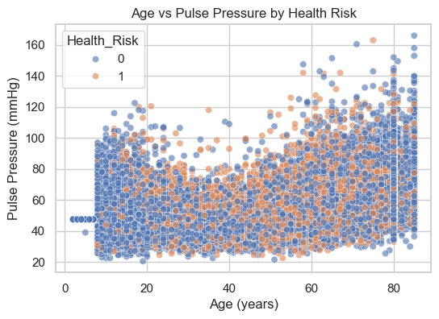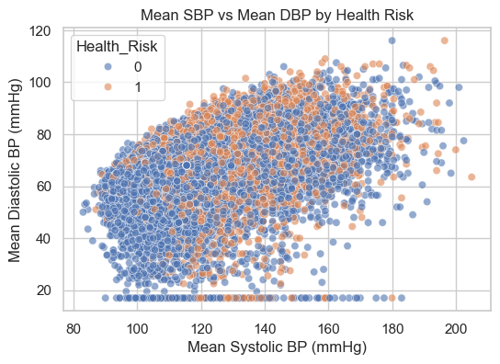
Figure 12-16: Scatter Plot for the distribution
Figure 17 shows the Pearson correlation matrix across different features and the output label.
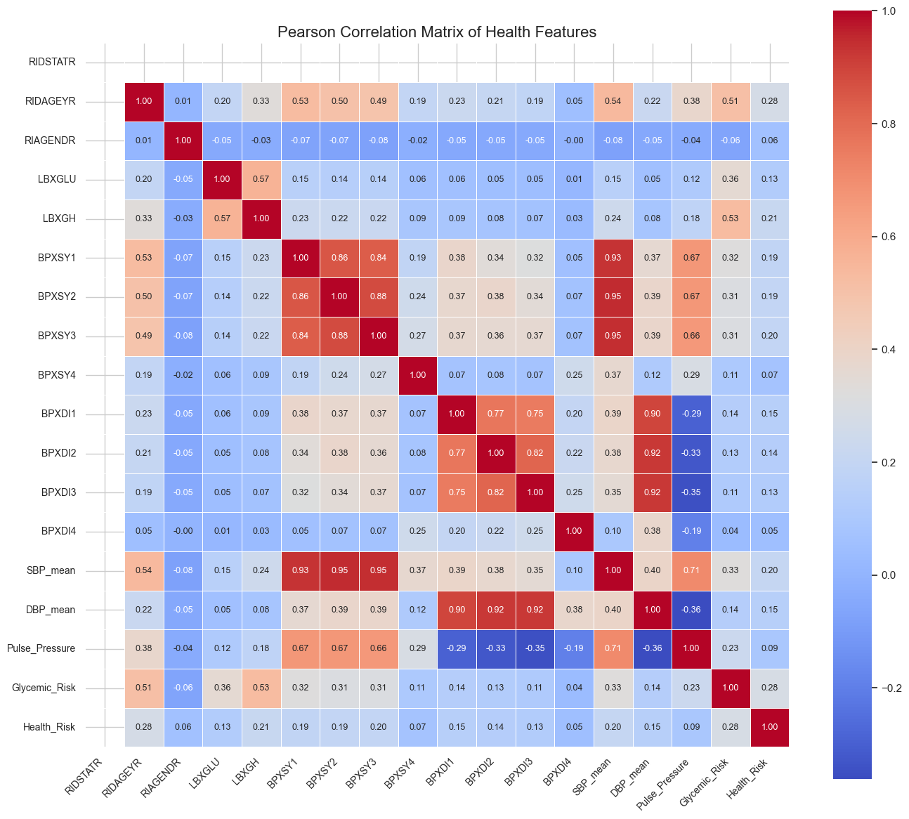
Figure 17: Pearson Correlation Matrix between Features
As shown in Figure 4-17, there is no clear linear relationship between these features and the labels.
As shown in Figure 4, the low health risk label is more common than the high health risk label, which creates an imbalance in the dataset. However, after further data training, the imbalance didn’t significantly affect the model performance of models like linear SVC. That’s because this is a simple binary classification task, with a large data set and sufficient feature detail, so the models can successfully learn the relationships.
Based on these visualisations, humans can’t analyse the relationship between the features and the output label with a simple mathematical formula. These analyses emphasize the importance of using a machine learning model to understand and demonstrate the relationship between features and the output label.
4.3 Model Training and Performance
The following models are trained separately on the balanced and standard datasets.
Table 1 shows the classification performance of the 9 models.
Model | Accuracy | Precision | Recall | F1-score | Performance
GaussianNB | 0.73 | 0.43 | 0.49 | 0.46 | Good recall score but too many mistake
BernoulliNB | 0.74 | 0.43 | 0.47 | 0.45 | Similar like GaussianNB
Random Forest (300 trees) | 0.76 | 0.48 | 0.44 | 0.46 | Accuracy improve but recall decrease
Random Forest (500 trees) | 0.76 | 0.48 | 0.44 | 0.46 | Similar with another random forest model
Linear SVC | 0.70 | 0.4 | 0.62 | 0.49 | Highest recall
Gradient Descent | 0.69 | 0.40 | 0.68 | 0.50 | Recall-driven model
Baseline MLP | 0.69 | 0.39 | 0.58 | 0.47 | Lower accuracy
Improved MLP | 0.50 | 0.31 | 0.97 | 0.47 | Extreme high recall
TabNet | 0.73 | 0.44 | 0.67 | 0.53 | High accuracy, and F1 score
Table 1: Model Performances
As shown in Table 1, the exceptionally high recall score of Improved MLP indicates that it cannot distinguish between the two labels. GaussianNB and BernoulliNB also show F1 scores that are too low. Even their recall is low, and their performance is too low. Two random forest models show the highest accuracy and a stable classification. However, their recall is relatively low, making their mistakes more harmful to classification. Linear SVC and Gradient Descent models achieve relatively low accuracy, mainly because they are linear classification models. The final comparison between Baseline MLP and TabNet shows that TabNet achieves relatively high accuracy and the highest F1 score, making it the best model for this classification task among these 9 models. However, such a comparison still needs support from a statistical test to find the significantly best model.
4.4 Model Comparison
Box and Whisker Plot
Figure 18 shows the box and whisker plot of the F1 score collected through cross-validation. Cause there are 9 models, and the distribution of F1 scores is quite different, the red scatter points show the mean F1 score for easier comparison.
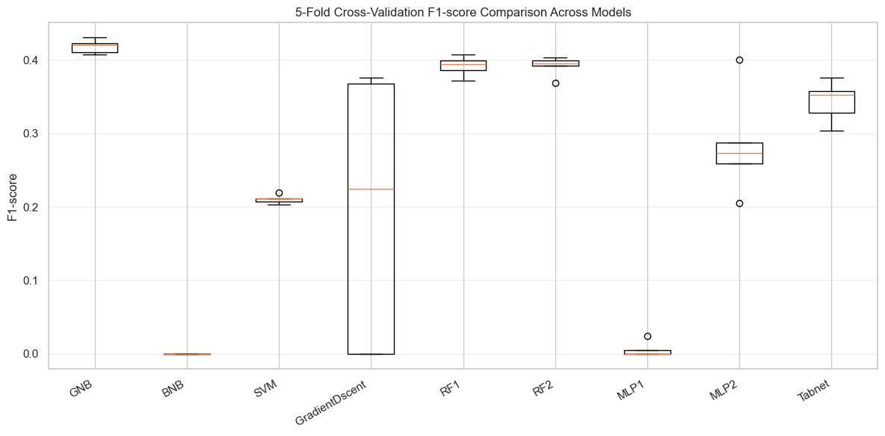
Figure 18: Box and Whisker Plot of the F1 score
As shown in Figure 18, GNB and Random Forest perform best among the 9 models, and TabNet also shows good performance. To confirm that, paired t-tests were conducted.
Paired Statistical t-test
Table 2 shows the results of the paired t-tests.
Model A | Model B | t-value | p-value | Significance | Better Model
GNB | BNB | 100.5895 | <0.001 | Significant | GNB
GNB | SVM | 104.1508 | <0.001 | Significant | GNB
GNB | Gradient Descent | 2.7919 | 0.0492 | Significant | GNB
GNB | RF (300) | 4.9931 | 0.0075 | Significant | GNB
GNB | RF (500) | 4.9374 | 0.0078 | Significant | GNB
GNB | MLP (Baseline) | 112.4400 | <0.001 | Significant | GNB
GNB | MLP (Improved) | 3.8632 | 0.0181 | Significant | GNB
GNB | TabNet | 5.0121 | 0.0074 | Significant | GNB
BNB | Gradient Descent | −2.3185 | 0.0813 | Not significant | No difference
BNB | MLP (Baseline) | −1.2404 | 0.2826 | Not significant | No difference
SVM | Gradient Descent | 0.2030 | 0.8490 | Not significant | No difference
SVM | MLP (Improved) | −2.1988 | 0.0928 | Not significant | No difference
Gradient Descent | RF (300) | −2.4079 | 0.0737 | Not significant | No difference
Gradient Descent | RF (500) | −2.4397 | 0.0712 | Not significant | No difference
Gradient Descent | MLP (Baseline) | 2.2427 | 0.0884 | Not significant | No difference
Gradient Descent | MLP (Improved) | −0.8332 | 0.4516 | Not significant | No difference
RF (500) | TabNet | 3.2114 | 0.0325 | Significant | RF (500)
MLP (Baseline) | MLP (Improved) | −8.5927 | 0.0010 | Significant | MLP (Improved)
MLP (Baseline) | TabNet | −23.2776 | <0.001 | Significant | TabNet
MLP (Improved) | TabNet | −1.6893 | 0.1664 | Not significant | No difference
Table 2: Paired t-test among 9 models

As shown in Table 2, although GNB performed better on F1 scores across these cross-validations, based on previous full performance metrics, GNB shows lower overall performance. As a result, even though GNB passed the t-test, it cannot be assumed to be a good performance model. The final comparison shows that Random Forest and TabNet both perform well compared to other models, based on previous overall metrics and results. However, Random Forest shows better in the t-test. TabNet still needs to be considered.
In summary, the two random forest models and the TabNet model achieve the best performance among all 9 models.

- Conclusion
This report evaluates the accessibility of using tabular-formatted medical indicator values to classify the health risk and systematically compares machine learning models and advanced neural network models. The report, based on extensive health interview data from NHANES, followed a complete data science workflow, including data preprocessing, feature engineering, model training, model evaluation, and statistical comparisons. The experiment results show that, although it lacks a mathematical formula, machine learning can still effectively learn the complex relationship between common medical indicators and health risk.

From a data perspective, effective data preprocessing and feature engineering are key to improving model performance. By combining multiple blood pressure measurements, introducing pulse pressure as a new indicator, and creating an elevated glycemic risk indicator, the dataset provides both the fundamental and aggregated indicators simultaneously. These feature engineering designs ensure the model can capture medical patterns and retain detailed physiological information. The future visualisation and analysis indicate that there is now a clear linear relationship between each feature and the labels, underscoring the need to use a machine learning method to build the model.

After a systematic comparison, TabNet Classifier and Random Forest both show the highest stability and performance on this task. They achieve the highest F1-score while maintaining high accuracy and recall.

In conclusion, this report shows that combining field-knowledge-driven feature engineering with reasonable model selection can significantly improve performance in health risk classification. This report emphasises models such as TabNet, which focus on structured datasets, demonstrating immense value in solving medical and public health problems.

Reference
[1] R. J. Glynn, C. U. Chae, J. M. Guralnik, J. O. Taylor, and D. Levy, “Pulse pressure and mortality in older people,” Arch. Intern. Med., vol. 160, no. 18, pp. 2765–2772, Oct. 2000, doi: 10.1001/archinte.160.18.2765.
[2] M. T. Schram, P. J. Kostense, R. A. J. M. van Dijk, J. M. Dekker, G. Nijpels, L. M. Bouter, R. J. Heine, and C. D. A. Stehouwer, “Diabetes, pulse pressure and cardiovascular mortality: The Hoorn Study,” J. Hypertens., vol. 20, no. 9, pp. 1743–1751, Sep. 2002, doi: 10.1097/00004872-200209000-00017.
[3] M. Ashwell and S. Gibson, “Waist-to-height ratio as an indicator of ‘early health risk’: Simpler and more predictive than using a ‘matrix’ based on BMI and waist circumference,” BMJ Open, vol. 6, no. 3, e010159, Mar. 2016, doi: 10.1136/bmjopen-2015-010159.
[4] S. S. Chugh, “Early identification of risk factors for sudden cardiac death,” Nat. Rev. Cardiol., vol. 7, pp. 318–326, Apr. 2010.
[5] S. A. Shammi, P. Ghosh, A. Sutradhar, F. M. J. Mehedi, M. A. Moni, and T. E. A. de Oliveira, “Advances in artificial intelligence and blockchain technologies for early detection of human diseases,” IEEE Trans. Comput. Social Syst., vol. 12, no. 1, pp. 210–237, 2024, doi: 10.1109/TCSS.2024.3449748.

Appendix:
Importance score between features:
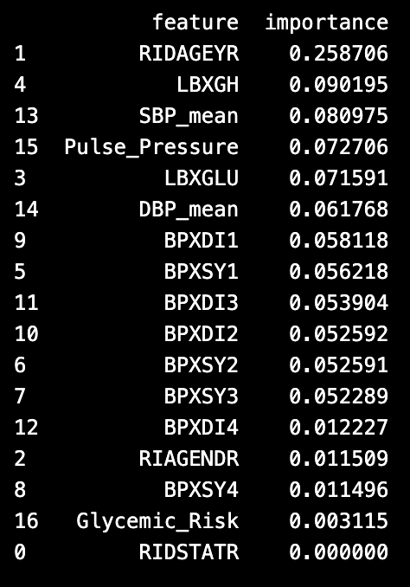

T-test result Matrix:
