Salmonellen-NGS-Cluster-Bericht
Berichtsstand 15.05.2023

Summary
This is a summary of the outbreak. It explains when it started, how many cases there are and describes them by age, sex and region of residence.
There are 14 cases in total.
This paragraph carries on in more detail. It includes some automated summary figures as well as text added manually later by humans. The paragraph will be highlighted with a background colour and appear on the first page, after the table of contents.

Inhaltsverzeichnis
1. Summary 0
2. Heading 1 1
2.1. Sub-heading 1 1
2.2. Sub-heading 2 1
2.2.1. Sub-heading 2.1 1
2.2.2. Sub-heading 2.2 2

14

Heading 1
This is the beginning of this document. It describes all kinds of things and is going to serve as an example template for the rest of the documents. It will have lots and lots of paragraphs, with different styles and headings and bullet points and so on.
This is the second paragraph. It is short and sweet, but I want to see if it has the same style as the paragraph before.

Sub-heading 1
In this sub-heading, we will try out a couple of sentences as well as some bullet points. I don’t want it to use the first paragraph thing if that’s not the style that would normally be used. Here are the bullet points:
- Bullet point 1
- Bullet point 2
- Bullet point 3

Sub-heading 2
In this sub-heading, we will try out some numbered points:
- This is the first point;
- This is the second point, which is much much longer and is going to spill over the line to make sure that we have the correct indentations in all the points;
- This is the third bullet point.

Sub-heading 2.1
Here we will try to construct another paragraph in a sub-sub heading, to check if this is working ok. This is very tiring but I hope it works.
I’m also putting another paragraph in here because I think this should be normal style. Lets see how it comes out when we knit the document.
Now we want to do a page break.

Sub-heading 2.2
In this section we will try adding a figure and a flextable. This will allow us to test that the figure widths are being applied correctly. Maybe we will use officedown in the YAML header to justify the figures and tables properly because the default justification (centre-justified) is annoying.
Here is some in-line R code: this document has 3 header levels. This template is for reports on Salmonella sp. NGS clusters. Don’t forget to translate the figure and table caption pre-words to German with officedown in the YAML header.
Here are some tables with captions:
Tabelle 1: mtcars subset
mpg | cyl | disp | hp | drat | wt | qsec | vs | am | gear | carb
21.0 | 6 | 160 | 110 | 3.90 | 2.620 | 16.46 | 0 | 1 | 4 | 4
21.0 | 6 | 160 | 110 | 3.90 | 2.875 | 17.02 | 0 | 1 | 4 | 4
22.8 | 4 | 108 | 93 | 3.85 | 2.320 | 18.61 | 1 | 1 | 4 | 1
21.4 | 6 | 258 | 110 | 3.08 | 3.215 | 19.44 | 1 | 0 | 3 | 1
18.7 | 8 | 360 | 175 | 3.15 | 3.440 | 17.02 | 0 | 0 | 3 | 2
Tabelle 2: iris subset
Sepal.Length | Sepal.Width | Petal.Length | Petal.Width | Species
5.1 | 3.5 | 1.4 | 0.2 | setosa
4.9 | 3.0 | 1.4 | 0.2 | setosa
4.7 | 3.2 | 1.3 | 0.2 | setosa
4.6 | 3.1 | 1.5 | 0.2 | setosa
5.0 | 3.6 | 1.4 | 0.2 | setosa
5.4 | 3.9 | 1.7 | 0.4 | setosa
Here are some figures. The first one is a boxplot.
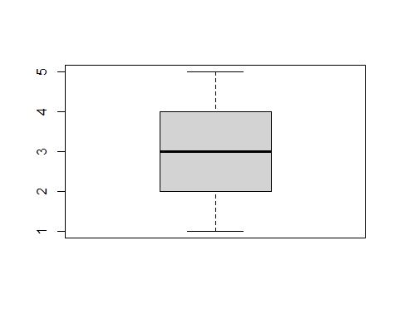
Abbildung 1: A boxplot
The second one is a barplot.
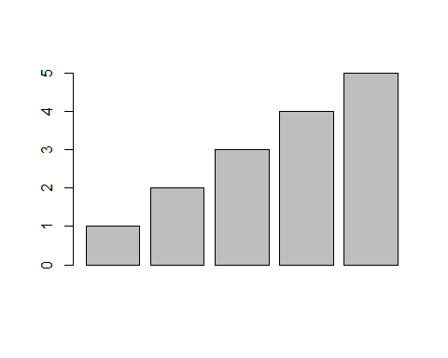
Abbildung 2: What a barplot

