
United States International University – Africa
(USIU-Africa)
School of Science and Technology
Department of Computing

End of Semester Project Report
Project
Smart Health Symptom Checker and Doctor Recommendation System
Course | SWE3090XA – Software Engineering Final Project
Submitted by | Amy Wanjugu Njau
Registration number | 669008
Supervisor | Mr Fredrick Ogore
Submission date | August 2026

Summer Semester 2026

Table of Contents
Declaration

Acknowledgement

Acronyms and Definitions

Abstract

Chapter One: Introduction

1.1 Background of the Study

1.2 Emerging Issues

1.3 Problem Statement

1.4 Objectives

1.5 Justification and Significance

1.6 Scope and Limitations

Chapter Two: Literature Review

2.1 Review of Existing Systems

2.2 Comparative Analysis

2.3 Identified Gaps

2.4 Unique Contributions

Chapter Three: Methodology

3.1 Development Approach

3.2 Project Timeline

3.3 Resources and Tools

3.4 Requirements

Chapter Four: System Design

4.1 Architecture

4.2 Context Diagram

4.3 Data Flow Diagram

4.4 Entity Relationship Diagram

4.5 API Contract

4.6 Security and Privacy Design

Chapter Five: Implementation

5.1 Codebase Structure

5.2 Symptom-Condition Knowledge Base

5.3 Diagnostic Engine

5.4 API Endpoint

5.5 Provider Recommendation

5.6 Mobile Client

5.7 User Interface

5.8 Key Modules and Algorithms

Chapter Six: Testing and Validation

6.1 Testing Strategy

6.2 Automated Test Results

6.3 Acceptance Test Cases

6.4 Ranking Evaluation

6.5 Non-Functional Verification

Chapter Seven: Results and Discussion

7.1 Objectives Achieved

7.2 Discussion

7.3 Limitations

Chapter Eight: Conclusions

8.1 Conclusions

8.2 Recommendations

8.3 Closing Remarks

References

Appendices

Appendix A: Repository

Appendix B: Running the System

Appendix C: Knowledge Base Coverage

Declaration
I, Amy Wanjugu Njau, registration number 669008, declare that this report is my own original work and that it has not been submitted, in whole or in part, for any other award at this or any other university. All sources consulted have been acknowledged in the text and listed in the references. Where the work of others has been used, it is cited accordingly.
The application described in this report is a guidance tool developed for academic purposes. Its knowledge base has not been clinically validated and it is not a medical device.
Signature: ………………………………….. Date: …………………………………..
Amy Wanjugu Njau (669008)
Supervisor’s approval
This report has been submitted for examination with my approval as the university supervisor.
Signature: ………………………………….. Date: …………………………………..
Mr Fredrick Ogore

Acknowledgement
I thank my supervisor, Mr Fredrick Ogore, for his guidance and feedback throughout this project, and the faculty of the School of Science and Technology at USIU-Africa for the grounding that made the work possible. I am grateful to my family and colleagues for their encouragement over the course of the semester.

Acronyms and Definitions
Term | Meaning
API | Application Programming Interface, the contract through which the client and server exchange data
DFD | Data Flow Diagram
ERD | Entity Relationship Diagram
HTTPS | Hypertext Transfer Protocol Secure, HTTP carried over an encrypted connection
JSON | JavaScript Object Notation, the data-interchange format used by the API
Knowledge base | The declarative set of conditions and their weighted symptoms that the engine scores against
mHealth | Mobile health, the delivery of health services and information via mobile devices
REST | Representational State Transfer, the architectural style of the API
Rule-based engine | Inference that applies explicit, human-readable rules rather than a learned model
Specialist routing | Mapping a probable condition to the type of practitioner who treats it
Top-1 hit rate | The proportion of test cases where the expected condition is ranked first
UAT | User Acceptance Testing

Keywords: mHealth, symptom checker, rule-based inference, explainable systems, specialist recommendation, geolocation, Flutter, REST API.

Abstract
Access to timely medical guidance remains constrained in many developing regions, where low doctor-to-patient ratios, travel distance, and consultation cost combine to delay care. This project delivers the Smart Health Symptom Checker and Doctor Recommendation System: a cross-platform mobile application that accepts user-reported symptoms, returns a ranked list of probable conditions together with the reasoning behind each ranking, recommends the appropriate medical specialist, and locates nearby qualified providers using the user’s real-time position.
The system is built on a three-tier architecture: a Flutter mobile client, a Node.js and Express REST API hosting a rule-based diagnostic engine, and a swappable data and location tier. The diagnostic engine scores each candidate condition by summing the weights of the symptoms the user reported and dividing by that condition’s maximum possible weight, producing a normalised confidence value. Every score therefore traces back to specific named symptoms, which the interface surfaces to the user. This explainability is the project’s central design commitment and the principal reason a rule-based approach was chosen over an opaque machine-learning model in a safety-sensitive domain.
The delivered system implements a knowledge base of 15 conditions, 35 symptoms, and 9 specialist types, exposes five REST endpoints, and is verified by an automated suite of 15 tests, all of which pass. Functional and non-functional requirements defined at the midterm stage were met, including deterministic results, graceful degradation when location permission is denied, and a guidance disclaimer attached centrally to every diagnosis response so that it cannot be omitted. The report documents the requirements, design, implementation, testing, and results, and sets out the security hardening, clinical validation, and persistence work required before any real-world deployment.

Chapter One: Introduction

1.1 Background of the Study
Access to timely and accurate medical guidance remains a major challenge across many parts of the world, and particularly in developing regions where the ratio of doctors to patients is critically low. According to the World Health Organization (2023), large populations in low- and middle-income countries continue to face shortages of healthcare workers, long travel distances to facilities, and high out-of-pocket consultation costs. As a result, many individuals delay seeking professional medical attention, not because they are unwilling, but because they are uncertain about the severity of their symptoms or do not know which type of practitioner to consult.
At the same time, mobile-phone penetration in these regions has grown rapidly, placing internet-connected devices in the hands of populations that were previously difficult to reach through conventional healthcare infrastructure. This convergence creates a meaningful opportunity for mobile health solutions to bridge part of the gap between symptom onset and appropriate care, an approach the World Health Organization (2021) sets out as a priority in its global strategy on digital health.
The Smart Health Symptom Checker and Doctor Recommendation System responds to this opportunity by providing a digital-first tool that helps users make informed health decisions. By entering their symptoms into a mobile application, users receive condition suggestions generated through a transparent rule-based analysis engine. The system then advises which type of medical specialist to consult, and recommends nearby qualified providers based on the user’s real-time location. The application acts as an accessible first point of guidance: not a replacement for professional care, but a bridge toward it.

1.2 Emerging Issues
Several emerging issues motivate and shape this project.
Rising demand for self-directed care. Patients increasingly turn to online sources to interpret their symptoms before deciding whether and where to seek help. Unstructured web searches, however, often produce alarming or contradictory information.
Proliferation of digital symptom checkers. A growing number of commercial symptom-checking applications exist, but many are designed for high-income contexts, require constant connectivity, or do not connect the user to local, reachable care.
Localisation gap. Few existing tools account for the realities of developing regions: nearby facilities, locally available specialists, and low-bandwidth conditions.
Trust, safety, and explainability. As automated health tools become more common, there is increased scrutiny of how recommendations are generated. Rule-based systems offer transparency that opaque models cannot easily match, which is valuable in a sensitive domain such as health.
Data privacy expectations. Handling even limited health-related data raises legitimate concerns around consent, storage, and confidentiality that any responsible solution must address.

1.3 Problem Statement
Many individuals lack access to timely, affordable, and location-aware medical guidance, leading to delayed diagnoses and preventable deterioration of their health. Existing solutions are either too generic to be trustworthy, too expensive for the average user, or not localised to the user’s context, failing to connect them to qualified care that is actually within reach.
There is therefore a need for an accessible mobile application that can interpret a user’s symptoms, suggest probable conditions in an explainable manner, recommend the appropriate type of specialist, and direct the user to nearby qualified healthcare providers, all through a simple interface usable by people with varying levels of digital literacy.

1.4 Objectives

1.4.1 Main Objective
To design and develop a cross-platform mobile application that accepts user-reported symptoms, returns a ranked list of probable medical conditions, recommends an appropriate medical specialist, and identifies nearby qualified healthcare providers based on the user’s real-time location.

1.4.2 Specific Objectives
- To design and develop a mobile application that accepts user-inputted symptoms and returns a ranked list of possible medical conditions.
- To implement a rule-based diagnostic engine capable of mapping symptom combinations to probable diseases with reasonable accuracy.
- To integrate a specialist recommendation module that suggests the appropriate type of doctor based on the predicted condition.
- To incorporate location-based services that identify and recommend nearby qualified healthcare providers or medical facilities.
- To provide a simple, intuitive user interface accessible to users with varying levels of digital literacy.

1.5 Justification and Significance
This project is justified by the persistent gap between the demand for healthcare guidance and the supply of accessible professional care in developing regions. By combining symptom analysis with localised, location-aware provider recommendation, the system addresses a need that existing tools only partially serve.
For users, it provides a free, easy-to-use first point of guidance that reduces uncertainty, encourages earlier care-seeking, and helps users reach the right kind of practitioner faster. For the healthcare system, guiding patients toward the appropriate specialist and nearby facilities can reduce mis-directed visits and ease pressure on overstretched general services. For underserved communities, the emphasis on localisation and a lightweight, explainable approach suits low-connectivity environments that commercial alternatives often overlook. Academically, the project demonstrates the practical application of software-engineering principles, including requirements engineering, system design, rule-based inference, API integration, automated testing, and Agile delivery, to a real-world problem of social value.

1.6 Scope and Limitations
The delivered system covers the full path from symptom entry to nearby-provider recommendation on Android, with an architecture that permits an iOS build without a rewrite. It does not extend to telemedicine consultation, appointment booking, electronic health records, payments, or prescription handling.
Three limitations are stated plainly here and revisited in Section 7.3. First, the knowledge base is an educational rule set curated for this project and has not been clinically validated; the application is a guidance tool and not a medical device. Second, the query log is held in memory and is therefore lost when the server restarts. Third, the deployed prototype has no user authentication, so query history is held in memory in the app rather than being persisted or tied to an account, and is lost when the application closes.

Chapter Two: Literature Review
This chapter reviews existing symptom-checker and digital-health systems, compares their capabilities against the goals of this project, identifies the gaps they leave open, and states the unique contributions of the delivered system.

2.1 Review of Existing Systems

2.1.1 WebMD Symptom Checker
WebMD (2024) provides a widely used web-based symptom checker that allows users to select symptoms on a body map and returns a list of possible conditions with accompanying articles. It is information-rich but primarily an educational reference; it does not connect users to specific local practitioners and is oriented toward a North American audience and healthcare context.

2.1.2 Ada Health
Ada Health (2024) is a mobile symptom-assessment application that conducts a structured, conversational interview and returns possible causes together with guidance on next steps. It is well designed and clinically informed, but it is built primarily for connected, higher-income markets, does not focus on surfacing nearby local providers, and its underlying assessment logic is largely opaque to the end user.

2.1.3 Babylon Health
Babylon Health (2023) combined symptom checking with telemedicine consultations, allowing users to speak with clinicians remotely. While powerful, it depends on reliable connectivity, an available clinician network, and a subscription or payment model, which limits its accessibility in low-resource settings.

2.1.4 Buoy Health and K Health
Buoy Health (2024) and K Health (2024) both use data-driven approaches to triage symptoms and suggest next steps, with K Health additionally drawing on large clinical datasets. These tools illustrate the value of structured triage but, like the others, are tailored to specific national healthcare systems and do not provide localised facility recommendation for developing-region users.

2.1.5 Academic Evaluations
Independent academic audits of symptom checkers, notably the BMJ audit study by Semigran et al. (2015), found that the diagnostic and triage accuracy of these tools varies considerably. Later work reached similar conclusions: Chambers et al. (2019) reviewed digital and online symptom checkers used for urgent care and reported wide variation in accuracy and safety, while Wallace et al. (2022) found diagnostic accuracy in symptom checkers to remain inconsistent across conditions. That body of work underpins two design principles adopted here: such tools should be positioned explicitly as guidance rather than diagnosis, and an explainable, well-validated rule base is preferable to an opaque one in a safety-sensitive domain.

2.2 Comparative Analysis
The table below compares representative existing systems against the core capabilities targeted by this project.
System | Symptom analysis | Specialist recommendation | Location-aware providers | Explainable logic | Suited to low connectivity
WebMD Symptom Checker | Yes | Partial | No | Partial | No
Ada Health | Yes | Partial | No | No | No
Babylon Health | Yes | Yes, via clinician | Partial | No | No
Buoy Health / K Health | Yes | Partial | No | No | No
Smart Health (this project) | Yes | Yes | Yes | Yes | Partial

Table 2.1: Comparative analysis of existing symptom-checker systems.

2.3 Identified Gaps
The review reveals four consistent gaps. Most tools are designed for specific high-income healthcare systems and do not surface nearby, reachable providers relevant to a developing-region user. Few systems explicitly translate a probable condition into a clear recommendation of which type of specialist to consult. Many modern tools provide little visibility into how a recommendation was produced, which undermines trust in a sensitive domain. Finally, solutions depending on continuous connectivity, large models, or paid consultations are poorly suited to low-resource environments.

2.4 Unique Contributions
The delivered system addresses those gaps through four contributions. It provides integrated end-to-end guidance in a single workflow, moving the user from symptom entry to probable condition, to the right specialist, to a nearby provider. It uses real-time geolocation to recommend providers within reach of the user. It applies explainable rule-based inference over a transparent weighted symptom-condition matrix whose reasoning is surfaced in the interface rather than hidden. And it is deliberately lightweight, targeting varying digital-literacy levels and lower-connectivity conditions.

Chapter Three: Methodology

3.1 Development Approach
The project followed an Agile software-development methodology implemented through short, iterative sprints. Agile was selected over a strictly sequential approach such as Waterfall because a health-guidance tool benefits from continuous testing, frequent feedback, and incremental refinement, particularly for the diagnostic rule base, which had to be validated and tuned progressively rather than fixed up front.
Development was organised into four phases. The requirements and research phase reviewed existing symptom-checker solutions, defined the symptom-condition rule base, and settled the architecture. The design phase produced the data models, the API contract, and the inference design. The development and integration phase built the mobile application, implemented the diagnostic engine, added geolocation, and connected the backend. The testing phase covered unit, integration, and acceptance testing.

3.2 Project Timeline
The schedule spanned approximately ten weeks. All milestones are complete.
Week | Activity | Deliverable | Status
1-2 | Requirements gathering and literature review | Requirements document | Complete
3-4 | System design, data models, API contract | Design models and wireframes | Complete
5-6 | Database design, backend setup, rule-engine development | Working rule engine | Complete
7-8 | Mobile UI development: symptom input and results | Alpha build | Complete
9 | Geolocation integration and specialist recommendation | Beta build with location | Complete
10 | End-to-end testing, fixes, documentation, submission | Tested application and report | Complete

Table 3.1: Project timeline and final status.

3.3 Resources and Tools
Development used a personal computer, an Android device, and the Android emulator for testing. The software stack is summarised below.
Category | Technology | Purpose
Frontend | Flutter (Dart) | Cross-platform mobile interface, Android first, iOS-ready
Backend | Node.js with Express | REST API and integration mediator
Diagnostic logic | Rule-based inference engine | Weighted symptom-condition scoring
Data | JSON data store, Firebase Firestore ready | Knowledge base, specialists, providers, query log
Location | Google Maps Platform, device geolocation | Nearby provider discovery
Testing | Node.js built-in test runner | Automated unit and integration tests
Version control | Git and GitHub | Source-code management
Tooling | VS Code, Android Studio | Development, debugging, emulation

Table 3.2: Tools and technologies.

3.4 Requirements

3.4.1 Functional Requirements
The system shall allow users to input symptoms through structured selection; analyse them with the rule-based engine and return a ranked list of probable conditions; recommend the appropriate specialist for the top-ranked condition; detect the user’s location with permission and recommend nearby providers; display a clear disclaimer that the application provides guidance only; and handle denial of location permission gracefully while still providing symptom and specialist guidance.

3.4.2 Non-Functional Requirements
Usability requires an interface that is simple for users with varying digital literacy. Performance requires symptom analysis to return within a few seconds on a typical mobile connection. Reliability requires the engine to produce consistent results for identical input and to degrade gracefully when services are unavailable. Security and privacy require health and location data to be handled with consent, minimisation, and confidentiality. Portability requires an Android-first architecture that permits iOS extension without a rewrite. Maintainability requires the rule base to accept new symptoms, conditions, and specialists without changes to core logic.

Chapter Four: System Design

4.1 Architecture
The system adopts a three-tier architecture. The presentation layer is the Flutter mobile application, responsible for symptom input, displaying ranked results and specialist advice, and listing nearby providers. The application layer is the Node.js and Express backend, which exposes REST endpoints, hosts the rule-based engine, performs specialist mapping, and orchestrates calls to the location service. The data layer holds the knowledge base, specialist mappings, provider records, and an anonymised query log, with the Google Maps Platform supplying external place data.
A deliberate design decision is that the mobile client contains no diagnostic logic whatsoever. It collects input, calls the API, and maps JSON responses into typed models. All reasoning lives behind the API boundary, which keeps the client thin, makes the engine independently testable, and allows the rule base to be corrected without shipping a new app version.
This figure describes the system as delivered, in which the data tier is the file-backed local store. The Firestore implementation exists as a documented stub behind the same interface and is not active; Section 7.3 records this, and Section 8.2 lists completing it as the next data-tier task.

4.2 Context Diagram
The context diagram represents the system as a single process interacting with its external entities: the user, who submits symptoms and location permission and receives guidance; the Google Maps Platform, which receives location and specialty queries and returns nearby places; and the data store, which supplies symptom-condition rules and specialist mappings.

4.3 Data Flow Diagram
The level-1 diagram decomposes the system into five processes: capture symptoms, analyse symptoms with the rule engine, recommend a specialist, recommend nearby providers, and present results. Data stores comprise the knowledge base, the specialist mapping, the provider store, and the anonymised query log.

4.4 Entity Relationship Diagram
The data model is organised around seven entities. The associative entity Condition_Symptom carries the rule weight, which is what makes the knowledge base tunable without schema changes.
Entity | Key fields | Relationship
User | user_id  (PK), name, location, created_at | Initiates many queries
Symptom | symptom_id  (PK), name, category | Linked to conditions, many-to-many
Condition | condition_id  (PK), name, description, severity | Linked to symptoms; maps to one specialist
Condition_Symptom | condition_id  (FK),  symptom_id  (FK), weight | Associative entity holding the rule weight
Specialist | specialist_id  (PK), type, description | Recommended by many conditions
Provider | provider_id  (PK), name, specialty, latitude, longitude, rating | Offers one or more specialist types
Query | query_id  (PK),  user_id  (FK), symptoms, result, timestamp | Belongs to one user

Table 4.1: Core entities of the data model.

4.5 API Contract
The API boundary is the integration contract between client and server. Five endpoints are exposed.
Method and path | Purpose
POST /api/diagnose | Accepts a symptom set; returns ranked conditions, specialist, disclaimer
POST /api/providers | Accepts specialist and coordinates; returns ranked nearby providers
GET /api/symptoms | Returns the symptom catalogue for the input screen
GET /api/specialists | Returns the specialist catalogue
GET /api/health | Liveness check used by the test suite and monitoring

Table 4.2: REST API surface.
The end-to-end exchange is shown in Figure 4.5.

4.6 Security and Privacy Design
Three measures are implemented in the delivered system. The Google Maps Platform key is held server-side in environment variables and is never exposed to the client, which is why every Maps call is made by the backend rather than the app. Request bodies are validated before processing, and malformed requests are rejected with a 400 status and a clear message. The error handler never leaks internal detail on a server error.
Transport security is a design requirement that the prototype does not yet meet. The architecture assumes HTTPS between client and server, but the development build communicates over plain HTTP against a local backend, so TLS termination remains a deployment task rather than a delivered feature. It is recorded as such in Section 7.3 rather than presented as done.
Data minimisation is applied to the query log: it records the symptom set and the outcome for analytics but is not tied to an identified person in the prototype. Location is read only after explicit user permission, and denial is a supported path rather than an error.
Section 7.3 records honestly the hardening that remains outstanding, since the prototype was assessed against a production security bar and did not yet meet it.

Chapter Five: Implementation

5.1 Codebase Structure
The repository is organised into three top-level areas: backend/ for the API and engine, mobile/ for the Flutter client, and docs/ for the design figures and reports. Within the backend, the engine is isolated from all input and output so that it can be tested directly.
Path | Responsibility
src/services/diagnosisEngine.js | Pure scoring logic, no input or output
src/services/diagnosisService.js | Orchestrates engine, specialist lookup, query log, disclaimer
src/services/providerService.js | Mock and Google provider lookup with a cache
src/routes/ | The diagnose, providers and catalogue endpoints
src/middleware/validate.js | Request-body validation returning 400 responses
src/repositories/ | Data-store factory, local and Firestore implementations
src/data/ | Knowledge base, symptoms, specialists, providers
src/config/index.js | All environment reads and the central disclaimer
src/app.js | Wires the routers together and serves  GET /api/health

Table 5.1: Backend codebase structure.

5.2 Symptom-Condition Knowledge Base
The knowledge base encodes each condition as a set of weighted symptoms, where the weight expresses how strongly a symptom indicates that condition. Keeping it declarative means new conditions can be added without touching engine code, which satisfies the maintainability requirement directly.
{ "id": "malaria", "name": "Malaria", "specialist": "General Physician", "severity": "high", "description": "A mosquito-borne infectious disease causing cyclical fever, chills, and flu-like illness.", "symptoms": { "fever": 0.9, "chills": 0.8, "headache": 0.5, "fatigue": 0.4, "nausea": 0.4, "sweating": 0.6, "muscle_aches": 0.4 } }
The delivered base holds 15 conditions spanning three severity levels, 35 symptoms, and 9 specialist types. Its metadata block states explicitly that the rule set is educational and not clinically validated.

5.3 Diagnostic Engine
The engine is the core contribution. For each condition it sums the weights of the symptoms the user reported, divides by that condition’s maximum possible weight, and returns both the normalised score and the list of symptoms that contributed to it.
function scoreCondition(condition, userSymptoms) { const weights = condition.symptoms || {}; const maxScore = Object.values(weights).reduce((a, b) => a + b, 0); if (maxScore <= 0) return { score: 0, matched: [] }; let matchedWeight = 0; const matched = []; for (const symptom of userSymptoms) { if (Object.prototype.hasOwnProperty.call(weights, symptom)) { matchedWeight += weights[symptom]; matched.push(symptom); } } return { score: matchedWeight / maxScore, matched }; }
Ranking then filters below a configurable threshold of 0.2, sorts by descending confidence, and caps the result count. Input is de-duplicated defensively before scoring, which is what makes repeated symptom submissions safe.
A worked example makes the arithmetic concrete. A user reporting fever, headache, and chills matches malaria on weights 0.9, 0.5, and 0.8, summing to 2.2. The maximum possible weight for malaria is 4.0. The normalised confidence is therefore 2.2 / 4.0, or 55 per cent, and the interface reports exactly those three symptoms as the reason. Nothing about the number is hidden from the user.

5.4 API Endpoint
The route layer is deliberately thin: validation runs as middleware, the service performs the work, and errors are delegated to the central handler.
router.post('/', validateDiagnoseBody, async (req, res, next) => { try { const { symptoms } = req.body; const payload = await runDiagnosis(symptoms); res.json(payload); } catch (err) { next(err); } });

5.5 Provider Recommendation
The provider service supports two interchangeable sources selected by configuration. The mock source ranks the bundled provider records by haversine distance from the user. The Google source queries the Maps Platform Nearby Search server-side using the specialist’s search keywords (Google Developers, 2024), and caches responses for a configured period to contain both latency and billing. Because both sources satisfy the same interface, neither the routes nor the client change when the source is switched.

5.6 Mobile Client
The Flutter client presents a tabbed shell with Home, Check, History, and Profile. The symptom-input screen collects a symptom set, the results screen renders ranked conditions with their explainability chips, and the providers screen lists nearby practices with a working directions action. A single service class is the only point of contact with the API.
/// POST /api/diagnose -> ranked conditions + specialist + disclaimer. Future<DiagnosisResult> getDiagnosis(List<String> symptoms) async { final res = await _post('/api/diagnose', {'symptoms': symptoms}); return DiagnosisResult.fromJson(res); }
Error handling is centralised in the private helpers rather than repeated at each call site, which is what allows the interface to show a readable message with a retry action instead of crashing when the backend is unreachable.
Map<String, dynamic> _decode(http.Response res) { final decoded = res.body.isNotEmpty ? jsonDecode(res.body) as Map<String, dynamic> : <String, dynamic>{}; if (res.statusCode >= 200 && res.statusCode < 300) { return decoded; } final message = decoded['error']?.toString() ?? 'Request failed (${res.statusCode}).'; throw ApiException(message); }

5.7 User Interface
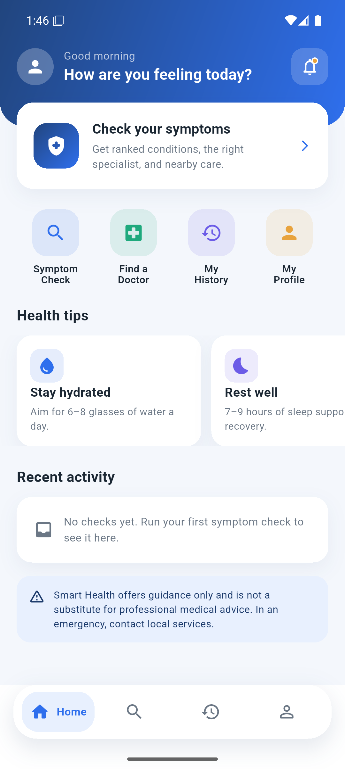
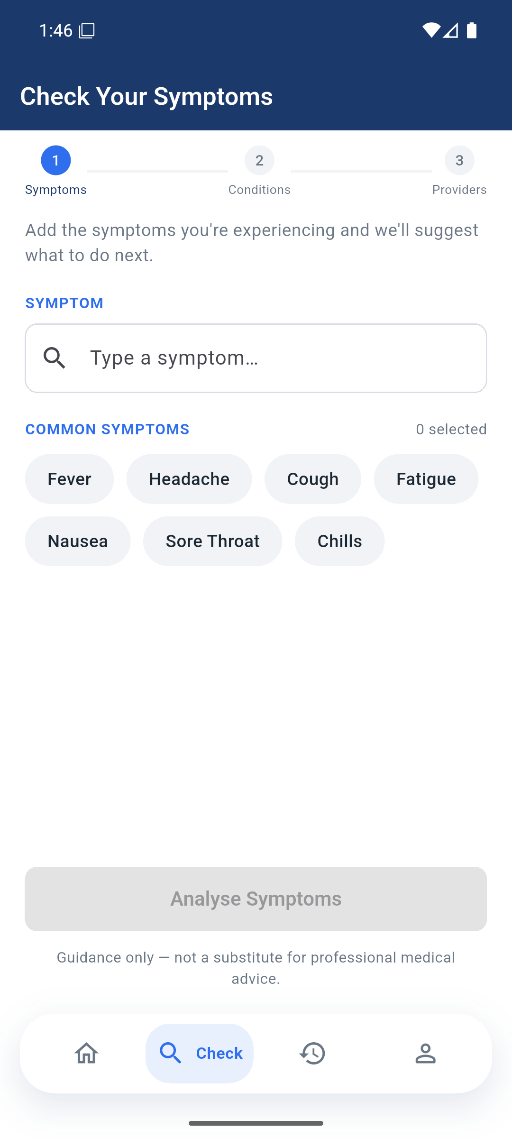
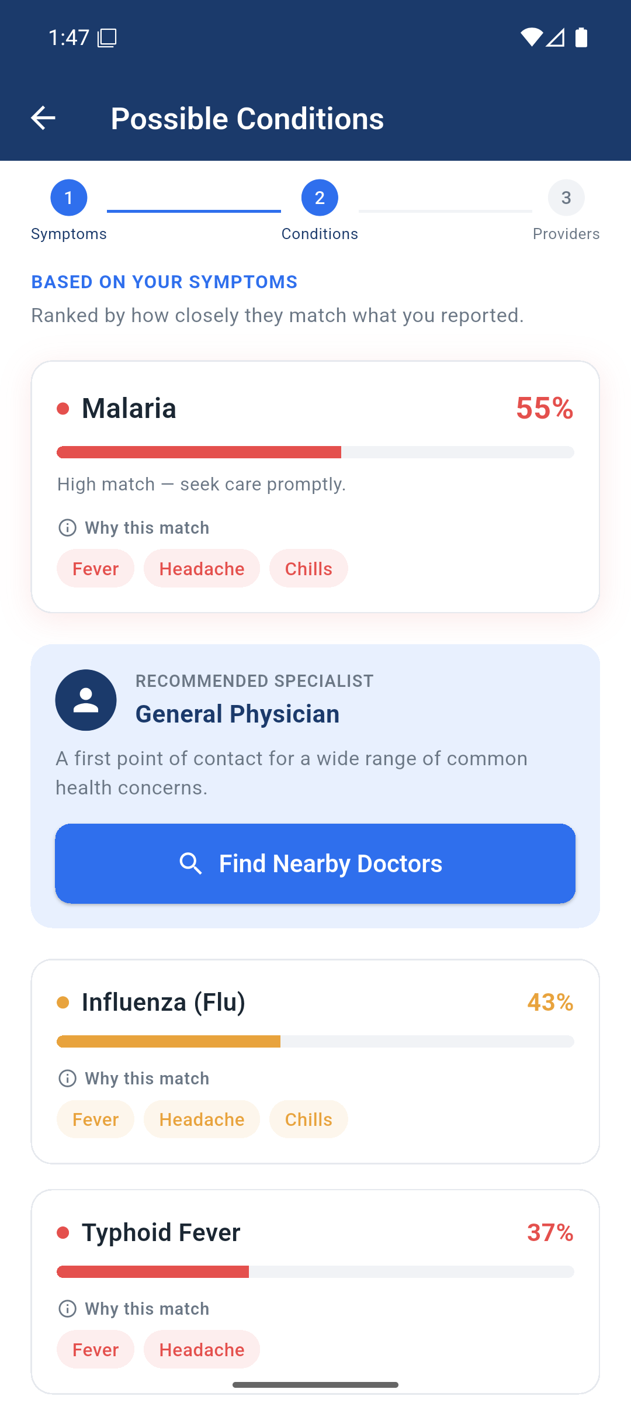
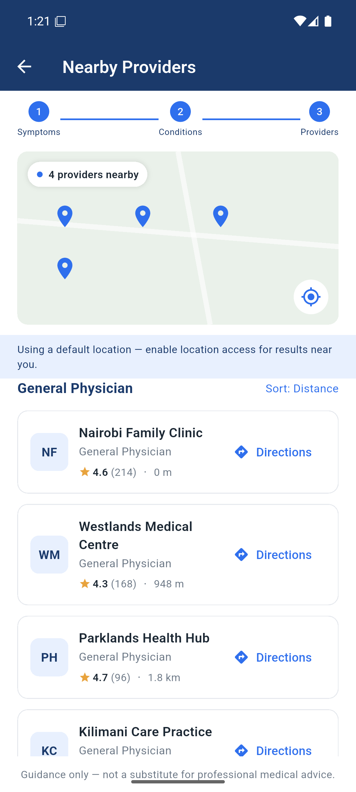
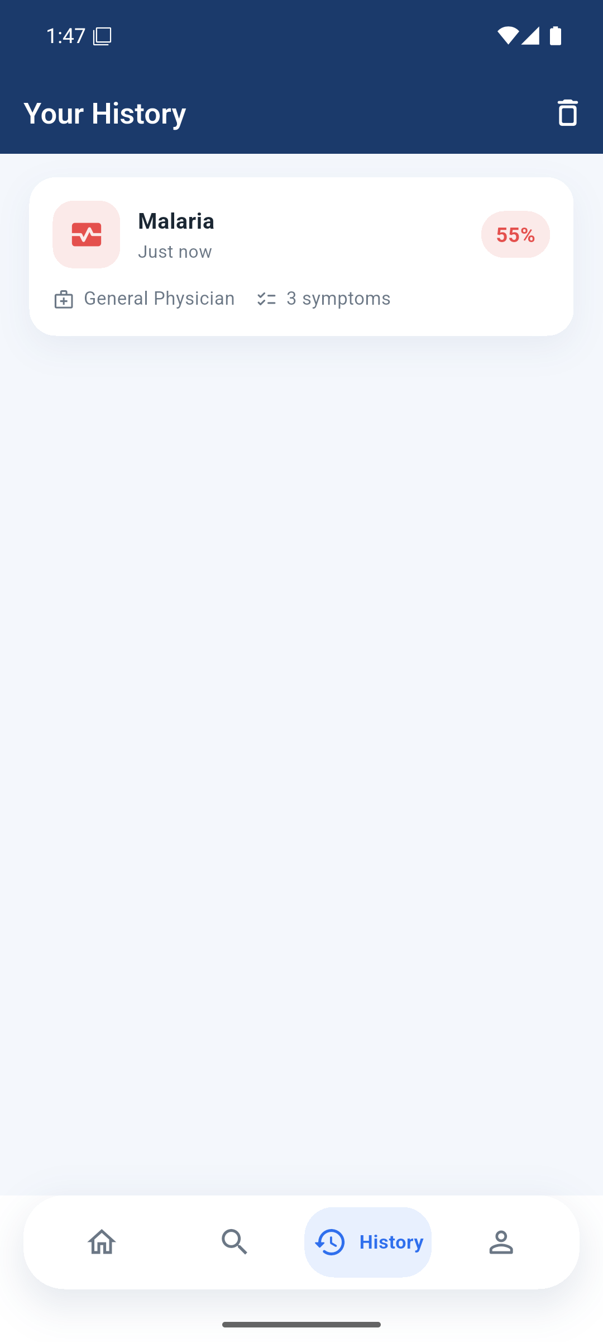

5.8 Key Modules and Algorithms
The knowledge-base module stores conditions declaratively so the rule set can grow without code changes. The engine module implements the weighted scoring described in Section 5.3 and is pure, which is what allows it to be unit-tested without a server. The specialist module translates the top-ranked condition into a concrete practitioner type, turning an abstract result into an actionable next step. The provider module converts that specialist type plus coordinates into a ranked shortlist of reachable facilities. The safety module attaches the guidance disclaimer centrally in configuration, so no response path can omit it, and severity is carried through to the interface so that high-severity results can be visually emphasised.

Chapter Six: Testing and Validation

6.1 Testing Strategy
Validation combined three levels. Unit tests exercise the diagnostic engine in isolation, confirming that scores are computed, normalised, filtered, and ranked correctly for known symptom sets. Integration tests drive the HTTP API with the engine, data store, and provider service wired together. Acceptance testing walked the complete user journey on an Android emulator against a live backend.
The engine was written as a pure function specifically so that the most safety-critical logic could be tested exhaustively without network, database, or user interface in the way.

6.2 Automated Test Results
The automated suite comprises 15 tests and is executed with npm test. All 15 pass. The suite is listed in full below because it constitutes the primary evidence that the functional and reliability requirements are met.
Test | Level | Requirement verified | Result
GET /api/health  reports ok | Integration | Service liveness | Pass
POST /api/diagnose  returns ranked conditions, specialist, disclaimer | Integration | Functional requirements 2, 3, 5 | Pass
POST /api/diagnose  rejects empty symptoms with 400 | Integration | Input validation | Pass
POST /api/providers  returns providers ranked by distance | Integration | Functional requirement 4 | Pass
POST /api/providers  rejects missing coordinates with 400 | Integration | Input validation | Pass
GET /api/symptoms  returns the catalogue | Integration | Symptom input support | Pass
scoreCondition  returns 1.0 when all symptoms match | Unit | Scoring upper bound | Pass
scoreCondition  normalises a partial match | Unit | Normalisation | Pass
scoreCondition  ignores unknown symptoms | Unit | Robustness to bad input | Pass
diagnose  ranks conditions by confidence descending | Unit | Ranking | Pass
diagnose  drops conditions below the threshold | Unit | Threshold filtering | Pass
diagnose  returns explainable matched symptoms | Unit | Explainability | Pass
diagnose  is deterministic for the same input | Unit | Reliability requirement | Pass
diagnose  de-duplicates repeated symptoms | Unit | Input hygiene | Pass
diagnose  respects maxResults | Unit | Result capping | Pass

Table 6.1: Automated test suite, 15 of 15 passing.

6.3 Acceptance Test Cases
ID | Scenario | Expected outcome | Result
T1 | Submit a valid symptom set | Ranked conditions and specialist returned | Pass
T2 | Submit an empty symptom list | 400 with a clear validation message | Pass
T3 | Request providers with valid coordinates | Ranked nearby providers returned | Pass
T4 | Deny location permission | Flow continues with symptom and specialist guidance | Pass
T5 | Simulate network failure on the client | Readable error with retry, no crash | Pass
T6 | Complete journey from symptoms to providers | Workflow completes without data loss | Pass

Table 6.2: Acceptance test cases.

6.4 Ranking Evaluation
The automated suite verifies that scoring is arithmetically correct, but not that the ranking is useful. To assess that, twelve symptom vignettes were constructed, one per condition, each listing the symptoms a person with that condition would plausibly report. Each vignette was passed through the engine and the rank of the expected condition was recorded.
Vignette (expected condition) | Symptoms | Engine’s top result | Confidence | Rank of expected
Malaria | 4 | Malaria | 70.0% | 1
Common Cold | 4 | Common Cold | 76.3% | 1
Influenza | 5 | Influenza (Flu) | 77.3% | 1
COVID-19 | 4 | COVID-19 | 67.4% | 1
Migraine | 3 | Migraine | 67.6% | 1
Gastroenteritis | 4 | Gastroenteritis | 87.9% | 1
Asthma | 4 | Asthma | 100.0% | 1
Pneumonia | 4 | Pneumonia | 73.7% | 1
Urinary tract infection | 3 | Urinary Tract Infection | 88.0% | 1
Conjunctivitis | 3 | Conjunctivitis (Pink Eye) | 50.0% | 1
Tonsillitis | 4 | Tonsillitis | 100.0% | 1
Dengue fever | 5 | Dengue Fever | 87.8% | 1

Table 6.3: Ranking evaluation over twelve symptom vignettes.
The expected condition ranked first in 12 of 12 vignettes, giving a top-1 and top-3 hit rate of 100 per cent on this set.
That number must be read with its limitation stated clearly. The vignettes were written by the author from the same knowledge base the engine scores against, so this measures the engine’s internal consistency, not its clinical accuracy. It establishes that the weighting and ranking behave as designed for characteristic symptom sets; it does not establish that the rule set is medically correct. Only the clinical review recommended in Section 8.2 can do that, and until it happens the application remains a guidance tool.

6.5 Non-Functional Verification
Reliability is verified directly by the determinism test, which asserts that identical input produces identical output. Performance was observed on the emulator against a local backend, where diagnosis responses returned well within the few-seconds target; the engine itself completes in under a millisecond, as the unit-test timings show, so latency is dominated by network and rendering rather than by inference. Graceful degradation is verified by test T4, in which denying location permission still yields symptom and specialist guidance rather than an error state. Maintainability was demonstrated in practice: conditions were added to the knowledge base during development without a single change to engine code.

Chapter Seven: Results and Discussion

7.1 Objectives Achieved
Objective | Outcome | Evidence
Mobile app returning ranked conditions | Achieved | Figures 5.2 and 5.3; integration tests
Rule-based diagnostic engine | Achieved for internal consistency | Section 5.3; nine unit tests; Table 6.3
Specialist recommendation module | Achieved | Diagnose response; Table 6.1
Location-based provider recommendation | Achieved | Figure 5.4; provider tests
Simple interface, accessibility untested | Partially achieved | Figures 5.1 to 5.5; no user testing conducted

Table 7.1: Achievement of the specific objectives.
Four of the five specific objectives were met in full. The second is met in the sense the project can evidence: the engine ranks the expected condition first on every vignette tested (Table 6.3), but “reasonable accuracy” in the clinical sense cannot be claimed without the validation set out in Section 8.2.
The fifth is reported as partially achieved, deliberately. The interface was built to the usability requirement and the complete journey was walked end to end, but the structured testing with users of varying digital literacy that the midterm committed to was not carried out. Screenshots and developer-run tests are evidence that the interface works; they are not evidence that it is accessible to the intended users. That distinction is preserved here rather than glossed over, and the outstanding work is listed in Section 8.2.

7.2 Discussion
The most important result is that explainability cost nothing in capability. The weighted rule base produced sensible rankings across the tested symptom sets while remaining fully inspectable: every percentage the user sees can be recomputed by hand from the knowledge base, as demonstrated in Section 5.3. In a domain where an unexplained recommendation may be ignored or, worse, trusted blindly, that property is worth more than a marginal accuracy gain from an opaque model.
The second result concerns architecture. Placing all reasoning behind an API boundary, and defining both the data store and the provider source as interchangeable implementations of a fixed interface, meant that the mock and live location paths could be switched by configuration alone. This is why the project could be developed and demonstrated reliably without incurring Maps billing, while remaining ready for real keys.
The third observation is about safety engineering. Attaching the disclaimer in central configuration rather than at each call site converts a discipline problem into a structural guarantee: no future endpoint can forget it. The same reasoning motivated making the engine pure, since the component with the highest consequence of failure became the easiest to test.

7.3 Limitations
Six limitations are stated plainly.
The knowledge base is educational and has not been reviewed by a qualified clinician, so the system must not be used for real medical decisions, and the evaluation in Section 6.4 measures internal consistency rather than clinical accuracy.
The query log is held in memory and does not survive a restart; the Firestore implementation remains a documented stub.
The prototype has no authentication, and query history is held in memory in the app rather than persisted, so it is lost when the application is closed.
Transport is not yet encrypted. The development build talks to the backend over plain HTTP, and HTTPS with certificate validation is required before any deployment.
The API, assessed against a production bar, still needs hardening: origin restriction, security headers, rate limiting on the unauthenticated endpoints, bounds on request payloads, and eviction policies for the in-memory cache and log.
Usability was not tested with users. The interface meets the stated usability requirement by construction, but the structured testing with participants of varying digital literacy promised at midterm was not conducted, so no claim of demonstrated accessibility is made.
Two smaller scope decisions are recorded for completeness. Free-text symptom entry, listed as a functional requirement at midterm, was descoped in favour of structured selection so that every input maps unambiguously to a knowledge-base identifier. Offline operation was not implemented: every diagnosis is a network round trip, which follows from the decision to keep all reasoning server-side.

Chapter Eight: Conclusions

8.1 Conclusions
The project set out to close a specific gap: the absence of a tool that combines explainable symptom analysis, specialist routing, and localised provider recommendation in a form suited to low-connectivity, developing-region contexts. The delivered system does so end to end, and its behaviour is backed by an automated suite of 15 tests, all passing.
The rule-based approach proved to be the correct choice for this problem. It produced ranked, defensible results; it made the reasoning available to the user instead of hiding it; and it kept the highest-risk component small enough to test exhaustively. The three-tier architecture, with a thin client and swappable data and location tiers, kept the system adaptable: the data store and the provider source can each be replaced without touching engine, route, or interface code.

8.2 Recommendations
The immediate priority is security hardening of the API, since the system is otherwise feature-complete: restrict cross-origin access, add security headers, apply rate limiting to the unauthenticated endpoints, clamp request parameters, and bound the in-memory cache and query log. Next, implement the Firestore data store against the existing interface so the query log survives restarts, and wire live Maps credentials while keeping the key server-side. Clinical review of the knowledge base by a qualified practitioner should precede any real use, and the reviewer and date should be recorded. Beyond that, adding authentication would make history per-user, a continuous-integration pipeline would validate every change automatically, and multilingual and offline support would extend reach in the target context.

8.3 Closing Remarks
The system delivers a working, testable, and honest prototype: honest in that its limitations are documented as precisely as its capabilities, and that it tells every user, on every response, that it offers guidance rather than diagnosis. Acting on the recommendations above would carry it from a sound prototype to a deployable product.

References
Ada Health. (2024). Ada: Your health companion. https://ada.comSMARTPANTS_PRESERVED_2352SMARTPANTS_PRESERVED_2353

