ForecastAll

Amy Racine

17 12 2020

## R Markdown

Forecast post lockdown outcome based on pre-lock down modelling using the best model from ITS for weekly and monthly data You need to run ITSAll to choose the best model as input

## Registered S3 method overwritten by 'quantmod':  
## method from  
## as.zoo.data.frame zoo

## -- Attaching packages ---------------------------------------------------------------------------- fpp2 2.4 --

## v ggplot2 3.3.2 v fma 2.4   
## v forecast 8.13 v expsmooth 2.3

##

## [1] "./log2wkImpute.csv"  
##   
## Call:  
## lm(formula = PTBrate ~ -1 + seasons + slope2, data = all1, weights = nbirth)  
##   
## Weighted Residuals:  
## Min 1Q Median 3Q Max   
## -1.23892 -0.21390 -0.00095 0.20776 1.73491   
##   
## Coefficients:  
## Estimate Std. Error t value Pr(>|t|)   
## seasons1 0.1460800 0.0063411 23.04 <2e-16 ***  
## seasons2 0.1516796 0.0066854 22.69 <2e-16 ***  
## seasons3 0.1516243 0.0067308 22.53 <2e-16 ***  
## seasons4 0.1483744 0.0069213 21.44 <2e-16 ***  
## seasons5 0.1537406 0.0073706 20.86 <2e-16 ***  
## seasons6 0.1487957 0.0067417 22.07 <2e-16 ***  
## seasons7 0.1439649 0.0069029 20.86 <2e-16 ***  
## seasons8 0.1377850 0.0069118 19.93 <2e-16 ***  
## seasons9 0.1338962 0.0070555 18.98 <2e-16 ***  
## seasons10 0.1287019 0.0070691 18.21 <2e-16 ***  
## seasons11 0.1367427 0.0070494 19.40 <2e-16 ***  
## seasons12 0.1395306 0.0071875 19.41 <2e-16 ***  
## slope2 0.0130618 0.0008431 15.49 <2e-16 ***  
## ---  
## Signif. codes: 0 '***' 0.001 '**' 0.01 '*' 0.05 '.' 0.1 ' ' 1  
##   
## Residual standard error: 0.4075 on 263 degrees of freedom  
## (17 observations deleted due to missingness)  
## Multiple R-squared: 0.9937, Adjusted R-squared: 0.9934   
## F-statistic: 3179 on 13 and 263 DF, p-value: < 2.2e-16  
##   
## fit LL UL stderr  
## 277 0.2543548 0.2208234 0.2878861 0.01710783  
## 278 0.2544227 0.2194996 0.2893458 0.01781790  
## 279 0.2544904 0.2198019 0.2891788 0.01769820  
## 280 0.2599240 -0.5426028 1.0624509 0.40945249  
## 281 0.2599912 0.2245296 0.2954528 0.01809264  
## 282 0.2600582 0.2261874 0.2939289 0.01728100  
## 283 0.2601249 0.2261495 0.2941002 0.01733437  
## 284 0.2552464 -0.5472717 1.0577644 0.40944800  
## 285 0.2553126 0.2209787 0.2896466 0.01751732  
## 286 0.2553786 0.2223477 0.2884095 0.01685251  
## 287 0.2554444 -0.5470738 1.0579626 0.40944805  
## 288 0.2506792 -0.5518422 1.0532006 0.40944968  
## 289 0.2507445 0.2173118 0.2841773 0.01705751  
## 290 0.2508096 0.2156220 0.2859973 0.01795287  
## 291 0.2508745 0.2160382 0.2857108 0.01777365  
## 292 0.2509391 0.2159861 0.2858922 0.01783318  
## 293 0.2448236 0.2088998 0.2807474 0.01832849  
## time obs_pred LL UL  
## 1 1 -0.005590375 -0.03912172 0.027940970  
## 2 2 -0.028210848 -0.06313394 0.006712242  
## 3 3 -0.033251423 -0.06793990 0.001437052  
## 4 4 -0.035461214 -0.83798809 0.767065656  
## 5 5 -0.032304513 -0.06776608 0.003157055  
## 6 6 -0.038936046 -0.07280681 -0.005065281  
## 7 7 -0.040855761 -0.07483112 -0.006880401  
## 8 8 -0.037178081 -0.83969616 0.765339999  
## 9 9 -0.038445134 -0.07277909 -0.004111181  
## 10 10 -0.071543426 -0.10457435 -0.038512506  
## 11 11 -0.063308306 -0.86582648 0.739209863  
## 12 12 -0.050242248 -0.85276362 0.752279125  
## 13 13 -0.042006672 -0.07543939 -0.008573957  
## 14 14 -0.019762698 -0.05495033 0.015424935  
## 15 15 -0.051227854 -0.08606420 -0.016391509  
## 16 16 -0.042754090 -0.07770713 -0.007801055  
## 17 17 -0.065775984 -0.10169983 -0.029852139

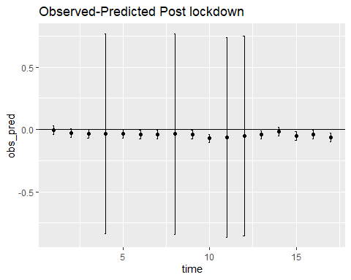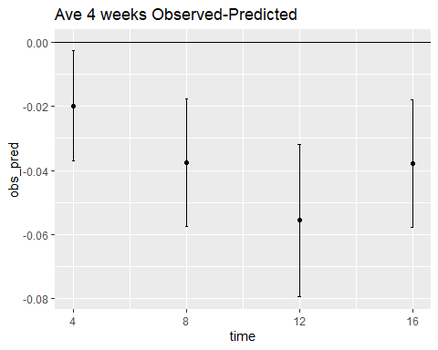

## time fit LL UL stderr observed  
## [1,] 4 0.2543878 0.2371798 0.2715957 0.00877956 0.2345353  
## [2,] 8 0.2600599 0.2401974 0.2799223 0.01013391 0.2225503  
## [3,] 12 0.2553469 0.2315641 0.2791297 0.01213408 0.1997221  
## [4,] 16 0.2508077 0.2309182 0.2706971 0.01014768 0.2128969  
## time obs_pred LL UL stderr observed  
## 1 4 -0.01985241 -0.002644475 -0.03706035 0.00877956 0.2345353  
## 2 8 -0.03750954 -0.017647067 -0.05737201 0.01013391 0.2225503  
## 3 12 -0.05562479 -0.031841988 -0.07940759 0.01213408 0.1997221  
## 4 16 -0.03791072 -0.018021267 -0.05780017 0.01014768 0.2128969

## [1] "./datalog2wk.csv"  
##   
## Call:  
## lm(formula = PTBrate ~ -1 + seasons + slope2, data = all1, weights = nbirth)  
##   
## Weighted Residuals:  
## Min 1Q Median 3Q Max   
## -1.31680 -0.26739 0.00916 0.28575 1.72749   
##   
## Coefficients:  
## Estimate Std. Error t value Pr(>|t|)   
## seasons1 0.1481343 0.0062360 23.75 <2e-16 ***  
## seasons2 0.1518396 0.0066014 23.00 <2e-16 ***  
## seasons3 0.1557445 0.0065667 23.72 <2e-16 ***  
## seasons4 0.1538797 0.0066747 23.05 <2e-16 ***  
## seasons5 0.1572170 0.0068464 22.96 <2e-16 ***  
## seasons6 0.1526777 0.0068248 22.37 <2e-16 ***  
## seasons7 0.1479300 0.0068548 21.58 <2e-16 ***  
## seasons8 0.1390863 0.0069421 20.04 <2e-16 ***  
## seasons9 0.1344493 0.0070190 19.16 <2e-16 ***  
## seasons10 0.1351386 0.0070164 19.26 <2e-16 ***  
## seasons11 0.1406662 0.0070907 19.84 <2e-16 ***  
## seasons12 0.1434928 0.0070466 20.36 <2e-16 ***  
## slope2 0.0126356 0.0008302 15.22 <2e-16 ***  
## ---  
## Signif. codes: 0 '***' 0.001 '**' 0.01 '*' 0.05 '.' 0.1 ' ' 1  
##   
## Residual standard error: 0.4535 on 263 degrees of freedom  
## (17 observations deleted due to missingness)  
## Multiple R-squared: 0.9938, Adjusted R-squared: 0.9935   
## F-statistic: 3235 on 13 and 263 DF, p-value: < 2.2e-16  
##   
## fit LL UL stderr  
## 277 0.2564015 0.2192418 0.2935612 0.01895905  
## 278 0.2564672 0.2177525 0.2951819 0.01975242  
## 279 0.2565326 0.2180800 0.2949852 0.01961867  
## 280 0.2599351 0.2213937 0.2984765 0.01966397  
## 281 0.2600001 0.2209924 0.2990078 0.01990190  
## 282 0.2600649 0.2228492 0.2972806 0.01898760  
## 283 0.2601294 0.2227959 0.2974629 0.01904772  
## 284 0.2556544 0.2178112 0.2934976 0.01930774  
## 285 0.2557185 0.2177509 0.2936860 0.01937118  
## 286 0.2557823 0.2192747 0.2922899 0.01862634  
## 287 0.2558459 0.2172383 0.2944536 0.01969778  
## 288 0.2511617 0.2134809 0.2888425 0.01922490  
## 289 0.2512249 0.2143341 0.2881157 0.01882182  
## 290 0.2512879 0.2124285 0.2901472 0.01982619  
## 291 0.2513506 0.2128855 0.2898158 0.01962508  
## 292 0.2514132 0.2128173 0.2900090 0.01969175  
## 293 0.2426317 0.2028406 0.2824229 0.02030162  
## time obs_pred LL UL  
## 1 1 -0.007637079 -0.04479682 0.0295226624  
## 2 2 -0.030255336 -0.06897007 0.0084593974  
## 3 3 -0.035293703 -0.07374630 0.0031588995  
## 4 4 -0.041462657 -0.08000405 -0.0029212665  
## 5 5 -0.032313412 -0.07132113 0.0066943035  
## 6 6 -0.038942760 -0.07615845 -0.0017270740  
## 7 7 -0.040860298 -0.07819382 -0.0035267745  
## 8 8 -0.040269766 -0.07811294 -0.0024265876  
## 9 9 -0.038850986 -0.07681851 -0.0008834649  
## 10 10 -0.071947124 -0.10845475 -0.0354394974  
## 11 11 -0.068680159 -0.10728780 -0.0300725171  
## 12 12 -0.037963747 -0.07564455 -0.0002829489  
## 13 13 -0.042487039 -0.07937780 -0.0055962744  
## 14 14 -0.020240940 -0.05910027 0.0186183883  
## 15 15 -0.051703980 -0.09016913 -0.0132388261  
## 16 16 -0.043228106 -0.08182393 -0.0046322842  
## 17 17 -0.063584130 -0.10337531 -0.0237929475

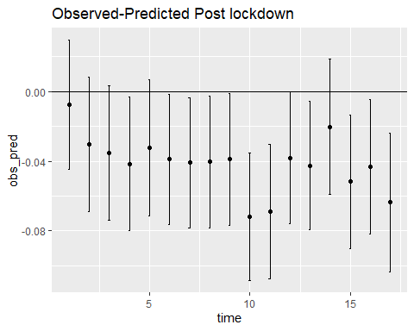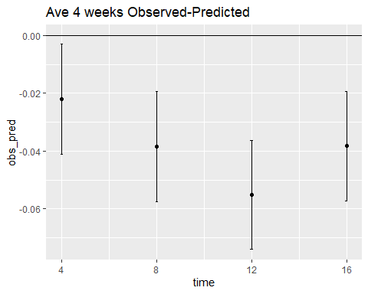

## time fit LL UL stderr observed  
## [1,] 4 0.2564334 0.2373594 0.2755073 0.009731615 0.2345377  
## [2,] 8 0.2600347 0.2410340 0.2790354 0.009694217 0.2215557  
## [3,] 12 0.2557500 0.2368960 0.2746039 0.009619358 0.2006060  
## [4,] 16 0.2512545 0.2322788 0.2702301 0.009681449 0.2129761  
## time obs_pred LL UL stderr observed  
## 1 4 -0.02189569 -0.002821726 -0.04096966 0.009731615 0.2345377  
## 2 8 -0.03847897 -0.019478302 -0.05747963 0.009694217 0.2215557  
## 3 12 -0.05514393 -0.036289991 -0.07399788 0.009619358 0.2006060  
## 4 16 -0.03827836 -0.019302719 -0.05725400 0.009681449 0.2129761

## [1] "./squaremonthImpute.csv"  
##   
## Call:  
## lm(formula = PTBrate ~ -1 + seasons + slope4, data = all1, weights = nbirth)  
##   
## Weighted Residuals:  
## Min 1Q Median 3Q Max   
## -0.94729 -0.21025 0.00435 0.24020 0.58795   
##   
## Coefficients:  
## Estimate Std. Error t value Pr(>|t|)   
## seasons1 1.511e-01 3.457e-03 43.71 <2e-16 ***  
## seasons2 1.569e-01 3.275e-03 47.91 <2e-16 ***  
## seasons3 1.670e-01 4.103e-03 40.70 <2e-16 ***  
## seasons4 1.652e-01 3.700e-03 44.65 <2e-16 ***  
## seasons5 1.508e-01 4.254e-03 35.45 <2e-16 ***  
## seasons6 1.469e-01 3.343e-03 43.93 <2e-16 ***  
## seasons7 1.370e-01 3.817e-03 35.90 <2e-16 ***  
## seasons8 1.352e-01 3.798e-03 35.60 <2e-16 ***  
## seasons9 1.444e-01 3.812e-03 37.88 <2e-16 ***  
## seasons10 1.463e-01 3.427e-03 42.70 <2e-16 ***  
## seasons11 1.457e-01 3.431e-03 42.48 <2e-16 ***  
## seasons12 1.559e-01 3.462e-03 45.04 <2e-16 ***  
## slope4 2.684e-05 9.218e-07 29.11 <2e-16 ***  
## ---  
## Signif. codes: 0 '***' 0.001 '**' 0.01 '*' 0.05 '.' 0.1 ' ' 1  
##   
## Residual standard error: 0.3549 on 50 degrees of freedom  
## (3 observations deleted due to missingness)  
## Multiple R-squared: 0.9986, Adjusted R-squared: 0.9983   
## F-statistic: 2782 on 13 and 50 DF, p-value: < 2.2e-16  
##   
## fit LL UL stderr  
## 64 0.2717048 0.2549541 0.2884554 0.00854625  
## 65 0.2607089 -0.4522743 0.9736921 0.36376695  
## 66 0.2602638 -0.4527024 0.9732300 0.36375828  
## time obs_pred LL UL  
## 1 1 -0.05431347 -0.07106412 -0.03756282  
## 2 2 -0.04331760 -0.75630082 0.66966562  
## 3 3 -0.04287249 -0.75583872 0.67009373

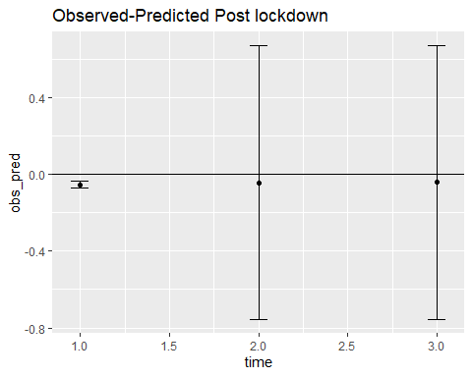

## [1] "./datasquaremonth.csv"  
##   
## Call:  
## lm(formula = PTBrate ~ -1 + seasons + slope4, data = all1, weights = nbirth)  
##   
## Weighted Residuals:  
## Min 1Q Median 3Q Max   
## -1.76154 -0.31538 0.04477 0.31246 0.94471   
##   
## Coefficients:  
## Estimate Std. Error t value Pr(>|t|)   
## seasons1 1.550e-01 4.396e-03 35.25 <2e-16 ***  
## seasons2 1.598e-01 4.434e-03 36.04 <2e-16 ***  
## seasons3 1.568e-01 4.475e-03 35.03 <2e-16 ***  
## seasons4 1.692e-01 4.694e-03 36.04 <2e-16 ***  
## seasons5 1.554e-01 4.740e-03 32.78 <2e-16 ***  
## seasons6 1.498e-01 4.748e-03 31.56 <2e-16 ***  
## seasons7 1.434e-01 4.766e-03 30.09 <2e-16 ***  
## seasons8 1.429e-01 4.779e-03 29.89 <2e-16 ***  
## seasons9 1.469e-01 4.805e-03 30.56 <2e-16 ***  
## seasons10 1.499e-01 4.838e-03 30.99 <2e-16 ***  
## seasons11 1.495e-01 4.832e-03 30.94 <2e-16 ***  
## seasons12 1.599e-01 4.868e-03 32.84 <2e-16 ***  
## slope4 2.423e-05 1.114e-06 21.75 <2e-16 ***  
## ---  
## Signif. codes: 0 '***' 0.001 '**' 0.01 '*' 0.05 '.' 0.1 ' ' 1  
##   
## Residual standard error: 0.5115 on 50 degrees of freedom  
## (3 observations deleted due to missingness)  
## Multiple R-squared: 0.9976, Adjusted R-squared: 0.997   
## F-statistic: 1624 on 13 and 50 DF, p-value: < 2.2e-16  
##   
## fit LL UL stderr  
## 64 0.2653720 0.2418803 0.2888637 0.01198557  
## 65 0.2546584 0.2309415 0.2783753 0.01210046  
## 66 0.2522159 0.2289354 0.2754964 0.01187781  
## time obs_pred LL UL  
## 1 1 -0.04798069 -0.07147241 -0.024488961  
## 2 2 -0.04966659 -0.07338350 -0.025949686  
## 3 3 -0.03102848 -0.05430899 -0.007747965

