ITSall

Amy Racine

17 12 2020

## R Markdown

Evaluate the result of ITS, data recorded in weeks or in month When no missing data, use original data when there are missing value first run missimpute and input impute data

## Registered S3 method overwritten by 'quantmod':  
## method from  
## as.zoo.data.frame zoo

## -- Attaching packages ---------------------------------------------------------------------------- fpp2 2.4 --

## v ggplot2 3.3.2 v fma 2.4   
## v forecast 8.13 v expsmooth 2.3

##

## [1] "./log2wkImpute.csv"  
## df AIC  
## modellinear 16 -1144.214  
## modellog2 16 -1169.651  
## modelsqrt 16 -1166.132  
## modelsquare 16 -1107.234  
## modelpoly 18 -1154.959  
## Estimate Std. Error t value Pr(>|t|)  
## seasons1 0.146045317 0.0062446300 23.387345 1.274840e-67  
## seasons2 0.151644217 0.0065837471 23.033117 2.104202e-66  
## seasons3 0.151588127 0.0066284532 22.869306 7.730153e-66  
## seasons4 0.148228003 0.0067908001 21.827767 3.235279e-62  
## seasons5 0.153748560 0.0070402390 21.838543 2.966172e-62  
## seasons6 0.147555450 0.0065529278 22.517484 1.276726e-64  
## seasons7 0.146051994 0.0066873264 21.840117 2.928771e-62  
## seasons8 0.137131960 0.0067593450 20.287759 8.878831e-57  
## seasons9 0.133858834 0.0069482076 19.265232 4.037481e-53  
## seasons10 0.128664010 0.0069615521 18.482087 2.676271e-50  
## seasons11 0.136704295 0.0069420898 19.692096 1.188974e-54  
## seasons12 0.139492133 0.0070781926 19.707310 1.048839e-54  
## slope2 0.013067325 0.0008301705 15.740532 2.362870e-40  
## diff.intercept -0.013071304 0.0123827794 -1.055603 2.920659e-01  
## diff.slope2 -0.009582673 0.0040651869 -2.357253 1.910405e-02

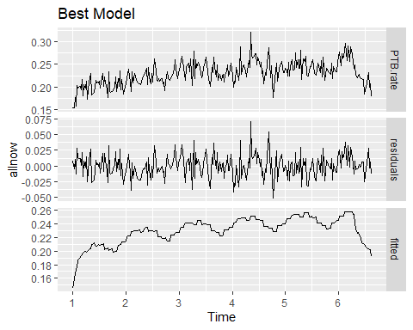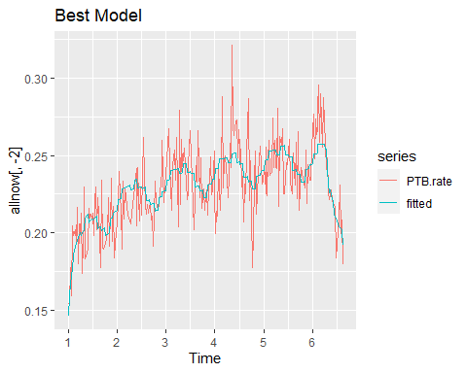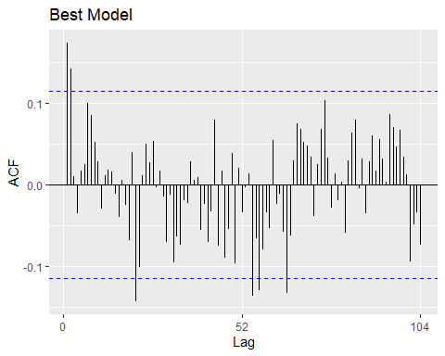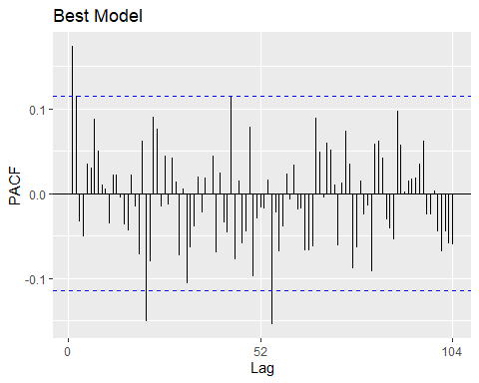

## [1] "./datalog2wk.csv"  
## df AIC  
## modellinear 16 -1462.215  
## modellog2 16 -1488.846  
## modelsqrt 16 -1485.770  
## modelsquare 16 -1424.251  
## modelpoly 18 -1475.881  
## Estimate Std. Error t value Pr(>|t|)  
## seasons1 0.148103819 0.0061441472 24.104862 4.547263e-70  
## seasons2 0.151807487 0.0065042101 23.339881 1.854652e-67  
## seasons3 0.155711751 0.0064699435 24.066941 6.116074e-70  
## seasons4 0.153842162 0.0065447878 23.506058 4.997345e-68  
## seasons5 0.157133029 0.0066039651 23.793740 5.199718e-69  
## seasons6 0.151097456 0.0065910319 22.924704 4.976690e-66  
## seasons7 0.149974168 0.0066445853 22.570885 8.334381e-65  
## seasons8 0.138645542 0.0067994696 20.390641 3.821461e-57  
## seasons9 0.134415285 0.0069156573 19.436372 9.810294e-54  
## seasons10 0.135104221 0.0069130753 19.543288 4.057495e-54  
## seasons11 0.140631173 0.0069862170 20.129803 3.244803e-56  
## seasons12 0.143458081 0.0069428372 20.662746 4.127760e-58  
## slope2 0.012640533 0.0008179466 15.453982 2.586919e-39  
## diff.intercept -0.016438794 0.0131504898 -1.250052 2.123319e-01  
## diff.slope2 -0.008908693 0.0043058667 -2.068966 3.947343e-02

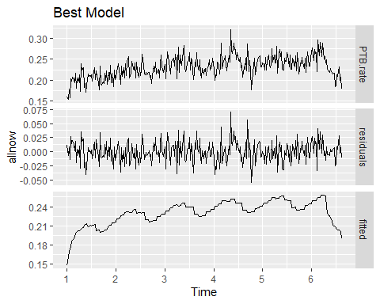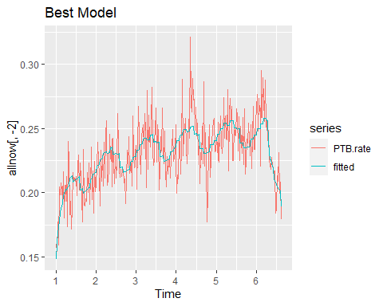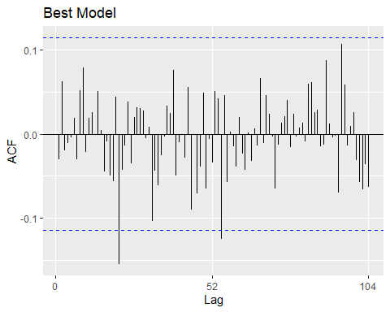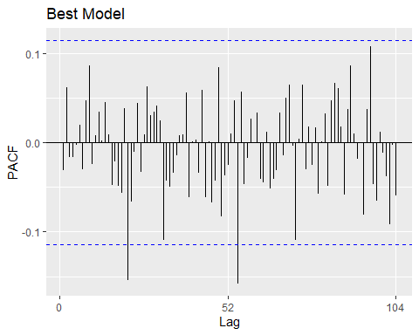

## [1] "./log2monthImpute.csv"  
## df AIC  
## modellinear 16 -310.5110  
## modellog2 16 -355.7246  
## modelsqrt 16 -347.6420  
## modelsquare 16 -266.5081  
## modelpoly 18 -342.4712  
## Estimate Std. Error t value Pr(>|t|)  
## seasons1 0.140779311 0.0051622495 27.270923617 4.443044e-32  
## seasons2 0.149955955 0.0045611873 32.876517524 5.332421e-36  
## seasons3 0.154141937 0.0048417734 31.835843091 2.552014e-35  
## seasons4 0.152891051 0.0050324949 30.380766283 2.466847e-34  
## seasons5 0.150312614 0.0053426958 28.134226532 9.991009e-33  
## seasons6 0.149802655 0.0048870462 30.653005597 1.601832e-34  
## seasons7 0.136262506 0.0054720890 24.901368836 3.333061e-30  
## seasons8 0.132392468 0.0052739141 25.103266098 2.276269e-30  
## seasons9 0.137174374 0.0053188341 25.790308606 6.339200e-31  
## seasons10 0.138151573 0.0050826026 27.181266290 5.200103e-32  
## seasons11 0.134978122 0.0051099511 26.414758061 2.034016e-31  
## seasons12 0.139983693 0.0051491266 27.185910474 5.157837e-32  
## slope2 0.018726885 0.0008404135 22.282940445 6.026548e-28  
## diff.intercept -0.026926998 0.0076776499 -3.507192791 9.544985e-04  
## diff.slope2 0.001633398 0.1804860006 0.009049997 9.928146e-01

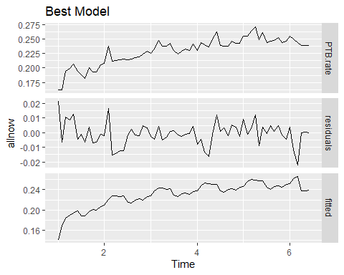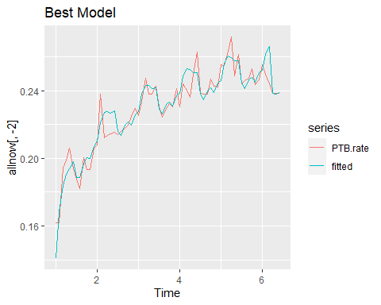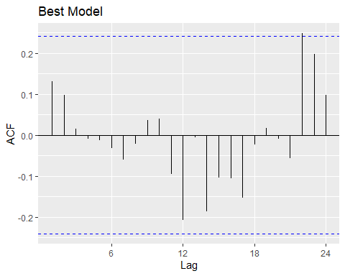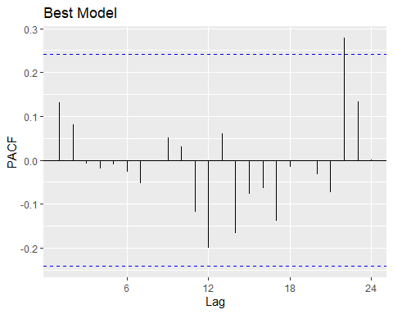

## [1] "./datalog2month.csv"  
## df AIC  
## modellinear 16 -365.1891  
## modellog2 16 -422.4505  
## modelsqrt 16 -404.9210  
## modelsquare 16 -329.1016  
## modelpoly 18 -400.2956  
## Estimate Std. Error t value Pr(>|t|)  
## seasons1 0.14234524 0.0051167144 27.819658 1.712789e-32  
## seasons2 0.15296391 0.0052461393 29.157425 1.794047e-33  
## seasons3 0.14651522 0.0053447314 27.413019 3.465658e-32  
## seasons4 0.15500901 0.0054514340 28.434539 6.001590e-33  
## seasons5 0.14717213 0.0054075715 27.215939 4.892868e-32  
## seasons6 0.15289958 0.0055472508 27.563127 2.668925e-32  
## seasons7 0.13915601 0.0056508713 24.625585 5.635459e-30  
## seasons8 0.13451378 0.0056992105 23.602178 4.136712e-29  
## seasons9 0.13878587 0.0057516985 24.129546 1.467841e-29  
## seasons10 0.14072880 0.0057942689 24.287586 1.080045e-29  
## seasons11 0.13758665 0.0058133542 23.667343 3.635797e-29  
## seasons12 0.14261968 0.0058527128 24.368133 9.243095e-30  
## slope2 0.01819584 0.0008729288 20.844588 1.301533e-26  
## diff.intercept -0.02783394 0.0093434608 -2.978975 4.419792e-03  
## diff.slope2 -0.01153333 0.0084848349 -1.359287 1.800360e-01

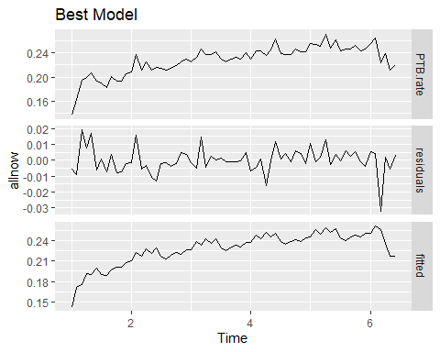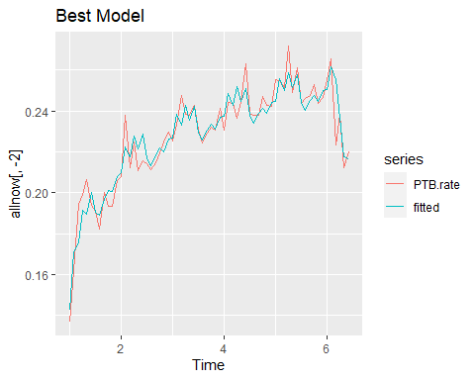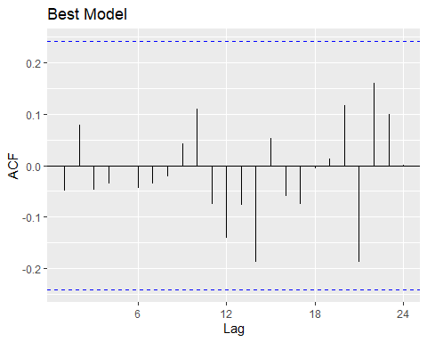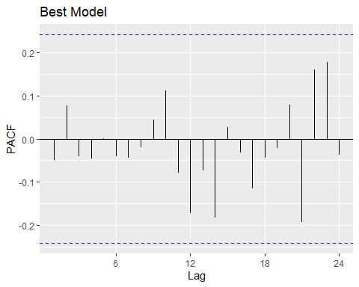

## [1] "./squarewkImpute.csv"  
## df AIC  
## modellinear 16 -1248.411  
## modellog2 16 -1056.702  
## modelsqrt 16 -1163.929  
## modelsquare 16 -1306.105  
## modelpoly 18 -1304.117  
## Estimate Std. Error t value Pr(>|t|)  
## seasons1 1.548905e-01 2.915408e-03 53.1282458 1.290733e-147  
## seasons2 1.593243e-01 3.197644e-03 49.8255236 1.335121e-140  
## seasons3 1.628079e-01 3.169930e-03 51.3600983 6.618923e-144  
## seasons4 1.621482e-01 3.122906e-03 51.9222077 4.267989e-145  
## seasons5 1.641492e-01 3.496785e-03 46.9428909 3.620665e-134  
## seasons6 1.577846e-01 3.066431e-03 51.4554531 4.150311e-144  
## seasons7 1.496151e-01 3.251865e-03 46.0090191 5.118785e-132  
## seasons8 1.422708e-01 3.130893e-03 45.4409626 1.080659e-130  
## seasons9 1.411573e-01 3.317301e-03 42.5518433 9.352603e-124  
## seasons10 1.419167e-01 3.278382e-03 43.2886341 1.476141e-125  
## seasons11 1.479001e-01 3.191367e-03 46.3438173 8.598044e-133  
## seasons12 1.490671e-01 3.390188e-03 43.9701585 3.331468e-127  
## slope4 1.236708e-06 3.942405e-08 31.3693806 2.548455e-93  
## diff.intercept -3.535514e-02 6.095833e-03 -5.7998864 1.801475e-08  
## diff.slope4 -2.968171e-05 4.507209e-05 -0.6585386 5.107371e-01

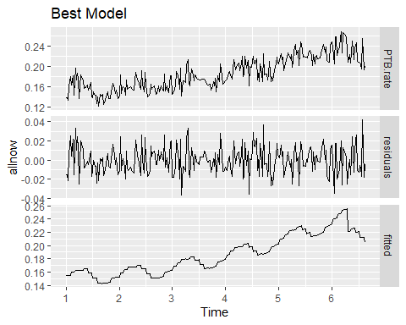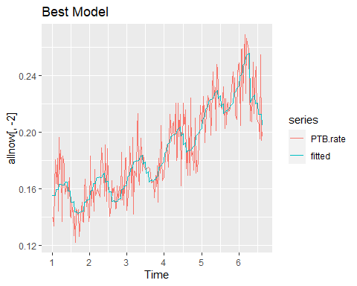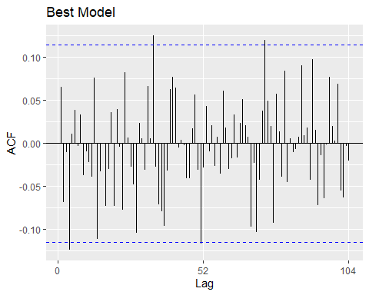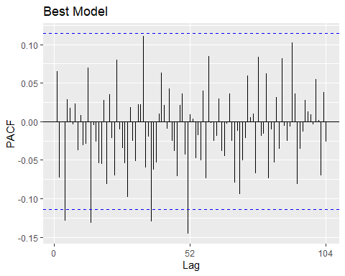

## [1] "./squaremonthImpute.csv"  
## df AIC  
## modellinear 16 -297.8632  
## modellog2 16 -217.2794  
## modelsqrt 16 -251.9022  
## modelsquare 16 -350.6015  
## modelpoly 18 -346.7243  
## Estimate Std. Error t value Pr(>|t|)  
## seasons1 1.510752e-01 3.422585e-03 44.14066534 2.639547e-42  
## seasons2 1.568991e-01 3.242682e-03 48.38559275 2.718882e-44  
## seasons3 1.669533e-01 4.062183e-03 41.09940376 9.125305e-41  
## seasons4 1.651920e-01 3.663370e-03 45.09290518 9.128120e-43  
## seasons5 1.507895e-01 4.211951e-03 35.80040772 8.256449e-38  
## seasons6 1.468814e-01 3.310551e-03 44.36765974 2.045260e-42  
## seasons7 1.370490e-01 3.779742e-03 36.25881426 4.420173e-38  
## seasons8 1.352346e-01 3.760963e-03 35.95742869 6.660154e-38  
## seasons9 1.443990e-01 3.774816e-03 38.25323892 3.167674e-39  
## seasons10 1.463286e-01 3.393550e-03 43.11961733 8.445376e-42  
## seasons11 1.457453e-01 3.397041e-03 42.90358782 1.083768e-41  
## seasons12 1.559251e-01 3.428032e-03 45.48532780 5.929679e-43  
## slope4 2.683603e-05 9.127024e-07 29.40283221 1.197901e-33  
## diff.intercept -5.431060e-02 8.256525e-03 -6.57790071 2.526917e-08  
## diff.slope4 3.337938e-03 8.527245e-02 0.03914439 9.689281e-01

