NBirthPoisson

Amy Racine

1 12 2020

## R Markdown

To model the no of birth before lockdown to estimate the change in no. of birth post lockdown

library(ggplot2)  
# read in data  
PortionEst<-function(Tlockdown)  
{   
datain<-read.csv2("./NbirthCheck.csv")  
 datain<-data.frame(datain)  
# total observation months  
Tend<-length(datain[,2])  
Tlockdown_1<-Tlockdown-1  
# time start lockdown in month  
   
# create season as a factor for evaluation  
time<-datain[,1]   
time_2<-datain[,1]^2  
season<-as.factor(datain[,4])  
all<-data.frame(datain[,1:3],time_2 )  
 colnames(all)<-c("time","PTB.rate","nbirth","time_2")  
   
all1<-all  
# use prelockdown birth to forecast post lockdown birth   
all1[Tlockdown_1:Tend,3]<-NA  
   
gg1<-ggplot(data=all,aes(x=time,y=nbirth)) +geom_point()+ggtitle("no of birth")  
print(gg1)  
   
model1<-glm(data=all1, nbirth~-1+season+time+time_2,family=poisson)  
 print("Poisson Model,polynomial , before lockdown with season and polynomial trend effect")  
 #print(summary(model1))  
w<-predict(model1,newdata=all,type="response")  
  
w_pred<-w[Tlockdown:Tend]   
   
Portion<-mean(all[Tlockdown_1:Tend,3])/mean(w_pred)  
  
# portion of prelockdown birth   
 print("portion of no of birth before lockdown")  
 print(Portion)  
}  
  
  
PortionEst(276)

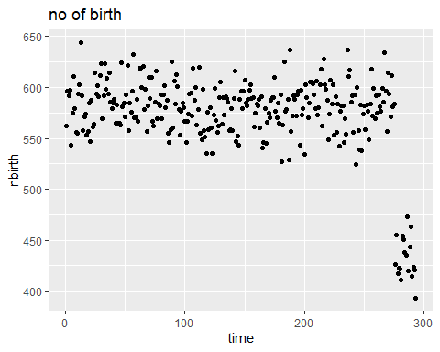

## [1] "Poisson Model,polynomial , before lockdown with season and polynomial trend effect"  
## [1] "portion of no of birth before lockdown"  
## [1] 0.7543458