Flowchart

Trello
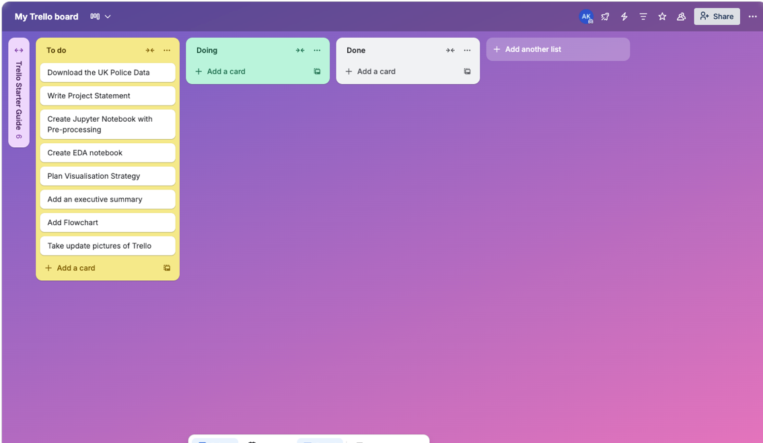
Initial Trello Board created with all the To-Dos

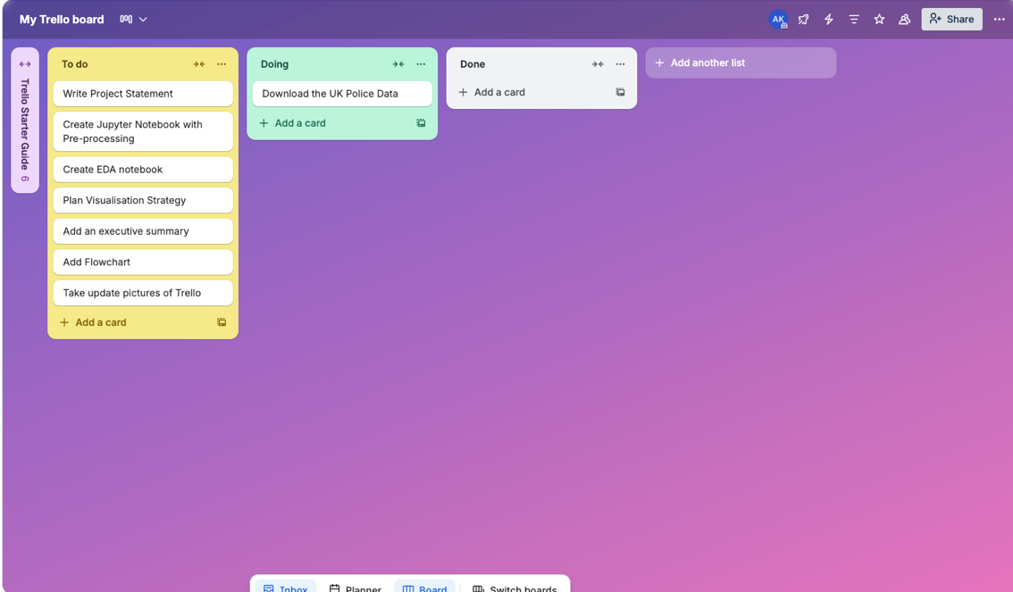
First step was to download all the UK Police Data

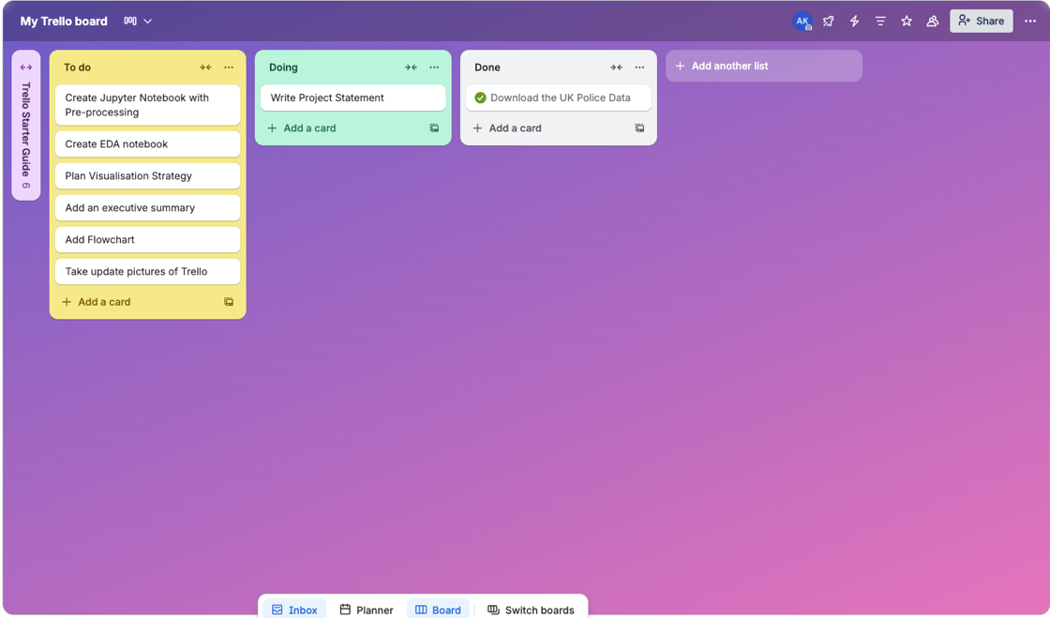
Once the Police Data was downloaded, it was then moved to the “Done” section. The Project Statement was moved to the “Doing” Section.

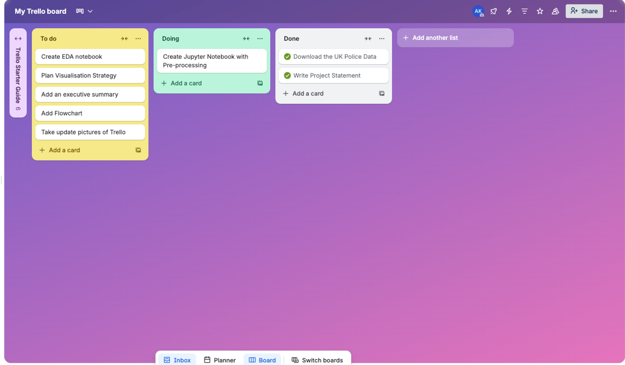
Once the Project Statement was finished, it was moved to the “Done” section. The Creation of Jupyter notebook and pre-processing was then moved to “Doing”.
The cycle continued on for the rest of the tasks in the “To Do” section.

