1. Open html file from the static folder then you will find iframe tag inside html file and if you need to change the URL then you can change the URL in iframe SRC attribute and if you want to change only port then you can change as well as.

Note: - You will put the URL in this format.

**URL:** http://localhost:3000/d/h5l-z1V4z/ist-saf-destination?orgId=1&refresh=5s&kiosk=tv

PORT: - <http://localhost:3000>

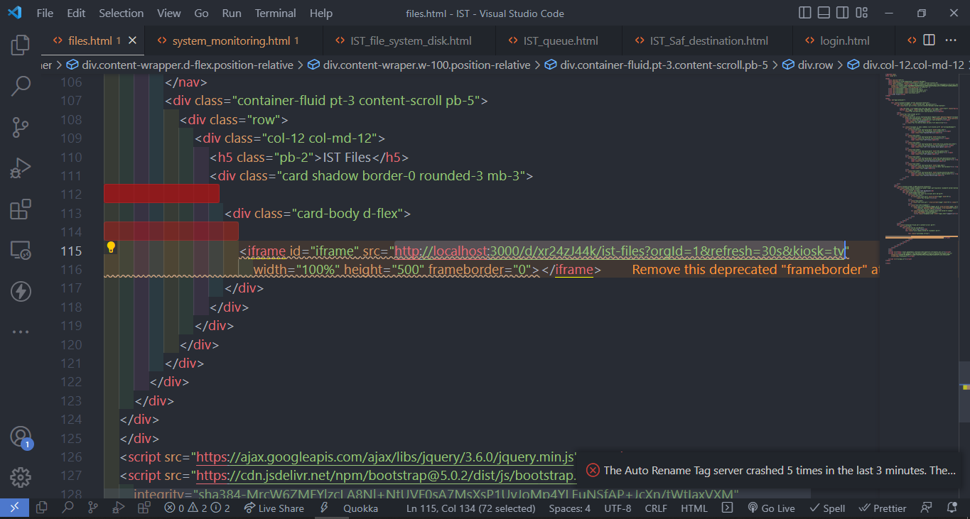

1. If you created a new dashboard in Grafana and you want to implement own html dashboard, then you will need to follow these steps.
   1. Create a new html file.
   2. Append the new list item to make a new link.
   3. Replace the dashboard URL In iframe src.

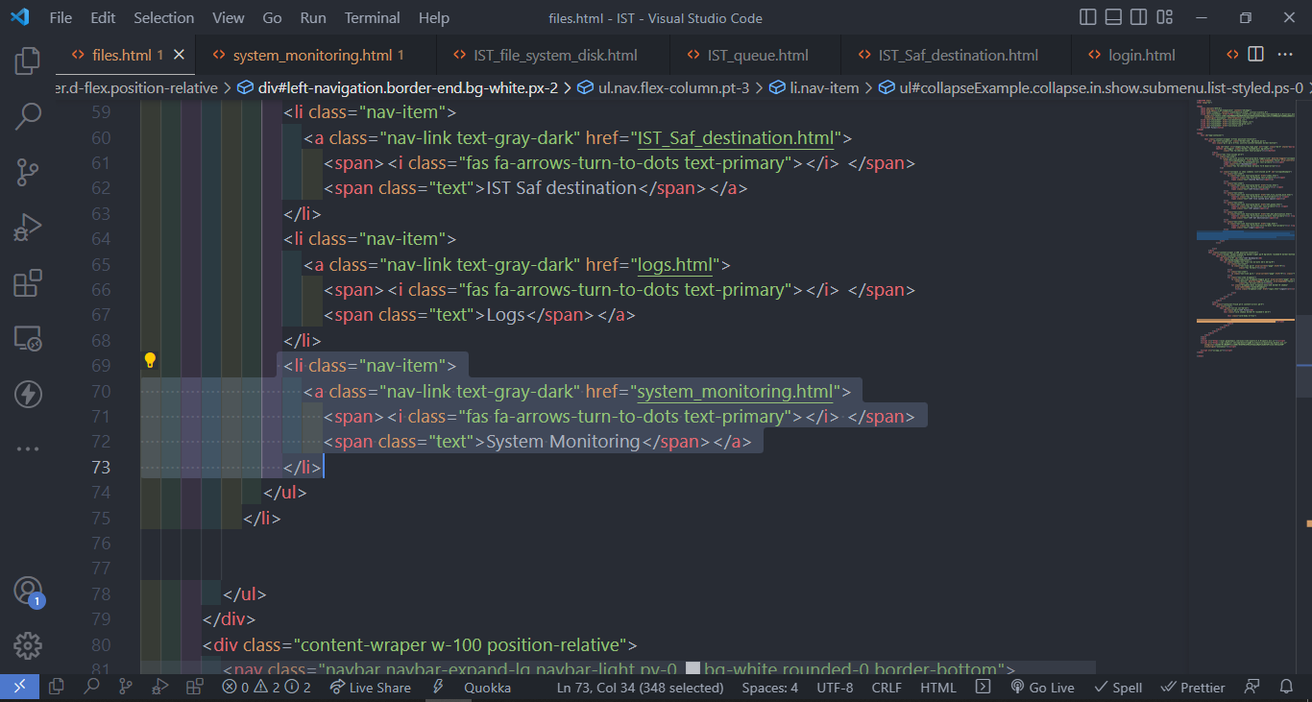

3. How to add data source in Grafana? Follow these steps.

> Move your cursor to the cog icon on the side menu which will show the configuration options.

> Click on Data sources. The data sources page opens showing a list of previously configured data sources for the Grafana instance.

> Click Add data source to see a list of all supported data sources.

> Search for a specific data source by entering the name in the search dialog. Or you can scroll through supported data sources grouped into time series, logging, tracing, and other categories.

> Move the cursor over the data source you want to add.

> Click Select. The data source configuration page opens.

> Enter the IP address of your data source in the URL section.

> Click save

4. How to do enable Anonymous auth in Grafana? Follow these steps.

> Navigate to grafana.ini config file

> Then go to "Anonymous Auth" section

> Change the # enable anonymous access from "false" to "true" (enabled = true)

> Change the org_name to = "whatever your organization name is set in Grafana"

> Save it

> Restart Grafana

5. How to add a Grafana dashboard.

> Click the New dashboard item under the Dashboards icon in the side menu.

> On the dashboard, click Add an empty panel.

> In the New dashboard/Edit panel view, go to the Query tab.

> Configure your query by selecting --your data source-- from the data source selector.

> Now you can add queries, panels, graphs as per your requirement

> Click the Save icon in the top right corner of your screen to save the dashboard.

> Add a descriptive name, and then click Save.