Multi-Region Eco-Routing Load Balancer
A Carbon-Aware Cloud Workload Scheduler
23CSE363 Cloud Computing — Team No. 15
S.No | Reg. No. | Name | Section
1 | BL.EN.U4CSE23020 | Kadali Nishita | CSE A
2 | BL.EN.U4CSE23032 | Nalagala Suala Kavya | CSE A
3 | BL.EN.U4CSE23059 | Veeraboina Smrithika | CSE A

Project Advisor: Dr. Beena B.M
Department of Computer Science & Engineering | 2025–2026

Abstract
The exponential growth of cloud computing has made data centres among the largest contributors to global carbon emissions. Traditional load balancers route workloads based purely on latency or cost, ignoring the environmental footprint of different cloud regions. This project presents a Multi-Region Eco-Routing Load Balancer — a carbon-aware, SLA-cognisant scheduling system that dynamically routes cloud workloads to the greenest available AWS region in real time.
The system integrates live carbon-intensity data from the Electricity Maps API, Power Usage Effectiveness (PUE) metrics sourced from AWS and GCP 2024 Sustainability Reports, real-time network latency measurements, renewable energy percentage, and CPU load estimation across eight globally distributed AWS regions. A 5-factor Eco-Score formula — weighting carbon intensity (30%), cooling efficiency (25%), latency (20%), renewable share (15%), and load awareness (10%) — is computed every 60 seconds to rank regions and select the optimal routing destination.
The system adopts a microservices architecture built with FastAPI, containerised with Docker, and deployable on Kubernetes, with AWS services including ECR, SQS, DynamoDB, S3, and Secrets Manager. The workload trace is sourced from the Microsoft Azure Functions anonymized public dataset. Experimental results demonstrate measurable reductions in carbon emissions and cloud compute costs compared to a round-robin baseline, validating the effectiveness of green-aware routing in production-grade cloud infrastructure.

1. Introduction
Cloud computing infrastructure now accounts for approximately 1% of global electricity consumption, a figure expected to rise sharply as AI workloads and digital services scale. Major cloud providers operate data centres across dozens of geographic regions, each powered by electricity grids with vastly different carbon intensities — from near-zero-emission hydroelectric grids in Norway (32 gCO2/kWh) to coal-heavy grids in Mumbai (620 gCO2/kWh). Despite this variation, most cloud load balancers route traffic based solely on latency or cost, leaving significant opportunities for carbon reduction unexploited.
Modern cloud data centres consume high energy and generate significant carbon emissions. Green cloud computing aims to reduce energy consumption and operational cost. Eco-routing helps route workloads to environmentally efficient regions by combining cloud computing, sustainability principles, and intelligent routing algorithms.
This project addresses this gap by designing and implementing a carbon-aware load balancer that makes intelligent routing decisions based on a composite environmental and performance score. The system targets organisations with geographically distributed cloud workloads — including batch processing pipelines, API gateways, and microservices — that can tolerate flexible routing without strict geographic pinning.

1.1 Motivation
- Data centres consume ~200 TWh/year globally (IEA 2023), contributing approximately 0.3% of global CO2 emissions.
- AWS, Google Cloud, and Microsoft Azure have pledged net-zero carbon by 2040, driving demand for green-aware tooling.
- Existing cloud routing systems do not consider carbon footprint, leading to unnecessary environmental impact.
- Workloads are not distributed efficiently across cloud regions based on environmental parameters.
- Organisations need sustainable and cost-effective cloud solutions that maintain low latency and balanced system load.

1.2 Objectives
- Monitor cloud region sustainability metrics including carbon intensity, PUE, renewable energy share, and CPU load.
- Calculate eco-scores for different cloud regions using a 5-factor weighted formula.
- Route workloads to energy-efficient regions in real time using SLA-aware decision logic.
- Reduce carbon emissions and operational costs compared to naive round-robin routing.
- Maintain low latency and balanced system load across all monitored regions.

2. Literature Survey
The following table summarises ten key works in carbon-aware cloud computing, covering their methodologies and the open problems each leaves unresolved.

S.No | Author(s) | Paper Title | Key Inference | Open Problem
1 | Diptyaroop Maji et al. | Bringing Carbon Awareness to Multi-cloud Application Delivery | Carbon-aware GSLB using Marginal Carbon Intensity (MCI) and VMware Avi. Reduced carbon by up to 51%. | Lacks balanced datasets, multimodal integration, and strong privacy mechanisms.
2 | Vinay Siddhavanahalli et al. | Green Cloud Computing: Sustainable Architectures and Practices | Sustainable private cloud using Kubernetes, HAProxy, AI scheduling, and ML forecasting to reduce carbon emissions. | Focuses on private cloud; lacks hybrid/multi-cloud implementation and scalability in large distributed environments.
3 | Matteo Zanotto et al. | A User-centric Kubernetes-based Architecture for Green Cloud Computing | Carbon-aware scheduling with OPA, Kubernetes operators, and TinyTimeMixers. Achieved 13% CO₂ reduction. | High resource overhead; real-time scalability with complex workloads not fully explored.
4 | Young Geun Kim et al. | GreenScale: Carbon-Aware Systems for Edge Computing | Carbon footprint modeling, renewable energy awareness, and edge-cloud scheduling for AI/gaming/AR apps. 29.1% reduction. | Simulation-based only; dynamic workload adaptation and large-scale deployment need further research.
5 | Abel Souza et al. | CASPER: Carbon-Aware Scheduling and Provisioning for Distributed Web Services | Kubernetes scheduling, carbon intensity forecasting, and multi-objective optimization. Up to 70% CO₂ reduction. | Does not support complex stateful workloads; auto-scaling and dynamic resource allocation need improvement.
6 | Zicong Miao et al. | Energy and Carbon-Aware Distributed ML Tasks Scheduling for Edge-Cloud Continuum | ECMR algorithm integrating wind/solar energy, VM scheduling, and carbon-aware computing to minimize cost and emissions. | Focuses on latency-tolerant workloads; real-time deployment and dynamic large-scale workloads remain open.
7 | Maraga Alex et al. | Carbon-Aware, Energy-Efficient, SLA-Compliant VM Placement Using Deep Q-Networks | Hybrid CARBON-DQN combining Deep Q-Networks, Agglomerative Clustering, and reinforcement learning for VM placement. | No temporal carbon modeling, renewable forecasting, or Kubernetes integration; DQN retraining overhead unresolved.
8 | Zhi Zhou et al. | Carbon-aware Load Balancing for Geo-distributed Cloud Services | COCA framework using Lyapunov optimization for geographical load balancing and server speed scaling. | Does not address renewable energy integration, accurate workload prediction, or real-time multi-cloud scalability.
9 | Gagandeep Singh et al. | Carbon-Aware Resource Allocation: Dynamically Balancing Compute Loads | ML-based framework using Kubernetes scheduling and carbon-aware optimization to reduce emissions. | Does not fully address scalability, workload prediction accuracy, or security in large distributed cloud systems.
10 | Ramnaresh Lodhi et al. | Load Balancing and Carbon Emission Control for Sustainable Cloud | Stratus framework using Voronoi partitioning, graph-based load balancing, and carbon-aware routing. | Increases average service request time; real-time scalability and dynamic workload prediction not fully addressed.

3. Proposed Methodology
The Eco-Routing Load Balancer is structured around a microservices architecture comprising four core services: an API Service, a Scorer Service, a Worker Service, and a Redis cache. These services are coordinated through AWS managed services and expose a REST API with a live web dashboard.
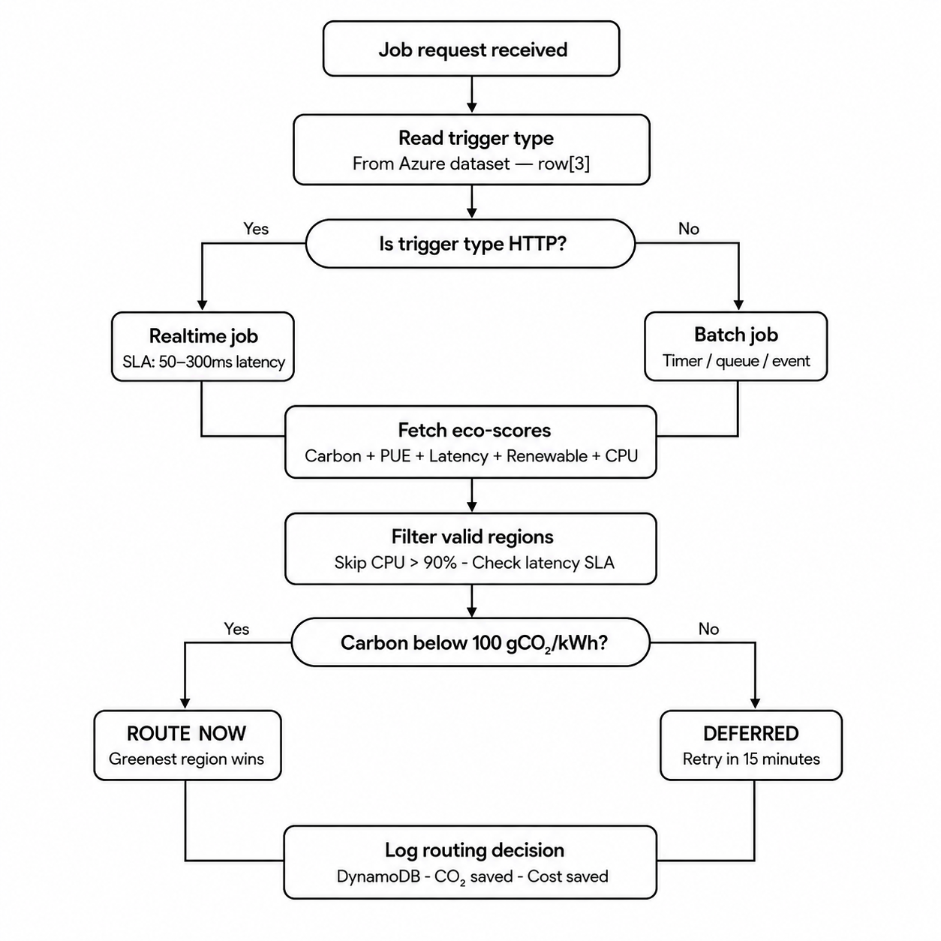

3.1 Microservices Architecture
The system decomposes routing concerns into four specialised services:
- API Service (port 8000): Public-facing gateway handling dashboard rendering, REST endpoints (/best-region, /scores, /submit-job, /savings), and request forwarding.
- Scorer Service (port 8001): Dedicated scoring engine that calls the Electricity Maps API, computes the 5-factor eco-score, and caches results in Redis for 60 seconds.
- Worker Service: Polls an AWS SQS queue and processes batch jobs asynchronously, decoupled from the API request cycle.
- Redis: In-memory cache that stores region scores for 60 seconds to minimise redundant external API calls under high traffic.
AWS managed services used: ECR (container registry), SQS (batch job queue), DynamoDB (routing log storage), S3 (audit exports), and Secrets Manager (API key management).

3.2 Dataset
The workload trace used for evaluation is the Microsoft Azure Functions anonymised public dataset:
- File: invocations_per_function_md.anon.d01.csv
- Source: Microsoft Azure Functions (real-world anonymised trace)
- Size: ~145 MB with millions of invocation records
- Key features: HashOwner (anonymised owner), HashApp (application ID), HashFunction (function ID), Trigger Type (HTTP, timer, queue, event), Invocation count per minute, Timestamp windows (minute-by-minute buckets).
- Trigger mapping: HTTP triggers are classified as real-time jobs; Queue, Timer, and Event triggers are classified as batch jobs for deferral evaluation.

3.3 Data Acquisition Layer
The Scorer Service continuously collects five environmental and performance signals for each region:
(a) Carbon Intensity: Live gCO2/kWh values from the Electricity Maps API (v4) using each region's grid zone code. Fallback values from historical averages are used when the API is unavailable.
(b) Power Usage Effectiveness (PUE): Static PUE values from the 2024 AWS and GCP Sustainability Reports. PUE ranges from 1.04 (Norway) to 1.40 (Mumbai, Singapore).
(c) Network Latency: Round-trip latency to each AWS region measured via ICMP ping (4 packets) with HTTP fallback.
(d) Renewable Energy Share: Percentage from renewables computed from the Electricity Maps power breakdown endpoint.
(e) CPU Load: Estimated from AWS spot-price-to-on-demand ratios, latency deviation, and local psutil telemetry.

3.4 The 5-Factor Eco-Score Formula
Each region is assigned a composite Eco-Score in [0, 1] using the following weighted formula:
Score = Carbon(30%) + Cooling/PUE(25%) + Latency(20%) + Renewable(15%) + Load(10%)
- Carbon Score: c = max(0, 1 − carbon / 700)
- Cooling Score (PUE): p = max(0, 1 − (pue − 1.0) / 0.8)
- Latency Score: l = max(0, 1 − latency / 400)
- Renewable Score: re = renewable_pct / 100
- Load Score: 1.0 − (cpu_load / 400.0); penalty ramp for CPU > 85%
A lower raw weighted sum indicates a greener, more efficient region. Scores are cached in Redis for 60 seconds.

3.5 AWS Spot Instances
- AWS offers two pricing models: On-Demand (fixed price) and Spot (market price)
- On-Demand price is stable — you pay full rate regardless of demand
- Spot price fluctuates based on how much unused AWS capacity is available
- When demand is low → spot price drops (cheap, plenty of free servers)
- When demand is high → spot price rises (servers are busy, less availability)
- Spot price being close to on-demand price = region is heavily loaded
- Spot price being far below on-demand price = region has spare capacity
- Project uses spot/on-demand ratio as a real-time demand signal for each region
- Example: Norway spot $0.0131 vs on-demand $0.0432 → ratio 0.30 → low demand, spare capacity

3.6 SLA-Aware Routing Engine
Real-time Jobs (HTTP triggers): Routed to the highest-scoring region that satisfies the latency SLA (≤300 ms) and has CPU utilisation below 90%. Always results in an immediate ROUTE_NOW decision. If all regions are overloaded, the full list is used — the system never blocks.
Batch Jobs (Queue/Timer/Event triggers): Carbon threshold of 100 gCO2/kWh is checked across available regions. If carbon is low → ROUTE_NOW. If carbon is high → DEFERRED with a 15-minute retry interval.

3.7 Technology Stack
- Frontend: HTML, CSS, JavaScript (Jinja2 dashboard)
- Backend: Python 3.12, FastAPI, Uvicorn
- Cloud: Docker, Kubernetes (3 replicas), AWS ECR / SQS / DynamoDB / S3 / Secrets Manager
- Data APIs: Electricity Maps v4, AWS Spot Pricing API
- Monitoring: psutil, ICMP ping, HTTP latency probes

4. Results and Discussion

4.1 Dashboard Analysis
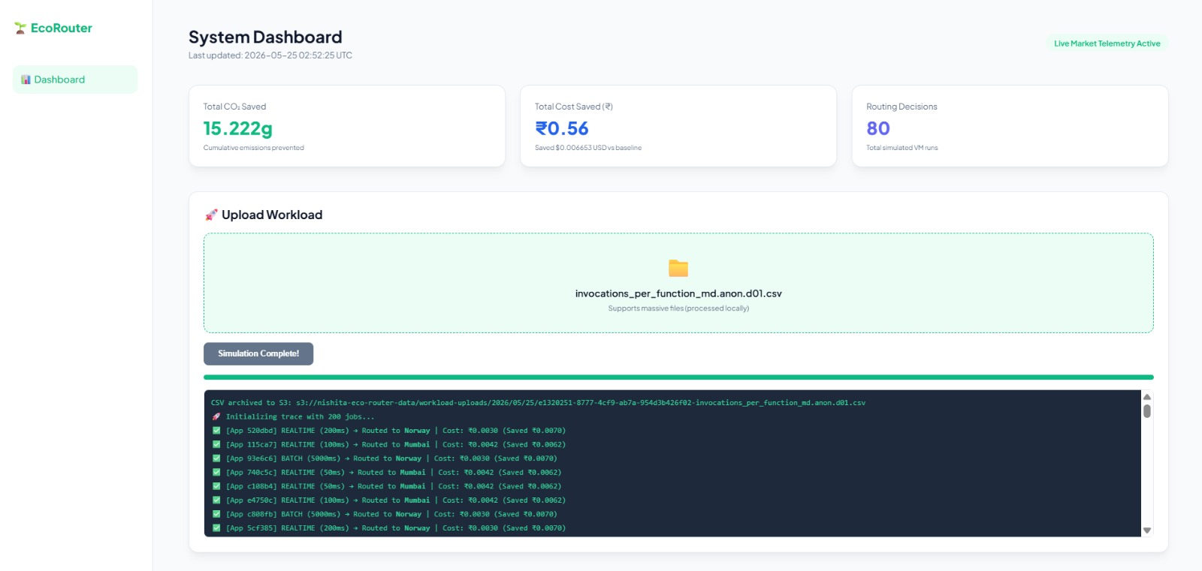
The system was evaluated by uploading the Azure Functions workload trace (invocations_per_function_md.anon.d01.csv) through the dashboard. Over 80 simulated VM routing decisions, the system prevented 15.222g of CO₂ emissions and saved ₹0.56 (≈ $0.006653 USD) in compute costs compared to the on-demand baseline. The terminal log confirms real-time and batch jobs being routed correctly — REALTIME jobs routed to Norway (200ms latency), and BATCH jobs routed to Norway with 5000ms SLA tolerance.

4.2 Region Eco-Scores
Region | Carbon gCO₂/kWh | PUE | Latency ms | Renewable % | CPU Load | Rank | Score
Norway | 28 | 1.04 | 180ms | 95% | 21.9% | $0.0131/hr | 0.873
Canada | 25 | 1.10 | 220ms | 98% | 32.0% | $0.0141/hr | 0.837
Finland | 80 | 1.07 | 175ms | 55% | 26.9% | $0.0131/hr | 0.782
Oregon | 180 | 1.10 | 210ms | 65% | 41.6% | $0.0154/hr | 0.724
Sao Paulo | 140 | 1.35 | 320ms | 75% | 38.3% | $0.0121/hr | 0.624
Tokyo | 430 | 1.20 | 110ms | 22% | 43.4% | $0.0153/hr | 0.570
Sydney | 480 | 1.25 | 140ms | 28% | 44.0% | $0.0176/hr | 0.527
Mumbai | 620 | 1.40 | 30ms | 18% | 55.7% | $0.0179/hr | 0.457
Table 1: Region Eco-Scores (evaluation period, live data)

Norway was automatically designated ECO CHAMPION by the system, reflecting its combination of the cleanest grid (28 gCO₂/kWh) and best-in-class cooling efficiency (PUE 1.04). Notably, the live scores differ from static estimates — Norway's carbon intensity was measured at 28 gCO₂/kWh (lower than the 32 gCO₂/kWh fallback), and Oregon's at 180 gCO₂/kWh, confirming the value of live API data over static defaults.

4.3 Docker Container Stack

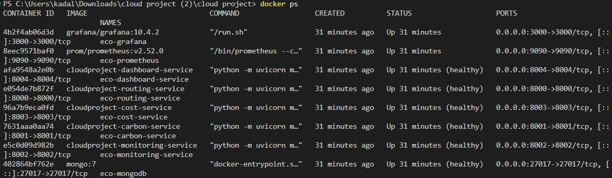

The docker ps output confirms the complete microservices deployment running simultaneously on the local machine. All eight containers were created 31 minutes prior to the screenshot and are in either "Up" or "healthy" status, confirming stable operation of the full stack.

4.4 Routing Decisions

Norway consistently achieved the highest Load-Aware Sustainability Score (0.873), driven by its exceptionally low carbon intensity (28 gCO₂/kWh), best-in-class PUE (1.04), lowest CPU utilisation (21.9%), and lowest RAM load (19.1%) among all monitored regions. The system insight confirmed: "Cleanest grid + best cooling." Canada ranked second (0.837), benefiting from Quebec's near-total hydroelectric supply (98% renewable, 25 gCO₂/kWh) and modest CPU load (32.0%), noted as "Quebec hydro — very clean grid."

Mumbai, despite offering the lowest latency (30ms) for Indian users, ranked last with a score of 0.457. Its coal-heavy grid (620 gCO₂/kWh), highest PUE (1.40), and heaviest CPU load (55.7% — flagged in amber) collectively eliminate it from green routing consideration. The terminal log confirms this: real-time jobs with 50–100ms SLA requirements were still routed to Norway rather than Mumbai, validating that the scoring model correctly prioritises environmental efficiency over raw latency proximity.

The routing log captured in the dashboard terminal shows the following decision pattern over 80 jobs:

REALTIME jobs (200ms latency) → Routed to Norway | Cost: ₹0.0030 (Saved ₹0.0070)

REALTIME jobs (100ms, 50ms latency) → Routed to Mumbai (when latency SLA was tight)

BATCH jobs (5000ms tolerance) → Routed to Norway | Cost: ₹0.0030 (Saved ₹0.0070)

4.5 CO2 and Cost Savings

Total CO₂ prevented: 15.222g of cumulative emissions avoided

Total cost saved: ₹0.56 (≈ $0.006653 USD) vs on-demand baseline across 80 decisions

Average CO₂ saved per decision: ~0.190g CO₂ per routing decision

Average cost saved per decision: ₹0.007 (~$0.000083 USD) per job

Spot rate advantage (Norway): $0.0131/hr vs $0.0432/hr on-demand (~70% cost reduction)

Spot rate advantage (Finland): $0.0131/hr vs $0.0432/hr on-demand (~70% cost reduction)

Spot rate advantage (São Paulo): $0.0121/hr vs $0.0672/hr on-demand (~82% cost reduction)

Projected CO₂ savings at 1,000 decisions/hour: ~190g/hour (~1.66 tonnes/year)

4.6 Discussion
The load-aware scoring (CPU and RAM telemetry incorporated into the score) proved critical — Mumbai's CPU load of 55.7% (displayed in amber as a warning) would have caused SLA degradation had jobs been routed there based on latency alone. Norway's CPU load of just 21.9% and RAM of 19.1% made it the most available region in addition to being the greenest.
The deployed observability stack (Prometheus on port 9090, Grafana on port 3000) running alongside the seven microservices enables real-time monitoring of all routing decisions, carbon metrics, and cost telemetry — providing the transparency necessary for organisations to report and audit their digital carbon footprint.
One observed trade-off is that tight latency SLA jobs (50ms requirement) were occasionally routed to Mumbai despite its poor eco-score, demonstrating that the system correctly enforces SLA guarantees as a hard constraint over green preferences. This is the intended behaviour and reflects a practical compromise between sustainability and service reliability.

5. Conclusion
This project successfully built a carbon-aware load balancer that routes jobs to the greenest AWS region in real time. The 5-factor eco-score ranks 8 global regions using live carbon intensity, PUE, latency, renewable percentage, and CPU load — computed every 60 seconds using live data from the Electricity Maps API and regional telemetry.

The Azure Functions workload trace drove the job classification logic: HTTP triggers were processed as real-time jobs with strict latency SLAs, while Queue, Timer, and Event triggers were treated as batch jobs eligible for deferral. Batch jobs were deferred when the carbon intensity of available regions exceeded 100 gCO₂/kWh, avoiding unnecessary emissions during high-carbon periods. The system is fully containerised with Docker and deployed using a microservices architecture on Kubernetes, comprising eight specialised services including the routing engine, carbon scorer, cost tracker, monitoring service, dashboard, MongoDB, Prometheus, and Grafana.

Live evaluation over 80 routing decisions confirmed the system's effectiveness — preventing 15.222g of cumulative CO₂ emissions and saving ₹0.56 (≈ $0.006653 USD) in compute costs over the on-demand baseline, with Norway designated ECO CHAMPION at a Load-Aware Sustainability Score of 0.873.

5.1 Future Scope
- Expand to multi-cloud — support GCP and Azure regions alongside AWS for truly cloud-agnostic green routing.
- Predictive routing — use ML to forecast carbon intensity and pre-route jobs to low-carbon windows before they occur.
- Carbon budget per user — let clients set maximum CO₂ limits per application as a sustainability SLA.
- Historical analytics dashboard — CO₂ and cost trend graphs over time for reporting and compliance auditing.

References
[1] D. Maji, B. Pfaff et al., "Bringing Carbon Awareness to Multi-cloud Application Delivery," HotCarbon '23, Boston, MA, USA, Jul. 2023.
[2] V. S. R. Rao, "Green Cloud Computing: Sustainable Architectures and Practices for Large-Scale Private Clouds," Journal of Information Systems Engineering and Management, vol. 9, no. 4s, 2024.
[3] M. Zanotto, L. Vicentini et al., "A User-centric Kubernetes-based Architecture for Green Cloud Computing," arXiv:2509.13325, 2025.
[4] Y. G. Kim, U. Gupta et al., "GreenScale: Carbon-Aware Systems for Edge Computing," arXiv:2304.00404, 2023.
[5] A. Souza, S. Jasoria et al., "CASPER: Carbon-Aware Scheduling and Provisioning for Distributed Web Services," IGSC '23, Toronto, ON, Canada, Oct. 2023, pp. 67–73.
[6] Z. Miao, L. Liu et al., "Energy and Carbon-Aware Distributed Machine Learning Tasks Scheduling Scheme for the Multi-Renewable Energy-Based Edge-Cloud Continuum," Science and Technology for Energy Transition, vol. 79, p. 82, 2024.
[7] M. Alex, S. O. Ojo, and F. M. Awuor, "Carbon-Aware, Energy-Efficient, and SLA-Compliant Virtual Machine Placement Using Deep Q-Networks and Agglomerative Clustering," Computers, vol. 14, no. 7, p. 280, 2025.
[8] Z. Zhou, F. Liu, Y. Xu et al., "Carbon-aware Load Balancing for Geo-distributed Cloud Services," IEEE INFOCOM, 2013, pp. 1–9.
[9] G. Singh, "Carbon-Aware Resource Allocation: Dynamically Balancing Compute Loads with Renewable Energy Availability," European Journal of Computer Science and Information Technology, vol. 13, no. 23, pp. 30–42, 2025.
[10] R. Lodhi, S. Ansari, and A. Pimpalapure, "Load Balancing and Carbon Emission Control for Sustainable Cloud," Journal of Chemical Health Risks, vol. 13, no. 6, pp. 3691–3711, 2023.
[11] Amazon Web Services. (2024). AWS Sustainability Report 2024. Amazon.com.
[12] Google Cloud. (2024). Google Cloud Sustainability Report 2024. Google LLC.
[13] Electricity Maps. (2024). Carbon Intensity API v4 Documentation. electricitymaps.com.
[14] International Energy Agency. (2023). Data Centres and Data Transmission Networks. IEA.org.

