Technical Architecture Document
  - Trade Data Processing Pipeline
Document Information
Document Type | Technical Architecture Document (TAD)
Author | Azameer — Technical Architect
Version | 1.0
Date | August 2026
Status | Implemented & Validated
Classification | Internal — Engineering Leadership

1. Executive Summary
This document presents the architecture, design rationale, and implementation details of a cloud-native trade data processing pipeline built on Snowflake. The system ingests thousands of trade events daily, validates them against five business rules, routes valid trades to a live trade book, logs rejections for compliance, and provides real-time monitoring with automated alerting.
Key outcomes delivered:
- End-to-end pipeline from ingestion to reporting in a single platform (Snowflake)
- Zero-infrastructure orchestration (no Airflow/Docker to maintain)
- Sub-minute processing latency via stream-triggered execution
- 100% audit coverage — every trade accepted or rejected with full traceability
- Automated quality gates via 22 dbt schema tests in CI/CD
- Three-tier alerting: failure detection, quality degradation, and stall detection

2. Problem Statement

2.1 Business Context
The organization processes thousands of trade events daily from multiple source systems. These trades go through amendments (version changes), cancellations, and natural expiry. Without a validated pipeline:
- Stale or duplicate trades pollute the trade book
- Expired trades remain incorrectly marked as active
- Rejected trades lack audit trails required by compliance
- Pipeline failures go undetected until downstream reports break

2.2 What We Need
Need | Why It Matters
Real-time ingestion | Traders need current positions; delays = risk exposure
Business rule validation | Incorrect trades in the book = financial and regulatory risk
Rejection audit trail | Compliance mandates: every rejection must be logged with reason
Automated monitoring | Manual checks don't scale; failures must be detected in minutes
Scalability | Trade volumes will grow 10x-100x as new desks onboard

2.3 Success Criteria
- All 5 business rules enforced on every trade event
- Rejected trades logged with code, reason, and original payload
- Pipeline failures detected and alerted within 10 minutes
- System handles 10,000x volume increase without architecture changes
- Full CI/CD: no untested code reaches production

3. Solution Architecture

3.1 High-Level Architecture

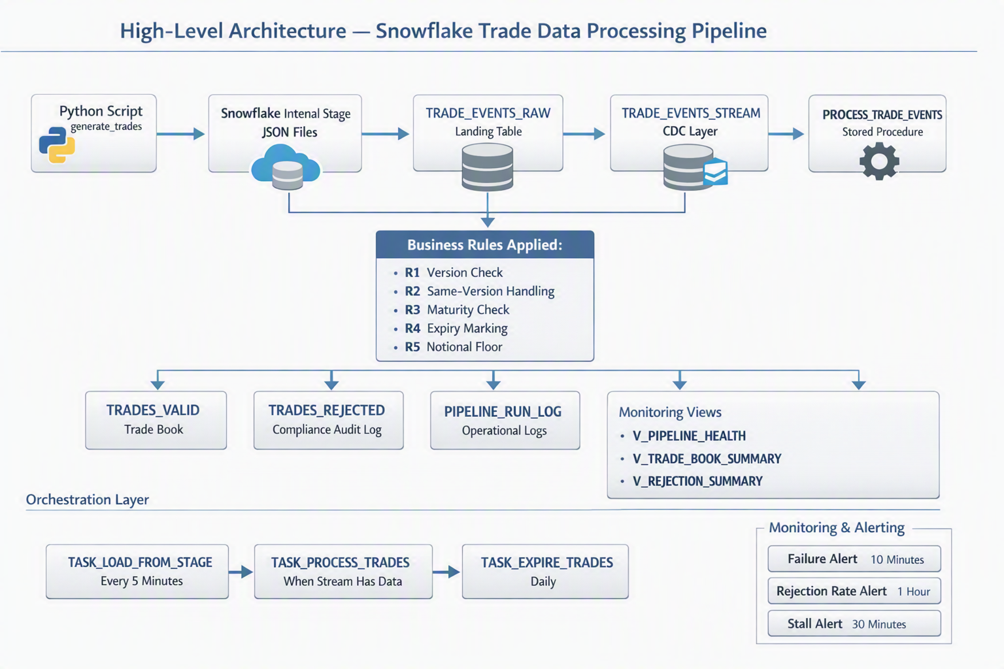
SNOWFLAKE PLATFORM
INF_EDW.EDWWORKDB
Source / Generator  Python Script  generate_trades | Ingestion Stage  STAGE  JSON files | Landing Layer  TRADE_EVENTS_RAW | CDC Layer  TRADE_EVENTS_STREAM | Processing Layer  PROCESS_TRADE_EVENTS  Stored Procedure
Flow: Python Script → Stage → Raw Table → Stream → Stored Procedure
Business Rules Applied
R1: Version Check | R2: Same-Version Handling | R3: Maturity Check | R4: Expiry Marking | R5: Notional Floor
Accepted Output  TRADES_VALID  Trade Book |  | Rejected Output  TRADES_REJECTED  Compliance Audit Log | Operational Logs  PIPELINE_RUN_LOG | Monitoring Views  V_PIPELINE_HEALTH  V_TRADE_BOOK_SUMMARY  V_REJECTION_SUMMARY
Orchestration Layer  TASK_LOAD_FROM_STAGE every 5 minutes → TASK_PROCESS_TRADES when stream has data → TASK_EXPIRE_TRADES daily |  |  | Monitoring & Alerting  Failure Alert: 10 minutes | Rejection Rate Alert: 1 hour | Stall Alert: 30 minutes

3.2 Design Principles
Principle | How We Applied It
Single Platform | Everything in Snowflake — no external systems to integrate, secure, or maintain
Event-Driven | Stream-triggered tasks fire only when data arrives — no polling, no wasted compute
Fail-Safe | Exception handling captures all errors; alerts fire within minutes
Audit-First | Every trade gets a verdict (accepted/rejected) with full provenance
Idempotent | Re-processing the same events produces the same result — safe retry
Separation of Concerns | Raw → Validated → Final layers; each has a clear responsibility

4. Technology Selection & Justification

4.1 Why Snowflake (Not Spark/Kafka/Custom)?
Factor | Snowflake | Alternative (Spark + Kafka)
Infrastructure | Zero — fully managed | Clusters, ZooKeeper, brokers to operate
Latency | Sub-minute (stream + task) | Lower (seconds), but overkill for this volume
Cost model | Pay per second of compute | Always-on cluster costs
SQL familiarity | Team already knows SQL | Requires Scala/Python expertise
Built-in CDC | Streams (native) | Kafka Connect + schema registry
Alerting | Native Alerts + email | Custom alerting infrastructure
Scaling | Resize warehouse, done | Add nodes, rebalance partitions
Decision: Snowflake provides all required capabilities with dramatically lower operational burden. The team's existing SQL skills transfer directly.

4.2 Why Snowflake Tasks (Not Airflow)?
Factor | Snowflake Tasks | Apache Airflow
Infrastructure | None (serverless) | Docker, scheduler, webserver, DB
Stream integration | Native (SYSTEM$STREAM_HAS_DATA) | Requires custom sensor
DAG definition | SQL AFTER clause | Python DAG file
Monitoring | TASK_HISTORY() + Alerts | Airflow UI + logs
Maintenance | Zero | Upgrades, security patches, scaling
Cost | Only when running | Always-on (even idle)
Decision: For a Snowflake-only pipeline, Tasks eliminate an entire infrastructure layer. Airflow would be justified if the pipeline spanned multiple systems (S3, APIs, ML services).

4.3 Why dbt (In Addition to Stored Procedures)?
Concern | Stored Procedure | dbt
Production execution | Real-time MERGE with stream trigger | Batch-oriented
Testing | Manual validation | 22 automated schema tests
Documentation | Comments in SQL | Auto-generated lineage + docs
CI/CD integration | Harder to test in isolation | dbt parse + dbt test in pipeline
Version control | Procedure is a single block | Each model is a versioned file
Decision: Both are implemented. The SP handles production real-time processing; dbt provides the quality assurance and CI/CD testing layer. They complement each other.

4.4 Why Not Dynamic Tables?
Dynamic Tables (Snowflake's declarative streaming) were considered but not used because:
- They don't support MERGE with complex multi-rule classification in a single pass
- The rejection logging requirement needs explicit INSERT to a separate table
- Version conflict detection requires a stateful join against the current book + intra-batch deduplication
Dynamic Tables would be appropriate for simpler transformations (aggregations, joins) without conditional routing.

5. Data Flow — End to End

5.1 Stage 1: Ingestion (WHAT happens)
Source: Trade events arrive as JSON (from source systems: TMS, Bloomberg, Murex, Calypso)
Process:
- Python script generates/receives trade events
- JSON files are uploaded to TRADE_INGEST_STAGE (Snowflake internal stage)
- LOAD_TRADES_FROM_STAGE() procedure runs COPY INTO with schema extraction
- Each JSON element becomes a row in TRADE_EVENTS_RAW with a unique event_id
WHY this design:
- Internal stage provides encryption at rest and in transit
- COPY INTO is idempotent — files already loaded are skipped automatically
- Raw payload preserved in VARIANT column for forensic replay if needed
- is_processed = FALSE flag enables dbt to also consume unprocessed events

5.2 Stage 2: CDC Capture (WHEN it triggers)
Object: TRADE_EVENTS_STREAM (append-only stream on TRADE_EVENTS_RAW)
Behavior:
- Captures every INSERT into the raw table
- Stream offset advances atomically when consumed by the procedure
- Zero-cost when idle (no polling, no compute)
WHY append-only:
- Raw events are immutable (write-once, read-many)
- We never UPDATE or DELETE raw data — amendments come as new events with higher versions
- Append-only streams are more efficient than standard streams for this pattern

5.3 Stage 3: Validation & Classification (HOW rules are applied)
Process: PROCESS_TRADE_EVENTS() stored procedure executes:
Step 1: Snapshot stream → TMP_PENDING (advances stream offset)
Step 2: Join against TRADES_VALID → TMP_CLASSIFIED (business rules applied)
Step 3: MERGE accepted trades → TRADES_VALID
Step 4: INSERT rejections → TRADES_REJECTED
Step 5: UPDATE expired trades → trade_status = 'EXPIRED'
Step 6: Mark raw events → is_processed = TRUE
Step 7: Log metrics → PIPELINE_RUN_LOG
WHY a stored procedure (not a series of SQL statements):
- Atomic execution — all steps succeed or the entire run is marked FAILED
- Exception handling with proper error logging
- Returns structured JSON result for programmatic consumption
- Single transaction boundary ensures consistency

5.4 Stage 4: Output (WHERE results land)
Destination | What Goes There | Retention
TRADES_VALID | Latest accepted version per trade_ref | Indefinite (active book)
TRADES_REJECTED | Every rejected event with code + reason | 7 years (compliance)
PIPELINE_RUN_LOG | Execution metrics per run | 1 year (operational)

6. Business Rules Engine — Detailed Logic

6.1 Rule Precedence (Order Matters)
Rules are evaluated in this specific order. The first matching rule wins:
Event Arrives | New trade event enters rule evaluation.
R3: Maturity Date Check | If maturity date is in the past, reject the trade.
R5: Bond Notional Floor | If instrument is BOND and notional is below 1000, reject the trade.
R1: Version Too Low | If incoming version is lower than existing version, reject the trade.
R2: Same Version | If incoming version equals existing version, accept and replace.
Accepted Trade | New trade or version upgrade is accepted into the trade book.
R4: Expiry Marking | If maturity date is today or earlier after acceptance, mark status as EXPIRED; otherwise mark ACTIVE.

6.2 Why This Order?
- R3 first: A trade with past maturity is invalid regardless of version — reject immediately, save processing
- R5 next: Business minimum threshold — cheap check, catches bad data early
- R1 before R2: Must reject stale versions before considering same-version replacements
- R4 last: Only applied AFTER acceptance — a trade can be accepted into the book and immediately marked expired (this is valid for audit purposes)

6.3 Intra-Batch Conflict Resolution
Problem: Multiple events for the same trade_ref can arrive in a single batch (e.g., v1, v2, and v1 again for TRD-001).
Solution:
ROW_NUMBER() OVER (PARTITION BY trade_ref ORDER BY version DESC) AS rn
- Only rn = 1 (highest version) enters the MERGE source
- Lower versions within the same batch are rejected as REJECT_VERSION_TOO_LOW
- This prevents Snowflake's non-deterministic MERGE behavior with duplicate keys
WHY this matters: Snowflake does not enforce PRIMARY KEY constraints. Without deduplication, MERGE's WHEN NOT MATCHED branch would insert multiple rows for the same trade_ref.

7. Orchestration Design

7.1 Task DAG Structure
TASK_LOAD_FROM_STAGE  Root task  Runs every 5 minutes  Loads files into raw table | TASK_PROCESS_TRADES  Child dependency  Runs only when stream has data  Calls PROCESS_TRADE_EVENTS('TASK') | TASK_EXPIRE_TRADES  Independent daily task  Runs at midnight UTC  Calls EXPIRE_STALE_TRADES()

7.2 Why 5-Minute Intervals (Not Real-Time)?
Consideration | Reasoning
Cost | XSMALL warehouse billed per-second; 5 min is cost-efficient for this volume
Latency tolerance | Trade book updates within 5 minutes meets business SLA
Batch efficiency | Processing 50-100 events per run is more efficient than one-at-a-time
Upgrade path | Can reduce to 1 minute or switch to Snowpipe for sub-second if needed

7.3 Failure Recovery
Failure Mode | Detection | Recovery
Procedure exception | TRY/CATCH → PIPELINE_RUN_LOG.run_status = 'FAILED' | Alert fires in 10 min; manual retry via EXECUTE TASK
Task timeout | Snowflake auto-marks as FAILED in task history | Task retries on next schedule
Stream offset stuck | ALERT_PIPELINE_STALLED (no success in 30 min) | Recreate stream or investigate lock
Bad data crashes SP | Exception handler logs error message | Fix data, re-run manually

8. Monitoring & Alerting Strategy

8.1 Three-Tier Alert Design
Tier 1: Critical | ALERT_PIPELINE_FAILURE detects failed runs in the last 10 minutes and emails the operations team with run details and error message.
Tier 2: Warning | ALERT_HIGH_REJECTION_RATE detects rejection rates above 30% in the last hour and prompts investigation of source system data quality.
Tier 3: Informational | ALERT_PIPELINE_STALLED detects no successful run in 30 minutes and prompts checks for suspended tasks or expected empty streams.

8.2 Operational Dashboards (Views)
View | Purpose | Audience
V_PIPELINE_HEALTH | Last 24h: run_id, duration, counts, status | Ops / On-call
V_TRADE_BOOK_SUMMARY | Live position: count/notional by status/instrument/currency | Trading desk
V_REJECTION_SUMMARY | Hourly rejection trends by code | Data quality team

8.3 Why These Thresholds?
- 10 minutes for failure: Balances alert fatigue vs. response time. Failures are rare; when they happen, 10 min is fast enough for a non-real-time system.
- 30% rejection rate: Normal is 5-15% (version conflicts from legitimate amendments). Above 30% indicates upstream system issues.
- 30 minutes stalled: Pipeline runs every 5 min. 30 min = 6 missed runs = definitely something is wrong (not just an empty stream).

9. Data Quality Framework

9.1 Automated Tests (22 total via dbt)
Category | Tests | What They Catch
Referential integrity | not_null on all key columns (8 tests) | Missing required fields
Uniqueness | unique on event_id, trade_ref, rejection_id (4 tests) | Duplicate processing
Domain validation | accepted_values on currency, instrument, status, codes (10 tests) | Invalid enum values, schema drift

9.2 When Tests Run
Trigger | What Runs | Failure Action
Every PR | dbt parse (syntax) + SQLFluff (style) | Block merge
Push to develop | dbt run + dbt test (CI schema) | Block promotion to main
Push to main | dbt run + dbt test (production) | Rollback if tests fail
Nightly | dbt test only (validates production data) | Alert team

9.3 Why dbt Tests (Not Just SP Validation)?
The stored procedure validates business rules (version, maturity, notional). dbt tests validate data integrity (uniqueness, nulls, valid enums). These are complementary:
- SP catches: "This trade should not enter the book"
- dbt catches: "The system itself produced inconsistent data"

10. Security & Compliance

10.1 Access Control
Object | Access Pattern
TRADE_EVENTS_RAW | Write: ingestion role only; Read: processing SP + dbt
TRADES_VALID | Write: processing SP only; Read: reporting roles
TRADES_REJECTED | Write: processing SP only; Read: compliance + audit roles
PIPELINE_RUN_LOG | Write: processing SP; Read: ops team
Stored Procedures | Execute: task service role only

10.2 Audit Trail Completeness
Every trade event results in exactly one of:
- A row in TRADES_VALID (accepted) — with created_at/updated_at timestamps
- A row in TRADES_REJECTED (rejected) — with rejection_code, reason, original payload, and timestamp
No event is silently dropped. The is_processed flag on raw events confirms every row was handled.

10.3 Data Retention
Table | Retention Policy | Rationale
TRADE_EVENTS_RAW | 90 days (Time Travel) + archival | Source of truth for replay
TRADES_REJECTED | 7 years minimum | Regulatory compliance
TRADES_VALID | Indefinite (active book) | Current state always needed
PIPELINE_RUN_LOG | 1 year | Operational troubleshooting

11. Scalability — From 1x to 10,000x

11.1 Current State (1x)
- ~1,000 trades/day
- XSMALL warehouse (1 credit/hour)
- 5-minute batch intervals
- Single stream, single task chain

11.2 Growth Path
Volume | Change Required | Effort
10x (10K/day) | No change needed — XSMALL handles this | Zero
100x (100K/day) | Resize to SMALL warehouse | 1 ALTER command
1,000x (1M/day) | Switch to Snowpipe (continuous) + MEDIUM warehouse | Half day
10,000x (10M/day) | Multi-cluster warehouse + partitioned streams + clustering keys | 1-2 days

11.3 Architecture Changes at 10,000x
Current: Stage → Raw Table → Stream → Task (5 min) → SP → Valid/Rejected
At scale: Snowpipe → Raw (clustered by ingested_at) → Multiple Streams
→ Serverless Tasks → Dynamic Tables for aggregation layer
Key point: The business logic (5 rules) doesn't change. Only the ingestion and compute layers scale.

12. Risk Register
# | Risk | Likelihood | Impact | Mitigation
1 | Source system sends malformed JSON | Medium | Low | ON_ERROR = 'CONTINUE' in COPY; bad rows skipped and logged
2 | Warehouse suspended during task run | Low | Medium | Task retries on next schedule; alert fires if stalled
3 | Stream offset corruption | Very Low | High | Recreate stream; replay from raw table using is_processed flag
4 | Runaway rejection rate (>90%) | Low | Medium | Alert at 30%; ops investigates upstream; tasks continue processing
5 | Snowflake service outage | Very Low | High | Snowflake SLA 99.9%; multi-region for DR if required
6 | dbt model change breaks production | Medium | Medium | CI/CD gate: dbt test must pass before merge to main
7 | Duplicate events from source | Medium | Low | Version-based idempotency — same event processed twice = same result

13. CI/CD & Deployment Strategy

13.1 Pipeline Flow
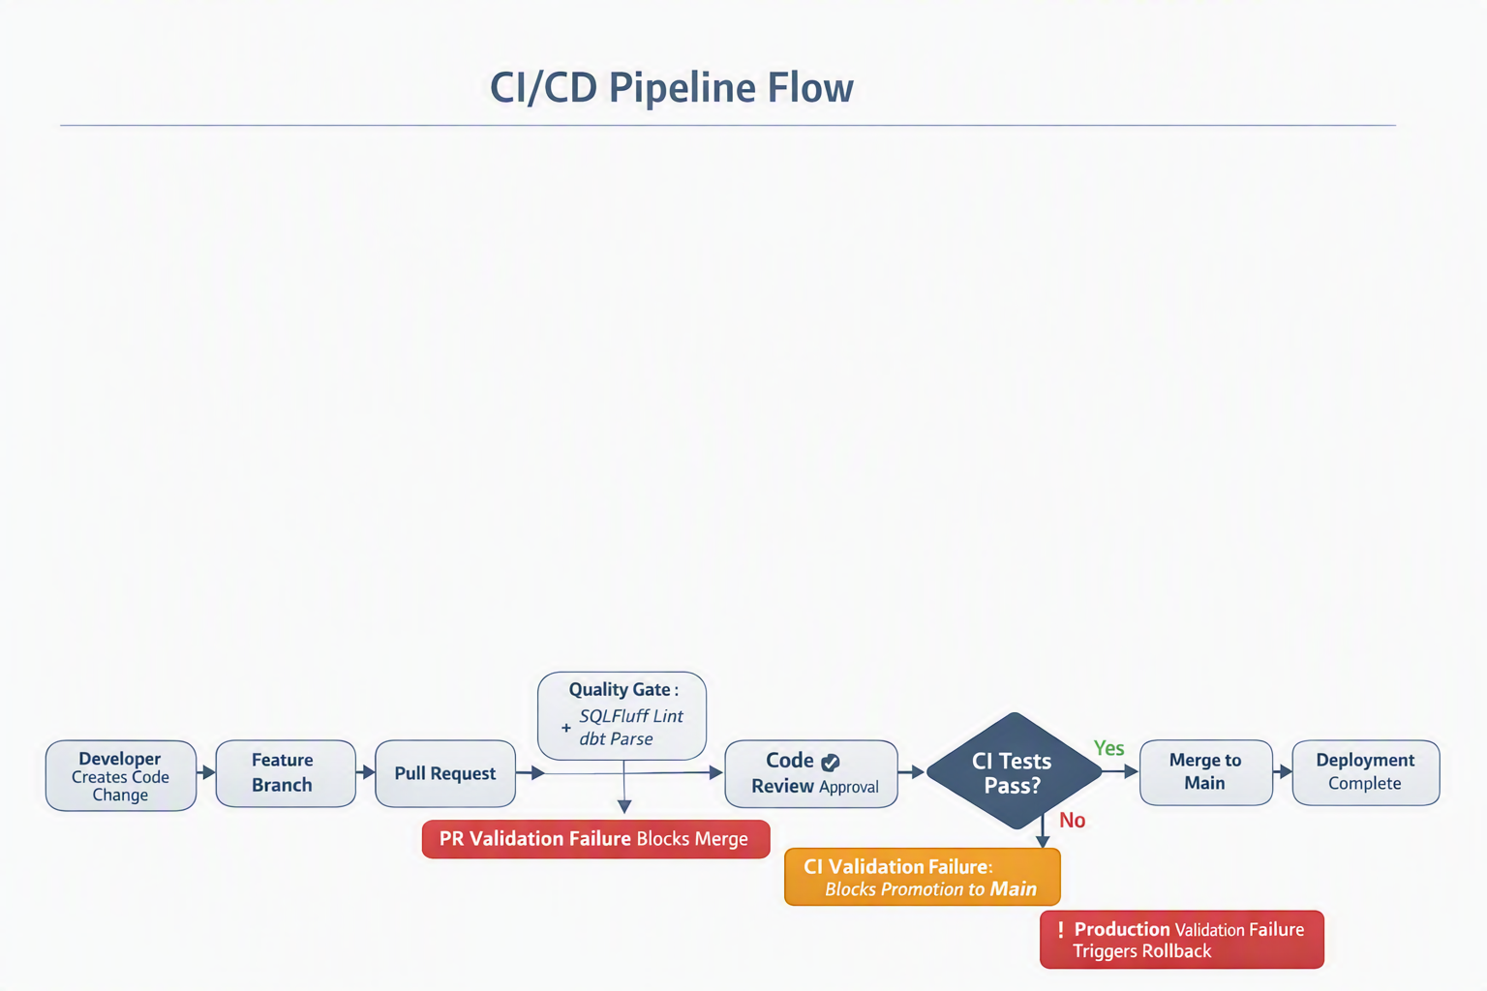

13.2 What Gets Tested
Stage | Tool | What's Validated
Pre-commit | SQLFluff | SQL style and formatting
PR check | dbt parse | Model syntax, ref resolution, YAML validity
CI build | dbt run + dbt test | Full execution + 22 data quality tests
Production | dbt run + dbt test | Same, against real data

13.3 Rollback Strategy
- dbt incremental models: run with --full-refresh to rebuild from source
- Stored procedure: CREATE OR REPLACE deploys instantly; previous version gone
- To rollback SP: revert git commit, re-run CREATE OR REPLACE from previous version
- Tables: Snowflake Time Travel (up to 90 days) for point-in-time recovery

14. Cost Analysis

14.1 Compute Costs (Estimated)
Component | Warehouse | Frequency | Duration | Credits/Day
TASK_LOAD_FROM_STAGE | XSMALL (1 cr/hr) | Every 5 min | ~5 sec each | ~0.14
TASK_PROCESS_TRADES | XSMALL | Every 5 min (when data) | ~10 sec | ~0.28
TASK_EXPIRE_TRADES | XSMALL | Once daily | ~3 sec | ~0.001
Alerts (3x) | XSMALL | 10/30/60 min | ~2 sec each | ~0.05
Total |  |  |  | ~0.47 cr/day

14.2 Storage Costs
Table | Estimated Size (1 year) | Monthly Cost
TRADE_EVENTS_RAW | ~5 GB | ~$1.15
TRADES_VALID | ~500 MB | ~$0.12
TRADES_REJECTED | ~2 GB | ~$0.46
PIPELINE_RUN_LOG | ~100 MB | ~$0.02

14.3 Cost Optimization Applied
- XSMALL warehouse: Smallest possible; auto-suspends after 60 seconds of idle
- Stream-triggered tasks: No execution when no data arrives (weekends, holidays)
- Append-only stream: Lower overhead than standard streams
- Clustering deferred: Only add clustering keys when query patterns justify the cost

15. Decision Log
# | Decision | Alternatives Considered | Why This Choice
1 | Snowflake-native orchestration (Tasks) | Airflow, Prefect, Dagster | Zero infra overhead; native stream integration; team knows SQL
2 | Stored Procedure for real-time processing | Dynamic Tables, dbt only | Need MERGE + conditional routing + rejection logging in one transaction
3 | dbt for testing/CI only (not production) | dbt for everything | SP provides real-time; dbt provides quality gates — complementary
4 | Append-only stream | Standard stream | Raw events are insert-only; append streams are cheaper and simpler
5 | Single schema (EDWWORKDB) | Multi-schema (RAW/STAGING/FINAL) | Simpler permissions; all objects visible in one place; team preference
6 | ROW_NUMBER deduplication | Pre-processing step, QUALIFY | Handles intra-batch conflicts within the MERGE source elegantly
7 | MD5 for surrogate keys | UUID_STRING, HASH | No external package dependency (dbt_utils unavailable in this env)
8 | 5-minute task interval | 1 min, Snowpipe | Cost-efficient for current volume; easy to reduce later
9 | Email alerts (not Slack/PagerDuty) | Webhook integration | Email works out-of-box; can add webhook later without architecture change
10 | Dual output tables (SP + dbt) | Single shared table | Prevents conflicts; allows independent testing of each path

16. Appendices

Appendix A: Object Inventory
22 Snowflake objects in INF_EDW.EDWWORKDB — see README.md for full list.

Appendix B: File Inventory
12 files in the repository — see README.md for full list.

Appendix C: How to Demo This to Leadership
-- 1. Show empty trade book
SELECT COUNT(*) FROM TRADES_VALID; -- 0

-- 2. Insert 7 test trades (mix of valid, version conflicts, expired, bad notional)
-- [run the INSERT from section 9 of Case studies.sql]

-- 3. Process them
CALL PROCESS_TRADE_EVENTS('DEMO');

-- 4. Show results
SELECT trade_ref, version, notional, trade_status FROM TRADES_VALID; -- 2 valid
SELECT trade_ref, rejection_code, rejection_reason FROM TRADES_REJECTED; -- 4 rejected with clear reasons
SELECT run_status, events_processed, trades_accepted, trades_rejected FROM PIPELINE_RUN_LOG; -- full metrics

-- 5. Show monitoring
SELECT * FROM V_TRADE_BOOK_SUMMARY; -- executive dashboard view

Appendix D: Questions Leadership May Ask
Question | Answer
"What if Snowflake goes down?" | 99.9% SLA; Time Travel for recovery; raw data preserved for replay
"How fast can we process?" | Currently 5 min batches; can go to sub-second with Snowpipe (config change only)
"What does this cost?" | ~$0.50/daycompute+$2/month storage at current volume
"Can other teams use this?" | Yes — clone the pattern; just change the business rules in the SP
"What about GDPR/data deletion?" | Add a CANCEL status + trade_ref lookup; DELETE from TRADES_VALID where requested
"Who maintains this?" | Zero-infrastructure; Snowflake manages everything. Team maintains business rules only

