PCB GUIDELINES:

USE THIS STACKUP:

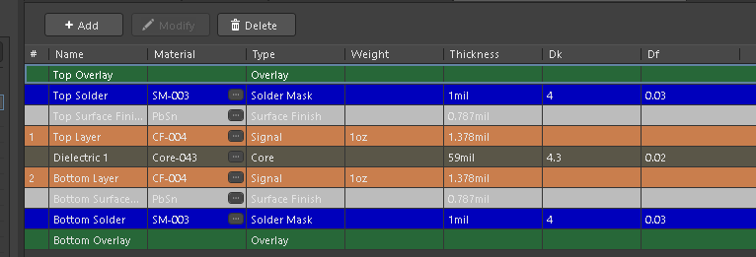

KEEP LINE WIDTH **>6 MIL**S FOR ALL TRaCES.

|  |  |  |  |  |
| --- | --- | --- | --- | --- |
|  | VOLATGE (V) | CURRENT (A) | ALL LAYERS | TO KEEP V DROPS < 0.15V, 10 DEG ABOVE AMBIENT |
| VSYS | 7.4 | 2.66063473 | 50 MILS | <3 INCHES |
| V3V3 | 3.3 | 0.8 | 25 MILS | <6 INCHES |
| V4V0 | 4 | 2.2 | 35 MILS | <3 INCHES |
| V5V0 | 5 | 1 | 25 MILS | <6 INCHES |

· Download Saturn PCB Toolkit and don’t exceed 0.1 V voltage drop. If u don’t understand this step pls refer the table above. Keep the ambient temperature at 25 °C and max temperature rise at 10 °C.

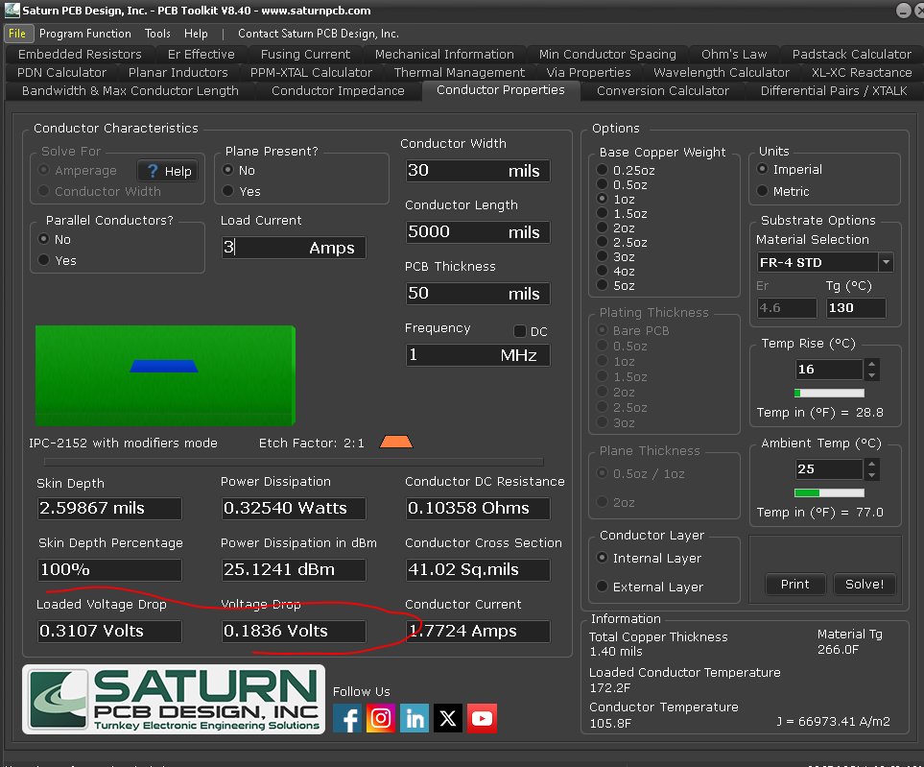

· Keep W = 2H for 50 Ω USB (DP, DN) traces. Use 3W spacing for loose coupling.

· Keep other signals at >2W spacing from I2C lines.

· Place the crystal close to the MCU with >20 mil clearance from other traces.

· Place decoupling capacitors (decaps) as close as possible to the power pins.

· Maintain a continuous return path for all USB. Use reference vias FOR EVERY 4 GPIOS.

· Use **10–25 mil** vias (each can carry ~1.4 A for your stackup).

Use multiple vias (at least 2–3) for power transitions for all PWR NETS.

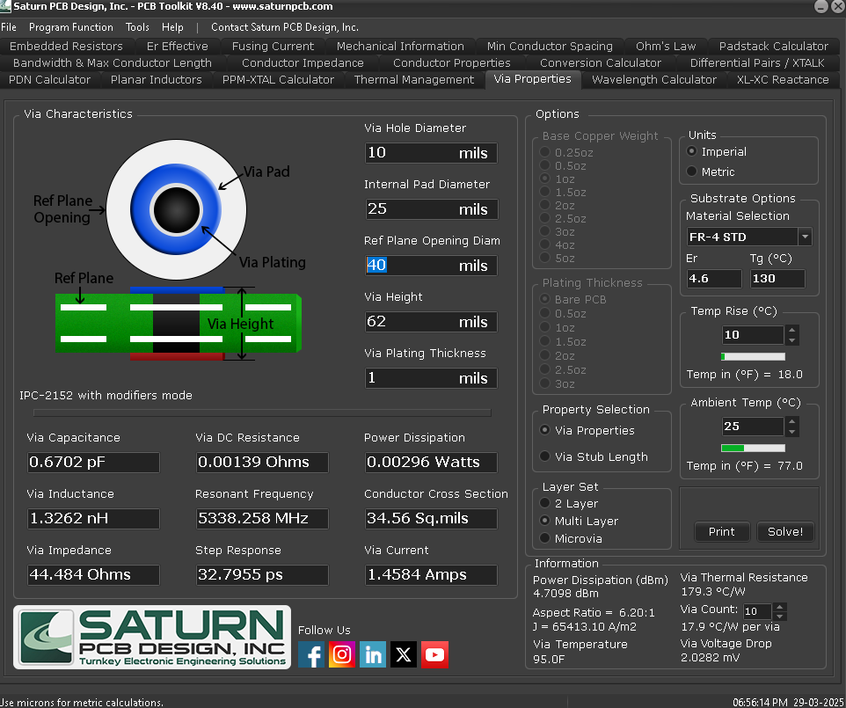

·Add silkscreen for all connectors. Label pin numbers or signal names — shorthand is okay.

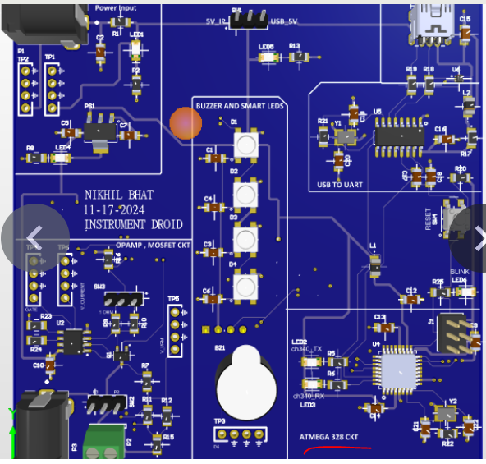

·  **PLEASE put silk markings this way otherwise there tehre will be problems with pcb assembly and eventually the brd.**

<https://www.pcbway.com/smt_ordering_guide.html>

