CEREBRO-X
An AI-Powered Digital Brain Twin Platform
for Alzheimer's Disease Monitoring, Progression Prediction & Clinical Decision Support

DATA ARCHITECTURE DOCUMENT

Document Type: Engineering Design Document
Version: 1.0
Project Phase: M.Tech Research — Architecture Planning
Date: August 2026

What is CEREBRO-X? (Plain Language)
💡 Think of CEREBRO-X as building a living, digital copy of a patient's brain inside a computer. Every time a patient visits the hospital — gets an MRI, takes a memory test, or has their EEG recorded — that information is fed into the system. The system updates its digital model of the patient's brain and answers the doctor's question: "How is this patient's brain changing over time, and where are they headed?" It is NOT just a detection system. It is a continuous monitoring and prediction platform.

1. Introduction
Alzheimer's Disease (AD) is a progressive neurodegenerative disorder with no single reliable biomarker. Accurate monitoring requires multimodal data — combining brain imaging, electrical signals, clinical history, and cognitive assessments.
Why Multimodal Data?
Single Modality | Limitation
MRI alone | Structural changes only — no functional insight
EEG alone | Functional activity only — no structural context
Clinical data alone | Subjective — no biological grounding
Cognitive scores alone | Late-stage indicator — coarse granularity

🎯 CEREBRO-X fuses all modalities into a Unified Patient Representation — the Digital Brain Twin — that captures the full neurological picture and evolves with every hospital visit.

2. Data Architecture Overview
2.1 End-to-End Pipeline (Plain Language)
- Step 1 — Collect: Patient data arrives: MRI scans, EEG recordings, clinical records, cognitive test scores.
- Step 2 — Clean: Each data type is processed to remove noise and standardize format.
- Step 3 — Extract: AI models convert each data type into a compact numerical "fingerprint".
- Step 4 — Fuse: All fingerprints are merged into one master representation of the patient's brain.
- Step 5 — Store: Representation saved as the patient's Digital Brain Twin alongside all past versions.
- Step 6 — Predict: System compares current and past Twins to detect changes and predict future decline.
- Step 7 — Explain: AI highlights which brain regions and data drove the prediction.
- Step 8 — Report: Doctor sees a clean dashboard with prediction, confidence, and visual explanation.
- Step 9 — Decide: Doctor uses this as supporting information to make clinical decisions.
- Step 10 — Update: At the next visit, the Twin is updated and the cycle continues.
2.2 High-Level Pipeline Flow
Pipeline Layer | Description
👤 Patient | Provides MRI, EEG, Clinical Records, Cognitive Scores
🔧 Preprocessing | Skull-strip, filter, impute, normalize — per modality
🔬 Feature Extraction | 3D CNN / BiLSTM / MLP produce compact embedding vectors
🔀 Multimodal Fusion | Cross-modal attention merges embeddings into 1024-d vector
🧬 Digital Brain Twin | Stored patient representation — updated each visit
📊 AI Outputs | Detection, Prediction, BHI, Change Detection, XAI, Similarity
🖥️ Doctor Dashboard | Clinical Decision Support — structured report for clinician

3. Data Modalities
3.1 Modality Comparison
Modality | What it Captures | Clinical Significance | Output Features
MRI | Brain anatomy, volume, structure | Hippocampal atrophy & cortical thinning are early AD biomarkers | 3D structural embeddings, regional volume metrics
EEG | Brain electrical activity over time | AD causes slowing of brain rhythms; reduced coherence | Band power features, connectivity matrices, temporal embeddings
Clinical Records | Patient history, demographics, medications | Contextualises biomarkers; captures risk factors | Encoded clinical feature vector
Cognitive Scores | Memory, reasoning, language performance | Direct measure of functional decline | Normalized score vector; trajectory slope

3.2 MRI — Structural Biomarkers
Feature | Description
Hippocampal Volume | Key early indicator — shrinks progressively in AD
Cortical Thickness | Measures grey matter atrophy across brain regions
Ventricular Size | Enlarges as brain tissue is lost
White Matter Integrity | Disrupted in moderate-advanced AD
Whole-Brain Volume | Overall brain atrophy measurement

3.3 EEG — Frequency Band Features
Band | Range | Role in AD
Delta | 0.5–4 Hz | Increases in AD; linked to cognitive impairment
Theta | 4–8 Hz | Increases; associated with memory dysfunction
Alpha | 8–13 Hz | Decreases; marker of early functional decline
Beta | 13–30 Hz | Altered; linked to attentional processing
Gamma | 30–100 Hz | Reduced; associated with higher cognition
Connectivity | — | Inter-region communication — disrupted in AD

3.4 Cognitive Assessment Scores
Score | Full Name | What it Measures | Range
MMSE | Mini-Mental State Examination | Orientation, memory, language | 0–30 (lower = worse)
CDR | Clinical Dementia Rating | Overall dementia severity | 0, 0.5, 1, 2, 3
ADAS-Cog | Alzheimer's Disease Assessment Scale – Cognitive | Cognitive function battery | 0–70 (higher = worse)
MoCA | Montreal Cognitive Assessment | Mild cognitive impairment screening | 0–30 (lower = worse)

4. Dataset Selection
Dataset | Modalities | Why Selected | Role in CEREBRO-X
ADNI | MRI + PET + CSF + Clinical + Cognitive | Gold-standard longitudinal AD dataset; multi-site; large-scale | Primary dataset — all modules
OASIS-3 | MRI + PET + Clinical + Cognitive | Longitudinal; freely accessible; well-annotated | Validation & supplementary training
OASIS-1/2 | MRI + Clinical | Simpler; good for baseline structural models | MRI module pre-training
PhysioNet | EEG | Open, high-quality EEG; preprocessing pipeline development | EEG module development
OpenNeuro | EEG | Community EEG recordings in dementia research | EEG module training
TUH EEG Corpus | EEG | Large clinical EEG corpus; diverse pathologies | EEG artifact removal & augmentation

⚠️ Fully matched multimodal datasets (MRI + EEG + Clinical + Cognitive for the same patient) are extremely limited in the public domain. CEREBRO-X's architecture is intentionally designed to integrate multiple validated public sources and handle missing modalities gracefully using masked fusion techniques.

5. Data Preprocessing Pipeline
5.1 MRI Preprocessing
Step | Tool / Method | Purpose
Skull Stripping | FSL BET / HD-BET | Remove non-brain tissue (skull, skin)
Bias Field Correction | N4ITK | Correct intensity inhomogeneities from scanner
Atlas Registration | ANTs / MNI152 | Align all brains to standard coordinate space
Intensity Normalization | Z-score / Min-Max | Standardize voxel intensity ranges across patients
Resizing | Interpolation | Standardize spatial dimensions (128×128×128)

5.2 EEG Preprocessing
Step | Tool / Method | Purpose
Bandpass Filter | MNE-Python (0.5–50 Hz) | Remove baseline drift and high-freq noise
Notch Filter | 50 / 60 Hz | Remove power line interference
Artifact Removal | ICA (Independent Component Analysis) | Remove eye blink, muscle, cardiac artifacts
Epoching | Fixed-length windows (2–4 sec) | Segment continuous signal into analysis units
Feature Extraction | FFT / CWT / PSD | Convert time-domain signal to frequency features
Normalization | Z-score per channel | Standardize across subjects and sessions

5.3 Clinical Data Preprocessing
Step | Method | Purpose
Missing Value Imputation | Median / KNN Imputer | Handle incomplete patient records
Categorical Encoding | One-Hot / Label Encoding | Convert text categories to numerical form
Feature Scaling | StandardScaler / MinMaxScaler | Prevent feature dominance during training
Feature Selection | Mutual Information / LASSO | Retain only clinically relevant features

5.4 Cognitive Score Preprocessing
Step | Method | Purpose
Data Cleaning | Outlier detection (IQR) | Remove data entry errors
Score Normalization | 0–1 scaling per test | Unify different test scales
Trajectory Computation | Δscore / Δtime | Compute rate of cognitive decline per patient
Severity Labeling | CDR staging | Map scores to CN / MCI / AD categories

6. Feature Extraction
💡 Feature extraction converts raw data into compact mathematical "fingerprints" (embedding vectors). Example: a full 3D MRI scan (millions of voxels) → a 512-number vector that summarises the brain's structural state.
6.1 Model Architecture & Output Summary
Modality | Model Architecture | Output Vector | Dimension
MRI | 3D CNN / Vision Transformer (ViT-3D) | Structural Embedding | 512-d
EEG | Bidirectional LSTM / Temporal Transformer | Temporal Embedding | 256-d
Clinical Data | Multi-Layer Perceptron (MLP) | Clinical Feature Vector | 128-d
Cognitive Scores | Multi-Layer Perceptron (MLP) | Cognitive Feature Vector | 64-d

7. Multimodal Fusion
🔀 Fusion is the step where all individual "fingerprints" are combined into a single, unified representation of the patient's brain state — the Digital Brain Twin.
7.1 Fusion Strategy Comparison
Strategy | How it Works | Pros | Cons | Suitable For
Early Fusion | Concatenate raw features before any model | Simple | Loses modality-specific patterns | Homogeneous data
Late Fusion | Train separate models; combine predictions | Robust to missing data | Loses inter-modal relationships | Independent modalities
Intermediate Fusion ✅ | Extract embeddings; fuse in shared space | Best balance | Moderate complexity | Heterogeneous multimodal data

7.2 Recommended: Intermediate Fusion with Cross-Modal Attention
- Project: Each 512/256/128/64-d embedding is projected to a common 256-d space.
- Attend: Cross-modal attention allows each modality to attend to others.
- Merge: Attended vectors are concatenated → 1024-d Unified Patient Representation.
- Store: This 1024-d vector IS the Digital Brain Twin for this visit.
7.3 Missing Modality Handling
Scenario | Strategy
EEG not available | Masking token replaces EEG embedding; attention re-weights remaining modalities
Clinical data incomplete | Imputed during preprocessing; flagged as low-confidence in output
All modalities present | Full fusion with learned attention weights

8. Digital Brain Twin
🧬 The Digital Brain Twin is a mathematical model stored in a database representing everything the system knows about a patient's brain at a given point in time. It is NOT an image. It is NOT a report. It is a living data structure that changes every time the patient has a new test.
8.1 What is Stored Inside the Twin
Component | Description | Update Frequency
Structural State | Latest MRI-derived embeddings; regional volumes | Per MRI visit
Functional State | Latest EEG-derived temporal embeddings | Per EEG session
Clinical State | Latest clinical record snapshot | Per clinical visit
Cognitive State | Latest normalized cognitive score vector | Per assessment
Unified Representation | Fused 1024-d vector (the Twin) | Per any new data
Longitudinal Trajectory | History of Twin vectors over all visits | Accumulates over time
Predicted Trajectory | Model's projection of future brain state | Computed per update

8.2 Static Diagnosis vs. Digital Brain Twin
Traditional Approach | CEREBRO-X Digital Brain Twin
Single-timepoint classification | Continuous longitudinal tracking
Binary output (AD / Not AD) | Multi-dimensional brain state vector
No memory of past visits | Full temporal history retained
No future projection | Trajectory-based progression prediction
No explainability | SHAP / Grad-CAM explanations

9. AI Outputs
Output Module | Description | Clinical Value
Disease Detection | Classify current brain state (CN → MCI → AD) | Baseline diagnostic support
Disease Progression Prediction | Predict likelihood and timeline of state transition | Proactive clinical planning
Brain Health Index (BHI) | Scalar metric (0–100) representing overall brain health | Longitudinal monitoring KPI
Brain Change Detection | Detect statistically significant changes between visits | Alert clinicians to sudden deterioration
Explainable AI | Highlight which brain regions / features drove prediction | Clinician trust and transparency
Patient Similarity Engine | Find historical patients with similar Twin trajectories | Evidence-based prognosis
Clinical Decision Support | Structured summary report for clinician review | Actionable information at point of care

⚠️ IMPORTANT: CEREBRO-X provides decision support, not clinical decisions. All diagnostic and treatment decisions remain the sole responsibility of the treating clinician. The system is designed to augment, not replace, clinical judgment.

10. Summary
10.1 Key Design Principles
Principle | Implementation
Longitudinal by design | Twin evolves with every visit; trajectory is a first-class citizen
Modality-agnostic | Architecture handles missing modalities via masking
Explainability-first | Grad-CAM + SHAP integrated at output layer
Clinician-facing | Dashboard designed for time-constrained clinical workflows
Research-grade | BHI and trajectory metrics are novel research contributions
Open data compatible | Designed around ADNI, OASIS, PhysioNet — all publicly available

10.2 Technology Stack
Layer | Technology
MRI Processing | FSL, ANTs, NiBabel, TorchIO
EEG Processing | MNE-Python, SciPy, PyWavelets
Deep Learning | PyTorch, Hugging Face Transformers
Fusion | Custom Cross-Modal Attention (PyTorch)
Explainability | SHAP, Captum (Grad-CAM)
Backend | FastAPI / Django REST
Database | PostgreSQL + MongoDB (multimodal store)
Dashboard | React.js + D3.js / Recharts

10.3 Complete Pipeline — 10-Step Plain Language Summary
- Step 1 — Collect: Patient data arrives: MRI scans, EEG recordings, clinical records, cognitive test scores.
- Step 2 — Clean: Each data type is processed to remove noise and standardize format.
- Step 3 — Extract: AI models convert each data type into a compact numerical "fingerprint".
- Step 4 — Fuse: All fingerprints are merged into one master representation of the patient's brain.
- Step 5 — Store: Representation saved as the patient's Digital Brain Twin alongside all past versions.
- Step 6 — Predict: System compares current and past Twins to detect changes and predict future decline.
- Step 7 — Explain: AI highlights which brain regions and data drove the prediction.
- Step 8 — Report: Doctor sees a clean dashboard with prediction, confidence, and visual explanation.
- Step 9 — Decide: Doctor uses this as supporting information to make clinical decisions.
- Step 10 — Update: At the next visit, the Twin is updated and the cycle continues.

Document prepared for M.Tech Research — CEREBRO-X Project | Version 1.0 | August 2026

SYSTEM ARCHITECTURE DIAGRAMS
Figure 1 — CEREBRO-X Full System Architecture Overview
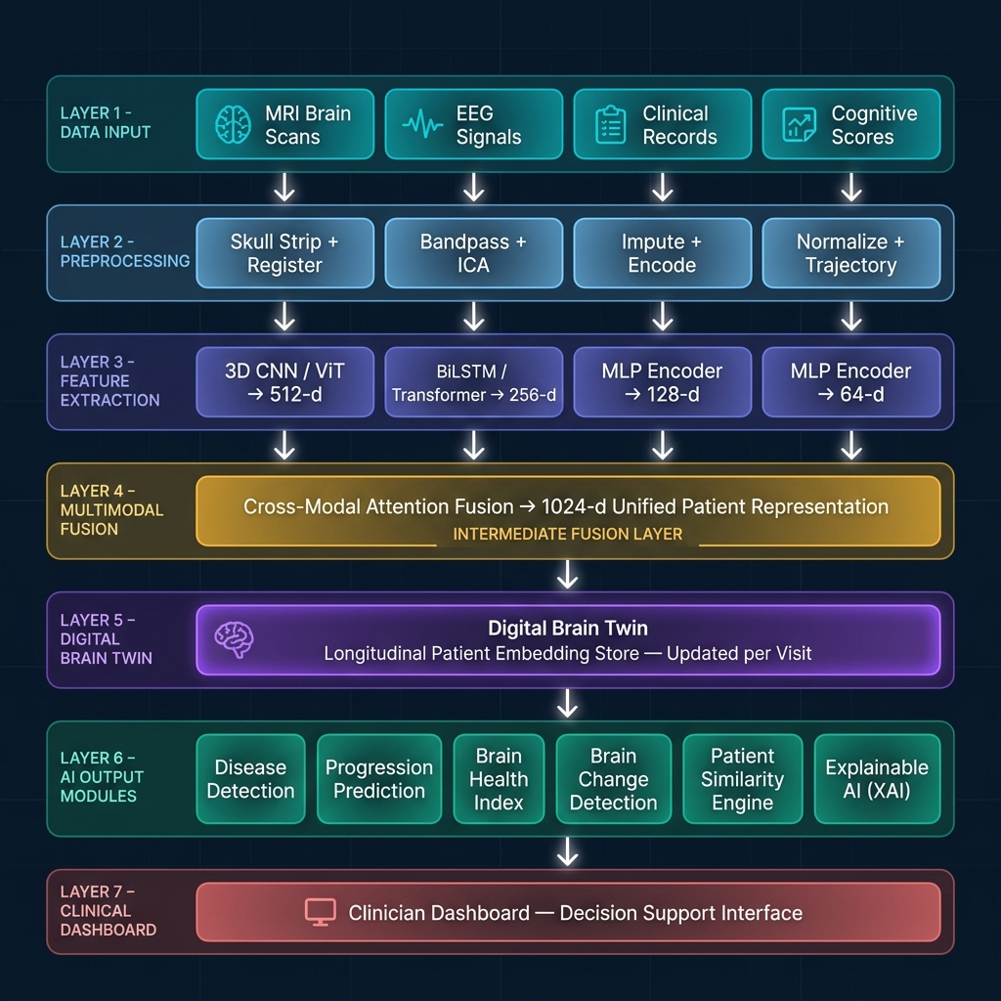
End-to-end pipeline: Multimodal Data Sources → Preprocessing → Feature Extraction → Fusion → Digital Brain Twin → AI Outputs → Clinician Dashboard

Figure 2 — CEREBRO-X Detailed Layer-by-Layer Architecture
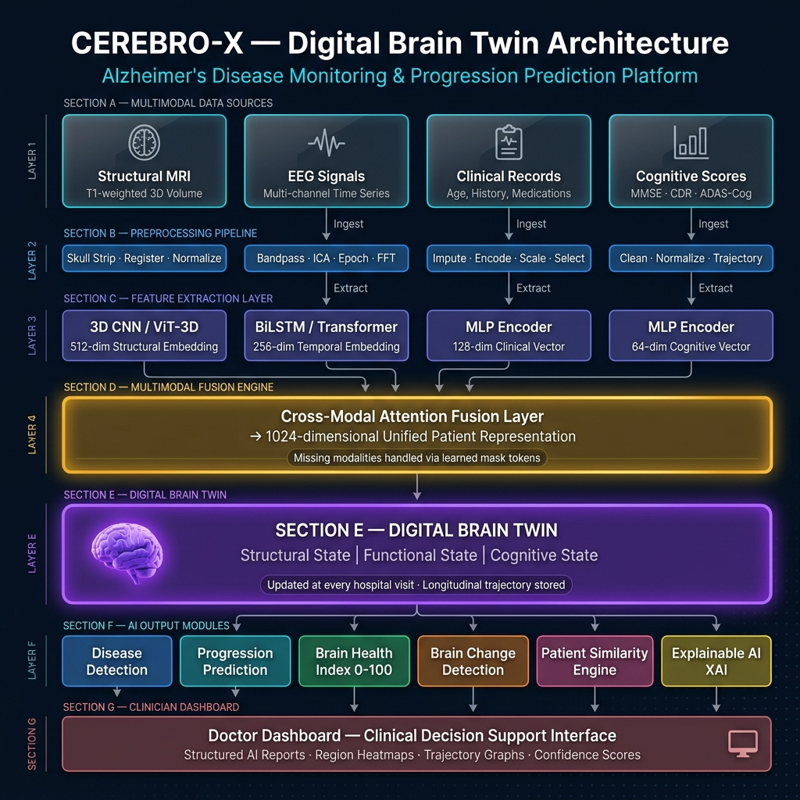
Layer-by-layer technical breakdown showing model architectures, embedding dimensions, cross-modal attention fusion, and Digital Brain Twin construction

