M.TECH COMPUTER SCIENCE — RESEARCH PROJECT
DOCUMENT 1 · PROJECT FOUNDATION

CEREBRO-X

An AI-Powered Digital Brain Twin Platform for Alzheimer's Disease
Monitoring, Progression Prediction and Clinical Decision Support

STUDENT [Student Name], [University Roll / Registration No.]
GUIDE [Guide / Supervisor Name], [Designation]
DEPARTMENT Department of Computer Science & Engineering
UNIVERSITY [University / Institute Name]
ACADEMIC YEAR 2025 – 2026

Table of Contents

3. Introduction

3.1 Alzheimer's Disease
Alzheimer's Disease (AD) is a progressive neurodegenerative disorder and the most common cause of dementia worldwide, characterized by the gradual accumulation of amyloid-beta plaques and neurofibrillary tau tangles, synaptic loss, and irreversible atrophy of brain tissue. Clinically, it manifests as a slow decline in memory, executive function, language, and orientation, eventually compromising a patient's ability to perform routine daily activities. The disease progresses through a continuum — from preclinical and prodromal stages such as Mild Cognitive Impairment (MCI) to mild, moderate, and severe dementia — and this continuum, rather than any single time point, is what makes Alzheimer's fundamentally difficult to characterize with a single test or a single visit.
Because the underlying pathology begins years, sometimes decades, before overt symptoms appear, Alzheimer's Disease is increasingly understood as a longitudinal condition that must be tracked over time rather than diagnosed as a static snapshot. This distinction is central to the motivation of CEREBRO-X.

3.2 Current Challenges
Despite decades of clinical and computational research, several structural challenges continue to limit effective monitoring and management of Alzheimer's Disease:
- Fragmented Data — Neuroimaging, cognitive assessments, genetic markers, and clinical history are typically collected and stored in isolation, with no unified patient-level representation connecting them.
- Late and Inconsistent Diagnosis — Cognitive decline is often noticed only after significant neurodegeneration has already occurred, and diagnostic thresholds vary across clinicians and institutions.
- Snapshot-Based Assessment — Most existing tools evaluate a patient at a single point in time, offering limited insight into the trajectory or rate of change of the disease.
- Lack of Personalization — Population-level diagnostic criteria do not adequately account for individual baseline variability in brain structure and cognitive reserve.
- Opacity of AI Models — Many machine learning models used in neuroimaging research function as black boxes, producing predictions without clinically interpretable justification.
- Limited Clinical Integration — Research-grade AI tools rarely translate into decision-support systems that fit naturally into a clinician's diagnostic and monitoring workflow.

3.3 Need for Artificial Intelligence
Artificial Intelligence offers the computational capacity to integrate heterogeneous, high-dimensional data — imaging, cognitive scores, genetic markers, and clinical notes — into coherent, patient-specific representations that would be impractical to derive through manual clinical review alone. AI-based pattern recognition can detect subtle structural and functional changes that precede overt symptoms, support risk stratification across large cohorts, and enable predictive modelling of disease trajectories. For a condition as data-intensive and heterogeneous as Alzheimer's Disease, AI is not merely a convenience; it is a practical necessity for extracting actionable insight from the volume and complexity of available biomedical data.

3.4 Need for Digital Twins
A Digital Twin is a continuously updated, data-driven virtual representation of a physical entity — in this context, an individual patient's brain and its evolving cognitive and structural state. Unlike a conventional diagnostic model that produces an isolated prediction, a Digital Twin maintains a persistent, evolving computational profile of the patient, updated with every new scan, test, or clinical visit. This enables comparison not only against population norms but against the patient's own historical baseline, making it possible to detect meaningful individual change rather than relying solely on generic thresholds. For a slow, heterogeneous, and highly individual-specific disease such as Alzheimer's, the Digital Twin paradigm offers a more clinically faithful way to represent and monitor disease progression than static, single-visit assessment.

3.5 Need for Explainable AI
Clinical adoption of AI systems depends fundamentally on trust, and trust depends on interpretability. A prediction of elevated risk or accelerated decline is of limited clinical value if the clinician cannot understand which factors contributed to that assessment. Explainable AI (XAI) techniques make model reasoning transparent by attributing predictions to specific, clinically meaningful evidence — such as regional volumetric change, a decline in a specific cognitive domain, or a genetic risk factor. This is particularly important in neurodegenerative disease monitoring, where clinical decisions carry significant consequences for patients and families, and where regulatory and ethical standards increasingly demand explainability as a precondition for the use of AI in healthcare decision-making.

4. Problem Statement
Existing computational approaches to Alzheimer's Disease predominantly treat diagnosis and risk assessment as isolated, single-visit classification problems, using disconnected sources of imaging, cognitive, and clinical data without constructing a persistent, patient-specific model of brain state. As a result, current systems are poorly equipped to represent disease progression over time, to quantify individual deviation from a patient's own baseline, or to communicate the reasoning behind their predictions in a form clinicians can trust and act upon.
There is, therefore, a need for a unified computational framework that continuously integrates multimodal patient data into a longitudinal, patient-specific digital representation of brain health; quantifies change and predicts progression against that individualized baseline; and presents its reasoning through explainable, clinically interpretable evidence within a decision-support interface suitable for real-world clinical and research use.
This research addresses that gap by proposing CEREBRO-X, an AI-powered Digital Brain Twin platform designed to model, monitor, and support clinical decision-making for Alzheimer's Disease as a continuous, individualized, and explainable process rather than a series of disconnected diagnostic snapshots.

5. Motivation
The motivation for CEREBRO-X arises from a convergence of clinical, technological, and research-level gaps in how Alzheimer's Disease is currently monitored and managed.

5.1 Current Healthcare Problems
- Alzheimer's Disease remains substantially underdiagnosed and is frequently identified only after considerable irreversible neurodegeneration has occurred.
- Follow-up care is often episodic, with long intervals between assessments that make it difficult to detect the rate and pattern of decline.
- Diagnostic interpretation of imaging and cognitive data still relies heavily on manual clinical judgement, which is time-intensive and subject to inter-observer variability.
- Existing digital tools rarely unify a patient's imaging, cognitive, genetic, and clinical history into a single coherent view.

5.2 Importance for Clinicians
Clinicians require tools that consolidate multimodal patient data into a single, longitudinally coherent view, enabling faster and more consistent assessment of disease status. A platform that highlights meaningful change against a patient's own baseline — and explains why that change is significant — can reduce diagnostic variability and support more timely, evidence-based clinical decisions.

5.3 Importance for Patients
For patients and their families, earlier and more consistent monitoring translates directly into more informed care planning, timely intervention, and better management of the disease trajectory. A patient-specific model of brain health also allows care to be tailored to the individual's own baseline and rate of change, rather than being governed solely by population-level thresholds.

5.4 Research Importance
From a research perspective, a structured, longitudinal, and explainable digital representation of brain health across a patient cohort constitutes a valuable resource for studying disease progression patterns, evaluating candidate biomarkers, and benchmarking predictive models. CEREBRO-X is designed to generate exactly this kind of structured research substrate as a by-product of its clinical monitoring function.

6. Project Vision
CEREBRO-X is envisioned not as an Alzheimer's detection tool, but as a Digital Brain Twin Platform — a continuously evolving, patient-specific computational representation of brain health that grows and updates with every new piece of clinical, cognitive, imaging, and genetic data available for a patient. Where a detection system produces a single output at a single point in time, a Digital Brain Twin persists across the patient's care journey, accumulating evidence, refining its understanding of the individual's baseline, and providing a continuously current picture of neurological and cognitive status.
The platform is conceived as an evolving computational counterpart to the patient's brain: one that can be consulted at any point in the care pathway, that improves in fidelity as more data becomes available, and that supports — rather than replaces — clinical judgement by surfacing individualized, explainable, and longitudinally grounded insight. This twin-centric vision underpins every architectural and algorithmic decision within CEREBRO-X and distinguishes it from conventional, single-shot diagnostic classifiers.
In its long-term form, the vision extends beyond Alzheimer's Disease toward a general-purpose Digital Brain Twin infrastructure capable of supporting the monitoring of multiple neurological and neurodegenerative conditions, with Alzheimer's Disease serving as the foundational first application through which the core twin architecture is designed, built, and validated.

7. Project Objectives

7.1 Short-Term Objectives
- Design a data model capable of representing a patient's multimodal neurological profile — imaging, cognitive, clinical, and genetic — within a single, coherent digital twin structure.
- Develop core twin-level computations, including a Brain Health Index, Brain Change Detection, and a Twin Completeness Score, to quantify individual patient status and data sufficiency.
- Establish a longitudinal monitoring mechanism capable of tracking a patient's brain twin across multiple visits and time points.
- Integrate Explainable AI methods so that every prediction generated by the platform is accompanied by clinically interpretable justification.
- Build an initial clinician-facing decision-support dashboard for reviewing twin status, risk indicators, and explanations.

7.2 Long-Term Objectives
- Extend the Digital Brain Twin architecture to support progression prediction with quantified confidence and uncertainty estimates.
- Develop a Patient Similarity Engine capable of contextualizing an individual's trajectory against comparable cohort patterns.
- Generalize the underlying twin framework to support additional neurological and neurodegenerative conditions beyond Alzheimer's Disease.
- Establish CEREBRO-X as a research-grade platform capable of supporting academic studies on disease progression, biomarker discovery, and model benchmarking.
- Explore integration pathways with real-world clinical and hospital information systems, subject to appropriate regulatory and ethical review.

8. Scope of the Project

8.1 Current Scope
Dimension | Coverage in the Current Phase
Disease Focus | Alzheimer's Disease and the Mild Cognitive Impairment (MCI) continuum
Data Modalities | Structural MRI-derived features, cognitive/neuropsychological test scores, clinical and demographic records, and available genetic/biomarker indicators
Core Capability | Construction of a patient-specific Digital Brain Twin with longitudinal update support
Analytical Outputs | Brain Health Index, Brain Change Detection, Twin Completeness Score, and explainable progression indicators
Interface | A clinician-facing decision-support dashboard and a research analytics dashboard
Deployment Context | Academic research and controlled experimental evaluation using publicly available, de-identified research datasets

8.2 Future Scope
- Incorporation of additional imaging modalities such as functional and diffusion MRI, and PET-based amyloid/tau imaging where available.
- Deeper integration of the Patient Similarity Engine for cohort-level trajectory comparison and stratified risk analysis.
- Refinement of uncertainty quantification within progression prediction to support more nuanced clinical risk communication.
- Development of secure, privacy-preserving pathways for potential integration with clinical health record systems, subject to institutional and regulatory approval.

8.3 Future Disease Extensions
While the initial implementation of CEREBRO-X is deliberately scoped to Alzheimer's Disease, the underlying Digital Brain Twin architecture is designed to generalize. Planned future extensions include monitoring platforms for Parkinson's Disease, Vascular Dementia, Mild Cognitive Impairment as an independent condition, and other progressive neurodegenerative and neurological disorders that share the same fundamental need for longitudinal, multimodal, individualized monitoring.

9. Why Alzheimer's Disease?
Alzheimer's Disease was selected as the foundational application for CEREBRO-X for several converging reasons that make it particularly well-suited to establishing and validating the Digital Brain Twin paradigm.
- Well-Characterized Progression — Alzheimer's Disease follows a relatively well-studied continuum — from preclinical stages through MCI to dementia — providing a structured framework against which longitudinal modelling can be meaningfully designed and evaluated.
- Rich Multimodal Data Availability — Decades of research have produced substantial publicly available, ethically approved longitudinal datasets combining neuroimaging, cognitive testing, genetic markers, and clinical history, making it feasible to build and validate a multimodal twin architecture.
- High Clinical and Societal Impact — As the leading cause of dementia globally, Alzheimer's Disease represents a condition where improved monitoring and earlier, more personalized insight can produce meaningful clinical and societal benefit.
- Naturally Longitudinal Nature — The slow, progressive character of Alzheimer's Disease makes it an ideal proving ground for a platform whose core value proposition is longitudinal, twin-based monitoring rather than single-visit classification.
- Strong Foundation for Generalization — Because Alzheimer's Disease requires the integration of nearly every data modality the platform is designed to support, building CEREBRO-X around it produces a sufficiently general twin architecture that can later be extended to other neurodegenerative conditions.

10. Key Innovations
CEREBRO-X introduces a set of interconnected conceptual innovations that together distinguish it from conventional, single-purpose diagnostic tools. Each component is designed to function as part of a unified Digital Brain Twin, rather than as an isolated predictive model.

10.1 Digital Brain Twin
The central innovation of the platform: a persistent, patient-specific, continuously updated virtual representation of an individual's brain health, constructed from all available multimodal data and refined with every new clinical encounter.

10.2 Multimodal AI
A unified modelling approach that integrates neuroimaging, cognitive assessment, clinical history, and genetic/biomarker data into a single coherent analytical framework, rather than analyzing each modality in isolation.

10.3 Longitudinal Monitoring
A structural capability to track a patient's Digital Brain Twin across multiple visits over time, enabling trend analysis and trajectory-based insight rather than single-point assessment.

10.4 Brain Health Index
A composite, interpretable metric summarizing a patient's overall structural and cognitive brain health status at a given point in time, designed to be tracked and compared across visits.

10.5 Brain Change Detection
A mechanism for identifying and quantifying meaningful deviation in a patient's brain twin relative to their own historical baseline, distinguishing genuine change from normal variability.

10.6 Patient Similarity Engine
A cohort-comparison capability that contextualizes an individual patient's trajectory by identifying other digital twins with structurally and clinically similar patterns and progression histories.

10.7 Twin Completeness Score
A transparency metric that quantifies how much data underpins a given patient's digital twin, allowing clinicians and researchers to gauge the confidence and reliability of the twin's outputs.

10.8 Explainable AI
An interpretability layer embedded throughout the platform, ensuring that every prediction or risk indicator is accompanied by clinically meaningful, human-understandable evidence.

10.9 Clinical Decision Support
A dashboard-driven layer that translates twin-level analytics into actionable, interpretable information designed to support — not replace — clinical judgement in real-world care settings.

10.10 Research Dashboard
A dedicated analytics interface enabling researchers to study cohort-level patterns, evaluate model behaviour, and derive insight from the aggregated, de-identified digital twin population.

11. Expected Outcomes
Category | Expected Outcome
Academic | A well-documented M.Tech research contribution demonstrating a novel Digital Brain Twin framework for longitudinal, multimodal, explainable disease monitoring.
Software | A functional prototype platform implementing digital twin construction, core analytical modules, and a clinician-facing decision-support dashboard.
Research | A structured, reusable methodology and dataset-agnostic architecture applicable to future research on Alzheimer's progression modelling and, eventually, other neurodegenerative conditions.
Industry | A conceptual foundation and technical blueprint that can inform future collaboration with healthcare technology providers, research hospitals, and digital health initiatives.

12. High-Level Project Pipeline
Figure 1 illustrates the conceptual, end-to-end flow of the CEREBRO-X platform — from the acquisition of multimodal patient data, through data fusion and the construction of the Digital Brain Twin, to AI-driven progression reasoning and, finally, presentation within the clinical and research decision-support dashboards.
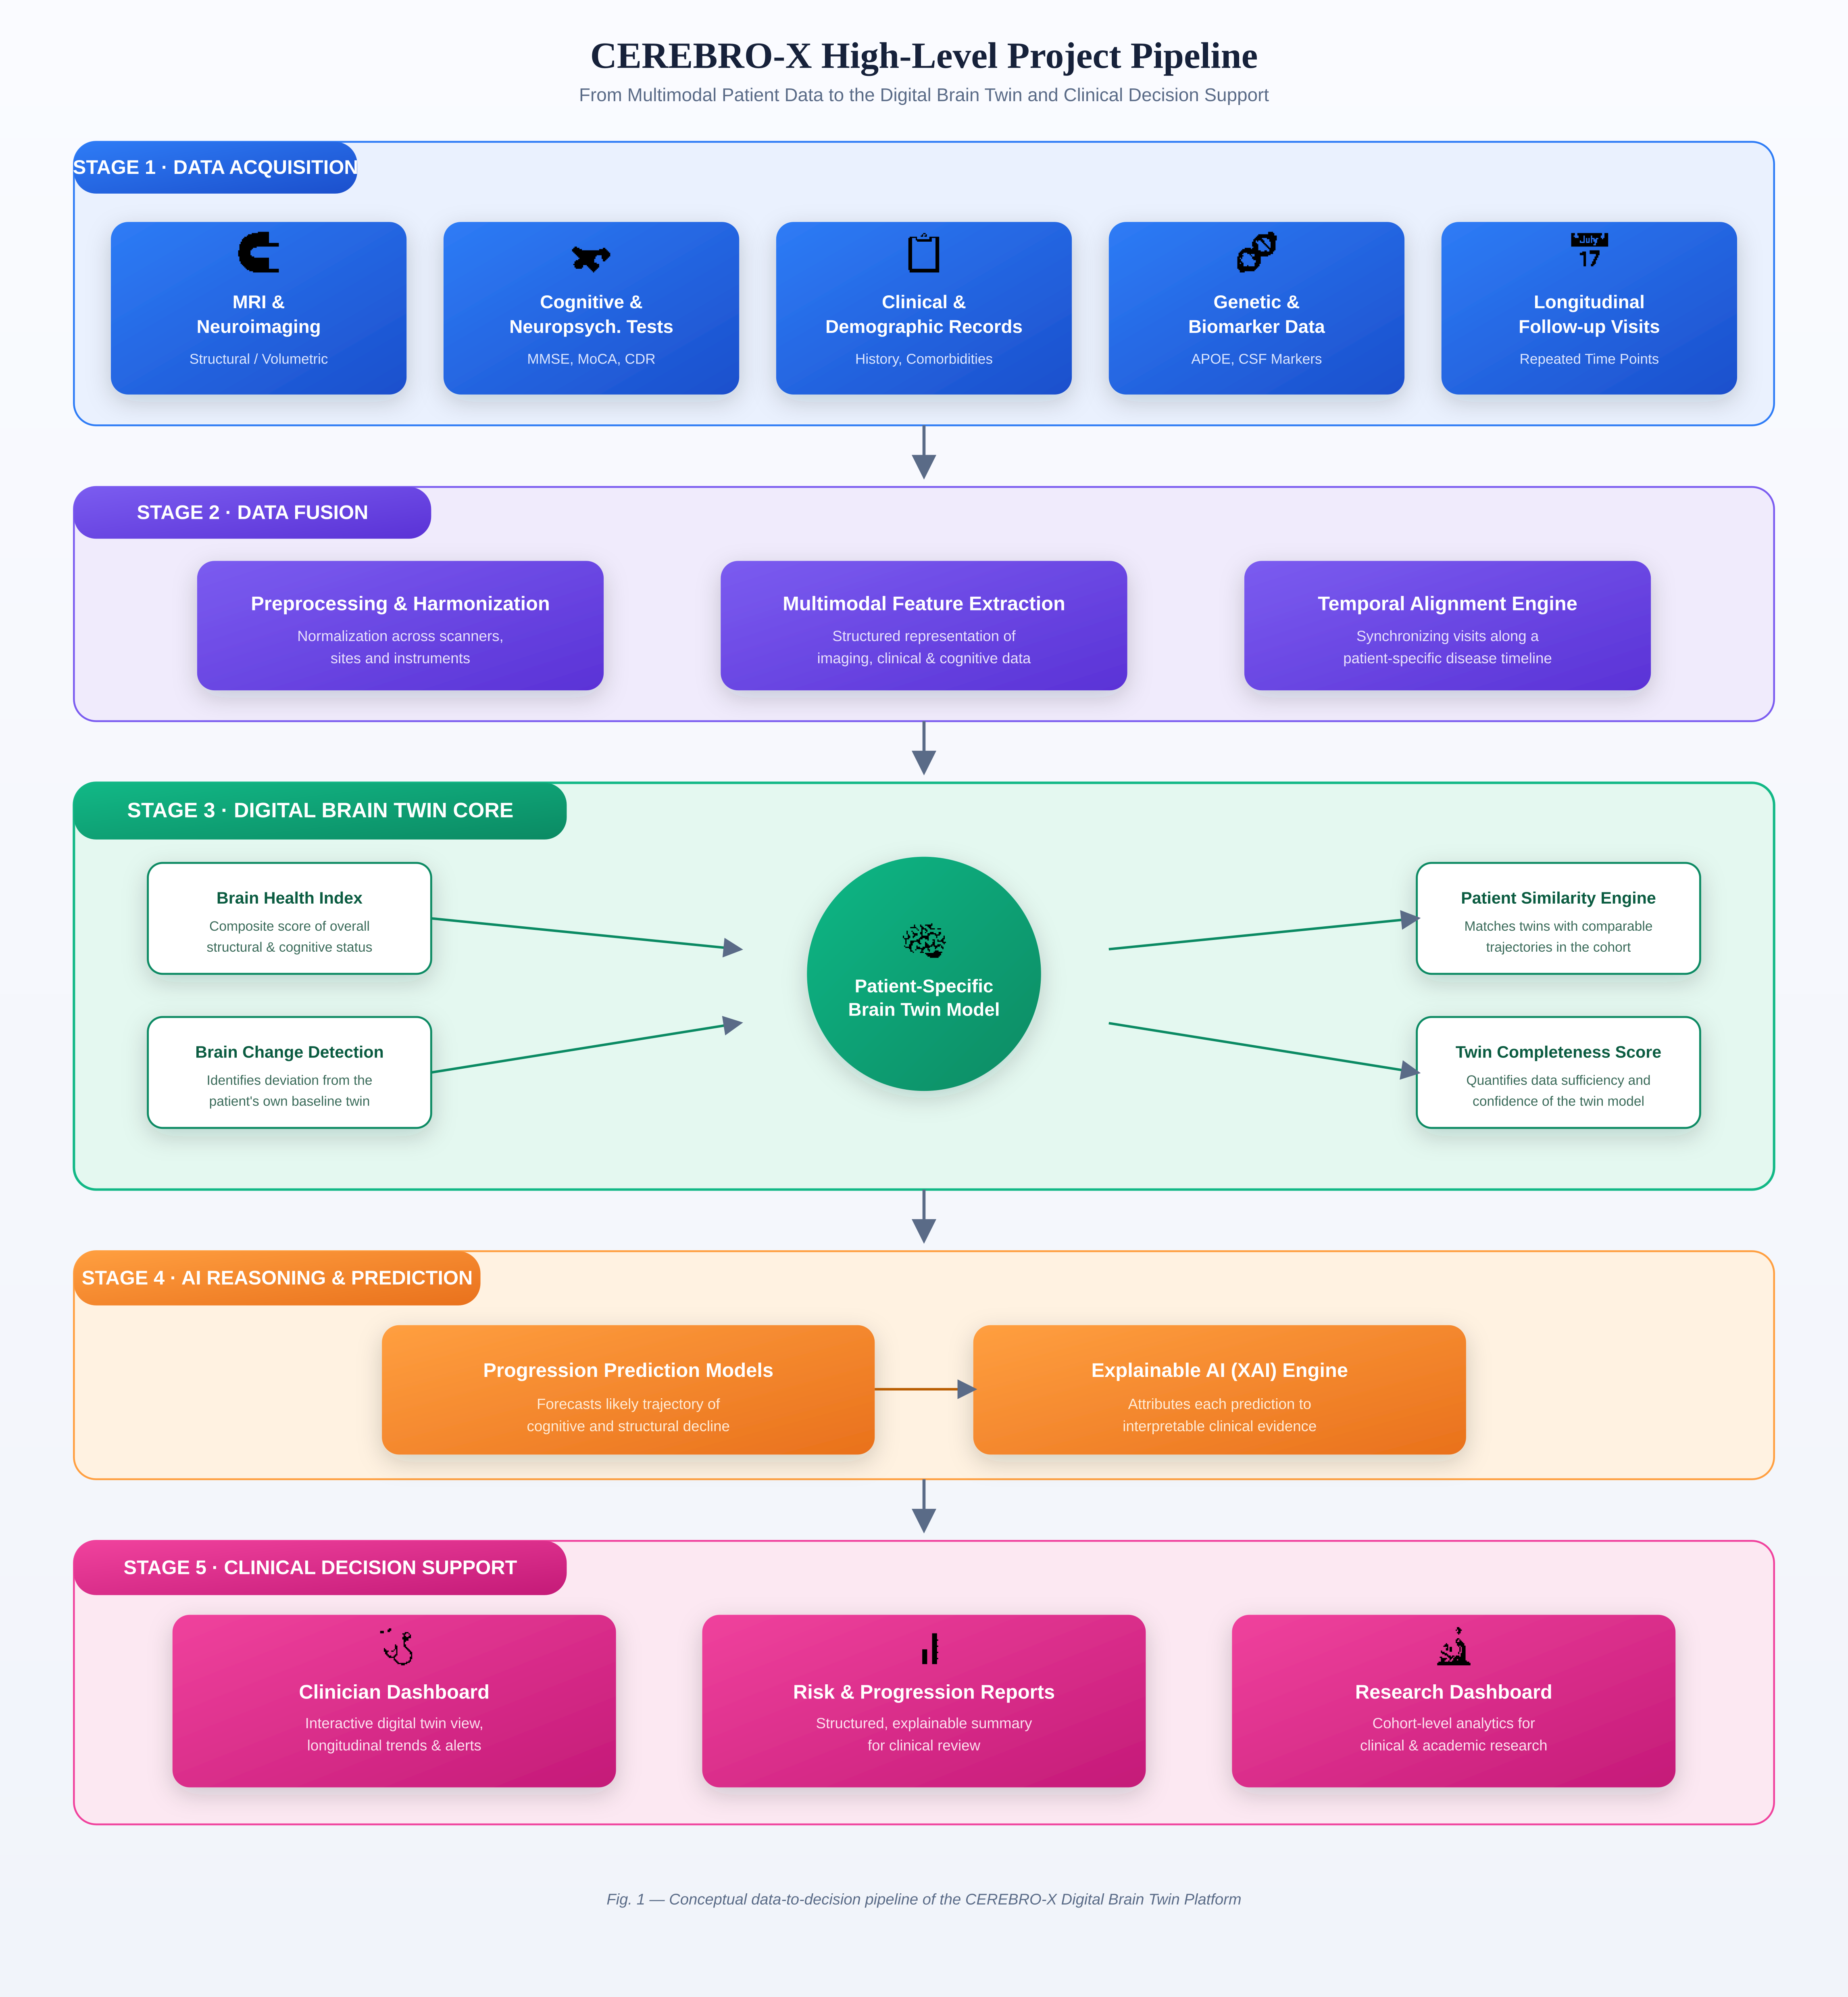
Fig. 1 — High-level data-to-decision pipeline of the CEREBRO-X Digital Brain Twin Platform.

13. Conclusion
This document has established the foundational basis of CEREBRO-X: an AI-powered Digital Brain Twin platform conceived to address the structural limitations of current, snapshot-based approaches to Alzheimer's Disease monitoring. By reframing disease assessment as a continuous, patient-specific, and explainable process — rather than a series of isolated diagnostic events — CEREBRO-X aims to provide clinicians with a longitudinally coherent view of brain health and to provide researchers with a structured substrate for studying disease progression.
Alzheimer's Disease has been chosen as the initial application of this platform on account of its well-characterized progression, rich multimodal data availability, and significant clinical impact, while the underlying Digital Brain Twin architecture has been deliberately designed for future generalization to other neurological and neurodegenerative conditions. The remaining documents in this project series will build upon this foundation to define the system's requirements, architecture, and implementation in detail.

