CEREBRO-X
An AI-Powered Digital Brain Twin Platform
for Alzheimer's Disease Monitoring, Progression Prediction
and Clinical Decision Support

RESEARCH PROPOSAL
M.Tech Computer Science — Academic Year 2025–2026

Student: [Your Full Name]
Roll No.: [Your Roll Number]
Guide: [Prof. / Dr. Guide Name]
Department: Department of Computer Science & Engineering
University: [University Name]
Date: August 2026

ABSTRACT
Alzheimer's Disease (AD) is a progressive neurodegenerative disorder affecting over 50 million people worldwide, with no curative treatment currently available. Existing AI-based systems predominantly focus on one-time disease detection from a single imaging modality, offering limited value for continuous clinical monitoring. This research proposes CEREBRO-X, an AI-Powered Digital Brain Twin Platform that moves beyond detection toward longitudinal, multimodal, and explainable neurological monitoring.
CEREBRO-X integrates four data modalities — MRI brain scans, EEG recordings, clinical records, and cognitive assessment scores — to construct a continuously evolving Digital Brain Twin (DBT) for each patient. The DBT is a unified, high-dimensional representation of a patient's neurological state that is updated at every hospital visit, enabling trajectory-based disease progression prediction rather than static classification.
Key research contributions include: a novel multimodal fusion architecture with cross-modal attention, a Brain Health Index (BHI) as a scalar longitudinal monitoring metric, a Brain Change Detection module, a Patient Similarity Engine, and a Twin Completeness Score to handle missing modalities. All model decisions are explained using SHAP and Grad-CAM, ensuring clinical trust and transparency. Outputs are delivered via a clinician-facing dashboard designed for point-of-care decision support.
CEREBRO-X is designed as a research-grade clinical decision-support platform and does not replace medical professionals. It is intended to augment clinical judgment through explainable, data-driven insights derived from validated public datasets including ADNI, OASIS, and PhysioNet/OpenNeuro.

1. INTRODUCTION
Alzheimer's Disease — Clinical Context
Alzheimer's Disease is the leading cause of dementia, responsible for 60–70% of cases globally. It progresses through three stages — Cognitively Normal (CN), Mild Cognitive Impairment (MCI), and Alzheimer's Disease (AD) — with gradual deterioration of memory, language, and executive function. Early and accurate tracking of progression is critical for timely clinical intervention.
Limitations of Current AI Approaches
- Single-modality models (MRI or EEG only) miss complementary neurological signals.
- Static classifiers produce a one-time label without tracking change over time.
- Most systems lack explainability, reducing clinician adoption.
- No existing platform unifies structural, functional, clinical, and cognitive data into one patient model.
Digital Twins in Healthcare
A Digital Twin is a dynamic virtual replica of a physical entity that evolves as new data arrives. In healthcare, Digital Twins enable predictive modelling, what-if simulations, and personalised care. CEREBRO-X applies this concept to the human brain — creating a Digital Brain Twin per patient that continuously learns from new clinical data.
Explainable AI (XAI)
Clinical AI must justify its decisions. CEREBRO-X embeds XAI techniques (Grad-CAM for imaging, SHAP for tabular data) to highlight which brain regions and features contribute to each prediction, enabling clinicians to understand, verify, and trust the AI's outputs.
Motivation
CEREBRO-X is motivated by the clinical need to move from episodic detection to continuous monitoring — building a system that grows with the patient, learns their trajectory, and provides actionable decision support at every hospital visit.

2. PROBLEM STATEMENT
Current AI systems for Alzheimer's Disease operate as single-timepoint classifiers applied to isolated data modalities. They are unable to model disease trajectory, integrate multimodal neurological data, or support continuous longitudinal clinical monitoring. Clinicians lack a unified, explainable, and continuously evolving digital model of a patient's brain that can track neurological change, predict progression, and guide personalised clinical decisions over time.
CEREBRO-X addresses this gap by proposing a Digital Brain Twin platform that fuses MRI, EEG, clinical records, and cognitive scores into a unified patient representation, updated at every clinical visit, with explainable AI outputs delivered through a clinician-facing dashboard.

3. RESEARCH OBJECTIVES
Primary Objective
To design and develop CEREBRO-X — a multimodal AI-powered Digital Brain Twin platform that enables continuous longitudinal monitoring, disease progression prediction, and explainable clinical decision support for Alzheimer's Disease.
Secondary Objectives
- Develop individual AI modules for MRI, EEG, clinical, and cognitive data processing.
- Design a multimodal fusion architecture using cross-modal attention to create a Unified Patient Representation.
- Implement a longitudinal tracking system that updates the Digital Brain Twin after each hospital visit.
- Define a Brain Health Index (BHI) as a scalar metric for tracking neurological health over time.
- Implement Brain Change Detection to identify statistically significant neurological deterioration.
- Build a Patient Similarity Engine to find historical patients with similar brain trajectories.
- Integrate Grad-CAM and SHAP for explainable AI outputs at the prediction layer.
- Develop a clinician-facing dashboard for point-of-care decision support.
Expected Deliverables
# | Deliverable
D1 | Multimodal preprocessing and feature extraction pipeline
D2 | Digital Brain Twin construction and longitudinal update mechanism
D3 | Disease progression prediction model with trajectory analysis
D4 | Brain Health Index scoring system
D5 | Brain Change Detection algorithm
D6 | Patient Similarity Engine
D7 | Explainable AI layer (Grad-CAM + SHAP)
D8 | Clinical Decision Support Dashboard
D9 | Research publication and technical report

4. RESEARCH QUESTIONS
- RQ1: Can a Digital Brain Twin provide more accurate longitudinal monitoring of Alzheimer's progression compared to standalone AI classifiers?
- RQ2: How does multimodal fusion of MRI, EEG, clinical records, and cognitive scores improve disease progression prediction accuracy?
- RQ3: Can a cross-modal attention mechanism effectively handle missing data modalities without significant loss of predictive performance?
- RQ4: Is the Brain Health Index (BHI) a clinically meaningful scalar metric for tracking neurological health over time?
- RQ5: How does the integration of Explainable AI (XAI) influence clinician trust in AI-generated predictions?
- RQ6: Can the Patient Similarity Engine identify meaningful historical analogues to support evidence-based prognosis?
- RQ7: How accurately can the Brain Change Detection module identify clinically significant neurological deterioration between visits?
- RQ8: What is the minimum viable modality combination to maintain reliable prediction performance within the CEREBRO-X pipeline?

5. SCOPE OF THE PROJECT
Category | Details
Current Scope | Alzheimer's Disease only; data from ADNI, OASIS, PhysioNet/OpenNeuro; four modalities (MRI, EEG, Clinical, Cognitive); offline batch processing; research-grade platform; clinician dashboard prototype
Future Scope | Extension to Parkinson's, Epilepsy, MS; wearable sensor integration; real-time monitoring; hospital EHR integration; multi-site deployment
Out of Scope | Drug recommendation, treatment prescription, genomic data, real-time clinical deployment (v1.0)
Limitations | Fully matched multimodal public datasets are limited; EEG and MRI are rarely collected simultaneously; model requires GPU infrastructure for training

6. NOVEL CONTRIBUTIONS
Contribution | Description | Research Value
Digital Brain Twin | Per-patient 1024-d evolving neural representation | First DBT approach for AD in open literature
Longitudinal Monitoring | Twin updated at each visit; trajectory tracked | Enables prediction of future state, not just current
Multimodal Fusion (XMA) | Cross-modal attention across MRI, EEG, Clinical, Cognitive | Captures inter-modal neurological relationships
Brain Health Index (BHI) | Scalar 0-100 score derived from Twin | Novel KPI for neurological health tracking
Brain Change Detection | Statistical comparison between Twin versions | Alerts clinicians to accelerated decline
Patient Similarity Engine | kNN search over Twin history embeddings | Evidence-based prognosis from similar past patients
Twin Completeness Score | Confidence metric when modalities are missing | Honest uncertainty quantification for clinical use
Explainable AI | Grad-CAM + SHAP at prediction layer | Regulatory compliance; clinician trust
Clinical Decision Support | Structured clinician dashboard with AI reasoning | Bridges research AI and clinical practice
Scalable Platform | Modular, REST-API-based software architecture | Extensible to other neurological diseases

7. PROPOSED METHODOLOGY
Pipeline Overview
CEREBRO-X follows a six-stage pipeline: Data Collection → Preprocessing → Feature Extraction → Multimodal Fusion → Digital Brain Twin → AI Outputs.
Stage | Module | Key Technologies
1. Data Ingestion | Patient data import (MRI, EEG, Clinical, Cognitive) | NiBabel, MNE-Python, Pandas
2. Preprocessing | Skull strip, bias correct, ICA, impute, normalize | FSL, ANTs, MNE, Scikit-learn
3. Feature Extraction | 3D CNN, BiLSTM, MLP encoders per modality | PyTorch, Hugging Face Transformers
4. Multimodal Fusion | Cross-modal attention; 1024-d Unified Representation | PyTorch (custom attention layer)
5. Digital Brain Twin | Store + update per visit; longitudinal trajectory | PostgreSQL + MongoDB
6. AI Outputs | Prediction, BHI, Change Detection, XAI, Similarity | SHAP, Captum, Scikit-learn
7. Dashboard | Clinician-facing UI with explanations | React.js, D3.js, FastAPI

Modality-Specific Preprocessing
Modality | Key Steps
MRI | Skull stripping (FSL) → Bias field correction (N4ITK) → MNI152 registration → Normalization → Resize 128^3
EEG | Bandpass filter (0.5-50 Hz) → Notch filter → ICA artifact removal → Epoching → FFT/PSD extraction
Clinical Records | Missing value imputation → One-hot encoding → Min-Max scaling → Feature selection (LASSO)
Cognitive Scores | Outlier removal → 0-1 normalization → Trajectory (delta score/delta time)

Feature Extraction
Modality | Model | Output
MRI | 3D CNN / Vision Transformer | 512-d structural embedding
EEG | Bidirectional LSTM / Transformer | 256-d temporal embedding
Clinical Records | MLP Encoder | 128-d clinical vector
Cognitive Scores | MLP Encoder | 64-d cognitive vector

Fusion & Twin Construction
All embeddings are projected to a common 256-d space. Cross-modal attention computes inter-modality relevance weights. The attended vectors are concatenated to form a 1024-d Unified Patient Representation — the Digital Brain Twin — stored in the database and updated at each hospital visit. Missing modalities are handled via learned mask tokens.
AI Output Modules
Module | Method | Output
Disease Stage Classification | Softmax classifier on Twin | CN / MCI / AD probability
Progression Prediction | LSTM on Twin trajectory history | Stage transition probability (6/12 months)
Brain Health Index | Weighted combination of Twin components | Scalar 0-100 score
Brain Change Detection | Cosine distance between Twin versions | Change magnitude + alert flag
Patient Similarity Engine | kNN over stored Twin embeddings | Top-K similar patients with outcomes
Explainable AI | Grad-CAM (MRI) + SHAP (tabular) | Region heatmaps + feature importance

8. DATASET STRATEGY
Dataset | Modalities | Role | Justification
ADNI | MRI + PET + CSF + Clinical + Cognitive | Primary — all modules | Gold-standard longitudinal AD dataset; largest multi-site AD cohort
OASIS-3 | MRI + PET + Clinical + Cognitive | Validation | Freely accessible; longitudinal; well-curated labels
OASIS-1/2 | MRI + Clinical | MRI pre-training | Simpler baseline; widely used in AD MRI benchmarks
PhysioNet | EEG | EEG dev + testing | Open; high-quality; suitable for preprocessing pipeline development
OpenNeuro | EEG | EEG training | Community AD EEG recordings; growing coverage
TUH EEG Corpus | EEG | EEG augmentation | Large clinical EEG corpus; diverse pathologies for robust training

Note: Fully matched multimodal datasets (same patient with simultaneous MRI + EEG + Clinical + Cognitive) are scarce. CEREBRO-X is architected for cross-dataset integration and missing modality handling.

9. TECHNOLOGY STACK
Layer | Technology | Reason
AI / Deep Learning | PyTorch + Hugging Face | Flexible; strong 3D CNN + Transformer support
MRI Processing | FSL, ANTs, NiBabel, TorchIO | Industry-standard neuroimaging tools
EEG Processing | MNE-Python, SciPy, PyWavelets | Comprehensive EEG analysis ecosystem
Explainability | SHAP, Captum (Grad-CAM) | State-of-the-art XAI for clinical transparency
Backend API | FastAPI (Python) | Fast, async, easy integration with AI models
Primary Database | PostgreSQL | Structured clinical records and metadata
Embedding Store | MongoDB / Weaviate | Flexible storage for high-dim Twin vectors
Frontend Dashboard | React.js + D3.js + Recharts | Interactive, real-time clinical visualisations
Model Experiment Track | MLflow | Reproducible research and model versioning
Deployment | Docker + NVIDIA CUDA | Reproducible containers; GPU training support

10. EXPECTED OUTCOMES
Domain | Expected Outcome
Academic | M.Tech thesis submission; 1 IEEE/Springer conference publication
Research | Novel Digital Brain Twin architecture; BHI metric; multimodal fusion method
Software | Working prototype: preprocessing pipeline + Twin engine + dashboard
Clinical | Proof-of-concept decision support for neurological monitoring (research context)
Industrial | Scalable platform architecture extensible to other neurological diseases

11. PROJECT TIMELINE (16 WEEKS)
Phase | Weeks | Milestone
Phase 1: Foundation | W1-W2 | Literature review, dataset access, environment setup
Phase 2: Data Pipeline | W3-W4 | MRI + EEG + Clinical preprocessing pipelines complete
Phase 3: Feature Extraction | W5-W6 | All four modality encoders trained and validated
Phase 4: Fusion + Twin | W7-W8 | Cross-modal attention + Digital Brain Twin storage
Phase 5: AI Outputs | W9-W10 | Prediction, BHI, Change Detection, Similarity Engine
Phase 6: XAI + Dashboard | W11-W12 | Grad-CAM + SHAP integration; Dashboard prototype
Phase 7: Evaluation | W13-W14 | Full system evaluation; baseline comparisons; ablation
Phase 8: Documentation | W15-W16 | Thesis writing; paper draft; final presentation

12. RISKS & CHALLENGES
Risk | Type | Mitigation
Scarce matched multimodal datasets | Data | Cross-dataset integration; missing modality masking
High GPU memory for 3D CNN training | Computational | Mixed-precision training; patch-based processing; cloud GPU
EEG data quality variability | Technical | Robust ICA pipeline; TUH corpus augmentation
Patient data privacy / ethics | Ethical | Use only de-identified public datasets (ADNI, OASIS)
Class imbalance (few AD vs. CN samples) | Technical | Weighted loss functions; SMOTE; augmentation
Overfitting on small EEG datasets | Technical | Cross-validation; dropout; transfer learning
Integration complexity across 4 modalities | Architecture | Modular design; independent module testing

13. FUTURE SCOPE
Extension | Description
Parkinson's Disease | Adapt Twin architecture for motor-circuit neurological tracking
Epilepsy | Incorporate seizure event detection into Twin update mechanism
Multiple Sclerosis | Model lesion load and white matter tract integrity over time
Wearable Sensor Integration | Continuous EEG/EEG-like data from consumer-grade wearables
Real-Time Monitoring | Streaming data pipeline for near-real-time Twin updates
Hospital EHR Integration | FHIR-compliant API for plug-in with hospital information systems
Federated Learning | Train across hospital sites without sharing raw patient data
Genetic Biomarkers | Incorporate APOE-e4 and PRS scores into Twin representation

14. CONCLUSION
CEREBRO-X represents a paradigm shift in AI-based neurological medicine — moving from single-point disease detection to continuous, longitudinal, and explainable brain monitoring. By constructing a Digital Brain Twin that evolves with every patient visit, the platform enables clinicians to track neurological trajectories, anticipate disease transitions, and make more informed decisions at the point of care.
The proposed architecture is grounded in validated public datasets, state-of-the-art deep learning methods, and a rigorous software engineering approach. The platform is designed as a research-grade proof of concept with a clear pathway to clinical translation.
CEREBRO-X does not replace the clinician. It equips the clinician with a richer, continuously updated picture of their patient's neurological health — powered by explainable AI, multimodal data integration, and longitudinal intelligence.
CEREBRO-X is intended as a research-oriented clinical decision-support platform. All clinical and treatment decisions remain the sole responsibility of qualified medical professionals.

CEREBRO-X Research Proposal | M.Tech Computer Science | Version 1.0 | August 2026

SYSTEM ARCHITECTURE DIAGRAMS
Figure 1 — CEREBRO-X Full System Architecture Overview
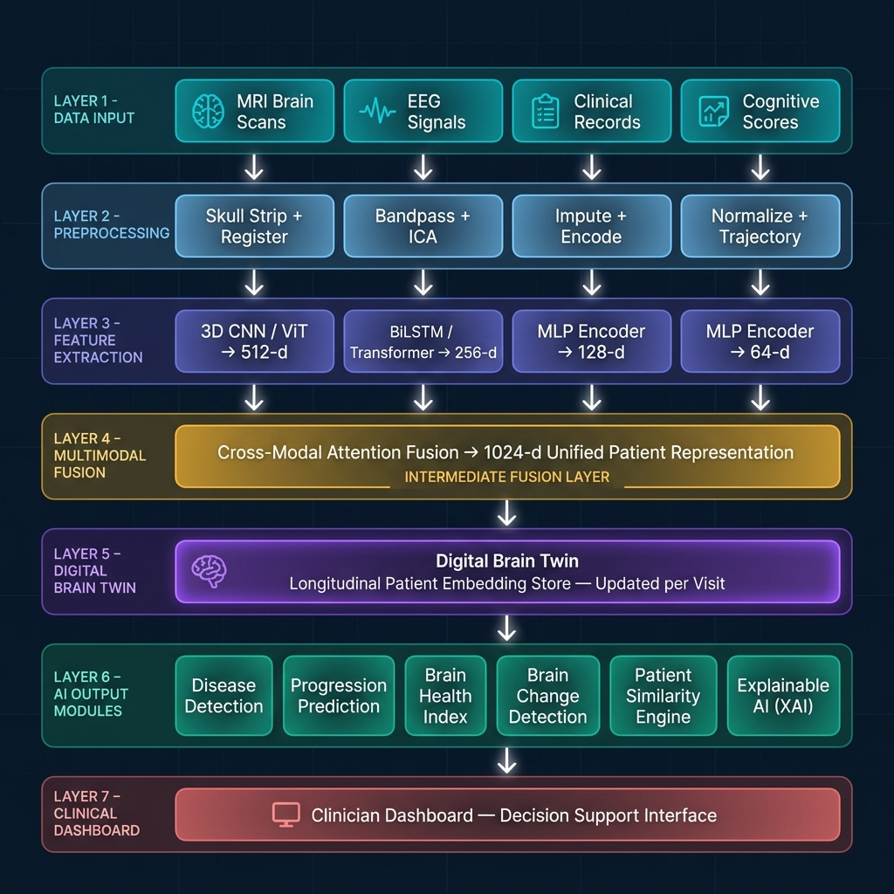
End-to-end pipeline: Multimodal Data Sources → Preprocessing → Feature Extraction → Fusion → Digital Brain Twin → AI Outputs → Clinician Dashboard

Figure 2 — CEREBRO-X Detailed Layer-by-Layer Architecture
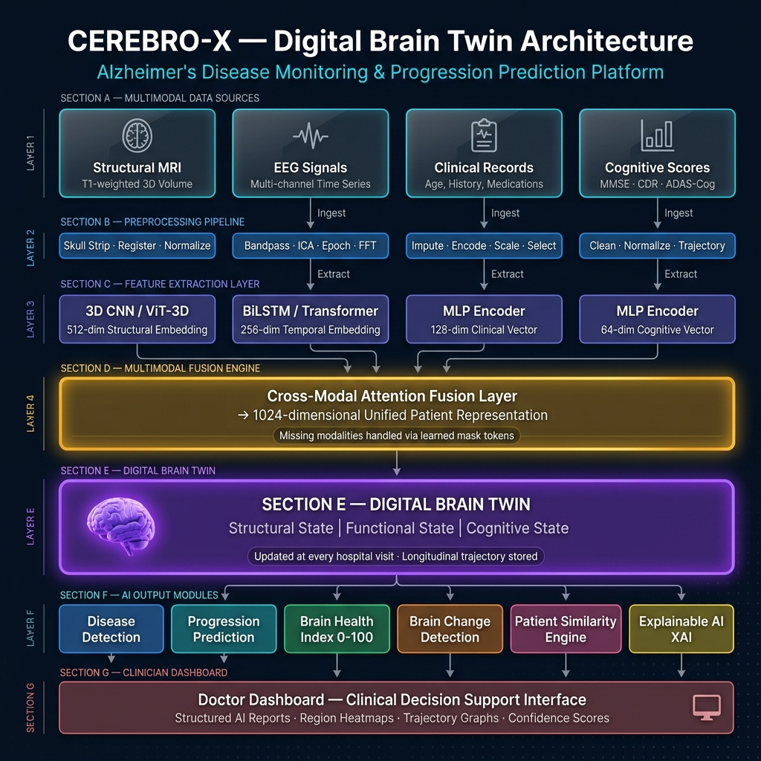
Layer-by-layer technical breakdown showing model architectures, embedding dimensions, cross-modal attention fusion, and Digital Brain Twin construction

