The keyword I didn't know about before.

-Instanceof:

The instanceof keyword checks whether an object is an instance of a specific class or an interface.

The instanceof keyword compares the instance with type. The return value is either true or false.

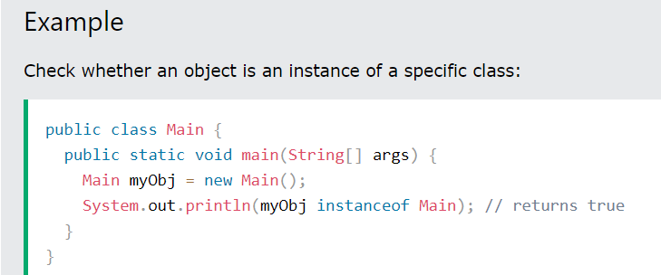

-assert:

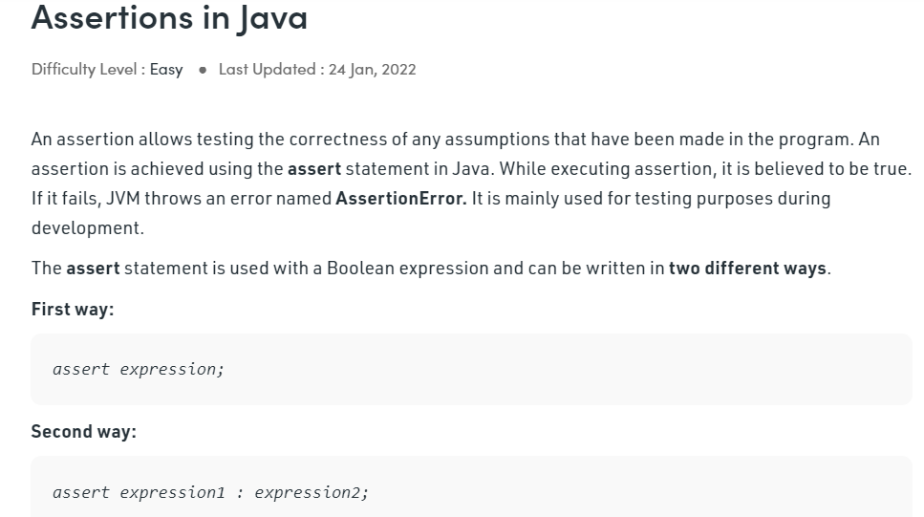

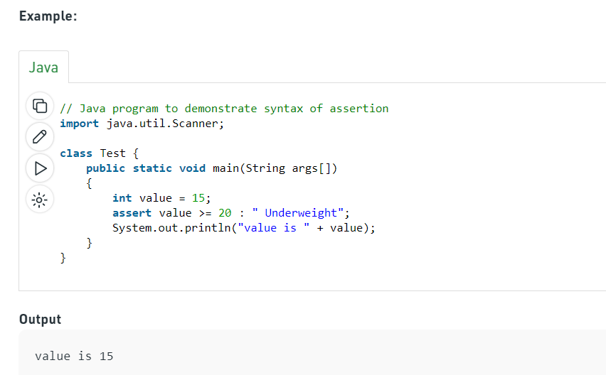

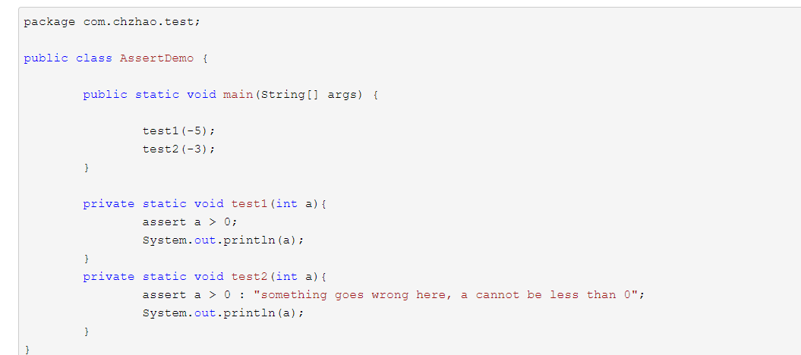

-**strictfp**

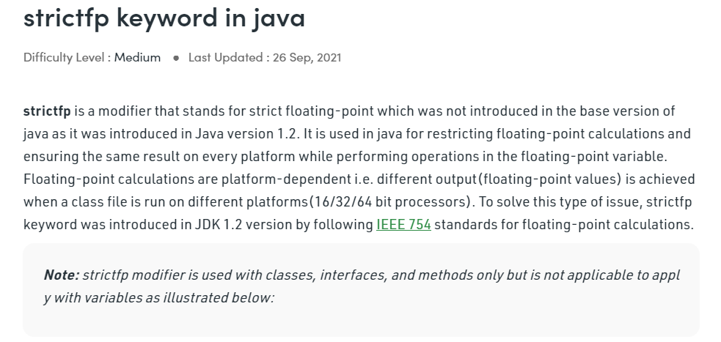

-transient

<https://www.geeksforgeeks.org/transient-keyword-java/>

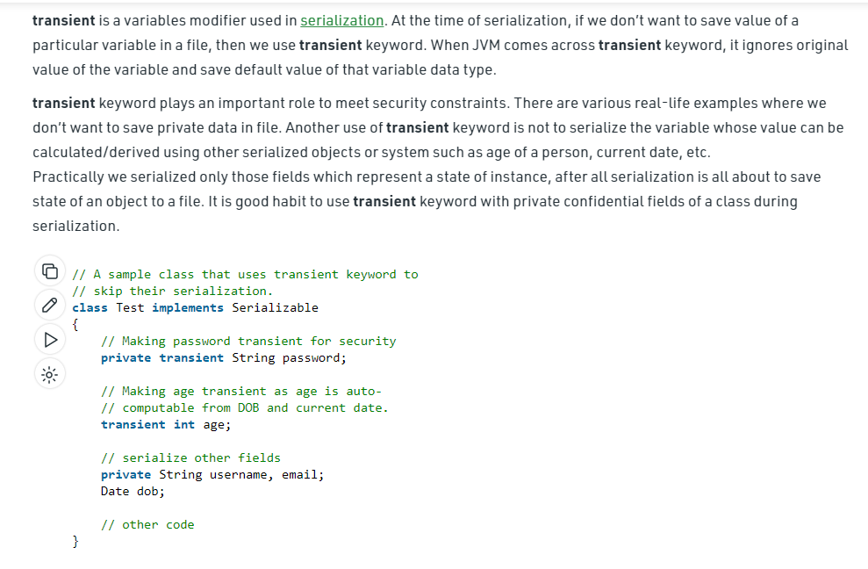

-violate

<https://www.geeksforgeeks.org/volatile-keyword-in-java/>

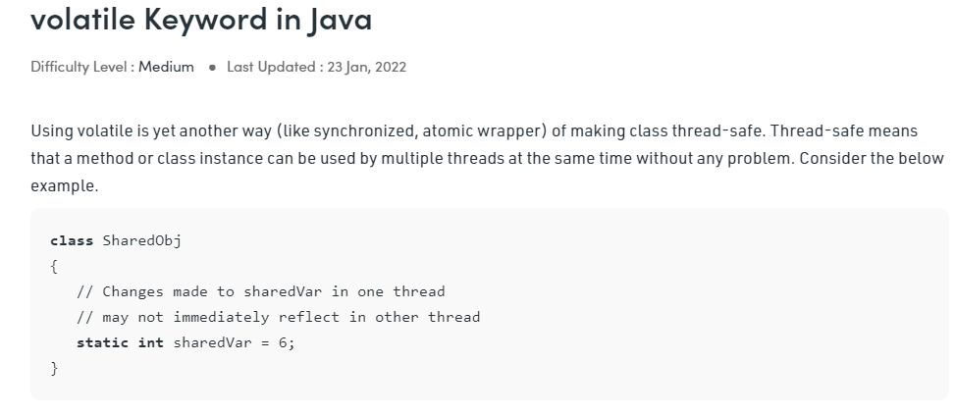

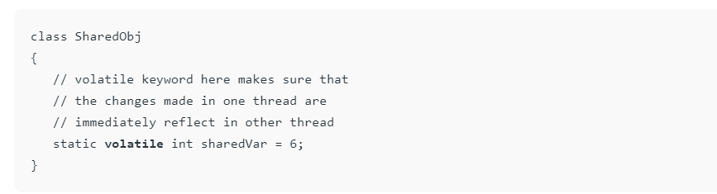

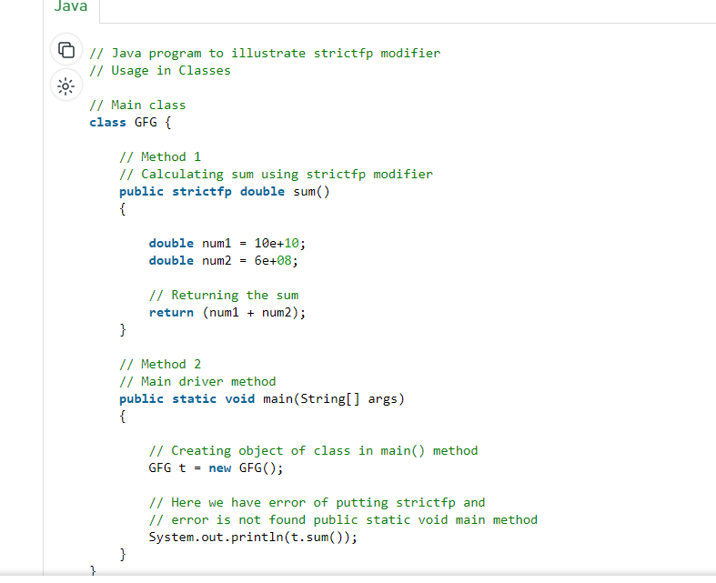

-native

<https://www.geeksforgeeks.org/native-keyword-java/>

