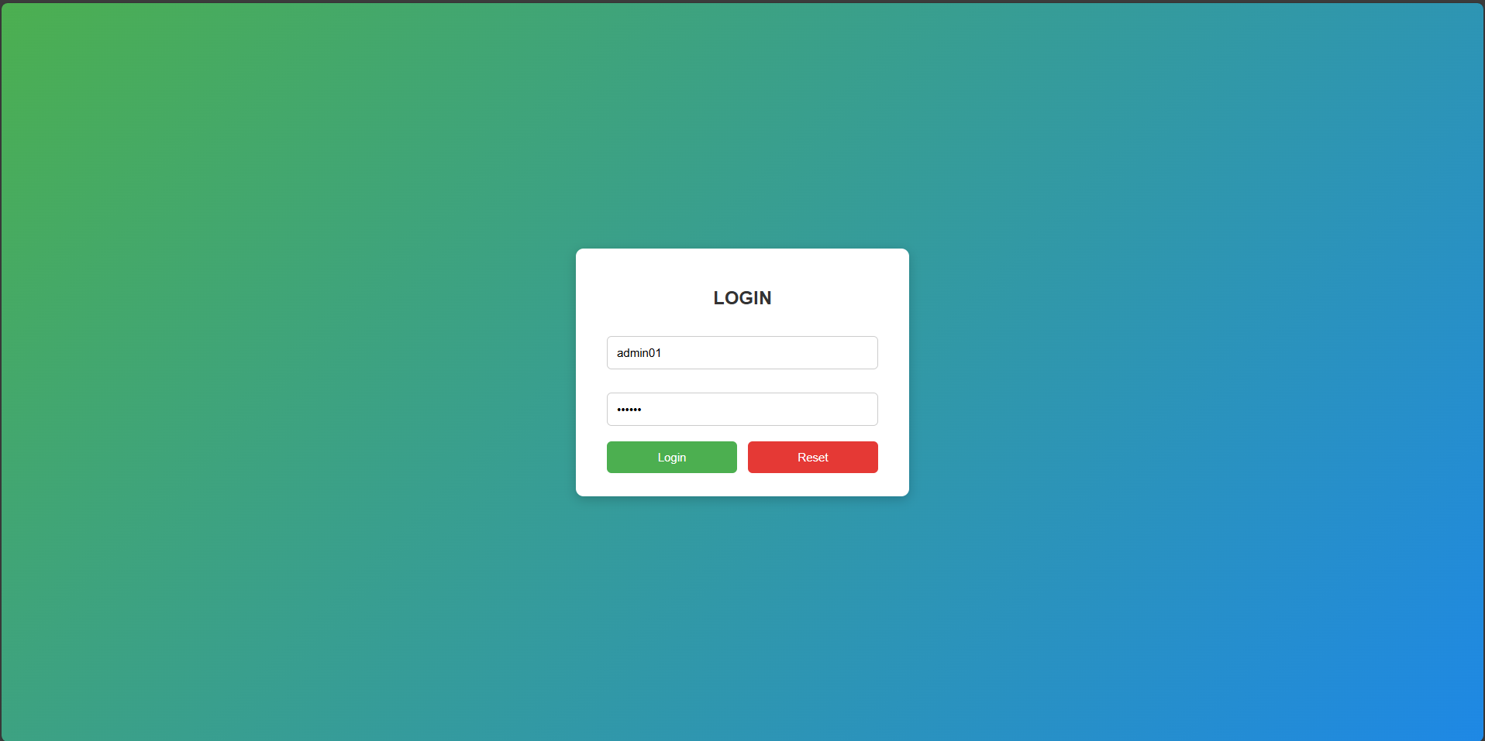
-Giao diện admin:
-Chức năng Login:
Lớp: 23T_DT2
Mã sinh viên: 102230226
Họ và tên: Nguyễn Hữu An
Kiểm tra cuối kỳ
Evaluation Warning : The document was created with Spire.PDF for java.

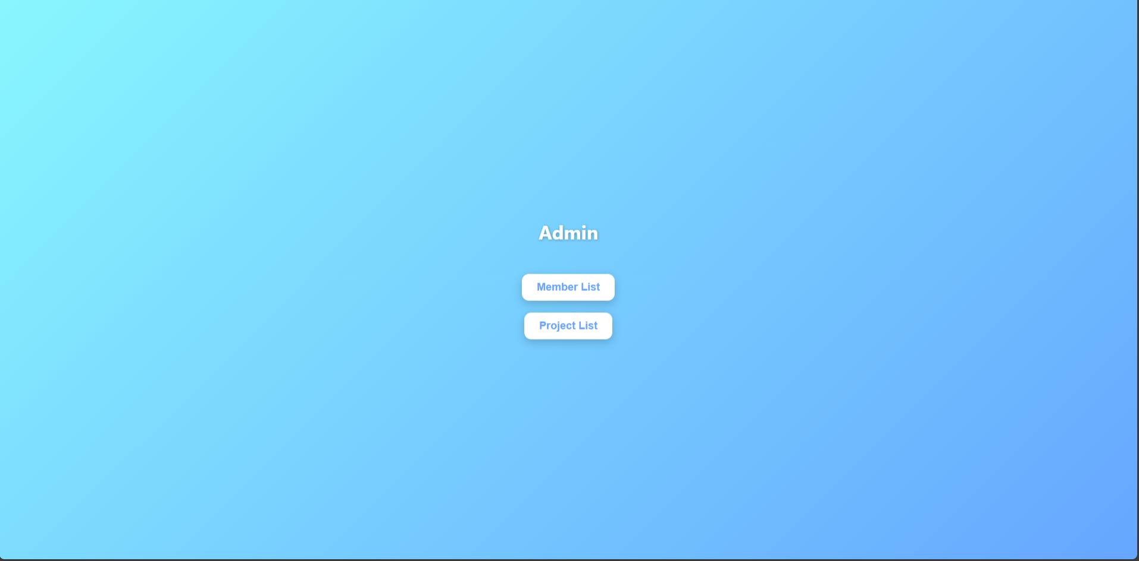

- Giao diện them project:
- Giao diện member:
Evaluation Warning : The document was created with Spire.PDF for java.

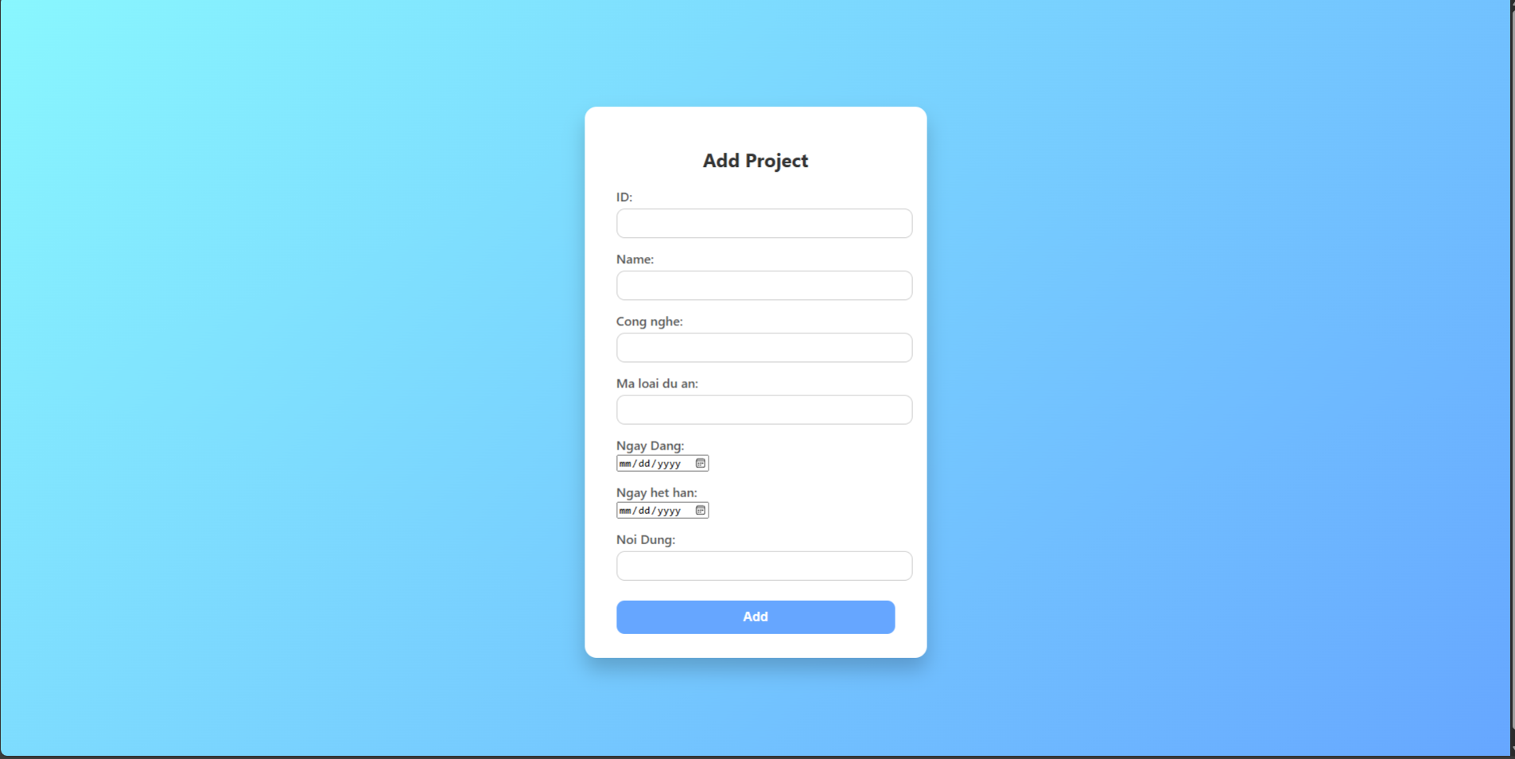
Evaluation Warning : The document was created with Spire.PDF for java.

