IIIT Bhubaneswar
Web Search Mining (WSM): Assignment Report
A Mini Information Retrieval System for Shakespeare's Plays
Name | ID | Branch | Institute
Anish Ray | B524011 | CE | IIIT Bhubaneswar

1. Introduction
This project is a small search engine in Python. It indexes 25 text documents, the five acts of five Shakespeare plays (All's Well That Ends Well, Antony and Cleopatra, As You Like It, Hamlet, Romeo and Juliet, about 131,700 words from the Folger Shakespeare Library). A user types a query and gets a ranked list of acts with a snippet around the match. I built every stage myself using classical retrieval techniques only: no machine learning, embeddings or search libraries.
Problem and motivation: scanning files for a word is slow and does not say which file matches best. A search engine builds an index once and scores documents, and I wanted to understand each stage by implementing it. Objectives: (1) inverted index; (2) Boolean, wildcard, phrase and proximity queries; (3) TF-IDF and cosine ranking with snippets; (4) stemming, sublinear TF and Rocchio relevance feedback; (5) measure ranking quality with Precision, Recall, F1, MAP and MRR; (6) a simple interface.

2. Technologies and Tools
Technology | Used for | Why
Python 3.12 (standard library only: re, math, collections, bisect, json, argparse) | All retrieval logic and the evaluation script | Dicts, sets and Counter map directly onto an inverted index; no dependencies (requirements.txt is empty).
http.server + HTML/CSS/JavaScript | Web interface (server.py, web/index.html) | A browser page looks better than a desktop window and needs no framework.
Tkinter | Original desktop GUI (gui.py, still available with --tk) | Ships with Python.
Git / GitHub | Version control | The commit history records the order of development.

3. Architecture
Retrieval logic is separate from the interface: the GUI and the web server only call SearchEngine.search() and SearchEngine.feedback(). This let me replace the Tkinter window with a web page without touching the search code.
.txt files -> document_loader -> text_processor -> indexer -> (index built once at start-up)
(tokenize, stop words, (postings, term counts,
optional stemming) positions)
query -> query_processor (+ wildcard) -> ranker (TF-IDF, cosine, Rocchio) -> search_engine
AND/OR/NOT, phrase, proximity (snippets)
/ \
server.py gui.py
(web/index.html) (Tkinter)

Module | Responsibility
document_loader, text_processor, stemmer | Load files; one preprocess() shared by documents and queries; Porter stemmer written from the published algorithm.
indexer | Posting lists, term frequencies, document lengths, positional index; phrase and proximity matching.
query_processor, wildcard | Parse the query; combine posting lists; expand wildcards through regular expressions on the vocabulary.
ranker | TF-IDF weights, cosine similarity, Rocchio query expansion.
search_engine | Wires the parts together, builds snippets; the only class the interfaces use.
evaluation, evaluate.py | Metrics, and an experiment script over 13 hand-judged queries.

4. Development Methodology and Implementation
Stage (date) | What I built
1. Core pipeline (2 Sep) | Corpus, loader, text processing, inverted index, AND + wildcard queries, TF-IDF cosine ranking, SearchEngine, Tkinter GUI, README.
2. Usability (2 Sep) | Query-focused snippets; OR and NOT; syntax hint under the search box.
3. Ranking fixes (3 Sep) | Common-word and wildcard weighting fixes (Section 7); GUI restyle.
4. Extensions (5 Nov) | Stemming, sublinear TF, phrase queries, Rocchio feedback, evaluation script, web interface, proximity queries.

Index. build() makes one pass per document and stores posting lists (term -> set of doc IDs), a Counter of term frequencies and the document length. For this corpus: 9,678 distinct terms from 75,150 indexed tokens (6,725 terms with stemming).
Ranking. Documents and queries are TF-IDF vectors; the score is their cosine. idf = log(N/df) + 1. Document vector lengths are computed once at start-up. Sublinear TF replaces tf by 1 + log(tf).
for term, q_weight in query_vector.items(): # cosine for one candidate document
tf = self.index.term_frequency(term, doc_id)
if tf > 0:
dot += q_weight * (self._tf_weight(tf) * self.idf[term])
score = dot / (query_norm * self.doc_norm[doc_id])

Query processing. OR turns the positive terms from intersection into union; NOT or - excludes the next term. A wildcard becomes a regular expression matched against the vocabulary, and the union of the matching terms' posting lists is used. Matched terms are grouped per query term and each group gets one unit of term frequency, so a wildcard cannot outweigh plain words.
Phrases and proximity. The positional index stores term -> {doc: [positions]} over the token stream with stop words kept, so a phrase made of stop words ("to be or not to be") still works. A phrase keeps start position p only if word i occurs at p + i. For a /N b, each position p of a is binary-searched against the sorted positions of b for a hit in [p - N, p + N].
lo = bisect_left(b_positions, p - distance) # proximity: b within N positions of a
hi = bisect_right(b_positions, p + distance)
pairs += max(hi - lo - (1 if term_a == term_b else 0), 0)

Rocchio feedback. q' = α·q + β·mean(relevant) − γ·mean(non-relevant) with α = 1, β = 0.75, γ = 0.15; document vectors are length-normalized, negative weights dropped, and only the 25 heaviest feedback terms are added. The expanded query is scored against all documents. Snippets are about 200 characters centred on the first matched word, phrase or window.

5. Features and Functionality
Feature | Behaviour | Example
Boolean AND / OR / NOT | AND by default; one OR makes all terms optional; NOT or - excludes. No parentheses. | love death, love OR death, hamlet NOT ghost
Wildcards | * = zero or more characters, at the start, middle or end. | king*, *ing, mach*ne
TF-IDF ranking | Cosine ranking; a relative score (% of best) is shown as a display aid. | any query
Phrase queries | Words in quotes must be adjacent and in order; can be negated. | "alas poor yorick"
Proximity queries | Two plain words within N positions, either order. | romeo /3 juliet
Stemming, log TF | Optional flags --stem, --log-tf. | loving also finds love
Relevance feedback | "+ More like this" under a result re-ranks with Rocchio and lists added terms. | ghost, then mark Hamlet Act 1
Messages | Empty query, only stop words, only exclusions, no match: a message, never a crash. | machine learning
Interfaces | Web page (python main.py); Tkinter window (--tk). The page is responsive (works at phone width) and supports dark mode. | Figure 1

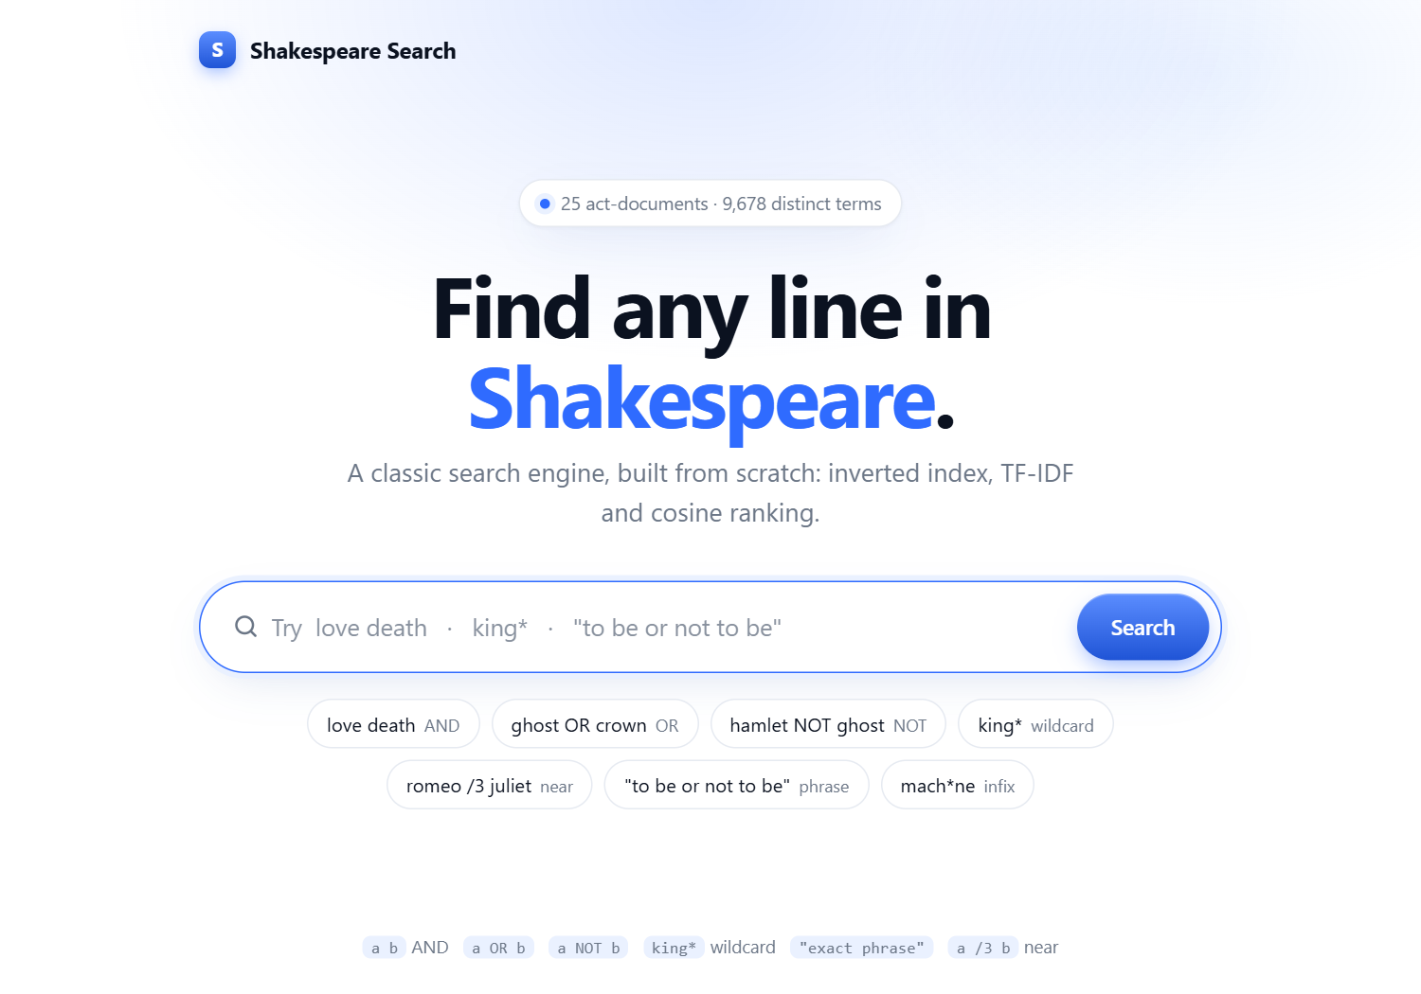  (a) Home page | 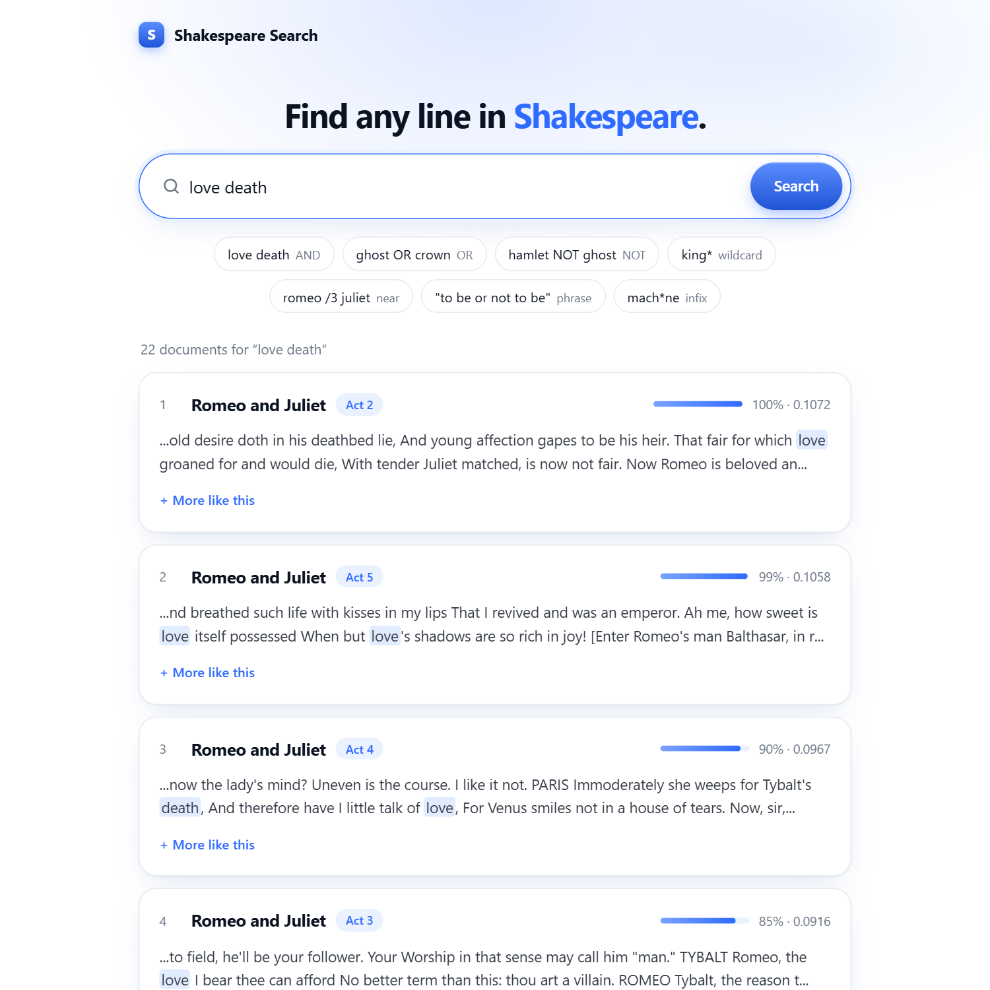  (b) AND query: love death
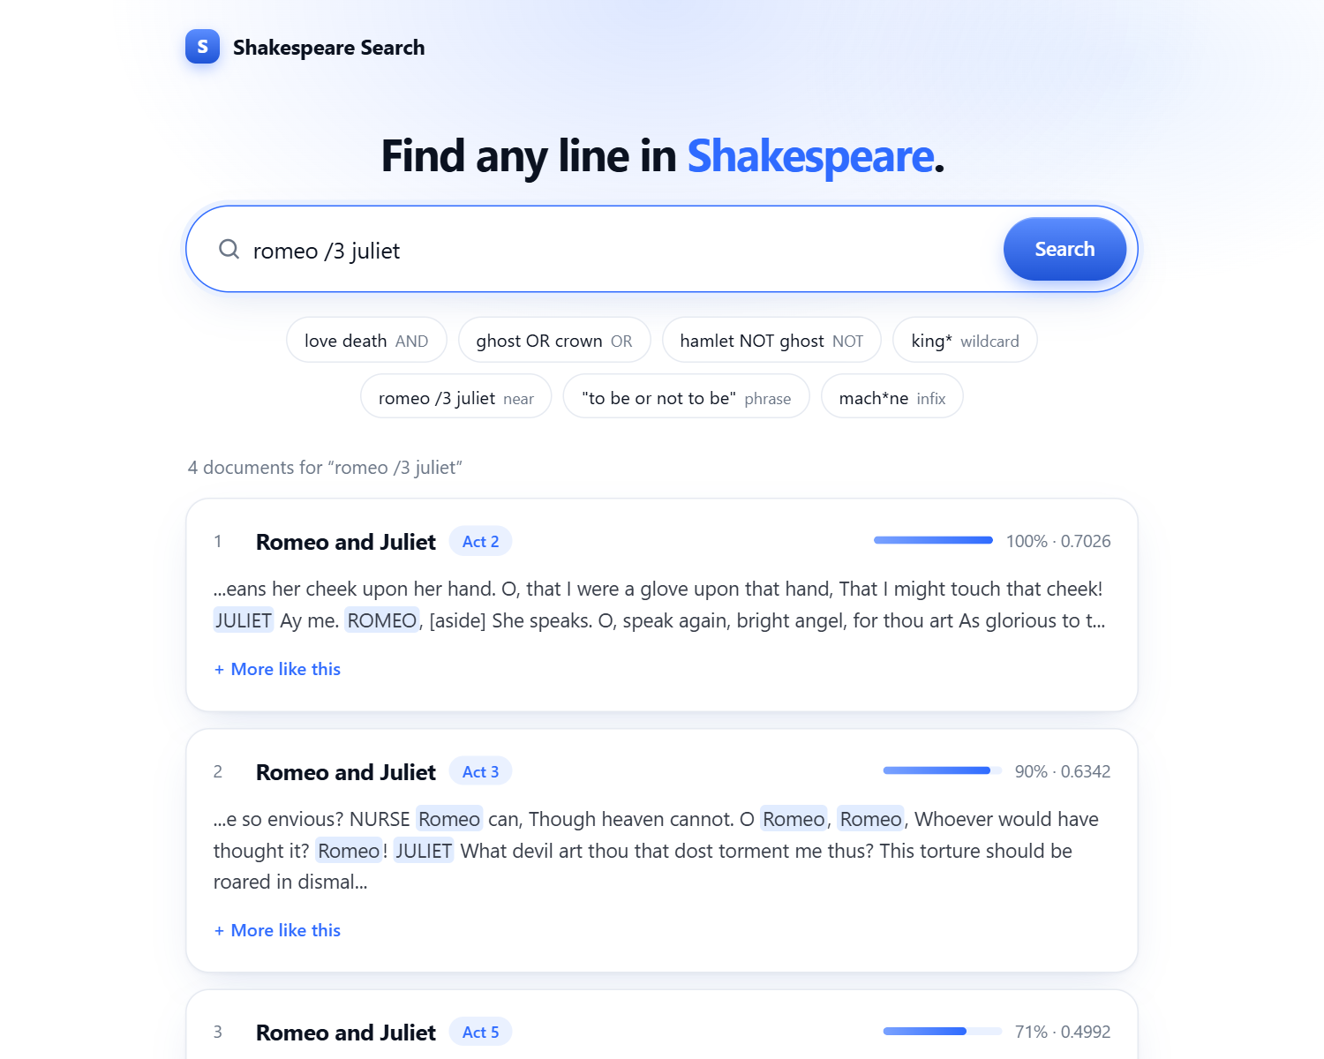  (c) Proximity query: romeo /3 juliet | 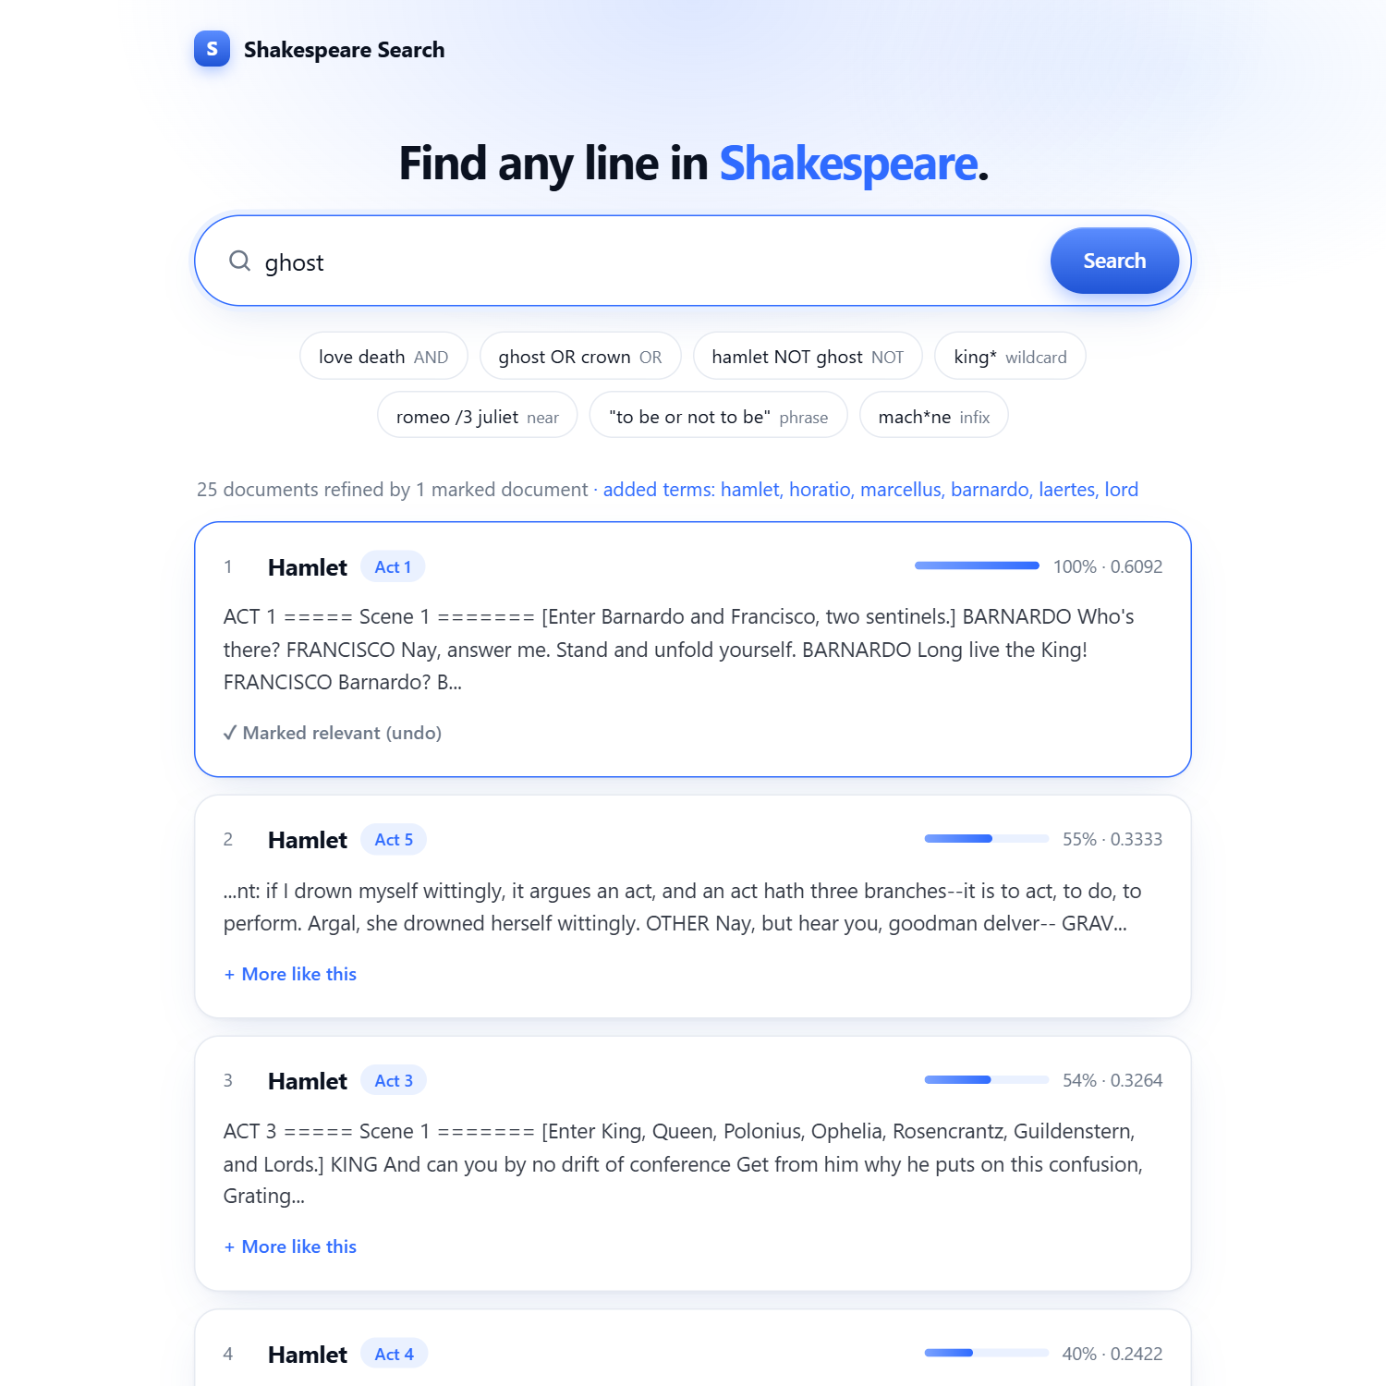  (d) Feedback on ghost, after marking Hamlet Act 1
Figure 1: Screenshots of the web interface. A Tkinter screenshot can be added by running python main.py --tk.

6. Testing and Results
I tested by running queries through the engine and the web page and checking results against the text. There are no automated unit tests. Ranking quality was measured with evaluate.py. Scores below are cosine values (raw TF, no stemming).
Query | Expected | Actual
love death | Acts with both words | 22 docs; top Romeo and Juliet Act 2 (0.107)
hamlet NOT ghost | Hamlet acts without ghost | 3 docs: Hamlet Act 5 (0.685), Act 2, Act 4
king* / mach*ne | King forms / machine | 18 docs, top Hamlet Act 4 / 1 doc, Hamlet Act 2
"to be or not to be" | Hamlet's soliloquy | 1 doc: Hamlet Act 3
romeo /3 juliet | Names close together | 4 docs; top Romeo and Juliet Act 2 (0.703)
the and of; machine learning; -death | Handled messages | only_stopwords; no_match; no_positive_terms
loving, stemming off vs on | Stemming widens matches | Top result changes from As You Like It Act 2 to Act 4
ghost + mark Hamlet Act 1 | Query expands towards Hamlet | Added: hamlet, horatio, marcellus, barnardo, laertes, lord

Ranking quality. I wrote 13 queries (11 keyword queries joined with OR, 2 phrase queries) with the acts I judged relevant (data/relevance.json). The judgments are mine, at act level and few, so differences of a few hundredths are noise. Results at k = 3:
Configuration | P@3 | R@3 | F1@3 | MAP | MRR
raw TF | 0.692 | 0.867 | 0.733 | 0.921 | 1.000
log TF | 0.718 | 0.905 | 0.764 | 0.932 | 0.962
raw TF + stemming | 0.692 | 0.867 | 0.733 | 0.905 | 0.962
log TF + stemming | 0.692 | 0.867 | 0.733 | 0.923 | 0.962

Log TF helped slightly; stemming helped some queries and hurt others. Rocchio was tested on the residual collection (the judged document removed before scoring): over 11 queries MAP fell from 0.775 to 0.674. The added terms are mostly character names, which lift every act of the same play. Smaller β (0.1 to 0.2) came out near the baseline, but I chose that after seeing the test set, so I kept the textbook values.

7. Challenges and Solutions
Problem | Solution
A one-word query for a very common word gave no ranking: log(N/df) is 0 for a word in every document. | Used log(N/df) + 1.
A wildcard such as king* expanded to many words and outweighed the plain words in the query. | Group matched terms per query term and give each group one unit of term frequency.
A phrase of stop words cannot be found if stop words are removed before positions are recorded. | Built the positional index with stop words kept.
Stemming vs. snippets and wildcards: raw text keeps original word forms, and wildcard patterns match the stemmed vocabulary. | Snippets stem each raw word before comparing. Wildcards are not stemmed, so *ing finds little when stemming is on (documented limitation).
A stray death /3 was read as the word "3" and matched "ACT 3" headings. | The parser now ignores an unpaired /N.
The web page highlighted deathbed for the query death, but the engine matches whole words. | The highlighter now matches whole words; only wildcards match prefixes.

8. Conclusion
I built a working search engine on the standard library alone. It supports Boolean, wildcard, phrase and proximity queries, TF-IDF cosine ranking, snippets, optional stemming and log TF, and Rocchio feedback, and I measured its ranking quality instead of judging by eye. Stemming and Rocchio did not improve results on this small collection, and I report that as measured. I learned how the index structures and the weighting details (such as the smoothed IDF) shape the ranking.
Run: python main.py (web, http://127.0.0.1:8000), --tk (Tkinter), --stem, --log-tf; python evaluate.py for the experiments. Source: https://github.com/An1sh-R/WSM-project

