**HA NOI UNIVERSITY**

**FACULTY OF INFORMATION TECHNOLOGY**

**Final Report  
Installation guidelines**

**Faculty: Information Technology**

**Course: Java Software Development**

**Teacher: MSc. Ngo Van Quyen**

**Students: 1901040002 – Vu Van An**

**1901040155 – Le Anh Phan**

**Date: November 10, 2024**

**Step 1: Download MySQL Workbench at:** [**https://dev.mysql.com/downloads/workbench/**](https://dev.mysql.com/downloads/workbench/)

**Step 2: Setup new connection by clicking on + icon**

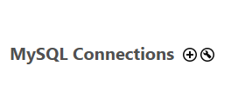

**Step 3: Make sure you fill-in these field correctly the click “Test Connection”**

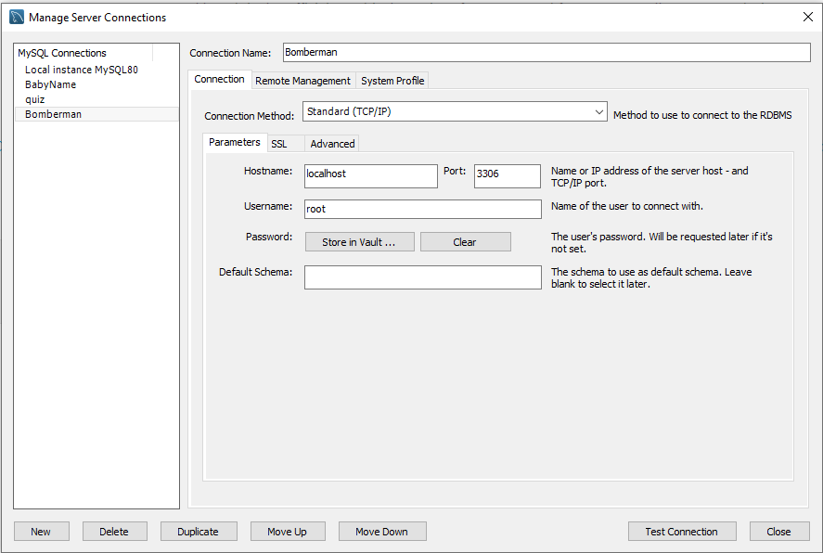

**Step 4: Download IntelliJ IDEA at:** [**https://www.jetbrains.com/idea/download/?section=windows**](https://www.jetbrains.com/idea/download/?section=windows)

**Step5.1: Clone from git, using git clone at the terminal where you stored the project: “ git clone** [**https://github.com/An2309/Bomberman.git**](https://github.com/An2309/Bomberman.git) **”**

**Step 5.2: Using zipfile instead of clone from git. Unzip and run project with IntellJ IDEA.**

**Step 6: Run project with IntellJ IDEA. Download JDK 1.8 if it is not installed.**