1. **Categories of Machine Learning System**

**Ans.** There are so many different types of Machine Learning systems that it is useful to classify them in broad categories, based on the following criteria:

• Whether or not they are trained with human supervision (supervised, unsupervised, semi supervised, and Reinforcement Learning)

• Whether or not they can learn incrementally on the fly (online versus batch learning)

• Whether they work by simply comparing new data points to known data points, or instead by detecting patterns in the training data and building a predictive model, much like scientists do (instance-based versus model-based learning)

1. **Supervised Learning:** This type of Machine Learning involves training the model using labeled data. The model learns to map input variables (features) to output variables (labels) based on the training data. Examples of supervised learning include image classification, speech recognition, and natural language processing.

2. **Unsupervised Learning:** This type of Machine Learning involves training the model on unlabeled data, and the model learns to find patterns and relationships in the data without any guidance. Examples of unsupervised learning include clustering and anomaly detection.

3. **Semi-Supervised Learning:** This type of Machine Learning involves training the model on a combination of labeled and unlabeled data. The model uses the labeled data to guide the learning process while discovering patterns in the unlabeled data. Semi-supervised learning is often used when obtaining labeled data is expensive or time-consuming.

4. **Reinforcement Learning:** This type of Machine Learning involves training the model to make decisions based on feedback from the environment. The model learns to take actions that maximize a reward signal and minimize a penalty signal. Reinforcement learning is often used in robotics, gaming, and control systems.

5. **Batch Learning**: In this type of Machine Learning, the model is trained using all available data at once. The model is trained offline, and once the training is complete, it is deployed to make predictions on new data.

6. **Online Learning:** In this type of Machine Learning, the model is trained on data that arrives in a stream, one example at a time. The model is updated as new data arrives, making it suitable for applications where the data is constantly changing.

7. **Instance-based Learning:** In this type of Machine Learning, the model learns by comparing new data points to known data points. The model stores the training data and uses it to make predictions on new data.

8. **Model-based Learning:** In this type of Machine Learning, the model learns to detect patterns in the training data and builds a predictive model. The model is then used to make predictions on new data. Examples of model-based learning include decision trees, logistic regression, and neural networks.

1. **Model Related Challenges and their Fixes…**

**Ans.** In Machine/Deep Learning, model-related challenges refer to difficulties in building, training, and optimizing models to achieve the desired level of accuracy and performance. Some of the main model-related challenges are:

1. **Model Selection:**

Challenge: Choosing the appropriate model architecture for a specific task is crucial but challenging. The model should strike a balance between complexity and generalization.

Fix: Perform model selection using techniques like cross-validation or grid search. Experiment with different architectures, evaluate their performance on validation data, and select the one that achieves the best trade-off between complexity and generalization.

1. **Overfitting:**

Challenge: Overfitting occurs when a model captures noise and random fluctuations in the training data, leading to poor performance on new or unseen data.

Fix: Address overfitting by employing regularization techniques such as L1 or L2 regularization, dropout, or early stopping. These techniques help prevent the model from becoming too complex and generalize better to unseen data.

1. **Underfitting:**

Challenge: Underfitting happens when a model is too simple to capture the underlying patterns in the data, resulting in poor performance on both training and new data.

Fix: Address underfitting by increasing the complexity of the model. This can be achieved by using more sophisticated architectures, increasing the number of layers or units, or incorporating more features into the dataset. Additionally, collecting more data or using data augmentation techniques can help the model capture the underlying patterns better.

1. **Hyperparameter Tuning:**

Challenge: Tuning hyperparameters such as learning rate, batch size, and number of epochs is crucial for achieving optimal model performance.

Fix: Utilize techniques like grid search, random search, or Bayesian optimization to search for the best combination of hyperparameter values. These methods systematically explore the hyperparameter space and identify the optimal configuration for improved model performance.

1. **Interpretability:**

Challenge: Complex models like deep neural networks are often considered black boxes, making it challenging to interpret their decisions.

Fix: Employ techniques for model interpretability, such as feature importance analysis, gradient-based methods, or model-agnostic approaches like LIME or SHAP. These methods provide insights into which features are most influential in the model's decision-making process, aiding in understanding and trust-building.

It's important to note that the fixes provided are general strategies, and the specific approach may vary depending on the problem and the data at hand.

1. **Bagging and pasting.**

**Ans.** Bagging and pasting are ensemble learning techniques that aim to improve the performance of machine learning models by combining the predictions of multiple individual models. Both bagging and pasting involve training several predictors on different subsets of the training data.

* **Bagging (bootstrap aggregating)** is a method where the training instances are sampled with replacement from the original training set. This means that a single training instance can be selected multiple times for the same predictor. Bagging allows for more diversity in the training data for each predictor, as some instances may be present in multiple subsets while others may not be included at all. After training all the predictors, the final prediction is made by aggregating the predictions of all the predictors, typically using majority voting for classification tasks or averaging for regression tasks.
* **Pasting**, on the other hand, is similar to bagging but involves sampling the training instances without replacement. This means that each predictor is trained on a different subset of the training data, ensuring that no training instance is selected more than once for a particular predictor. Similar to bagging, the predictions of all predictors are aggregated to make the final prediction.

The main benefit of bagging and pasting is that they reduce both bias and variance compared to a single predictor trained on the entire training set. Each individual predictor may have higher bias because it is trained on a subset of the data, but the aggregation of predictions helps to reduce the variance. This results in a more robust and accurate ensemble model.

Another advantage of bagging and pasting is their scalability. Since the predictors can be trained in parallel, either on different CPU cores or even different servers, the training process can be significantly faster. Similarly, predictions can also be made in parallel, making these methods suitable for large datasets.

In summary, bagging and pasting are ensemble learning techniques that improve the performance of machine learning models by training multiple predictors on different subsets of the training data and aggregating their predictions. Bagging involves sampling with replacement, while pasting involves sampling without replacement. These methods help to reduce variance and bias, improve model accuracy, and are highly scalable.

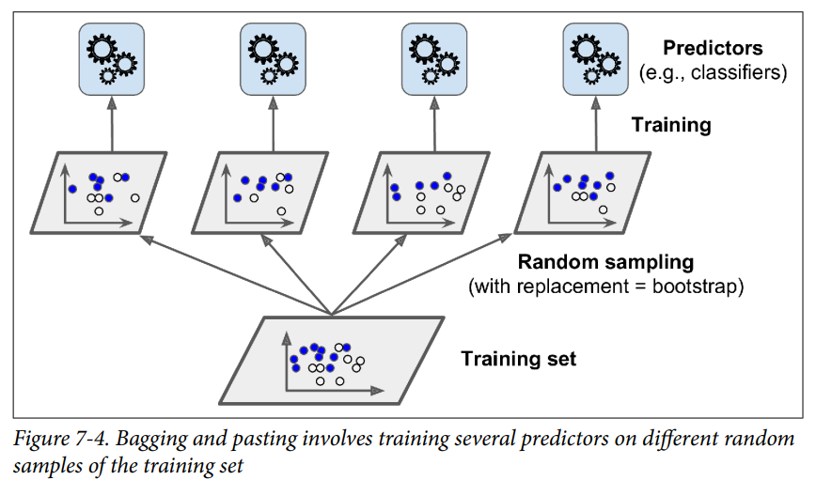

1. **Different Strategies in Multiclass Classification…**

**Ans.** In multiclass classification, there are several strategies that can be used to classify instances into multiple classes. The two main strategies are the one-versus-the-rest (OvR) strategy and the one-versus-one (OvO) strategy. Let's discuss these strategies in more detail:

**1. One-versus-the-rest (OvR) strategy:** This strategy involves training a separate binary classifier for each class. For example, if there are 10 classes (0 to 9), 10 binary classifiers will be trained, where each classifier distinguishes between one class and the rest of the classes. During prediction, the decision scores from all classifiers are obtained, and the class with the highest score is selected as the predicted class. OvR is also called one-versus-all.

**2. One-versus-one (OvO) strategy:** In this strategy, a binary classifier is trained for every pair of classes. If there are N classes, then N * (N-1) / 2 classifiers are trained. For example, in the case of 10 classes, 45 binary classifiers are trained. During prediction, each classifier votes for its respective class, and the class that wins the most "duels" is selected as the predicted class. OvO requires running predictions through all classifiers for each instance.

The choice between OvR and OvO depends on the algorithm being used and the size of the training set:

* OvO is preferred for algorithms that scale poorly with the size of the training set, such as Support Vector Machine (SVM) classifiers. Training many classifiers on small training sets is faster than training a few classifiers on large training sets.
* OvR is preferred for most binary classification algorithms because it simplifies the problem to multiple independent binary classification tasks. It allows the use of binary classifiers that are designed to handle two classes.

Scikit-Learn automatically detects the type of algorithm being used and applies the appropriate strategy (OvR or OvO) for multiclass classification tasks. It provides the `OneVsOneClassifier` and `OneVsRestClassifier` classes, which can be used to explicitly force the use of a specific strategy.

Overall, both strategies are effective for multiclass classification, but the choice depends on the algorithm, training set size, and computational efficiency considerations.

1. **Define a Perceptron… (Hint Chap. 10 – Very Simple)**

**Ans.** The Perceptron is a simple artificial neural network architecture invented by Frank Rosenblatt in 1957. It is based on a linear threshold unit (LTU) or threshold logic unit (TLU) that takes numeric inputs and produces numeric outputs. The TLU computes a weighted sum of its inputs and applies a step function to determine the output.

The Perceptron is primarily used for binary classification tasks. It can classify input data into two classes based on a linear decision boundary. By comparing the weighted sum to a threshold, it outputs the positive class if the sum exceeds the threshold; otherwise, it outputs the negative class. A Perceptron consists of a single layer of TLUs, with each TLU connected to all the inputs.

The training algorithm for the Perceptron is based on Hebb's rule, which strengthens connections between neurons that fire together frequently. During training, the Perceptron is fed one training instance at a time, makes predictions, and adjusts the connection weights based on the error. For example, it can tell if something is a circle or a square based on certain characteristics.

However, Perceptrons have limitations. They can only learn linearly separable patterns, meaning they struggle with problems that require nonlinear decision boundaries. To overcome this limitation, multiple Perceptrons can be stacked together, forming a Multilayer Perceptron (MLP). MLPs, with their ability to incorporate hidden layers, can solve more complex problems by capturing nonlinear relationships between inputs and outputs.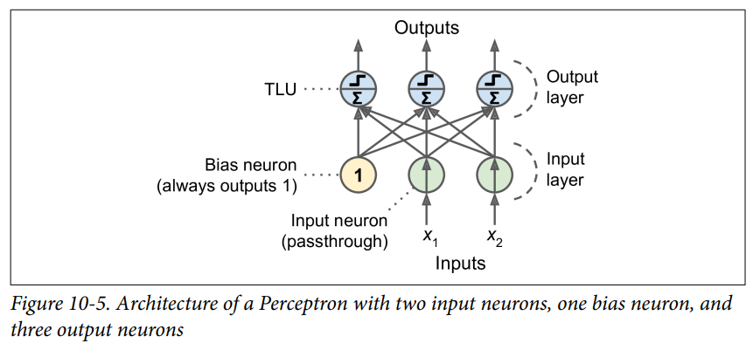

1. **Broad Challenges We May Face While Training a Deep Neural Network… (Hint Chap. 11 – Very Simple)**

**Ans.** Training a deep neural network (DNN) can indeed pose several challenges. Here are some broad challenges that are commonly encountered during the training process:

1. **Vanishing and Exploding Gradients:** The vanishing gradients problem occurs when the gradients become extremely small as they propagate backward through the layers of the network. As a result, the lower layers receive weak gradient signals, hindering their ability to learn effectively. On the other hand, the exploding gradients problem happens when the gradients become extremely large, leading to unstable training and making it difficult to converge to a good solution.

2. **Insufficient Training Data:** Deep neural networks often require a large amount of labeled training data to generalize well. However, acquiring labeled data can be challenging, especially in domains where manual labeling is time-consuming, expensive, or requires domain expertise. Insufficient training data can lead to overfitting, where the model becomes too specialized in the training data and performs poorly on unseen examples.

3. **Computational Complexity and Training Speed:** Deep neural networks with a large number of layers and parameters can be computationally intensive to train. The forward and backward passes through the network, involving matrix multiplications and backpropagation, can require significant computational resources. Training such networks may require specialized hardware or distributed computing setups to achieve reasonable training times.

4**. Overfitting:** Deep neural networks, especially those with a large number of parameters, are prone to overfitting. Overfitting occurs when the model becomes too complex and starts to memorize the training data instead of learning generalizable patterns. This is particularly problematic when the training dataset is small, noisy, or unrepresentative of the target population.

**5. Hyperparameter Tuning:** Deep neural networks have various hyperparameters, such as learning rate, batch size, regularization strength, and network architecture choices. Finding the optimal combination of hyperparameters can be challenging and often requires extensive experimentation. Poorly tuned hyperparameters can result in slow convergence, suboptimal performance, or training instability.

**6. Network Architecture Design:** Choosing an appropriate network architecture for a given task can be a challenge. Different architectures, such as convolutional neural networks (CNNs) for image data or recurrent neural networks (RNNs) for sequential data, have specific strengths and weaknesses. Selecting the right architecture that captures the relevant patterns in the data and balances complexity and interpretability is crucial.

**7. Data Preprocessing and Augmentation:** Properly preparing data, including normalization, handling missing data, and applying augmentation techniques, is crucial for successful training.

**8. Interpretability and Debugging:** Deep neural networks are often considered black-box models, making it difficult to interpret their decisions and understand their inner workings. Debugging training issues, identifying sources of errors, and diagnosing performance bottlenecks can be challenging due to the complex nature of deep networks.

Addressing these challenges often requires a combination of experience, domain expertise, careful experimentation, and the use of specialized techniques such as gradient clipping, regularization, early stopping, transfer learning, and model architecture modifications.

1. **PCA – Principal Component Analysis**

**Ans.**  PCA, or Principal Component Analysis, is a popular algorithm used for dimensionality reduction. It works by identifying the hyperplane that lies closest to the data and then projecting the data onto it. This helps to preserve the maximum variance in the data while reducing the number of dimensions. PCA can be used to compress data, speed up classification algorithms, and even visualize high-dimensional data. There are different variations of PCA, including Incremental PCA, Randomized PCA, and Kernel PCA, each with their own advantages and use cases.

* Incremental PCA is useful for large training sets and for applying PCA online, as it allows you to split the training set into mini-batches and feed an IPCA algorithm one mini-batch at a time.

For example, in the MNIST dataset, you can use Incremental PCA to reduce the dimensionality of the dataset down to 154 dimensions.

* Randomized PCA is a stochastic algorithm that quickly finds an approximation of the first d principal components, making it dramatically faster than full SVD when d is much smaller than n.

For example, you can also use Randomized PCA by setting the svd_solver hyperparameter to "randomized".

* Kernel PCA is a technique that implicitly maps instances into a very high-dimensional space (called the feature space), enabling nonlinear classification and regression with Support Vector Machines. It makes it possible to perform complex nonlinear projections for dimensionality reduction.

For example, Finally, you can use Kernel PCA with an RBF kernel to perform kPCA.

1. **Design Principal of Scikit-Learn…**

**Ans.**

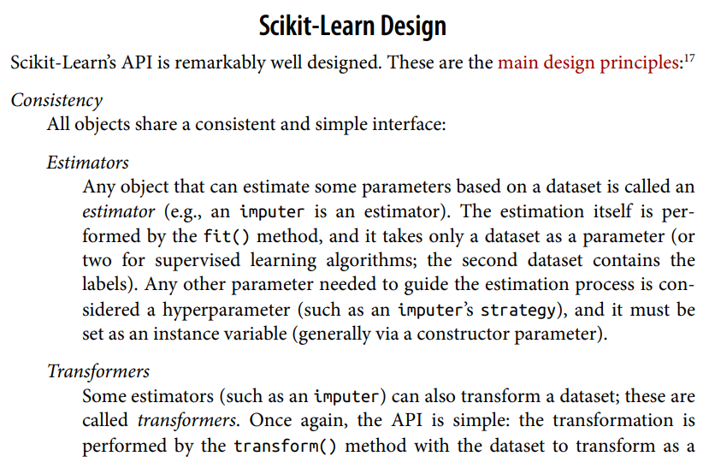

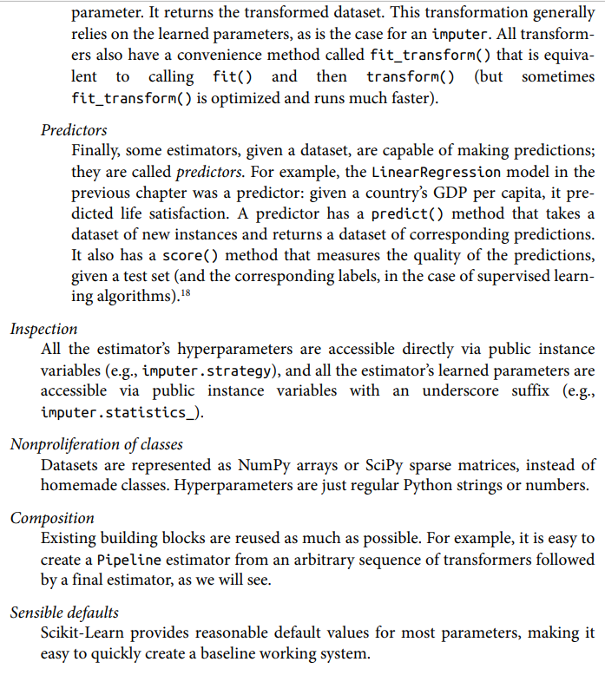  Scikit-Learn's API design follows several main principles:

1. Consistency: All objects in Scikit-Learn share a consistent and simple interface.

2. Estimators: Objects that estimate parameters based on a dataset are called estimators. They use the fit() method to perform the estimation, taking the dataset as a parameter. Hyperparameters, guiding the estimation process, are set as instance variables.

3. Transformers: Some estimators can also transform datasets. These are called transformers and use the transform() method. They rely on learned parameters, and a convenience method called fit_transform() ,combines fit() and transform().

4. Predictors: Estimators capable of making predictions are called predictors. They have a predict() method that takes new instances and returns corresponding predictions. The score() method measures prediction quality.

5. Inspection: Hyperparameters are accessible via instance variables, and learned parameters have underscore-suffixed variables.

6. Nonproliferation of classes: Scikit-Learn uses NumPy arrays or SciPy sparse matrices for datasets and regular Python strings or numbers for hyperparameters.

7. Composition: Existing building blocks are reused, allowing easy creation of pipelines from transformers and final estimators.

8. Sensible defaults: Scikit-Learn provides reasonable default parameter values for ease of use.

Overall, Scikit-Learn's well-designed API ensures consistency, simplicity, and flexibility in building machine learning models.

1. **Logistic Regression…**

**Ans.** Logistic regression is a statistical algorithm used for binary classification. It models the relationship between input features and the target variable using a logistic function. In deep learning, logistic regression is considered a simple form of a neural network with a single layer and output node.

The input features are multiplied by weights, and the sum is passed through a logistic function to predict the probability of the input belonging to the positive class. Training involves minimizing a loss function, often binary cross-entropy, using optimization algorithms like gradient descent.

While not a standalone deep learning technique, logistic regression is a fundamental component in various neural network architectures. It can serve as the output layer in MLPs or be combined with other layers and activation functions in models like CNNs and RNNs to learn complex patterns.

Certainly! Let's consider an example to illustrate the application of logistic regression in deep learning.

Example: Email Spam Classification

Suppose you have a dataset of emails labeled as either spam or not spam. You want to build a model that can predict whether a new email is spam or not based on its content.

**1. Data Preparation**: You start by preprocessing the email data, converting the text into numerical features. This could involve techniques like bag-of-words representation or word embeddings.

**2. Logistic Regression Model:** In a deep learning context, you can use logistic regression as the final layer of a neural network. Let's say you have a feed-forward neural network with an input layer, one or more hidden layers with activation functions (such as ReLU), and a final output layer with a logistic activation function.

**3. Training:** You split your labeled dataset into training and validation sets. During training, you pass the preprocessed email data through the network, compute the predicted probabilities using logistic regression, and compare them with the actual labels. You update the weights of the network using an optimization algorithm like gradient descent, minimizing the binary cross-entropy loss between the predicted probabilities and the true labels.

4**. Evaluation:** After training, you evaluate the performance of your model on a separate test set. You can use metrics like accuracy, precision, recall, or F1 score to assess how well the model classifies spam and non-spam emails.

**5. Prediction:** Finally, you can use the trained model to predict the probability of new, unseen emails being spam or not. The logistic regression outputting values close to 0 indicates a prediction of non-spam, while values close to 1 indicate a prediction of spam.

Applications of Logistic Regression in Deep Learning:

* Image Classification: Logistic regression can be used as the output layer in a convolutional neural network (CNN) for tasks like classifying images into different categories.
* Sentiment Analysis: Logistic regression can be employed as a component in a recurrent neural network (RNN) to determine the sentiment of text, such as movie reviews or social media posts.
* Fraud Detection: Logistic regression can be utilized in deep learning models to identify fraudulent transactions based on various features, such as transaction amount, location, and user behavior.
* Medical Diagnosis: Logistic regression in deep learning models can assist in diagnosing medical conditions based on patient data, such as symptoms, lab results, and medical history.

These are just a few examples of how logistic regression can be applied in deep learning. The flexibility and versatility of logistic regression make it a valuable tool in various domains where binary classification is required.

1. **Decision Tree Regularization…**

**Ans.** Decision tree regularization is a technique used to prevent decision trees from overfitting the training data and improve their generalization performance. Regularization involves introducing constraints or limitations on the decision tree's structure during the training process.

Decision trees have the ability to adapt themselves to the training data very closely, which can lead to overfitting. Overfitting occurs when the decision tree captures the noise or random variations in the training data, making it less effective in predicting outcomes for new, unseen data.

To address overfitting, regularization hyperparameters are used to control the complexity and flexibility of the decision tree. The following regularization hyperparameters can be adjusted:

**1. Max Depth:** This hyperparameter, denoted as `max_depth`, limits the maximum depth or number of levels in the decision tree. By restricting the depth, the model becomes less complex, reducing the chances of overfitting. A shallow decision tree is more likely to generalize well but may have less predictive power.

**2. Min Samples Split:** The `min_samples_split` hyperparameter sets the minimum number of samples required to split an internal node further. If a node has fewer samples than the specified threshold, splitting is halted. This constraint prevents the decision tree from creating branches with too few instances, which can be noise or outliers.

**3. Min Samples Leaf:** The `min_samples_leaf` hyperparameter specifies the minimum number of samples required to be present in a leaf node. Similar to `min_samples_split`, it prevents the tree from creating leaf nodes with a small number of instances, which can lead to overfitting.

**4. Min Weight Fraction Leaf:** This hyperparameter, `min_weight_fraction_leaf`, is similar to `min_samples_leaf`, but it is expressed as a fraction of the total weighted instances instead of a fixed number.

**5. Max Leaf Nodes:** The `max_leaf_nodes` hyperparameter limits the maximum number of leaf nodes in the decision tree. Restricting the number of leaf nodes can prevent the model from becoming too complex and overfitting the data.

**6. Max Features:** The ‘max_features’ hyperparameter controls the number of features considered for splitting at each node. By limiting the number of features, the decision tree focuses on a subset of features, reducing complexity and potential overfitting.

By adjusting these hyperparameters, you can regulate the decision tree's growth and complexity, striking a balance between capturing the underlying patterns in the data and preventing overfitting. Regularization helps ensure that the decision tree generalizes well to unseen data and improves its performance on test or validation datasets.

1. **Voting Classifier Method – Pros and Cons…**

**Ans.**  The Voting Classifier method is an ensemble learning technique where multiple classifiers are combined to make predictions. It aggregates the predictions of each individual classifier and selects the class with the majority of votes as the final prediction. Here are the pros and cons of using the Voting Classifier method:

**Pros:**

**1. Improved Accuracy:** The Voting Classifier often achieves higher accuracy than the best individual classifier in the ensemble. It leverages the strengths of different classifiers and can compensate for their individual weaknesses, leading to better overall performance.

**2. Reduces Overfitting:** By combining multiple classifiers, the Voting Classifier can reduce the risk of overfitting. If each individual classifier is trained on a different subset of the data or using a different algorithm, the ensemble can generalize better and make more robust predictions.

**3. Handles Different Learners:** The Voting Classifier can incorporate various types of classifiers, such as logistic regression, SVM, random forest, or K-nearest neighbors. It is flexible and can handle diverse learning algorithms, allowing it to capture different aspects of the data and make more informed predictions.

**4. Simple Implementation**: Implementing a Voting Classifier is relatively straightforward. It involves training multiple classifiers and combining their predictions using a majority voting scheme. Most machine learning libraries provide built-in support for creating Voting Classifiers.

**Cons:**

**1. Limited Interpretability:** The Voting Classifier combines the predictions of multiple models, making it more challenging to interpret the underlying decision-making process. Unlike individual classifiers, it does not provide explicit insights into feature importance or model behavior.

**2. Increased Complexity:** As the number of classifiers in the ensemble increases, the complexity of the model also grows. Training and evaluating multiple models can be computationally expensive and time-consuming, especially for large datasets or complex classifiers.

**3. Correlated Errors:** If the individual classifiers in the ensemble are trained on the same data or make similar errors, their predictions may be correlated. This can lead to a higher number of wrong majority votes, reducing the accuracy of the Voting Classifier.

**4. Sensitivity to Outliers:** The Voting Classifier gives equal weight to the predictions of all classifiers. If some classifiers are more sensitive to outliers or noisy data, their predictions can adversely affect the ensemble's performance.

Overall, the Voting Classifier method is a useful technique for improving prediction accuracy and handling diverse classifiers. However, it is essential to consider the specific characteristics of the individual classifiers, their independence, and potential correlations in their errors when constructing an effective ensemble.

1. **Four-Five Applications of Clustering…**

**Ans.** Clustering algorithms are widely used in various fields and have numerous applications. Here are some of the main applications of clustering algorithms:

**1. Data Analysis:** Clustering helps in understanding the underlying structure or patterns within a dataset. It can be used for exploratory data analysis to discover groups or clusters of similar data points, which can provide insights into the data and aid in decision-making.

**2. Customer Segmentation**: Clustering is used in marketing and customer relationship management to segment customers into distinct groups based on their similarities, such as demographics, purchasing behavior, or preferences. This segmentation allows businesses to personalize marketing strategies and target specific customer groups effectively.

**3. Recommender Systems:** Clustering algorithms can be used in recommender systems to group similar users or items. By analyzing patterns and similarities among users or items, clustering helps in generating personalized recommendations based on the preferences or behavior of similar users.

**4. Search Engines:** Clustering is employed in search engines to organize search results into meaningful groups. This helps users to navigate and explore search results more effectively, providing a better user experience.

**5. Image Segmentation:** Clustering algorithms are utilized in image processing and computer vision tasks, such as image segmentation. By clustering pixels based on their color, intensity, or spatial proximity, images can be divided into meaningful regions or objects, enabling further analysis or manipulation.

**6. Semi-Supervised Learning**: Clustering algorithms can be used in semi-supervised learning scenarios where there is a limited amount of labeled data available. By clustering unlabeled data points, clusters can be assigned labels based on the known labeled instances, thus assisting in the classification of unlabeled data.

**7. Dimensionality Reduction:** Clustering algorithms can be used for dimensionality reduction by grouping similar data points together. Instead of representing high-dimensional data, a reduced set of representative cluster centroids can be used, which can help in visualizing and understanding complex datasets.

**8. Anomaly Detection:** Clustering algorithms can identify outliers or anomalies in data by considering them as points that do not belong to any cluster. By clustering normal data points and considering deviations from the clusters as anomalies, clustering helps in detecting unusual patterns or behaviors.

**9. Novelty Detection:** Clustering algorithms can be used to identify novel or previously unseen patterns in data. By clustering existing data and identifying data points that do not belong to any cluster, clustering algorithms can detect novel instances or patterns, which can be valuable in various domains.

These are some of the main applications of clustering algorithms. However, it's worth noting that clustering can be applied in many other domains where identifying groups or patterns within data is crucial for analysis, decision-making, or problem-solving.

1. **Confusion Matrix…**

**Ans.** A Confusion matrix is a table that is used to evaluate the performance of a classification model. It provides a detailed breakdown of the predicted and actual class labels, allowing us to assess how well the model is performing.

The confusion matrix is constructed based on the predictions made by a classifier on a set of instances with known true labels. It consists of four important elements:

* True Positives (TP): These are the instances that are correctly predicted as positive by the classifier. In other words, these are the instances where the predicted class label matches the actual class label.
* True Negatives (TN): These are the instances that are correctly predicted as negative by the classifier. The predicted class label aligns with the actual class label, indicating correct classification of negative instances.
* False Positives (FP): These are the instances that are incorrectly predicted as positive by the classifier. The classifier assigns a positive class label, but the actual class label is negative.
* False Negatives (FN): These are the instances that are incorrectly predicted as negative by the classifier. The classifier assigns a negative class label, but the actual class label is positive.

For example, the task is to classify images as either "5" or "non-5." After training the classifier and making predictions on the training set, the following results are obtained:

- Out of the actual "non-5" images, the classifier correctly predicted 53,057 as "non-5" (true negatives) and misclassified 1,522 as "5" (false positives).

- Out of the actual "5" images, the classifier correctly predicted 4,096 as "5" (true positives) and misclassified 1,325 as "non-5" (false negatives).

Based on these results, the confusion matrix can be constructed as follows:

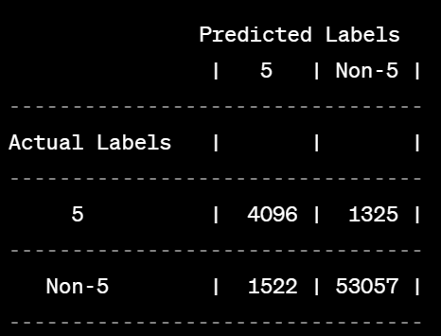

From this confusion matrix, we can calculate various performance metrics:

- Accuracy: (TP + TN) / (TP + TN + FP + FN) = (4096 + 53057) / (4096 + 53057 + 1522 + 1325) ≈ 0.969 or 96.9%.

- Precision: TP / (TP + FP) = 4096 / (4096 + 1522) ≈ 0.729 or 72.9%.

- Recall: TP / (TP + FN) = 4096 / (4096 + 1325) ≈ 0.756 or 75.6%.

These metrics provide insights into the classifier's performance. The high accuracy indicates that the classifier is performing well overall. The precision score indicates that out of all instances predicted as "5," around 72.9% are correctly classified, while the recall score suggests that the classifier can identify around 75.6% of the actual "5" instances.

Note that this example is specifically focused on binary classification (classifying images as either "5" or "non-5"), but the concept of the confusion matrix and the associated metrics can be extended to other classification problems with more than two classes.

