**Water Pollution RC Boat**



**A Project Submitted in Partial Fulfillment of the Requirements for the Degree of B.Sc. (Hon’s) in Computer Science and Engineering**

**Submitted by:**

**Faysal Mahmud Rabby Shamimul Islam  
Roll No: 205 Roll No: 206**

**Reg. No: 14502000595 Reg. No: 14502000419**

**Session: 2014-2015 Session: 2014-2015**

Department of Computer Science and Engineering

Dhaka City College

Under of National University, Bangladesh

**December, 2021**

## APPROVAL

The project is titled **“Water Pollution RC Boat”** submitted by Reg No: 14502000595 and Reg No: 14502000419 to the development of Computer Science and Engineering. Dhaka City College of Science, Dhaka, Bangladesh has been accepted as satisfactory for partial fulfillment of the required studio style and content for a Bachelor's Degree in Computer Science and Engineering.

**Signature of Internal**  **Signature of External**

**Examiner**  **Examiner**

**Supervisor Head of the Department**

**Md. Shahiduzzaman Sabiha Sultana**

Lecturer Associate Professor

Department of CSE Department of CSE

Dhaka City College Dhaka City College

## DECLARATION

## DECLARATION

We here by, declare that the work presented in this project “**Water Pollution RC Boat”** is the outcome of the investigation performed by use under the supervision of **Md. Shahiduzzaman**, Lecturer, CSE Department, Dhaka City College, Dhaka, Bangladesh. We also declare that no part of this project and there of has been or is being submitted elsewhere for the award of any degree or diploma.

**Supervised by:**

**__________________**

**Md. Shahiduzzaman**

**Lecturer**

**Department of Computer Science and Engineering**

**Dhaka City College**

**Submitted by:**

**Foysal Mahmud Rabby Shamimul Islam**

**Reg. No.: 14502000595 Reg. No.: 14502000419**

## Abstract

Smart solutions for water pollution monitoring are gaining importance with advancement in communication technology. This paper presents a detailed overview of recent works carried out in the field of smart water pollution monitoring. Also, a power efficient, simpler solution for in-pipe water quality monitoring based on Internet of Things technology is presented. The model developed is used for testing water samples and the data uploaded over the Internet are analyzed. The system also provides an alert to a remote user, when there is a deviation of water quality parameters from the pre-defined set of standard values. This device will surf on the water bodies and will provide the required measurement data for the given parameters and will also self-analyses and inform us accordingly. The solution is kept to be minimalistic yet a fully-fledged device for a given task. This solution has a lot of scope and practical implementation and can also help in curb the water pollution. Using the given detailed approach, methodology and fabrication anyone can produce, assemble and launch this device.

## ACKNOWLEDGEMENTS

All praises are for the almighty Allah for giving us strength, without which I could not afford to attempt this research work.

I would link to express my sincere and heartiest gratitude to my honorable thesis supervisor **Kanija Muntarina**, Assistant Professor, Dept. of Computer Science and Engineering, Dhaka City College, for his continuous motivation, guidance and keen encouragement, which helped me throughout the time of my research work. Noting is comparable to his keen advice.

I would like to think all the members of the board examiner for their precious time in understanding my work and their insightful comment. I would like to thank all of my friends for their co-operation. Finally, yet importantly, I am grateful to my parents for their continuous support and co-operation.

I also express our sincere thanks and gratitude to Prof. Bedar Uddin Ahmed (Principal) and **Shamima Sultana** (Head of the Department) for their support and guidance and constant encouragement for completion of project report.

I also thankful to other respected teachers of the department, who helped me in a number of ways by providing various resources and moral support.

Any omission in this brief acknowledgment does not mean lack of gratitude.

Contents

APPROVAL ii

DECLARATION ii

DECLARATION iii

Abstract iv

ACKNOWLEDGEMENTS v

Table of Figures ix

Chapter 1 1

Introduction 1

Chapter 1 2

Introduction 2

1.1 Introduction 2

1.1 Literature Review 3

1.2 Aims and Objectives 5

1.3 Summary of the Project 5

Chapter 2 6

Components of Project 6

Chapter 2 7

Components of Project 7

2.1 Arduino Nano 7

2.1.1 Arduino NANO Pinout 8

2.1.2 Arduino NANO Programming 8

2.2 nRF24l01 9

2.2.1 How to use nRF24l01 Module 10

2.3 Atmega 328P Microcontroller 11

2.4 Crystal Oscillator 12

2.4.1 Crystal Circuit Diagram 13

2.5 LED 14

2.5.1 Working of LED 15

2.6 Resistor (1K, 220ohm) 16

2.6.1 Resistors in parallel: 18

2.6.2 Resistors in series: 18

2.7 Buzzer 19

2.7.1 Working Principle of Buzzer 19

2.8 Power Supply 20

2.9 Battery 22

2.10 TP4056 24

2.11 Transistor (BC547) 25

Chapter 3 27

Design 27

Chapter 3 28

Design 28

2.1 Application of the Project 28

2.2 Methodology 29

2.3 Procedure 30

2.4 Software Design 32

References 34

## Table of Figures

Figure 1: Arduino Nano 7

Figure 2: Arduino nano pinout 8

Figure 3 nRF24l01 Module 9

Figure 4 Working Diagram of nRF24l01 10

Figure 5 Atmega 328 11

Figure 6 Atmega 328 Pinout 12

Figure 7 Crystal 13

Figure 8 Crystal Diagram 14

Figure 9 LED 15

Figure 10 LED Diagram 16

Figure 11 Resistor 17

Figure 12 Resistor in Parallel 18

Figure 13 Resistor in Series 18

Figure 14 Buzzer 19

Figure 15 Active Buzzer 20

Figure 16 Passive Buzzer 20

Figure 17 Power Supply 21

Figure 18 Li-ion Battery 22

Figure 19 Li-ion Cell Discharge Curve 23

Figure 20 TP4056 24

Figure 21 BC547 26

Figure 22 Transistor Symbol 26

Figure 23 Block Diagram 31

Figure 24 Circuit Diagram 32

Figure 25 Flowchart 33

# Chapter 1

# Introduction

## Chapter 1

## Introduction

### 1.1 Introduction

Ensuring the safety of water is a challenge due the excessive sources of pollutants, most of which are man-made. The main causes for water quality problems are over-exploitation of natural resources. The rapid pace of industrialization and greater emphasis on agricultural growth combined with latest advancements, agricultural fertilizers and non-enforcement of laws have led to water pollution to a large extent. The problem is sometimes aggravated due to the non-uniform distribution of rainfall. Individual practices also play an important role in determining the quality of water (Central Ground Water Board, 2017). Water quality is affected by both point and nonpoint sources of pollution, which include sewage discharge, discharge from industries, run-off from agricultural fields and urban run-off. Other sources of water contamination include floods and droughts and due to lack of awareness and education among users. The need for user involvement in maintaining water quality and looking at other aspects like hygiene, environment sanitation, storage and disposal are critical elements to maintain the quality of water resources. Poor water quality spreads disease, causes death and hampers socio-economic progress. Around 5 million people die due to waterborne diseases around the world (Water Resource Information System of India, 2017). Fertilizers and pesticides used by farmers can be washed through the soil by rain, to end up in rivers. Industrial waste products are also washed into rivers and lakes. Such contaminants enter the food chain and accumulate until they reach toxic levels, eventually killing birds, fish and mammals. Chemical factories also dispose of waste in the water. Factories use water from rivers to power machinery or to cool down machinery. Raising the temperature of the water lowers the level of dissolved oxygen and upsets the balance of life in the water (Central Ground Water Board, 2017). All the above factors make water quality monitoring essential. Water quality monitoring is defined as the collection of information at set locations and at regular intervals in order to provide data which may be used to define current conditions, establish trends, etc. (Neil et al., 2016; Muinul et al., 2014; Jianhua et al., 2015). Main objectives of online water quality monitoring include measurement of critical water quality parameters such as microbial, physical and chemical properties, to identify deviations in parameters and provide early warning identification of hazards. Also, the monitoring system provides real time analysis of data collected and suggests suitable remedial measures. The aim of this paper is twofold. One is to provide a detailed survey of recent work carried out in the area of smart water quality monitoring in terms of application, communication technology used, types of sensors employed etc. Second, is to present a low cost, less complex smart water quality monitoring system using a controller with inbuilt Wi-Fi module to monitor parameters such as pH, turbidity and conductivity. The system also includes an alert facility, to inform the user on deviation of water quality parameters.

### Literature Review

Nikhil Kedia entitled “Water Quality Monitoring for Rural Areas-A Sensor Cloud Based Economical Project.” Published in 2015 1st International Conference on Next Generation Computing Technologies (NGCT-2015) Dehradun, India. This paper highlights theentire water quality monitoring methods, sensors, embedded design, and information dissipation procedure, role of government, network operator and villagers in ensuring proper information dissipation. It also explores the Sensor Cloud domain. While automatically improving the water quality is not feasible at this point, efficient use of technology and economic practices can help improve water quality and awareness among people.[1] Jayti Bhatt,Jignesh Patoliya entitled “Real Time Water Quality Monitoring System”.This paper describes to ensure the safe supply of drinking water the quality should be monitored in real time for that purpose new approach IOT (Internet of Things) based water quality monitoring has been proposed. In this paper, we present the design of IOT based water quality monitoring system that monitor the quality of water in real time. This system consists some sensors which measure the water quality parameter such as pH, turbidity, conductivity, dissolved oxygen, temperature. The measured values from the sensors are processed by microcontroller and this processed values are transmitted remotely to the core controller that is raspberry pi using Zigbee protocol. Finally, sensors data can view on internet browser application using cloud computing.[2] Michal Lom, Ondrej Pribyl, Miroslav Svitek entitled “Industry 4.0 as a Part of Smart Cities”. This paper describes the conjunction of the Smart City Initiative and the concept of Industry 4.0. The term smart city has been a phenomenon of the last years, which is very inflected especially since 2008 when the world was hit by the financial crisis. The main reasons for the emergence of the Smart City Initiative are to create a sustainable model for cities and preserve quality of life of their citizens. The topic of the smart city cannot be seen only as a technical discipline, but different economic, humanitarian or legal aspects must be involved as well. In the concept of Industry 4.0, the Internet of Things (IoT) shall be used for the development of so–called smart products. Subcomponents of the product are equipped with their own intelligence. Added intelligence is used both during the manufacturing of a product as well as during subsequent handling, up to continuous monitoring of the product lifecycle (smart processes). Other important aspects of the Industry 4.0 are Internet of Services (IoS), which includes especially intelligent transport and logistics (smart mobility, smart logistics), as well as Internet of Energy (IoE), which determines how the natural resources are used in proper way (electricity, water, oil, etc.). IoT, IoS, IoP and IoE can be considered as an element that can create a connection of the Smart City Initiative and Industry 4.0 – Industry 4.0 can be seen as a part of smart cities.[3] Zhanwei Sun,Chi Harold Li,Chatschik Bisdikian,Joel W.Branch and Bo Yang entitled “QOI-Aware Energy Management in Internet-of-Things Sensory Environments”. In this paper an efficient energy management frame work to provide satisfactory QOI experience in IOT sensory environments is studied. Contrary to past efforts, it is transparent and compatible to lower protocols in use, and preserving energy-efficiency in the long run without sacrificing any attained QOI levels. Specifically, the new concept of QOI-aware “sensor-to-task relevancy” to explicitly consider the sensing capabilities offered by an sensor to the IOT sensory environments, and QOI requirements required by a task. A novel concept of the “critical covering set” of any given task in selecting the sensors to service a task over time. Energy management decision is made dynamically at runtime, as the optimum for long-term traffic statistics under the constraint of the service delay. Finally, an extensive case study based on utilizing the sensor networks to perform water level monitoring is given to demonstrate the ideas and algorithms proposed in this paper, and a simulation is made to show the performance of the proposed algorithms.[4] Sokratis Kartakis, Weiren Yu, Reza Akhavan, and Julie A. McCann entitled “Adaptive Edge Analytics for Distributed Networked Control of Water Systems” This paper presents the burst detection and localization scheme that combines lightweight compression and anomaly detection with graph topology analytics for water distribution networks. We show that our approach not only significantly reduces the amount of communications between sensor devices and the back end servers, but also can effectively localize water burst events by using the difference in the arrival times of the vibration variations detected at sensor locations. Our results can save up to 90% communications compared with traditional periodical reporting situations.[5]

### Aims and Objectives

Our aims and objectives are given below:

* Design and build water monitoring RC boat.
* Boat is controlled by Remote Controller.
* Boat will travel through water and collect water related data.
* Measure pH, Turbidity, Temperature of water.
* Connectivity by Bluetooth.

### Summary of the Project

Monitoring of Turbidity, PH & Temperature of Water makes use of water detection sensor with unique advantage and existing GSM network. The system can monitor water quality automatically, and it is low in cost and does not require people on duty. So, the water quality testing is likely to be more economical, convenient and fast. The system has good flexibility. Only by replacing the corresponding sensors and changing the relevant software programs, this system can be used to monitor other water quality parameters. The operation is simple. The system can be expanded to monitor hydrologic, air pollution, industrial and agricultural production and so on. It has widespread application and extension value. By keeping the embedded devices in the environment for monitoring enables self-protection (i.e., smart environment) to the environment. To implement this need to deploy the sensor devices in the environment for collecting the data and analysis. By deploying sensor devices in the environment, we can bring the environment into real life i.e., it can interact with other objects through the network. Then the collected data and analysis results will be available to the end user through the Bluetooth.

# Chapter 2

# Components of Project

## Chapter 2

### Components of Project

### 2.1 Arduino Nano

Arduino Nano is one [type of microcontroller](https://www.elprocus.com/arm7-based-lpc2148-microcontroller-pin-configuration/) board, and it is designed by Arduino.cc. It can be built with a microcontroller like Atmega328. This microcontroller is also used in [Arduino](https://www.elprocus.com/arduino-sim-for-iot-based-devices-launched-by-arduino/) UNO. It is a small size board and also flexible with a wide variety of applications. Other [Arduino boards](https://www.elprocus.com/different-types-of-arduino-boards/) mainly include Arduino Mega, Arduino Pro Mini, Arduino UNO, Arduino YUN, Arduino Lilypad, Arduino Leonardo, and Arduino Due. And other development boards are AVR Development Board, PIC Development Board, [Raspberry Pi](https://www.elprocus.com/new-raspberry-pi-3-model-a-with-wi-fi-and-bluetooth/), Intel Edison, MSP430 Launchpad, and ESP32 board.

This board has many functions and features like an Arduino Development board. However, this Nano board is different in packaging. It doesn’t have any DC jack so that the power supply can be given using a small USB port otherwise straightly connected to the pins like VCC & GND. This board can be supplied with 6 to 20volts using a mini USB port on the board.

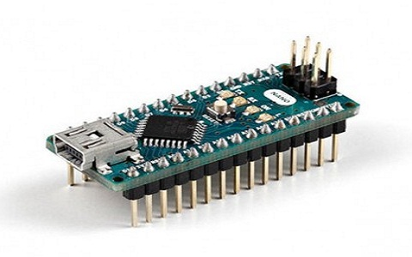

Figure : Arduino Nano

### 2.1.1 Arduino NANO Pinout

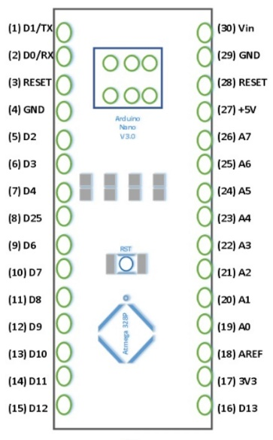

Figure : Arduino nano pinout

1. **Power Pin (Vin, 3.3V, 5V, GND):** These pins are power pins
2. **Analog Pins (A0-A7):** These pins are used to calculate the analog voltage of the board within the range of 0V to 5V
3. **I/O Pins (Digital Pins from D0 – D13):** These pins are used as an i/p otherwise o/p pins. 0V & 5V
4. **Serial Pins (Tx, Rx):** These pins are used to transmit & receive TTL serial data.
5. **External Interrupts (2, 3):** These pins are used to activate an interrupt.
6. **PWM (3, 5, 6, 9, 11):** These pins are used to provide 8-bit of PWM output.
7. **SPI (10, 11, 12, & 13):** These pins are used for supporting [SPI communication](https://www.elprocus.com/serial-peripheral-interface-spi-communication-protocol/).
8. **Inbuilt LED (13):** This pin is used to activate the LED.
9. **IIC (A4, A5):** These pins are used for supporting TWI communication.
10. **AREF:** This pin is used to give reference voltage to the input voltage

### 2.1.2 Arduino NANO Programming

The programming of an Arduino nano can be done using the Arduino software. Click the Tools option and select the nano board. Microcontroller ATmega328 over the Nano board comes with preprogrammed with a boot loader. This boot loader lets to upload new code without using an exterior hardware programmer. The communication of this can be done with the STK500 protocol. Here the boot loader can also be avoided & the microcontroller program can be done using the header of in-circuit serial programming or ICSP with an Arduino ISP.

## 2.2 nRF24l01

The nRF24L01 is a wireless transceiver module, meaning each module can both send as well as receive data. They operate in the frequency of 2.4GHz, which falls under the ISM band and hence it is legal to use in almost all countries for engineering applications. The modules when operated efficiently can cover a distance of 100 meters (200 feet) which makes it a great choice for all wireless remote-controlled projects.

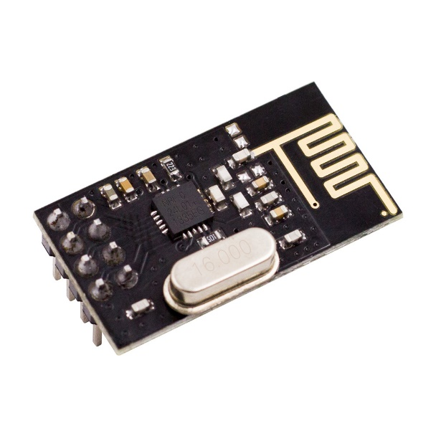The module operates at 3.3V hence can be easily used with 3.2V systems or 5V systems. Each module has an address range of 125 and each module can communicate with 6 other modules hence it is possible to have multiple wireless units communicating with each other in a particular area. Hence mesh networks or other types of networks are possible using this module. So, if you are looking for a wireless module with the above properties then this

Figure nRF24l01 Module

## 2.2.1 How to use nRF24l01 Module

The NRF24L01 module works with the help of SPI communications. These modules can either be used with a 3.3V microcontroller or a 5V microcontroller but it should have an SPI port. The complete details on how to use the module through SPI is given the data sheet below. The circuit diagram shows how the module should be interfaced with a microcontroller.

Here I have shown how for a 3.3V microcontroller, but it applies the same for a 5V MCU as well. The SPI Pins (MISO<MOSI and SCK) are connected to the SPI pins of the Microcontroller and the signal pins (CE and CSN) are connected to the GPIO pins of the MCU.

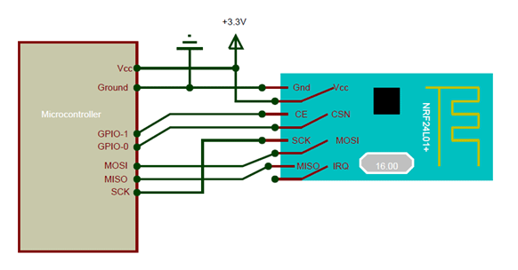If you are interfacing the module with Arduino, then there are ready made libraries available like the R24 Library. With the help of these libraries you can easily interface the nRF24L01 with Arduino with few lines of code. If you are using for some other microcontroller then you have to read through the datasheet to understand how to establish the SPI communication.

Figure Working Diagram of nRF24l01

The nRF24L01 module is a bit tricky to use especially since there are many cloned versions in the market. If you are having any problem with getting it work, try adding a 10uF and 0.1uF capacitor in parallel to the Vcc and Ground pins. Also make sure the 3.3V supply is clean and does not have any noise coupled in it.

### 2.3 Atmega 328P Microcontroller

Figure Atmega 328

**ATMEGA328P** is high performance, low power controller from Microchip. ATMEGA328P is an 8-bit microcontroller based on AVR RISC architecture. It is the most popular of all AVR controllers as it is used in ARDUINO boards.

Although we have many controllers ATMEGA328P is most popular of all because of its features and cost. ARDUINO boards are also developed on this controller because of its features.

With program memory of 32 Kbytes ATMEGA328P applications are many.

With various POWER SAVING modes, it can work on MOBILE EMBEDDED SYSTEMS.

With Watchdog timer to reset under error it can be used on systems with minimal human interference.

With advanced RISC architecture, the controller executes programs quickly.

Also, with in chip temperature sensor the controller can be used at extreme temperatures.

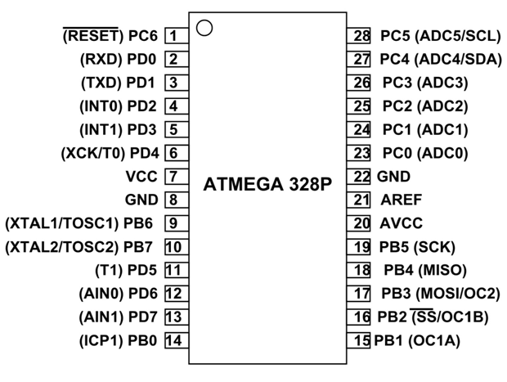These all features add together promoting ATMEGA328P further.

Figure Atmega 328 Pinout

Since ATmega328P is used in Arduino Uno and Arduino nano boards, you can directly replace the Arduino board with ATmega328 chip. For that first you need to install the Arduino bootloader into the chip (Or you can also buy a chip with bootloader – ATMega328P-PU). This IC with bootloader can be placed on Arduino Uno board and burn the program into it. Once Arduino program is burnt into the IC, it can be removed and used in place of Arduino board, along with a Crystal oscillator and other components as required for the project. Below is the pin mapping between Arduino Uno and ATmega328P chip.

### 2.4 Crystal Oscillator

A crystal oscillator is an electronic oscillator circuit that is used for the mechanical resonance of a vibrating crystal of piezoelectric material. It will create an electrical signal with a given frequency. This frequency is commonly used to keep track of time for example wristwatches are used in digital integrated circuits to provide a stable clock signal and also used to stabilize frequencies for radio transmitters and receivers. Quartz crystal is mainly used in radio-frequency (RF) oscillators. Quartz crystal is the most common type of piezoelectric resonator, in oscillator circuits, we are using them so it became known as crystal oscillators. Crystal oscillators must be designed to provide a load capacitance.

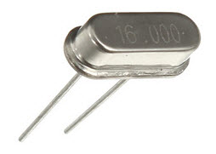

Figure Crystal

There are different types of oscillator electronic circuits that are in use they are namely: Linear oscillators – Hartley oscillator, Phase-shift oscillator, Armstrong oscillator, Clapp oscillator, Colpitts oscillator. Relaxation oscillators – Royer oscillator, Ring oscillator, Multidirector and Voltage Controlled Oscillator (VCO). Soon we are going to discuss in detail crystal oscillators like working and applications of a crystal oscillator.

## 2.4.1 Crystal Circuit Diagram

The above figure is a 20psc New 16MHz Quartz Crystal Oscillator and it is one kind of crystal oscillators, that works with 16MHz frequency.

Generally, bipolar transistors or FETs are used in the construction of Crystal oscillator circuits. This is because operational amplifiers can be used in different low-frequency oscillator circuits which are below 100KHz but operational amplifiers do not have the bandwidth to operate. It will be a problem at the higher frequencies that are matched to crystals which are above 1MHz.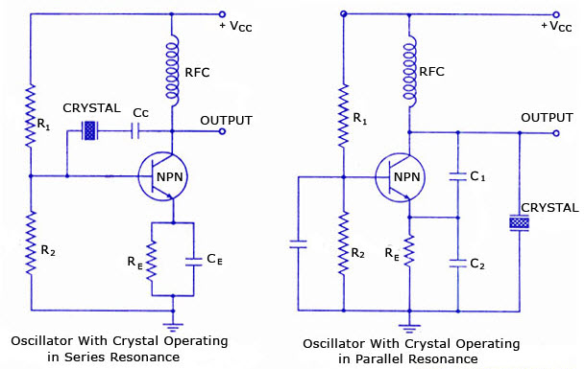

Figure Crystal Diagram

The crystal oscillator circuit usually works on the principle of the inverse piezoelectric effect. The applied electric field will produce a mechanical deformation across some materials. Thus, it utilizes the vibrating crystal’s mechanical resonance, which is made with a piezoelectric material for generating an electrical signal of a particular frequency.

### 2.5 LED

The LED is a[PN-junction](https://circuitglobe.com/p-n-junction.html)diode which emits light when an [electric current](https://circuitglobe.com/electric-current.html)passes through it in the forward direction. In the LED, the recombination of charge carrier takes place. The electron from the N-side and the hole from the P-side are combined and gives the energy in the form of heat and light. The LED is made of [semiconductor](https://circuitglobe.com/semiconductors.html) material which is colorless, and the light is radiated through the junction of the diode.

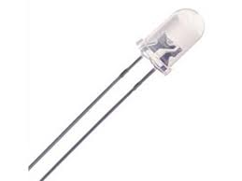

Figure LED

The LEDs are extensively used in segmental and dot matrix displays of numeric and alphanumeric character. The several LEDs are used for making the single line segment while for making the decimal point single LED is used.

### 2.5.1 Working of LED

The working of the LED depends on the quantum theory. The quantum theory states that when the energy of electrons decreases from the higher level to lower level, it emits energy in the form of photons. The energy of the photons is equal to the gap between the higher and lower level.

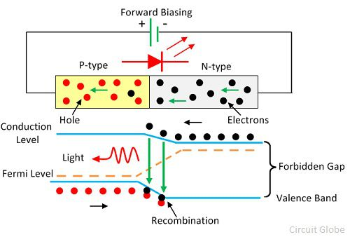

Figure LED Diagram

The LED is connected in the forward biased, which allows the current to flows in the forward direction. The flow of current is because of the movement of electrons in the opposite direction. The recombination shows that the electrons move from the conduction band to valence band and they emit electromagnetic energy in the form of photons. The energy of photons is equal to the gap between the valence and the conduction band.

### 2.6 Resistor (1K, 220ohm)

Resistor is an electrical component that reduces the electric current.

The resistor's ability to reduce the current is called resistance and is measured in units of ohms (symbol: Ω).

If we make an analogy to water flow through pipes, the resistor is a thin pipe that reduces the water flow.

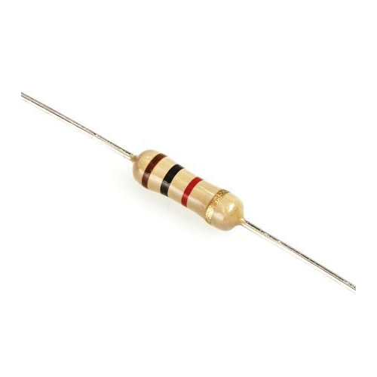

Figure Resistor

Ohm's law

The resistor's current *I* in amps (A) is equal to the resistor's voltage *V* in volts (V)

divided by the resistance *R*in ohms (Ω):



 The resistor's power consumption *P* in watts (W) is equal to the resistor's current*I*in amps (A)

times the resistor's voltage *V* in volts (V):

*P* = *I* × *V*

The resistor's power consumption *P* in watts (W) is equal to the square value of the resistor's current *I* in amps (A)

times the resistor's resistance *R* in ohms (Ω):

*P* = *I*2 × *R*

The resistor's power consumption *P* in watts (W) is equal to the square value of the resistor's voltage *V* in volts (V)

### 2.6.1 Resistors in parallel:

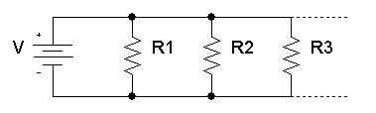

Figure Resistor in Parallel

The total equivalent resistance of resistors in parallel *RTotal* is given by:



So, when you add resistors in parallel, the total resistance is decreased.

### 2.6.2 Resistors in series:

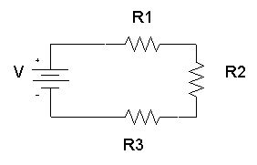

Figure Resistor in Series

The total equivalent resistance of resistors in series *Rtotal*is the sum of the resistance values:

*Rtotal* = *R*1+ *R*2+ *R*3+...

In this project we are using 1kilo-ohm resistor for Buzzer and 220ohm resistor for LED.

## 

## 2.7 Buzzer

Buzzer is a kind of electronic sound receiver with integrated structure. It is widely used as a voice device in electronic products like computers, printers, copying machines, alarm apparatus, electronic toys, auto electronic devices, telephones, etc. In this experiment, we are going to use micro: bit to drive buzzer and make its sound circulate between high frequency and low frequency just like alarm song. And we will present its sound frequency on micro: bit with bar chart format.

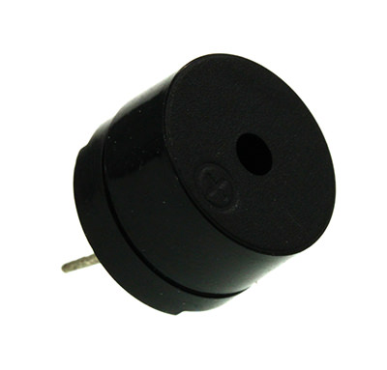

Figure Buzzer

Buzzer is a kind of voice device. It is made of vibration and resonance device. According to the difference of control method, we can divide buzzer into active type and passive type.

### 2.7.1 Working Principle of Buzzer

Because active buzzer has integrated amplify sampling circuit and resonance system, when DC power input passes through active buzzer, it will make resonance device generate sound signal. We can see the schematic diagram below for the working principle of active buzzer:

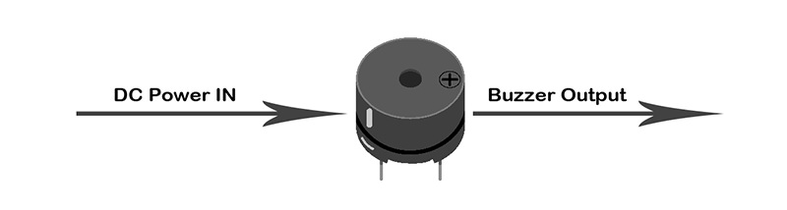

Figure Active Buzzer

When square wave signal passes through the buzzer, its resonance device will transform the square wave signal input into sound signal output. Below is the schematic diagram for the working principle of passive buzzer:

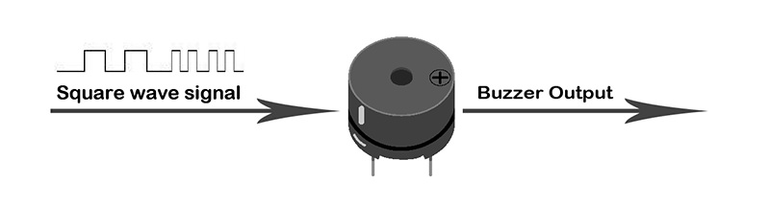

Figure Passive Buzzer

In this Project we are using active Buzzer.

## 2.8 Power Supply

5V power supplies (or 5VDC power supplies) are one of the most common power supplies in use today. In general, a 5VDC output is obtained from a 50VAC or 240VAC input using a combination of transformers, diodes and transistors. 5V power supplies can be of two types: 5V regulated power supplies, and 5V unregulated power supplies.5V regulated power supplies come in three styles: Switching regulated AC to DC, Linear regulated AC to DC, and Switching regulated DC to DC.

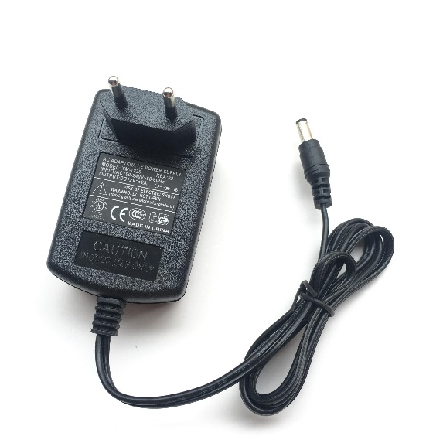

Figure Power Supply

**Specification:**

Module Properties: non-isolated step-down constant current, constant voltage module (CC CV)

Input voltage: AC 220V

Output voltage: DC 5V  
Continuously adjustable Output Current: 2.5A

Turn lamp current: constant current value (0.1), turn the lamp current and constant value linkage, such as constant current Value is 3A, turn the lamp current is set to a constant current is 0.1 times (0.1 * 3A = 0.3A).

Lowest pressure: 1V  
Output Power: Maximum power is about 12W  
Conversion efficiency: up to about 95%  
Operating frequency: 300KHZ  
Output ripple: 20M bandwidth Input 5V  
Output 5V 2.5A ripple around 50mV (Excluding noise)  
Output short circuit protection : Yes, constant current Input  
Reverse Polarity Protection: None  
Output prevent backflow: None  
Wiring: Terminal  
No-load current: Typical 20mA (5V switch 5V)  
Load regulation: 1% ( constant )  
Voltage regulation: 1%

## 2.9 Battery

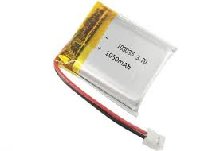Depending on the design and chemistry of your lithium cell, you may see them sold under different nominal "voltages". For example, almost all lithium polymer batteries are 3.7V or 4.2V batteries. What this means is that the maximum voltage of the cell is 4.2v and that the "nominal" (average) voltage is 3.7V. As the battery is used, the voltage will drop lower and lower until the minimum which is around 3.0V. You should see the number 3.7V written on the battery itself somewhere.

Figure Li-ion Battery

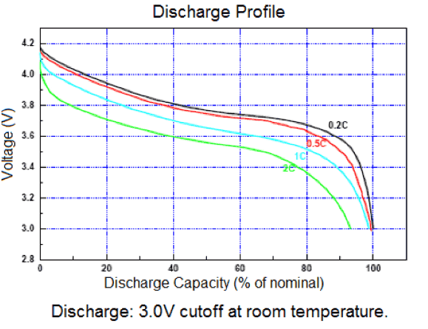For example, here is a profile of the voltage for a 'classic' 3.7V/4.2V battery. The voltage starts at 4.2 maximum and quickly drops down to about 3.7V for the majority of the battery life. Once you hit 3.4V the battery is dead and at 3.0V the cutoff circuitry disconnects the battery (more on that later.

Figure Li-ion Cell Discharge Curve

You may also run across 4.1V/3.6V batteries. These are older than 4.2V/3.7V - they use a slightly different chemistry and you'll see the 3.6V marking on the cell.

Nowadays you may also be able to purchase 4.35V cells! These are the latest chemistry; they have a little more power as indicated by the voltage being higher than 4.2V. They tend to be cylinder lithium ion's used for laptop batteries, and lights so it’s not terribly likely you'll just run into one unless you're looking for it.

Make sure when you're buying batteries and chargers to match them up! Overcharging a 3.6V battery by attaching it to a 4.2V battery charger can at the very least permanently damage your battery and at worst cause a fire!

## 2.10 TP4056

The TP4056 is a complete constant-current/constant-voltage linear charger for single cell

lithium-ion batteries. Its SOP package and low external component count make the TP4056

ideally suited for portable applications. Furthermore, the TP4056 can work within USB and wall adapter. No blocking diode is required due to the internal PMOSFET architecture and have prevent to negative Charge Current Circuit. Thermal feedback regulates the charge current to limit the die temperature during high power operation or high ambient temperature. The charge voltage is fixed at 4.2V, and the charge current can be programmed externally with a single resistor. The TP4056 automatically terminates the charge cycle when the charge current drops to 1/10th the programmed value after the final float voltage is reached. TP4056 Other features include current monitor, under voltage lockout, automatic recharge and two status pin to indicate charge termination and the presence of an input voltage.

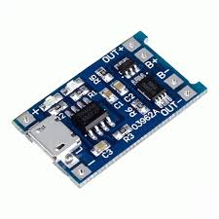

Figure TP4056

**FEATURES:**

· Programmable Charge Current Up to

1000mA

·No MOSFET, Sense Resistor or Blocking

Diode Required

· Complete Linear Charger in SOP-8

Package for Single Cell Lithium-Ion

Batteries

·Constant-Current/Constant-Voltage

·Charges Single Cell Li-Ion Batteries Directly

from USB Port

·Preset 4.2V Charge Voltage with 1.5%

Accuracy

·Automatic Recharge

·two Charge Status Output Pins

·C/10 Charge Termination

·2.9V Trickle Charge Threshold (TP4056)

·Soft-Start Limits Inrush Current

·Available Radiator in 8-Lead SOP Package,

the Radiator need connect GND or

impending

## 2.11 Transistor (BC547)

The transistor is a semiconductor device which transfers a weak signal from low resistance circuit to high resistance circuit. The words trans mean transfer property and sitar mean resistance property offered to the junctions. In other words, it is a switching device which regulates and amplify the electrical signal likes voltage or current.

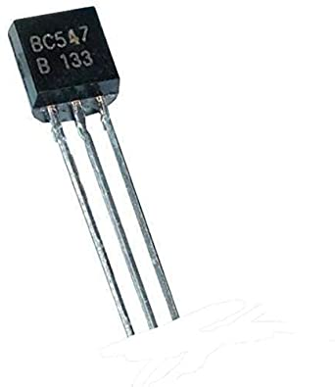The transistor consists two PN diode connected back to back. It has three terminals namely emitter, base and collector. The base is the middle section which is made up of thin layers. The right part of the diode is called emitter diode and the left part is called collector-base diode. These names are given as per the common terminal of the transistor. The emitter-based junction of the transistor is connected to forward biased and the collector-base junction is connected in reverse bias which offers a high resistance.

Figure BC547

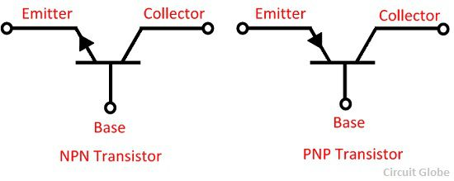There are two types of transistor, namely NPN transistor and PNP transistor. The transistor which has two blocks of n-type semiconductor material and one block of P-type semiconductor material is known as NPN transistor. Similarly, if the material has one layer of N-type material and two layers of P-type material then it is called PNP transistor. The symbol of NPN and PNP is shown in the figure below.

Figure Transistor Symbol

The arrow in the symbol indicates the direction of flow of conventional current in the emitter with forward biasing applied to the emitter-base junction. The only difference between the NPN and PNP transistor is in the direction of the current.

# Chapter 3

# Design

## Chapter 3

## Design

### 2.1 Application of the Project

* Smart water quality approaches have been considered for lake and sea water applications. For such applications, distributed wireless sensor networks are required to monitor the parameters over a larger area and send the data monitored to a centralized controller using wireless communication. Such applications normally monitor parameters such as chlorophyll (Francesco et al., 2015), dissolved oxygen concentration (Christie et al., 2014; Anthony et al., 2014) and temperature (Peng et al., 2009 ; Francesco et al., 2015 ; Christie et al., 2014 ).
* Aquaculture centers require water quality monitoring and forecasting for healthy growth of aquatic creatures (Goib et al., 2015; Gerson et al., 2012; Xiuna et al., 2010 ). In (Gerson et al., 2012) authors have developed biosensors using Arduino microcontroller to monitor animal behavioral changes due to aquatic pollution. The abnormal behavior of animals can be considered as an indication of water contamination. In (Xiuna et al., 2010) authors have proposed a smart water quality monitoring system to forecast water quality using artificial neural networks. Extensive tests have been carried out for a period of 22 months at isolated local area network and the data has been transferred to internet using CDMA technology.
* Water quality monitoring in distribution systems is challenging in the context of management of distributed wireless sensor networks (WSN). A water distribution network for monitoring chlorine concentration has been presented in (Eliades et al., 2014). Solar enabled distributed WSN has been proposed in (Ruan & Tang, 2011) for monitoring parameters such as pH, turbidity and oxygen density. Water at different sites is monitored in real-time using an architecture composed of solar cell enabled sensor nodes and base station. Flexibility, low carbon emission and low power consumption are the advantages of the method proposed in the paper. A combined system for water and air quality measurement is proposed in (Mitar et al., 2016) using additional sensors for measuring air temperature and relative humidity

### 2.2 Methodology

#### 2.2.1 Parameters monitored

Based on extensive experimental evaluation carried out by US Environmental Protection Agency (USEPA) it has been concluded that chemical and biological contaminants used have an effect on many water parameters monitored including Turbidity (TU), Oxidation Reduction Potential (ORP), Electrical Conductivity (EC) and pH. Thus, by monitoring and detecting changes in the water parameters, it is feasible to infer the water quality (Theofanis et al., 2014). A detailed list of work carried out to monitor water parameters is presented in Table 2 . The pH of the water is one of the most important factors when investigating water quality, as it measures how basic or acidic the water is. Water with a pH of 11 or higher can cause irritation to the eyes, skin and mucous membrane. Acidic water (pH 4 and below) can also cause irritation due to its corrosive effect (Niel et al., 2016). Measurement of dissolved oxygen (DO) is important for aquaculture centers since this parameter determines whether or not a species can survive in the said water source. ORP is a measure of degree to which a substance is capable of oxidizing or reducing another substance. ORP is measured in millivolts (mv) using an ORP meter. Tap water and bottled water have a positive value of ORP. Turbidity refers to concentration of suspended particles in water. Conductivity gives an indication of the number of impurities in the water, the cleaner the water, the less conductive it is. In many cases, conductivity is also directly associated with the total dissolved solids (TDS).

#### 2.2.2 Communication between sensors and controller

Sensors are connected to the controller, either directly using UART protocol or remotely using Zigbee protocol. ZigBee is a technology for data transfer in wireless networks. It has a low energy consumption and is designed for multichannel control systems, alarm systems and lighting control. ZigBee builds on the physical layer and media access control defined in IEEE standard 802.15.4 for low-rate WPANs. In smart water quality systems, Zigbee protocol is used for communication between sensor nodes and the controller when the sensors are placed in remote locations away from the controller. For in-pipe domestic monitoring, direct connection of sensors and controller is preferred. In (Tomoaki et al., 2016 ) authors have developed a WSN system for water quality monitoring. Sensors are connected to the transmission module using UART. Communication with the outside of the sensor nodes is performed with the Internet connection using the 3G mobile network. Authors in (Theofanis et al., 2014 ) have proposed a water quality monitoring system for in-pipe monitoring and assessment of water quality on fly. Sensor nodes are installed in the pipes that supply water at consumer sites.

#### 2.2.3 Communication between controller and data storage

Communication between controller and centralized data storage is carried out using long range communication standards such as 3G and Internet. Some of the previous works aim at alerting the user in the form of SMS about the water quality. Such systems (Peng et al., 2009 ; Xin et al., 2011 ; Liang, 2014 ; Wei et al., 2012 ) require additional SIM cards for the GPRS module connected with the controller. The drawbacks of such systems are additional cost for SIM card operation. Also, large quantities of data storage and retrieval are not possible at the user premises. Recently, IoT enabled solutions are gaining importance. Authors in (Alessio et al., 2016 ) provide a survey on the wide range of applications possible with Internet of Things and Cloud computing. IoT is a recent communication paradigm in which objects of everyday day life are equipped with microcontrollers, transceivers for digital communication, which will make the objects communicate with one another and the users, thus becoming an integral part of the Internet (Bushra & Mubashir, 2016 ; Biljana et al., 2017 ; Andrea et al., 2014 ). In (Vijayakumar & Ramya, 2015 ; Thinagaran et al., 2015 ; Mitar et al., 2016 ) an external Wi-Fi module is connected to the controller, which enables the controller to get connected to the nearest Wi-Fi hotspot and subsequently to the Internet cloud.

### 2.3 Procedure

Conductivity is the measure of solutions ability to carry current. This parameter is used to determine the salt content in the water. In the proposed design, YL-69 is used to measure the conductivity of the water. It consists of two electrodes, when placed in water a potential is generated which is proportional to conductivity. It is measured in Siemens per cm. Acceptable range of conductivity is from 300 to 800 μ siemens per cm.

pH measures amount of acid or base in the solution. Three in 1 ph meters with inverting operational amplifiers is used to measure pH. Inverting Op-amp is used to boost the voltage from mV to voltage range. pH sensor consists of two electrodes which is reference electrode and pH electrode also known as measuring electrode. When placed in the solution pH electrode develops a potential that is proportional to pH. The value ranges from 0 to 14. The acceptable range of pH for drinking water is 6.5 to 8.5.

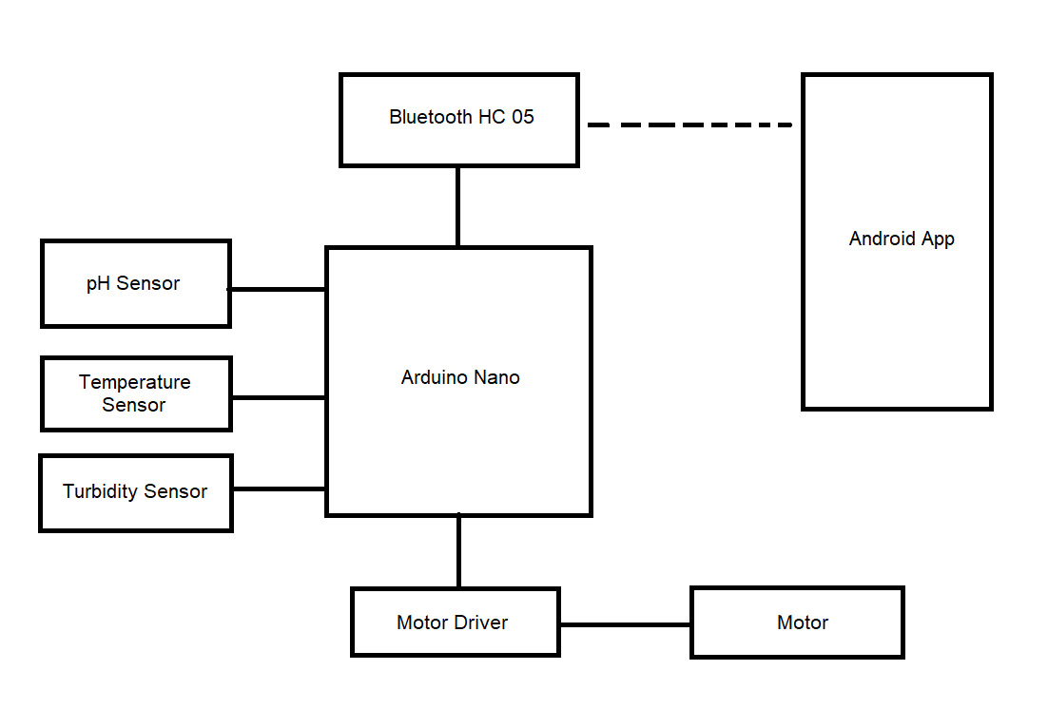

Figure 23 Block Diagram

Turbidity is a measure of cloudiness in the water. opt electronic devices such as LDR and LED are used to measure the turbidity. Light is transmitted and reflected by suspended solids and reflected light is received by the sensors. An LDR is a high resistance semiconductor. If light falling on the device is of high frequency, photons absorbed by the semiconductor give the bound electrons enough energy to jump into the conduction band. In the proposed system the distance between the LED and LDR is 9 cm. The resulting free electrons conduct electricity thereby lowering resistance. Water level is sensed to determine the depth of the water in the tank. This is done using the probe method. Three probes are used to indicate the level of the water such as high, low and medium.

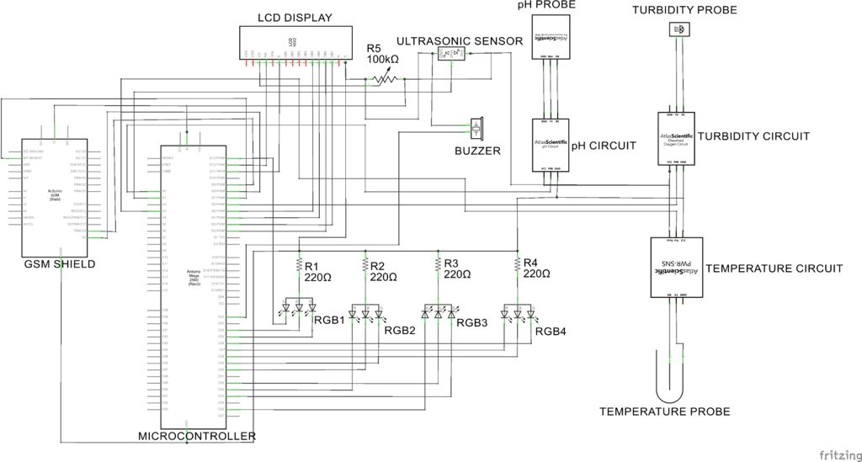

Figure 24Circuit Diagram

### 2.4 Software Design

The flow chart for sensor data updating in the cloud. Reading from the sensor is constantly updated in the cloud and also displayed in the LCD connected. The programming is done using Arduino IDE.

Data sent from the controller are stored in “Ubidots” cloud. “Ubidots” offers a platform for developers to capture data and turn it into useful information. The features include a real-time dashboard to analyze data or control devices and share the data through public links. Data stored in the cloud can be used for detailed analysis. The cloud is programmed to send alert SMS messages whenever the monitored parameter exceeds the threshold limit. The Table 8 presents a summary of useful features of Ubidots cloud platform (Ubidots, 2017 ).

In order to solve this problem, it is proposed to make use of low-cost sensors available to integrate with open-source Arduino platform summing up a low-cost real-time monitoring device for the cause. The device is planned to float by placing the sensors in the RC (Remote Controlled) boats as shown in figure 3. As of now featured with data storage in SD card along with Thing speak IOT Platform and plans are there to make robotic swam to float around the water body and make measurements.

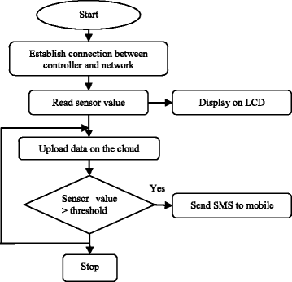

Figure 25 Flowchart

The Water Quality Monitor comprises of four sensors (pH, Temperature, Turbidity and Conductivity), Wifi Module, SD card Module and Controller as illustrated in the block diagram in figure 2 . The water parameters data are sensed by the sensors and converted to digital. These digital values are fed to controller as input. The digital sensor data is stored in the cloud using the Wifi module. The sensor data is also stored in SD Card for further analysis. At present buoy are used for water quality monitoring in Ganga and Yamuna which is fixed in a location. In Buoys the water is pumped from the water resource floor and tested for the water quality parameters in some time intervals. The sensed data is viewed in web pages for immediate action in case of contamination. The major disadvantage is that it is Expensive and so it is not affordable enough to place many locations

## References

1. <https://www.britannica.com/science/water-pollution>
2. <https://www.nrdc.org/stories/water-pollution-everything-you-need-know>
3. <https://www.hsph.harvard.edu/ehep/82-2/>
4. <http://www.jwrc-net.or.jp/aswin/en/symposium_archive/images/data/009_inv_es_Shuili-Yu.pdf>
5. <https://www.researchgate.net/publication/321289637_WATER_POLLUTION-SOURCESEFFECTS_AND_CONTROL>
6. <http://iced.cag.gov.in/wp-content/uploads/2013/09/Water%20pollution.pdf>
7. <https://projects.worldbank.org/en/projects-operations/project-detail/P006541>
8. <https://www.sciencedirect.com/science/article/pii/S2666285X2100090X>
9. <https://www.researchgate.net/publication/344167317_Internet_of_Things_IoT_Based_Water_Quality_Monitoring_System>
10. <https://www.rtinsights.com/the-internet-of-things-steps-up-for-water-quality-and-air-pollution/>