Contents
- Methodological task statement
- Building the monthly data panel
- Feature engineering before modeling
- Unified backtesting protocol and model ladder
- Saved results of the forecasting block
- Feature attribution and graphical results
- Portfolio block and model selectors
- Final set of artifacts
- Appendix: tabular previews of results

1. Methodological task statement
The task is divided into sequential stages: first, a unified monthly panel of Moscow Exchange stocks is formed; then the evidentiary basis for the dependence of premiums and exposures on market regimes is fixed; after that, a forecasting ladder of models is run; at the final stage, the forecasts are converted into comparable investment strategies.
Table 2. Workflow structure
Stage | Meaning of the stage | Practical content
Phase 1 | Dataset construction | Monthly panel: stocks, dates, returns, factor features, regime indicators, and interactions.
Phase 2 | Block 1: evidentiary component | A check that factor effects and premiums may differ across inflation, volatility, and stress states.
Phase 3 | Block 2: forecasting ladder | Sequential comparison of linear, regularized, adaptive, nonlinear, and sequential models on one feature set.
Phase 4 | Block 3: selector and portfolio | Conversion of forecasts into long-only portfolios and comparison of strategies using the same optimizer.

2. Building the monthly data panel
The file data_creation_explanation.ipynb prepares the final data.csv table. The work begins with service functions for checking calendar completeness by ticker, assessing panel coverage by years and months, and filtering series with long gaps. These checks are not used to build the model itself, but to control that the merged panel does not contain hidden breaks that could distort the rolling backtest.

2.1. Calculating the company size feature
The first source is the monthly_market_cap.csv table. It provides market capitalization, month-end date, and instrument identifier. On this basis, the size_it feature is created as the logarithm of market capitalization. During the control step, one row with missing capitalization was identified; after that, the size table is used as one of the basic components of the final panel.
Table 3. Fragment of the company size table from data_creation_explanation.ipynb
mcap_base_dict | month_end | secid | size_it
1.044114e+10 | 2023-07-31 | ABIO | 23.069020
1.033314e+10 | 2023-08-31 | ABIO | 23.058622
1.047226e+10 | 2023-09-30 | ABIO | 23.071996
9.864536e+09 | 2023-10-31 | ABIO | 23.012212
8.801019e+09 | 2023-11-30 | ABIO | 22.898133

2.2. Calculating the value feature
Next, equity_monthly_from_quarters.csv is loaded. Quarterly equity data are converted to the monthly grid and merged with market capitalization by the month_end and secid pair. The value feature is computed as the logarithm of the ratio of equity to market capitalization. If equity is negative or the ratio cannot be logarithmized, the feature value remains missing; it is not removed at the assembly stage, but is retained as part of the data structure.
Table 4. Fragment of the value feature table
mcap_base_dict | month_end | secid | quarter_end | equity | value_it
1.044114e+10 | 2023-07-31 | ABIO | 2023-09-30 | 5.628253e+09 | -0.617955
1.033314e+10 | 2023-08-31 | ABIO | 2023-09-30 | 5.628253e+09 | -0.607557
1.047226e+10 | 2023-09-30 | ABIO | 2023-09-30 | 5.628253e+09 | -0.620931
9.864536e+09 | 2023-10-31 | ABIO | 2023-12-31 | 5.452935e+09 | -0.592792
8.801019e+09 | 2023-11-30 | ABIO | 2023-12-31 | 5.452935e+09 | -0.478714

2.3. Illiquidity and the target variable
The illiq_monthly.xlsx file is used for the illiquidity feature. It provides the monthly illiq_amihud_m measure. In the same block, the target variable for the next quarter is formed from monthly returns: for each stock, the presence of three consecutive months after date t is checked, then the future three-month return is calculated, and extreme values are capped at the 1st and 99th percentiles. The cleaned target variable target_q_fwd_clean is included in the final dataset.
Table 5. Fragment of the illiquidity table
secid | month_end | illiq_amihud_m
ABIO | 2009-12-31 | 1.134537e-09
ABIO | 2010-01-31 | 1.413304e-09
ABIO | 2010-02-28 | 2.729674e-09
ABIO | 2010-03-31 | 1.278595e-09
ABIO | 2010-04-30 | 1.480389e-09

2.4. Market features and state indicators
Monthly market features and states are loaded from market_block1a.xlsx: MOM, mkt_vol, state_infl_high, and state_dd_stress. They are defined at the common monthly level and then joined to all stocks for the corresponding month. As a result, individual stock features and market-wide states appear in a single stock-month table.

2.5. Regime interactions
After the base features are loaded, the interactions value_x_inflhigh and illiq_x_stress are created. The first reflects the value feature only in months with a high inflation regime, while the second reflects illiquidity during drawdown stress. Thus, the models receive not only the base factor, but also the ability to account for changes in its role when the market state is active.
Table 6. Fragment of the value x high inflation interaction calculation
value_it | month_end | secid | state_infl_high | value_x_inflhigh
-0.617955 | 2023-07-31 | ABIO | 0.0 | -0.000000
-0.607557 | 2023-08-31 | ABIO | 0.0 | -0.000000
-0.620931 | 2023-09-30 | ABIO | 1.0 | -0.620931
-0.592792 | 2023-10-31 | ABIO | 1.0 | -0.592792
-0.478714 | 2023-11-30 | ABIO | 1.0 | -0.478714

2.6. Merging tables and writing data.csv
The final dataset is assembled through sequential outer-merge operations. Individual features are merged by secid and month_end: size, value, illiquidity, regime interactions, and target return. Market-wide features MOM, mkt_vol, and binary state indicators are added by month_end. After merging, the table is restricted to the interval from 2016-10-31 to 2025-09-30 and rows with missing size_it, illiq_amihud_m, or target_q_fwd_clean are removed.
Table 7. Control characteristics of the final panel
Parameter | Value
Final size of data_with_secid | 24,636 rows x 12 columns
Period after filtering | 2016-10-31 — 2025-09-30
Number of secid after filtering | 290
Fully populated calendar series | 172 secid out of 290
Maximum coverage by years | 10 years
Maximum monthly coverage within a year | 12 months
Table 8. First rows of the final data_with_secid panel
size_it | month_end | secid | value_it | illiq_amihud_m | value_x_inflhigh | illiq_x_stress | MOM | mkt_vol | state_infl_high | state_dd_stress | target_q_fwd_clean
22.709715 | 2016-10-31 | ABRD | -1.192200 | 1.843932e-07 | -0.0 | 0.000000e+00 | 0.038509 | 0.068871 | 0.0 | 0.0 | 0.266088
25.739235 | 2016-10-31 | AFKS | 0.491660 | 9.866532e-11 | 0.0 | 0.000000e+00 | 0.038509 | 0.068871 | 0.0 | 0.0 | 0.240208
25.407146 | 2016-10-31 | AFLT | -0.296973 | 3.951919e-11 | -0.0 | 0.000000e+00 | 0.038509 | 0.068871 | 0.0 | 0.0 | 0.340285
25.094363 | 2016-10-31 | AKRN | -1.033306 | 6.673845e-10 | -0.0 | 0.000000e+00 | 0.038509 | 0.068871 | 0.0 | 0.0 | 0.170000
21.415803 | 2016-10-31 | ALBK |  | 2.199913e-05 |  | 0.000000e+00 | 0.038509 | 0.068871 | 0.0 | 0.0 | -0.175127
Table 9. Composition of the final panel according to data_with_secid.info()
Column | Non-null values | Type
size_it | 24636 | float64
month_end | 24636 | datetime64[ns]
secid | 24636 | object
value_it | 11863 | float64
illiq_amihud_m | 24636 | float64
value_x_inflhigh | 11863 | float64
illiq_x_stress | 24636 | float64
MOM | 24636 | float64
mkt_vol | 24636 | float64
state_infl_high | 24636 | float64
state_dd_stress | 24636 | float64
target_q_fwd_clean | 24636 | float64

3. Feature engineering before modeling
The model block receives 24,636 observations and 12 initial columns as input. This dataset is then expanded to 21 columns through cross-sectional normalization, missing-value indicators, and regime interactions on the normalized scale.
Table 10. First rows of data.csv loaded in the modeling notebook
size_it | month_end | secid | value_it | illiq_amihud_m | value_x_inflhigh | illiq_x_stress | MOM | mkt_vol | state_infl_high | state_dd_stress | target_q_fwd_clean
22.709715 | 2016-10-31 | ABRD | -1.1922 | 1.844e-07 | -0 | 0 | 0.038509 | 0.068871 | 0 | 0 | 0.266088
25.739235 | 2016-10-31 | AFKS | 0.49166 | 9.867e-11 | 0 | 0 | 0.038509 | 0.068871 | 0 | 0 | 0.240208
25.407146 | 2016-10-31 | AFLT | -0.296973 | 3.952e-11 | -0 | 0 | 0.038509 | 0.068871 | 0 | 0 | 0.340285
25.094363 | 2016-10-31 | AKRN | -1.033306 | 6.674e-10 | -0 | 0 | 0.038509 | 0.068871 | 0 | 0 | 0.17
21.415803 | 2016-10-31 | ALBK |  | 2.200e-05 |  | 0 | 0.038509 | 0.068871 | 0 | 0 | -0.175127
For size, value, momentum, and illiquidity, cross-sectional ranks are built within each date. This approach puts the features on a comparable scale across all stocks in the current month and makes the model less sensitive to level differences between features. Missing-value indicators are additionally created for value_it and illiq_amihud_m. Regime interactions are recalculated using the cross-sectional features: value_cs_x_inflhigh and illiq_cs_x_stress.
Table 11. Feature set used in the models
Feature | Description
size_cs | cross-sectional rank of company size
value_cs | cross-sectional rank of the value feature
mom_cs | cross-sectional rank of the momentum signal
mkt_vol | market volatility at the date
illiq_cs | cross-sectional rank of log-transformed illiquidity
state_infl_high | indicator of a high inflation regime
state_dd_stress | drawdown stress indicator
value_cs_x_inflhigh | interaction of the value feature with the inflation regime
illiq_cs_x_stress | interaction of illiquidity with the stress regime
value_missing | missing-value indicator for value_it
illiq_missing | missing-value indicator for illiq_amihud_m
Table 12. Fragment of the engineered dataset after feature engineering v2
secid | month_end | size_cs | value_cs | mom_cs | mkt_vol | illiq_cs | state_infl_high | state_dd_stress | value_cs_x_inflhigh | illiq_cs_x_stress | value_missing | illiq_missing
ABRD | 2016-10-31 | 0.068282 | -0.403061 | 0.002203 | 0.068871 | 0.046256 | 0 | 0 | -0 | 0 | 0 | 0
AFKS | 2016-10-31 | 0.389868 | -0.05102 | 0.002203 | 0.068871 | -0.372247 | 0 | 0 | -0 | -0 | 0 | 0
AFLT | 2016-10-31 | 0.359031 | -0.27551 | 0.002203 | 0.068871 | -0.4163 | 0 | 0 | -0 | -0 | 0 | 0
AKRN | 2016-10-31 | 0.337004 | -0.382653 | 0.002203 | 0.068871 | -0.310573 | 0 | 0 | -0 | -0 | 0 | 0
ALBK | 2016-10-31 | -0.125551 |  | 0.002203 | 0.068871 | 0.495595 | 0 | 0 |  | 0 | 1 | 0
Before training, train-only preprocessing is added to the pipeline. In each rolling window, the medians for imputing missing values, the winsorization boundaries, and robust scaling are calculated only on the training part. The same parameters are then applied to validation and to the test quarter. This preserves the principle of no future-information leakage.

4. Unified backtesting protocol and model ladder
The forecasting block is implemented as a quarterly out-of-sample backtest. At each test date, the model is trained only on earlier quarters; the last validation_periods quarters of the training window are used for parameter selection. After parameters are selected, the model is refitted on the available history and produces a target_q_fwd_clean forecast for the current rebalancing date.
Table 13. Main settings of the forecasting protocol
Parameter | Value
Target variable | target_q_fwd_clean, future quarterly return
Frequency of test dates | quarter end
warmup_periods | 8 quarters
validation_periods | 2 quarters
Base q_grid for Kalman TVP | 1e-5, 1e-4, 1e-3
rolling_window_grid | 4, 8, 12 quarters
winsorize_target | False
feature winsorization | 1% and 99%, only on the training part
Table 14. Composition of the Block 2 forecasting ladder
Model | Role in the model ladder
kalman_tvp | adaptive linear model with time-varying coefficients
ols | ordinary linear regression as the baseline reference point
ridge | linear model with L2 regularization
lasso | linear model with L1 regularization
elastic_net | combination of L1 and L2 regularization
rolling_ols | linear model on a fixed-length rolling window
catboost_lags_regimes | nonlinear tabular model on current features and lags
patchtst_global | global PatchTST-class sequential model across all stocks
For CatBoost, lags of the initial features are created for 1-4 quarters. For PatchTST, a sequence of length 8 quarters is formed; within the network, the sequence is split into patches of length 4 with stride 2. The model is trained globally, meaning that a single model instance uses observations for all stocks rather than being built separately for each secid.
Table 15. Parameters of the extended CatBoost and PatchTST models
Parameter | Value
CatBoost grid | 3 sets: depth 4/6, learning_rate 0.03/0.05, l2_leaf_reg 3/5/8, iterations 300/400
PatchTST seq_len | 8
PatchTST patch_len / stride | 4 / 2
PatchTST d_model | 64 or 96
PatchTST num_layers | 2 or 3
PatchTST batch_size | 256
PatchTST epochs / patience | 12 / 3
random_state | 42
After forecasts are obtained, reliability scaling is applied. For each forecast, the absolute error on past observations is calculated; then a lagged rolling error estimate is built by asset and, when history is insufficient, by the model as a whole. Based on this value, the forecast is shrunk: the higher the recent error relative to the cross-section, the more strongly the expected return used in the portfolio block is reduced. In predictions.csv, this is reflected in the columns abs_error, e_reliability_i_t_m, q_reliability, mu_tilde_i_t_m, and prediction_scaled.

5. Saved results of the forecasting block
The file registry and table dimensions are shown below. For large tables, only the first few rows are used in the appendix to preserve readability.
Table 16. Saved tables
File | Rows | Columns | Purpose
predictions.csv | 50916 | 93 | tabular Block 2 result
metrics.csv | 224 | 14 | tabular Block 2 result
coefficient_paths.csv | 224 | 117 | tabular Block 2 result
validation_log.csv | 2402 | 26 | tabular Block 2 result
regime_summaries.csv | 32 | 7 | tabular Block 2 result
model_summary.csv | 8 | 7 | tabular Block 2 result
shap_importance.csv | 209 | 4 | tabular Block 2 result
best_params_log.csv | 448 | 5 | tabular Block 2 result
Table 17. model_summary.csv: aggregated table by model
model | mse_mean | mse_median | mae_mean | mae_median | spearman_rank_corr_mean | spearman_rank_corr_median
catboost_lags_regimes | 0.066568 | 0.045068 | 0.17608 | 0.151927 | -0.016512 | -0.000641
elastic_net | 0.067521 | 0.046462 | 0.177394 | 0.16494 | -0.006442 | -0.038451
lasso | 0.067633 | 0.046462 | 0.176205 | 0.162487 | 0.001865 | 0.014135
ridge | 0.068029 | 0.048888 | 0.179555 | 0.151226 | 0.010999 | 0.012116
ols | 0.068409 | 0.048986 | 0.180663 | 0.148683 | 0.016692 | 0.01111
kalman_tvp | 0.074021 | 0.050706 | 0.192924 | 0.161737 | -0.006472 | -0.000743
patchtst_global | 0.088007 | 0.046627 | 0.211876 | 0.158093 | -0.039193 | -0.045721
rolling_ols | 0.092776 | 0.051207 | 0.217652 | 0.16097 | 0.019689 | 0.03129
Table 18. metrics.csv: first rows of quarterly metrics
month_end | model | n_assets | mse | mae | spearman_rank_corr | state_date | state_infl_high | state_dd_stress
2018-12-31 | kalman_tvp | 226 | 0.086619 | 0.173799 | 0.230017 | 2018-09-30 | 1 | 0
2019-03-31 | kalman_tvp | 228 | 0.054215 | 0.14257 | -0.321265 | 2018-12-31 | 0 | 0
2019-06-30 | kalman_tvp | 227 | 0.044363 | 0.117104 | 0.131782 | 2019-03-31 | 0 | 0
2019-09-30 | kalman_tvp | 228 | 0.025365 | 0.112367 | -0.172437 | 2019-06-30 | 0 | 0
2019-12-31 | kalman_tvp | 230 | 0.049254 | 0.181298 | 0.149232 | 2019-09-30 | 0 | 0
The first 5 rows out of 224 are shown.
Table 19. regime_summaries.csv: grouping of metrics by regimes
model | regime_dimension | state_infl_high | mse | mae | spearman_rank_corr | state_dd_stress
kalman_tvp | state_infl_high | 0 | 0.07256 | 0.189741 | -0.034592
kalman_tvp | state_infl_high | 1 | 0.076278 | 0.197841 | 0.036987
kalman_tvp | state_dd_stress |  | 0.051479 | 0.157654 | -0.032104 | 0
kalman_tvp | state_dd_stress |  | 0.088607 | 0.215745 | 0.010114 | 1
ols | state_infl_high | 0 | 0.059685 | 0.161296 | 0.021565
ols | state_infl_high | 1 | 0.081892 | 0.210592 | 0.009162
ols | state_dd_stress |  | 0.051043 | 0.155206 | -0.026666 | 0
ols | state_dd_stress |  | 0.079646 | 0.197134 | 0.044748 | 1
ridge | state_infl_high | 0 | 0.05947 | 0.16083 | 0.012982
ridge | state_infl_high | 1 | 0.081256 | 0.208493 | 0.007934
ridge | state_dd_stress |  | 0.05058 | 0.15354 | -0.034695 | 0
ridge | state_dd_stress |  | 0.07932 | 0.196387 | 0.040565 | 1
lasso | state_infl_high | 0 | 0.060716 | 0.163698 | 0.04015
lasso | state_infl_high | 1 | 0.078323 | 0.195534 | -0.10023
lasso | state_dd_stress |  | 0.048466 | 0.146522 | -0.327644 | 0
lasso | state_dd_stress |  | 0.080034 | 0.195412 | 0.034816 | 1
elastic_net | state_infl_high | 0 | 0.060429 | 0.164616 | 0.033972
elastic_net | state_infl_high | 1 | 0.078481 | 0.197141 | -0.100741
elastic_net | state_dd_stress |  | 0.048511 | 0.147881 | -0.326699 | 0
elastic_net | state_dd_stress |  | 0.079821 | 0.19649 | 0.029142 | 1
rolling_ols | state_infl_high | 0 | 0.098988 | 0.220121 | 0.026975
rolling_ols | state_infl_high | 1 | 0.083176 | 0.213836 | 0.008428
rolling_ols | state_dd_stress |  | 0.058928 | 0.172004 | -0.036165 | 0
rolling_ols | state_dd_stress |  | 0.114677 | 0.247188 | 0.055829 | 1
catboost_lags_regimes | state_infl_high | 0 | 0.061696 | 0.170716 | -0.018121
catboost_lags_regimes | state_infl_high | 1 | 0.074098 | 0.18437 | -0.014025
catboost_lags_regimes | state_dd_stress |  | 0.049147 | 0.145977 | 0.004503 | 0
catboost_lags_regimes | state_dd_stress |  | 0.077841 | 0.195559 | -0.030111 | 1
patchtst_global | state_infl_high | 0 | 0.073017 | 0.202145 | -0.052756
patchtst_global | state_infl_high | 1 | 0.111174 | 0.226914 | -0.018231
patchtst_global | state_dd_stress |  | 0.063712 | 0.180658 | -0.068549 | 0
patchtst_global | state_dd_stress |  | 0.103727 | 0.232075 | -0.020197 | 1
Table 20. shap_importance.csv: five leading features for each model
model | rank | feature | mean_abs_shap
catboost_lags_regimes | 1 | mkt_vol__lag2 | 0.025573
catboost_lags_regimes | 2 | mom_cs | 0.018358
catboost_lags_regimes | 3 | mkt_vol__lag4 | 0.009818
catboost_lags_regimes | 4 | mkt_vol | 0.008935
catboost_lags_regimes | 5 | mom_cs__lag1 | 0.008867
elastic_net | 1 | mom_cs | 0.026032
elastic_net | 2 | mkt_vol | 0.010316
elastic_net | 3 | state_infl_high | 0.007158
elastic_net | 4 | state_dd_stress | 0.006631
elastic_net | 5 | illiq_cs_x_stress | 0.004791
kalman_tvp | 1 | mom_cs | 0.067208
kalman_tvp | 2 | mkt_vol | 0.040756
kalman_tvp | 3 | state_infl_high | 0.018653
kalman_tvp | 4 | size_cs | 0.01521
kalman_tvp | 5 | state_dd_stress | 0.014995
lasso | 1 | mom_cs | 0.026076
lasso | 2 | mkt_vol | 0.008919
lasso | 3 | state_dd_stress | 0.00662
lasso | 4 | state_infl_high | 0.005386
lasso | 5 | illiq_cs_x_stress | 0.004744
ols | 1 | mom_cs | 0.053539
ols | 2 | state_infl_high | 0.021108
ols | 3 | mkt_vol | 0.018879
ols | 4 | state_dd_stress | 0.018572
ols | 5 | size_cs | 0.01045
patchtst_global | 1 | mkt_vol__lag3 | 0.022073
patchtst_global | 2 | mkt_vol__lag5 | 0.02023
patchtst_global | 3 | mom_cs__lag4 | 0.018234
patchtst_global | 4 | mom_cs__lag2 | 0.017782
patchtst_global | 5 | mkt_vol__lag2 | 0.015693
ridge | 1 | mom_cs | 0.052244
ridge | 2 | mkt_vol | 0.018732
ridge | 3 | state_infl_high | 0.018126
ridge | 4 | state_dd_stress | 0.017302
ridge | 5 | size_cs | 0.009685
rolling_ols | 1 | mom_cs | 0.10723
rolling_ols | 2 | mkt_vol | 0.074359
rolling_ols | 3 | state_dd_stress | 0.063249
rolling_ols | 4 | state_infl_high | 0.034361
rolling_ols | 5 | size_cs | 0.013678

6. Feature attribution and graphical results
A SHAP-compatible summary plot is built for each model. For linear models, Rolling OLS, and Kalman TVP, feature contributions are calculated for each out-of-sample quarter using the current coefficients and are then combined. Tree SHAP is used for CatBoost. For PatchTST, gradient attribution is applied and brought to the same plot format.
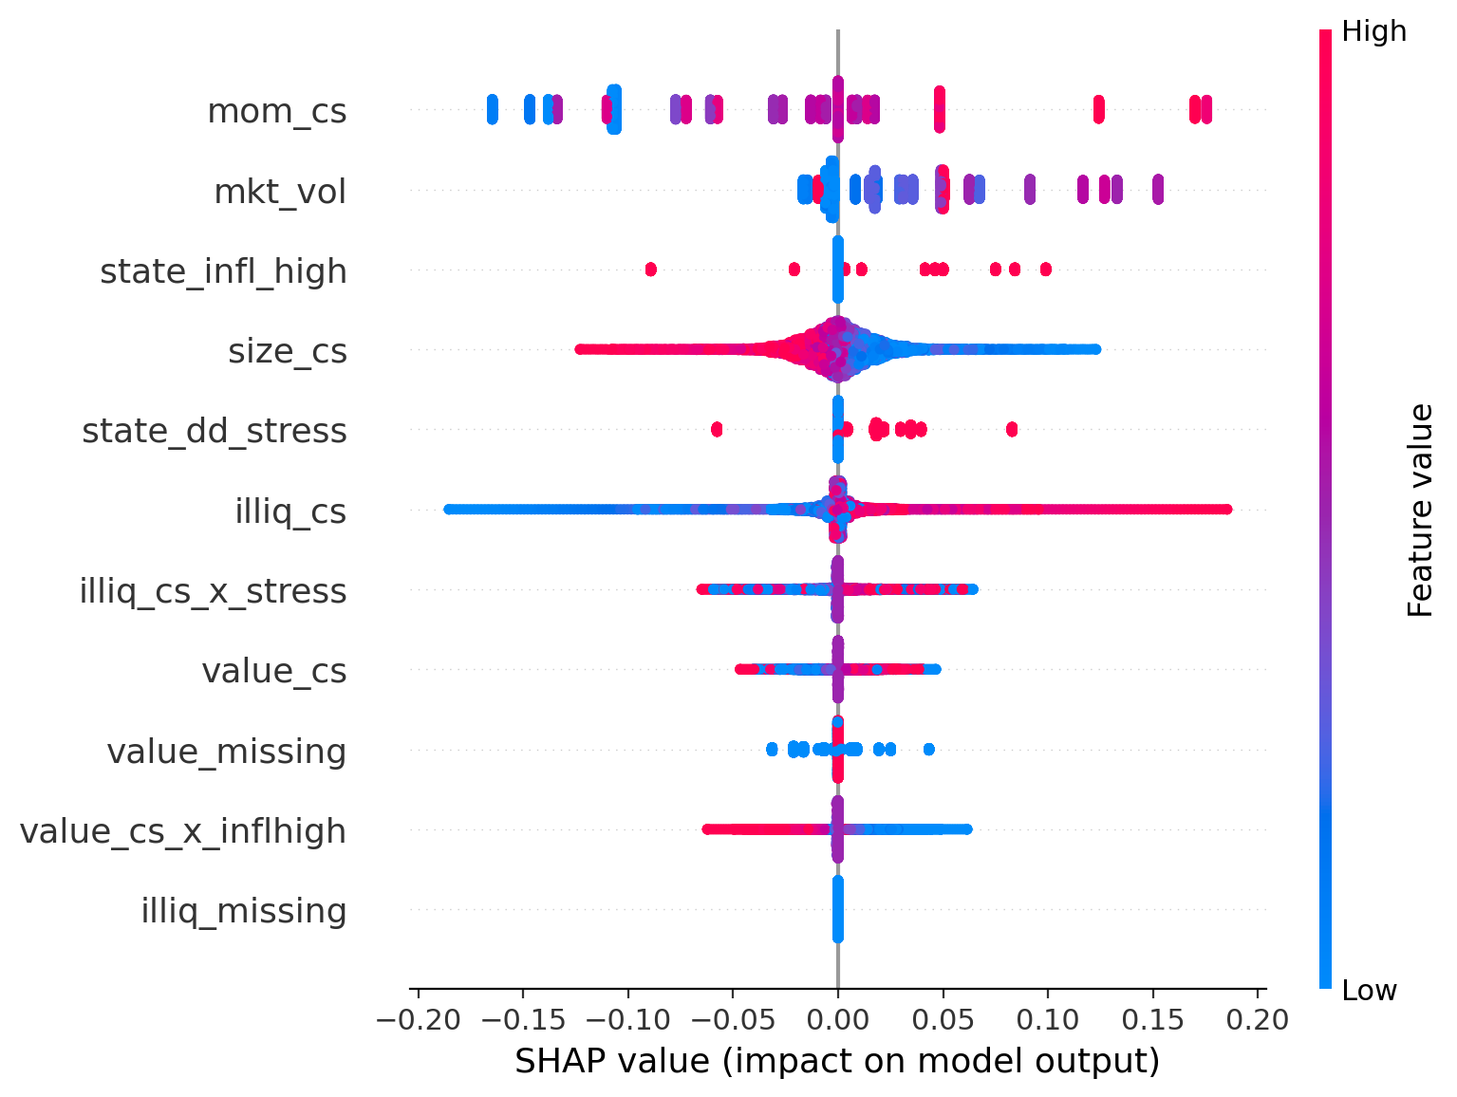
Figure 1. SHAP summary for kalman_tvp
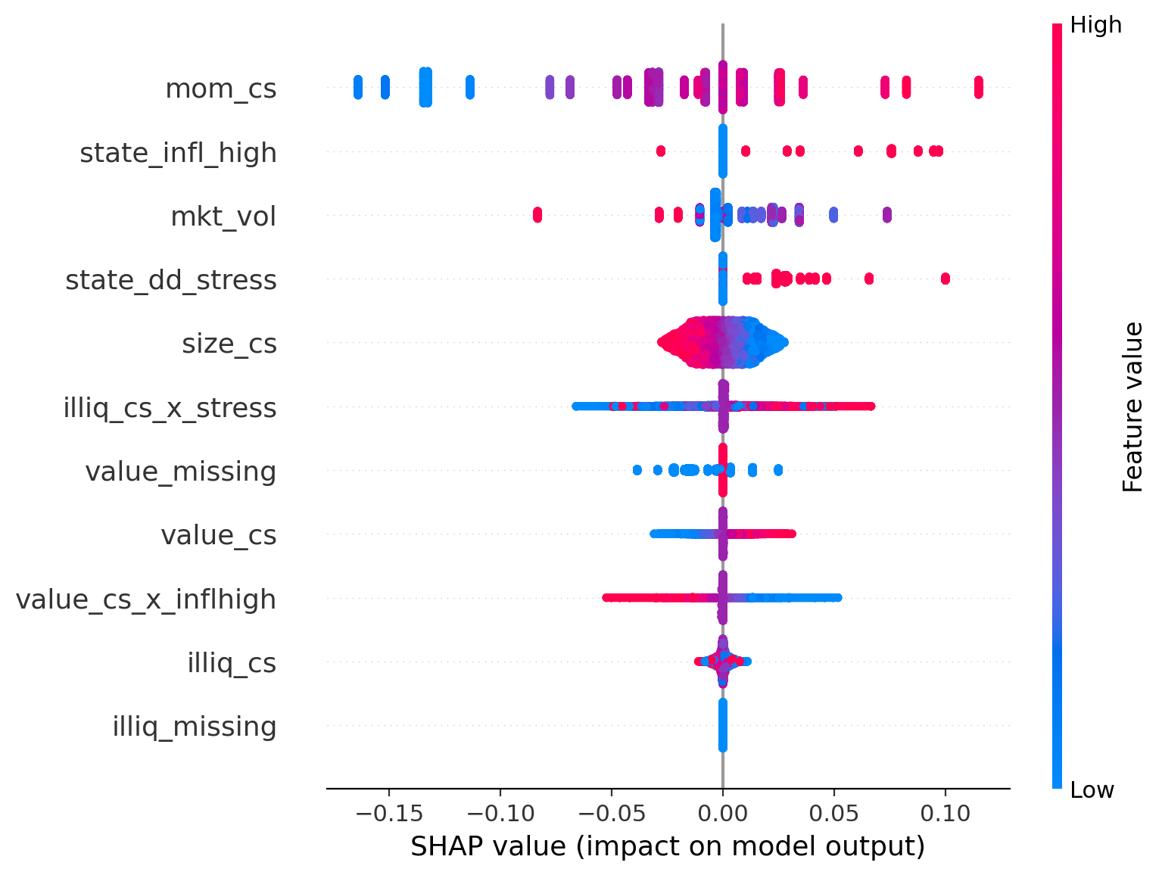
Figure 2. SHAP summary for ols
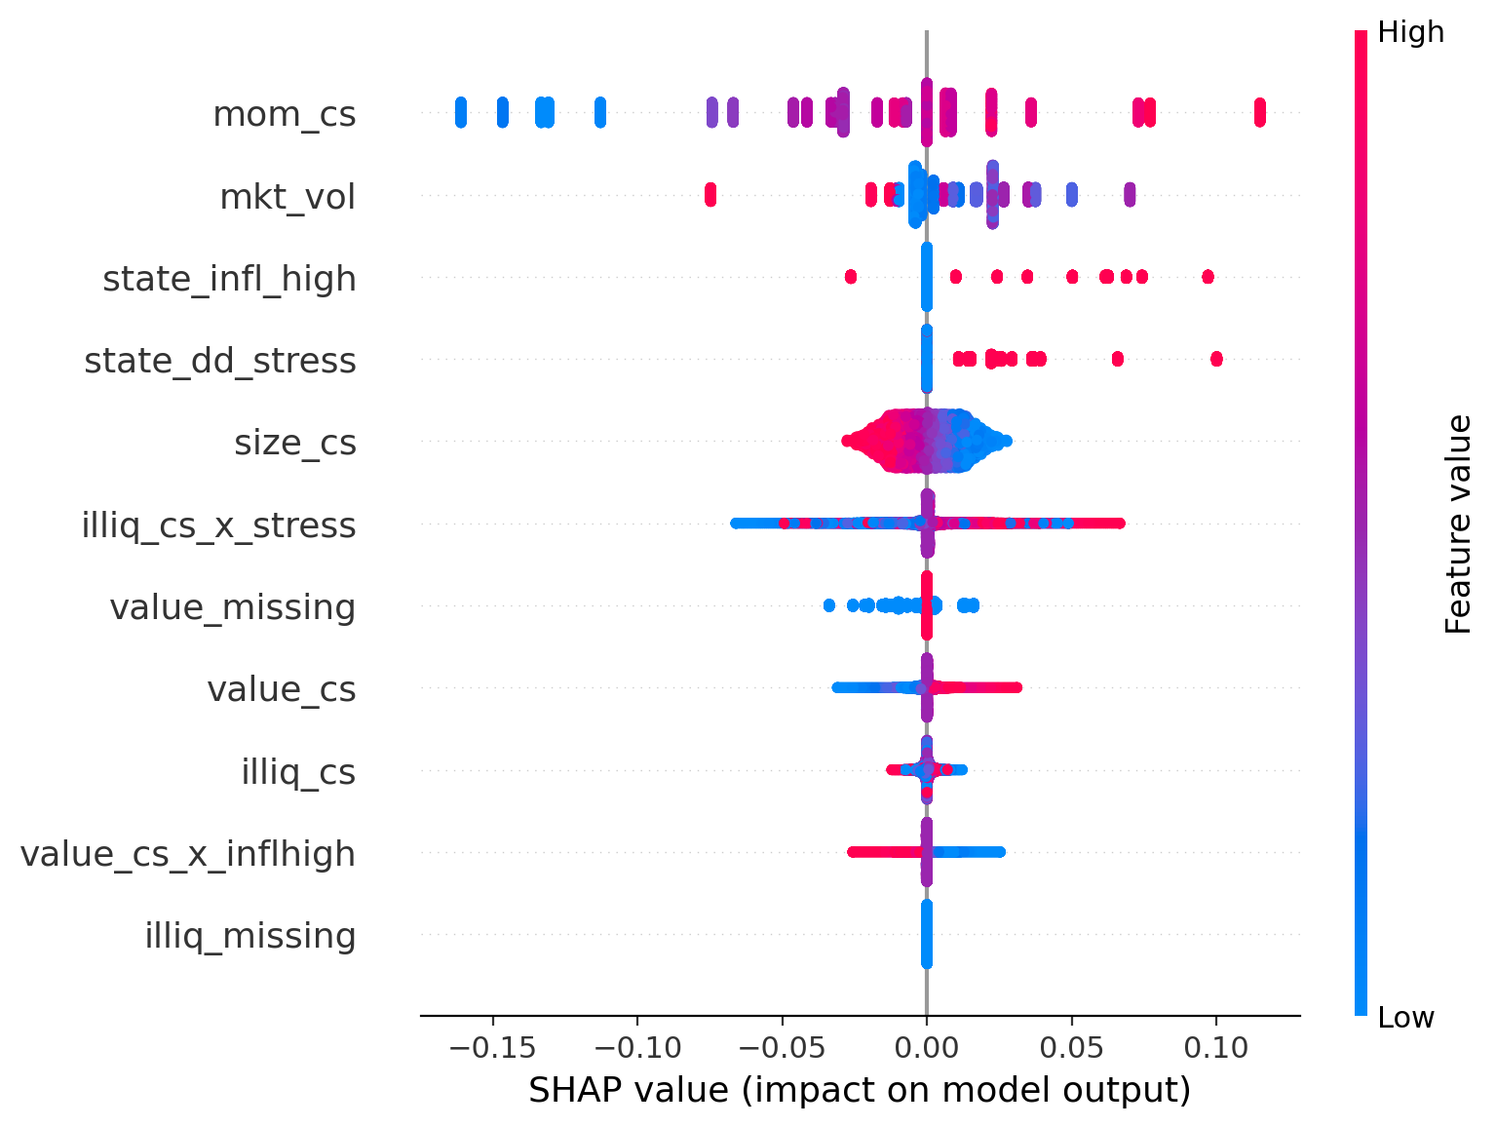
Figure 3. SHAP summary for ridge
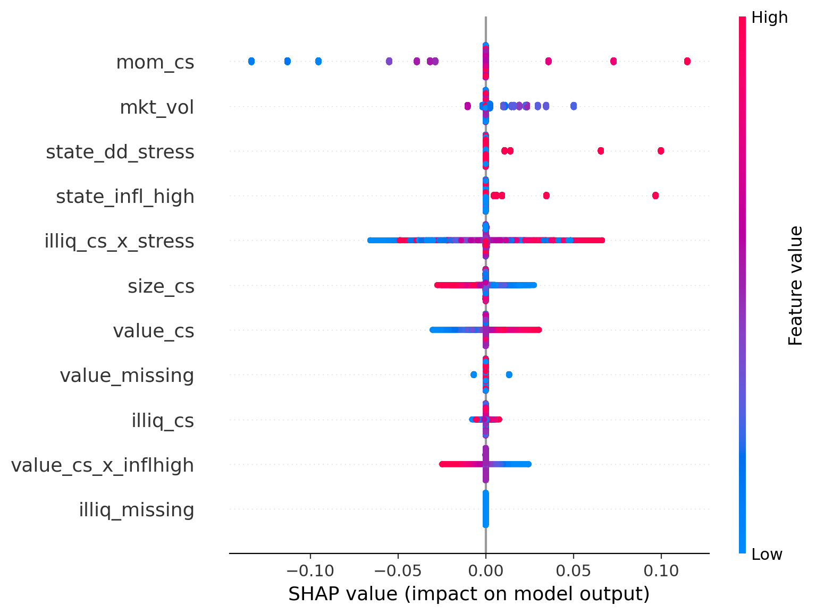
Figure 4. SHAP summary for lasso
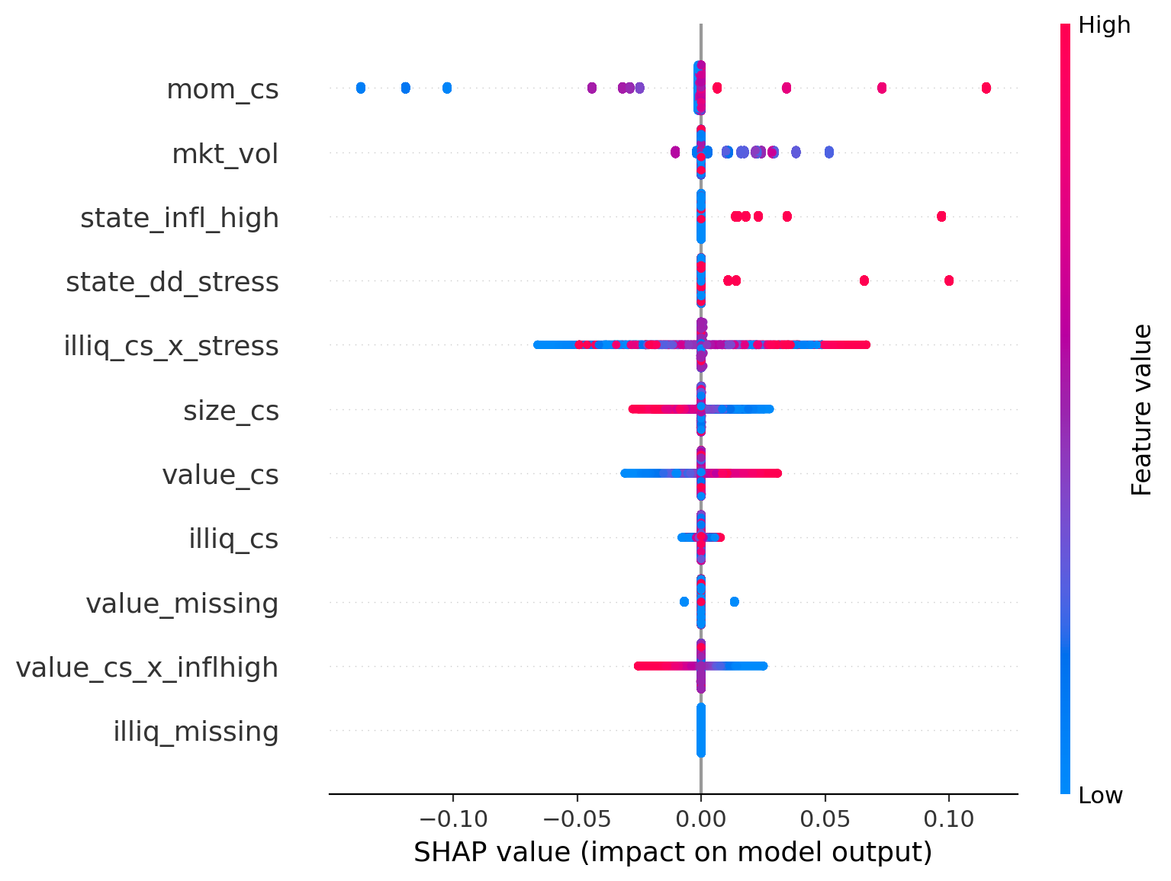
Figure 5. SHAP summary for elastic_net
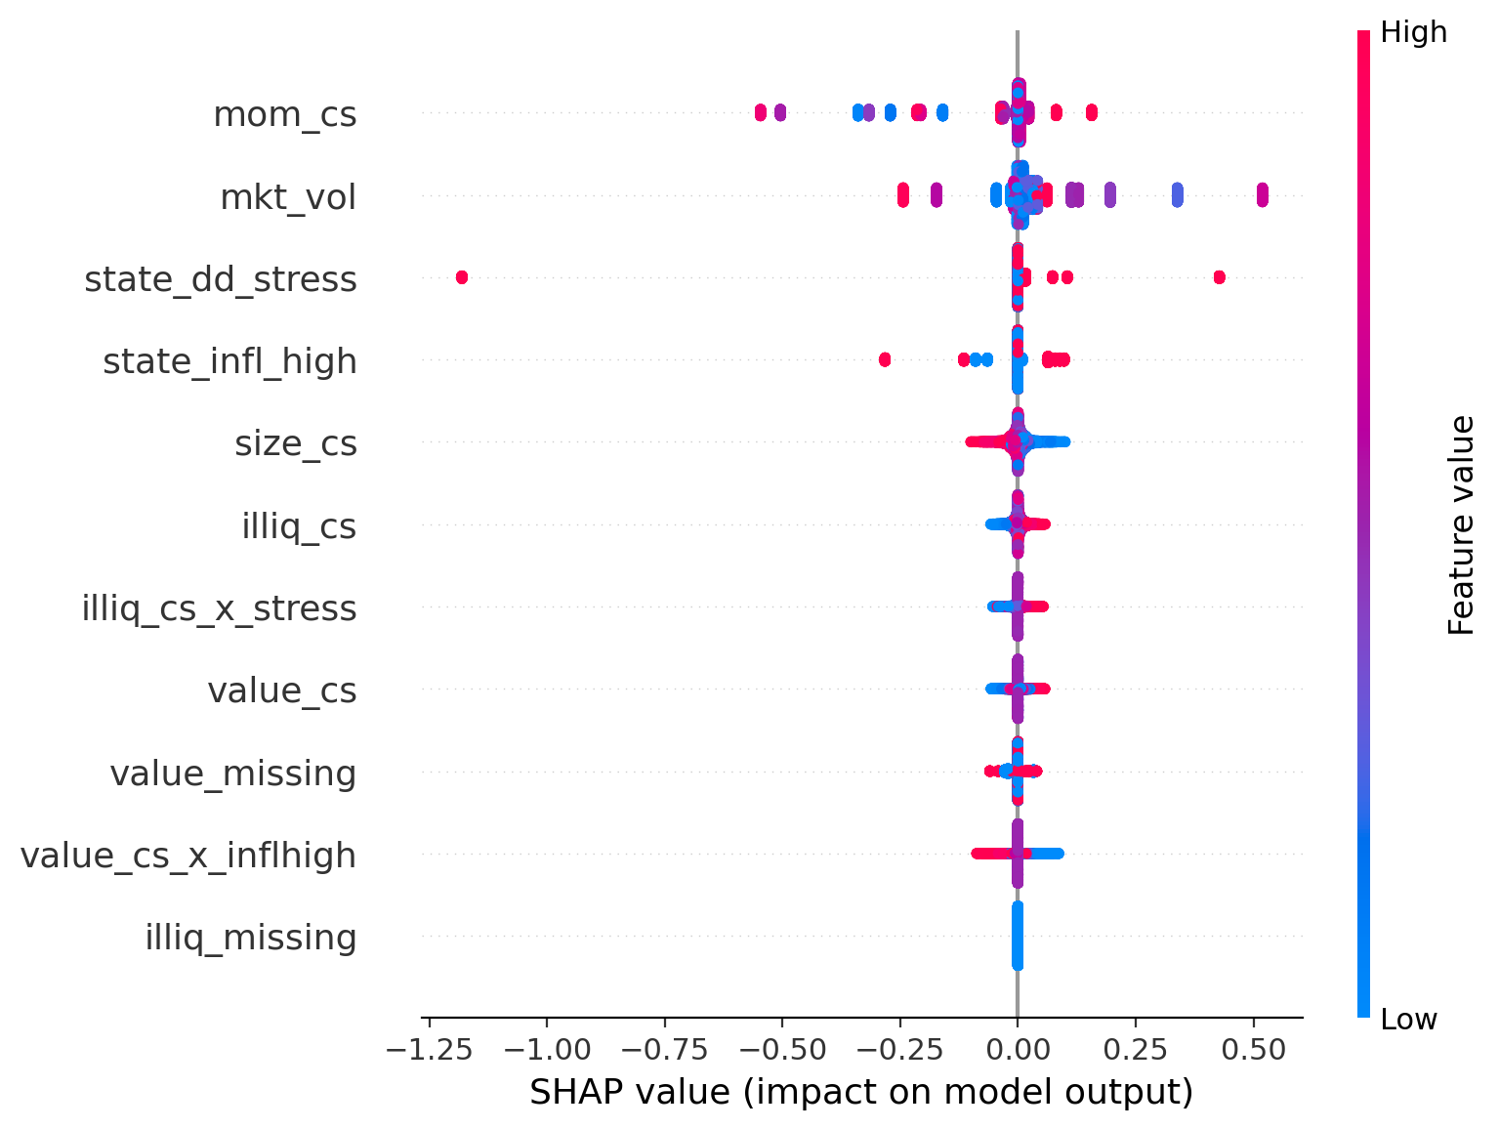
Figure 6. SHAP summary for rolling_ols
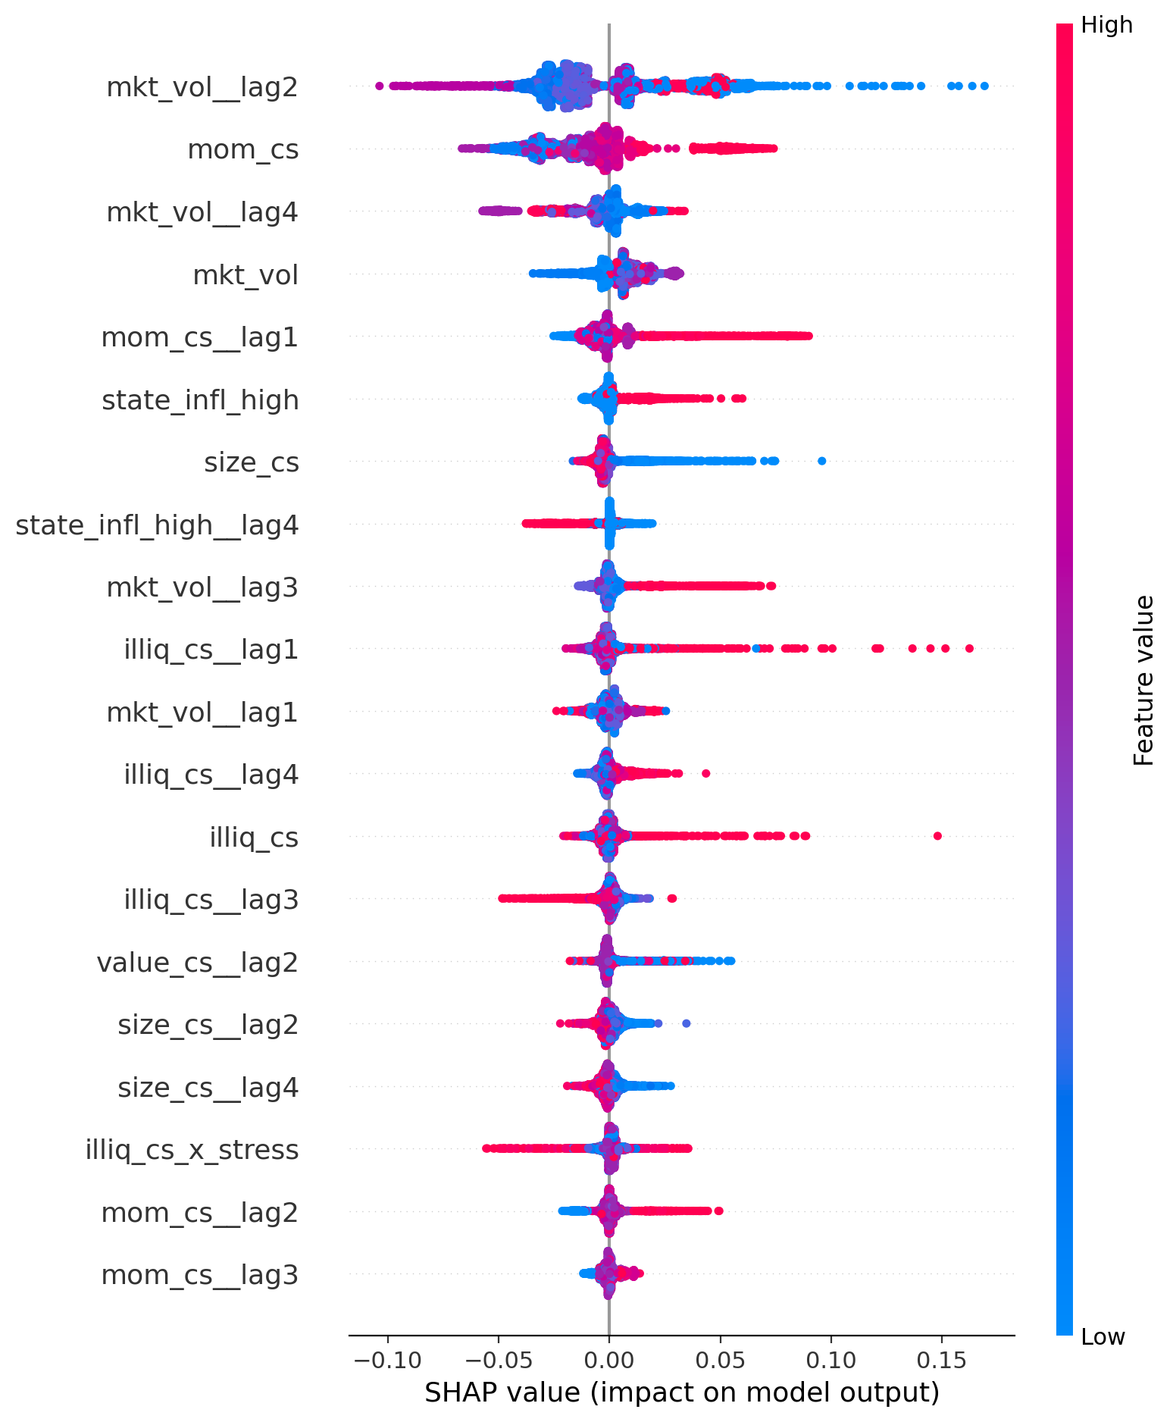
Figure 7. SHAP summary for catboost_lags_regimes
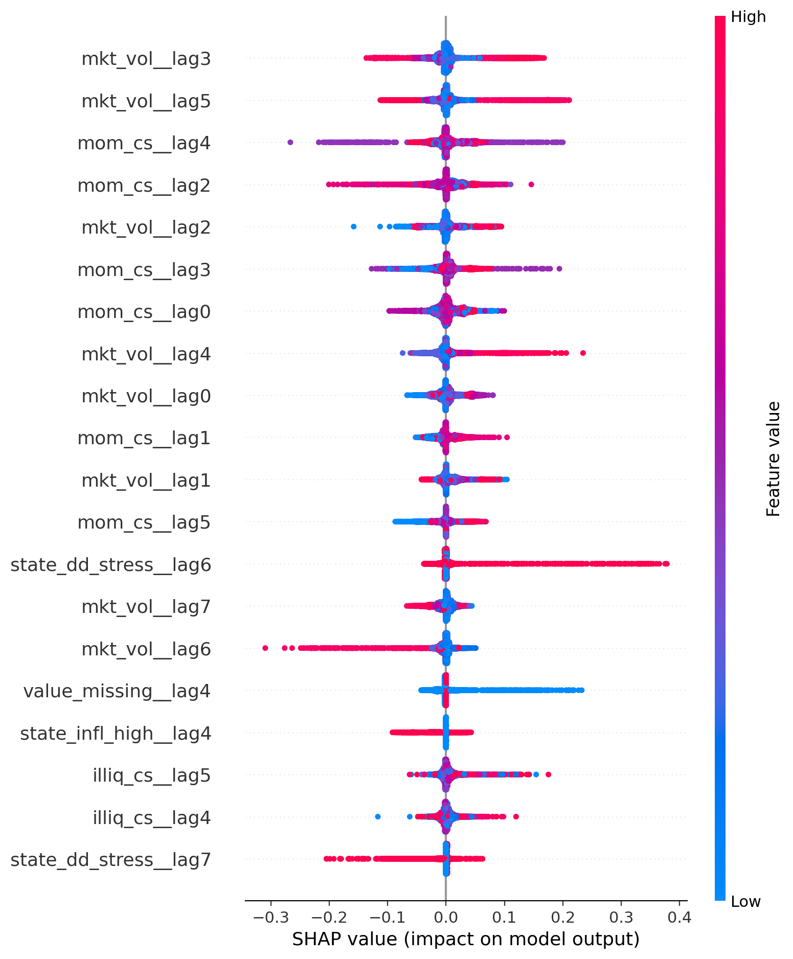
Figure 8. SHAP summary for patchtst_global

7. Portfolio block and model selectors
Block 3 converts forecasts into portfolio strategies. At each rebalancing date, the expected-return vector is selected: by default, prediction_scaled is used, and if it is unavailable, the ordinary prediction is used. The same long-only mean-variance optimizer is applied to all strategies; only the model from which the expected return is taken differs.
Table 21. Strategies formed in Block 3
Parameter | Value
always_linear | always uses the linear class; ridge is specified as the preferred model in the settings
always_transformer | always uses the transformer/PatchTST class; the preferred model is patchtst_global
selector_rule_based | selects the model based on observable market states at the rebalancing date
selector_composite | selects the model using rolling metrics of past forecasts, accounting for regime matching when sufficient history is available
Table 22. Portfolio optimization and diagnostic parameters
Parameter | Value
Maximum number of assets | 25
Minimum number of assets | 5
Maximum weight of a single asset | 0.15
Covariance matrix window | 24 months
Risk aversion coefficient | 5.0
Annualization frequency for metrics | 4 quarters
Block bootstrap | 1000 repetitions, block length 4
VaR/CVaR alpha | 0.05
The selector_rule_based rule works as follows: under drawdown stress or elevated volatility, the transformer model is selected; under a high inflation regime, the nonlinear tabular model is selected; in all other states, the linear model is selected. The code also saves the model selection log, holdings tables, portfolio returns, aggregated metrics, bootstrap results, and additional diagnostic tables.
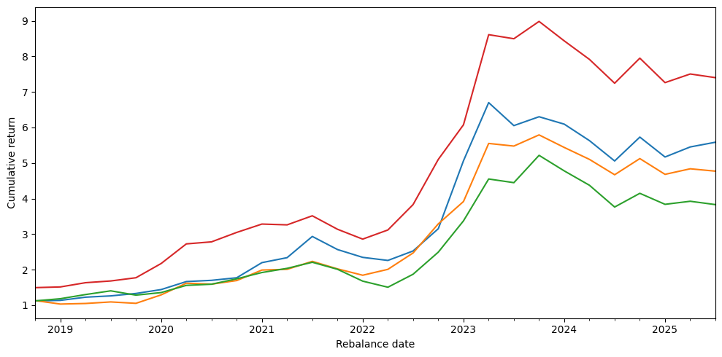
Figure 9. Cumulative return of Block 3 strategies
Table 23. Number of model uses by selectors
strategy | catboost_lags_regimes | elastic_net | kalman_tvp | lasso | ols | patchtst_global | ridge | rolling_ols
selector_composite | 6 | 6 | 8 | 3 | 1 | 0 | 1 | 3
selector_rule_based | 6 | 0 | 0 | 0 | 0 | 17 | 5 | 0
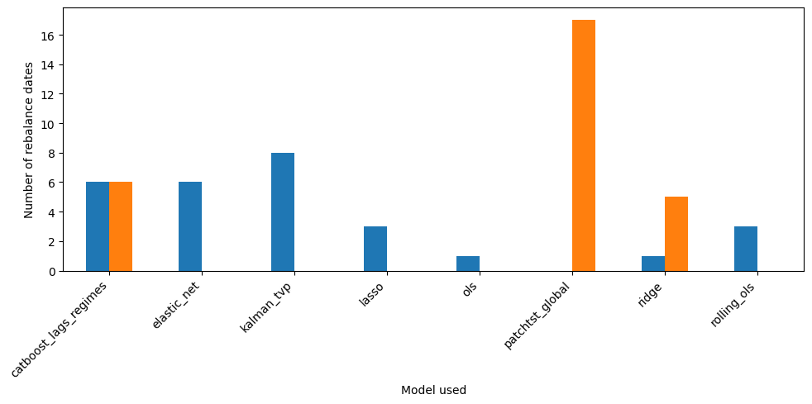
Figure 10. Distribution of models used in the selectors
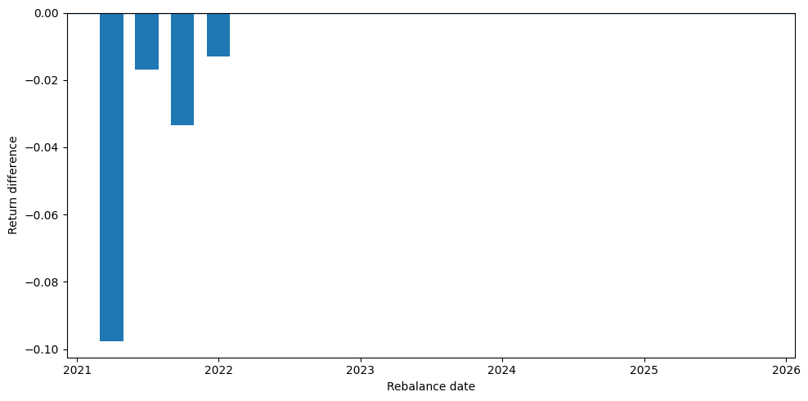
Figure 11. Return difference between selector_rule_based and always_transformer after 2020
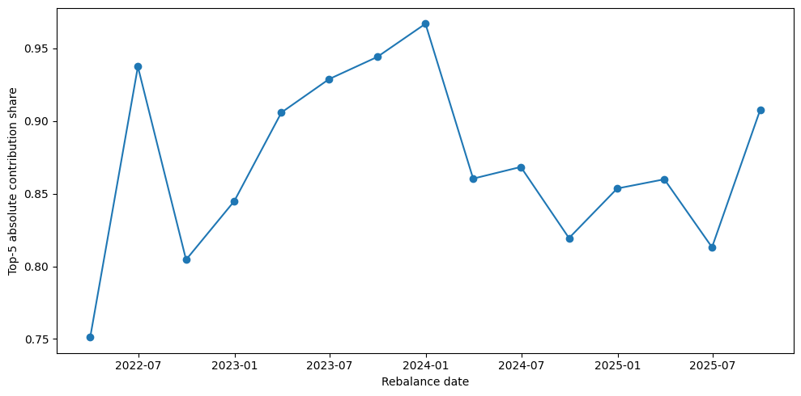
Figure 12. Share of the five largest contributions during PatchTST selection periods
Table 24. Bootstrap CI overlap summary from Block 3
metric | benchmark_strategy | median_diff_selector_minus_benchmark | ci_overlap_ratio_to_narrower | selector_materially_dominates | heavy_overlap
mean_return | always_linear | 0.005422 | 1 | False | True
mean_return | always_transformer | 0.008479 | 0.987629 | False | True
annualized_return | always_linear | 0.037427 | 1 | False | True
annualized_return | always_transformer | 0.040178 | 0.979521 | False | True
annualized_vol | always_linear | -0.039151 | 1 | False | True
annualized_vol | always_transformer | -0.000119 | 1 | False | True
sharpe | always_linear | 0.218697 | 0.94433 | False | True
sharpe | always_transformer | 0.126737 | 0.956262 | False | True
sortino | always_linear | 0.042356 | 1 | False | True
sortino | always_transformer | -0.107153 | 0.985071 | False | True
max_drawdown | always_linear | 0.036493 | 0.915975 | False | True
max_drawdown | always_transformer | 1.110e-16 | 1 | False | True
calmar | always_linear | 0.370773 | 0.988154 | False | True
calmar | always_transformer | 0.156134 | 0.989595 | False | True
var_5_return | always_linear | 0.012475 | 0.733739 | False | True
var_5_return | always_transformer | 9.531e-05 | 1 | False | True
cvar_5_return | always_linear | 0.01291 | 0.485169 | False | False
cvar_5_return | always_transformer | -0.006447 | 1 | False | True

8. Final set of artifacts
Table 25. Map of final artifacts
Artifact | Where it is formed/stored | Purpose
data.csv | created by main.ipynb | monthly stock-month panel for modeling
predictions.csv | All_models_and_portfolio.zip | out-of-sample forecasts, target variable, and reliability-scaled forecast
metrics.csv | All_models_and_portfolio.zip | quarterly model metrics
model_summary.csv | All_models_and_portfolio.zip | summary of mean and median metrics by model
regime_summaries.csv | All_models_and_portfolio.zip | metrics grouped by market states
coefficient_paths.csv | All_models_and_portfolio.zip | coefficients and parameters by dates/models
validation_log.csv | All_models_and_portfolio.zip | parameter selection log on validation dates
best_params_log.csv | All_models_and_portfolio.zip | selected parameters for test dates
shap_importance.csv | All_models_and_portfolio.zip | table of mean absolute feature importance
shap_summary_*.png | All_models_and_portfolio.zip | feature attribution plots by model
phase4_block3/*.csv | formed by the notebook code | tables of returns, holdings, metrics, bootstrap results, and portfolio diagnostics

9. Appendix: tabular previews of results
Table 26. predictions.csv: first rows
month_end | secid | model | target_q_fwd_clean | prediction | prediction_scaled | state_date | forecast_date | q_reliability
2023-09-30 | ABIO | catboost_lags_regimes | -0.108547 | 0.037696 | 0.024363 | 2023-06-30 | 2023-09-30 | 0.646296
2023-12-31 | ABIO | catboost_lags_regimes | 0.081373 | -0.019699 | -0.012671 | 2023-09-30 | 2023-12-31 | 0.643249
2024-03-31 | ABIO | catboost_lags_regimes | -0.146888 | 0.025692 | 0.016511 | 2023-12-31 | 2024-03-31 | 0.642634
2024-06-30 | ABIO | catboost_lags_regimes | 0.077453 | 0.010363 | 0.00677 | 2024-03-31 | 2024-06-30 | 0.653289
2024-09-30 | ABIO | catboost_lags_regimes | -0.16853 | -0.002097 | -0.001666 | 2024-06-30 | 2024-09-30 | 0.794544
The first 5 rows out of 50916 are shown.
Table 27. coefficient_paths.csv: first rows
month_end | forecast_date | model | q | obs_var | intercept | size_cs | value_cs | mom_cs | mkt_vol | alpha | l1_ratio | window
2018-09-30 | 2018-12-31 | kalman_tvp | 0.001 | 0.042754 | -0.005259 | -0.027115 | 0.023369 | 0.015144 | 0.016896
2018-12-31 | 2019-03-31 | kalman_tvp | 0.0001 | 0.045944 | 0.00387 | -0.03285 | 0.025527 | 0.013004 | 0.014535
2019-03-31 | 2019-06-30 | kalman_tvp | 1.000e-05 | 0.046667 | 0.026119 | -0.023153 | 0.0262 | 0.016707 | 0.008649
2019-06-30 | 2019-09-30 | kalman_tvp | 0.0001 | 0.046484 | 0.041831 | -0.009335 | 0.027565 | -0.017418 | 0.007106
2019-09-30 | 2019-12-31 | kalman_tvp | 0.0001 | 0.0449 | 0.049539 | 0.007639 | 0.027845 | -0.009074 | 0.004841
The first 5 rows out of 224 are shown.
Table 28. validation_log.csv: first rows
month_end | model | n_assets | mse | mae | spearman_rank_corr | state_date | param_name | param_value | alpha | l1_ratio | window
2018-06-30 | kalman_tvp | 226 | 0.044972 | 0.160128 | 0.044599 | 2018-03-31 | q | 1.000e-05
2018-09-30 | kalman_tvp | 224 | 0.047309 | 0.170649 | -0.055338 | 2018-06-30 | q | 1.000e-05
2018-06-30 | kalman_tvp | 226 | 0.047311 | 0.167665 | 0.161807 | 2018-03-31 | q | 0.0001
2018-09-30 | kalman_tvp | 224 | 0.044335 | 0.160347 | -0.138081 | 2018-06-30 | q | 0.0001
2018-06-30 | kalman_tvp | 226 | 0.046634 | 0.165215 | 0.216434 | 2018-03-31 | q | 0.001
The first 5 rows out of 2402 are shown.

Table 29. best_params_log.csv: first rows
model | forecast_date | state_date | param_name | param_value
kalman_tvp | 2018-12-31 | 2018-09-30 | q | 0.001
kalman_tvp | 2019-03-31 | 2018-12-31 | q | 0.0001
kalman_tvp | 2019-06-30 | 2019-03-31 | q | 1.000e-05
kalman_tvp | 2019-09-30 | 2019-06-30 | q | 0.0001
kalman_tvp | 2019-12-31 | 2019-09-30 | q | 0.0001
The first 5 rows out of 448 are shown.
Table 30. shap_importance.csv: first rows of the source table
model | feature | mean_abs_shap | rank
kalman_tvp | mom_cs | 0.067208 | 1
kalman_tvp | mkt_vol | 0.040756 | 2
kalman_tvp | state_infl_high | 0.018653 | 3
kalman_tvp | size_cs | 0.01521 | 4
kalman_tvp | state_dd_stress | 0.014995 | 5
The first 5 rows out of 209 are shown.

10. Description of phase 4 block3
Stock forecasts at the rebalancing date and the historical panel of returns are used as inputs. The same portfolio construction procedure is applied to all strategies; only the source of expected return differs, that is, the model or selector from which the forecast is taken.

10.1. Purpose and composition of the archive
Table 31. phase4_block3.zip: artifact map
Artifact | Content
block3_bootstrap_bands.csv | confidence intervals for strategy metrics obtained by block bootstrap
block3_bootstrap_ci_overlap.csv | diagnostics of confidence-interval overlap between the selector and baseline strategies
block3_cumulative_returns.png | cumulative return chart for Block 3 strategies
block3_holdings.csv | security weights, expected return, and realized contribution by asset
block3_patchtst_selected_asset_drivers.csv | diagnostics of individual-security contributions during PatchTST selection periods
block3_patchtst_selected_concentration.csv | concentration diagnostics for periods when the rule-based selector used PatchTST
block3_patchtst_top5_contribution_share.png | share of the five largest absolute contributions during PatchTST selection periods
block3_portfolio_returns.csv | quarterly portfolio returns and the model selected by strategy
block3_regime_metrics.csv | strategy metrics grouped by regime indicators
block3_rule_based_ex_ante_audit.csv | audit of information sources used by the rule-based selector
block3_sector_metrics.csv | aggregated strategy metrics within the evaluation sector
block3_sector_returns.csv | sector-level contribution table; in this archive, the evaluation sector is defined as all
block3_selector_log.csv | requested and actually used model, as well as technical selector fields
block3_selector_minus_transformer_after2020.png | return difference between selector_rule_based and always_transformer after 2020
block3_selector_model_counts.png | distribution of models selected by selector strategies
block3_selector_switch_regime_diagnostics.csv | log of selector switches and simultaneous regime changes
block3_selector_vs_transformer_after2020.csv | comparison of selector_rule_based with always_transformer by dates after 2020
block3_selector_vs_transformer_after2020_summary.csv | summary comparison of selector_rule_based with always_transformer after 2020
block3_strategy_metrics.csv | aggregated metrics for portfolio strategies
block3_turnover_diagnostics.csv | portfolio turnover, entered and exited securities, and portfolio size by date
pipeline_file.ipynb | notebook with the Block 3 implementation and execution cells

10.2. Input forecasts and construction of expected return
Within Block 3, the forecast table is converted to a unified format: forecast date, security identifier, model, forecast return, and realized future return. If the prediction_scaled column is present in the data, it is used as the main estimate of expected return; if it is absent, the ordinary prediction column is used. This procedure allows reliability-scaled forecasts to be applied without changing the general logic of the portfolio block.
For each quarter, a set of available securities is formed. Assets with the highest forecast returns are selected from this set, after which a covariance matrix is built from historical returns. On this basis, the weights of a long-only portfolio are calculated with a constraint on the maximum weight of a single security. All strategies pass through the same optimizer; therefore, the comparison does not mix model quality with changes in portfolio-construction rules.
Table 32. Block 3 configuration parameters
Parameter | Value
Preferred linear model | ridge
Preferred transformer model | patchtst_global
Preferred nonlinear model | catboost_lags_regimes
Expected-return column | prediction_scaled; fallback option: prediction
Maximum number of securities | 25
Minimum number of securities | 5
Maximum weight of a single security | 0.15
Covariance matrix window | 24 months
Risk aversion coefficient | 5
Annualization frequency | 4 quarters
Number of bootstrap repetitions | 1.000e+03
Bootstrap block length | 4
VaR/CVaR alpha level | 0.05

10.3. Strategies and model selectors
always_linear always uses the linear representative specified as ridge. always_transformer always uses the PatchTST representative specified as patchtst_global. selector_rule_based selects the model according to the observable market regimes at the rebalancing date: under drawdown stress or high volatility, PatchTST is selected; under high inflation, CatBoost is selected; in all other cases, the linear model is used. selector_composite selects the model based on the accumulated history of past forecasts, taking into account rolling quality metrics and, where possible, regime matching.
The selector_log.csv log stores not only the final model used, but also the requested model, regime indicators, and technical selector fields.

10.4. Portfolio construction and saving
After the forecast source is selected, a portfolio is formed for each strategy. The holdings table stores security weights, expected contribution, and realized contribution to return. The portfolio_returns table then aggregates quarterly strategy returns, the number of securities, the maximum weight, the sum of weights, and the regimes observed at the corresponding state date.
sector_returns and sector_metrics are saved separately. In the archive under consideration, the sector breakdown is represented as a single group.
Table 33. block3_strategy_metrics.csv: aggregated strategy metrics
strategy | n_periods | mean_return | annualized_return | annualized_vol | sharpe | sortino | max_drawdown | calmar | var_5_return | cvar_5_return
always_linear | 28 | 0.073339 | 0.278549 | 0.314066 | 0.886912 | 4.345352 | -0.245037 | 1.13676 | -0.100252 | -0.113563
always_transformer | 28 | 0.065413 | 0.250101 | 0.273606 | 0.914089 | 3.790778 | -0.19355 | 1.292179 | -0.087873 | -0.091649
selector_composite | 28 | 0.058064 | 0.211471 | 0.284475 | 0.743374 | 2.396121 | -0.318053 | 0.664892 | -0.126721 | -0.152878
selector_rule_based | 28 | 0.083742 | 0.331025 | 0.306052 | 1.081597 | 4.361014 | -0.19355 | 1.710286 | -0.087777 | -0.098095
Table 34. block3_portfolio_returns.csv: first rows of quarterly portfolio returns
strategy | forecast_date | month_end | state_date | model_requested | model_used | expected_return | portfolio_return | n_assets | max_weight | weight_sum | expected_col | state_infl_high | state_vol_high_auto | state_dd_stress
always_linear | 2018-12-31 | 2018-12-31 | 2018-09-30 | ridge | ridge | 0.037894 | 0.121319 | 11 | 0.15 | 1 | prediction_scaled | 1 | 0 | 0
always_linear | 2019-03-31 | 2019-03-31 | 2018-12-31 | ridge | ridge | -0.016286 | 0.013111 | 12 | 0.15 | 1 | prediction_scaled | 0 | 0 | 0
always_linear | 2019-06-30 | 2019-06-30 | 2019-03-31 | ridge | ridge | 0.020656 | 0.079062 | 12 | 0.15 | 1 | prediction_scaled | 0 | 0 | 0
always_linear | 2019-09-30 | 2019-09-30 | 2019-06-30 | ridge | ridge | 0.011275 | 0.029704 | 11 | 0.15 | 1 | prediction_scaled | 0 | 0 | 0
always_linear | 2019-12-31 | 2019-12-31 | 2019-09-30 | ridge | ridge | -1.617e-04 | 0.053883 | 11 | 0.15 | 1 | prediction_scaled | 0 | 0 | 0
The first 5 rows out of 112 are shown.
Table 35. block3_holdings.csv: first rows of portfolio holdings
strategy | forecast_date | state_date | model_requested | model_used | secid | block3_sector | sector_for_eval | weight | block3_expected_return | target_q_fwd_clean | weighted_expected_return | weighted_realized_return | state_infl_high | state_vol_high_auto | state_dd_stress
always_linear | 2018-12-31 | 2018-09-30 | ridge | ridge | BELU | all | all | 0.15 | 0.037066 | 0.14951 | 0.00556 | 0.022426 | 1 | 0 | 0
always_linear | 2018-12-31 | 2018-09-30 | ridge | ridge | BISVP | all | all | 0.15 | 0.039155 | 0.122195 | 0.005873 | 0.018329 | 1 | 0 | 0
always_linear | 2018-12-31 | 2018-09-30 | ridge | ridge | KAZTP | all | all | 0.15 | 0.036206 | 0.138 | 0.005431 | 0.0207 | 1 | 0 | 0
always_linear | 2018-12-31 | 2018-09-30 | ridge | ridge | KROTP | all | all | 0.025595 | 0.035968 | -0.011673 | 9.206e-04 | -2.988e-04 | 1 | 0 | 0
always_linear | 2018-12-31 | 2018-09-30 | ridge | ridge | KZOSP | all | all | 0.018171 | 0.038716 | 0.089888 | 7.035e-04 | 0.001633 | 1 | 0 | 0
The first 5 rows out of 1,055 are shown.
Table 36. block3_sector_metrics.csv: metrics for the evaluation sector
strategy | sector_for_eval | n_periods | mean_return | annualized_return | annualized_vol | sharpe | sortino | max_drawdown | calmar | var_5_return | cvar_5_return
always_linear | all | 28 | 0.073339 | 0.278549 | 0.314066 | 0.886912 | 4.345352 | -0.245037 | 1.13676 | -0.100252 | -0.113563
always_transformer | all | 28 | 0.065413 | 0.250101 | 0.273606 | 0.914089 | 3.790778 | -0.19355 | 1.292179 | -0.087873 | -0.091649
selector_composite | all | 28 | 0.058064 | 0.211471 | 0.284475 | 0.743374 | 2.396121 | -0.318053 | 0.664892 | -0.126721 | -0.152878
selector_rule_based | all | 28 | 0.083742 | 0.331025 | 0.306052 | 1.081597 | 4.361014 | -0.19355 | 1.710286 | -0.087777 | -0.098095
Table 37. block3_sector_returns.csv: first rows of sector-level returns
strategy | forecast_date | sector_for_eval | sector_weight | sector_contribution_return | sector_expected_contribution | n_assets | sector_sleeve_return
always_linear | 2018-12-31 | all | 1 | 0.121319 | 0.037894 | 11 | 0.121319
always_linear | 2019-03-31 | all | 1 | 0.013111 | -0.016286 | 12 | 0.013111
always_linear | 2019-06-30 | all | 1 | 0.079062 | 0.020656 | 12 | 0.079062
always_linear | 2019-09-30 | all | 1 | 0.029704 | 0.011275 | 11 | 0.029704
always_linear | 2019-12-31 | all | 1 | 0.053883 | -1.617e-04 | 11 | 0.053883
The first 5 rows out of 112 are shown.
Table 38. block3_regime_metrics.csv: metrics grouped by regime states
strategy | regime_dimension | regime_value | n_periods | mean_return | annualized_return | annualized_vol | sharpe | sortino | max_drawdown | calmar | var_5_return | cvar_5_return
always_linear | state_infl_high | 0 | 17 | 0.069152 | 0.25335 | 0.344152 | 0.73616 | 3.888141 | -0.275825 | 0.91852 | -0.098461 | -0.101646
always_linear | state_infl_high | 1 | 11 | 0.079811 | 0.318491 | 0.276609 | 1.151412 | 7.73797 | -0.200398 | 1.589291 | -0.111005 | -0.12548
always_transformer | state_infl_high | 0 | 17 | 0.051959 | 0.185861 | 0.28628 | 0.649228 | 3.035446 | -0.263345 | 0.705769 | -0.086601 | -0.086819
always_transformer | state_infl_high | 1 | 11 | 0.086205 | 0.356292 | 0.2605 | 1.367725 | 3.927553 | -0.174908 | 2.037022 | -0.091649 | -0.094858
selector_composite | state_infl_high | 0 | 17 | 0.055836 | 0.195562 | 0.309348 | 0.632175 | 2.83376 | -0.334003 | 0.585511 | -0.109754 | -0.139918
selector_composite | state_infl_high | 1 | 11 | 0.061507 | 0.236475 | 0.255539 | 0.925398 | 1.650748 | -0.240413 | 0.983618 | -0.12762 | -0.165837
selector_rule_based | state_infl_high | 0 | 17 | 0.068336 | 0.266338 | 0.271074 | 0.982532 | 4.537252 | -0.263345 | 1.011366 | -0.085038 | -0.086547
selector_rule_based | state_infl_high | 1 | 11 | 0.107551 | 0.437554 | 0.36225 | 1.207878 | 4.248752 | -0.186661 | 2.344108 | -0.098095 | -0.107751
always_linear | state_vol_high_auto | 0 | 22 | 0.059164 | 0.231049 | 0.229985 | 1.004627 | 3.331174 | -0.245037 | 0.942914 | -0.10139 | -0.113563
always_linear | state_vol_high_auto | 1 | 6 | 0.125318 | 0.468941 | 0.542204 | 0.864878 | 7.307917 | -0.097665 | 4.801543 | -0.094665 | -0.097665
always_transformer | state_vol_high_auto | 0 | 22 | 0.052943 | 0.197644 | 0.254901 | 0.775375 | 2.976417 | -0.19355 | 1.021154 | -0.086711 | -0.090838
always_transformer | state_vol_high_auto | 1 | 6 | 0.111135 | 0.462879 | 0.344358 | 1.344181 | 172.883654 | -0.086547 | 5.348309 | -0.087967 | -0.08844
selector_composite | state_vol_high_auto | 0 | 22 | 0.047303 | 0.178474 | 0.219985 | 0.811304 | 2.180328 | -0.278768 | 0.640225 | -0.089237 | -0.11466
selector_composite | state_vol_high_auto | 1 | 6 | 0.097518 | 0.340562 | 0.473538 | 0.719186 | 3.641768 | -0.102213 | 3.331879 | -0.149931 | -0.165837
selector_rule_based | state_vol_high_auto | 0 | 22 | 0.076271 | 0.297174 | 0.301835 | 0.984557 | 3.770375 | -0.19355 | 1.535391 | -0.083515 | -0.096206
selector_rule_based | state_vol_high_auto | 1 | 6 | 0.111135 | 0.462879 | 0.344358 | 1.344181 | 172.883654 | -0.086547 | 5.348309 | -0.087967 | -0.08844
always_linear | state_dd_stress | 0 | 11 | 0.072206 | 0.298407 | 0.211974 | 1.407755 |  | -0.12548 | 2.378119 | -0.056185 | -0.12548
always_linear | state_dd_stress | 1 | 17 | 0.074073 | 0.265861 | 0.37197 | 0.714738 | 4.606843 | -0.245037 | 1.084982 | -0.098461 | -0.101646
always_transformer | state_dd_stress | 0 | 11 | 0.028543 | 0.104806 | 0.173503 | 0.604057 | 1.360711 | -0.094858 | 1.104875 | -0.090838 | -0.094858
always_transformer | state_dd_stress | 1 | 17 | 0.089269 | 0.354146 | 0.318364 | 1.112396 | 5.407935 | -0.19355 | 1.829745 | -0.086925 | -0.08844
selector_composite | state_dd_stress | 0 | 11 | 0.049365 | 0.201321 | 0.145997 | 1.378938 | 43.201567 | -0.089402 | 2.251855 | -0.087755 | -0.089402
selector_composite | state_dd_stress | 1 | 17 | 0.063692 | 0.218084 | 0.350568 | 0.622089 | 2.179631 | -0.278768 | 0.782314 | -0.145102 | -0.165837
selector_rule_based | state_dd_stress | 0 | 11 | 0.075199 | 0.296066 | 0.300343 | 0.985762 | 2.075231 | -0.107751 | 2.747695 | -0.05731 | -0.107751
selector_rule_based | state_dd_stress | 1 | 17 | 0.089269 | 0.354146 | 0.318364 | 1.112396 | 5.407935 | -0.19355 | 1.829745 | -0.086925 | -0.08844
Table 39. block3_selector_log.csv: first rows of the model selection log
forecast_date | strategy | model_requested | model_used | state_infl_high | state_vol_high_auto | state_dd_stress | selector_scope | selector_score | selector_mse | selector_spearman | selector_tail_ratio | selector_n_dates | selector_n_obs
2018-12-31 | always_linear | ridge | ridge | 1 | 0 | 0 | not_used
2018-12-31 | always_transformer | patchtst_global | patchtst_global | 1 | 0 | 0 | not_used
2018-12-31 | selector_composite | ridge | ridge | 1 | 0 | 0 | fallback_no_history |  |  |  |  | 0 | 0
2018-12-31 | selector_rule_based | catboost_lags_regimes | catboost_lags_regimes | 1 | 0 | 0 | rule_based
2019-03-31 | always_linear | ridge | ridge | 0 | 0 | 0 | not_used
The first 5 rows out of 112 are shown.
Table 40. block3_turnover_diagnostics.csv: first rows of portfolio turnover diagnostics
strategy | forecast_date | turnover | n_entered | n_exited | n_assets
always_linear | 2018-12-31 |  |  |  | 11
always_linear | 2019-03-31 | 0.741933 | 10 | 9 | 12
always_linear | 2019-06-30 | 0.38769 | 5 | 5 | 12
always_linear | 2019-09-30 | 0.505684 | 5 | 6 | 11
always_linear | 2019-12-31 | 0.595508 | 7 | 7 | 11
The first 5 rows out of 112 are shown.

10.5. Selector and robustness diagnostics
In addition to the basic returns, the block saves diagnostic tables. turnover_diagnostics records changes in securities between adjacent rebalancing dates. rule_based_ex_ante_audit describes which information sources are used by the rule-based selector. selector_switch_regime_diagnostics links model switches with changes in regime indicators. Separate files after 2020 show on which dates the rule-based selector coincided with the PatchTST strategy and on which dates it selected a different model class.
For the periods when the rule-based selector chose PatchTST, portfolio concentration measures and individual-security contribution measures are additionally saved.
Table 41. block3_rule_based_ex_ante_audit.csv: audit of information used by the rule-based selector
rule_name | rule_version | declared_fixed_ex_ante | rule_lock_date | uses_realized_portfolio_returns | uses_future_returns | uses_forecast_values | uses_observable_regime_states | regime_inputs_available | linear_model | transformer_model | nonlinear_model | interpretation
selector_rule_based | rule_based_v1 | False |  | False | False | False | True | state_infl_high, state_vol_high_auto, state_dd_stress | ridge | patchtst_global | catboost_lags_regimes | Strong evidence only if declared_fixed_ex_ante=True and the rule was fixed before running portfolio backtest. Otherwise treat selector result as provisional.
Table 42. block3_selector_switch_regime_diagnostics.csv: model switches and regime changes
forecast_date | model_used | prev_model_used | model_switch | regime_break | switch_around_regime_break | state_infl_high | state_vol_high_auto | state_dd_stress | state_infl_high_changed | state_vol_high_auto_changed | state_dd_stress_changed
2021-03-31 | catboost_lags_regimes |  | False | False | False | 1 | 0 | 0 | False | False | False
2021-06-30 | catboost_lags_regimes | catboost_lags_regimes | False | False | False | 1 | 0 | 0 | False | False | False
2021-09-30 | catboost_lags_regimes | catboost_lags_regimes | False | False | False | 1 | 0 | 0 | False | False | False
2021-12-31 | catboost_lags_regimes | catboost_lags_regimes | False | False | False | 1 | 0 | 0 | False | False | False
2022-03-31 | patchtst_global | catboost_lags_regimes | True | True | True | 1 | 1 | 1 | False | True | True
2022-06-30 | patchtst_global | patchtst_global | False | True | False | 0 | 1 | 1 | True | False | False
2022-09-30 | patchtst_global | patchtst_global | False | False | False | 0 | 1 | 1 | False | False | False
2022-12-31 | patchtst_global | patchtst_global | False | True | False | 1 | 1 | 1 | True | False | False
2023-03-31 | patchtst_global | patchtst_global | False | True | False | 0 | 1 | 1 | True | False | False
2023-06-30 | patchtst_global | patchtst_global | False | True | False | 0 | 0 | 1 | False | True | False
2023-09-30 | patchtst_global | patchtst_global | False | True | False | 1 | 0 | 1 | True | False | False
2023-12-31 | patchtst_global | patchtst_global | False | True | False | 0 | 0 | 1 | True | False | False
2024-03-31 | patchtst_global | patchtst_global | False | False | False | 0 | 0 | 1 | False | False | False
2024-06-30 | patchtst_global | patchtst_global | False | False | False | 0 | 0 | 1 | False | False | False
2024-09-30 | patchtst_global | patchtst_global | False | False | False | 0 | 0 | 1 | False | False | False
2024-12-31 | patchtst_global | patchtst_global | False | True | False | 1 | 0 | 1 | True | False | False
2025-03-31 | patchtst_global | patchtst_global | False | True | False | 0 | 1 | 1 | True | True | False
2025-06-30 | patchtst_global | patchtst_global | False | True | False | 0 | 0 | 1 | False | True | False
2025-09-30 | patchtst_global | patchtst_global | False | False | False | 0 | 0 | 1 | False | False | False
Table 43. block3_selector_vs_transformer_after2020.csv: comparison after 2020
forecast_date | always_transformer | selector_rule_based | transformer_model_used | selector_model_used | return_diff_selector_minus_transformer | selector_same_as_transformer | period_type
2021-03-31 | 0.174665 | 0.077106 | patchtst_global | catboost_lags_regimes | -0.097559 | False | switch_away_from_transformer
2021-06-30 | 0.010097 | -0.00687 | patchtst_global | catboost_lags_regimes | -0.016967 | False | switch_away_from_transformer
2021-09-30 | 0.111676 | 0.078269 | patchtst_global | catboost_lags_regimes | -0.033407 | False | switch_away_from_transformer
2021-12-31 | -0.094858 | -0.107751 | patchtst_global | catboost_lags_regimes | -0.012893 | False | switch_away_from_transformer
2022-03-31 | -0.08844 | -0.08844 | patchtst_global | patchtst_global | 0 | True | identical_to_transformer
2022-06-30 | 0.090021 | 0.090021 | patchtst_global | patchtst_global | 0 | True | identical_to_transformer
2022-09-30 | 0.22935 | 0.22935 | patchtst_global | patchtst_global | 0 | True | identical_to_transformer
2022-12-31 | 0.331398 | 0.331398 | patchtst_global | patchtst_global | 0 | True | identical_to_transformer
2023-03-31 | 0.191031 | 0.191031 | patchtst_global | patchtst_global | 0 | True | identical_to_transformer
2023-06-30 | 0.417265 | 0.417265 | patchtst_global | patchtst_global | 0 | True | identical_to_transformer
2023-09-30 | -0.013283 | -0.013283 | patchtst_global | patchtst_global | 0 | True | identical_to_transformer
2023-12-31 | 0.05734 | 0.05734 | patchtst_global | patchtst_global | 0 | True | identical_to_transformer
2024-03-31 | -0.06098 | -0.06098 | patchtst_global | patchtst_global | 0 | True | identical_to_transformer
2024-06-30 | -0.061745 | -0.061745 | patchtst_global | patchtst_global | 0 | True | identical_to_transformer
2024-09-30 | -0.084661 | -0.084661 | patchtst_global | patchtst_global | 0 | True | identical_to_transformer
2024-12-31 | 0.097311 | 0.097311 | patchtst_global | patchtst_global | 0 | True | identical_to_transformer
2025-03-31 | -0.086547 | -0.086547 | patchtst_global | patchtst_global | 0 | True | identical_to_transformer
2025-06-30 | 0.033444 | 0.033444 | patchtst_global | patchtst_global | 0 | True | identical_to_transformer
2025-09-30 | -0.013734 | -0.013734 | patchtst_global | patchtst_global | 0 | True | identical_to_transformer
Table 44. block3_selector_vs_transformer_after2020_summary.csv: summary of the comparison after 2020
sample | n_quarters | n_identical_to_transformer | n_switch_away_from_transformer | mean_selector_return | mean_transformer_return | mean_diff_selector_minus_transformer | median_diff_selector_minus_transformer | hit_rate_selector_gt_transformer | cumulative_selector_return | cumulative_transformer_return | cumulative_diff_selector_minus_transformer
all_after_2020 | 19 | 15 | 4 | 0.056764 | 0.065229 | -0.008465 | 0 | 0 | 1.428493 | 1.817289 | -0.388796
identical_to_transformer | 15 | 15 | 0 | 0.069185 | 0.069185 | 0 | 0 | 0 | 1.359713 | 1.359713 | 0
switch_away_from_transformer | 4 | 0 | 4 | 0.010188 | 0.050395 | -0.040207 | -0.025187 | 0 | 0.029147 | 0.193911 | -0.164764
Table 45. block3_patchtst_selected_concentration.csv: concentration during PatchTST selection periods
forecast_date | n_assets | portfolio_return | max_weight | top5_weight | weight_hhi | effective_n_assets | top1_abs_contribution_share | top5_abs_contribution_share | top_abs_contributor | top_abs_contribution
2022-03-31 | 10 | -0.08844 | 0.15 | 0.649129 | 0.112485 | 8.890072 | 0.336357 | 0.751198 | NLMK | -0.033595
2022-06-30 | 8 | 0.090021 | 0.15 | 0.75 | 0.140187 | 7.133345 | 0.645017 | 0.937328 | ELTZ | 0.114883
2022-09-30 | 12 | 0.22935 | 0.15 | 0.721317 | 0.12511 | 7.992937 | 0.211814 | 0.804538 | ELTZ | 0.04858
2022-12-31 | 10 | 0.331398 | 0.15 | 0.747977 | 0.134045 | 7.460178 | 0.307704 | 0.844839 | KRKOP | 0.101972
2023-03-31 | 8 | 0.191031 | 0.15 | 0.75 | 0.141587 | 7.062793 | 0.428389 | 0.905795 | SARE | 0.081836
2023-06-30 | 7 | 0.417265 | 0.15 | 0.75 | 0.145 | 6.896552 | 0.424578 | 0.928763 | LVHK | 0.192873
2023-09-30 | 7 | -0.013283 | 0.15 | 0.75 | 0.145 | 6.896552 | 0.450802 | 0.944008 | CHGZ | 0.099393
2023-12-31 | 8 | 0.05734 | 0.15 | 0.75 | 0.139741 | 7.156093 | 0.510422 | 0.966826 | UWGN | 0.048786
2024-03-31 | 8 | -0.06098 | 0.15 | 0.75 | 0.137052 | 7.296477 | 0.292273 | 0.860311 | RUSI | -0.034848
2024-06-30 | 10 | -0.061745 | 0.15 | 0.730103 | 0.13148 | 7.605709 | 0.285994 | 0.86834 | CBOM | -0.023323
2024-09-30 | 9 | -0.084661 | 0.15 | 0.704911 | 0.125045 | 7.997096 | 0.274314 | 0.819425 | RUSI | -0.044118
2024-12-31 | 9 | 0.097311 | 0.15 | 0.75 | 0.135662 | 7.371279 | 0.219807 | 0.853535 | AVAN | 0.027928
2025-03-31 | 8 | -0.086547 | 0.15 | 0.75 | 0.136075 | 7.348871 | 0.251287 | 0.859851 | PRMB | -0.026048
2025-06-30 | 9 | 0.033444 | 0.15 | 0.696903 | 0.123249 | 8.113629 | 0.245336 | 0.813094 | KRKOP | 0.013096
2025-09-30 | 8 | -0.013734 | 0.15 | 0.75 | 0.134005 | 7.462392 | 0.281713 | 0.907653 | KRKN | 0.019828
Table 46. block3_patchtst_selected_asset_drivers.csv: first rows of asset-contribution diagnostics
secid | n_patchtst_quarters | total_contribution | total_abs_contribution | avg_weight | max_weight | abs_contribution_share | cum_abs_contribution_share
CHGZ | 4 | 0.220252 | 0.220252 | 0.132355 | 0.15 | 0.087534 | 0.087534
LVHK | 1 | 0.192873 | 0.192873 | 0.15 | 0.15 | 0.076653 | 0.164187
ELTZ | 4 | 0.156862 | 0.174462 | 0.105348 | 0.15 | 0.069336 | 0.233523
RUSI | 4 | -0.023748 | 0.134184 | 0.135188 | 0.15 | 0.053328 | 0.286851
ARSA | 6 | 0.026041 | 0.130694 | 0.125334 | 0.15 | 0.051941 | 0.338793
The first 5 rows out of 74 are shown.

10.6. Bootstrap intervals and interval-overlap check
In Block 3, a block bootstrap over the time axis is additionally applied. It saves interval estimates for the key strategy metrics and a separate table of interval overlap between selector_rule_based and the baseline strategies always_linear and always_transformer. The file records the lower bound, median, upper bound, number of repetitions, and block length.
The confidence-interval overlap table is used as a technical check: it shows whether there is a meaningful separation of the intervals or whether they remain strongly overlapping.
Table 47. block3_bootstrap_bands.csv: bootstrap intervals of metrics
strategy | metric | ci_low | median | ci_high | n_bootstrap | block_len
always_linear | mean_return | 0.011179 | 0.072984 | 0.156548 | 1.000e+03 | 4
always_linear | annualized_return | 0.025662 | 0.274209 | 0.69916 | 1.000e+03 | 4
always_linear | annualized_vol | 0.180641 | 0.313911 | 0.435635 | 1.000e+03 | 4
always_linear | sharpe | 0.106824 | 0.906936 | 1.865809 | 1.000e+03 | 4
always_linear | sortino | 0.430453 | 4.337184 | 17.879462 | 1.000e+03 | 4
always_linear | max_drawdown | -0.428905 | -0.230043 | -0.097665 | 1.000e+03 | 4
always_linear | calmar | 0.063625 | 1.154598 | 5.790234 | 1.000e+03 | 4
always_linear | var_5_return | -0.12548 | -0.100252 | -0.058893 | 1.000e+03 | 4
always_linear | cvar_5_return | -0.12548 | -0.111005 | -0.091043 | 1.000e+03 | 4
always_transformer | mean_return | 0.011385 | 0.069927 | 0.144847 | 1.000e+03 | 4
always_transformer | annualized_return | 0.02506 | 0.271457 | 0.663945 | 1.000e+03 | 4
always_transformer | annualized_vol | 0.1908 | 0.274879 | 0.335741 | 1.000e+03 | 4
always_transformer | sharpe | 0.116658 | 0.998896 | 2.130685 | 1.000e+03 | 4
always_transformer | sortino | 0.468774 | 4.486693 | 11.093654 | 1.000e+03 | 4
always_transformer | max_drawdown | -0.395652 | -0.19355 | -0.086819 | 1.000e+03 | 4
always_transformer | calmar | 0.06868 | 1.369236 | 6.102072 | 1.000e+03 | 4
always_transformer | var_5_return | -0.094858 | -0.087873 | -0.052288 | 1.000e+03 | 4
always_transformer | cvar_5_return | -0.094858 | -0.091649 | -0.069384 | 1.000e+03 | 4
selector_composite | mean_return | -0.002826 | 0.061418 | 0.141867 | 1.000e+03 | 4
selector_composite | annualized_return | -0.034321 | 0.225962 | 0.634761 | 1.000e+03 | 4
selector_composite | annualized_vol | 0.173166 | 0.288589 | 0.370779 | 1.000e+03 | 4
selector_composite | sharpe | -0.155548 | 0.795405 | 2.003219 | 1.000e+03 | 4
selector_composite | sortino | -0.49341 | 2.823976 | 8.150634 | 1.000e+03 | 4
selector_composite | max_drawdown | -0.575991 | -0.318053 | -0.102213 | 1.000e+03 | 4
selector_composite | calmar | -0.068728 | 0.686677 | 4.27211 | 1.000e+03 | 4
selector_composite | var_5_return | -0.165837 | -0.126721 | -0.084386 | 1.000e+03 | 4
selector_composite | cvar_5_return | -0.165837 | -0.148558 | -0.08675 | 1.000e+03 | 4
selector_rule_based | mean_return | 0.016159 | 0.078406 | 0.146459 | 1.000e+03 | 4
selector_rule_based | annualized_return | 0.042526 | 0.311635 | 0.676938 | 1.000e+03 | 4
selector_rule_based | annualized_vol | 0.180878 | 0.27476 | 0.34294 | 1.000e+03 | 4
selector_rule_based | sharpe | 0.204747 | 1.125633 | 2.256299 | 1.000e+03 | 4
selector_rule_based | sortino | 0.627391 | 4.37954 | 14.345511 | 1.000e+03 | 4
selector_rule_based | max_drawdown | -0.401072 | -0.19355 | -0.06098 | 1.000e+03 | 4
selector_rule_based | calmar | 0.131459 | 1.525371 | 8.683401 | 1.000e+03 | 4
selector_rule_based | var_5_return | -0.107751 | -0.087777 | -0.013283 | 1.000e+03 | 4
selector_rule_based | cvar_5_return | -0.107751 | -0.098095 | -0.044772 | 1.000e+03 | 4
Table 48. block3_bootstrap_ci_overlap.csv: bootstrap interval overlap diagnostics
metric | selector_strategy | benchmark_strategy | selector_ci_low | selector_median | selector_ci_high | benchmark_ci_low | benchmark_median | benchmark_ci_high | median_diff_selector_minus_benchmark | ci_overlap_width | ci_overlap_ratio_to_narrower | selector_materially_dominates | benchmark_materially_dominates | heavy_overlap
mean_return | selector_rule_based | always_linear | 0.016159 | 0.078406 | 0.146459 | 0.011179 | 0.072984 | 0.156548 | 0.005422 | 0.1303 | 1 | False | False | True
mean_return | selector_rule_based | always_transformer | 0.016159 | 0.078406 | 0.146459 | 0.011385 | 0.069927 | 0.144847 | 0.008479 | 0.128688 | 0.987629 | False | False | True
annualized_return | selector_rule_based | always_linear | 0.042526 | 0.311635 | 0.676938 | 0.025662 | 0.274209 | 0.69916 | 0.037427 | 0.634412 | 1 | False | False | True
annualized_return | selector_rule_based | always_transformer | 0.042526 | 0.311635 | 0.676938 | 0.02506 | 0.271457 | 0.663945 | 0.040178 | 0.62142 | 0.979521 | False | False | True
annualized_vol | selector_rule_based | always_linear | 0.180878 | 0.27476 | 0.34294 | 0.180641 | 0.313911 | 0.435635 | -0.039151 | 0.162061 | 1 | False | False | True
annualized_vol | selector_rule_based | always_transformer | 0.180878 | 0.27476 | 0.34294 | 0.1908 | 0.274879 | 0.335741 | -1.188e-04 | 0.144941 | 1 | False | False | True
sharpe | selector_rule_based | always_linear | 0.204747 | 1.125633 | 2.256299 | 0.106824 | 0.906936 | 1.865809 | 0.218697 | 1.661061 | 0.94433 | False | False | True
sharpe | selector_rule_based | always_transformer | 0.204747 | 1.125633 | 2.256299 | 0.116658 | 0.998896 | 2.130685 | 0.126737 | 1.925937 | 0.956262 | False | False | True
sortino | selector_rule_based | always_linear | 0.627391 | 4.37954 | 14.345511 | 0.430453 | 4.337184 | 17.879462 | 0.042356 | 13.71812 | 1 | False | False | True
sortino | selector_rule_based | always_transformer | 0.627391 | 4.37954 | 14.345511 | 0.468774 | 4.486693 | 11.093654 | -0.107153 | 10.466263 | 0.985071 | False | False | True
max_drawdown | selector_rule_based | always_linear | -0.401072 | -0.19355 | -0.06098 | -0.428905 | -0.230043 | -0.097665 | 0.036493 | 0.303408 | 0.915975 | False | False | True
max_drawdown | selector_rule_based | always_transformer | -0.401072 | -0.19355 | -0.06098 | -0.395652 | -0.19355 | -0.086819 | 0 | 0.308833 | 1 | False | False | True
calmar | selector_rule_based | always_linear | 0.131459 | 1.525371 | 8.683401 | 0.063625 | 1.154598 | 5.790234 | 0.370773 | 5.658775 | 0.988155 | False | False | True
calmar | selector_rule_based | always_transformer | 0.131459 | 1.525371 | 8.683401 | 0.06868 | 1.369236 | 6.102072 | 0.156134 | 5.970613 | 0.989595 | False | False | True
var_5_return | selector_rule_based | always_linear | -0.107751 | -0.087777 | -0.013283 | -0.12548 | -0.100252 | -0.058893 | 0.012475 | 0.048858 | 0.733739 | False | False | True
var_5_return | selector_rule_based | always_transformer | -0.107751 | -0.087777 | -0.013283 | -0.094858 | -0.087873 | -0.052288 | 9.531e-05 | 0.042569 | 1 | False | False | True
cvar_5_return | selector_rule_based | always_linear | -0.107751 | -0.098095 | -0.044772 | -0.12548 | -0.111005 | -0.091043 | 0.01291 | 0.016708 | 0.485169 | False | False | False
cvar_5_return | selector_rule_based | always_transformer | -0.107751 | -0.098095 | -0.044772 | -0.094858 | -0.091649 | -0.069384 | -0.006447 | 0.025474 | 1 | False | False | True

10.7. Graphical artifacts
The graphical files record the cumulative return of the strategies, the distribution of models selected by the selectors, the return difference between selector_rule_based and always_transformer after 2020, and the share of the five largest contributions during PatchTST selection periods.
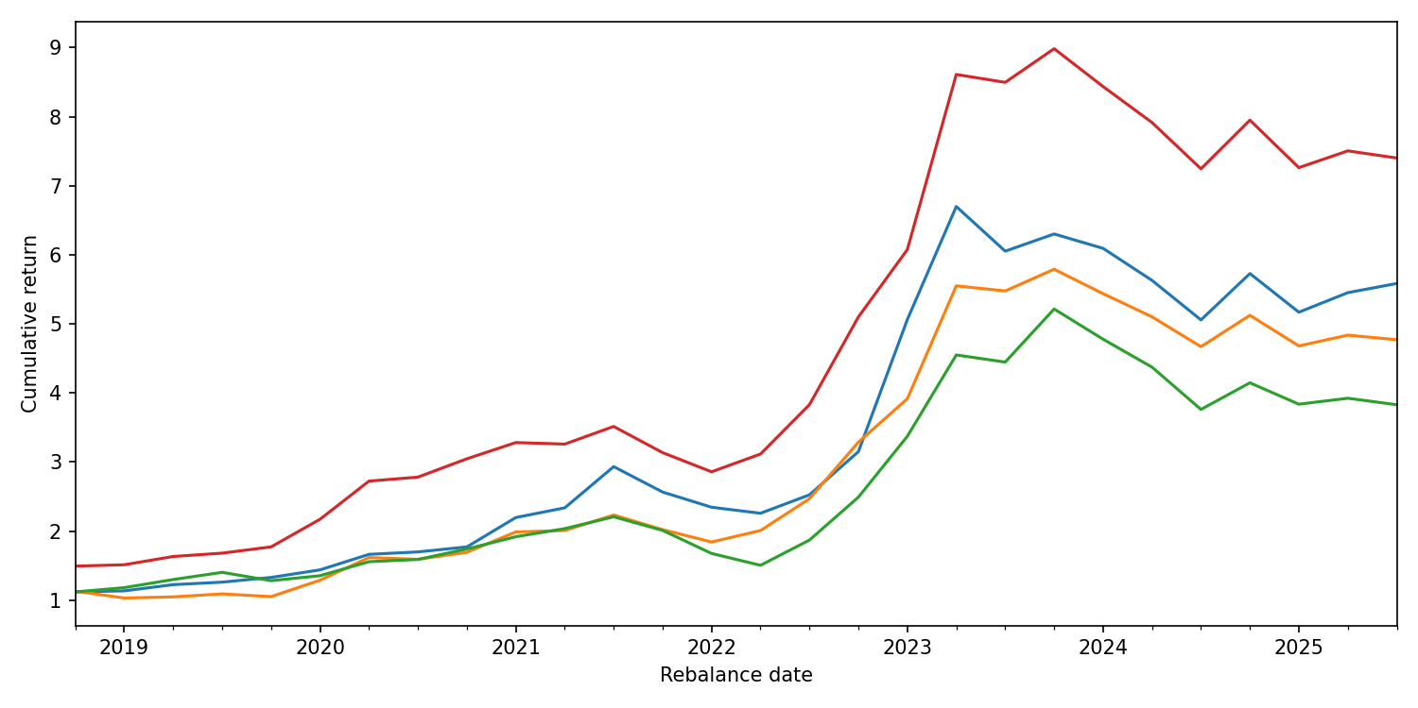
Figure 13. Cumulative return of Block 3 strategies
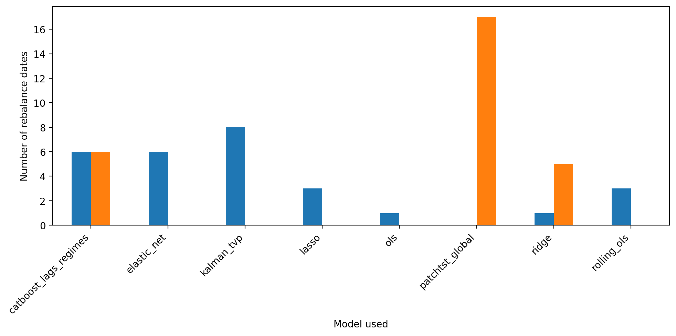
Figure 14. Distribution of models used by selector strategies
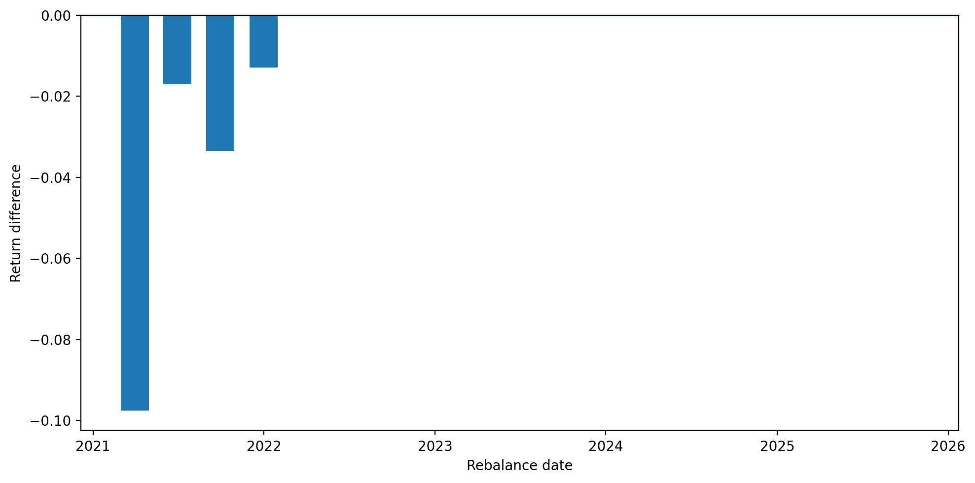
Figure 15. Return difference between selector_rule_based and always_transformer after 2020
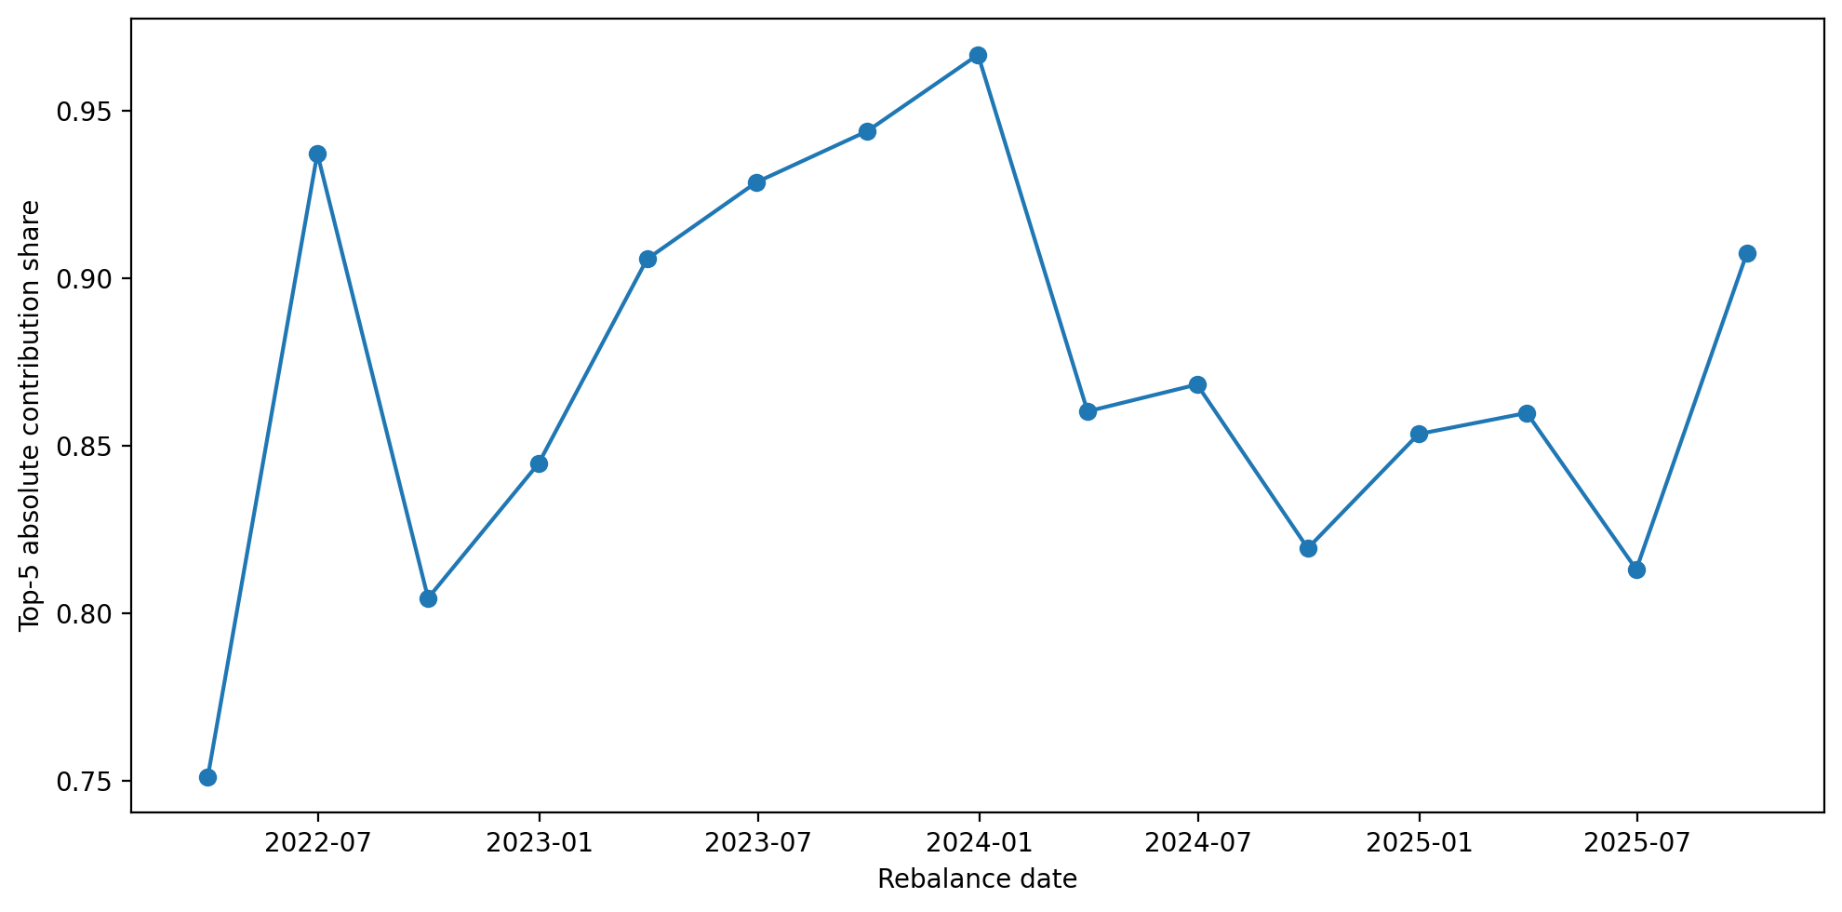
Figure 16. Share of the five largest absolute contributions during PatchTST selection periods

