Name: Ngô Lê Thiên Ân

ID: ITITWE21117

**WEB APPLICATION DEVELOPMENT**

**LAB 3**

**Exercise 1**

* Form at initial state

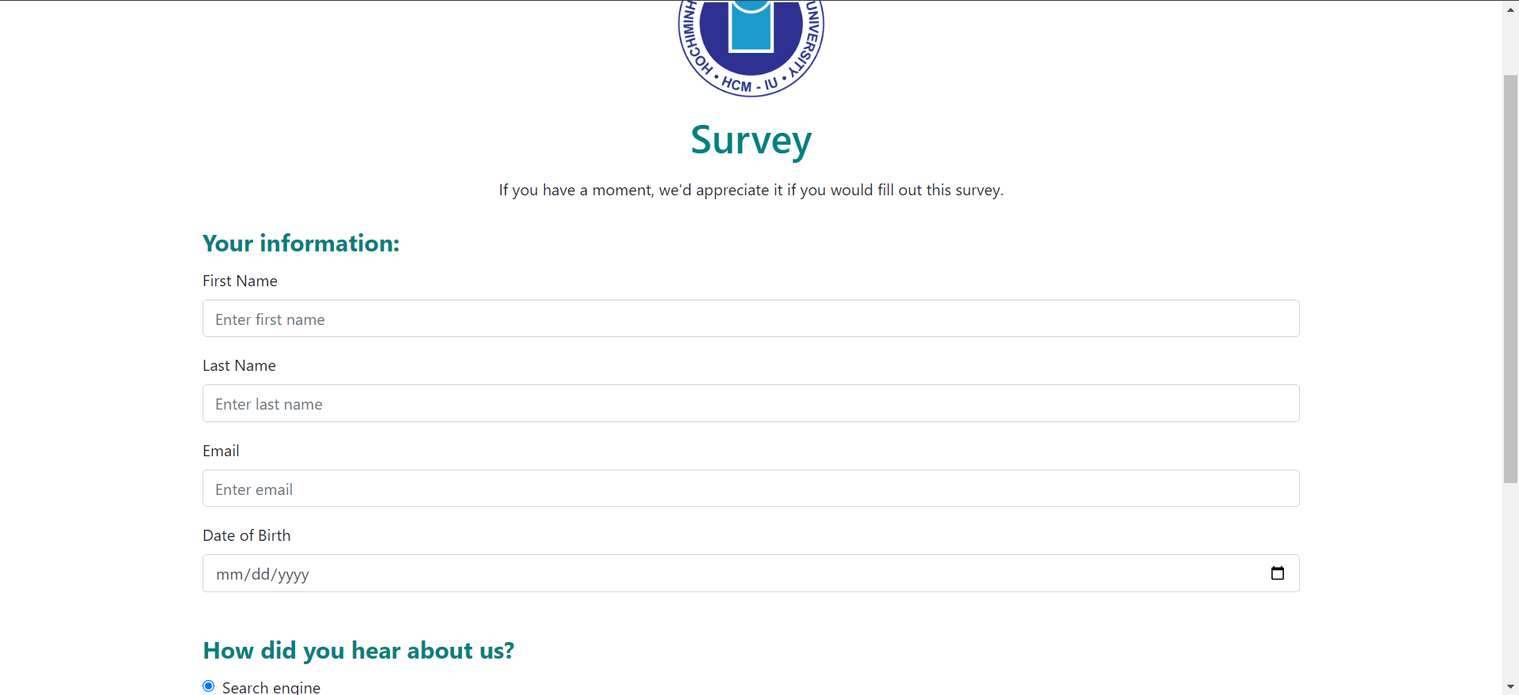

* Form after filling information

* The result page after clicking the Submit button

**Exercise 2**

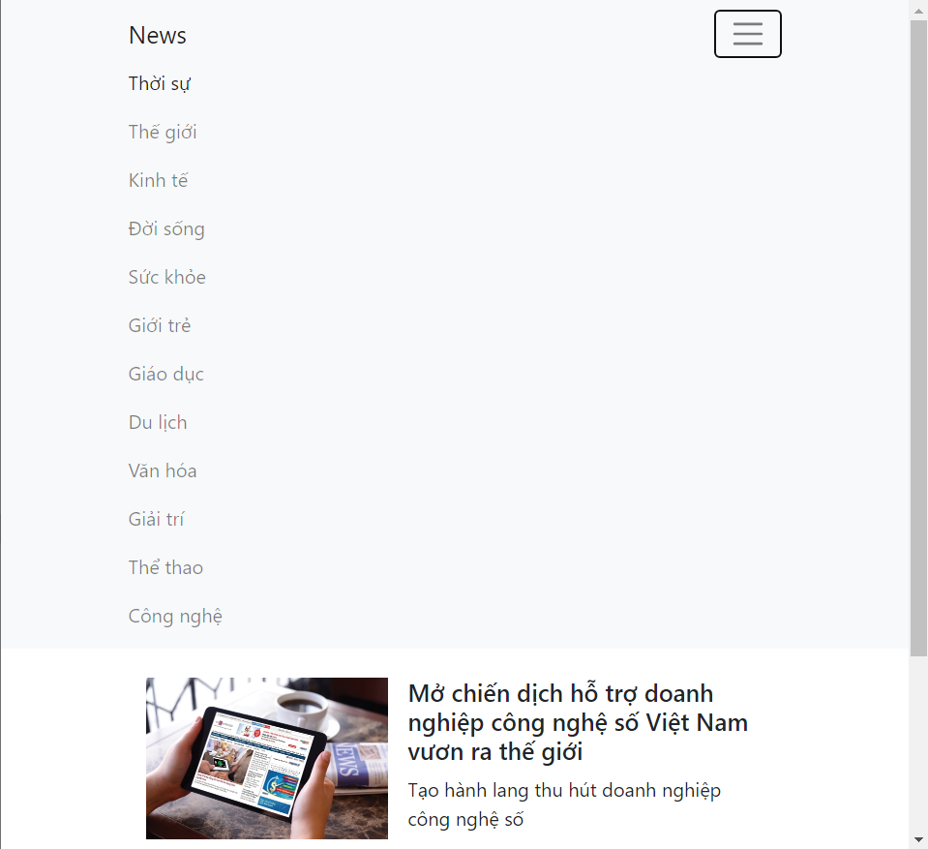

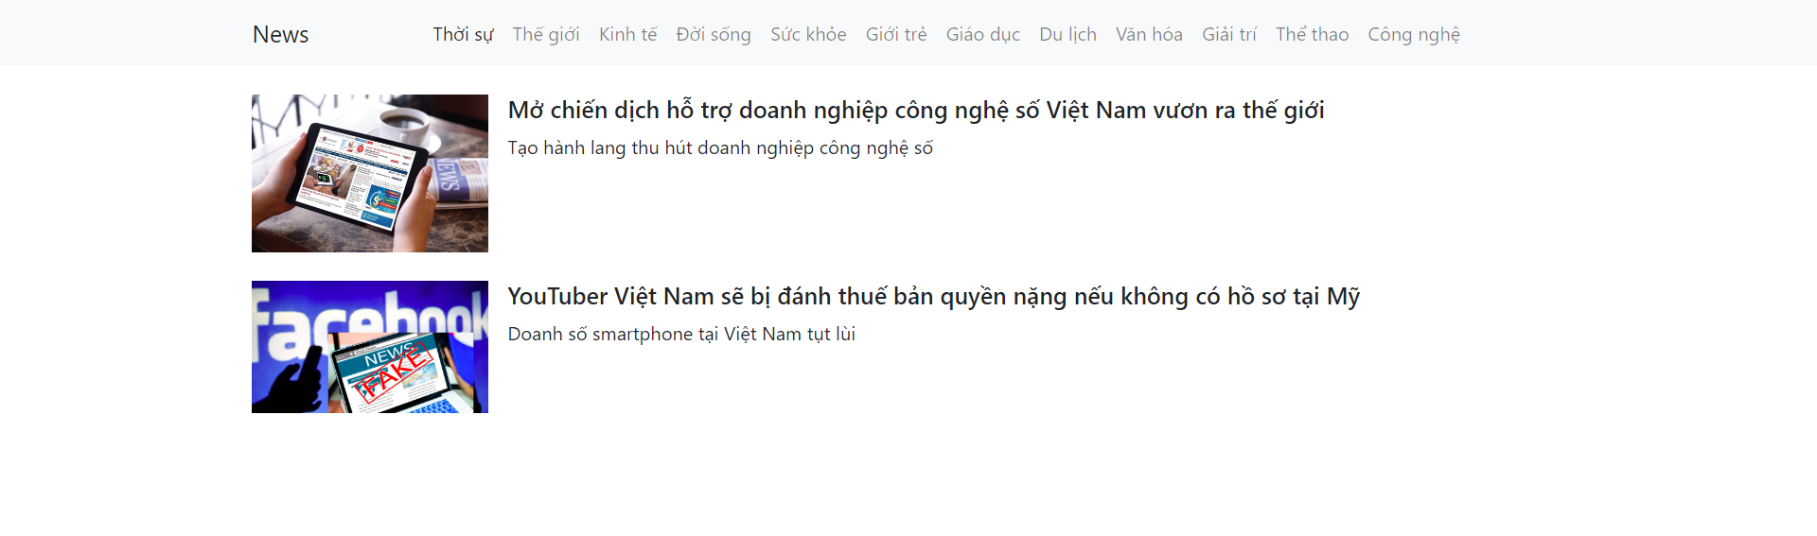

**Exercise 3**

**Exercise 4**

**Exercise 5**

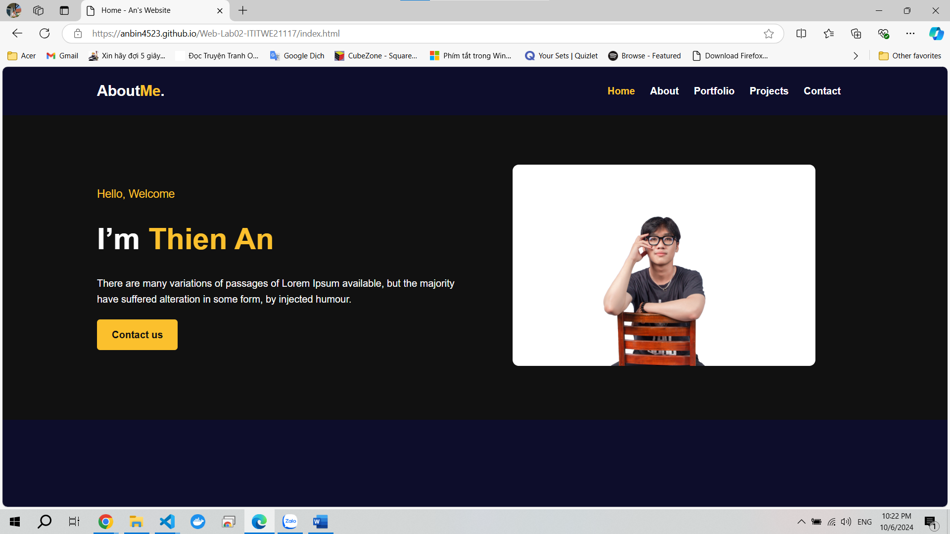

Link github: <https://github.com/AnBin4523/Web-Lab02-ITITWE21117>

Link website: <https://anbin4523.github.io/Web-Lab02-ITITWE21117/>