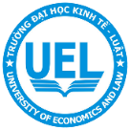**University of Economics and Law**  
  
 Faculty of Information Systems

Project Report

**ANALYZE THE PROCESS OF ERP IMPLEMENTATION OF TH TRUE MILK AND PROCESS NEW   
TECHNOLOGY SOLUTIONS**

|  |  |  |  |  |
| --- | --- | --- | --- | --- |
| **NO.** | **Full name** | **Student ID** | **Role** | **Email** |
|  | Mai Nguyễn An Bình | K184060777 | Leader | binhmna18406c@st.uel.edu.vn |
|  | Trần Kim Giao | K184060783 | Member | giaotk18406c@st.uel.edu.vn |
|  | Hoàng Nguyễn Quỳnh Hương | K184060789 | Member | huonghnq18406c@st.uel.edu.vn |
|  | Trương Thị Tuyết Nga | K184060795 | Member | ngattt18406c@st.uel.edu.vn |
|  | Nguyễn Thị Thu Thảo | K184060804 | Member | thaontt18406c@st.uel.edu.vn |

**May 2020, Ho Chi Minh City**

CONTENT

TH TRUE MILK 4

1. About the company 4

1.1. General Introduction 4

1.1.1. Vision and mission 5

1.1.2. 5 core values of TH Group 5

1.1.3. Genetic 5

1.2. Identify and explain the implementation process of this ERP systems 5

1.2.1. SAP SuccessFactor: 6

1.2.2. Afimilk dairy farm management system: 7

1.2.3. Acumatica Financial and Distribution Management 8

2. Compare to ERP of Vinamilk 9

2.1. Company introduction 9

2.2. ERP system implementation process 10

2.2.1. Information Technology 10

2.2.2. Human resources 10

2.2.3. Budget situation 11

2.3. Conclusion 11

2.3.1. Benefits and successes achieved 11

2.3.2. Limitations and Difficulties 11

3. Existing problems and challenges 12

3.1. Porter’s Five Competitive Forces of TH True Milk 12

3.1.1. Power of suppliers 13

3.1.2. Threat of substitutes 13

3.1.3. Power of buyers 13

3.1.4. Threat of new entrants 14

3.1.5. Intensity of rivalry 14

3.2. Problems and challenges come from the company itself and/ or from the Porter’s 5 Competitive Forces 14

3.2.1. About power of suppliers 14

3.2.2. About power of buyers 15

3.2.3. About the branch system 15

4. Solution 15

4.1. Recommend the solutions 15

4.1.1. TH True Milk continues cooperating with Acumatica 15

4.1.2. Microsoft Dynamics 365 16

4.1.3. SAP Cloud Platform 18

4.2. Solution choosing 19

4.3. How will the chosen solutions help the company dealing with Porter’s 5 Competitive Forces? 20

4.4. Business values new systems bring to the company? 21

4.4.1. Business values new systems bring to the company 21

4.4.2. The company solving problems and overcome challenges 22

4.5. Steps involved in the systems implementation 22

4.5.1. At the beginning 22

4.5.2. Build together, complete the solution with Acumatica 23

4.5.3. Trial deployment 23

4.5.4. System-wide application 23

4.6. The challenges involved in the implementation process? How to overcome them? 24

5. Project Evaluation Process 24

5.1. GANTT chart and PERT chart 25

5.1.1. Task table 25

5.1.2. PERT Chart 25

5.1.3. GANTT Chart 27

5.2. Table Assignment 28

5.3. Evaluate the project planning and execution process 30

5.4. Final evaluation 30

**REFERENCES** 32

TH TRUE MILK

# 1. About the company

## General Introduction

The TH Milk Food Joint Stock Company as part of **TH Group** which was established with the financial advisor of North Asia Commercial Joint Stock Bank is a well-known brand in dairy industry of Vietnam. Processing and UHT milk is their major business. The company is famous for advanced management system and integrated production processes, synchronized by international standards from planting grass, building barns, cattle feed processing, management veterinary control, processing and packaging, to the distribution of products to consumers.

Their goal to become clean milk and UHT milk supplier in Vietnam and at the same time develop chain convenience stores called TH True mart to provide clean fresh produce from Farm TH, safe and high-end products for consumers.

The first milk production project in the northern central region on December 26 launched its maiden product line TH True Milk on the local market.

The production project of TH Milk Company has an investment of US$1.2 billion.

The company has imported 10,000 cows from New Zealand, Uruguay and Canada, and produced pure milk processed by equipment and advanced technology from Israel.

The farms and the milk plant are based in the province's remote Nghia Dan district, an area that many experts mistakenly thought did not have the right natural conditions for dairy farming.

"Raising a cow can benefit farmers more than one hectare of rice cultivation can. I believe this milk project will change the local rural facade and economic structure," Deputy Prime Minister Truong Vinh Trong said at the launch ceremony.

Thai Huong, general director of Bac A Bank, the project investor, said the economy would benefit from the project. At the ceremony, the company donated VND9 billion (US$418,604) to build a cemetery for local war martyrs and offered milk valued at VND3 billion (US$139,534) to local poor children.

### Vision and mission

The TH Group aims to become the Vietnam’s leading manufacturer of dairy products. Today TH Group is the second-ranked dairy manufacturer, behind Vinamilk JSC, in Vietnam. The objective of the company is to meet 50% of the national milk demand by 2020. The core of the strategy of the group is anchored in the concept of “True Milk” or “True natural Milk”, i.e. it does not use powder milk for processing The company is proud of the fact that: All products are made from “fresh clean pure milk” produced in the TH commercial farm. For this reason, all the products are sold under the brand “TH True Milk”.

### 5 core values of TH Group

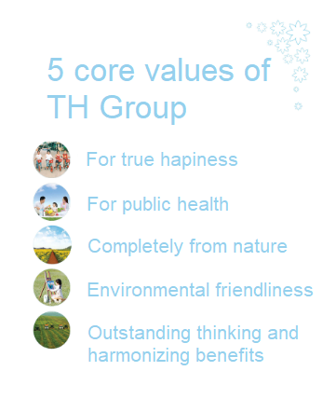

### Genetic

Genetic TH group imports dairy cows from several countries: Australia, New Zealand, Uruguay, Canada and United State. No reference to China.

## Identify and explain the implementation process of this ERP systems

When it comes to the health and happiness of the people of Vietnam, few companies are as dedicated to the nation’s progress as TH Group. Best known for TH true MILK brand dairy products, the company is also active in sugar production, pharmaceuticals, herbal products, field crops, medium-density fiberboard and plywood, educational services, and healthcare. To keep up with rapid growth and manage a complex workforce spread over eight businesses and five geographical areas, TH Group needed ERP.

In 2010, at HCMC, Dairy Food Joint Stock TH Company (TH Milk) officially signed with IBM and CSC to launch the 5-millions-USD-project deploying enterprise resource planning system (ERP, using SAP software version ECC 6.0. Solution ERP of SAP is a corporate governance model based on analyzing overall system, allows the moderator operates and uses sources of the enterprise in the most effective way. The management by information technology applications is becoming popular in the world, helps the enterprise managing effectively their sources. The company CSC (NO.3 in the world) was chosen as consulting partner and IBM as hardware solution provider. After that, TH also deployed softwares like **SAP SuccessFactor, Afimilk dairy farm management system, Acumatica Financial and Distribution Management.**

### SAP SuccessFactor:

* The strategic approach to the effective management of people in a company or organization so that they help their business gain a [competitive advantage](https://en.wikipedia.org/wiki/Competitive_advantage).
* Provider: SAP SE (US)
* Purpose: maximizing the productivity of an organization by optimizing the effectiveness of its employees.
* How?
* SAP SuccessFactor digitize all employee and salary data, which get real-time reports on all aspects of HR, from tax reporting to social insurance report. SuccessFactor app on mobile phones, tablets, computers are convenient for TH Group to know which employees have met their weekly or monthly business targets.
* SAP SuccessFactor integrates key tasks such as introductory training for new employees, collaboration and social networking tools, training management system, management performance,...The advantage is use easily, quickly and still provide all necessary information to analysis for managers.
* SAP SuccessFactor is the best solution to boost the overall productivity of TH Group, while improving employee satisfaction and efficiency in personnel management as well as shortening the time for internal approval.
* Result:
* Enabled HR management, based on proven best practices.
* Centralized payroll and fully digitalized personnel data and attendance tracking.
* Made performance much easier to manage and monitor by giving line managers personalized dashboards.
* Helped make TH Group an award-winning employer of choice in Vietnam.

### Afimilk dairy farm management system:

* Provider: SAE Afikim (Israel)
* (What?) Afimilk dairy farm management system is one of the most modernist farm management systems in the world. This system includes: Afifarm management program, Afimilk milking rig management system, AfiAct automatic estrus detection system, Afisort (cattle classification), Afiweight (automatic scale), Afifeed (program the diet).
* (Purpose?) The Afifarm system can help TH manage herds, classify those cow groups, detect heat early and especially mastitis - the most common disease in dairy farming, which can reduce productivity, reproductive capacity or even kill cows if not treated promptly.
* (How?)
* Afifarm is an easy-to-use ERP software specifically for dairy farms. It is an effective tool for managing daily activities and long-term strategic planning. The system implements information collection automatically and provides comprehensive analysis reports covering factors such as: yield, health, fertility, nutrition, etc…
* Cows are worn a chip tag (Afitag) on their feet for close monitoring of health and milk production. The chip tag is an electronic device with many features in collecting data related to the health and condition of each cow, but the most outstanding is the ability for data to detect mastitis early on clinical.
* (Results): Supporting perfectly for the production of the cleanest, safest and most refined milk lines from nature. Reports with complete parameters help experts devise appropriate treatment research protocols.

### Acumatica Financial and Distribution Management

* + **Defines each system, who provides it?**

In 2013, TH Milk decided to invest in a centralized Acumatica Cloud ERP platform. Assisted by DMSpro, an Acumatica Gold Certified Partner, TH Milk deployed the enterprise edition of the Acumatica Financial and Distribution Management suites onto its own private cloud and there is no problem integrating the Acumatica platform with TH’s existing ERP software with SAP.

* + **The purpose of the system?**

To track their sales force and get real-time information from sales. The data will also allow TH Milk to measure distributors' sales performance and capacity.

* + **How does this system work?**

Salespersons synchronize their sales data with TH Milk’s server via the AiM app. This allows them to receive new pricing or sales promotion information without spending 30-60 minutes to update information like before. They also obtain specific purchasing information for each outlet, enabling them to recommend the right products and quantity for each retailer. Once orders are confirmed, the salespersons log them on the AiM app. The orders are immediately relayed to TH Milk’s server. Instead of waiting till the end of the day for sales orders to be relayed, TH Milk is now able to track every new order in real-time.

 Loaded with DMSpro’s AiM (All-in Mobile) application and leveraging nationwide 3G coverage, mobile devices brought real-time sales force automation to the fingertips of TH Milk’s salespersons, fully integrated with Acumatica.

**Result:**

* + - * When salespersons spot a competitor’s product on sale or on display, they alert TH Milk with a touch of the button. Now, with the web-based Acumatica platform, TH Milk knows how much product retailers are selling, and how much stock there is at outlets and distributors’ warehouses. This real-time visibility enables more accurate production planning, and helps optimize inventory costs across its warehouses nationwide.
      * TH Milk’s sales supervisors can monitor their salespeople’s activities online, see which outlets have been visited, and view the orders taken. This enables supervisors to identify which salesperson needs more help to achieve their targets.

# 2. Compare to ERP of Vinamilk

## 2.1. Company introduction

"Vinamilk", this brand of milk was voted a "Floating brand" and was one of the 100 strongest brands voted by the Ministry of Industry and Trade in 2006.

Business lines and main products: producing and trading canned milk, powdered milk, nutritious powder, cakes, fresh milk, soy milk, soft drinks and other dairy products. In addition, the company also deals in food, chemicals, raw materials, real estate brokerage, warehousing business, transportation business,...

## ERP system implementation process

### Information Technology

* In order for the product distribution system to be effective, Vinamilk has applied three international ERP solutions of Oracle, SAP and Microsoft. Vinamilk wishes that this is a tool to support employees in their work, allowing Vinamilk worldwide distribution network to be connected to the data center. That data source helps businesses to accurately support the planning, respond to information promptly, bring satisfaction to customers.
* Before deploying SAP CRM, enterprise information is gathered manually. Currently, the Information and Reporting Intelligence System (BI) is set up in the data center to manage sales distribution channels and promotions. Distributors can use SAP, Solomon by accessing the Internet and agents using PDAs to record transactions. This process assists employees to improve their capacity, professionalism and the ability to capture information.
* The enterprise has integrated daily data from distributors to employee mobile PDAs into server systems running SAP CRM software. Here, employees can analyze the status of inventory, revenue, liabilities of each distributor. At Vinamilk, Netweaver is integrated with Oracle's ERP Information System along with Solomo system used in employee PDAs. These three applications, integrated into the Business Warehouse (BW), help to report quickly and accurately and have an overview of the business.

### Human resources

* The company has a deployment orientation to train human resources, operate the system by sending a qualified and capable person to specialized training. Leadership motivates and trusts for employees. In addition, to improving knowledge for employees, the company needs to know more about the situation and status of employees to be able to ensure that the company's human resources are really effective.

### Budget situation

* Vinamilk spent huge amounts of money to invest in the IT Department from the purchase of hardware, software, infrastructure to training quality human resources to effectively use these tools.

=> ERP helps the company strictly implement, avoiding risks in accounting work; With Decentralization, clear authority, financial work - accounting is much more convenient than before. Warehouse management, distribution, business administration, customer relations and production processes have been better managed by the company, significantly reducing risks; between sales and distribution is more rhythmic, more flexible; The tracking functions are carried out in real time. The level of information technology staff at Vinamilk has been more advanced than before.

## Conclusion

### Benefits and successes achieved

* In terms of organizational structure, the company has improved the qualifications of its employees, the system has met the needs of users, the management has become easier.
* Vinamilk's products have grown in the international market, thanks in part to an effective management system of distribution channels.
* Vinamilk has agreed on the processes with distributors according to requirements such as price management, sales promotion, planning and operations of PDA salespeople.

### Limitations and Difficulties

* Pythis did not really meet the needs of Vinamilk, so it forced Vinamilk to buy software from Oracle and SAP to continue to improve. This increases deployment costs and also reduces the likelihood of assimilation
* "Huge" investment costs: ERP is expensive for businesses. Not only investments in equipment, hardware, software and infrastructure systems but also human capacity. The software regularly updates new versions so it requires the cost of equipment and, most importantly, the human level.

# Existing problems and challenges

## Porter’s Five Competitive Forces of TH True Milk

Warrant Buffet, the most successful investor of the 20th century, mentioned his idea of a company's moat in the talk about investing. The moat is a simple way of describing a company’s competitive advantages. Company with a strong competitive advantage has large moats and therefore higher profit margins. One of his methodologies called the Porter’s Five Forces Analysis. Any business, including TH True Milk needs to find out its X- factor that makes a difference with other competitors. It can be said that enterprises often use this model to analyze whether they should join in one market or run the business in other market. In the case of TH True Milk, its staff determines that dairy market is a fierce competition, therefore, before making a decision to compete against strong rivals, TH True Milk needs to make sure that the company is owning a X - factor which helps the TH Group become a winner. And this model will give a hand to discover it.

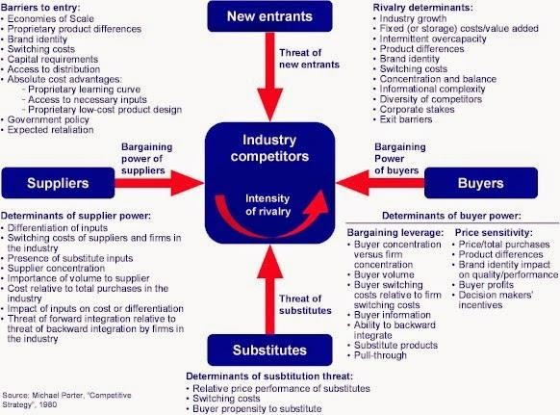*Porter’s Five Competitive Forces of TH True Milk*

### Power of suppliers

As the origination of dairy products from TH, the cows are imported from overseas countries like Canada or Australia. Some of them are affected by animal disease such as BSE (2011) in which leads to lots of consumers skeptical about the quality and safety of the products. Moreover, Viet Nam has a humid monsoon tropical which will create some challenges for the dairy industry. Thus, the change in climate will cause trouble for the imported cows even in the high conditions of TH farms and milk will be rot or easy to be denatured if it is not preserved or treated in time. Besides, the climate is also an advantage. It makes a great condition for growing plants. The rising cost in feeding and taking care of these cows will not be a small number. From a different point of view, like other industry, the unpredictable rise of petrol (in transportation of milk) and equipment will require TH a fully prepared financial support to both maintaining the current system and bring consumers best quality milk. According to demand and supply theory the price as a consequence will be raised as well. Therefore, TH should have suitable adjustment in pricing to both cover the cost and ensure the firm’s profitability.

### Threat of substitutes

Food and beverage industry in Vietnam is growing very fast and variety with many kinds of products such as yogurt, C2, soymilk, caramel, sweeties, mineral water…The threat from substitute products is not high as milk is a drink full complement of essential nutrients for human needs. In fact, Vietnamese people perceived dairy products is as essential as rice. Regarding nutrient level, they prefer fresh milk to juices or carbonated drinks. Thus, threat of substitute products is low. However, market share competition can be seen among products in the industry. For example, soy milk or other products like cereal or cocoa may pose threat to liquid milk product’s market share, or the functional products, although, the functional products are very expensive.

### Power of buyers

Users have a significant power on companies’ product quality. There are a variety of dairy products available, which can be substitutes for each other. Price is not the most important factor to consumers in their consumption decision. Therefore, companies have to compete with each other by the quality of product and brand power, before competing by price.

### Threat of new entrants

Open economy and upcoming free trade agreements are positive signs for new entrants. Customer loyalty to established brands is quite strong. Each company has its own brand, its own characteristics that make different for firms in the same industry. Unless the new entrant can create a great product differentiation, it cannot win the customers from existing dairy companies. More importantly, technology in dairy industry is well updated, not only in foreign companies but also in domestic companies thanks to government supports. Better technology leads to better product quality so that existing firms has a big advantage against new entrants. In the future, the company TH True Milk will be able face new competitors from overseas market due to the economy and the outstanding technical, capital and inputs. Hence competitive pressures will increase from potential rival new features.

### Intensity of rivalry

Competitors’ evaluation is crucial whenever a company enter a market. International market, certainly, implied more competitiveness than the domestic one. In Vietnam, in competition with TH, there is likely to be Vinamilk a huge rival. Vinamilk in domestic milk market is well known for its strong brand which is familiar to everyone in Vietnam while TH is aimed to upper class in society with high standard products. Nonetheless, overseas market is a huge playground for milky brands and TH at that time will have much more rivals to take into consideration when operating, Nestle, Dutch Lady and so on from this point with more experienced in international market will turn into their biggest difficulties. Hence, TH is needed a fully analysis of their rivals and suitable research in which set the stage for their further strategy in promoting TH Brand. In conclusion, whether it is international marketing or domestic marketing, companies are required to have clear understanding and realizing the current situation of the place they are in and utilizing the nature of markets, turning demerits into merits are needed for firms to succeed.

## Problems and challenges come from the company itself and/ or from the Porter’s 5 Competitive Forces

### About power of suppliers

The problems come from the imported cows caused by the humid monsoon tropical climate will strongly effect on the quality of the TH Milk. Besides, the unpredictable rise of petrol will challenge TH Group to adjust the right price to guarantee the profitability and also the milk quality.

### About power of buyers

There are variety of products available on the market. And the price is not the only thing consumers think about when they make consumption decision. TH True Milk must have a clear plan to compete with the strong and perennial dairy food like Vinamilk, Nutifood,… in Vietnam while these companies already have trust from consumers.

### About the branch system

The TH True marts are growing so fast but its popularity is not spread out among the community. Consumers usually choose to buy TH goods at the market or the supermarket instead of going to the TH True marts. The reasons of this problem firstly come from the lack of flexibility in supplying all items of TH True Milk for the consumers, secondly that the marketing and management for the branch system of TH True marts are not deployed using ERP systems like others stages. TH True Milk is discussing with DMSpro to solve this trouble.

# Solution

## Recommend the solutions

While TH Group has been choosing a cloud computing system of Acumatica for tracking their sales force and getting real-time information from sales places, but has not deployed ERP system to manage their branch system. We have some suggestions for this case.

### TH True Milk continues cooperating with Acumatica

* Pros
* Flexible Deployment Options: Acumatica gives users complete control over how they would like to deploy the software. You can buy it as a SaaS subscription, so that all you need is a computer or smartphone, no bulky, expensive servers required. If you’re in a highly regulated industry, or a SaaS subscription just isn’t your speed, you can also choose to set the system up on your own servers. Or, you can find a hosting partner to run the system on their servers, allowing you to access it on the go, just like with a SaaS subscription.
* Easy to Use Interface: Built for the web, Acumatica’s windows always look the same, no matter what device you are using (computer, tablet, or smartphone).
* Ready to Grow with Your Business: With Acumatica, you can easily add additional functionality such as distribution, customer relationship management, project management and human resource management, at any time. The best part is, as you add more modules they’re all interconnected, meaning that you always have a single source of the truth. You never have to wonder if the data you’re looking at is incomplete or out of date.
* Industry-Standard Customization Tools: It is built using the common development tools C# and .NET. So, there’s no proprietary knowledge needed to customize the software.
* Flexible Upgrade Schedule: Acumatica does not require its customers to upgrade on a set schedule.
* Pay Only for What You Use: The cost of Acumatica is different for each customer. Your exact price is based on several factors, including which modules you are using and how many transactions your company does in a day.
* Cons
* Pricing Can Seem Confusing: As I mentioned earlier, Acumatica has a pricing structure all its own. So, if you have used other ERP products in the past, you may find the pricing scheme a little difficult to follow at first.
* Lots of Features and Customization Options Make Implementation Seem Daunting
* Pricing
* Acumatica Cloud ERP pricing **starts at $13000.00 per year**. They do not have a free version. Acumatica Cloud ERP**does not offer a free trial**.

### Microsoft Dynamics 365

Microsoft Dynamics 365 is a repackaged software developed from Dynamics CRM Online tool and eventually broken down into individual applications.

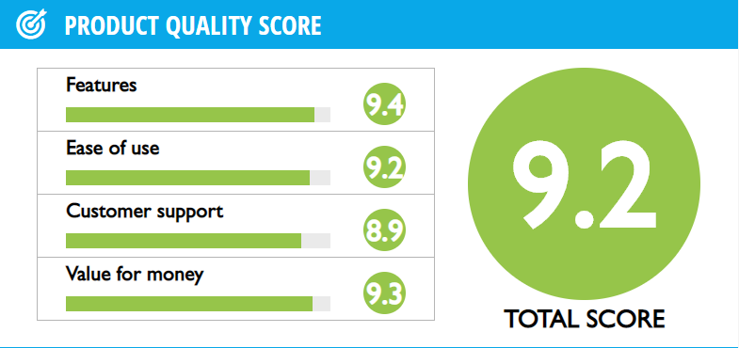

* Pros
* What makes the software unique is that in a single cloud service, ERP Dynamics and CRM solutions are combined. You can also do some customization in Microsoft Dynamics using Flow and PowerApps. You can create mobile applications with PowerApps while the Flow workflow engine can be used to connect applications from third-party providers.
* Microsoft Dynamics 365 consists of integrated tools that enable companies to perform tasks such as field service automation, sales growth, improvement of mobile device operations, lead tracking, and enhancement of various cloud-based business apps.
* The product has a wide range of apps for Android, Windows Phone, and iOS devices. These can be used offline so that you can continue your work even if there is no Internet connection, but data is automatically synchronized once the connection is restored.
* Microsoft Dynamics 365 integrates seamlessly with OneNote, Word, SharePoint, and other Microsoft applications. With these integrations, you can reduce dual entry and save time.
* The mobile app of Microsoft Dynamics 365 has been improved to provide you with a platform to do some personal customization that would help you complete tasks quickly. It shows a list of priorities so that users will be reminded of the important tasks to be completed.
* Cons
* As access to information, or access to particular sections of the tool, can be restricted for some users by the main admins, this can be frustrating as not all team members have access to the same information. This means that admins must build more strategy around how the tool will be used.
* The cost and licensing document for Dynamics 365 is 61 pages and will take a rocket scientist to understand it. It's better to just have your Microsoft help estimate the cost if they are willing to help you that.
* Microsoft Dynamics can be slow at times, due to how much data it contains. This is a minor inconvenience at best, but it can be frustrating.
* Pricing

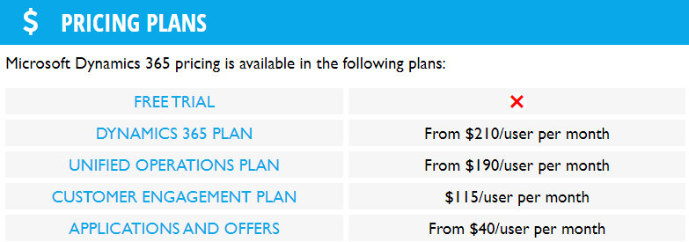

### SAP Cloud Platform

* Pros
* Reuse library: We can understand The Reuse Library as a container of Reuse functions. You can create and define your reuse libraries and custom reuse functions to better organize complex code in your solution.
* Easiness of creating screens (UI) for business object + UI Designer: We like the ease of creating screens for custom business objects. As a big plus, we consider UI Designer, which is directly integrated into SAP Cloud Applications Studio. This tool is used to design the user interface.
* Easiness of creating a data source for reports: Creating a data source is easy, as you can create it directly from a business object. The wizard is very intuitive and helpful in creating a data source for your business object.
* Cons
* Some processes in SAP can be confusing due to the various tabs and options you have within. Also it can be very slow depending on how large the order is.
* Complexities.
* Security is not easily integrated with other SAP authorizations and is not providing full configuration flexibility.
* Pricing

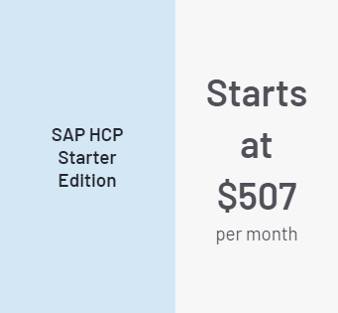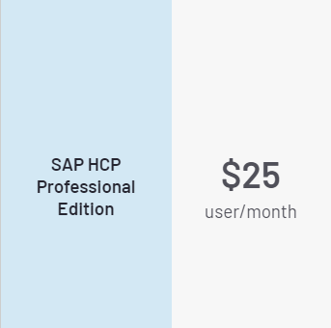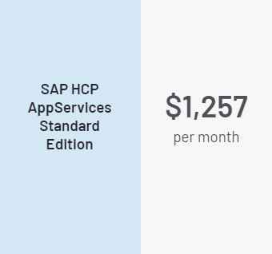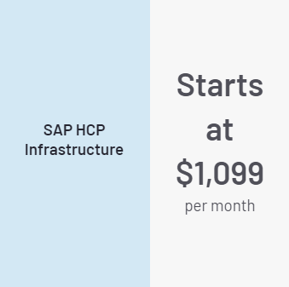

## Solution choosing

While the TH Group has already cooperated with DMSpro to implement Acumatica Cloud ERP platform for tracking sales force and getting real-time information from sales, continuing choosing Acumatica for upgrading their management on the branch system is a better idea than all of the others. Firstly, because of savings money. Implementing a whole new system will cost the company a large sum of money. Secondly, when a new system applied to the company, it will take long time to train the staffs using the new system competently. Finally, while TH is very comfortable with DMSpro by how they work, keep transacting with them can be more convenient.

## How will the chosen solutions help the company dealing with Porter’s 5 Competitive Forces?

* *Low-cost leadership*

Produce products and services at a lower price than competitors by achieving lowest operational costs. A low cost producer must find and exploit all sources of cost advantage.

* *Product differentiation*

In a differentiation strategy, the company enabled new products or services, greatly change customers’ convenience and experience and seeks to be unique in its industry along some dimensions that are widely valued by buyers.

* *Focus on market niche*

Use new system to enabled a focused strategy on a single market niche or specialize. In adopting a narrow focus, the company ideally focuses on a few target markets (also called a segmentation strategy or niche strategy). These should be distinct groups with specialised needs. The choice of offering low prices or differentiated products/services should depend on the needs of the selected segment and the resources and capabilities of the firm. It is hoped that by focusing your marketing efforts on one or two narrow market segments and tailoring your marketing mix to these specialised markets, you can better meet the needs of that target market. The firm typically looks to gain a competitive advantage through product innovation and/or brand marketing rather than efficiency.

* *Strengthen customer and supplier intimacy*

Use new system, information systems to develop strong ties and loyalty with customers and suppliers. Customer intimacy is the largest source of company growth, sustainable competitive advantage, and profit. Everyone in organization should practice it. Customer-intimate companies bring an entirely fresh perspective.  In the integration of operations, suppliers become more than merely useful Strengthen Customer and Supplier Intimacy: apply information systems to tighten long-term relationship and create brand loyalty with customers and suppliers, including increasing switching costs.

## Business values new systems bring to the company?

### Business values new systems bring to the company

*Saves time*

* The need for quick information is a major challenge facing organizations as they run their operations. In a bid to make crucial decisions and execute business operations efficiently, prompt access to all essential information is a necessity.
* Eliminate delays through automated sales order processing and shipping order generation. Set rules to manage multiple warehouses, returns, credit limits, drop shipments, and more.

*Improve customer satisfaction while minimizing cost*

* A new system enables managers to have a detailed look at every customer relationship and ensures that communications with their consumers are timely, informative, and efficient. The more information you have, the better you can fulfill the needs of the customer.
* Efficiently manage distribution processes with real-time visibility of available inventory, inventory in transit, reorder quantities, and inventory costs. Minimize inventory and costs; optimize quoting, acceptance, order entry, and fulfillment.

*Strengthen performance of business*

* To survive an omnichannel business environment, it makes sense to synchronize all the input from your business into one system. The company have the ability to increase or decrease inventory, change lines according to customer spending trends, seamlessly introduce new products, and re-analyze costs. The system will also streamline business processes and make it easier and more efficient for companies to collect data regardless of the department.

*Increased productivity*

* Less time is wasted guessing what to order, design, ship or purge. More time is spent implementing new strategies, adjusting inventory, and planning new lines based on what your customer is reacting to right now.

*Security*

* New system improves the security of all data. Data is as secure as you deem fit, with a customized solution that meets your business requirements.

### The company solving problems and overcome challenges

This solution is worth to replace old systems with new ones.

TH Milk should choose this solution because of the following reason:

* Standardized sales performance, increasing productivity among sales staff and office.
* Allows TH True Milk to track its sales force and get real-time information from sales.
* Allows TH Milk to measure distributors' performance and sales capabilities.

With solution, TH Milk can know how many product retailers are selling, and how many are available in stores and distribution warehouses. This real-time visibility allows for more accurate production planning, and helps optimize inventory costs across the nation's warehouse.

## Steps involved in the systems implementation

### At the beginning

Create a project launch document to define project management. In this step, TH True milk should understand clearly their ERP system, determine the goals that the new system will achieve. Besides that, TH milk specifies the problems or difficulties with the old one. Then, TH True milk also needs to control the budget. Because the costs may change continually and exist some additional expenses. So they need to plan their budget in advance.

Complete the project schedule. Details of the system implementation step by step should be clearly designed in the schedule and prevent arising situations to ensure the project goes on schedule.

### Build together, complete the solution with Acumatica

***Moving data:*** First, TH milk need to consider the data they want to migrate to the new ERP system. This will probably cost more and take more time. Not to mention there will be many risks in the process of data conversion. Conversion of any form of data needs to be carefully considered in terms of benefits, time, and project impact and costs. The final data issues should be completed many months before going into ERP implementation.

This is the stage of applying the management business processes to the actual system. Any business processes that do not meet their need have to be changed to be able to manage effectively, Acumatica must be adjusted.

For large enterprises like TH true milk, there is a barrier that affects the efficiency of system deployment. It is a requirement to develop a company's features that are not clear, often described at a general level or internal disagreements about the features that need to be developed and repaired many times. Therefore, when building a description of the features to be developed, TH True milk needs to have unification at all levels and departments and regularly check and coordinate with Acumatica to offer the best solution.

### Trial deployment

After the solution has been completed, all data has been put on the system, TH True milk needs to undergo a "trial" step to evaluate the effectiveness, stability and re-adjust it before deploying to all areas.

### System-wide application

After the trial deployment process, TH Milk and Acumatica need to evaluate the effectiveness of applying DMSpro, including: evaluating all business processes performed on the system and assessing the level of response and feasibility of the solution.

However, to be able to deploy on a large scale, TH True milk needs to have an extremely specific plan and widely notify all employees and departments. Due to the fact that many businesses have abandoned technology products after construction, not because of ineffective software but from the company's internal, such as the opposition of the staffs.

## The challenges involved in the implementation process? How to overcome them?

TH True Milk decided to continue cooperating with DMSpro from Acumatica and combine with SAP SE to further improve the management of their branch system. This reduces the ability to assimilate, the relationship between the information in the software, leading to a decrease in the correct performance for decision making. Therefore, each company needs to keep a close eye on the offers that it makes. The company should compare, network, and weakness of each proposal to make effective decisions for each moment and each business of the company.

"Huge" investment costs: TH True Milk is expensive for businesses from deploying a new system. Not only invest in equipment, hardware, software and infrastructure systems. Acumatica has asked for a high price for a proposal to manage branch system. TH True Milk needs to have a lot of capital by calling for capital, asking for investment, selling stocks, ...

Besides, the implementation of manage their branch system needs both human capabilities. TH True Milk employees need to have a solid knowledge of the new systems and how to operate them. That forces the company to regularly organize training sessions for employees and send excellent employees to study new technology abroad to improve the qualifications and capabilities of the employees.

In addition, the software regularly updates new versions, is more efficient and effective so it requires TH True Milk to spend money to buy and upgrade equipment. TH True Milk needs to strengthen international cooperation in training technical and high-tech human resources. This is the key point when the majority of domestic training institutions only meet a very small part of the demand.

# Project Evaluation Process

## GANTT chart and PERT chart

### Task table

For project managers, the matter of time is the most important factor of time, cost and level of work completion. For this topic, in order to strictly control the time and schedule, the team built the Task Table as shown below. The Task Table sets out the tasks to be done and manages the time required for each task. Besides, Task Table has clearly assigned the park for each member. This helps each member to have a sense of accomplishment and their responsibilities.

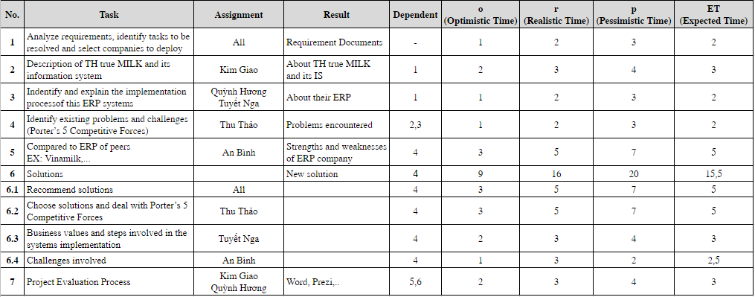

### PERT Chart

There are two main methods for representing a work network. It is the method of "putting work on arrows" (AOA - Activities on Arrow) and the method of "putting jobs in nodes" (AON - Activities on Node). Both of these methods have the same principle: to be able to start a new job, the prearranged jobs must be completed, the arrows drawn from left to right, reflecting the logic relation. back and forth between jobs, but the length of the arrow does not make sense to reflect the length of time.

**Method AOA (Activity On Arrow)**

Building an AOA work network is based on several concepts:

* Work (action - activities) is a specific task or group of tasks that need to be performed of the project. It requires time, resources and cost to complete.
* Events are transition points, marking one or a completed work group and the beginning of the next one or a group of work.
* A road is a continuous connection of work in the direction of the arrow, from the first event to the last.

 Building work network based on AOA method based on the following principles:

* Use a directed arrow to present a job. Each job is represented by an arrow connecting 2 events.
* Ensure the logic of AOA on the basis of clearly defining the order of execution and the relationship between jobs (which must be done first, which works to be performed later, which jobs can be performed) show concurrently).

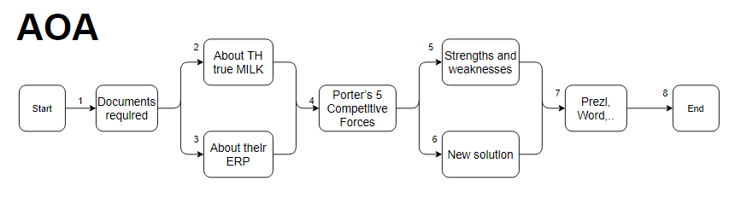

**Method AON (Activity On Node)**

Building work network by AON method should ensure the following principles:

* Firstly, the jobs are presented in a button (rectangle). The information in the rectangle includes the job title, start date, end date and duration of the job.
* Second, the arrows merely determine the order of work.
* Third, all nodes, except for the last one, have at least one node behind. All points, except the first, have at least one preceding node.
* Fourthly, in the network diagram there is only one first node (event) and the last one (event) node.

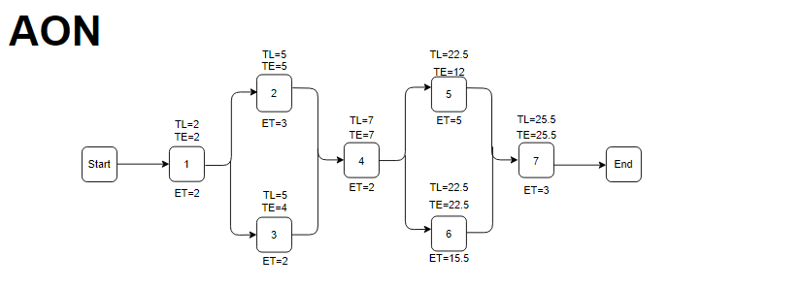

### GANTT Chart

The GANTT chart has several main effects:

* The easy-to-read, easy-to-read GANTT chart method, identifying the actual situation as well as the plan of each job as well as the overall situation of the entire project.
* Easy to build, so it is quite popular.
* Through the chart you can see the status of the work done quickly or slowly and their continuity. On that basis, there are measures to accelerate the process, reorganize the work to ensure continuity and redistribute resources for each job in order to ensure the rational use of resources.
* The chart usually has a number of specific symbols to highlight important milestones, issues related specifically to the work.
* GANTT Charts help this resource layout can choose a reasonable scheme based on the earliest start time (ES) diagram and the latest deployment time map (LS).

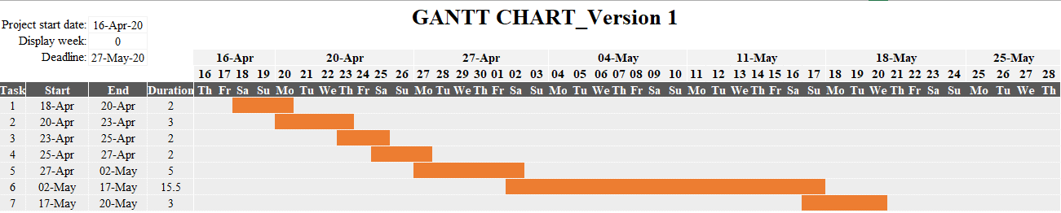

During the operation, the group had some activities that were generated and changed. The changes have been updated in detail from time to time with each timeline as the ChangeLog table below. This update helps the team quickly update the changes in the research work.

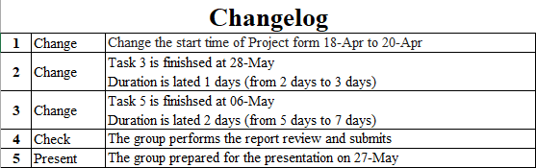

Below is the Gantt Chart after being updated with the changes mentioned in the ChangeLog section.

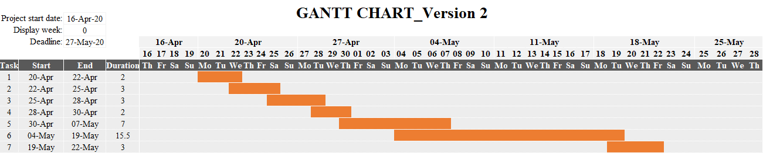

## Table Assignment

|  |  |  |  |  |
| --- | --- | --- | --- | --- |
| **Fullname** | **Role** | **Level of Completion** | **Contribution Rate** | **Comment of the group** |
| Mai Nguyễn An Bình | -Learn about topic requests.  -Design Task Table, Pert, Gantt and plan for work.  -Learn about ERP's manual exchange  -Learn about difficulties if implementing new solutions and solutions | -Very well done, on time and actively at work and receive tasks. -Divide the work and promote team work. | 100% | -Present at the meetings, contribute ideas, actively exchange and research.  -Accelerate progress and take on the external role of the group |
| Trần Kim Giao | -Learn about topic requests.  -Description of the company and its information system status  -Summary of Word and censorship of the report. | -Very well done, on time and actively at work and receive tasks.  -Complete censorship of content by other members. | 100% | -Present at the meetings, contribute ideas, actively exchange and research.  - People with good post synthesis skills. |
| Hoàng Nguyễn Quỳnh Hương | -Learn about topic requests.  -Collaborate on the ERP study of TH True Milk  -Making Prezi for the report | -Very well done, on time and actively at work and receive tasks.  -There are often many good ideas for groups. | 100% | - Present at the meetings, contribute ideas, actively exchange and research.  -There are many good ideas. |
| Trương Thị Tuyết Nga | -Learn about topic requests.  -Collaborate on the ERP study of TH True Milk.  -Make steps taken by the new solution | -Very well done, on time and actively at work and receive tasks.  -Complete censorship of content by other members. | 100% | - Present at the meetings, contribute ideas, actively exchange and research.  -People with good post synthesis skills. |
| Nguyễn Thị Thu Thảo | -Learn about topic requests.  -Provide the business value of the new solution  -Make Porter’s Five Competitive Forces of TH True Milk | -Very well done, on time and actively at work and receive tasks.  -Strictly comply with the requirements of the revised report. | 100% | Present at the meetings, contribute ideas, actively exchange and research.  -Ability to correct errors. |

## Evaluate the project planning and execution process

Evaluate the project planning process and execution of the group has achieved efficiently. The group always prioritizes solving difficult issues and needs a lot of cooperation, contributing much to online and offline meetings of group members. That helps the team solve problems in many ways that each member presents and chooses.

But the situation remains troubled by the late deadline and the team members have joined hands to handle this challenge.

## Final evaluation

During the course of the research, the team encountered a number of issues, shortcomings, disadvantages and mistakes:

* Due to the situation of the Covid-19 epidemic, the number of offline meetings was limited, and most groups conducted online meetings. Members attend on time, which wastes time for the remaining members.
* The team also had difficulty making choices about a company to start researching, analyzing, and implementing ERP for that company. The team had a disagreement over whether or not to choose a company that successfully implemented ERP, a small, medium or medium sized company. But in the end, the group agreed and made a choice, TH True Milk.
* In the process of implementing the GANTT and PERT chart, the group is likely to be delayed, but thanks to time-shortening techniques such as Fast Tracking and Crashing, the team has solved this problem extremely effectively.
* The group agreed to come up with a new solution for TH True Milk. However, finding and implementing a decision is difficult. In search of a new solution, the team explored the TH True Milk ERP situation, Porter’s 5 Competitive Forces of the company, and researched the successes of its competitors' ERP implementation. The team synthesized and proposed the most appropriate and effective solution.

In the future, the team has made suggestions for the research process to be more effective

* The group will agree on the requirements for selecting topics and companies for research and analysis.
* Enhancing offline meetings, before each meeting, informing the meeting content so that each member can learn and give opinions, avoiding wasting time searching for documents in each meeting. After each meeting, there should be a meeting minutes to record the meeting process, as well as provide information for some absent members.
* Each member should be responsible for what they have done. The team leader and deputy will read the entire content of the study and make a request to correct errors if any errors are made.
* In addition, the Team will minimize the late delivery deadline. The group will usually hold a small talk and eating session which is an opportunity for them to know the progress of the work and the difficulties and problems that each member has. From there, the team will devise a strategy to overcome difficulties and share work.

**REFERENCES**

1. Kenneth-C.-Laudon-Jane-P.-Laudon-Management-Information-Systems_Managing-the-Digital-Firm-Pearson-2017

2. Automate processes and reduce errors in purchasing, order fulfillment, inventory tracking, and customer support with distribution management software from Acumatica, Acumatica The Cloud ERP

<<https://www.acumatica.com/cloud-erp-software/distribution-management/>>

3. Acumatica: Distribution Management Overview, youtube.com

<<https://www.youtube.com/watch?v=_JQvLDeJkEY>>

4. Nhà Sản Xuất Sữa Tươi Hàng Đầu Việt Nam Triển Khai Hệ Thống Quản Lý Phân Phối Với Acumatica, 22-01-2016, DMSpro

<<https://www.dmspro.vn/th-true-milk-trien-khai-he-thong-quan-ly-phan-phoi-voi-acumatica/>>

5. Sáng Tạo Khi Tích Hợp Với Acumatica, Di Central

<<https://www.dicentral.com.vn/tich-hop/giai-phap-erp/acumatica>>

6. Thử thách trong việc lựa chọn giải pháp ERP cho ngành sản xuất, 18-05-2018, HoNguyen

<<https://blog.trginternational.com/vi/thu-thach-trong-viec-lua-chon-giai-phap-erp-cho-nganh-san-xuat>>

7. Chiến lược Marketing của công ty sữa Vinamilk so với hai đối thử cạnh tranh là Dutch Lady và TH True Milk,Lưu Đình Lại

<<https://text.123doc.net/document/4582577-chien-luoc-marketing-cua-cong-ty-sua-vinamilk-so-sanh-voi-hai-doi-thu-canh-tranh-dutchlady-va-th-true-milk.htm>>

8. Lợi thế cạnh tranh và năng lực đặc thù của công ty Vinamilk, phân tích môi trường bên ngoài và bên trong

<[https://123doc.net//document/2417115-loi-the-canh-tranh-va-nang-luc-dac-thu-cua-cong-ty-vinamilk-phan-tich-moi-truong-ben-ngoai-ben-trong.htm](https://123doc.net/document/2417115-loi-the-canh-tranh-va-nang-luc-dac-thu-cua-cong-ty-vinamilk-phan-tich-moi-truong-ben-ngoai-ben-trong.htm)>

9. Phân tích môi trường ngành và đánh giá điểm mạnh, yếu của Vinamilk, 20-05-2019

<<https://www.quantri123.com/phan-tich-moi-truong-nganh-va-danh-gia-diem-manh-yeu-cua-vinamilk/>>

10. TH MILK TRIỂN KHAI HỆ THỐNG SAP ERP, Duong Tuan, 08-06-2010

<<https://eacvietnam.wordpress.com/2010/06/08/th-milk-trien-khai-he-thong-sap-erp/?fbclid=IwAR2tQzH8IXtqy7zWWK4ZWz6wXuCZTd09F27Gu_HHroxtExzMbN77CmOCCNw>>