

*Report*

**PROJECT MANAGEMENT BI SOLUTION FOR HUMAN RESOURCES IN ADVENTURE WORKS**

Instructor: PhD Ho Trung Thanh

MSc Ha Hai Dang

Implementation: Group 5

1. Mai Nguyen An Binh - K184060777
2. Hoang Nguyen Quynh Huong – K184060789
3. Truong Thi Tuyet Nga – K184060795
4. Dang Minh Thu – K184060807

*TP. HCM City, May, 2021*

# ACKNOWLEDGEMENTS

During the learning process "PROJECT MANAGEMENT INFORMATION SYSTEMS", Group 5 has always received the attention and guidance from PhD Ho Trung Thanh, MSc Ha Hai Dang. First of all, Group 5 would like to express our deep gratitude to with teachers who have wholeheartedly helped Group 5 during the past time.

The report was made within 2,5 months. Although limited because of limited knowledge, through which the group must be methodical in order to cover all aspects of the project and facilitate it to take place successfully. Therefore, this course will provide the background knowledge of information system project management and guide students to participate in implementation as a member or as a project manager.

Intuitive, accurate, complete and timely information will help administrators in assessing, forecasting the situation, planning strategies as well as building policies and plans for business development in the short and long term. .

Group 5 would like to thank you!

# COMMITMENT

Group 5 hereby declares that the project: “PROJECT MANAGEMENT BI SOLUTION FOR HUMAN RESOURCES IN ADVENTURE WORKS” is an independent research work under the guidance of the instructors of PhD Ho Trung Thanh and MSc Ha Hai Dang. Also do not have any copying by others. The topic and content of the internship report are the products that Group 5 has made efforts to research during their study at the school as well as the subject “Project Managemnet of Information Systems”. The data and results presented in the report are completely honest, Group 5 would like to take full responsibility and discipline of the faculty and the school if there are problems.

**TABLE OF CONTENT**

ACKNOWLEDGEMENTS 1

COMMITMENT 2

LIST OF FIGURES 6

LIST OF TABLES 7

LIST OF ACRONYMS 8

CHAPTER 1: OVERVIEW 9

1.1 Background of Adventure Work company 9

1.2 Business strategy and business case of company 10

1.2.1 SWOT analysis 10

1.2.2 Robson’s analysis of the five forces and IS opportunities 12

1.2.3 Investment appraisal (IRR, NPV, ROI) 13

1.3 Business Intelligence strategy of company 14

1.3.1 Can IS generate new products and services to forestall external threats of substitution? 14

1.3.2 Can IS increase the cost to the buyer or switching suppliers? 15

1.3.3 Can IS help the customer to dominate the supplier? 16

1.3.4 Can IS create barriers to entry? 16

1.4 Introduction to the project of company 17

CHAPTER 2: OBJECTIVES AND SCOPE OF THE PROJECT 18

2.1 Objectives 18

2.1.1 Business objective 18

2.1.2  Project objective 18

2.2 Scope 18

2.3 Constraints 19

2.4 Authority 19

2.5 Resources 20

2.6 Generic project organization and roles 20

2.6.1 Project manager 20

2.6.2 Quality manager 21

2.6.3 Chief analyst 22

2.6.4 Chief designer 22

CHAPTER 3. DEVELOPMENT LIFECYCLE AND APPROACHES 23

3.1 Suggest an approach to systems development 23

3.1.1 Describe 23

3.1.2 Application 23

3.1.3 Advantages 24

3.1.4 Disadvantage 24

3.2 System development lifecycle and project lifecycles 24

3.2.1 Feasibility study 24

3.2.2 Inception: Planning the project 24

3.2.3 Analysis of requirements and production of requirements specification 25

3.2.4 Technical design 25

3.2.5 Code and test of programs (software development and testing) 26

3.2.6 Integration and system test 26

3.2.7 User training 27

3.2.8 Acceptance testing 27

3.2.9 Implementation 29

CHAPTER 4: PROJECT PLANNING 30

4.1 Work breakdown structure for BI project of HR 30

4.2 Product breakdown structure for BI project of HR 31

4.3 Dependency diagram for BI project of HR 33

CHAPTER 5 PROJECT PLANNING: ESTIMATING, SCHEDULING, AND RESOURCING 35

5.1 Estimating 35

5.1.1 CoCoMo 2 35

5.1.2 CoCoMo elapsed time estimates 36

5.1.3 PERT estimating 36

5.1.4 Estimate for BI project 40

5.2 Scheduling and resourcing 40

5.2.1 Critical path network for BI project of HR 40

5.2.2 Network analysis results for BI project of HR 41

5.2.3 GANTT chart for BI project of HR 43

CHAPTER 6: MONITORING PROGRESS AND QUALITY 45

6.1 Documenting quality control 45

6.2 Checkpoint meeting report 46

6.3 Change control form 47

6.4 The risk register 48

CHAPTER 7: PROJECT EVALUATION AND CONCLUSION 50

7.1. Results 50

7.2. Limitations 50

7.3. Future works 50

REFERENCES 51

# LIST OF FIGURES

Picture 3.1: Incremental model 23

Picture 4.1.1: Work breakdown structure of top level 30

Picture 4.1.2: Work breakdown structure of second level 30

Picture 4.2.1: Product breakdown structure of top level 32

Picture 4.2.2: Product breakdown structure of second level 33

Picture 4.3.1: Product breakdown structure for BI of HR 33

Piture 4.3.2: Dependency diagram for BI of HR 34

Picture 5.1.3.2.1: Action On Arc (AOA) 39

Picture 5.1.3.2.1: Action On Node (AON) 40

Picture 5.2.1: Critical path network 41

Picture 5.2.2.1: Network diagram drawing convention 43

Picture 5.2.2.2: Network analysis results after backward pass 43

Picture 5.2.3: GANTT chart 44

Picture 6.2: Checkpoint meeting report No.4 47

Picture 6.4: Extract from Human Resource BI Solutions project risk register 49

# LIST OF TABLES

Table 1.2: SWOT analysis 10

Table3.2.8: Roles and Responsibilities 28

Table 5.1.3.1: Program Evaluation and Review Technique (PERT) 38

Table 5.2.2: Network analysis results 42

# LIST OF ACRONYMS

|  |  |  |
| --- | --- | --- |
| **No.** | **Abbreviation** | **Definition** |
| 1 | BI | Bussiness Intelligence |
| 2 | DW | Data Warehouse |
| 3 | ETL | Extracts Transforms Load |
| 4 | KPI | Key Performance Indicator |
| 5 | DB | Database |
| 6 | HR | Human Resource |
| 7 | OLTP | Online Transaction Processing |
| 8 | OLAP | Online Analysis Processing |
| 9 | MDX | Multi Dimensional eXpression |
| 10 | SSIS | SQL Server Integration Services |
| 11 | SSAS | SQL Server Annalysis services |
| 12 | SQL | Structured Query Language |
| 13 | AD | Adventure Work company |
| 14 | ERP | Enterprise Resource Planning |
| 15 | SWOT | Strengths, Weaknesses, Opportunities, Threats |
| 16 | IRR | Internal Rate Of Return |
| 17 | NPV | Net Present Value |
| 18 | ROI | Return On Investment |
| 19 | TDD | Test-Driven Development |
| 20 | PM | Person-month |
| 21 | WBS | Work Breakdown Structure |
| 22 | PBS | Project Breakdown Structure |

# CHAPTER 1: OVERVIEW

## Background of Adventure Work company

* Analyzing the environment: Adventure Company is a large multinational company with market systems in 3 regions of North America, Europe and Asia. However, compared to its competitor Global Bike, the company's information system is not strong, and has not taken advantage of the Website system to reach and sell to customers. Besides, customer service is not as well as its rival Trek. Due to Covid-19, gyms are closed, buses and trains are limited, outdoor modes of exercise take precedence ... making bike sales skyrocketing around the world, so that is great opportunity for Adventure works.
* Planning the direction**:** Adventure wants to expand the market and improve the website system, customer service. Besides, the company also aims to cut selling expenses through cutting production costs.
* Planning the strategy**:** The company's market expansion strategy is focus on sales to key customers. To do that, it is also necessary to have a good information system to help manage and retrieve information quickly, which can support analysis, data mining, and prediction of the trend of service prices, customer behavior or help to discover potential customer. In addition, Adventure Work will perform ERP like Global Bike to reduce costs and focus on the approach provides Adventure work with an advanced, controlled business platform, allowing unified operations and processes global integrity.
* Implementing the strategy:
* Analysis of the requirements..
* Design, development and implementation of the internet systems, ERP system and secure communications links.
* Training staff in the use of the systems.
* ‘Skills transfer’ to Adventure Work’s IT department, so that ongoing maintenance and development of the new system can be handled in-house. The development of the MIS aspects of the new system will be dealt with by Adventure Work’s IT department.

The date now is March and Adventure Work wants to have the new system up and running for the start at the end of June.

## 1.2 Business strategy and business case of company

### 1.2.1 SWOT analysis

##### Table 1.2: SWOT analysis

|  |  |
| --- | --- |
| **Strengths**  Distribution system is quite wide (in 3 regions North America, Europe and Asia), solid financial potential, large production scale.  Data is beautiful, specifically stored and decentralized, consistent across departments. | **Weaknesses**  The information technology system is not good, has not taken advantage of the Website system to reach and sell to customers better.  The production process is not streamlined, production components in factories must be transferred to the headquarters for assembly to increase production costs.  Large scale and coverage in Europe but currently Adventure works cycle has only 290 employees. This is quite a small number.  There is no automatic payroll system for employees. |
| **Opportunities**  Because current users tend to shift to clean, economical and environmentally friendly means, this market has strong growth potential.  Fears of Covid-19 infection while on public transport in Europe and the US have catapulted demand for bicycles. | **Threats**  Compete with domestic companies in market areas.  Facing the threat of the big trend of the electric vehicle industry. |

Conclusion:

Through SWOT analysis of two rival companies. We see that Adventure has a loss in terms of both economic and human resource management.

To answer the question "What should Adventure works cycle do to make human resource management truly the most efficient and cost effective?" In the short term, Adventure works cycle needs a truly effective human resource management strategy. Because human resource management plays a particularly important and increasingly important role.

Administrators are interested in research and analysis, see this as a core function and the most important part of the governance process. Human resource management is often the cause of success or failure production and business activities of the enterprise. Here are the solutions in place:

- Human resource management system stores full information about each individual file, easy to update, modify, create more data, ... The system focuses on business human resources Karma.

- This system needs to say the unity between purpose and direction leadership of the organization on human resources, all data and information analysis for work decision-making and issues related to manpower.

- This information system manages human resources and related resources must be arranged as a process throughout, handy for checking and monitoring all of your activities each person.

### 1.2.2 Porter’s five forces model

We need to search for the US bicycle industry because our company Adventure Work Cycle has a large investigation in the US market. Here is the Porter’s Five Forces Model to the bicycle industry and our company. (2)

* Suppliers: the suppliers of the domestic manufacturers are there, but they have medium power. Often the components are imported for specialization. Hence, they are not in a position to dictate price.
* Buyers:  The buyer power in this industry is high. The population is huge, and the demands for bicycles have been increasing among the health conscious citizens. However, they have got a plethora of choice in terms of variety and price. Thus the switching cost is also less. The bargaining power of the buyer is high. Thus, the company needs to keep the price of the products competitive.
* Competitive Rivalry: the competitive rivalry is considered to be high. The US market of bicycles is dominated by imported products. The imports are from China and Taiwan. The domestic manufacturing market is also much fragmented. About 100 brands are available and many do domestic manufacturing. The Chinese bicycle is more sophisticated with advanced technology at a lower price.
* Substitutes: the threat of substitutes is high. The consumers can easily move to the Chinese product for getting more value. Moreover, the health conscious customers can resort to some other equipment for fitness.
* New entrants: The threat of new entrants is from medium to high. The companies which achieve economies of scale are more profitable. The manufacturing of such an amount of units would require capital investments. High advertisements would provide a greater advantage. Intensive distribution would be also profitable.

That’s the reason why we need to build a Business Intelligence strategy to meet our mission and vision. Business Intelligence is the means of turning raw data into useful insights. It allows you to collect data from different sources, organize it, and then enjoy the analytics. A BI strategy will allow us to address all our data problems and needs, develop a cohesive system.

### 1.2.3 Investment appraisal (IRR, NPV, ROI)

#### 1.2.3.1 Net present value (NPV)

Net present value (NPV) is translated as Net Present Value, which means that the present value of all future project cash flows is discounted to the present. (1)



n – number of periods

i – the discount rate (the rate of return which could be earned on an investment in

the financial markets with similar risk)

Rt – the net cash flow (the amount of cash, inflow minus outflow) at time t

Decision making:

NPV > 0 – The investment would add value to your company.

NPV < 0 – The investment would subtract value to your company.

NPV = 0 – The investment would neither gain nor lose value for your company.

* Normally, the NPV is not only considered to be an indicator, but is also considered the best method for assessing the profitability of a plan or project because its semantic meaning indicates the net profit of the project after it has been made. recover the initial investment and cover all costs (including inflation).
* However, this NPV method has the disadvantage of requiring accurate cost calculation, which is often difficult to implement for long-life projects. So in practice one develops the cost of capital into a discount rate or the minimum acceptable rate of return - the barrier rate.
* The project has the budget for $4,000 and the budget estimate is 10% of the budget.

#### 1.2.3.2. Internal rate of return (IRR)

Internal rate of return (IRR) of the internal rate of return. That means the project's own return, IRR is the root of the equation NPV = 0. In other words, if you want to find IRR, you only need to solve the equation NPV (IRR) = 0. This is a high order equation, if there is a change of sign there will be many solutions. (1) (3)



NPV – Net present value

n – number of periods

Ct – total net cash flow during period t

C0 – total initial investment costs

* In general, looking at the IRR is easy to imagine because the specific%, seeing the NPV in money is difficult to interpret.

#### 1.2.3.3 Return on investment (ROI)

ROI stands for Return On Investment. In business, investments to improve the company, such as time and money. ROI is the efficiency of return on investment. ROI is often defined as the ratio of net return to total investment costs. (3)



ROI > 0 – The investment would add value over the project life.

ROI < 0 – The investment would subtract value over the project life.

ROI = 0 – The investment would neither gain nor lose value over the project life.

#### 1.2.3.4 Investment appraisal of Adventure Works Cycles

Adventure Works Cycles is starting the project with a 3-year life at $ 4,000. The project will generate cash flow of $ 2,000, $ 3,000 and $ 4,500 in year 1, year 2 and year 3 respectively. The discount rate is 10%. The following cash flows have been estimated for the project:

|  |  |  |  |  |
| --- | --- | --- | --- | --- |
|  | **0** | **1** | **2** | **3** |
| **Investment and Cost**  *(outflows)* | - 4,000 | - 500 | - 500 | - 500 |
| of which: investment | - 4,000 |  |  |  |
| of which: cost | 0 | - 500 | - 500 | - 500 |
| **Benefit and Earnings** *(inflows)* | 0 | 2,500 | 3,500 | 5,000 |
| **Cash Flow** | **- 4,000** | **2,000** | **3,000** | **4,500** |

The next table contains discounted cash flows for each period. They are calculated using the above mentioned formula, with the results summarized in the following tables. The Net Present Value is the sum of all discounted cash flows.

|  |  |  |  |
| --- | --- | --- | --- |
| **Year** | **Net Cash Flow** | **DCF** | **NPV** |
| 0 | - 4,000 | 1 | - 4,000 |
| 1 | 2,000 | 0.91 | 1,820 |
| 2 | 3,000 | 0.83 | 2,490 |
| 3 | 4,500 | 0.75 | 3,375 |
| **Total** |  |  | **3,685** |

NPV is positive then the project should be accepted (NPV=$3,685)

Then, we can calculate: IRR = 29.29% and ROI = 12.5% which means that the investment would add value over the project life.

## 1.3 Business Intelligence strategy of company

### 1.3.1 Can IS generate new products and services to forestall external threats of substitution?

To forestall threats of substitution, our company needs to make a difference between our products and services and others. Using IS for this, in particular, in sales there could be an order entry system and customer care system where customers do not want to find other products because of the convenience and modernity we provide them.  However, we also should consider to generate new products and services bounding our competitors. By using IS, the manufacturing area might support a total quality management system for us to prepare products correctly. Moreover, IS development is a corporate asset bridging the whole company that everyone is obliged to use.

→ Strategy: Adventure Works Cycle can use the Internet and Information Technology to gather information and use BI to analyze them into useful data about the customers’ needs and rivals’ products. Then, to make difference between the company and other competitors, the company must ensure that its competitors do not already have such products to satisfy the needs of those “special customers”. The product or service must be something that most of its customers see as important, and the company must position itself in a unique position so as to meet those needs. In particular, our products are bicycles that access the need to be healthy and solve some environmental problems or traffic jams. So, why we do not think about any type of bicycles which can tackle more health issue or a lighter bike which users can carry through the traffic jams. However, our company must try to keep similar costs levels as our competitors so that the cost of “uniqueness” does not exceed the premium that the customer is prepared to pay.

### 1.3.2 Can IS increase the cost to the buyer or switching suppliers?

Instead of increasing the cost, IS gives company cost efficiency.

From the point of view of economics, IT changes both the relative costs of capital and the costs of information. Information systems technology can be viewed as a factor of production that can be substituted for traditional capital and labor. As the cost of information technology decreases, it is substituted for labor, which historically has been a rising cost. Hence, information technology should result in a relative decline in the number of middle managers and clerical workers as information technology substitutes for their labor (Laudon, 1990).

Information technology, especially the use of networks, can help Adventure Work lower the cost of market participation (transaction costs) because it becomes easier and cheaper for the firm to contract for the purchase of goods and services in the marketplace. In addition, Information technology, by reducing the costs of acquiring and analyzing information, permits organizations to reduce agency costs because it becomes easier for managers to oversee a greater number of employees. By using IS, Adventure Work will have downsize, reducing the number of employees and the number of levels in its organizational hierarchies.

Therefore the cost to the buyer or switching suppliers will decrease due to the Information System. In order to be effective, an information system (IS) needs to be flexible, that is, it must be able to accommodate a certain amount of variation regarding the requirements of the supported business process.

→ Strategy: Adventure Works Cycle should implement a Cloud-based HRMS and KPIs system to assist in performing tasks such as hiring, calculating and evaluating performance, and allow HR employees to work better with their employees.

### 1.3.3 Can IS help the customer to dominate the supplier?

All most all the companies in the Business Services industry buy their raw material from numerous suppliers and Adventure Work Cycle is no exception. Suppliers in dominant position can make increase the cost of production and decrease the margins Adventure Inc. can earn in the market. Powerful suppliers in Services sector use their negotiating power to extract higher prices from the firms in Business Services field. The overall impact of higher supplier bargaining power is that it lowers the overall profitability of Business.

→ Strategy: Using information technology and systems can support to control the force about supplier, we suggest the strategy: Improve strengthen customer and supplier intimacy. Use information systems to tighten linkages with suppliers and develop intimacy with customers. We can use information systems to facilitate direct access from suppliers to production schedules, and even permits suppliers to decide how and when to ship suppliers to the factories. This allows suppliers more lead time in producing goods. Strong linkages to customers and suppliers increase switching costs (the cost of switching from one product to a competing product) and loyalty to your firm.

### 1.3.4 Can IS create barriers to entry?

Barriers to entry are the obstacles or hindrances that make it difficult for new companies to enter a given market. These may include technology challenges, government regulations, patents, start-up costs, or education and licensing requirements. Adventure works  cycle have medium barriers to entry because it belongs to monopolistic competition. Barriers to entry generally operate on the principle of asymmetry, where different firms have different strategies, assets, capabilities, access, etc. Barriers become dysfunctional when they are so high that incumbents can keep out virtually all competitors, giving rise to monopoly or oligopoly.

→ Strategy: Adventure work cycle is an established company that can easily manufacture and distribute a few more products at low cost because costs like managing and renting a factory are distributed in a large amount. product.

## 1.4 Introduction to the project of company

The project "PROJECT MANAGEMENT BI SOLUTION FOR HUMAN RESOURCES IN ADVENTURE WORKS" will help Adventure Work get an overview of the resource activities of employees in the company. And from there, there are reasonable policies and strategies to improve the working quality of employees, as well as the satisfaction of employees at the company.

# CHAPTER 2: OBJECTIVES AND SCOPE OF THE PROJECT

## 2.1 Objectives

### 2.1.1 Business objective

Adventure Work's goal is to improve HR management, specifically managing 290 employees at its headquarters in Bothell, Washington as well as in its markets including North America, Europe, and Asia. . The company wants 100 percent of employees to achieve their business goals and job satisfaction through a competency framework that evaluates each department, each department position in the business. Besides, the company wants to convert 50% of traditional recruitment to the Candidate Tracking System.

### 2.1.2  Project objective

The goal of this project is to:

* Research an overview of data analysis methods, decision support models and Business Intelligence - BI, SQL Server Business Intelligence solutions and metric KPIs assess performance in HR management and employees’ performances, then apply these studies to data analysis and build analysis reports to support management-level decision-making on Microsoft's Adventure works database.
* Analyze the possible risks and difficulties for the center, find solutions to overcome.

## 2.2 Scope

The scope of this project is limited in construction BI solutions for the Human resource module of the Adventure Works company.

* This project addresses the following requirements:
* Development process: Employees perf the operation, the process of timekeeping, payroll at HR, and departmental change process
* Creating monthly or annual reports.
* Decision support.
* The project lasted in 2.5 months:
* Start day: 23/02/2021.
* End day: 16/05/2021.
* The project has the budget for $4000 and the budget estimate is 10% of the budget.

## 2.3 Constraints

- The project scope did not change during the project so the time and budget for the project did not change.

- The project shall be managed using the Microsoft Project software.

- .Project handover no later than 10 days is not accepted.

- The customer is not responsible for all technical risk or people risk.

- If there is any change to the data or requirements, the Adventure Works company's representative must notify in advance.

## 2.4 Authority

The authority for the project will be the Adventure Works company's representative:  BonBon Mai, director of Adventure Works, who will work with a project board that also includes CoCo, Adventure Works the Head of HR department, and An Binh, project manager as well as leader of Group 5. The authority’s responsibilities will include:

* Make major decisions on the project.
* .Authorizing changes to the project.
* Providing resources for the project.
* The reconciliation of conflicts between users.
* Final acceptance of the project.

## 2.5 Resources

* Group 5 will provide the following resources:
* Project manager (An Binh)
* Team manager (An Binh)
* Quality manager (Quynh Huong)
* Chief analyst (Minh Thu)
* Chief designer (Tuyet Nga)
* Designer (An Binh, Tuyet Nga, Minh Thu and Quynh Huong)
* Analysts (Minh Thu, Tuyet Nga Quynh Huong and An Binh)
* Adventure work provide the following resources:
* Team manager (HoHo)
* Analyst/programmer (TuTu)
* Reasonable access to other personnel for fact-finding, training, testing etc.
* A fixed price of $400,000 has been agreed for those parts of the project being undertaken by Group 5.
* Historical database with 290 employees of 16 departments divided into 6 groups: Research and Development, Sales and Marketing, Inventory Management, Manufacturing, Executive General and Administration, Quality Assurance

## 2.6 Generic project organization and roles

### 2.6.1 Project manager

Appointed by the sponsor and is responsible for the manager management of the project on a day-to-day basis and for the achievement of the project objectives. The project manager’s role is to:

* Achieve the project’s objectives within the time, cost and quality/performance constraints imposed by the sponsor.
* Make or force timely decisions to assure the project’s success.
* Plan, monitor and control the project through to completion.
* Select, build and motivate the project team. n Keep the sponsor and senior management informed of progress and alert them to problems – especially if these could have an impact on the project’s achieving its business objectives.
* Recommend termination of the project to the sponsor, if necessary.
* Serve as the principal point of contact between the sponsor, management and contributors.
* Select and manage subcontractors

### 2.6.2 Quality manager

Again, on a large project, it could be worthwhile to appoint someone as quality manager manager. Under the guidance of the project manager, this person will write the quality plan, develop the quality control procedures, check that these procedures are being followed and provide advice and guidance to team members on quality-related issues. The quality manager’s role is to:

* Understand customer expectations of and needs from a product.
* Develop quality control processes.
* Design product specifications.
* Ensure products are designed with adherence to legal and safety standards.
* Supervise staff and monitor production standards.
* Examine the quality of raw materials that are used in production.
* Monitor and evaluate internal production processes.
* Evaluate the final output of products to determine their quality.
* Reject products that fail quality standards.
* Engage with customers and gather product feedback.
* Produce statistical reports on quality standards.
* Report to upper management on quality standard issues.
* Evaluate product recalls.
* Improve production efficiency and managing waste

### 2.6.3 Chief analyst

This is a senior and experienced business or systems analyst who will, under the direction of the project manager, lead the analysis work. The chief analyst will advise the project manager and project team on analysis methods and techniques and, with the quality manager, ensure that appropriate standards are being followed. It is useful to have as chief analyst someone with extensive experience of the type of business being studied who can authoritatively discuss business issues at the highest levels in the user organization. The Chief analyst’s role is to:

* Assess the state of the company's data which, more often than not, is in some state of disrepair
* Develop a data warehouse that acts as a central repository for all of the company's data
* Define the data governance, management and ownership frameworks that will ensure data quality is created and maintained
* Work with business to understand data requirements and then how to provide them with this data - whilst maintaining control (see point above)
* Assist in developing reporting tools through BI, visualization tools, etc.

### 2.6.4 Chief designer

Like the chief analyst, the chief designer works under the direction of the project manager to control the work of the design team, and probably that of the programmers as well. The chief designer will have extensive experience of the technology being used and can provide advice and guidance to the project team as well as develop any project-specific standards that are required.

# CHAPTER 3. DEVELOPMENT LIFECYCLE AND APPROACHES

## 3.1 Suggest an approach to systems development

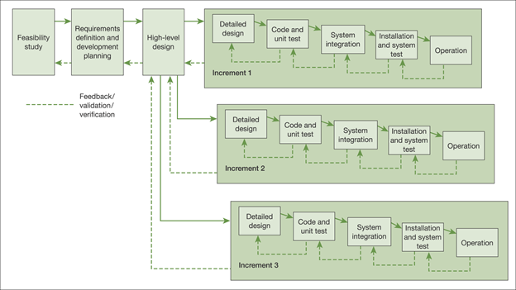

###### Picture 3.1: Incremental model

### 3.1.1 Describe

* Spec is divided into several parts.
* The cycle is divided into small, easy-to-manage modules.
* Each module will go through the requirements of design, implementation, etc. like a normal development life cycle.

### 3.1.2 Application

* Applies to projects where requirements are clearly described, defined and understood.
* Customers have demand for products soon.

### 3.1.3 Advantages

* Rapid development.
* This model is more flexible, less expensive to change scope and requirements.
* Easier to check and correct.

### 3.1.4 Disadvantage

* Need good planning and design.
* Total cost is higher than waterfall model

## System development lifecycle and project lifecycles

### 3.2.1 Feasibility study

With the project's goal of building a BI solution for Adventure Work Cycle, which is limited to the scope of the HR module, supporting business decision-making during 2.5 months, this project is considered feasible within allowable resources and costs.

### 3.2.2 Inception: Planning the project

At the beginning of a project launch, a solid project plan needs to be established to set direction on time and on budget. The plan provides guidance for obtaining resources as well as output quality orientation, thereby assisting in communicating benefits, persuading stakeholders or seeking investment.

The project starts from establishing the main work to be completed at a level 1 generality. Then, list the resources needed to meet the scope of the project requirement. Also allocate initial costs to resources.

At the same time, having a contingency plan is extremely necessary to ensure handling of possible risks. In addition to setting holidays during the project period, the estimation of other holidays due to objective factors of the external environment or the client's side also needs to be considered. To solve that case, we can set some lead time, lag time, delay according to the actual situation.

### 3.2.3 Analysis of requirements and production of requirements specification

Clearly defined requirements are essential signs on the road that leads to a successful project. They establish a formal agreement between a client and a provider that they are both working to reach the same goal. High-quality, detailed requirements also help mitigate financial risks and keep the project on a schedule.

Requirements specification document: The document contains descriptions of the functions and capabilities that the product must provide. The documentation also defines constraints and assumptions. It can be a single document that communicates the functional requirements, or it can be accompanied by other software documentation such as user stories and use cases.

The business requirements of the HR department at Adventure Work are described in detail through 4 main operations: Recruitment, Training & Development, Evaluation and Off-boarding process. Each of the above tasks will be described in detail in each specific document after agreeing with the customer.

### 3.2.4 Technical design

The functional design specifies how a program will behave to outside agents and the technical design describes how that functionality is to be implemented in code. The Technical Design Document (TDD) must be approved by the IT project sponsor before proceeding to the development/integration phase. (4)

A [Technical Design Document (TDD)](https://drive.google.com/a/stanford.edu/file/d/1FYTuTgtCp9OGbrXlEdY_z3DKYBncomLs/view?usp=sharing) is written by the development team and describes the detail of either the entire design or specific parts (human resource) of it, such as:

* Including all data types/structures required (input data types, output data types, exceptions)
* Detailed class models that include all methods, attributes, dependencies, and associations
* Physical data models that include attributes and types of each entity/data type

### 3.2.5 Code and test of programs (software development and testing)

The development team will proceed to write code for the program based on the requirement document and technical design document are developed and approved before. According Incremental model, the coding and testing phases are done together, meaning that each coding step is tested in parallel to make sure the program is built correctly.

### 3.2.6 Integration and system test

System testing is a testing level  in which tests are performed to know if a complete build aligns with functional and nonfunctional requirements made for it. In contrast, Integration testing is a testing stage where two or more software units are joined and tested simultaneously.

The primary purpose of system testing is to examine the build’s functionality. For Adventure Work, after completing the demo BI solution for HR module, we will put it into system testing and integration testing.

System testing is carried out as follows:

* Step 1: Test plan: Create a test plan, including test cases and use cases.
* Step 2: Test data: Create test data and perform an automated test, followed by a manual test.
* Step 3: Test results: Review the test result and write a report based on it. Log the errors and carry our regression testing after reporting the errors.
* Step 4: Debug: Fix the errors found in the system.
* Step 5: Recycle: Repeat the cycle and stop when all errors have been removed.

The purpose of integrated testing is to find out if these combined units interact without issues. By doing an integration test, testers can recognize errors between joined units. Here, we conduct integrated testing process between HR module and Sales module because sales is the department that has the most intimate links with the human resources department because of the constraints of the majority of the sales staff.

### 3.2.7 User training

User training is an important step in the project. For example, you can upgrade everyone to the latest version of Office, but without any Office 365 training, your users won't take advantage of all the new features and capabilities you paid for. In the project of implementing BI solutions for adventure work companies, it is the same, after completing the design and analysis of the data warehouse, user training sessions will be held to ensure that users can take full advantage of all the functions of the system itself built. Attached are detailed instructions on how to use it.

### 3.2.8 Acceptance testing

User acceptance test (UAT): The purpose of User Acceptance Testing (UAT) is to ensure that the solution by the project meets the functional and non-functional requirements specified in the business requirements. UAT may also identify issues that have not been specified in the BRD such as those relating to usability. UAT is the final step before rolling out the solution. UAT is typically carried out by end users in an environment that closely models the real world. A well-managed UAT process will give the Project Sponsor, project team and end users confidence that the solution being delivered meets the requirements.

##### Table 3.2.8: Roles and Responsibilities

|  |  |
| --- | --- |
| **ROLE** | **RESPONSIBILITIES** |
| **Project Manager** | ·  Communication with the Business Assurance Coordinator to agree format and scope of UAT  · Ensure acceptance criteria are agreed prior to commencing UAT |
| **Chief Analyst** | ·  Assist Business Assurance Coordinator with the creation of a detailed test plan  ·   Review scripts/cases and scenarios for accuracy, completeness and sequencing.  ·   Confirm test data is correct. |
| **Chief Designer** | ·   Validation of UAT environment |
| **Business Assurance Coordinator (Analyst)** | ·   Ensure that a detailed test scripts/cases, scenarios and instructions are available for test users prior to the start of testing  ·   Ensure testing takes place within agreed timeframes |
| **Quality manager** | ·   Execute test scripts/cases  ·   Document test results |

### 3.2.9 Implementation

Project implementation (or project execution) is the phase where visions and plans become reality. This is the logical conclusion, after evaluating, deciding, visioning, planning, applying for fund and finding the financial resources of a project.

For this project, when entering the go live phase, a new BI solution on human resources module will be put into use at Adventure Work company. The project's implementation team will come to the company to support until everything is complete to put into use. This process includes steps to prepare the environment, infrastructure for deployment as well as system maintenance, post-deployment performance evaluation.

# CHAPTER 4: PROJECT PLANNING

## 4.1 Work breakdown structure for BI project of HR

A WBS (5) is “a deliverable-oriented hierarchical decomposition of the work to be executed by the project team to accomplish the project objectives and create the required deliverables. It organizes and defines the total scope of the project.

To understand how this works, let us consider a project BI for HR, say a feasibility study in a builder’s merchant to see if there is scope for introducing a computerized stock control system. If we consider the project as a whole, we might decide that the work breaks down into two main components, as shown a below photo.

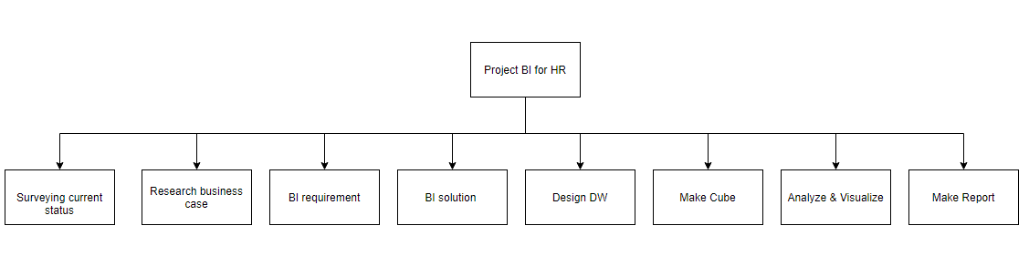

###### Picture 4.1.1: Work breakdown structure of top level

If we look in more detail at the first of these components –BI solution – we could break it down further, as shown in a below photo.

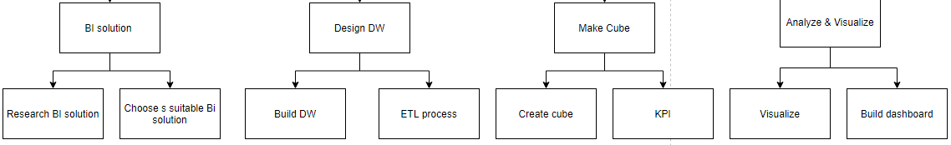

###### Picture 4.1.2: Work breakdown structure of second level

Actually, in this case we probably would not subdivide the work this far. We would probably decide that a single interview – conducting it, writing it up and reviewing the results – is a small enough work package, say a day’s work. But this does illustrate the principle involved.

The idea, then, is that we continue to break down each activity until we arrive at tasks that are:

* Fairly atomic, that is do not readily lend themselves to further subdivision or to assignment to more than one person.
* Small enough to estimate with reasonable accuracy, say are about half a day to two days’ duration.

Some IT departments and system companies have developed standard work breakdown structures (WBSs) based on their experiences over a number of projects. If these are available, they provide a useful starting point for the creation of a project-specific WBS and they make it more likely that the project manager will not forget something. The danger of using a standard WBS (or a standard anything else for that matter) is that each project has some distinctive features and it is important not to try to fit the project to a standardized approach; if anything, the standardized approach must be customized for each project.

## 4.2 Product breakdown structure for BI project of HR

A Product Breakdown Structure (PBS) (5) is a hierarchical structure of things that the project will make or outcomes that it will deliver. It can be thought of as the project “shopping list.”

It decomposes a "Main Project Product" into its constituent parts in the form of a hierarchical structure.

It ensures that the project’s focus is on what is to be achieved rather than how, in other words on the ends rather than the means. This is valuable in that projects are not undertaken for their own sake but to achieve some wider purpose, and keeping their eyes on the products helps remind the project team of this fact.  
When approaching a new area of work, it is sometimes difficult to envisage exactly what one needs to do – in other words, the work. However, it is somewhat easier to consider what one has to develop – the products – and starting from the product end is more productive.  
Project managers who have used the product-based approach report that it is less easy to forget something in the plans than it is when using a work breakdown approach.

Once all of the products have been identified, then other things can be associated with them. What quality standards will be applied? Who shall review them? What will be the configuration management regimes? And so on.

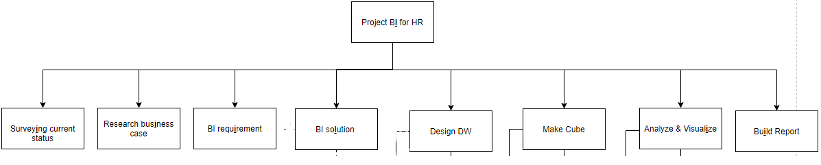

###### Picture 4.2.1: Product breakdown structure of top level

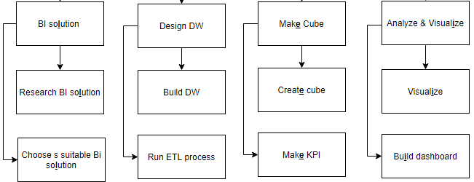

###### Picture 4.2.2: Product breakdown structure of second level

## 4.3 Dependency diagram for BI project of HR

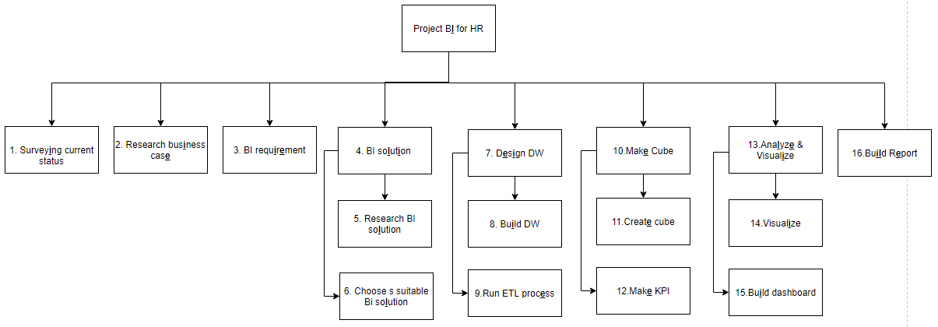

###### Picture 4.3.1: Product breakdown structure for BI of HR

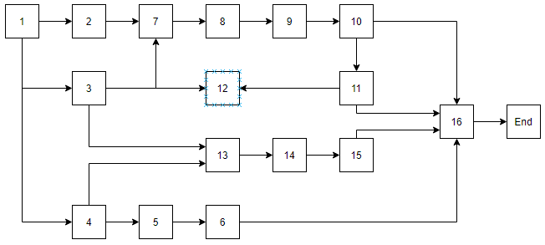

###### Picture 4.3.2: Dependency diagram for BI of HR

Planning is essential to the successful execution of an IS project. Planning involves thinking hard about the project, what it is to achieve and how the team will go about it. The starting point for a good plan is a proper understanding of the requirement and the project manager must ensure that this is available before planning begins. The work to be done is analyzed using either a work breakdown structure or a product breakdown structure. In either case, the product is a set of activities that will need to be performed to complete the project. With the activities identified, the next step is to understand the dependencies between them. A network diagram shows these dependencies and can be used to identify the critical path through the project. Bar charts provide a visual means of showing the sequence of activities in a project, but are less useful for assessing the progress of work overall. The project manager needs to understand the tolerances – of time, cost and quality – within which the project must operate. Project planning software can take much of the drudgery out of the planning process, produces high-quality output and facilitates what-if analysis of various scenarios.

# CHAPTER 5 PROJECT PLANNING: ESTIMATING, SCHEDULING, AND RESOURCING

## 5.1 Estimating

### 5.1.1 CoCoMo 2

CoCoMo II (5) model is one of the cost, effort estimation models using top-down estimation approach. In this model, the estimated unit of effort (PM) is the man-months. A man-months is the time a person spends that time working on a software development project for a month. This period does not include holidays and holidays but only weekend holidays. The number of months someone differs from the number of months it will take to complete the project, which is known as developmental progress.

With CoCoMo 2, estimates are produced at different stages of the development lifecycle, namely:

* Application composition: This takes place where the system has been designed from the user perspective, using techniques such as prototyping. For a small scale project using evolutionary prototyping, this approach may result in a finished system.
* Early design: For a larger or more complex system, it is necessary to produce an overall design before proceeding to designing the individual modules. A revised estimate can therefore be produced at this stage.
* Post-architecture: This is the point where, for a larger project, actual construction of the software starts.

According to parsing of Group 5, MM = effort in man-months. So, if we estimate that our project will result in 420 delivered source instructions, we can calculate that the development effort will be:

2.4 × (420)1.05 = 0.96 (man-months)

In the CoCoMo formulae, a man-month equates to 739.03 working hours or 75 working days, so effort figures can also be expressed in man-hours, man-days or man-years.

### 5.1.2 CoCoMo elapsed time estimates

Whilst the full original CoCoMo approach is not always followed, one of the major formulae – that relating effort to elapsed time – is quite widely used. The elapsed time is calculated using the formula:

TDEV = 2.5(Estimated effort in man-months)0.33

where TDEV is total development time. So, for our example, the elapsed time would be calculated as:

2.5 × (0.96)0.33 =2.47, or about 2.5 months

The main disadvantage of the CoCoMo equations is that they depend upon an assessment of the number of delivered source instructions – more or less lines of code. The obvious snag with this is that it is not possible to estimate accurately the likely number of lines of code until quite late in a project.

In addition, it is not entirely clear how the CoCoMo formulae should be interpreted for projects using more advanced programming tools and fourth generation programming languages. The elapsed time formula, however, is extremely valuable and seems to work pretty well whatever the environment. Despite these reservations, all serious students of software development should study Boehm’s book because of the insight it provides into the dynamics of the software development process.

### 5.1.3 PERT estimating

PERT (Program Evaluation and Review Technique) is an estimating technique that uses a weighted average of three numbers to come up with a final estimate.

PERT is a three point activity estimating technique that considers estimation uncertainty and risk by using three estimates to define an approximate probability for estimating for tasks / deliverables. It is based on the order and estimated duration of the tasks and uses the network diagram to do this. There are two main methods for representing the network diagram, including: AOA (Action On Arc) and AON (Action On Node).

#### 5.1.3.1 The three estimates used

* The most optimistic (A) case where everything goes right
* The most likely (B) case given normal problems and opportunities
* The most pessimistic (C) case when everything goes wrong
* The expected completion time (E) is calculated by taking a weighted average of these 3 three estimates

The resulting PERT estimate is calculated as E= $\frac{A+4B+C}{6}$.

This is called a "weighted average" since the most likely estimate is weighted four times as much as the other two values. You'll notice that the final PERT estimate is moved slightly toward either the optimistic or pessimistic value - depending on which one is furthest from the most likely. Generally this ends up moving the final estimate toward the worst case, since the worst case value tends to be further out from the most likely that the optimistic number.

##### Table 5.1.3.1: Program Evaluation and Review Technique (PERT)

|  |  |  |  |  |  |  |  |
| --- | --- | --- | --- | --- | --- | --- | --- |
| **No** | **Task Name** | **Result** | **Dependent** | **A (Optimistic Time)** | **B (Realistic Time)** | **C (Pessimistic Time)** | **ET (Expected Time)** |
| 1 | **Analyzing requirements** | Decrement | ~ | 1 | 2 | 3 | 2 |
| 2 | **Surveying current status of Adventure Work Company** | About Adventure Work | 1 | 3 | 5 | 7 | 5 |
| 3 | **Research about business strategy and business case** | About business case | 2 | 3 | 5 | 7 | 5 |
| 4 | **Determining Business Intelligence requirements** | Requirement for HR | 3 | 4 | 6 | 8 | 6 |
| 5 | **Introduction to BI solutions** | Solution | 4 | 5 | 7 | 9 | 7 |
| 5.1 | Researching BI solutions |  |  |  |  |  |  |
| 5.2 | Choosing the suitable BI solution |  |  |  |  |  |  |
| 6 | **Design Data warehouse** | Data warehouse | 4,3 | 5 | 7 | 9 | 7 |
| 6.1 | Build Data washhouse |  |  |  |  |  |  |
| 6.2 | ETL process |  |  |  |  |  |  |
| 7 | **Create Cube and build KPI** | Cube | 6 | 5 | 7 | 9 | 7 |
| 7.1 | Create Cube |  |  |  |  |  |  |
| 7.2 | KPI |  |  |  |  |  |  |
| 8 | **Analyzing Data** | Dashboard | 6,5 | 7 | 9 | 11 | 9 |
| 8.1 | Visualize |  |  |  |  |  |  |
| 8.2 | Create dashboard |  |  |  |  |  |  |
| 9 | **Write a report (word, power point, poster…)** | Report | 8 | 5 | 7 | 9 | 7 |

#### 5.1.3.2 Two main methods for representing the network diagram

* **AOA method (Action On Arc)**

Building a work network according to AOA method is based on some of the following concepts:

* Action is a specific task or group of tasks that need to be performed in the project. It requires time, resources and cost to complete.
* An event is a transition point, marking one or more completed workgroups and the beginning of the next work group or group.
* The line is the continuous connection of jobs in the direction of the arrow, from the start event to the last event.

Principles established AOA network diagram:

* Use a directional arrow to present a job. Each job is represented by an arrow that connects 2 events.
* Ensuring the logic of AOA on the basis of clearly defining the order of execution and the relationship between the tasks.

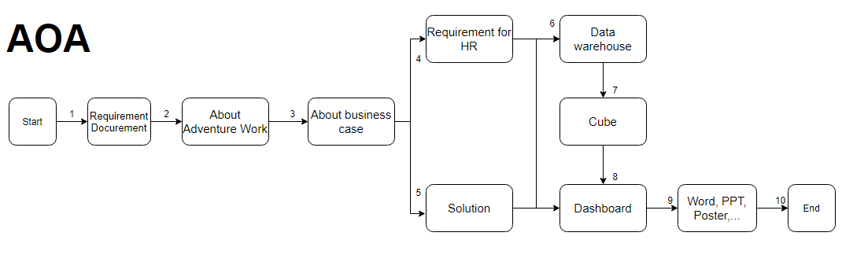

###### Picture 5.1.3.2.1: Action On Arc (AOA)

* **AON method (Action On Node)**

Principles established AON network diagram:

* The jobs are presented in a button.
* Arrows only specify the front and back order of the jobs.
* All nodes, except for the last node, have at least one node behind them. All points, except the first node, have at least one preceding node.

In a network diagram there are only one node (event) and one last (event) node.

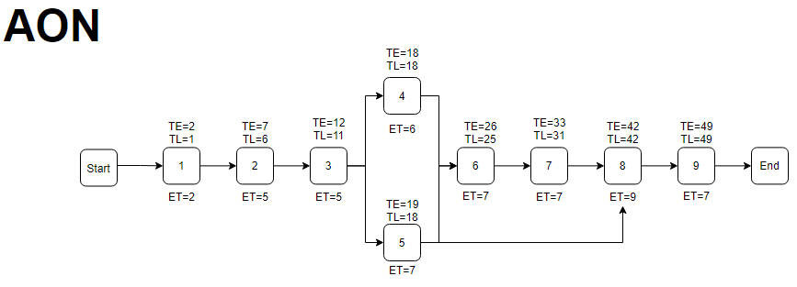

###### Picture 5.1.3.2.1: Action On Node (AON)

### 5.1.4 Estimate for BI project

The project "PROJECT MANAGEMENT BI SOLUTION FOR HUMAN RESOURCES IN ADVENTURE WORKS" is estimated as:

* Will be completed as early as 38 days with Optimistic Time, 72 days at the latest with Pessimistic Time; The average project completion time is 55 days
* The budget for this project is up to $4000 with 4 staff members.
* A man-month equates to 739.03 working hours or 75 working days

## 5.2 Scheduling and resourcing

### 5.2.1 Critical path network for BI project of HR

Critical path network (5) will tell us which jobs must follow the plan. Because if you change, it will immediately affect the progress of the project. The impact (in terms of progress - timelines) can include changing the timing of the project completion, changing the contours.

The job reserve period tells us how much work can be delayed, how much it can last without affecting other work or without affecting the change in timing of the end of the project. When work changes beyond the time reserve limit, the project progress is affected.

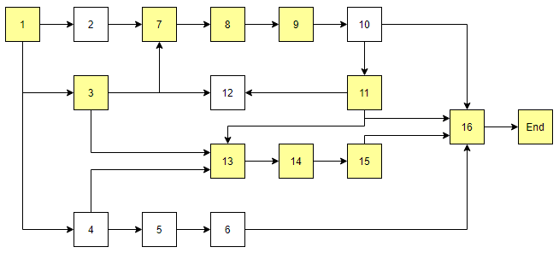

###### Picture 5.2.1: Critical path network

### 5.2.2 Network analysis results for BI project of HR

Network Analysis (5)- a network chart is a standard way of presenting project activities and their relationships. The tasks are represented as boxes, or nodes, and the relationships between the tasks are drawn as the lines connecting the nodes. Unlike Gantt charts, timetable views, Network analysis allows you to view project activities in a more coherent way, similar to the flowchart format. This is useful if you want to focus more on the relationships between activities rather than their deadlines and sequences.

In the backward pass, we establish the earliest start time (EST) and earliest finish time (EFT) for each activity, and we do this by addition. We record the EST for each activity in the top left-hand box and obtain the EFT by adding to this the duration of the activity. The result is then recorded in the top box. Moving through the model, the EST for an activity is the same as the EFT of its predecessor.

In addition, the model to establish the latest start time (LST) and latest finish time (LFT) for each activity, this time by subtracting durations from our EFT for the whole project of 75 days.

The LFT for each activity is recorded in the bottom right-hand box and the LST is arrived at by subtracting the duration of the activity from the LFT. The LFT for an activity is the same as the LST of its successor on the model.

|  |  |  |  |  |  |  |  |
| --- | --- | --- | --- | --- | --- | --- | --- |
| **No** | **Task Name** | **Dependent** | **EST** | **EFT** | **LST** | **LFT** | **Float** |
| 1 | **Analyzing requirements** | ~ | 1 | 2 | 1 | 2 | 0 |
| 2 | **Surveying current status of Adventure Work Company** | 1 | 3 | 6 | 5 | 8 | 2 |
| 3 | **Research about business strategy and business case** | 2 | 9 | 11 | 10 | 13 | 2 |
| 4 | **Determining Business Intelligence requirements** | 3 | 14 | 19 | 18 | 21 | 3 |
| 5 | **Introduction to BI solutions** | 4 | 22 | 27 | 24 | 30 | 3 |
| 5.1 | Researching BI solutions |  |  |  |  |  |  |
| 5.2 | Choosing the suitable BI solution |  |  |  |  |  |  |
| 6 | **Design Data warehouse** | 4,3 | 31 | 35 | 31 | 40 | 5 |
| 6.1 | Build Data wahouse |  |  |  |  |  |  |
| 6.2 | ETL process |  |  |  |  |  |  |
| 7 | **Create Cube and build KPI** | 6 | 41 | 47 | 43 | 49 | 2 |
|  | Create Cube |  |  |  |  |  |  |
| 7.2 | KPI |  |  |  |  |  |  |
| 8 | **Analyzing Data** | 6,5 | 50 | 60 | 50 | 65 | 5 |
| 8.1 | Visualize |  |  |  |  |  |  |
| 8.2 | Create dashboard |  |  |  |  |  |  |
| 9 | **Write report +Edit (word, power point, poster…)** | 8 | 61 | 68 | 65 | 75 | 7 |

##### Table 5.2.2: Network analysis results

Apply Network diagram after backward pass to represent Network diagram according to the following standards

* EST (earliest start time) will be on the top left
* EFT (earliest finish time) will be on the top right been
* LST (latest start time) will be at the bottom, left side
* LFT (latest finish time) will be at the bottom right

That is shown in the following figure

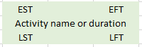

###### Picture 5.2.2.1: Network diagram drawing convention

Based on the conventions in Table 5.2.2.1 and Picture 5.2.2.2, we get the Network diagram after backward pass as follows.

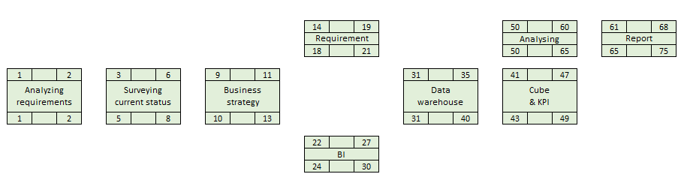

###### Picture 5.2.2.2: Network analysis results after backward pass

### 5.2.3 GANTT chart for BI project of HR

The GANTT chart (5) was introduced in 1917 by Henry Laurence Gantt (a pioneer in scientific management). GANTT chart is a method of presenting the actual progress as well as the project's work plan in chronological order. The aim of the GANTT is to determine the most reasonable progression for the various project tasks. This progress depends on the length of the job, the conditions and the deadlines to be followed.

In the Gantt diagram:

* The vertical axis presents the work.
* The execution time of each respective job is shown on the horizontal axis.
* Each line represents one job. Line length is the work length.
* The position of the straight line represents the front-to-back order relationship between jobs.
* Each job has a start & end timing to control progress in real time.

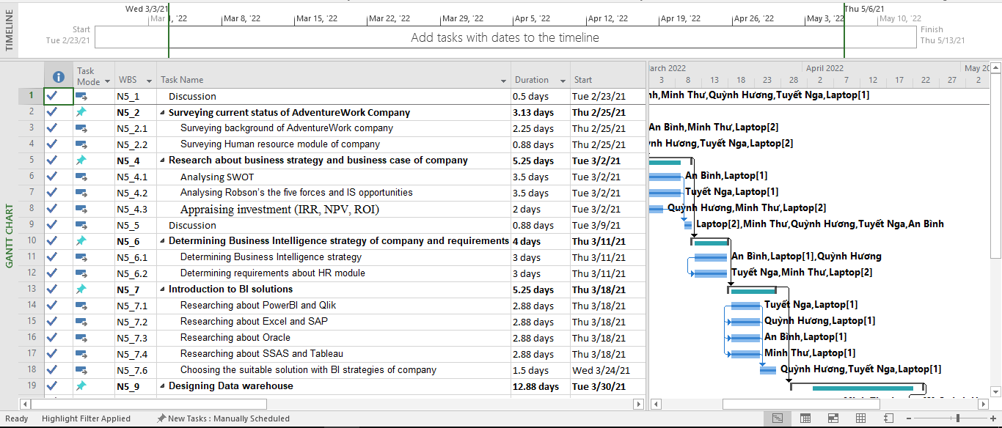

###### Picture 5.2.3: GANTT chart

# CHAPTER 6: MONITORING PROGRESS AND QUALITY

In the actual running of  the project on a day-to-day basis, monitoring progress and quality control is very important to make changes as necessary to ensure that it keeps on track for delivering its final results. There are several mechanisms for the project manager to monitor progress and quality control; however below are some mechanisms that they can apply to manage their project.

## 6.1 Documenting quality control

To monitor quality of our project, we used various methods depending on the situation:

* Self-checking: In most tasks, our members try their best to learn something new and apply to those tasks. However, sometimes we found it too difficult to have the right approach at the first time. We used trial and error methods in those situations. So our members self-checked their tasks after every period as we received feedback from our teacher.
* Peer reviews: Because we almost shared the same tasks for all members to learn new knowledge together, peer reviews is the most common method we used to monitor quality.
* External review: Our teachers are very kind to review our project in some beginning periods and especially in the Visualizing period. After  receiving the review, we discussed it again and applied 2 methods above to rework those tasks.

However, whatever methods are employed for the quality control, we need to document it properly. According to ISO 9001, it is possible to trace the quality control process from the discovery of a problem to its solution. There are many ways of documenting the process and the precise documentation. However, a simple two-layer process below shows the most effectively:

* A log is maintained of all checks carried out.
* For each check, a report sheet is compiled.

Our group often has a discussion every finishing period to review the result in that week, and find solutions to any problems we meet. Although we did not have a quality control review for each discussion, we adjusted our Gantt chart and discussed the solutions together.

## 6.2 Checkpoint meeting report

Checkpoint meetings are held frequently, usually weekly or fortnightly, and are attended by the team leaders and team members and, optionally, by the stage manager and project assurance team. Progress is reviewed against individual work plans and a report is produced showing many points such as:

* Activities during the period
* Products completed and the result achieved
* Problems encountered and solutions suggested
* Plans for the next period

Here is one example of our checkpoint meeting report which recorded our discussion followed by the Gantt chart.

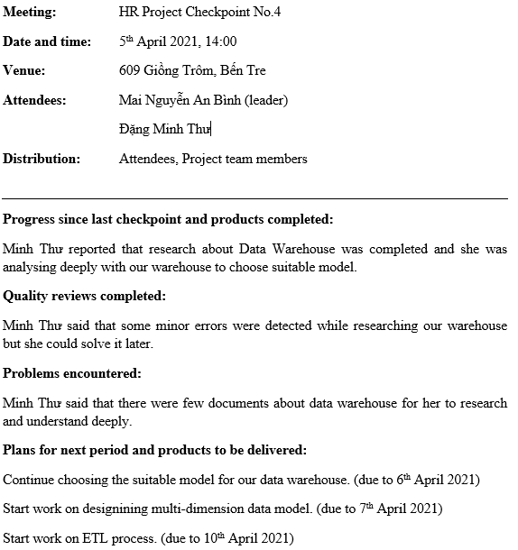

###### Picture 6.2: Checkpoint meeting report No.4

The report suggests that the project is generally going well. One of our member’s task is research about data warehouse, which is completed. However, she found some minor errors while researching. As a result, our group planned a discussion the following day to find a solution to those problems.

## 6.3 Change control form

Change control is the process through which all requests to change the approved baseline of a project, programmed or portfolio are captured, evaluated and then approved, rejected or deferred. After each discussion, which documented the present process and some change would be raised if there were some problems. Whenever we realize that we need a change in our project, we should consider many things to ensure that it was a right decision. These are some steps that our team need to prepare before implementing a change:

* Give the detailed evaluation of the impact on baseline, costs, time, scope, risks.
* The plan needs to be updated or not.
* Who is responsible for the change?
* What necessary actions are taken when the change implements.

To record the change and have a clear proof, we should use the Change control form. Change control form is a report recording any changes during performing the project and assessing its impact on the whole project.

## 6.4 The risk register

Risk register is one of the most important documents in the risk management process. In the Extract from [name project] risk register report, the manager can define the risks that the project is facing, then assess those risks and find responses to them.

Using the brainstorming technique, our group identified some potential risks to the project. One of these risks is shown in our Extract from Human Resource BI Solutions project risk register below. Some potential risks that we found are:

* The system requires the use of tools, techniques are new to our members.
* The project plan does not spend time and take into account the need to revisit work from the previous phase.
* System software is not yet available. Our team must install the software many times due to some problems, which wasted too much time at the beginning phase.

Here is our Extract from Human Resource BI Solutions project risk register about the rash R002: The development environment is too new to developers so we faced many challenges at first approach

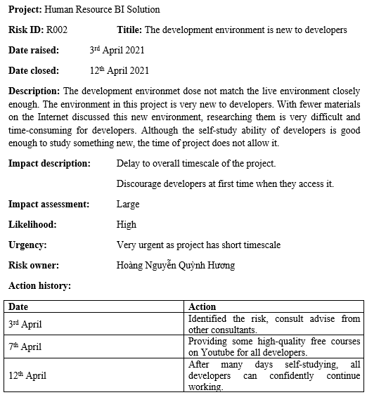

###### Picture 6.4: Extract from Human Resource BI Solutions project risk register

# CHAPTER 7: PROJECT EVALUATION AND CONCLUSION

## 7.1. Results

Understand and apply the knowledge learned in the PMIS subject to the report "PROJECT MANAGEMENT INFORMATION SYSTEMS". For example, Group 5 ability to observe and see the market (SWOT, ROBON,..); the ability to estimate human resources for project implementation,...

Understand and proficiently use Microsoft Project tools to perform task management, estimate and create reports, ..

Group 5 know that the information systems project is required to manage all related activities and provide the necessary resources to create all conditions for the business to achieve the expected results. This management must be methodical in order to cover all aspects of the project and facilitate it to take place successfully.

## 7.2. Limitations

The first phase of the project was delayed because the business case system survey and analysis were not deep and the data warehouse was not well understood.

The return of Covid-19 should have all offline meetings of the group cancelled.

The online working group is not really effective when there are situations such as network transmission, power outages, ..

## 7.3. Future works

Expand the implementation of building a set of business reports of the entire business system module of the enterprise on the basis of AdventureWorks database.

Applying many other analytical tools and methods such as Qlik, Python, ... to have more opportunities to apply new technologies into the learning and research process as well as building a solid foundation when approaching actual projects at the enterprise.

# REFERENCES

1. FERNANDO, JASON. Internal Rate of Return (IRR). *Investopedia.* [Online] 4 7, 2021. https://www.investopedia.com/terms/i/irr.asp, Viewed date 15/4/2021.

2. Business Intelligence Strategy: How to Develop and Document your BI Roadmap. *Altexsoft.* [Online] 11 10, 2020. https://www.altexsoft.com/blog/business-intelligence-strategy, Viewed date 23/3/2021.

3. FERNANDO, JASON. Return on Investment (ROI). *Investopedia.* [Online] 4 8, 2021. https://www.investopedia.com/terms/r/returnoninvestment.asp, Viewed date15/3/2021.

4. University, Stanford. Technical Design. *Stanford University.* [Online] https://uit.stanford.edu/pmo/technical-design, Viewed date 7/3/2021.

5. Yeates, James Cadle & Donald. *Project Management for Information Systems.* Wiley : 5th Edition, 2007, Viewed date 30/2/2021.