**Assignment 01**

**Building a Sales Management Application with Windows Presentation Foundation (WPF)**

# Introduction

Imagine you're an employee of a product retailer named **FStore**. Your manager has asked you to develop a Windows Presentation Foundation (WPF) application for member management, product management, and order management. The application has a default account whose email is “**admin@fstore.com**” and password is “**admin@@**” that stored in the **appsettings.json**.

The application has to support adding, viewing, modifying, and removing products—a standardized usage action verbs better known as Create, Read, Update, Delete (CRUD) and Search. This assignment explores creating an application using Windows Presentation Foundation (WPF) with .NET Core, C#, and ADO.NET / Entity Framework Core. The MS SQL Server database will be created to persist the data and it will be used for reading and managing data.

# Assignment Objectives

In this assignment, you will:

* Use the Visual Studio.NET to create Windows Presentation Foundation (WPF) and Class Library (.dll) projects.
* Perform CRUD actions using ADO.NET or Entity Framework Core.
* Use LINQ to query and sort data.
* Apply passing data in the WPF application.
* Apply 3-Layers architecture to develop the application.
* Apply MVVM (Model-View ViewModel) pattern in the application.
* Apply Dependency injection (DI) in the application.
* Apply Repository pattern and Singleton pattern in a project.
* Add CRUD and searching actions to the application.
* Apply to validate data type for all fields.
* Run the project and test the WPF application actions.

# Database Design

# 

# Main Functions

* Member management, Product management, and Order management: Read, Create, Update and Delete actions. Creating and Updating actions must be performed by popup dialog
* Search Product by ID , ProductName (by keyword of ProductName), UnitPrice, and UnitInStock
* Create a report statistics sales by the period from StartDate to EndDate, and sort sales in descending order
* Member authentication by Email and Password. If the user is “**Admin**” then allows to perform all actions, otherwise, the normal user is allowed to view/create/update the profile and view their orders history.

# Guidelines

# Activity 01: Build a solution [01 mark]

Create a Blank Solution named **Ass01Solution** that includes Class Library Project: **DataAccess, BusinessObject,** and a Windows Presentation Foundation (WPF) project named **SalesWPFApp**

**Step 01**. Open the Visual Studio .NET application and create a Blank solution named **Asm01Solution**

**Step 02.** Create a Class Library project named **DataAccess**

From the File menu | Add | New Project, on the Add New Project dialog, select “Class Library” and performs steps as follows:

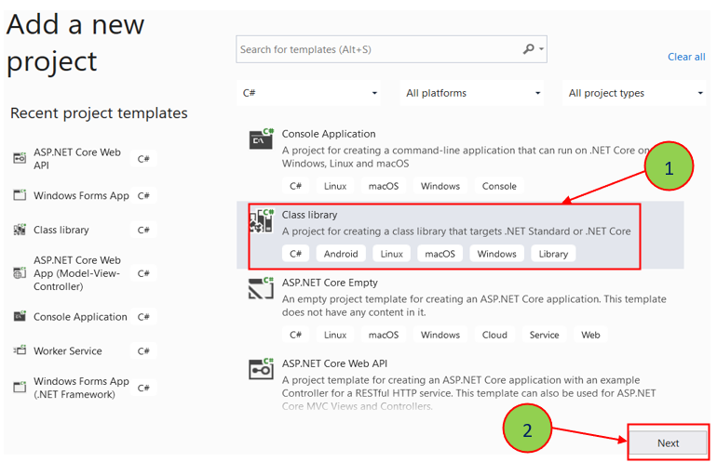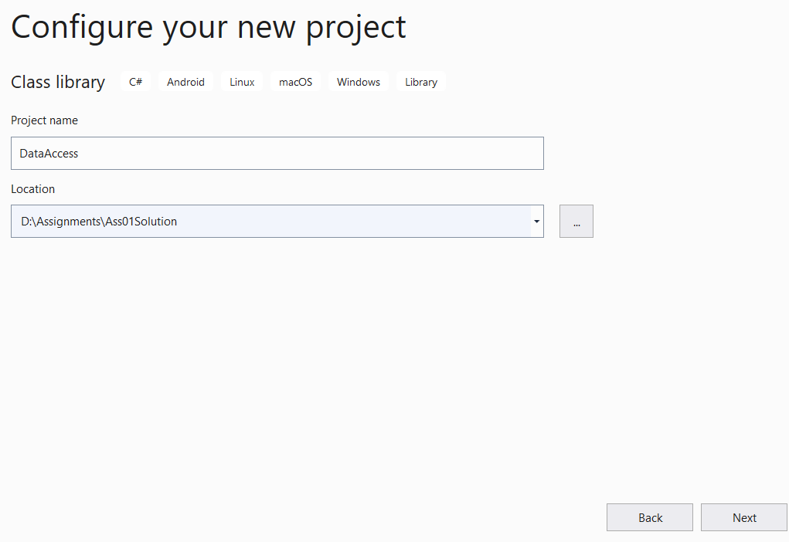

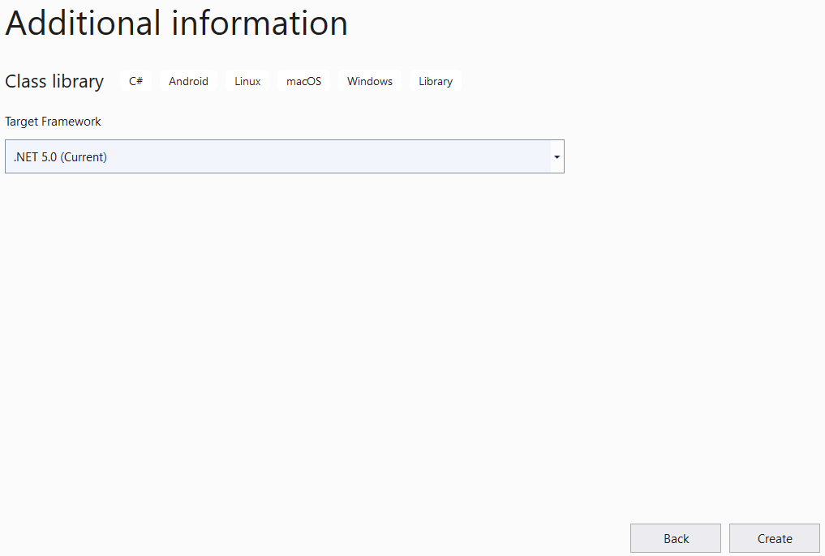

**Step 03.** Repeat **Step 02** to create a **BusinessObject** project.

**Step 04.** Create a Windows Presentation Foundation (WPF) project named **SalesWPFApp**

* From the File menu | Add | New Project, on the Add New Project dialog, select “WPF Application” and performs steps as follows:

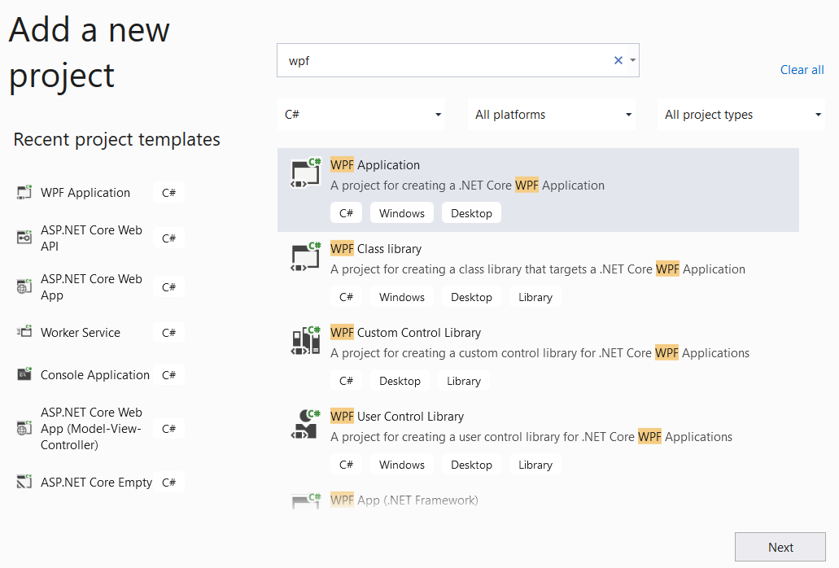

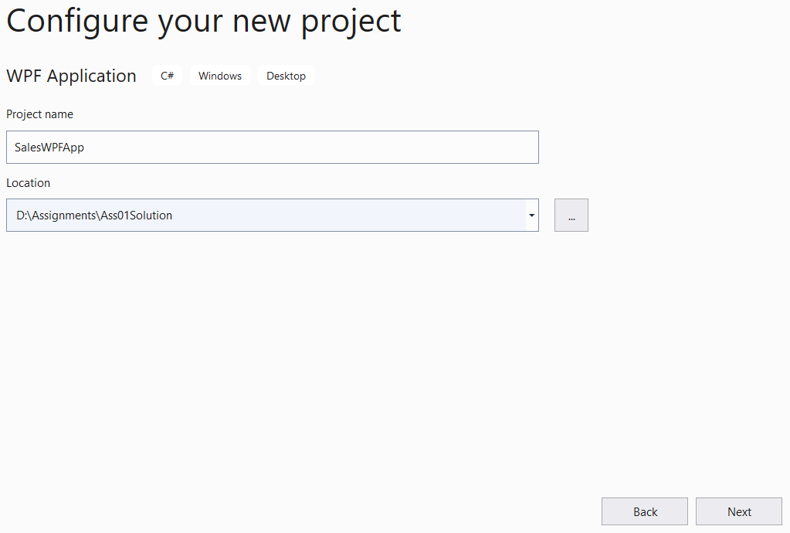

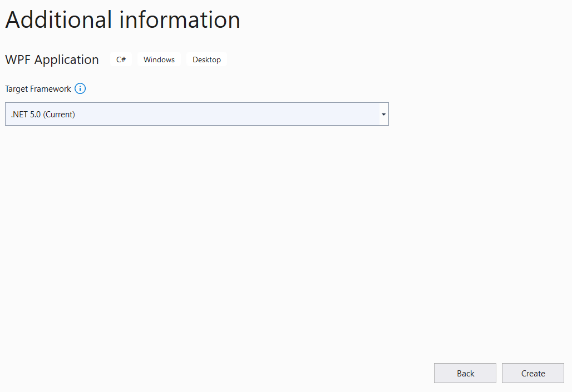

**Step 05**. Create folders and add classes to the projects as follows:

# 

# Activity 02: Develop BusinessObject project

# [02 marks]

**Step 01**. Write codes to create classes and definition all data members

**Step 02**. Write codes to perform business rules for data members

# Activity 03: Develop DataAccess project [03 marks]

**Step 01**. Add the project reference to the **BusinessObject** project

**Step 02**. Write codes for **MemberDAO.cs, IMemberRepository.cs** and **MemberRepository.cs**

**Step 03**. Write codes for **ProductDAO.cs, IProductRepository.cs** and **ProductRepository.cs**

**Step 04**. Write codes for **OrderDAO.cs, IOrderRepository.cs** and **OrderRepository.cs**

**Step 05**. Write codes for **OrderDetailDAO.cs, IOrderDetailRepository.cs** and **OrderDetailRepository.cs**

***Hints*:** If using Entity Framework Core, you can install the AutoMapper package from Nuget to map Entity with Busines Object

# Activity 04: Develop SalesWPFApp project

# [03 marks]

**Step 01**. Add the reference to **BusinessObject** and **DataAccess** projects

**Step 02**. Design UI (XAML code) for windows and write codes to perform functions

# Activity 05: Run the WPF project and test all actions [01 mark]