ASSIGNMENT 4

OPTION 2

1. URL website:

<https://designbyanchi.000webhostapp.com/>

Các trang HTML con:

<https://designbyanchi.000webhostapp.com/Aboutus/Aboutus.html>

<https://designbyanchi.000webhostapp.com/product/PRODUCT.html>

<https://designbyanchi.000webhostapp.com/course/Courses.html>

<https://designbyanchi.000webhostapp.com/newinfo/newinfo.html>

<https://designbyanchi.000webhostapp.com/Member/member.html>

<https://designbyanchi.000webhostapp.com/service/service.html>

1. Áp dụng kỹ thuật SEO:

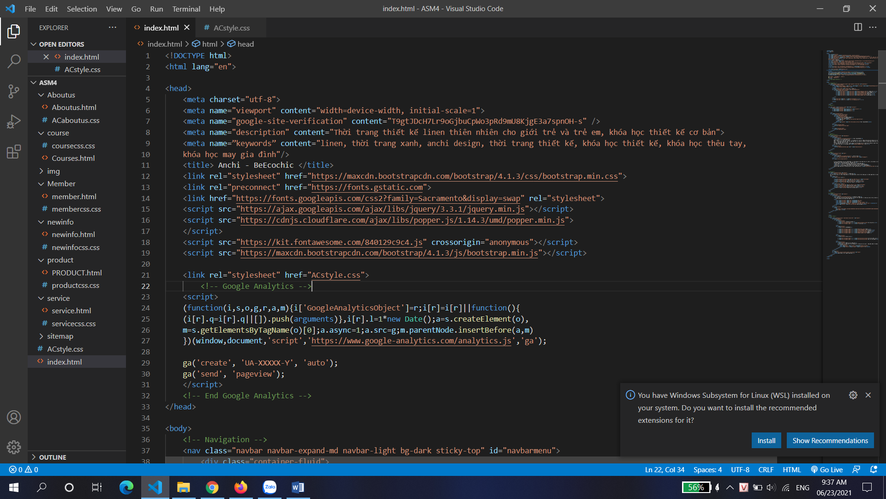

1. Tiến hành submit trang lên google để thực hiện indexing:

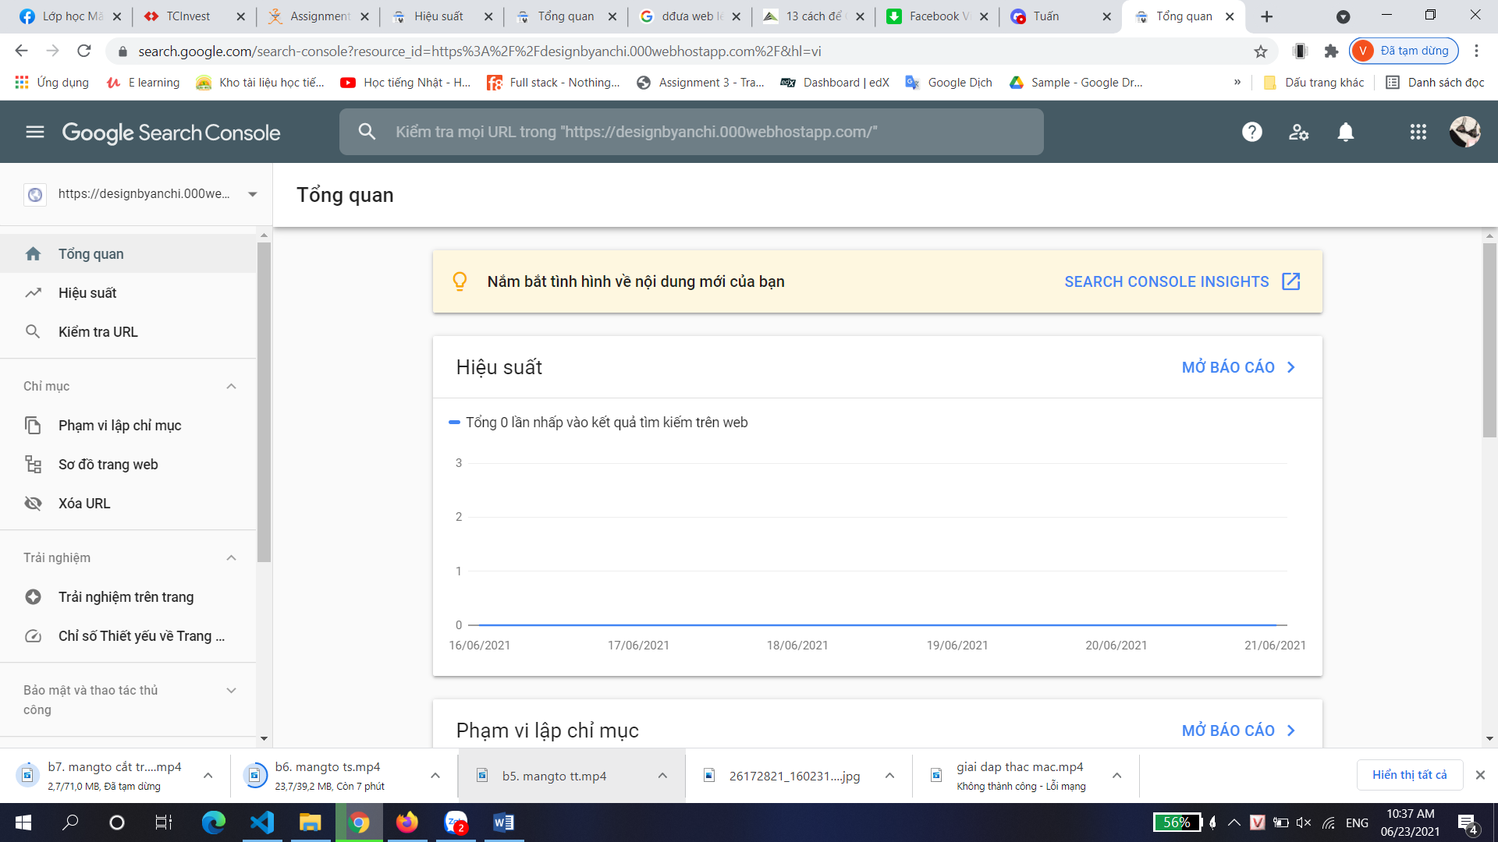

1. Tích hợp thêm Google Analytics :

