**Nitin chaudary**

**F7**

**9921103163**

**Answers are implemented by me on my sql command line client-**

**First I am pasting entire images of what I have coded and in last I am going to past entire code which I have written for all answers –**

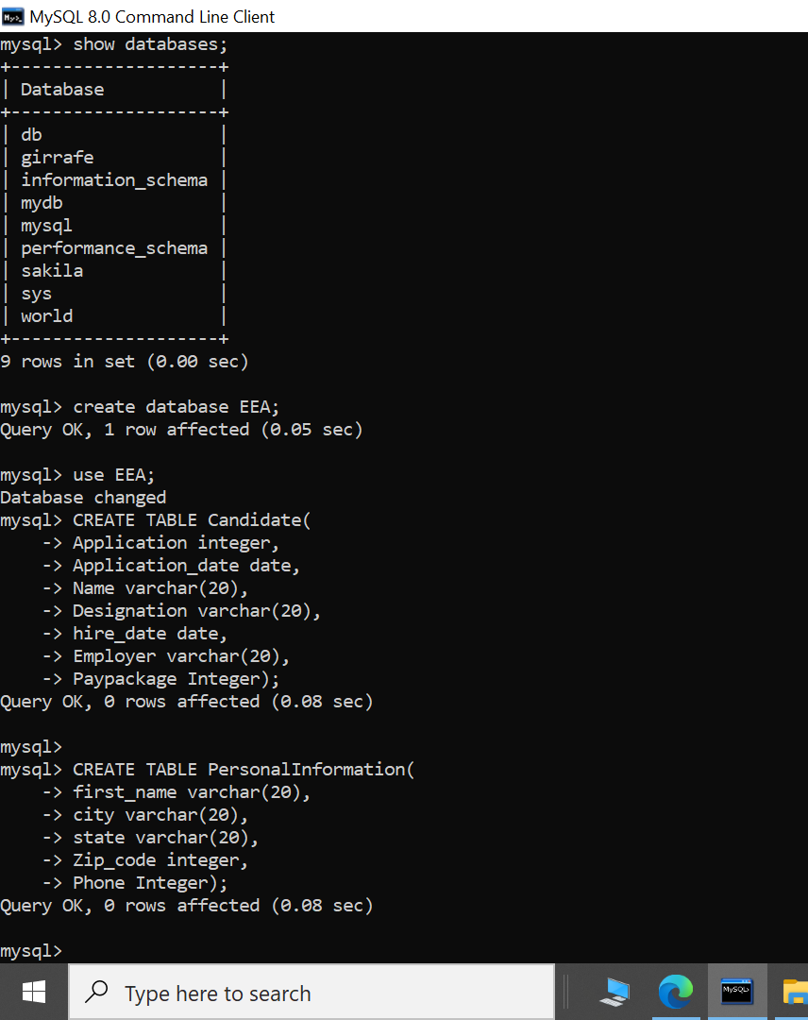

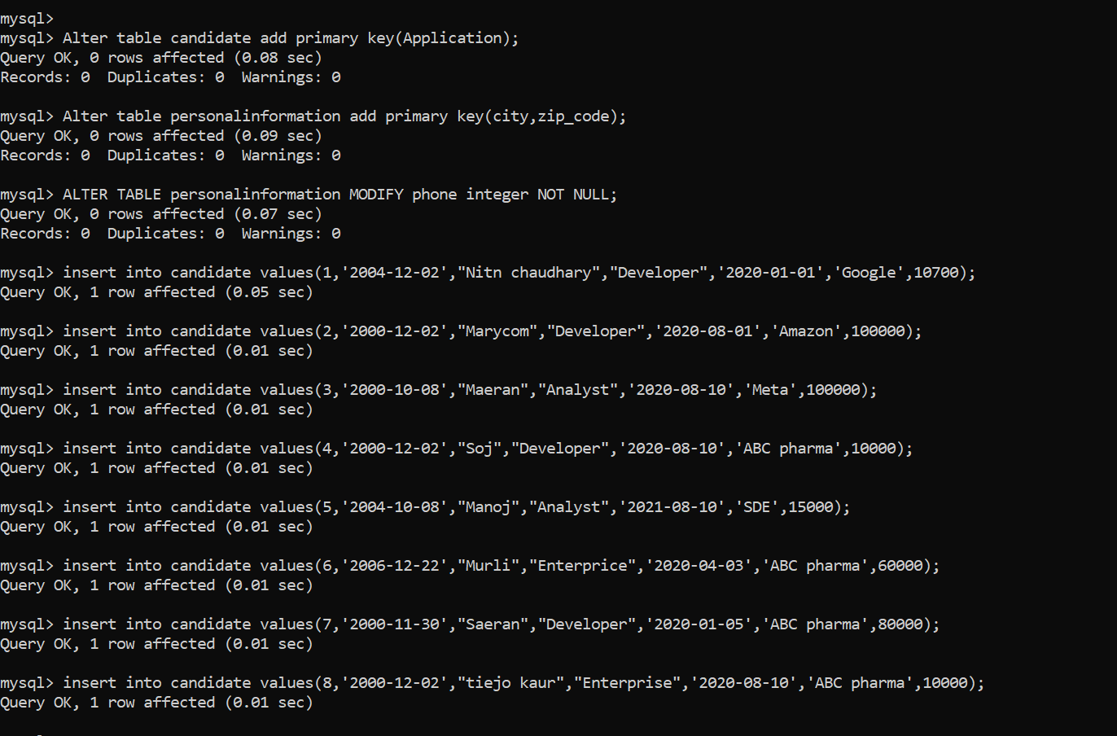

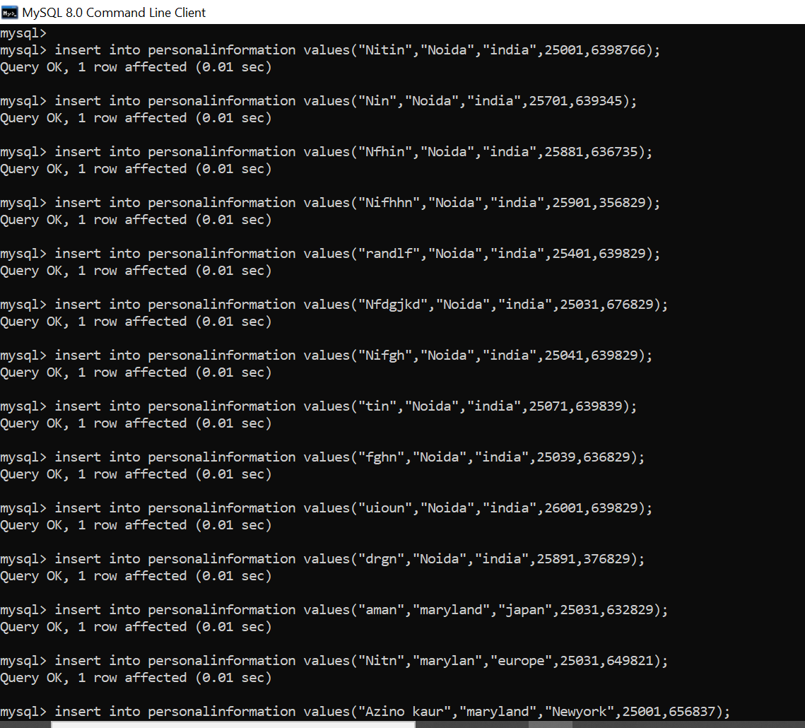

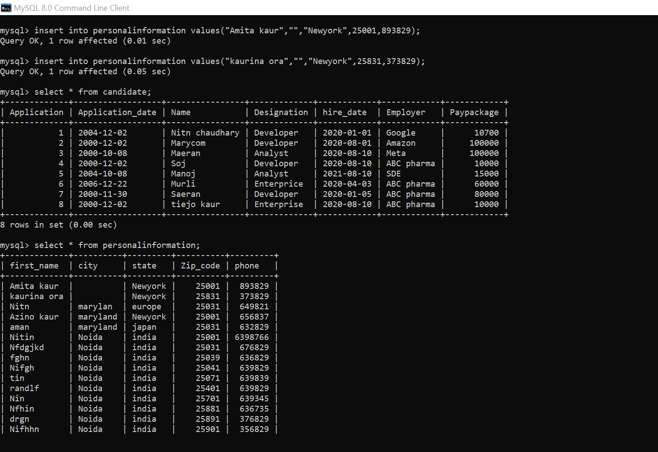

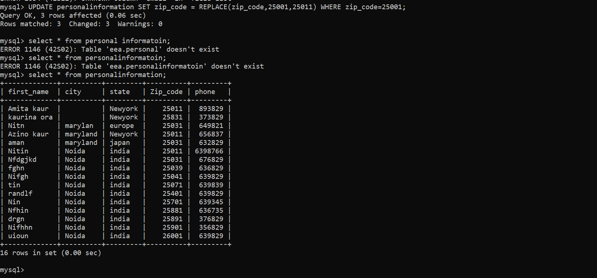

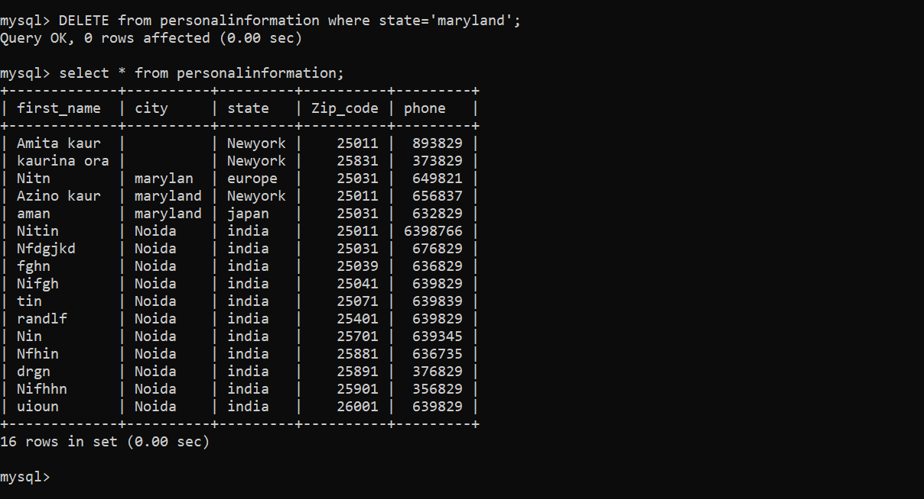

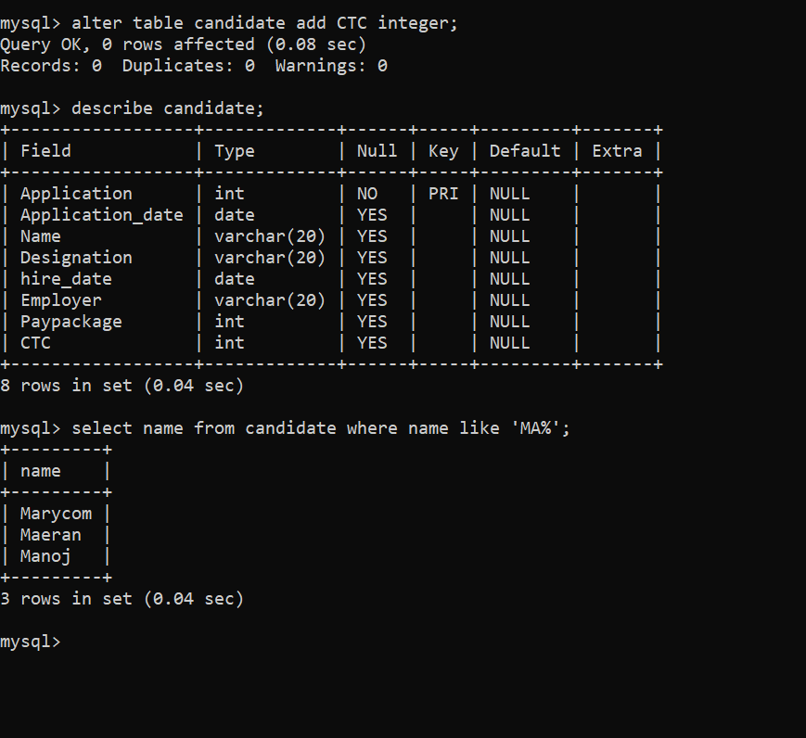

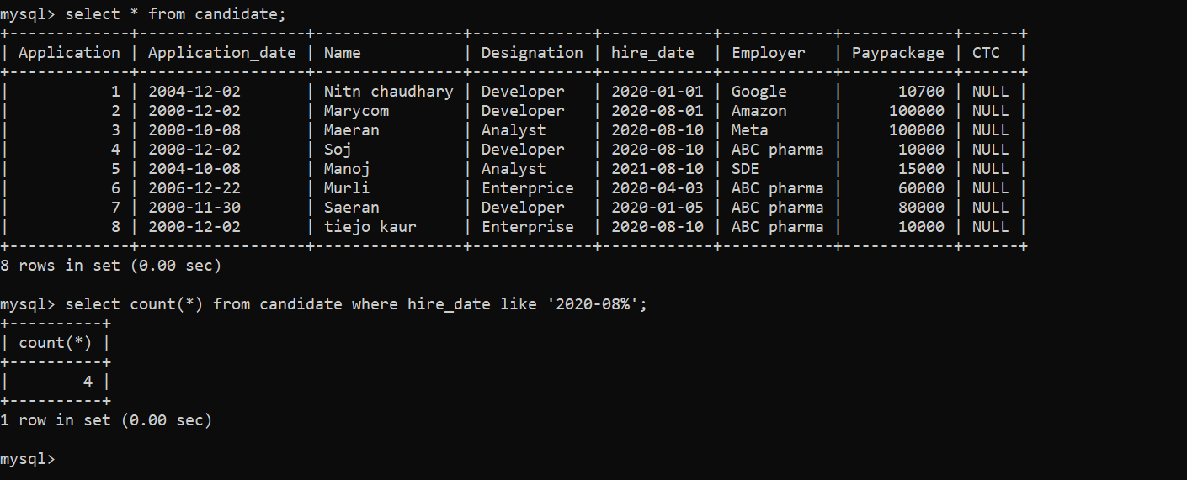

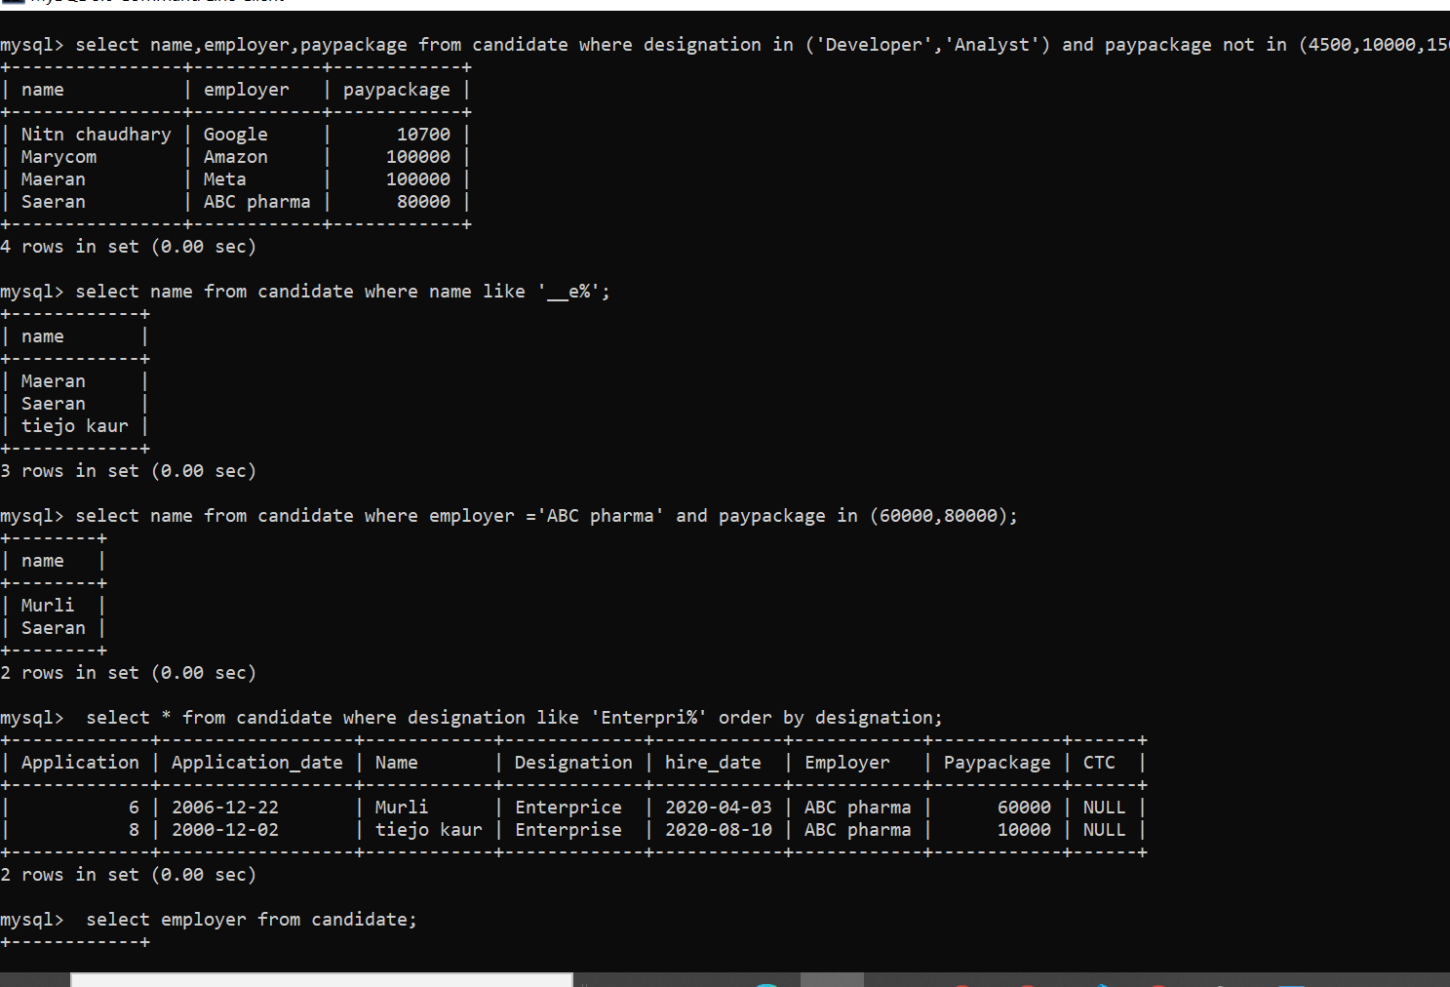

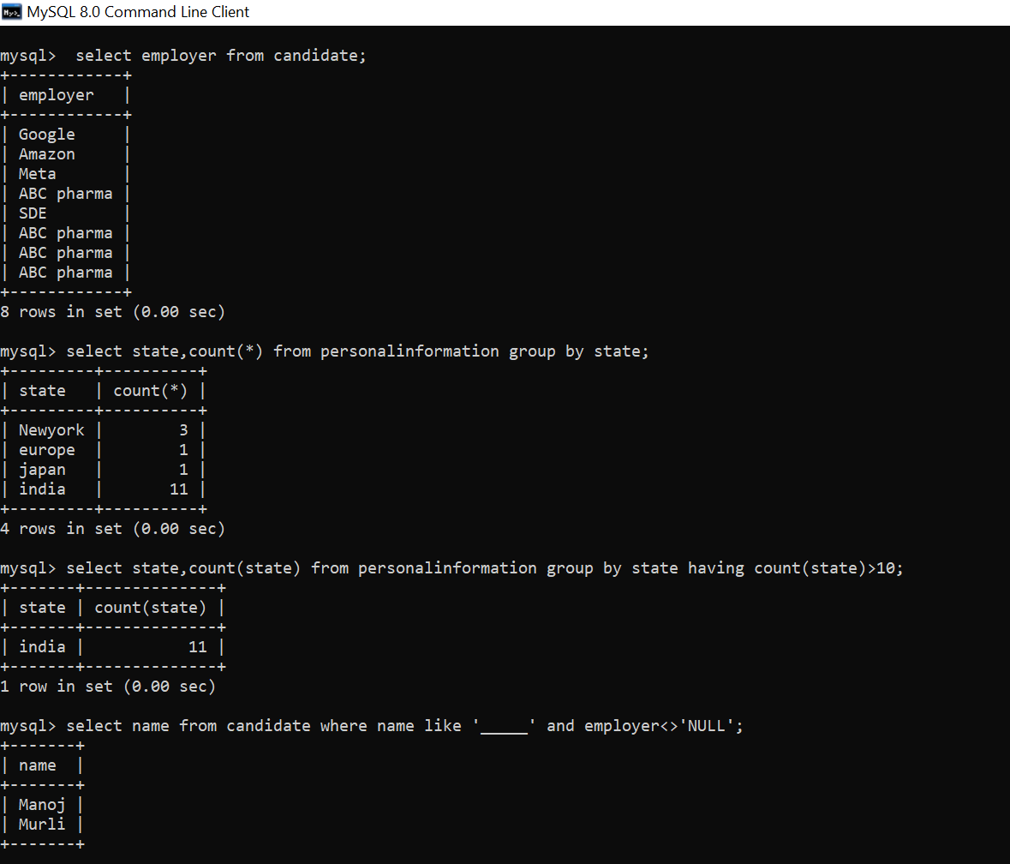

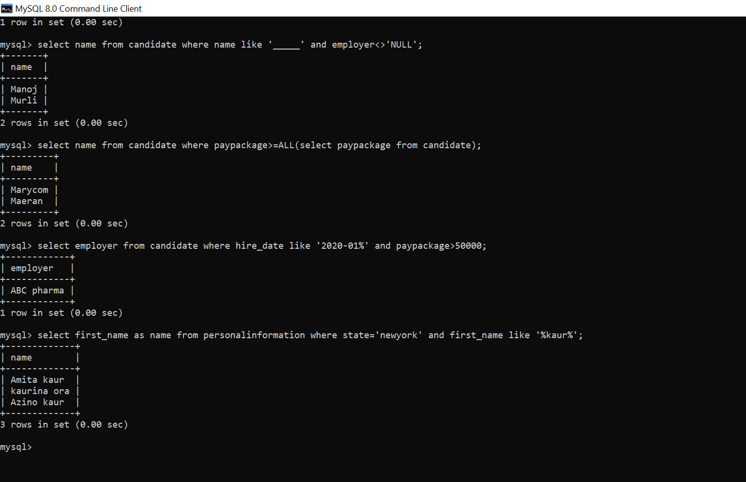

**All content which I write in mysql command line client-**

**create database EEA;**

**use EEA;**

**CREATE TABLE Candidate(**

**Application integer,**

**Application_date date,**

**Name varchar(20),**

**Designation varchar(20),**

**hire_date date,**

**Employer varchar(20),**

**Paypackage Integer);**

**CREATE TABLE PersonalInformation(**

**first_name varchar(20),**

**city varchar(20),**

**state varchar(20),**

**Zip_code integer,**

**Phone Integer);**

**Alter table candidate add primary key(Application);**

**Alter table personalinformation add primary key(city,zip_code);**

**ALTER TABLE personalinformation MODIFY phone integer NOT NULL;**

**Alter table candidate add constraint pkg check('package'>0);**

**insert into candidate values(1,'2004-12-02',"Nitn chaudhary","Developer",'2020-01-01','Google',10700);**

**insert into candidate values(2,'2000-12-02',"Marycom","Developer",'2020-08-01','Amazon',100000);**

**insert into candidate values(3,'2000-10-08',"Maeran","Analyst",'2020-08-10','Meta',100000);**

**insert into candidate values(4,'2000-12-02',"Soj","Developer",'2020-08-10','ABC pharma',10000);**

**insert into candidate values(5,'2004-10-08',"Manoj","Analyst",'2021-08-10','SDE',15000);**

**insert into candidate values(6,'2006-12-22',"Murli","Enterprice",'2020-04-03','ABC pharma',60000);**

**insert into candidate values(7,'2000-11-30',"Saeran","Developer",'2020-01-05','ABC pharma',80000);**

**insert into candidate values(8,'2000-12-02',"tiejo kaur","Enterprise",'2020-08-10','ABC pharma',10000);**

**insert into personalinformation values("Nitin","Noida","india",25001,6398766);**

**insert into personalinformation values("Nin","Noida","india",25701,639345);**

**insert into personalinformation values("Nfhin","Noida","india",25881,636735);**

**insert into personalinformation values("Nifhhn","Noida","india",25901,356829);**

**insert into personalinformation values("randlf","Noida","india",25401,639829);**

**insert into personalinformation values("Nfdgjkd","Noida","india",25031,676829);**

**insert into personalinformation values("Nifgh","Noida","india",25041,639829);**

**insert into personalinformation values("tin","Noida","india",25071,639839);**

**insert into personalinformation values("fghn","Noida","india",25039,636829);**

**insert into personalinformation values("uioun","Noida","india",26001,639829);**

**insert into personalinformation values("drgn","Noida","india",25891,376829);**

**insert into personalinformation values("aman","maryland","japan",25031,632829);**

**insert into personalinformation values("Nitn","marylan","europe",25031,649821);**

**insert into personalinformation values("Azino kaur","maryland","Newyork",25001,656837);**

**insert into personalinformation values("Amita kaur","","Newyork",25001,893829);**

**insert into personalinformation values("kaurina ora","","Newyork",25831,373829);**

**UPDATE personalinformation SET zip_code = REPLACE(zip_code,25001,25011) WHERE zip_code=25001;**

**DELETE from personalinformation where state='maryland';**

**alter table candidate add CTC integer;**

**select name from candidate where name like 'MA%';**

**select count(*) from candidate where hire_date like '2020-08%';**

**select name,employer,paypackage from candidate where designation in ('Developer','Analyst') and paypackage not in (4500,10000,15000);**

**select name from candidate where name like '__e%';**

**select name from candidate where employer ='ABC pharma' and paypackage in (60000,80000);**

**select * from candidate where designation like 'Enterpri%' order by designation;**

**select employer from candidate;**

**select state,count(*) from personalinformation group by state;**

**select state,count(state) from personalinformation group by state having count(state)>10;**

**select name from candidate where name like '_____' and employer<>'NULL';**

**select name from candidate where paypackage>=ALL(select paypackage from candidate);**

**select employer from candidate where hire_date like '2020-01%' and paypackage>50000;**

**select first_name as name from personalinformation where state='newyork' and first_name like '%kaur%';**

**This last query was not executed by me as I am not aware about how to perform operations on dates so I have commented out it.**

**-- select name from candidate where (Application_date-Hire_date)<All(select (Application_date-Hire_date from candidate));**