**Nitin Chaudhary**

**Tutorial 12**

**9921103163**

**F7**

**Ans 1-**

**DELIMITER $$**

**CREATE PROCEDURE fact(IN n INT)**

**BEGIN**

**DECLARE f INT DEFAULT 1;**

**DECLARE i INT DEFAULT 1;**

**WHILE i<=n DO**

**SET f=f*i;**

**SET i=i+1;**

**END WHILE;**

**SELECT f AS FACTORIAL;**

**END$$**

**DELIMITER;**

**CALL fact(5);**

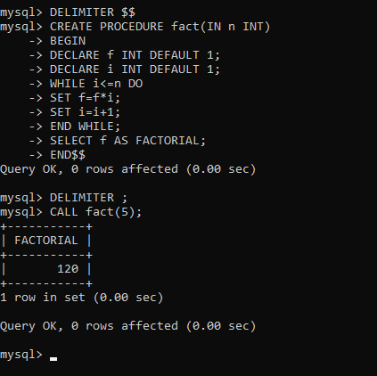

Ans 2-

**create table employee(**

**emp_id int,**

**salary double(14,5));**

**insert into employee values(1,200);**

**insert into employee values(2,300);**

**insert into employee values(3,500);**

**insert into employee values(4,600);**

**DELIMITER $$**

**CREATE PROCEDURE increment_salary()**

**BEGIN**

**UPDATE employee**

**SET salary=salary*1.10;**

**END$$**

**DELIMITER ;**

**CALL increment_salary();**

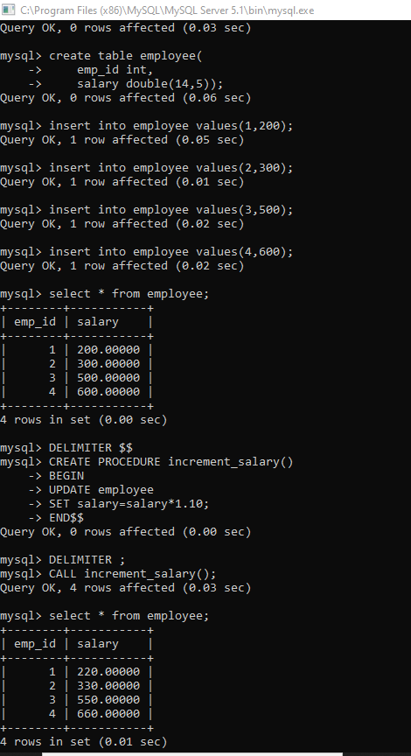

Ans 3-

**DELIMITER $$**

**CREATE FUNCTION fibb(n  INT)**

**RETURNS  varchar(255)  DETERMINISTIC**

**BEGIN**

**DECLARE a  INT DEFAULT 0;**

**DECLARE b  INT DEFAULT 1;**

**DECLARE c  INT ;**

**DECLARE i  INT ;**

**DECLARE str  VARCHAR(255);**

**SET str='0,1,';**

**SET i=2;**

**WHILE i<n DO**

**SET c=a+b;**

**SET str=CONCAT(str,c,',');**

**SET a=b;**

**SET b=c;**

**SET i=i+1;**

**END WHILE;**

**RETURN str;**

**END $$**

**DELIMITER ;**

**SET @result=fibb(5);**

**SELECT @result;**

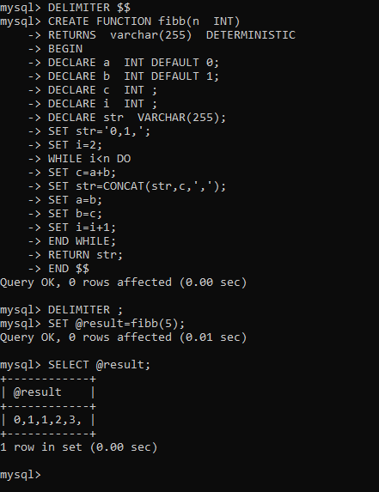

Ans 4-

**Create table customers(**

**Id int,**

**Salary int);**

**insert into customers values(1,45000);**

**insert into customers values(2,5000);**

**insert into customers values(3,4000);**

**insert into customers values(4,55000);**

**insert into customers values(5,20000);**

**DELIMITER $$**

**CREATE FUNCTION count_cust()**

**RETURNS INT**

**BEGIN**

**DECLARE a int default 0;**

**SELECT Count(*) into a**

**from customers**

**where salary>40000;**

**RETURN a;**

**END $$**

**DELIMITER ;**

**SET @count=count_cust();**

**SELECT @count;**

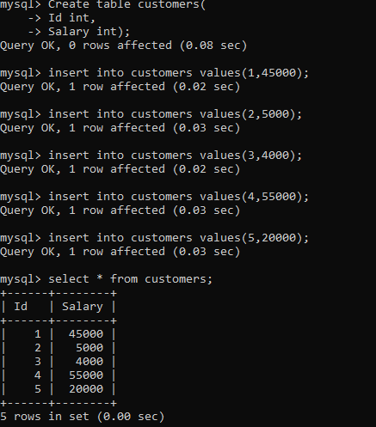

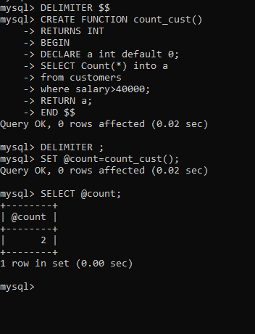

**Ans 5-**

**Create table customers(**

**ID int,**

**Name varchar(20),**

**Age int,**

**Address varchar(20),**

**Salary double(10,2));**

**Insert into customers values(1,’Ramesh’,32,’Ahmedabad’,2500.00);**

**Insert into customers values(2,’Khilan’,25,’Delhi’,2500.00);**

**Insert into customers values(3,’Kaushik’,23,’Kota’,2000.00);**

**Insert into customers values(4,’Chaitali’,25,’Mumbai’,7000.00);**

**Insert into customers values(5,’Hardik’,27,’Bhopal’,9000.00);**

**Insert into customers values(6,’Komal’,22,’MP’,5000.00);**

**DELIMITER $$**

**CREATE PROCEDURE GETLIST(inout info varchar(4000), inout count_no INT)**

**BEGIN**

**DECLARE finisher integer default 0;**

**Declare cus_id int;**

**Declare cus_name varchar(50) default '';**

**Declare cus_addr varchar(50) default '';**

**Declare curdetail cursor for**

**Select id,name,address from Customers where age>25;**

**Declare continue handler for not found set finisher =1;**

**Open curdetail;**

**getdetail:LOOP**

**Fetch curdetail into cus_id,cus_name,cus_addr;**

**If finisher=1 then**

**LEAVE getdetail;**

**END IF;**

**SET info=CONCAT(cus_id,',',cus_name,',',cus_addr,',',info);**

**SET count_no=count_no+1;**

**END LOOP getdetail;**

**CLOSE curdetail;**

**END $$**

**DELIMITER ;**

**SET @cuslist = "";**

**SET @affected = 0;**

**CALL GETLIST(@cuslist,@affected);**

**SELECT @cuslist;**

**select @affected;**

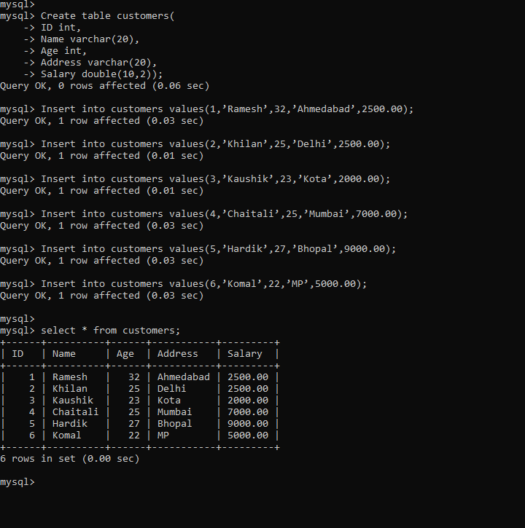

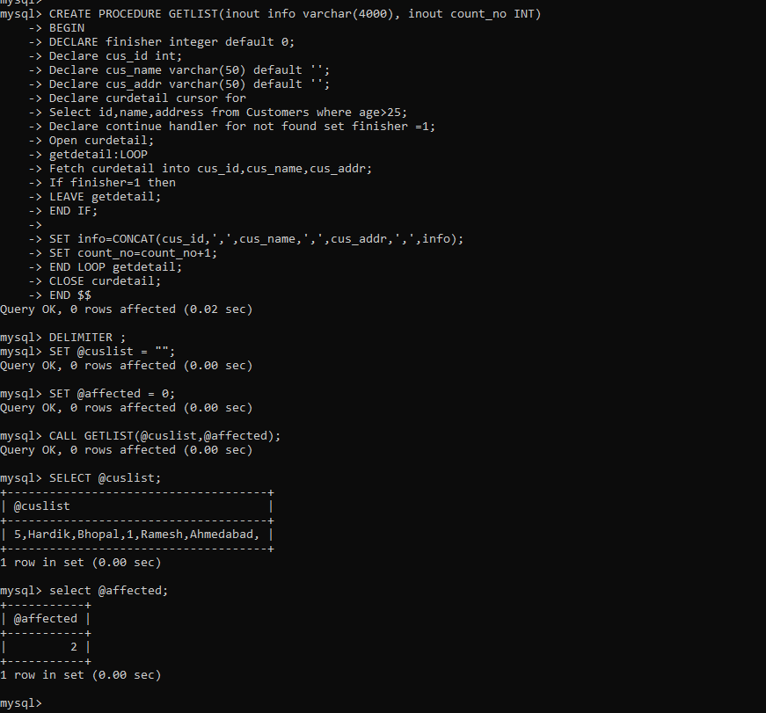

**Ans 6-**

**create table product(**

**ID int primary key auto_increment,**

**Code varchar(10),**

**Price int,**

**UpdationDate date);**

**create table PriceLogs(**

**Code varchar(10),**

**Price int,**

**UpdationDate date);**

**insert into product values(1,’abc’,200,’2022-08-09’);**

**insert into product values(2,’bc’,400,’2022-07-08’);**

**insert into product values(3,’c’,100,’2022-03-09’);**

**insert into product values(4,’abdc’,500,’2022-06-05’);**

**DELIMITER $$**

**CREATE TRIGGER price_changes**

**BEFORE UPDATE**

**ON product FOR EACH ROW**

**BEGIN**

**INSERT INTO  PriceLogs VALUES(OLD.code, OLD.price,old.UpdationDate);**

**END $$**

**DELIMITER ;**

**Update product set price=600 where code=’abc’;**

